- Unix Script for Data Collection

  - Getting Crypto prices (current, 24h high, 24h low)
Website used
URL="https://coinmarketcap.com/currencies/${coin}/"
${coin} = the two coins being scraped, “bitcoin” and “ethereum”
  - Storing in Database
This is run inside the script, creates the database and relevant tables if absent
$MYSQL -e "CREATE DATABASE IF NOT EXISTS $DB; USE $DB";

$MYSQL $DB -e "CREATE TABLE IF NOT EXISTS $TABLE (
id INT AUTO_INCREMENT PRIMARY KEY,
timestamp DATETIME DEFAULT CURRENT_TIMESTAMP,
current DECIMAL(15,2),
high DECIMAL(15,2),
low DECIMAL(15,2)
);" >> "$LOGFILE" 2>&1

  - Crontab
Crontab is set to run every hour, and export contents (the logs) into a log file
0 * * * * cd "/mnt/c/Users/Bryan Ong/OneDrive - University of Southampton/YEAR1/Data Management/Coursework" && ./data_scraper.sh >> history.log 2>&1

Notes:

Errors are handled
for attempt in $(seq 1 $MAX_RETRIES); do
echo "$(date): [$coin] Attempt $attempt/$MAX_RETRIES" | tee -a "$LOGFILE"

If any variables were not scraped successfully (due to network errors or too many requests), the script will sleep for a specified time (~around 30 seconds) and will be reran up to 5 times.

- Unix Script for Plotting

  - Getting values from the database

Initially I tried to connect directly to the database for plotting which worked, but the syntax was hard to work with. I resorted to just exporting the database to a csv file and using the values from there.
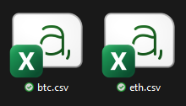
The two csv files contain all the data from the database, delimited by a whitespace.

  - Plotting Graphs
All plotting and calculations are done within a single file, having 10 different files + 10 image outputs would clog up the working directory.

The 10 graphs plotted were:
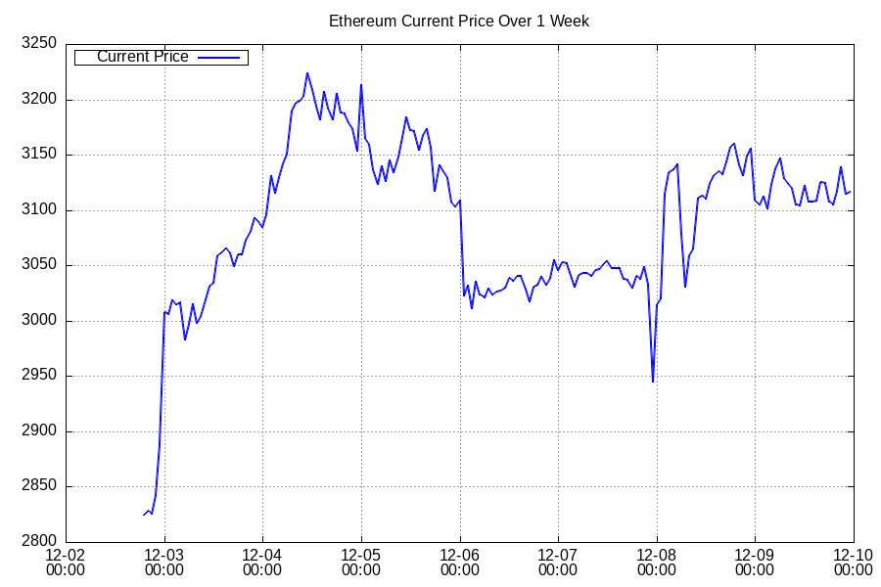
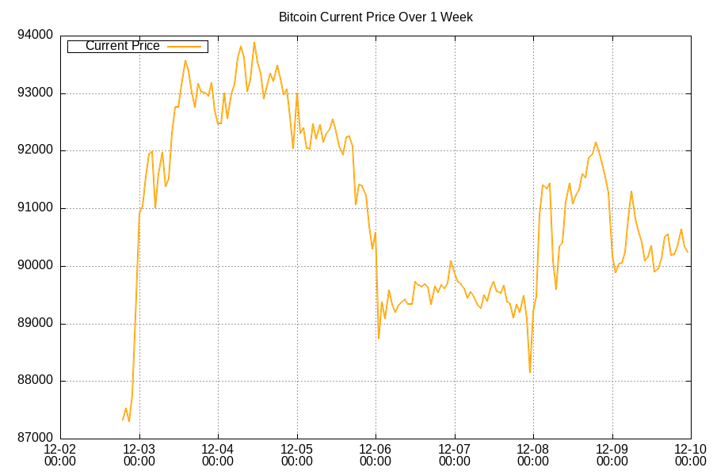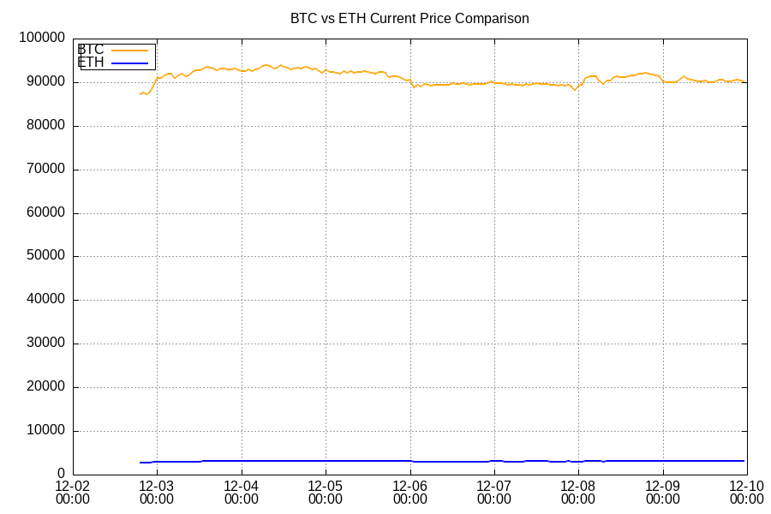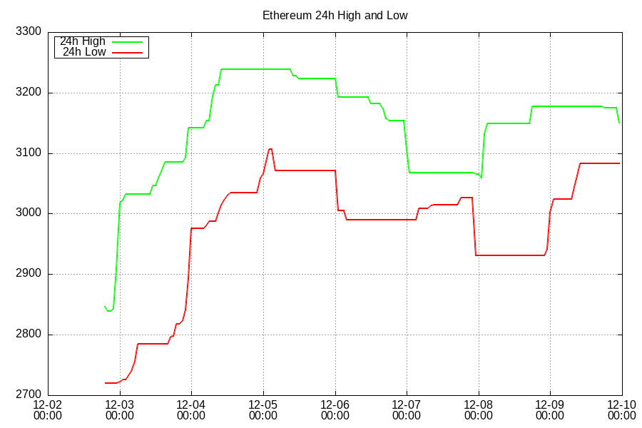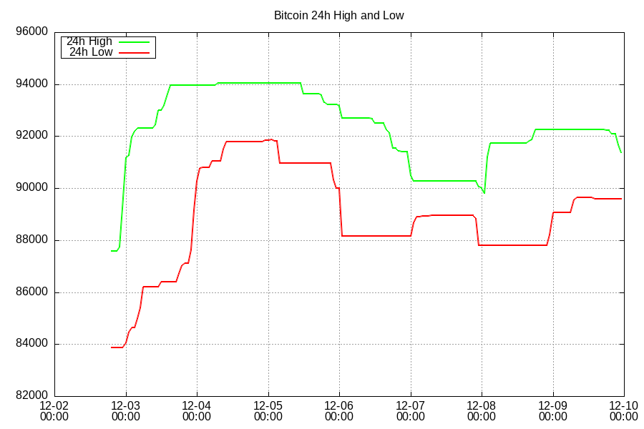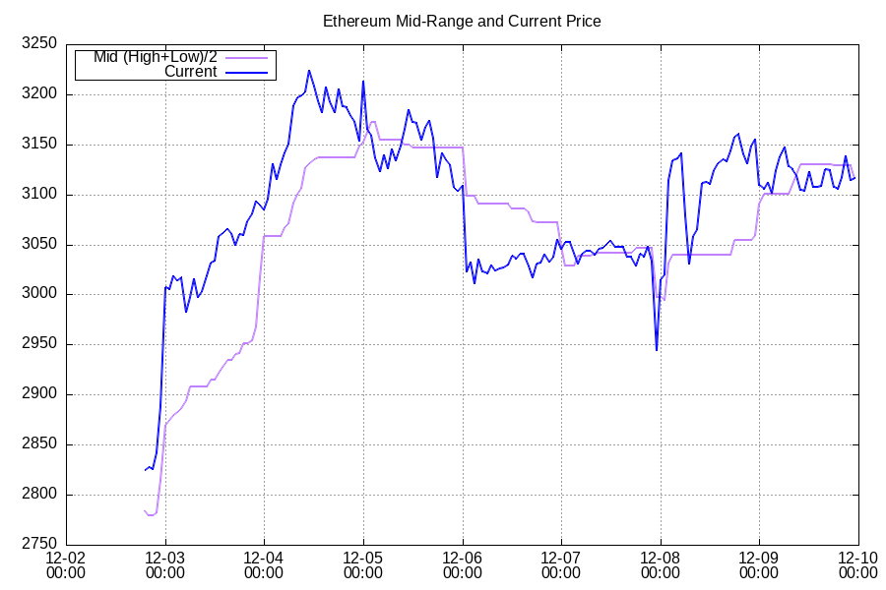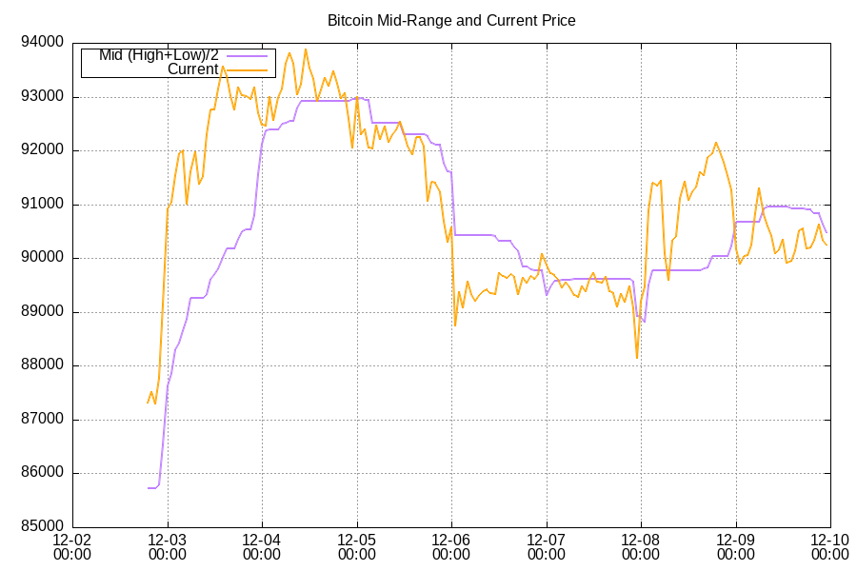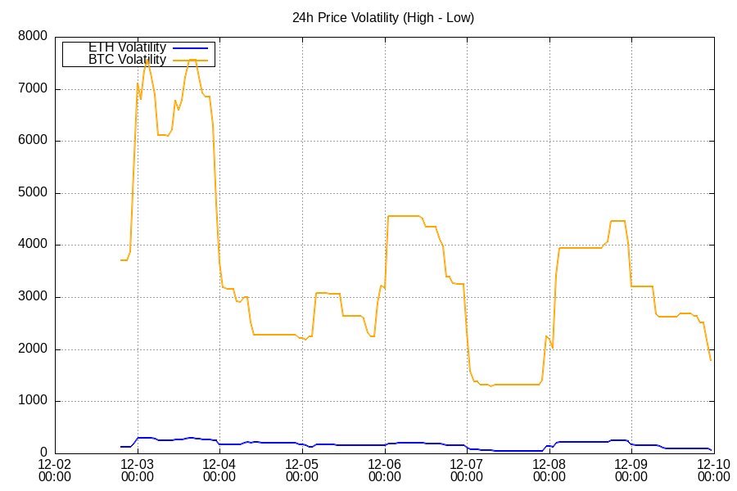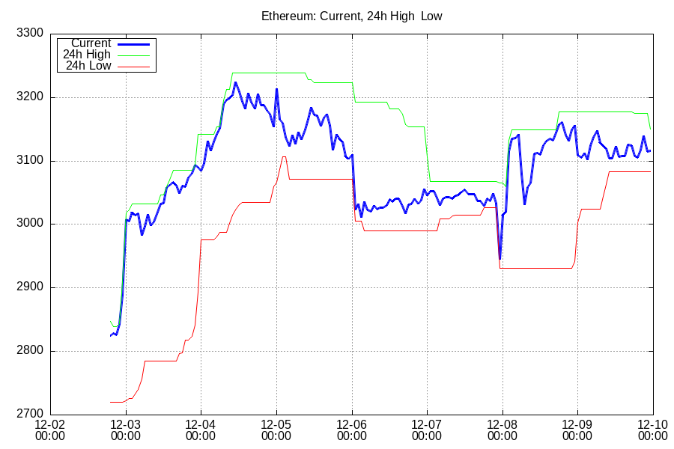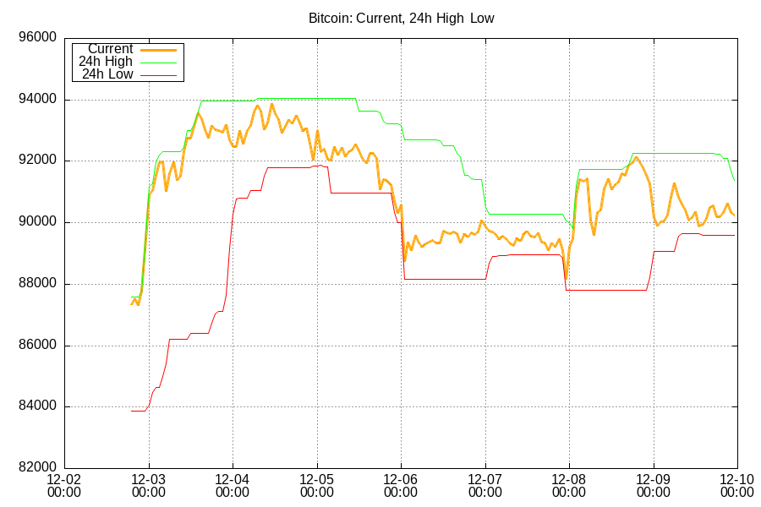

- Git Version Control

I only managed 7 commits (8 including this documentation). It has been almost 2 weeks since the first commit, fulfilling the timeframe requirement.

Repository

Here are the first 25 entries for each table.

bitcoin_prices:
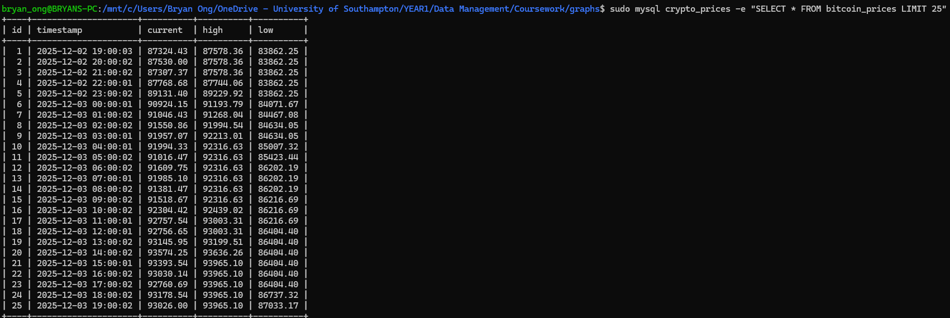

ethereum_prices:
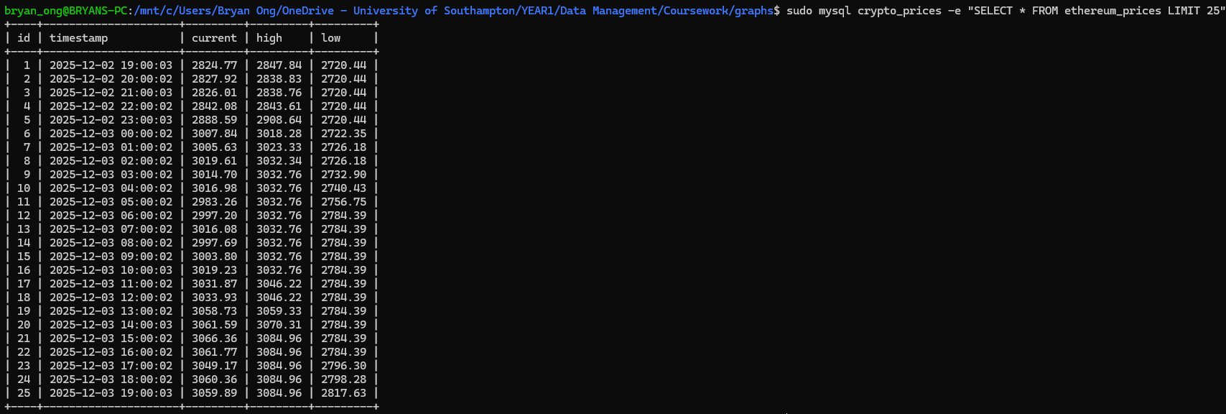

ERD Diagram:

