作业

mysql> create database mydb;
Query OK, 1 row affected (0.47 sec)

mysql> use mydb;
Database changed
mysql> create table topic (
-> id int comment '专题编号',
-> title varchar(255) comment '专题名称',
-> intro varchar(255) comment '专题介绍',
-> start_time int comment '专题开始时间',
-> end_time int comment '专题结束时间'
-> );
Query OK, 0 rows affected (1.03 sec)

mysql> desc topic;
+------------+--------------+------+-----+---------+-------+
| Field | Type | Null | Key | Default | Extra |
+------------+--------------+------+-----+---------+-------+
| id | int(11) | YES | | NULL | |
| title | varchar(255) | YES | | NULL | |
| intro | varchar(255) | YES | | NULL | |
| start_time | int(11) | YES | | NULL | |
| end_time | int(11) | YES | | NULL | |
+------------+--------------+------+-----+---------+-------+
5 rows in set (0.00 sec)

mysql> show tables;
+----------------+
| Tables_in_mydb |
+----------------+
| topic |
+----------------+
1 row in set (0.00 sec)

mysql> create table goods (
-> total int comment '库存量'
-> );
Query OK, 0 rows affected (0.89 sec)

mysql> alter table goods add add_time int comment '发布时间';
Query OK, 0 rows affected (0.93 sec)
Records: 0 Duplicates: 0 Warnings: 0

mysql> desc goods;
+----------+---------+------+-----+---------+-------+
| Field | Type | Null | Key | Default | Extra |
+----------+---------+------+-----+---------+-------+
| total | int(11) | YES | | NULL | |
| add_time | int(11) | YES | | NULL | |
+----------+---------+------+-----+---------+-------+
2 rows in set (0.00 sec)

mysql> show columns from goods;
+----------+---------+------+-----+---------+-------+
| Field | Type | Null | Key | Default | Extra |
+----------+---------+------+-----+---------+-------+
| total | int(11) | YES | | NULL | |
| add_time | int(11) | YES | | NULL | |
+----------+---------+------+-----+---------+-------+
2 rows in set (0.00 sec)

数据的查询
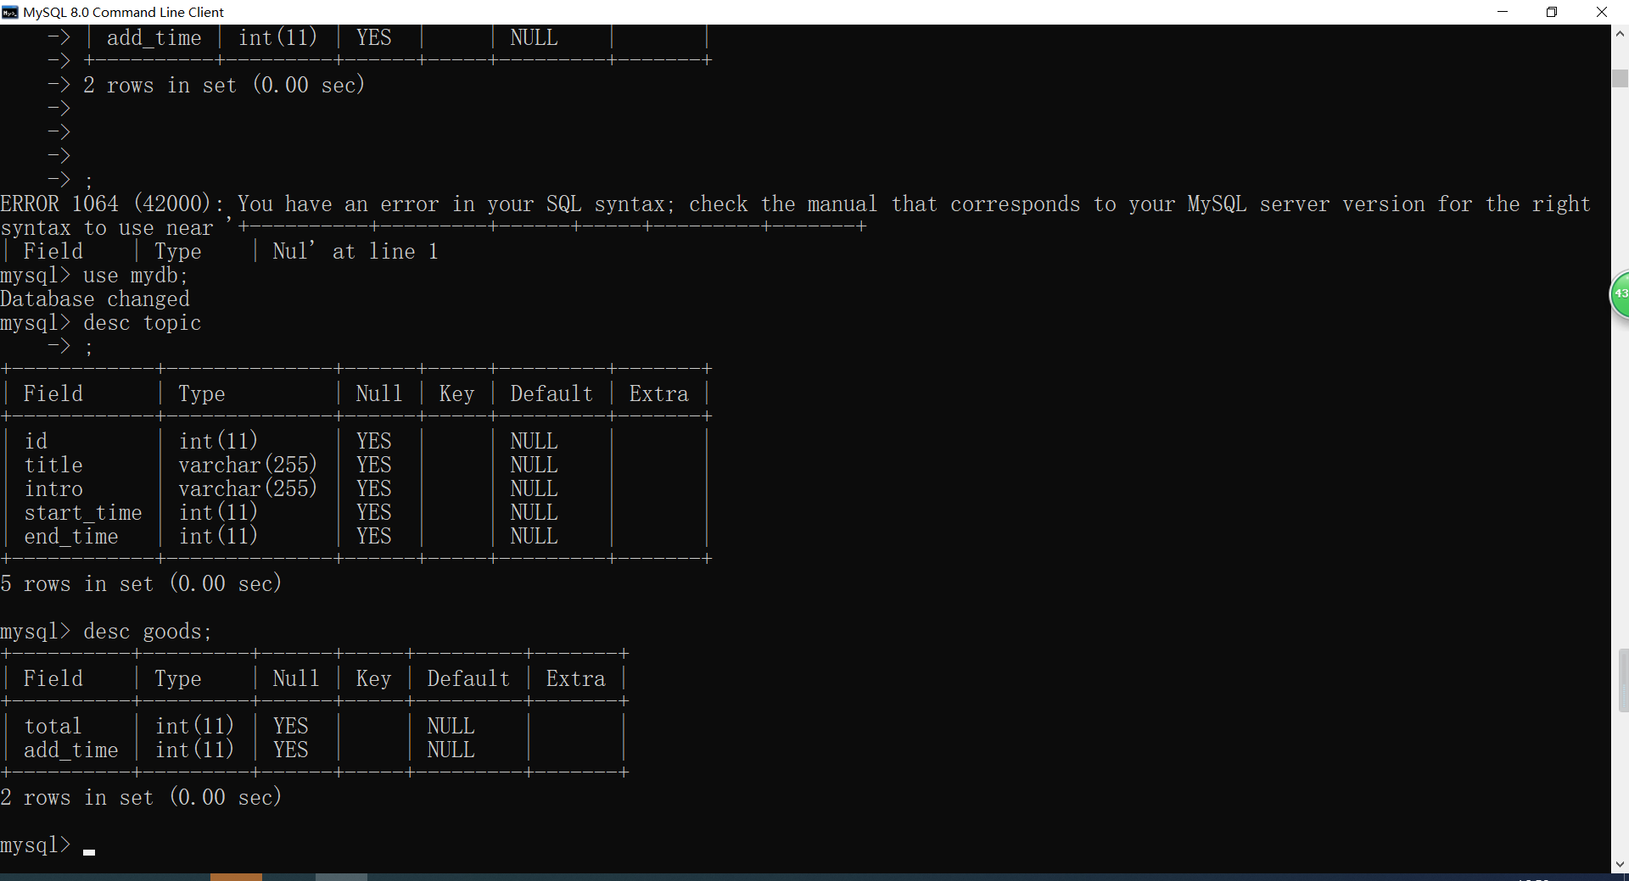

goods表
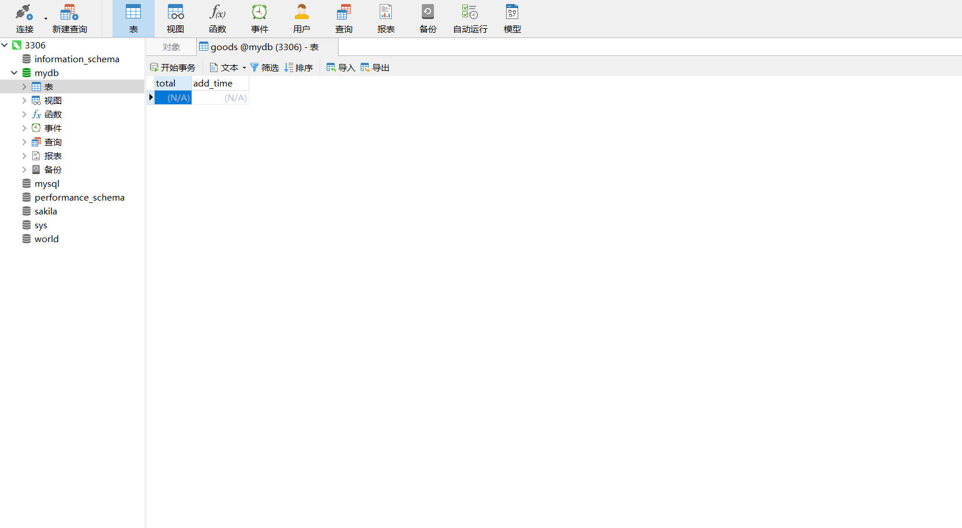

topic表
