**Introduction**

In the intricate landscape of academic assessment, where each grade holds substantial weight and every misstep can significantly shape a student's trajectory, the calculation of Grade Point Average (GPA) and Cumulative Grade Point Average (CGPA) is paramount. These metrics serve as critical indicators of academic performance, influencing opportunities for scholarships, internships, and future employment. For many students, however, the manual computation of GPA and CGPA represents a formidable challenge, fraught with complexities, time-intensive procedures, and the ever-present risk of errors. The Smart CGPA Advisor emerges as a pioneering web-based solution designed to streamline this process, furnishing students with precise calculations and personalized recommendations for academic enhancement.

Imagine navigating the complex world of academic performance, where every grade counts and every mistake can impact your future. For students, calculating GPA and CGPA can be a daunting task, especially when done manually. The process can be time-consuming, prone to errors, and often leads to frustration. That's where the Smart CGPA Advisor comes in – an innovative web-based solution designed to simplify the process and provide personalized performance improvement suggestions.

In today's fast-paced educational landscape, accuracy and efficiency are crucial. Traditional manual methods are not only time-consuming but also prone to errors, which can have serious consequences. The Smart CGPA Advisor addresses this need by automating GPA calculations, ensuring reliable academic record management, and providing students with actionable advice for improvement.

**Background of Study**

The concept of GPA and CGPA has been around for decades, serving as a benchmark for academic performance. However, the process of calculating these metrics has remained largely manual, relying on cumbersome spreadsheets and tedious calculations. This approach is not only error-prone but also fails to provide students with meaningful insights into their academic performance.

Recent advancements in technology have paved the way for innovative solutions that can streamline the process and provide personalized feedback. The Smart CGPA Advisor is one such solution, designed to leverage the power of technology to simplify the process and enhance the overall academic experience.

The principles of GPA and CGPA have been integral to academic evaluation for decades, serving as benchmarks for assessing student performance. However, the methodologies for calculating these metrics have largely remained rooted in manual processes, often involving complex spreadsheets and laborious computations. This traditional approach is not only error-prone but also fails to offer students meaningful perspectives on their academic standing, hindering their ability to identify areas for improvement.

Recent technological advancements have paved the way for innovative solutions that can streamline these processes and deliver personalized feedback. The Smart CGPA Advisor embodies such a solution, harnessing the power of technology to simplify calculations, enhance accuracy, and provide students with valuable insights into their academic performance. This web-based tool is designed to integrate seamlessly into the academic workflow, offering a user-friendly interface and robust functionality that caters to the diverse needs of students and educational institutions alike.

**Problem Statement**

Manual result processing presents significant challenges, particularly in institutions with large student populations. Delays, errors, and student frustration are common issues. The Smart CGPA Advisor aims to eliminate these problems by offering a seamless and efficient experience for students and administrators. By automating GPA and CGPA calculations, the system reduces the potential for human error and saves valuable time.

Specific Issues with the Current System Human Error:

1. Manual calculations are prone to inaccuracies, which can have severe consequences for students' academic records and future opportunities.
2. Time-Consuming: Manual calculations require considerable time, diverting attention from other crucial academic activities.
3. Lack of Transparency: Students often have limited visibility into their academic performance, making it difficult to identify areas for improvement and track their progress effectively.
4. Delays in Result Processing: Large student populations and complex academic records can lead to significant delays in processing and disseminating results, impacting students' ability to make informed decisions about their academic pathways.
5. Shortage of Manpower: Insufficient staffing resources can exacerbate bottlenecks in the result processing pipeline, further contributing to delays and inefficiencies.
6. Tedious Work: Manual calculations are often monotonous and tiresome, leading to decreased motivation and increased error rates among those responsible for performing these tasks.
7. Difficulty in Identifying Trends: Manual systems often lack the analytical capabilities needed to identify performance trends and patterns, making it difficult for students and educators to develop targeted intervention strategies.

**Research Objectives**

The primary goal is to create a revolutionary tool that:

1. Simplifies GPA Calculations: Provides accurate results and reduces manual errors, ensuring that students receive reliable assessments of their academic performance.
2. Offers Personalized Advice: Helps students identify areas for improvement and develop strategies for success. Based on Akyel and Kocaman’s (2024) insights on student engagement during the transition to higher education, the Smart CGPA Advisor provides personalized feedback and actionable recommendations tailored to students’ motivations and social contexts.
3. Streamlines Result Processing: Reduces delays and errors, providing a seamless experience for both students and administrators, enhancing the overall efficiency of academic record management.
4. Provides a User-Friendly Interface: Easy to navigate and understand, making it accessible to all students, regardless of their technical proficiency.
5. Enhances the Overall Academic Experience: Empowers students to take control of their academic journey and achieve their goals, fostering a sense of ownership and responsibility for their learning outcomes. Smith (2018) emphasizes the importance of engagement in the first year of studies; the Smart CGPA Advisor extends this engagement throughout a student's academic career by providing ongoing feedback and support.

**Significance of the Study**

The Smart CGPA Advisor has the potential to revolutionize academic performance management. By providing accurate, reliable, and personalized results, it can:

1. Boost Student Engagement and Motivation: Encourage students to take an active role in their academic journey, fostering a sense of ownership and responsibility for their learning outcomes. According to Macquarie University (2020), understanding and calculating GPA is a critical part of student academic life.
2. Improve Academic Outcomes and Success Rates: Help students achieve their goals and succeed in their academic pursuits, providing them with the tools and resources they need to excel.
3. Reduce Administrative Burdens and Costs: Streamline result processing, reducing the workload and costs associated with manual calculations, freeing up administrative staff to focus on other important tasks.
4. Foster a More Efficient and Effective Educational Ecosystem: Create a seamless and integrated system that supports student academic success, promoting collaboration and communication between students, educators, and administrators.
5. Promote Transparency and Accountability: By providing students with clear and transparent access to their academic records, the Smart CGPA Advisor can promote a culture of accountability and responsibility, encouraging students to take ownership of their learning and strive for excellence.
6. Promote Transparency and Accountability: By providing students with clear and transparent access to their academic records, the Smart CGPA Advisor can promote a culture of accountability and responsibility, encouraging students to take ownership of their learning and strive for excellence.
7. Promote Transparency and Accountability: By providing students with clear and transparent access to their academic records, the Smart CGPA Advisor can promote a culture of accountability and responsibility, encouraging students to take ownership of their learning and strive for excellence.

**Scope of the Study**

The Smart CGPA Advisor is designed to be adaptable and scalable, making it an ideal solution for institutions of all sizes. Our focus is on creating a user-centric tool that meets the unique needs of students, administrators, and educators.

This includes:

1. User-Centric Design: Developing a user-friendly interface that is intuitive and easy to navigate, ensuring that all users can access and utilize the system effectively.
2. Customization Options: Providing customization options that allow institutions to tailor the system to their specific needs and requirements, such as configuring grading scales, defining academic policies, and integrating with existing student information systems.
3. Comprehensive Reporting Capabilities: Offering a range of reporting capabilities that provide insights into student performance, identify areas for improvement, and track the effectiveness of intervention strategies.
4. Secure Data Management: Ensuring the security and confidentiality of student data through robust security measures, including encryption, access controls, and regular security audits.
5. Integration with Existing Systems: Designing the system to integrate seamlessly with existing student information systems, learning management systems, and other academic platforms, minimizing disruption and maximizing efficiency.
6. Mobile Accessibility: Developing a mobile-friendly interface that allows students to access the system from their smartphones and tablets, providing them with access to their academic records and performance data.
7. Continuous Improvement: Committing to continuous improvement by regularly soliciting feedback from users, monitoring system performance, and implementing updates and enhancements to address emerging needs and challenges.

**Definition of Key Terms**

1. **GPA** : Grade Point Average – a measure of academic performance for a specific semester or academic year.
2. **Database** : A structured collection of data stored electronically for easy access and retrieval.
3. **CGPA (Cumulative Grade Point Average):** A numerical representation of a student's overall academic performance across all semesters or academic years. It's a weighted average of grades, where the weights are typically the credit hours for each course. According to Usha P, Subashini E, Sushma S, Pradeepa S, Karthikadevi K1, a CGPA calculator can benefit students by "knowing their grades."
4. **Student Management System:** A system designed to manage and organize student-related information, including personal details, academic records, attendance, and other relevant data1.
5. **Web-Based Application:** A software application that is accessed through a web browser, meaning it doesn't need to be installed directly on a user's computer.
6. **HTML (Hypertext Markup Language):** The standard markup language for creating the structure of web pages.
7. **CSS (Cascading Style Sheets):** A style sheet language used for describing the presentation (look and formatting) of a document written in HTML. CSS is used for formatting the design of Web pages.
8. **JavaScript:** A scripting language primarily used to add interactivity and dynamic elements to websites. JavaScript is described as the most well-known scripting language of all time.
9. **Bootstrap:** A free and open-source CSS framework directed at responsive, mobile-first front-end web development. It contains CSS- and (optionally) JavaScript-based design templates for typography, forms, buttons, navigation, and other interface components.
10. **Student Profile:** A collection of information about a student, including personal details, contact information, educational background, and other relevant data.
11. **Academic Activities:** Information and tools related to a student's academic progress, such as exam schedules, grades, and performance reports1.
12. **Attendance Management System:** A system for tracking and recording student attendance in classes or other academic activities.
13. **Self-Regulatory Learning Behaviors**: Strategies employed by students to manage their learning processes effectively.
14. **Intervention Strategies**: Actions designed to assist students in overcoming academic challenges.

## ****Flowchart Explanation****

The flowchart visually represents the operational phases of the Smart CGPA Advisor, a web-based tool designed to simplify GPA and CGPA calculations while providing actionable improvement suggestions. Below is a detailed explanation of each phase:

## ****1. Input Phase****

* **Purpose**: Students enter their biodata (e.g., name, student ID) and course details (e.g., course codes, grades, credit hours).
* **Key Features**:

1. User-friendly interface for data entry.
2. Validation checks to ensure accurate input.

* **Importance**: This phase sets the foundation for accurate calculations by collecting essential data.

## ****2. Processing Phase****

* **Purpose**: Grades and credit hours are processed to prepare for GPA and CGPA computation.
* **Key Features**:

1. Automated handling of data to avoid human error.
2. Integration with databases for efficient record management.

* **Importance**: Ensures that the entered data is formatted and verified for subsequent calculations.

## ****3. Calculation Phase****

* **Purpose**: GPA (Grade Point Average) and CGPA (Cumulative Grade Point Average) are computed using standardized formulas.
* **Key Features**:

1. Use of weighted averages where credit hours act as weights.
2. Formula application:

GPA=Total Grade Points EarnedTotal Credit HoursGPA = \frac{\text{Total Grade Points Earned}}{\text{Total Credit Hours}}GPA=Total Credit HoursTotal Grade Points Earned CGPA=Sum of All Semester GPAsTotal SemestersCGPA = \frac{\text{Sum of All Semester GPAs}}{\text{Total Semesters}}CGPA=Total SemestersSum of All Semester GPAs

3. Transparency in calculation steps for user understanding.

* **Importance**: Provides students with precise academic performance metrics.

## ****4. Suggestion Phase****

* **Purpose**: Generate personalized recommendations for academic improvement based on trends in performance.
* **Key Features**:

Analysis of historical GPA/CGPA trends.

Suggestions such as focusing on specific subjects or improving study habits.

Machine learning algorithms may be used for predictive insights.

* **Importance**: Empowers students to take actionable steps toward academic success.

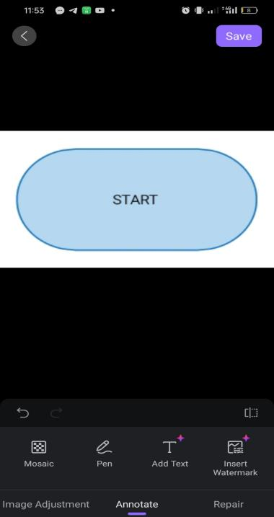

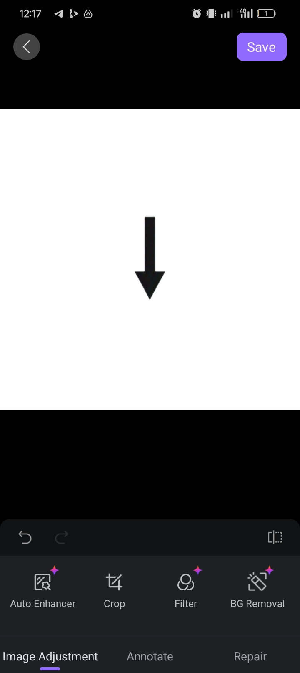

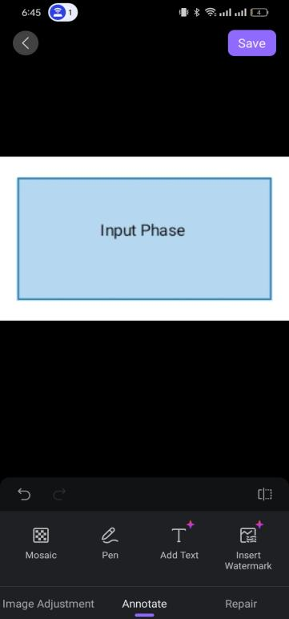



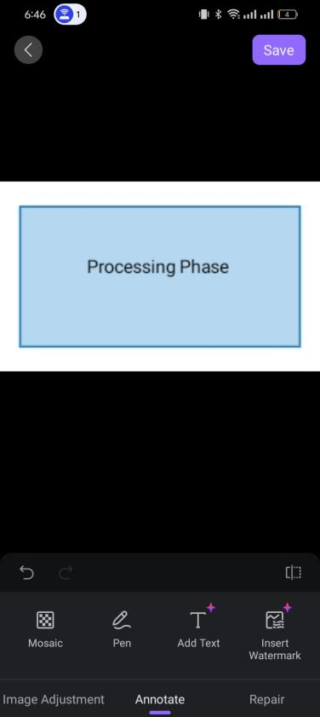



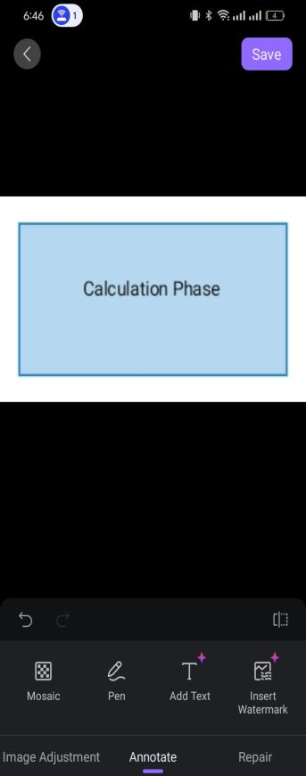



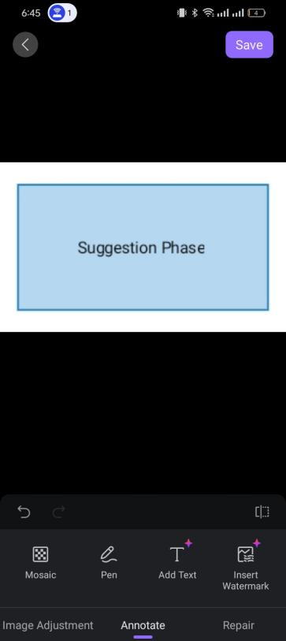



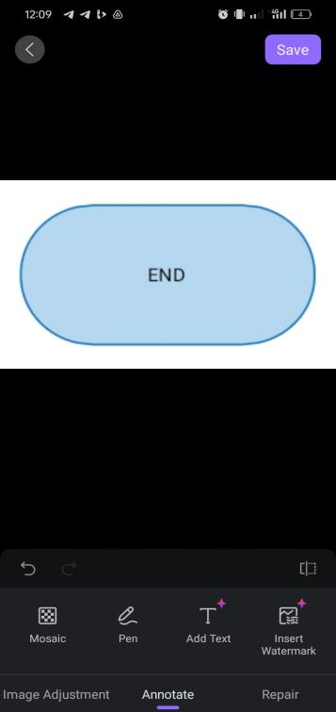

## References

Umuagwo-Ohaji.. design and implementation of an online students’ grade point (gp) calculator.2012. Imo State Polytechnic,. <https://www.academia.edu/14169548/DESIGN_AND_IMPLEMENTATION_OF_AN_ONLINE_STUDENTS_GRADE_POINT_GP_CALCULATOR>

Mohd. Rizal Razaka*, Muhd. Eizan Shafiq Abd. Azizb , Nor Zalina Ismailc ,Nazirah Ramli. 2016. Gpa And Cgpa Forecast Calculator (Gcfc). International Invention & Innovative Competition (InIIC) Series 2

A. Zarif Bhuiyan, Md Abu Bakar, Mohammad Rifatul Islam Marof, Mahar Afroz Tarin, Abir Kundu. (2025). "Projecr Report on Android-based CGPA Calculator Application". <https://www.researchgate.net/publication/389778161_Project_Report_on_CGPA_Calculator_Android_Application>

AMIN ZOLLANVARI1 , (Member, IEEE), REFIK CAGLAR KIZILIRMAK1 , (Member, IEEE),

YAU HEE KHO2 , (Senior Member, IEEE), AND DANIEL HERNÁNDEZ-TORRANO. 2017. Predicting Students’ GPA and Developing Intervention Strategies Based on Self-Regulatory Learning Behaviors. IEEE ACCESS.

Akyel, A., & Kocaman, O. (2024). Personal and social facilitators of student engagement: transition into higher education. Frontiers in Education, 9, Article 1286867.

Macquarie University. 2020. Understanding and calculating your GPA MQ Sydney https://students.mq.edu.au/study/assessment-exams/weighted-average-mark/gpa-calculator

Craig Smith Ed.D. 2018. A Comprehensive First Year Engagement Theory.https://digitalcommons.wcupa.edu/jarihe

# Priya Garg. 2025**.** CGPA to Percentage Calculator: How to Convert CGPA into Percentage?. Shiksha Study Board. https://www.shiksha.com/studyabroad/calculate-cgpa-to-percentage-articlepage-146711

Usha P, Subashini E, Sushma S, Pradeepa S, Karthikadevi K. Student Management System and SGPA, CGPA Calculator. International Journal of New Innovations in Engineering and Technology. 2023 Apr;22(1):760-764. https://www.ijniet.org/wp-content/uploads/2023/04/120.pdf