


ORDER #  2020996-1 | BUSINESS NAME  Super Taqueria | QTY  1000

Track1 magnetic & QR Code
Starting from 000000001→ ending at 000001000

First card: %A000000001^BLogicSystems^SuperTaqueria^2020996?
Last card: %AA000001000^BLogicSystems^SuperTaqueria^2020996?
FRONT   | BACK  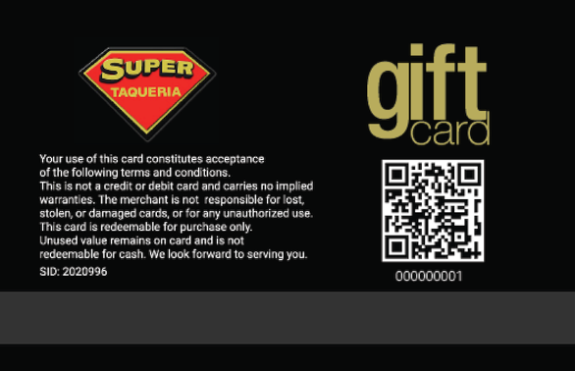[

Card number: 000000001
QR Code & Magnetic:
%A000000001^BLogicSystems^SuperTaqueria^2020996?

