Measurement Protocol
Measurement Object | 01-06-GC5320
Measurement Object Description | S600
Measurement Object Serial Number | #1
Subproject Related Measurement  Object Description | 351815.01.000457.0
Measurement Object Manufacturer
Manufacturer Description

Subproject | TYPE1
Based On Standard | GSM11_10_RF_Rev05
Report Generation Date | 7/28/2006 11:24
Responsible Person | Administrator

Status Overview
SMD | Status | Single Value Description | Single Value | Object
6.3.1 SFR. P.50 RF | OK | Min. dist. to tolerance scheme [dB], at 2057.5 Hz | 3.64 | 01-06-GC5320
6.3.2 SLR P.501, RF | OK | SLR [dB] | 8.93 | 01-06-GC5320
6.3.3 RFR. P.50 RF | OK | Min. dist. to tolerance scheme [dB], at 305.9 Hz | 2.31 | 01-06-GC5320
6.3.4 RLR nom. vol. P.501 RF | OK | RLR [dB] | 4.16 | 01-06-GC5320
6.3.4 RLR max. vol. P.501 RF | NOT OK | RLR [dB] | -13.67 | 01-06-GC5320
6.3.5 STMR P.501, RF | OK | STMR (unsealed) [dB] | 9.12 | 01-06-GC5320
6.3.7 Distortion sending RF | OK |  |  | 01-06-GC5320

6.3.1 SFR. P.50 RF 4
6.3.2 SLR P.501, RF 4
6.3.3 RFR. P.50 RF 5
6.3.4 RLR nom. vol. P.501 RF 6
6.3.4 RLR max. vol. P.501 RF 7
6.3.5 STMR P.501, RF 8
6.3.7 Distortion sending RF 9

6.3.1 SFR. P.50 RF

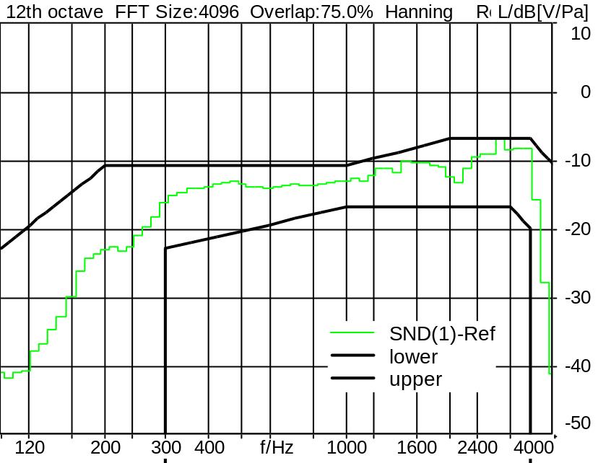

Absolute minimal distance
3.64 dB at 2057.5 Hz Ok

Ok
7/28/2006 11:03 ACQUA 2.1.100

6.3.2 SLR P.501, RF

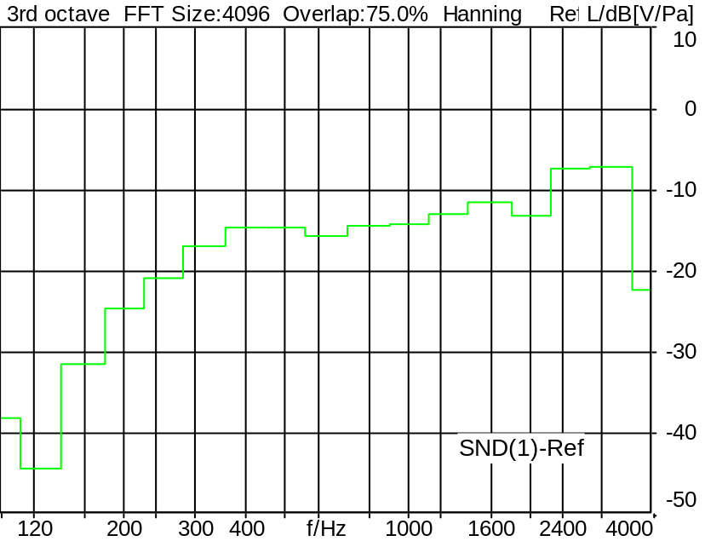

SLR: 8.93 dB Ok

Ok
7/28/2006 11:04 ACQUA 2.1.100

6.3.3 RFR. P.50 RF

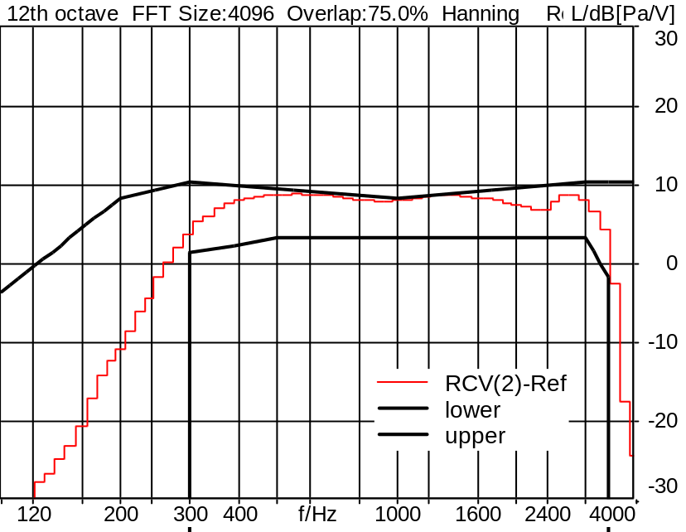

Absolute minimal distance
2.31 dB at 305.9 Hz Ok

Ok
7/28/2006 11:07 ACQUA 2.1.100

6.3.4 RLR nom. vol. P.501 RF

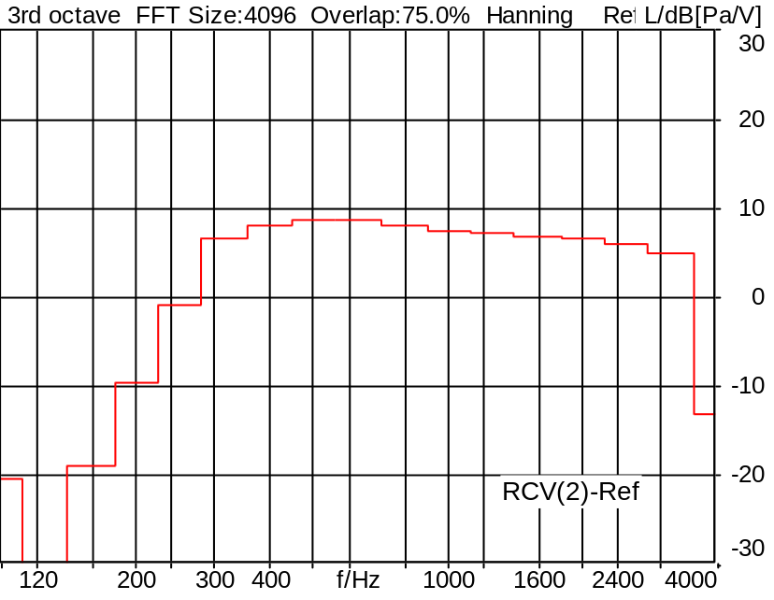

RLR: 4.16 dB Ok

Ok
7/28/2006 11:06 ACQUA 2.1.100

6.3.4 RLR max. vol. P.501 RF

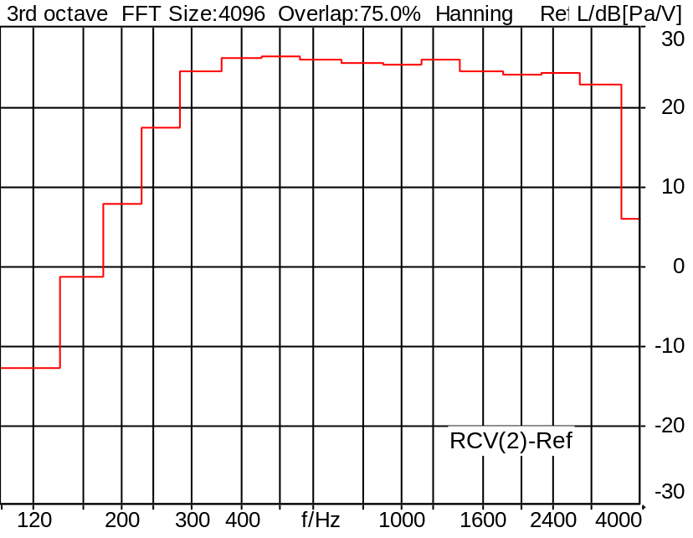

RLR: -13.67 dB Not Ok

Not Ok
7/28/2006 11:08 ACQUA 2.1.100

6.3.5 STMR P.501, RF

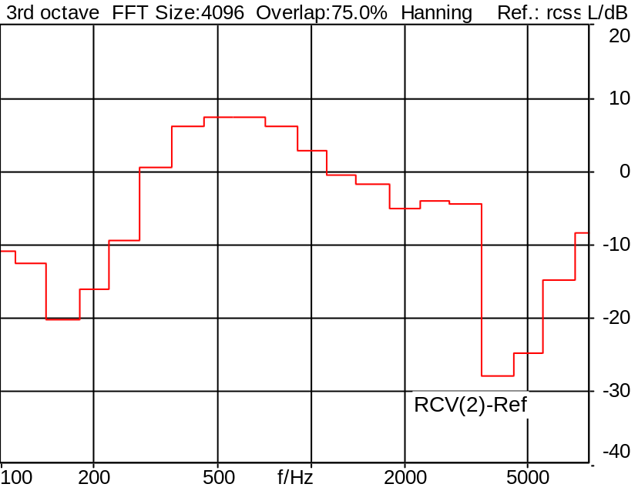

STMR (unsealed): 9.12 dB Ok

Ok
7/28/2006 11:04 ACQUA 2.1.100

6.3.7 Distortion sending RF

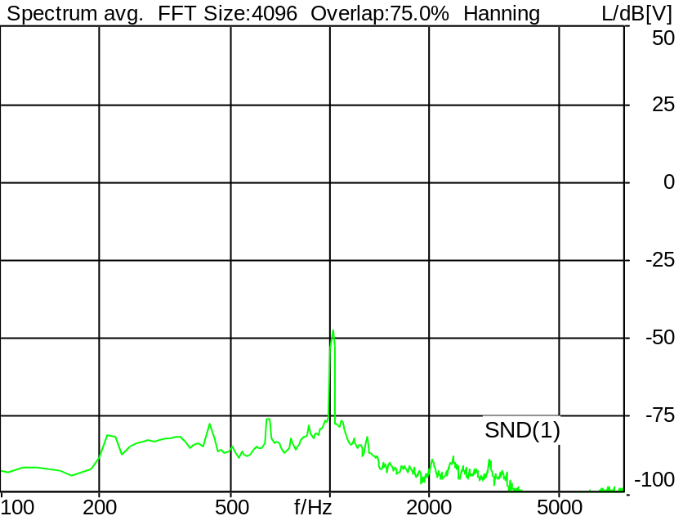

Level: -35.0 dB Freq.: 1020 Hz
Distortion SND(1): 22.38 dB (7.60%)

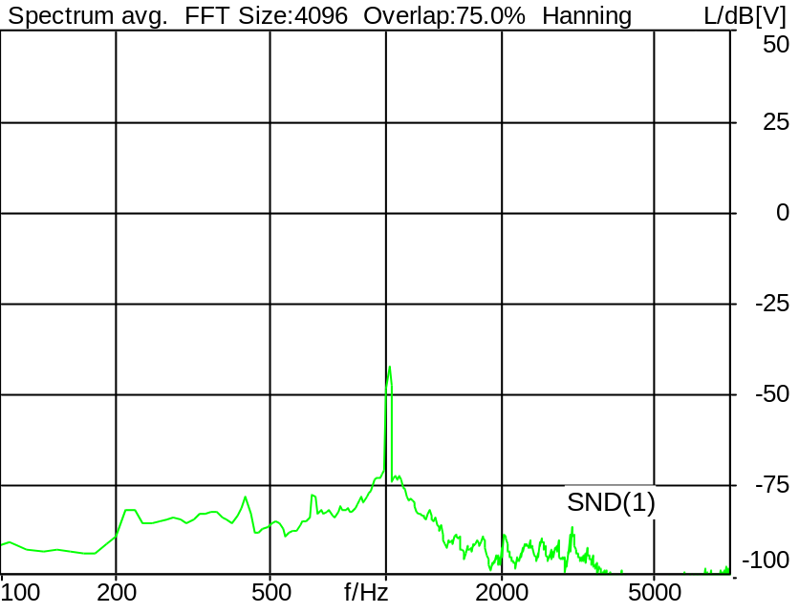

Level: -30.0 dB Freq.: 1020 Hz
Distortion SND(1): 27.79 dB (4.08%)

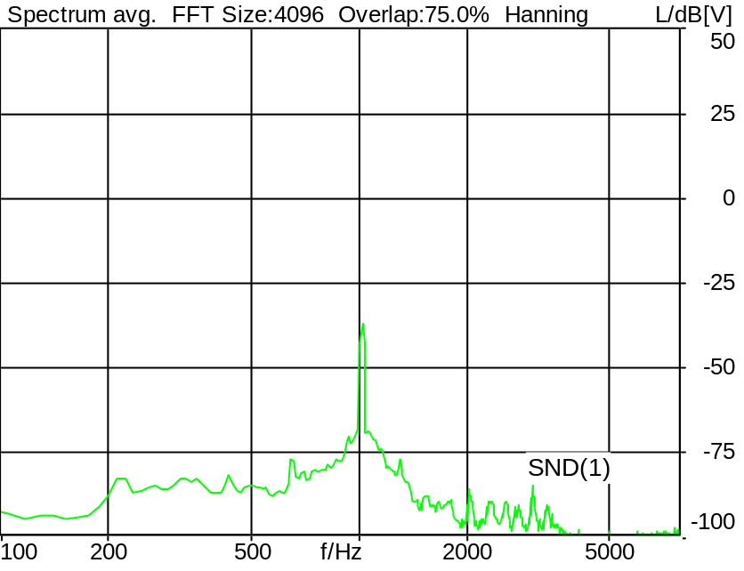

Level: -25.0 dB Freq.: 1020 Hz
Distortion SND(1): 32.82 dB (2.29%)

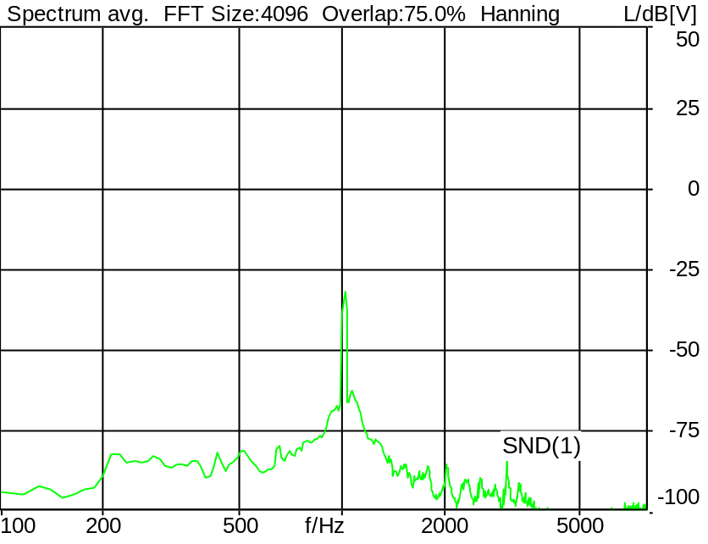

Level: -20.0 dB Freq.: 1020 Hz
Distortion SND(1): 37.84 dB (1.28%)

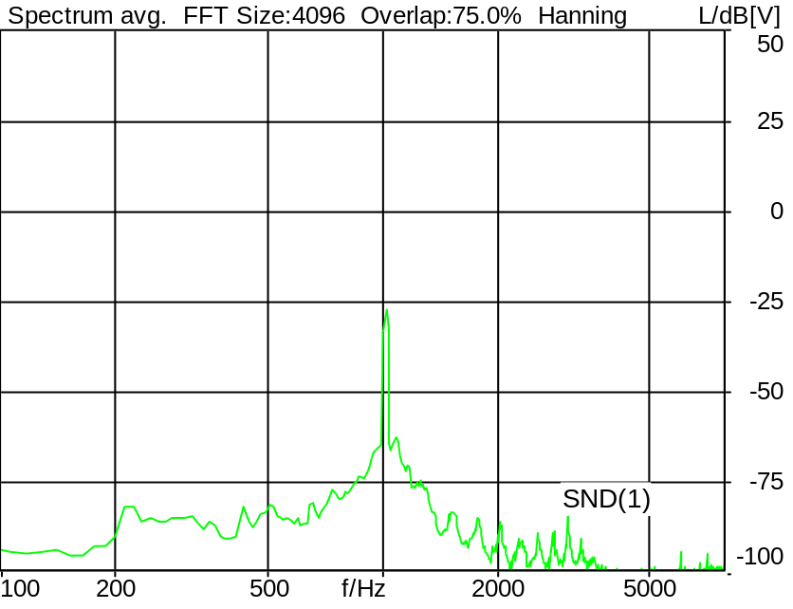

Level: -15.0 dB Freq.: 1020 Hz
Distortion SND(1): 42.55 dB (0.75%)

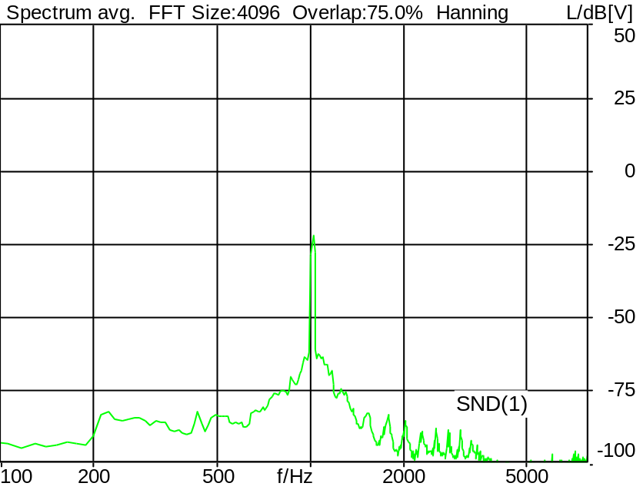

Level: -10.0 dB Freq.: 1020 Hz
Distortion SND(1): 47.37 dB (0.43%)

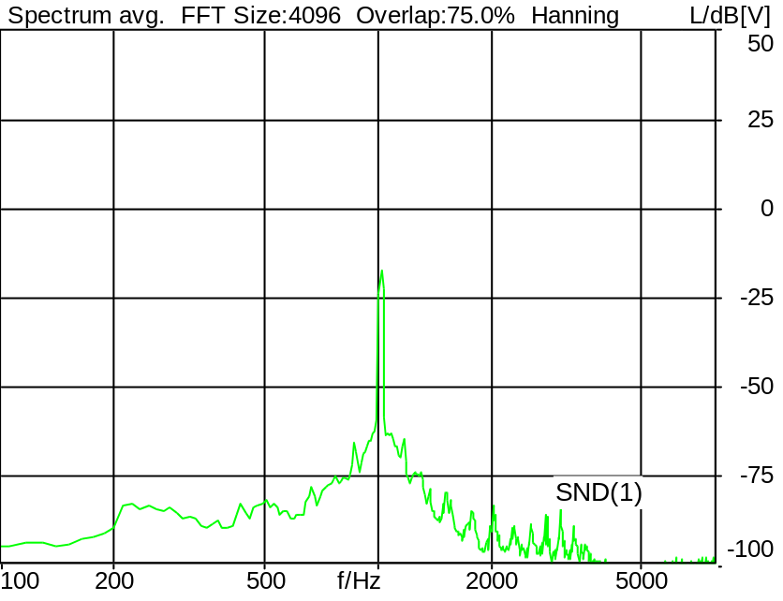

Level: -5.0 dB Freq.: 1020 Hz
Distortion SND(1): 51.19 dB (0.28%)

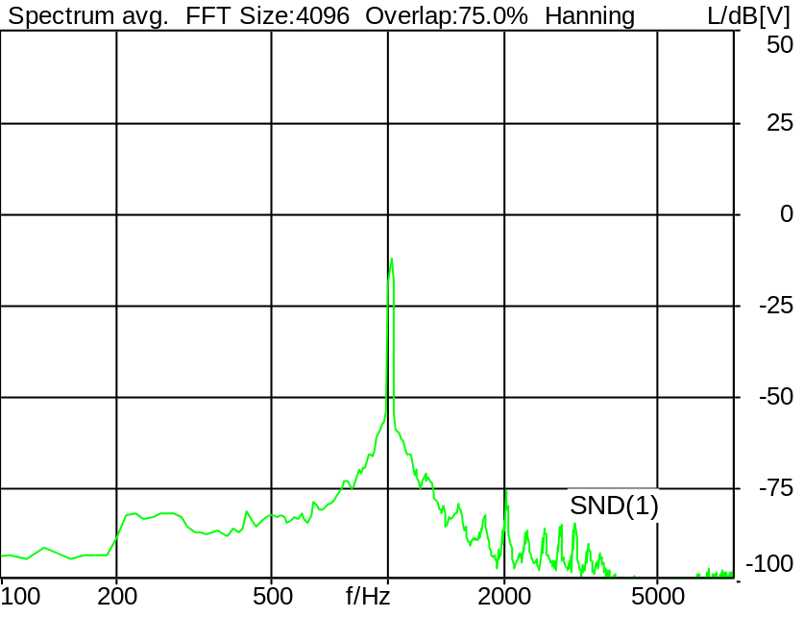

Level: 0.0 dB Freq.: 1020 Hz
Distortion SND(1): 54.51 dB (0.19%)

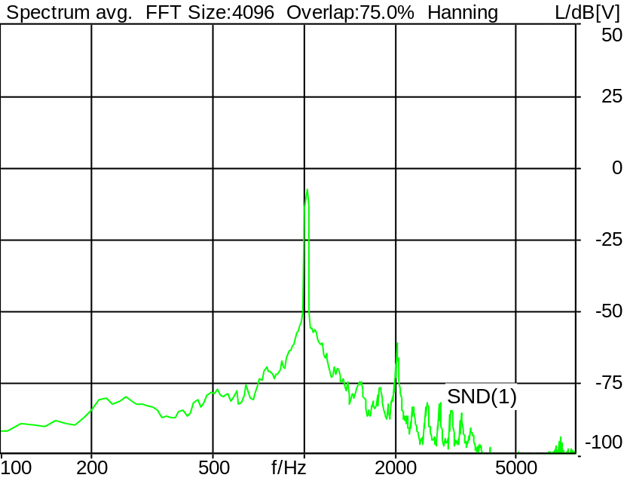

Level: 5.0 dB Freq.: 1020 Hz
Distortion SND(1): 52.09 dB (0.25%)

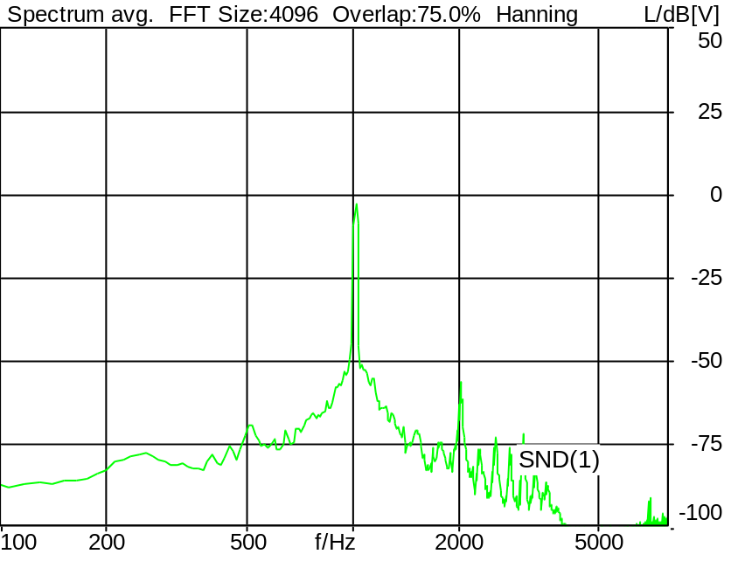

Level: 10.0 dB Freq.: 1020 Hz
Distortion SND(1): 51.86 dB (0.26%)

Gain | Dist.(SND(1))
-35.0 dB | 22.38 dB (7.60%) | Ok
-30.0 dB | 27.79 dB (4.08%) | Ok
-25.0 dB | 32.82 dB (2.29%) | Ok
-20.0 dB | 37.84 dB (1.28%) | Ok
-15.0 dB | 42.55 dB (0.75%) | Ok
-10.0 dB | 47.37 dB (0.43%) | Ok
-5.0 dB | 51.19 dB (0.28%) | Ok
0.0 dB | 54.51 dB (0.19%) | Ok
5.0 dB | 52.09 dB (0.25%) | Ok
9.5 dB (10.0 dB) | 51.86 dB (0.26%) | Ok

Ok
7/28/2006 11:05 ACQUA 2.1.100

