Collaborative Research: Spatiotemporal variability in ecosystem stability landscapes
Ecosystem dynamics reflect both the state of a system and the dynamical structure governing how that state can change. Stability landscapes, often illustrated using the “ball-and-cup” diagram (e.g., Figure 1), represent this structure: stable equilibria define states toward which ecosystems tend, unstable equilibria (i.e., “thresholds” or “tipping points”) separate their basins of attraction, and landscape geometry determines whether perturbations of a given magnitude are absorbed or instead push a system into an alternative state. Thus, ecosystems in similar states may respond very differently to the same perturbation if their underlying stability landscapes differ. Ecology has developed a rich understanding of how ecosystems move within stability landscapes, but far less understanding of how and why those landscapes vary among ecosystems or change through time, due in part to limitations in data and analytical methods that have only very recently been relaxed.
Most ecological theory and empirical tests implicitly treat stability landscapes as relatively fixed properties of ecosystems. Although theory identifies mechanisms that determine the location of stable equilibria and thresholds that separate their basins of attraction, we know far less about how these dynamical features vary spatiotemporally. If stability landscapes are themselves dynamic, then ecological thresholds are not fixed values to be discovered but instead are emergent properties that shift as the processes and interactions governing ecosystem dynamics change. This perspective may also help reconcile the strong theoretical basis for alternative stable states with equivocal evidence for their prevalence in nature: empirical tests that assume fixed stability landscapes may obscure rather than reveal the underlying dynamical structure.
The shape of the stability landscape and an ecosystem’s position in it emerge from interactions between internal processes (e.g., predator–prey dynamics) and external perturbations (e.g., climate variability; Figure 1). Strong internal feedbacks deepen the basins of the stability landscape, making the ecosystem more resilient to external shocks in the sense that i) a larger external shock would be needed to push the system into a new basin of attraction and ii) the system would recover more quickly from a shock that does not cause the system to enter a new basin of attraction, compared to a system in a shallower basin of attraction. Importantly, stability landscapes are not merely conceptual; there is a mathematical basis for their shape and depth, making them quantifiable with appropriate tools. While concepts like stability, tipping points, and resilience are well established among ecologists (REFS), fundamental questions remain concerning the processes shaping real-world ecosystem stability landscapes, including how stability landscapes change over time and among similar ecosystems; the primary mechanisms driving these changes; and whether such changes occur synchronously in a portfolio of ecosystems or arise individually.
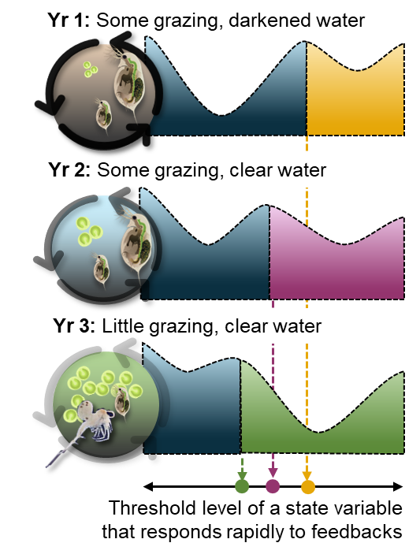 | Figure 1. Stability landscapes of primary production over 3 years in a lake. The shape of the blue basin is controlled by feedbacks that vary due to light attenuation and grazing with invasion of a predatory zooplankton. Note the shift in the threshold levels as feedbacks weakened.
Advancing understanding of the processes that govern ecosystem resilience has been a central focus of modern ecology^{9–13}. However, progress in this area has been critically held back by limitations in data availability and analysis methods. For example, easy-to-apply statistical indicators of resilience¹⁴ can signal eroding resilience without identifying thresholds, but these methods can be unreliable^{15,16}, especially when the rate of change of the driver is mismatched to the frequency of observations¹⁷. Reconstruction of stability landscapes offers a highly detailed view of ecosystem stability including identifying stable and unstable equilibria, characteristics of basins of attraction, and direct measures of resilience; but this practice has long been limited by its reliance on mathematical models that abstract real-world systems^{18,19} or massive amounts of data²⁰. Recent methodological advances enable reconstruction of ecosystem stability landscapes from more modestly sized datasets²¹, greatly expanding opportunities to study how and why ecosystem resilience varies through time and among systems.
Objectives
We propose combining recently developed analytical methods for reconstructing stability landscapes with long-term ecosystem monitoring and shorter-term whole-ecosystem manipulations in an ensemble of lakes to investigate how and why stability landscapes vary. Whole-lake experiments that intentionally alter ecosystem feedbacks provide a valuable test of resilience theory, while long-term monitoring captures changes in the stability landscape potentially driven by climatic influences on land-lake interactions. We will synthesize 140 lake-years of data from the National Ecological Observatory Network (NEON) and North Temperate Lakes Long-Term Ecological Research (NTL-LTER) programs and a series of linked whole-lake experiments supported by NSF awards to advance understanding of ecosystem resilience. Specifically, we propose to:
Objective 1: Quantify how stability landscapes vary spatiotemporally. We hypothesize (H1.1): Spatial variability in stability landscapes exceeds temporal variability; but (H1.2:) temporal variation among lakes in stability landscapes is spatially synchronous.
Objective 2: Investigate how spatiotemporal variation in stability landscapes relates to ecosystem characteristics and climate variation. (H2.1): Spatial variability is related to variables describing biological complexity and landscape connectivity; (H2.2) temporal variation in stability landscapes can be attributed to climatic variation.
Objective 3: Compare the magnitude of change in stability landscapes resulting from intentional manipulation of trophic interactions and physicochemical conditions to changes driven by interannual climate variability. (H3.1): management of the feedbacks that shape resilience changes stability landscapes in predictable ways, but (H3.2): interannual variation in climate generates a similar magnitude of change to manipulations.
Understanding how ecosystem stability landscapes vary spatiotemporally stands to advance ecological theory and improve management. While it may seem intuitive that environmental conditions affect stability landscapes, prevailing theoretical models lack feedbacks between environmental variation and ecosystem structure^{9,18,20}. Clarifying the nature of these feedbacks will strengthen the theoretical basis for understanding resilience and regime shifts. Equally important is determining whether such variation is spatially synchronous, as shared gains or losses in resilience amplify the risk of simultaneous regime shifts among ecosystems in a regional portfolio. Finally, evaluating how stability landscapes respond to deliberate manipulations will clarify the extent to which resilience can be intentionally managed.
Background and Previous Research
A popular means of conceptualizing ecosystem stability and resilience is the “ball-and-cup diagram” (Figure 1), where a ball representing the system state rests on a surface, the stability landscape. Locally low points indicate stable equilibria in a basin of attraction and peaks mark thresholds (unstable equilibria) separating basins. Perturbations move the ball around this landscape; if the push is insufficient to cross a threshold, the system remains in the basin and tends to return toward its stable equilibrium. However, sufficiently large perturbations can cause a threshold crossing to a new basin, and over time, the shape of the stability landscape itself may change, altering equilibrium locations and basin characteristics.
Stability has commonly been understood in terms of system’s persistence in a basin over time (REFS) and/or its temporal invariance (REFS), while resilience has commonly been understood as a system’s capacity to withstand large perturbations without entering a new basin of attraction (REFS) and/or its ability to quickly return to equilibrium (REFS).
The “ball-and-cup” conceptual model suggests intuitive metrics of resilience: deeper and broader basins require larger perturbations to induce regime shifts. Crucially, the ball-and-cup diagram is not merely metaphorical: the stability landscape can be mathematically reconstructed^{18,20,21} because the stability landscape corresponds to the potential function of the system (or a context-appropriate approximation thereof like the quasi-potential (REF) or effective potential, used here). As the ball-and-cup heuristic suggests, the potential function determines how fast and in what direction a system will change (i.e., the ball will roll) from any point, in the absence of external perturbation.
Historically, reconstructing these landscapes has been challenging, requiring extensive data (REFS) or sophisticated model-based analyses (REFS). Consequently, to this point research has mainly focused instead on generic statistical indicators, such as variance and autocorrelation, which are easy to calculate and have theoretical links to ecosystem stability, resilience, and state transitions^{14,22,23}. While useful in some cases^{5,24}, these indicators provide limited insight into how ecosystem stability varies spatiotemporally^{15,16}. For example, generic statistical indicators of resilience are naïve to differences in the strength of environmental forcing, potentially making among-system comparisons misleading.
Our stability landscape approach is coherent with other prominent approaches to conceptualizing and quantifying stability and resilience in ecology. In community ecology, stability has commonly been quantified in terms of the temporal invariance (e.g., 1/standard deviation or 1/coefficient of variation) in total community biomass or abundance (and indices thereof) (REFS). Assuming equal strengths of external perturbation among systems, systems residing in deeper and more steeply sloped basins of attraction will exhibit lower temporal variance compared with systems residing in shallower, gently sloping basins of attraction. Other studies have quantified resilience in terms of return time to equilibrium (REFS) and, similarly, systems residing in deeper and more steeply sloped basins of attraction will return to an equilibrium faster than those residing in shallower basis of attraction. Neither of these established approaches, however, can reveal when tipping points have been crossed and so can be misleading when systems shift among multiple basins of attraction.
Recent advances in stability landscape reconstruction have viewed ecosystems as Langevin systems^{20,25}, i.e., instances of a stochastic differential equation that can be estimated from empirical data. This approach marked a fundamental breakthrough by enabling quantification of stability landscapes without detailed dynamical models. However, early implementations demanded datasets with several thousands of observations, limiting their applicability even in an era of increasing accessibility of high-frequency automated sensors from instrumented buoys, flux towers, and other platforms. Arani et al.²¹ recently introduced refined methods that dramatically reduce data requirements and can be applied to time series on the order of hundreds of observations. As many real-world datasets now meet these criteria, this advance positions us to make significant progress in understanding spatiotemporal variability in ecosystem stability.
Lake Stability – Primary production is a fundamental ecosystem function that regulates carbon balance and supports food webs²⁶. In lakes, multiple stable equilibria often emerge from the feedbacks between nutrients, light availability, and food web structure²⁷. For example, a lake may persist in a low-productivity, clear water state stabilized by efficient grazing and low nutrient recycling or a high-productivity, turbid state reinforced by internal nutrient cycling and reduced grazing^{3,28}. The gradual erosion of resilience, reflected in changes in the stability landscape, from external drivers such as nutrient enrichment, climate variability, or species loss, can cause these self-reinforcing feedbacks to weaken or reorganize (Figure 1), increasing the chances of a threshold crossing to the other state or critical transition^{3,19,24}.
Climate strongly mediates the connection between lakes and their surrounding landscapes, shaping in-lake physical and chemical processes from year to year^{29,30}. Variation in precipitation form, timing, and magnitude influences the delivery of terrestrially derived dissolved organic carbon (DOC) to lakes^{29,31}, altering light and nutrient availability for primary production^{32,33}. The magnitude and consequences of DOC inputs are mediated by relatively time-invariant lake and watershed characteristics such as basin morphology, hydrologic connectivity, and land use^{34,35}. However, there is evidence that large changes in interannual DOC concentration influence ecosystem metabolism and productivity^{35–38}, and those changes can be synchronous among lakes in a region^{29,31,36}. Ice phenology provides an additional climatic control in seasonally ice-covered lakes: the timing of ice-off influences the depth and duration of stratification, thereby regulating vertical nutrient transport, oxygen dynamics, and water column temperatures that control growing-season productivity³⁹. These bottom-up controls interact with top-down processes, which can be restructured by human intervention such as fisheries management, species introductions, or invasions that alter grazing pressure^{19,40}. Together, these human and climate-mediated pathways create year-to-year variation in the physical, chemical, and biological feedbacks that shape the stability landscape of primary production in lakes.
Research Plan
Study System: To meet our objectives, we will use data from 5 lakes influenced only by external climate variability and natural shifts in food web structure, and 6 lakes that experience the same climate variation but have been directly manipulated to alter food web structure or the physicochemical environment (Figure 2). This combination provides a powerful framework to disentangle the roles of external forcing, internal dynamics, and targeted interventions in shifting stability landscapes. These 11 lakes are located within 30 km of each other in the Northern Highlands Lake District of Wisconsin and the Upper Peninsula of Michigan, USA. The lakes range in size, trophic state, and landscape position^{41,42}, all within predominantly forested watersheds, and due to their close proximity share similar underlying geology and are exposed to the same regional climate. Across three long-term programs, 140 lake-years of high frequency dissolved oxygen (DO) data have been collected using automated sensors deployed at the deep site in each lake^{43–50} (Figure 2), although these data sets are not harmonized. Each program also collected supporting meteorological, water chemistry, and community abundance data for each lake-year.
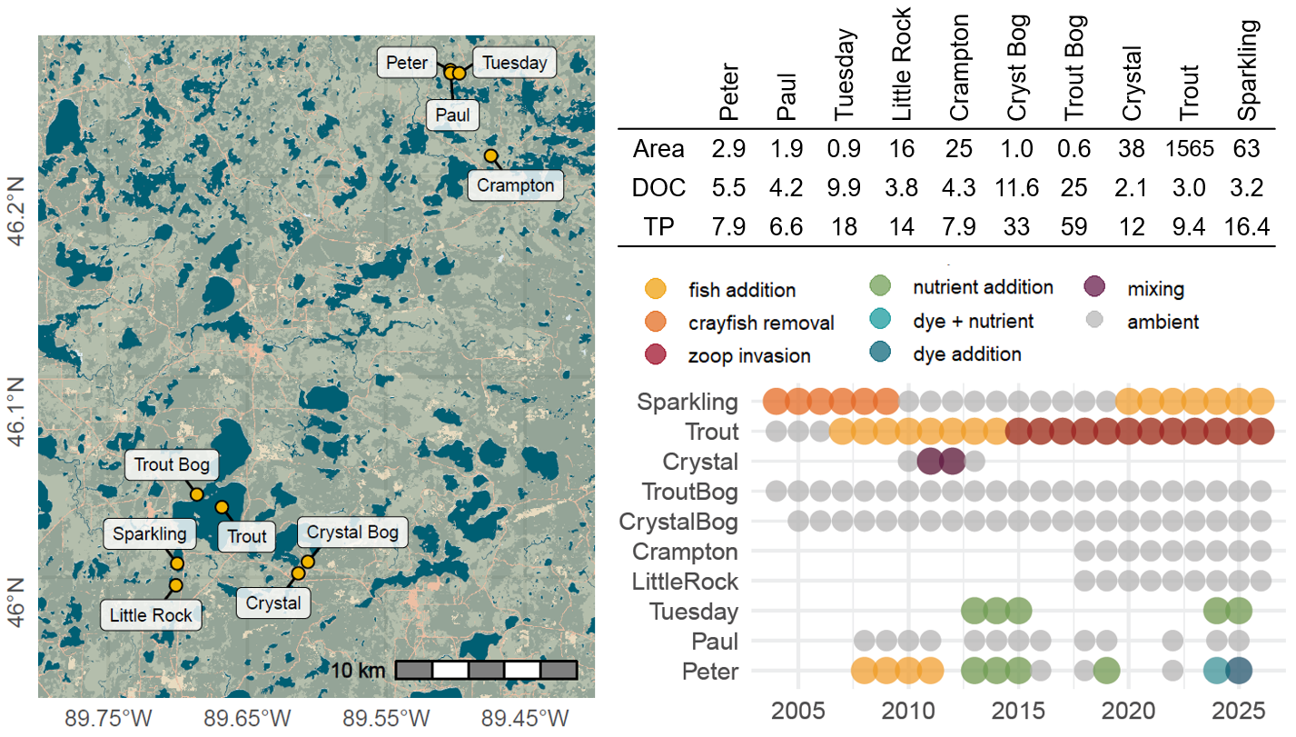
Figure 2: (left) The study lakes (yellow points) in the Northern Highlands Lake District are all located within 30 km of each other. (right) Available high frequency dissolved oxygen data. Each circle represents a summer of data collection; color coding corresponds to manipulations.
Regional Hydrology and Climate: The Northern Highlands Lake District is underlain by Precambrian bedrock overlain by 40–60 m of permeable glacial and fluvial deposits that form an extensive unconfined aquifer. Lakes are tightly coupled to this groundwater system; many are seepage lakes nested within the water table, making groundwater a dominant component of regional hydrology. The region has a cool, humid continental climate with strong seasonality and historically substantial, but highly variable, winter snowfall. Since 2007, annual snowfall totals have declined sharply relative to preceding decades, while summer precipitation increased shortly thereafter, including several exceptionally wet summers during the 2010s. Despite lower snowfall totals, snow water equivalent has been markedly elevated, though variable, since 2013, indicating a shift toward a denser, higher-water-content snowpack. Greater snowfall totals are also associated with higher water color in the subsequent summer, demonstrating that variation in winter precipitation can have persistent effects on lake conditions well into the open-water season. Together, these changes point to an important shift in the seasonality and form of water inputs to the region, with reduced snowfall and increased warm-season rainfall altering the hydrologic regime experienced by lakes.
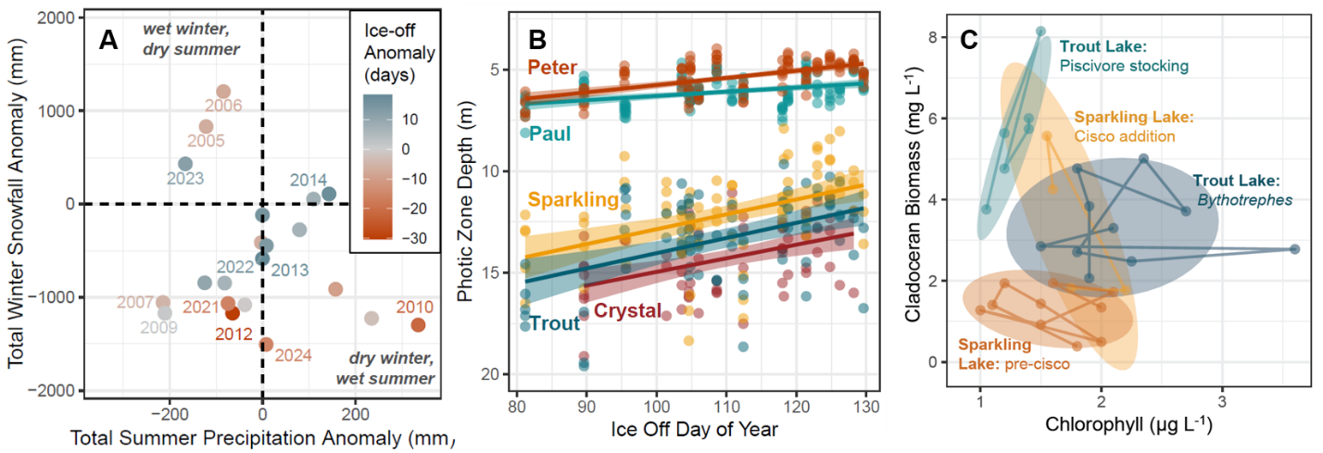
Figure 3. Examples of variation among years and lakes in weather conditions, light availability, and grazing pressure. [A] Summer precipitation anomaly versus winter snowfall anomaly, colored by ice-off anomaly. All anomalies calculated using data from 1980-2025. Drier winters tend to have earlier ice-off dates and winters have had anomalously low total snowfall since 2007. [B] Years with later ice-off are correlated with shallower photic zone depth (i.e., the depth of 1% surface irradiance) in the early summer (May and June). [C] Examples of shifts in the relationship between summer surface chlorophyll concentrations and zooplankton grazer biomass with the addition of cisco (Sparkling Lake) and invasion of Bythotrephes (Trout Lake).
Long-term records from NTL lakes document a loss of winter ice cover, superimposed on substantial interannual variability in ice phenology. While some of the climate variation and ice phenology followed decadal-scale oscillations, instances of “weather whiplash⁵⁸” occurred, such as ice-off on March 20, 2012 followed by ice-off on May 17, 2013. In the smaller, sheltered lakes that numerically dominate the Northern Highlands, earlier ice-off extends the period of spring warming and is associated with warmer temperatures deeper in the water column (Dugan 2021, Szydlowski et al. in review), linking variation in winter conditions to the physical structure of lakes during the subsequent open-water season.
The lakes range in size, trophic state, and landscape position…
Mechanistic hypotheses: We hypothesize that the stability landscape of pelagic primary production is governed by interactions between relatively slow and fast ecosystem variables (Walker et al. 2012). In our framework, zooplankton grazing pressure and light attenuation are slow variables that vary among lakes and year-to-year, influencing the shape of the stability landscape, whereas nutrient availability and temperature are fast variables that vary substantially within a growing season and move primary production within that landscape. Thus, changes in food web structure that reduce zooplankton grazing or increases in light availability should weaken constraints on phytoplankton growth making basin walls more shallow and primary production more responsive to fast changes in nutrients and temperature; conversely, stronger grazing or greater light attenuation should steepen basin walls and constrain that response.

Nutrients and temperature can drive primary production across a threshold between alternative states without necessarily changing the underlying stability landscape. However, sufficiently high nutrient availability or temperature may themselves alter feedbacks and alter basin shape, eliminating the low-production equilibrium so that a system with two alternative stable states transitions to one with only a high-production equilibrium. This distinction allows us to separate movement within a stability landscape and threshold crossing from changes in the shape of the landscape itself, and to test whether trophic cascades, invasions, and changes in light attenuation alter the resilience of pelagic primary production.
Mechanism and Prediction | Effect on Metabolism | Lake and Manipulation
Stronger top-down control: reduction in planktivores increases grazing pressure, resulting in steeper basins in the stability landscape | Lower primary productivity and weaker response to variation in nutrients and temperature; hypolimnetic nutrients may elevate metabolic rates in Crystal temporarily during mixing | Peter: bass stocking (Carpenter et al. 2011)
 |  | Trout: lake trout stocking (Martin et al. 2022)
 |  | Crystal: mixing-induced smelt reduction (REFS)
Weaker top-down control:  increase in planktivory decreases grazing pressure, resulting in shallower basin walls | Higher primary productivity and greater responsiveness to variation in nutrients and temperature | Trout: Bythotrephes invasion (REFS)
 |  | Sparkling: smelt removal / cisco stocking (REFS)
Stronger bottom-up control:  Higher CDOM increases light attenuation, or higher macrophyte biomass increases nutrient competition, resulting in steeper basin walls | Lower primary productivity due to restricted light availability despite nutrient enrichment | Tuesday, Peter: high-color with nutrients (2013-2015)
 |  | Peter: Aquashade addition with nutrients (2024-2025)
 | Lower pelagic productivity due to reduced nutrient availability from macrophyte competition | Sparkling: macrophyte recovery (YEARS) (REFS)
Weaker bottom-up control:  Lower CDOM decreases light attenuation, resulting in shallower basin walls | Greater primary productivity due to greater light availability | Tuesday: low-color with enrichment (2024-2025)
 |  | Peter: low-color with enrichment (2018-2019)
Natural variability in top-down and bottom-up control: Shifts due to climate-driven changes in resource/light availability or population cycles altering grazing pressure, resulting in smaller changes in basin wall geometry compared to intentional manipulations | Substantial interannual variation in production may occur, but should be explained more by movement within stability landscapes by fast variables such as nutrient availability and temperature than by major changes in landscape geometry | Paul (2008-2025)
 |  | Little Rock (2018-2026)
 |  | Crampton (2018-2026)
 |  | Trout Bog
 |  | Crystal Bog
Cross-lake synthesis: Together, these experiments create replicated contrasts in the mechanisms hypothesized to reshape the stability landscape of pelagic primary production. We will test whether lake-years characterized by strong zooplankton grazing or high light attenuation consistently result in deepening basins, whereas reduced grazing or greater light availability produce shallower basins, regardless of whether those conditions arose through trophic cascades, species invasions, natural variation in water color, or experimental manipulation. Within these contrasting landscapes, seasonal variation and experimental manipulation of nutrients and temperature provide fast forcing that moves primary production within and potentially between basins, allowing us to test whether the response to these drivers is amplified when stabilizing constraints are weakened. Comparing repeated manipulations within lakes, analogous mechanisms across lakes, and unmanipulated reference lakes will allow us to distinguish changes in ecosystem state caused by fast forcing from changes in the stability landscape caused by rewiring of slower ecological controls.
Ecosystem state variables: We will use high frequency (every 5-60 min) time series of dissolved oxygen (DO) saturation and daily estimates of ecosystem metabolism rates to reconstruct stability landscapes for the 140 lake-years. Because DO integrates the effects of photosynthesis, respiration, and their regulatory feedbacks, it is a useful state variable for tracking the integrated dynamics of aquatic ecosystems at high sampling frequencies. Daily rates of ecosystem metabolism will be estimated from DO dynamics; ecosystem metabolism represents the balance of photosynthesis and respiration while accounting for physical processes such as atmospheric gas exchange. Thus, it also tracks the integrated dynamics of aquatic ecosystems with deeper inference into ecological process, but at a loss of measurement frequency compared to DO because sub-daily data are integrated to compute metabolism. In these lakes, metabolic rates are sensitive to phytoplankton biomass and dissolved organic carbon^{38,51,52}. An extensive body of literature examines how the diversity (REFS) and structure (REFS) of biotic communities mediate ecological stability and resilience, and while our ecosystem measurements integrate the biotic community through its net effects on primary production and respiration, they offer a limited view of community dynamics. Because most community data are taken at coarser temporal intervals (e.g., monthly, annually) they are not suitable for the stability landscape reconstruction approaches we will employ; instead, we investigate how biotic communities shape variability in stability landscapes measured from ecosystem variables (see Objective 2, H2.1 and Objective 3, H3.1).
Ecosystem metabolism will be estimated using the Kalman filter method⁵³ implemented in the LakeMetabolizer R package⁵⁴. Metabolic rates can be modeled at a daily time scale; however, the uncertainty surrounding these derived estimates may dampen signals of changing resilience⁵⁵. In contrast, sub-daily DO saturation reflects the production–respiration balance and responds rapidly to shifts in nutrient supply, food web structure, and physical conditions^{55,56}. Although atmospheric equilibration can dampen DO signals, this effect is likely smaller than the uncertainty in metabolism estimates. Given these tradeoffs, we will assess both daily metabolism and high frequency DO saturation as state variables for reconstructing stability landscapes. Phytoplankton pigment concentration (chlorophyll, phycocyanin) are also candidate state variables useful for studying regime shifts^{5,12,19,25}, but high frequency pigment data are only available for 53 lake-years (versus XXX for DO). We will compare DO- and pigment-based stability landscapes where data overlap to assess the robustness of conclusions drawn from DO landscapes.
Climate and Manipulations: The lakes are dimictic, with regular ice cover in winter. Average summer air temperature is 19 °C and water year precipitation is 864 mm in this region. However, climate conditions have varied substantially over the past two decades, driving interannual variability in physicochemical conditions in the lakes^{29,30}. Annual water year precipitation varied from 548-1220 mm during the study period, and ice cover duration varied by up to two months⁵⁷. While some of the climate variation followed decadal-scale oscillations, instances of “weather whiplash⁵⁸” occurred, such as ice-off on March 20, 2012 followed by ice-off on May 17, 2013. These climatic variations contributed to ≈2-10x variations in summer water color⁵⁹ a key control on the light available for primary production.
Grazing pressure, light and nutrient availability, and temperature have all been experimentally manipulated in one or more of the lakes (Figure 2). Zooplanktivory was altered in Sparkling Lake by removing omnivorous rainbow smelt⁶⁰ and later adding zooplanktivorous cisco⁶¹. Invasive rusty crayfish were removed through trapping⁶², increasing macrophyte cover 2-4x⁶³. Stocking piscivorous largemouth bass in Peter Lake and lake trout in Trout Lake induced trophic cascades that reduced phytoplankton biomass^{24,64}, although the invasion by spiny water flea (Bythotrephes) of Trout Lake reversed the effect⁶⁵. Transparency was experimentally reduced in Peter and Ward Lakes by adding a blue dye⁶⁶, which also altered thermocline depths. The thermocline was eliminated in Crystal Lake via experimental whole-lake mixing, which had a large effect on metabolic rates⁶⁷. Finally, additions of N and P were performed in Peter and Tuesday Lakes to generate phytoplankton blooms^{16,56}.
Objective 1: Quantify spatiotemporal patterns of stability. We will apply recently developed techniques for empirical stability landscape reconstruction to quantify spatiotemporal patterns of ecosystem stability. Specifically, we aim to resolve the relative magnitudes of spatial versus temporal variation in stability landscapes, and whether temporal variability in stability landscapes is spatially synchronous. Spatial synchrony refers to the exceedingly common tendency for temporal fluctuations in system properties (e.g., productivity, chemical
concentrations) to be correlated across locations, often due to shared climatic fluctuations^{31,68,69}.
We will use the “Hermite” method described in Arani et al.²¹ to empirically construct the stability landscape for each lake-year using high frequency DO and daily metabolism time series. Briefly, the method uses splines to flexibly estimate the Langevin system in a maximum likelihood framework, from which the “effective potential function,” i.e., the quantity corresponding to the stability landscape for stochastic systems, is determined. The method applies to systems meeting 3 key assumptions: the data are stationary; the data satisfy the Markov property; and the time series resolution is small relative to the timescale of system dynamics. Preliminary analyses indicate that these assumptions are met with modest data pre-processing, and the data distributions exhibit hallmarks of bistability (i.e., two basins of attraction with stable equilibria separated by an unstable equilibrium/threshold) in many lake-years.
From the reconstructed stability landscapes, we will extract information such as the position of the threshold, stable equilibria, distance between equilibria, and basin width and depth (Figure 3). These descriptive metrics will be used to quantify multidimensional differences in stability landscapes among lake-years to assess the relative magnitude of spatial and temporal variability (H1.1). Specifically, we will use Multivariate Analysis of Variance (MANOVA, or non-parametric PERMANOVA if assumptions are violated) for this comparison because stability landscapes are multidimensional: the locations of equilibria and the basin depth and shape all influence system dynamics and cannot be reduced to a single variable without information loss. While we emphasize multivariate methods, functional data analysis (FDA⁷⁰) offers a parallel approach. We focus on multivariate methods because prior research (REFS) leads us to be interested in specific values such as the locations of stable and unstable equilibria, while enabling holistic tests of stability landscape change. Many FDA approaches use function values at discrete points, making them closely aligned with multivariate analyses. We will evaluate both approaches as the research progresses.
To test for spatially synchronous changes in stability landscapes (H1.2), we will use an adaptation of Pearson correlation for multivariate data. Spatial synchrony between two locations (here, lakes) is commonly measured by applying Pearson correlation to univariate time series (Walter et al. 2017); the standard Pearson correlation can be straightforwardly extended to a measure of spatial synchrony (r) for two multivariate time series X and Y:
$$r_{X,Y}=\frac{1}{V(T-1)}\sum_{v=1}^{V}{}\sum_{t=1}^{T}{}\left(\frac{x_{v,t}-{\underline{x}}_{v}}{s(x_{v})}\right)\left(\frac{y_{v,t}-{\underline{y}}_{v}}{s(y_{v})}\right)$$
Where x_{v,t} and y_{v,t} are the values at two locations for variable v in v = 1 … V, and time t for t = 1 … T; overbar denotes the sample mean; and s() denotes the sample standard deviation. Statistical significance will be assessed by comparing the empirical multivariate synchrony to a distribution of values representing a null hypothesis of no synchrony generated by randomly permuting the
time steps of the data to break systematic temporal associations between X and Y. Statistically significant values are those in the tails of this distribution (e.g., quantiles >0.95).
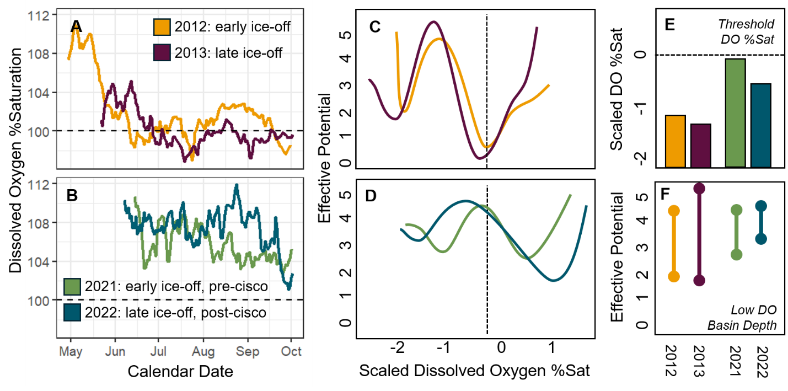
Figure 4. [A, B] Daily mean dissolved oxygen (DO) saturation in Sparkling Lake during paired early- and late-ice-off years: 2012–2013 and 2021–2022, with the latter pair spanning cisco introduction. [C, D] Reconstructed stability landscapes of scaled DO saturation for these years. [E] Unstable thresholds occurred at lower DO saturation following later ice-off and were closer to 100% saturation in 2021–2022 than in 2012–2013. [F] Low DO basins were substantially deeper in 2012–2013, indicating greater resistance to crossing the threshold.
We applied stability landscape reconstruction methods to 4 years of hourly DO data from Sparkling Lake to demonstrate proof-of-concept (see also Figure X on stability landscapes measured from algal pigments). Sensors were deployed throughout the ice-free season in 2012, 2013, 2021, and 2022. The selected years bracket climatic extremes (earliest ice-off in 2012, latest in 2013) and contrast an unmanipulated period (‘12, ‘13) with a fish addition (‘21, ‘22) that increased the density of zooplanktivores. Supporting the premise of this proposal, there is considerable year-to-year variability in lake stability landscapes (Figure 4). While in all years there was evidence for low-DO and high-DO stable equilibria, the locations of these equilibria, tipping points, and basin depth and breadth were highly variable.
Objective 2: Attribute causes of variability in ecosystem stability. Interannual variation in climate conditions (e.g., precipitation type and frequency, ice-off date) influences year-to-year variation in lake physicochemistry (e.g., transparency, mixing depth)^{31,71}. Lake and watershed characteristics (e.g., connectivity, residence time) mediate the extent and nature of these climate-driven physical and chemical changes^{72,73}. To investigate controls on spatiotemporal variation in stability landscapes, we will evaluate a selection of temporally static ecosystem characteristics (H2.1) and temporally dynamic climate variables (H2.2) as explanatory variables. While prior work has shed light on why stability landscapes change in theoretical models^{3,18} and during specific regime shifts in empirical systems^{19,25,56}, it is essentially unknown how stability landscapes change spatiotemporally across an ensemble of real ecosystems.
For climatic variables, we will focus on a selection of variables that influence lake ecosystem dynamics, including: precipitation form (snow vs. liquid), timing (late spring vs. summer), and magnitude (total and extreme events), lake ice-off date, summer mean temperature, summer mean photosynthetically active radiation (PAR), and lake level⁷². Variation in climate drives interannual changes in physical and chemical conditions in lakes. For example, precipitation flushes nutrients and organic matter from watersheds into lakes, altering nutrient availability and the light environment⁷⁴. Ice-off dates influence algal dynamics and net carbon balance ³⁹, mixing and anoxia depths, and have varied widely in these lakes⁵⁷. Light and temperature influence rates of primary production and biogeochemical reactions⁵⁴. Lake-groundwater interactions shape littoral plant communities and chemical concentrations^{75,76}. To capture these potential effects, we will also consider annual summertime mean mixing depth, light extinction, concentrations of DOC, total and dissolved N and P concentrations, lake level, chlorophyll concentrations, and macrophyte biomass.
It is widely understood that the diversity and structure of biotic communities shapes their stability and resilience. For example, it has commonly been observed that more taxonomically and/or functionally diverse communities exhibit greater stability (REFS), although the diversity-stability relationship may depend on food web topology when multiple trophic levels are considered (REFS). The study lakes have had their biotic communities regularly sampled, enabling tests of how biotic community diversity and structure are related to variation in ecosystem stability landscapes.
To quantify the complexity of biotic communities, we will combine field data with an AI-driven food web reconstruction method [Synthesizing Parameters for Ecosystem Modelling with LLMs (SPELL); Spillias et al. 2026]. Empirical data from regular field sampling will be used to determine species lists (inclusive of phytoplankton, zooplankton, macroinvertebrates, and fish) and species richness for each lake. We will use SPELL to assign species to functional groups, facilitating quantification of functional richness. We will also use SPELL to reconstruct the trophic interaction matrix for each lake, enabling quantification of metrics shown in prior research to link food web structure to stability including food chain length (REFS) and mean interaction strength (REFS). AI-generated food webs will be validated based on expert knowledge and existing food webs for some study lakes (REFS—Tyler’s work).
For static ecosystem characteristics, we will focus on landscape position, drainage ratio, residence time, lake morphometry, and food chain length. Land use does not vary substantially among these lakes, but hydrologic connectivity, residence time, and landscape position influence chemical conditions^{41,77}. Lake morphometry also modifies the effect of climate-varying physicochemical changes on primary production; for example, changes in light attenuation with DOC influence the volume of littoral habitat supporting benthic primary production⁷⁸. Lake drainage ratio (watershed area/surface area) is an indicator of the susceptibility to external influences, especially those related to runoff from the surrounding watershed⁷⁹. Food chain length will be estimated from extensive community data and is an indicator of the strength of top-down internal feedbacks⁸⁰. This collection of lake, biotic community, and climatic variables captures important drivers of among-lake variation, but other variables collected by the various programs will also be considered in the statistical analysis.
Focusing on 70 lake-years without ecosystem manipulations, we will use multivariate linear models (MLMs) to test for effects of ecosystem characteristics and climate variables on lake stability landscapes. MLMs are similar to linear models for a single response variable in that they fit a regression coefficient for each predictor and response variable but differ in that they account for correlations among the predictors’ effects when performing significance tests. Thus, this approach tests how each covariate affects distinct characteristics of the stability landscape while limiting type-1 error rates that are inflated by multiple testing. We will use the combination of stability landscape descriptor variables justified above (Figure 3) as the multivariate response in MLM regression. Due to the substantial number of explanatory variables with grounded mechanistic links to H2.1 (biocomplexity and connectivity drive spatial variation) and H2.2 (temporal patterns can be attributed to climate variability), we will use cross-validation-based model selection⁸¹ to identify a parsimonious model of spatiotemporal variation in stability landscapes, from which we can evaluate support for these hypotheses.
Supporting H2.2, preliminary results (Figure 4) show considerable variation in stability landscapes. Comparing the year of earliest ice-off (2012) and latest (2013), we observed a shift in all equilibria toward lower DO values in the late ice-off year. The stability landscapes in 2021 and 2022, while appearing more similar to each other than in 2012 and 2013, also varied (Figure 4). Other differences between the year pairs may be explained by ecosystem manipulations (Objective 3). Formal analysis involving many lake-years and explanatory variables will facilitate inference into the consistency and likely causes of these differences.
Objective 3: How ecosystem manipulations shape stability. Throughout the data record, several study lakes have been subject to intentional manipulations (Table X, Figure 2); two main classes of manipulation are defined by whether the target proximal effect is on the physico-chemical conditions of the lake (e.g., nutrient or dye additions) or biotic community (e.g., predator addition/removal). The manipulations of our study lakes are broadly representative of human impacts on ecosystems across habitat types and global regions and enable us to explore opportunities for ecosystem management to enhance the resilience of ecosystem services.
To examine whether ecosystem management changes stability landscapes in predictable ways (H3.1), we will analyze year-by-year differences in multivariate characterizations of the stability landscape (Figure 3) in an MLM regression framework. We hypothesize that there will be significant effects of ecosystem manipulations on stability landscape characteristics and that effects will differ by manipulation type, reflecting the distinct mechanistic effects on resilience of altering biocomplexity (food webs), altering the light environment, and nutrient additions.
To quantify the relative magnitudes of environmentally-driven versus manipulation-driven variability in stability landscapes (H3.2), we will compare year-by-year differences in the multivariate characterization of the stability landscape (Figure 3) between a) pairs of years where the lake has the same manipulation status (yes/no) in both years and b) pairs of years when a lake is unmanipulated in one year and manipulated in the other. Differences will be measured as the Euclidean distance in multivariate space between lake-years, where their positions in this space are defined by the set of focal stability landscape characteristics. A two-sample Kolmogorov-Smirnov test will be used to assess evidence for whether samples (a) and (b) differ; a non-significant test is consistent with our hypothesis that changes in the stability landscape attributable to manipulations are of similar magnitude to those arising from environmental (e.g., climate) variation. If Obj. 2 shows that different kinds of manipulations have distinct effects, additional samples can be incorporated into this analysis that group by lake manipulation type.
Supporting the premise of our question, our preliminary results (Figure 4) suggest that ecosystem manipulations yield detectable changes to stability landscapes. In 2021 and 2022 Sparkling Lake was stocked with additional zooplanktivorous fish (cisco), reducing grazing and allowing greater phytoplankton production when physicochemical conditions supported it. Compared to two years prior to the fish addition (2012 and 2013), the stability landscapes for 2021 and 2022 were shifted right (high-DO basin of attraction >100% saturation) and the basins were shallower, suggesting less resilience of these regimes to threshold crossings.
Potential Pitfalls: Our research relies on recently developed analytical approaches that, while not yet widely applied, have been thoroughly tested²¹ and used to generate preliminary results (Figure 4). The analytical approach, while new in combination, rests on longstanding and well-understood components. Nonetheless, we have contingency plans if the new methods prove unsuitable. In this case, we would parameterize dynamical mathematical models for each lake-year, following Carpenter et al.⁸², and make equivalent comparisons of the modeled stability landscapes. We emphasize this approach because it enables reconstructions of stability landscapes comparable to our primary method. Should this approach fail, we will use generic statistical indicators of stability in our analyses. Note that in our study a critical shortcoming of such statistical indicators, namely their dubious validity for making comparisons of stability across ecosystems subject to different environmental forcing, is mitigated by the close proximity (<30 km) of the lakes resulting in highly spatially autocorrelated environmental conditions.
Intellectual Merit
There is a critical need to understand how and why ecosystem stability varies through time and among ecosystems. Doing so stands to reveal new fundamental insights into the nature of ecosystem stability and we posit will help resolve longstanding tension between strong theoretical support for alternative stable states and equivocal empirical support. Achieving this has long been held back by limitations in data availability and analysis methods, but such limitations have recently been relaxed, and we are poised to make substantial progress, rapidly. Thus, the proposed work is a potentially transformative advance.
Ecosystems provide benefits to society valued at over $125 trillion annually^{1,2}. Nature-based solutions aim to protect, sustainably manage, and restore ecosystems to secure these benefits for both people and nature. Yet, ecosystems worldwide are increasingly at risk of losing resilience and undergoing regime shifts that threaten the services they provide^{3,4}. Maintaining desirable ecosystem states can involve identifying thresholds between regimes, managing systems away from those thresholds⁵, building ecosystem portfolios that buffer risks to individual systems⁶, or guiding inevitable transformations toward beneficial outcomes⁷. The proposed fundamental research supports applied science and ecosystem management by shedding new light on, and stress-testing a generalizable methodological framework for testing, where thresholds lie, whether they are shifting over time, the mechanisms driving change, and whether those changes are shared across ecosystems or are locally unique.
We will facilitate the scientific community building on our work by publishing i) a synthesized dataset harmonizing across the three distinct but concurrent monitoring programs, including documentation following an Artificial Intelligence (AI)-friendly metadata standard (e.g., Croissant) and code facilitating further data interoperability and re-use including by AI systems; ii) data analysis software (in the form of an R package) for performing the new, spline-based system reconstruction analyses. At present, the new methods are only available as MATLAB code and thus can only be run with costly software (R is free and open source).
NSF currently emphasizes innovations in AI, which seeks to enable machines to make intelligent decisions from data. In addition to leveraging new AI tools and validating them in new contexts (Obj. 2), and to publishing a new AI-ready dataset, the proposed work lays the groundwork for AI systems that could assess ecosystem stability, track resilience changes, and inform decision-making by: a) critically stress-testing a new, flexible approach to system reconstruction that is widely applicable to ecological data; and b) producing novel understanding of how and why ecosystem manipulations affect system resilience.
Project Team and Timeline
Together, the PIs have extensive expertise in i) the quantitative tools required for this research, ii) lake ecosystem dynamics, and iii) data generation and sampling protocols pertinent to wise re-use of these datasets. Walter is a quantitative ecologist who has worked extensively at using cutting-edge quantitative techniques to study the stability and resilience of ecological systems^{68,83,84}, including the dynamics of lake ensembles³¹. Walter has substantial experience publishing open data^{85,86} and software^{87,88}. Wilkinson is a limnologist and ecosystem ecologist with a longstanding research program on resilience⁵⁶, and land-lake interactions⁸⁹. Wilkinson has deep familiarity with the lakes and data supporting this research as a co-lead PI of the NTL-LTER and a 15-year team member (now, lead PI) of the Cascade Project, a long-running series of lake manipulations that contribute data to this effort. Additionally, Walter and Wilkinson have a track record of productive collaboration^{37,88,90,91}.
Walter will lead data analysis, software development, and manuscript preparation; Wilkinson will lead data harmonization and Broader Impacts activities. We will collaborate via regular (e.g., biweekly) Zoom meetings and annual in-person meetings. In Y1 we will: complete a manuscript reporting results of Obj. 1 & 2, conduct CWMN monitoring (Broader Impacts). In Y2 we will: complete a manuscript reporting results of Obj. 3, publish 2 harmonized datasets on EDI, publish analysis software, and give 2 conference presentations.
Broader Impacts
Constructed ponds are nature-based solutions in urban areas to reduce flooding, trap sediment, and provide recreation⁹². However, stormwater ponds often have flashy hydrology, elevated nutrients, and frequent species introductions⁹³, making their stability landscapes prone to rapid, synchronous change. The Wilkinson Lab’s Community Water Monitoring Network (CWMN) includes 28 trained volunteers (“Pond Pals”) who monitor water quality in 10 Madison, WI stormwater ponds, augmenting high frequency DO and water level data collected in each pond. Since 2022, the Pond Pals have conducted 300+ sampling events, collecting >700 samples.
We will continue supporting the Pond Pals’ water quality monitoring, building a long-term pond record paired with high frequency DO data. Using this record, we’ll explore the magnitude, synchrony, and drivers of stability changes across the Madison pondscape. At the 2027 Pond Pals workshop, we’ll work with volunteers to link their observations to stability landscapes generated with our methods, providing insight into the drivers and impacts of changing resilience in urban stormwater ponds. These efforts will also provide a comparison to the changes observed in the longer-term records evaluated for this project. We will also share findings and management recommendations with local governments that support the CWMN during annual presentations and incorporate concepts of resilience and temporal variability in our annual Pond Exploration Day public events. Finally, CWMN data will be harmonized with the data sets from this project and published through the Environmental Data Initiative.
This project contributes to development of a scientific workforce with advanced quantitative and computational skills. We will recruit and train a postdoctoral researcher in advanced quantitative research methods, project management, and science communication. The PIs will recruit and train undergraduate students [GMW to provide details].
We will engage K-12 students and the public by developing outreach materials on ecosystem resilience that will be delivered at outreach events (e.g., school visits, open houses) organized by the UC Davis Center for Watershed Sciences, University of Wisconsin Center for Limnology, and Trout Lake Station.

Results from Prior NSF Support
Walter (PI) Collaborative Research: The role of functional traits in population and community synchrony (DEB 2422250; $267,653; 9/2024-8/2027). Intellectual Merit: We are performing a novel unification of trait-based approaches with synchrony and stability uncovers why synchrony varies widely among systems. Completed f ield collection of plant traits at 11 sites and analyses are ongoing . To date, we have published NN manuscripts (REFS) and one manuscript will be submitted in Fall ‘26.… . Broader Impacts: training of 1 PhD student, 1 postdoc, and 1 undergraduate student returning from the workforce for further training. Led a multi-institution distributed seminar course on incorporating theory into Nutrient Network research in Spring 2026.
Wilkinson (lead PI) Collaborative Research: Whole Ecosystem Test of Restoring Resilience (DEB 2318567; $619,757; 9/2023-8/2026) Intellectual Merit: We are performing a set of lake manipulations to alter resilience to nutrient enrichment by reducing transparency and evaluating the performance of three resilience metrics as the lakes are transformed across thresholds from low to high algal biomass. The whole-lake experiments were completed in August 2025 and the data will be available for this project. To date, we’ve published five papers^{21,94–97}, two data products^{98,99}, code^{100,101}, three manuscripts currently in review, and are supporting two PhD theses. Broader Impacts: In July 2025, a high school science teacher was embedded with the research team. The research skills she gained will be brought back into her classroom this fall through hands-on water quality curriculum she developed. Our research has been shared widely with the public through presentations and events (~1000 combined participants), and local media. We’ve trained 11 undergraduate and two PhD students through this project.

