Collaborative Research: Spatiotemporal variability in ecosystem stability landscapes
Ecosystem dynamics reflect both the state of a system and the dynamical structure governing how that state can change. Stability landscapes, often illustrated with “ball-and-cup” diagrams (e.g., Figure 1), represent this structure: stable equilibria define states toward which ecosystems tend, unstable equilibria define thresholds separating their basins of attraction, and landscape geometry determines whether external perturbations of a given magnitude are absorbed or instead push a system across a threshold into an alternative state. Thus, ecosystems in similar states may respond very differently to the same perturbation if their underlying stability landscapes differ. Ecology has developed a rich understanding of how ecosystems move within stability landscapes, but far less understanding of how stability landscapes themselves vary among ecosystems and through time, what drives that variation, and what its spatial and temporal structure reveals about the processes governing ecosystem resilience. This gap has persisted in part because of limitations in data and analytical methods that have only recently been relaxed.
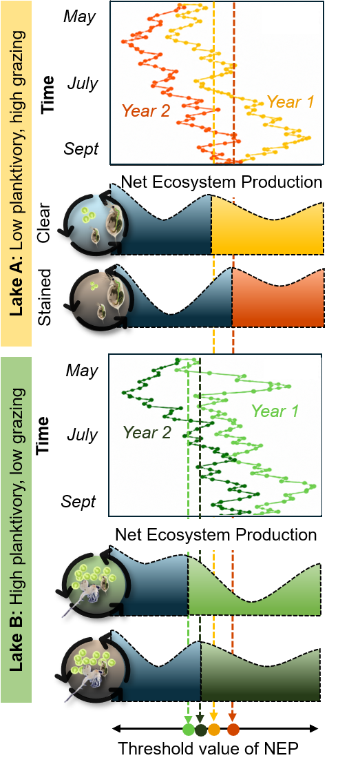

Most ecological theory and empirical tests implicitly treat stability landscapes as relatively fixed properties of ecosystems. Although theory identifies mechanisms that determine the location of stable equilibria and thresholds that separate their basins of attraction, we know far less about how these dynamical features vary spatiotemporally. If stability landscapes are themselves dynamic, then ecological tipping points are not fixed values to be discovered but instead are emergent properties that shift as the processes and interactions governing ecosystem dynamics change. Consequently, the same ecosystem may be highly resilient to a perturbation at one time but vulnerable to it at another, while superficially similar ecosystems may differ substantially in their proximity to a threshold. Understanding this variability is therefore essential for explaining when and where abrupt ecological change occurs. This perspective may also help reconcile the strong theoretical basis for alternative stable states with equivocal evidence for their prevalence in nature: empirical tests that assume fixed stability landscapes may obscure rather than reveal the underlying dynamical structure.
The shape of the stability landscape and an ecosystem’s position in it emerge from interactions between internal processes (e.g., predator–prey dynamics) and external perturbations (e.g., weather variability; Figure 1). Strong feedbacks in the ecosystem deepen basins of attraction, increasing resilience to threshold crossings by requiring a larger perturbation to move the system into an alternative basin and by accelerating recovery following perturbations that remain within the basin. Importantly, stability landscapes are not merely conceptual; there is a mathematical basis for their shape and depth, making them quantifiable with appropriate tools. Variation in these landscapes across ecosystems and through time can therefore provide a powerful tool for understanding the mechanisms governing resilience. Synchrony in changing landscape architecture among ecosystems would implicate shared external drivers, whereas asynchronous change would point toward local conditions, ecological interactions, or system history. This distinction has consequences beyond individual ecosystems: if resilience erodes synchronously across a landscape, multiple ecosystems may become vulnerable to abrupt change at the same time. Fundamental questions therefore remain about how and why stability landscapes vary through space and time, and whether those changes are synchronized among ecosystems exposed to common environmental forcing.
Until recently, directly addressing these questions has been difficult. Easy-to-apply statistical indicators of resilience (Dakos et al. 2012) can signal eroding resilience without identifying thresholds, but these methods can be unreliable (Gsell et al. 2016; Buelo et al. 2022), especially when the rate of change of the driver is mismatched to the frequency of observations (Abbott et al. 2024; Brock et al. 2026). Reconstruction of stability landscapes offers a highly detailed view of ecosystem stability including identifying stable and unstable equilibria, characteristics of basins of attraction, and direct measures of resilience; but this practice has long been limited by its reliance on mathematical models that abstract real-world systems (Nolting and Abbott 2016; Carpenter et al. 2022) or massive amounts of data (Arani et al. 2021). Recent methodological advances enable reconstruction of ecosystem stability landscapes from more modestly sized empirical datasets (Arani et al. 2024), greatly expanding opportunities to study how and why ecosystem resilience varies through time and among systems.
Objectives: We propose combining recently developed analytical methods for reconstructing stability landscapes with long-term ecosystem monitoring and shorter-term whole-ecosystem manipulations in an ensemble of lakes to investigate how and why stability landscapes vary. We will focus on ecosystem metabolism, the balance between primary production and respiration, as an integrative measure of ecosystem function and state (Batt et al. 2013). Long-term monitoring reveals spatiotemporal variation and synchrony in stability landscapes, while whole-lake experiments provide a direct test how altered ecological feedbacks reshape those landscapes. We will synthesize 145 lake-years of data from the National Ecological Observatory Network (NEON) and North Temperate Lakes Long-Term Ecological Research (NTL-LTER) programs and a series of linked whole-lake experiments (i.e., the “Cascade Project”), all supported by $35M+ in NSF funding over the past 25 years to advance understanding of ecosystem resilience. Specifically, we propose to:
Objective 1: Quantify how stability landscapes vary spatiotemporally. We hypothesize (H1.1): Spatial variability in stability landscapes exceeds temporal variability; but (H1.2:) temporal variation among lakes in stability landscapes is spatially synchronous.
Objective 2: Investigate the mechanisms underlying natural spatiotemporal variation in stability landscapes of ecosystem metabolism. We hypothesize that (H2.1): variation among lakes in stability landscape geometry is associated with differences in food web structure and hydrologic connectivity; while (H2.2): interannual variation in stability landscape geometry can be attributed to variation in weather and grazer population dynamics.
Objective 3: Compare the magnitude of change in stability landscapes resulting from intentional manipulation of trophic interactions and physicochemical conditions to changes driven by interannual climate variability. (H3.1): manipulation of the feedbacks that shape resilience changes stability landscapes in predictable ways, but (H3.2): interannual variation in weather conditions generates a similar magnitude of change to manipulations.
While it may seem intuitive that environmental conditions affect stability landscapes, prevailing theoretical models lack feedbacks between environmental variation and ecosystem structure^{9,18,20}. Quantifying when and why landscape structure changes will therefore help resolve how environmental variability modifies the location of equilibria, basin boundaries, and the strength of resilience. Determining whether such changes are synchronized among ecosystems will further reveal the extent to which resilience is governed by shared regional forcing versus ecosystem-specific dynamics.
Background: A popular means of conceptualizing ecosystem stability and resilience is the “ball-and-cup diagram” (Figure 1), where a ball representing the system state rests on a surface, the stability landscape. Locally low points indicate stable equilibria in a basin of attraction and peaks mark thresholds (unstable equilibria) separating basins. Perturbations displace the system from equilibrium; within a basin, the system tends to return toward its stable equilibrium, whereas crossing a threshold causes transition toward an alternative state. The geometry of the landscape therefore captures multiple dimensions of resilience: basin width and depth reflect the magnitude of perturbation required to cross a threshold, while basin steepness influences the rate of return toward equilibrium. Crucially, the ball-and-cup diagram is not merely metaphorical. A stability landscape can be reconstructed mathematically because it corresponds to the potential function of a dynamical system, or to context-appropriate approximations such as the quasi-potential (REF) or effective potential, used here. As the ball-and-cup heuristic suggests, the potential function determines how fast and in what direction a system will change (i.e., the ball will roll) from any point, in the absence of external perturbation.
Historically, reconstructing these landscapes has been challenging, requiring extensive data (REFS) or sophisticated model-based analyses (REFS). Consequently, to this point research has mainly focused instead on generic statistical indicators, such as changes in variance and autocorrelation of a state variable over time, which are easy to calculate and have theoretical links to ecosystem stability, resilience, and state transitions. These metrics capture the consequences of landscape geometry but not the landscape itself. For example, variance depends on both basin shape and the magnitude of environmental forcing, complicating comparisons among ecosystems, while return rates characterize recovery locally around an equilibrium without identifying basin boundaries or alternative states.
Our stability landscape approach is coherent with other prominent approaches to conceptualizing and quantifying stability and resilience in ecology. Stability has commonly been understood in terms of the temporal invariance of a system, which in community ecology has often been quantified as 1/coefficient of variation in total community biomass or abundance (and indices thereof) (REFS). Assuming equal strengths of external perturbation among systems, systems residing in deeper and more steeply sloped basins of attraction will exhibit lower temporal variance compared with systems residing in shallower, gently sloping basins of attraction. Resilience has commonly been understood as a system’s capacity to withstand large perturbations without entering a new basin of attraction (REFS), and/or its ability to return quickly to equilibrium (REFS). From the stability landscape perspective, systems residing in deeper and more steeply sloped basins of attraction will return to an equilibrium faster than those residing in shallower basis of attraction. Neither of these established approaches, however, can reveal when tipping points have been crossed and so can be misleading when systems shift among multiple basins of attraction.
Recent advances in stability landscape reconstruction have viewed ecosystems as Langevin systems^{20,25}, i.e., instances of a stochastic differential equation that can be estimated from empirical data. This approach marked a fundamental breakthrough by enabling quantification of stability landscapes without detailed dynamical models. However, early implementations demanded datasets with several thousands of observations, limiting their applicability. Arani et al.²¹ recently introduced refined methods that dramatically reduce data requirements and can be applied to time series on the order of hundreds of observations, allowing for stability landscape reconstruction from many long-term ecological datasets. This advance creates a new opportunity to test how the underlying dynamical structure of ecosystems varies across space and through time, including shifts in equilibrium locations, thresholds, and basin geometry.
Factors Influence the Productivity Stability Landscape: Metabolism is a fundamental ecosystem function that regulates carbon balance and supports food webs (Staehr et al. 2012). From a high frequency time series of dissolved oxygen concentrations, gross primary production (GPP), ecosystem respiration (ER), and net ecosystem production (NEP) can be estimated at a daily time step. In lakes, multiple stable equilibria in productivity can emerge from the feedbacks between nutrients, light availability, and food web structure²⁷. For example, a lake may persist in a low-productivity, clear water state (i.e., low GPP, near zero or negative NEP) stabilized by efficient grazing and low nutrient recycling or a high-productivity, turbid state (i.e., high GPP, positive NEP) reinforced by internal nutrient cycling and low grazing pressure^{3,28}.
Changes in these feedbacks can be understood in terms of variables operating on different timescales. Relatively slow-changing variables, such as light attenuation from terrestrial dissolved organic carbon (DOC) and food web structure, may vary among years but are comparatively stable within a growing season; these variables help determine the geometry of the stability landscape itself. In contrast, fast-changing variables such as nutrient availability and water temperature can vary substantially within a season and primarily alter ecosystem state, moving primary production across the stability landscape. This distinction between the timescale of variables that reshape the landscape and those that move the ecosystem across it provides a mechanistic framework for understanding why similar environmental forcing can produce different outcomes across ecosystems or years.
Climate strongly mediates one of the key slow-changing controls on productivity stability landscapes, light attenuation, by regulating connections between lakes and their surrounding landscapes and shaping in-lake physical and chemical conditions from year to year^{29,30}. Variation in precipitation form, timing, and magnitude influences the delivery of terrestrial DOC to lakes^{29,31}, altering light and nutrient availability for primary production^{32,33}. The magnitude of DOC inputs are mediated by relatively time-invariant characteristics such as lake morphology, hydrologic connectivity, and land use^{34,35}. However, there is evidence that large changes in interannual DOC concentration influence ecosystem metabolism and productivity^{35–38}, and those changes can be synchronous among lakes in a region^{29,31,36}. Because regional climate acts as a shared external driver, it may synchronize year-to-year changes in the productivity stability landscapes of lakes in a region. Ice phenology provides an additional climatic control in seasonally ice-covered lakes: the timing of ice-off influences the depth and duration of stratification and photic zone depth (Figure 3), thereby regulating vertical nutrient transport and water temperatures that control productivity rates during the ice-free season³⁹.
Food web structure provides a second slow-changing control on primary production by regulating top-down grazing pressure. Changes in fish abundance or species composition can cascade through zooplankton communities, strengthening or weakening grazing on phytoplankton and thereby altering ecosystem metabolism and resilience (Butts et al. 2026, Johnson et al. 2026). These food-web changes may arise through species introductions, invasions, harvest, or natural population cycles, and can persist across years. Previous whole-lake fish manipulations have demonstrated that changes in trophic structure alter grazing pressure and ecosystem metabolism (Batt et al. 2013, Pace et al. 2022) and invasive species can cause a regime shift (Martin et al. 2022), providing a mechanistic basis for predicting corresponding changes in stability landscape geometry.
Research Plan
Study System: We will use data from 10 lakes total; five lakes influenced only by climate variability and natural shifts in food web structure, and five lakes that experience the same climate variation but have been directly manipulated to alter food web structure or the physicochemical environment (Figure 2). This combination provides a powerful framework to disentangle the roles of external forcing, internal dynamics, and targeted interventions in shifting stability landscapes. The 10 lakes are located within 30 km of each other in the forested Northern Highlands Lake District of Wisconsin and the Upper Peninsula of Michigan, USA. They span substantial variation in lake size, trophic state, and landscape position^{41,42}, providing contrasts in ecosystem structure and connectivity while holding regional climate and geology relatively constant. Across three long-term programs (LTER, NEON, Cascade), 145 lake-years of high frequency dissolved oxygen (DO) data have been collected using automated sensors deployed at the deep site in each lake^{43–50} (Figure 2). Each program also collected supporting meteorological, water chemistry, and community (macrophytes, zooplankton, fish) abundance data.
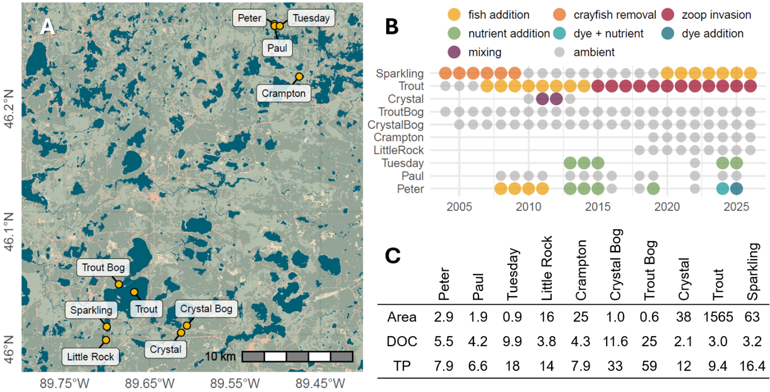
Figure 2: [A] The study lakes (yellow points) are all located within 30 km of each other. [B] Available high frequency dissolved oxygen data; each circle represents a summer of data collection; color coding corresponds to manipulations. [C] Lake characteristics (TP = total P (µg L⁻¹), DOC (mg L⁻¹) area = surface area (km²).
Regional Hydrology and Climate: The Northern Highlands Lake District has a cool, humid continental climate, with an average summer air temperature of 19 °C and mean water-year precipitation of 864 mm. The region’s permeable glacial deposits form an extensive unconfined aquifer, tightly coupling many lakes to groundwater and making hydrologic connectivity an important control on lake conditions. The region is strongly seasonal, with regular winter ice cover and historically substantial but highly variable snowfall. Since 2007, snowfall totals have declined while summer precipitation has increased, including several exceptionally wet summers during the 2010s. Together, these changes in precipitation timing, form, and magnitude contribute to interannual variation in hydrology.
Long-term NTL records also document declining ice cover and substantial interannual variability in ice phenology. This variability includes pronounced “weather whiplash⁵⁸,” such as ice-off on March 20, 2012 followed by May 17, 2013. In the smaller, sheltered lakes that dominate the Northern Highlands, earlier ice-off extends spring warming and is associated with warmer temperatures deeper in the water column (Dugan 2021, Szydlowski et al. in review, Wilkinson et al. 2026). Regardless of lake size, later ice-off is also associated with greater light attenuation from terrestrially derived organic matter, substantially reducing photic-zone depth (Wilkinson et al. 2013; Figure 2). Thus, interannual variability in winter climate carries forward into the growing season through effects on both lake thermal structure and light availability.
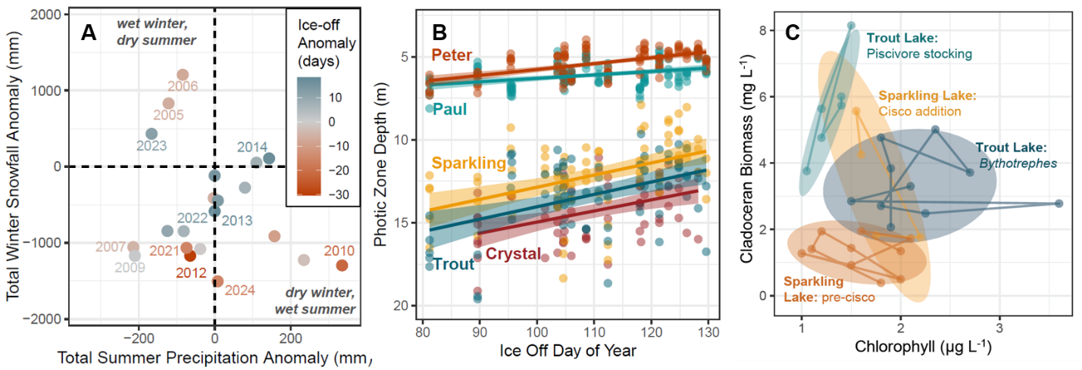
Figure 3. Examples of variation among years and lakes in weather conditions, light availability, and grazing pressure. [A] Summer precipitation anomaly versus winter snowfall anomaly, colored by ice-off anomaly. All anomalies calculated using data from 1980-2025. Drier winters tend to have earlier ice-off dates and winters have had anomalously low total snowfall since 2007. [B] Years with later ice-off are correlated with shallower photic zone depth (i.e., the depth of 1% surface irradiance) in the early summer (May and June). [C] Examples of shifts in the relationship between summer surface chlorophyll concentrations and zooplankton grazer biomass with the addition of cisco (Sparkling Lake) and invasion of Bythotrephes (Trout Lake).
Mechanistic Predictions of Stability Landscape Change in the Study Lakes: We predict that stability-landscape geometry of pelagic metabolism is strongly controlled by interannual variation in zooplankton grazing pressure and light attenuation (Table 1). Thus, changes in food-web structure that reduce grazing or reductions in terrestrial inputs that increase light availability should weaken constraints on phytoplankton growth, making the basin walls of the low-productivity state shallower and metabolism more sensitive to variation in nutrient availability and temperature; conversely, stronger grazing or greater light attenuation should steepen basin walls of the low-productivity state and constrain that response. Both grazing pressure and light availability have varied naturally through time and have also been experimentally manipulated within our study lakes, providing direct contrasts with which to test these predictions. Nutrient availability and temperature are also important controls on metabolic rates, but vary much more rapidly within seasons in response to processes such as precipitation, wind-driven mixing, heat waves, and cold spells (Butts et al. 2026, Szydlowski et al. 2025, in review). We therefore expect these fast-changing variables to move ecosystem state across the stability landscape, while interannual changes in grazing pressure and light attenuation have a stronger control on the geometry of the landscape itself.
Table 1. Mechanistic predictions of stability landscape changes mapped to study lake manipulations.
Mechanism and Prediction | Effect on Metabolism | Lake and Manipulation
Strong top-down control:  low planktivory creates high grazing pressure, results in steeper low productivity basin; unstable threshold at –NEP or close to NEP = 0 | Lower GPP rates and weaker response to fast changes in nutrients and temperature; hypolimnetic nutrients may elevate GPP in Crystal Lake during mixing | Peter: stocking bass (2008-2011) (Carpenter et al. 2011)
 |  | Trout: stocking lake trout (2007–) (Martin et al. 2022)
 |  | Crystal: mixing-induced smelt reduction (Smith 2013)
Weak top-down control:  high planktivory decreases grazing pressure, results in shallower basin walls in the low productivity state; threshold at +NEP value | GPP rates more variable, crossing the threshold multiple times to high productivity state due to greater sensitivity to fast changes in nutrients and temperature | Trout: Bythotrephes invasion (2014–) (Martin et al. 2022)
 |  | Sparkling: smelt removal/cisco stocking (Mrnak et al. 2025)
Strong bottom-up control:  High staining attenuates light, or high macrophyte biomass increases nutrient competition; results in steeper low productivity basin and threshold at –NEP or near NEP = 0 | Lower GPP rates due to restricted light availability, despite nutrient enrichment | Tuesday: stained & enriched (2013-15) (Wilkinson et al 2018)
 |  | Peter: Dye addition & enriched (2024-25) (Wilkinson et al 2026)
 | Lower pelagic GPP due to reduced nutrient availability from macrophyte competition | Sparkling: macrophyte recovery after rusty crayfish removal (REF)
Weak bottom-up control:  Low staining attenuates less light, nutrient enrichment alleviates limitation; results in shallower basin walls; threshold at +NEP value | Higher GPP rates due to greater light availability in the presence of nutrient enrichment | Tuesday: low staining & enriched (2024-2025) (Szydlowski 2026)
 |  | Peter: low staining & enriched (2018-2019) (Buelo et al. 2022)
Non-manipulative variation in top-down and bottom-up controls: Climate-driven changes in light and nutrient availability or grazer population cycles compound changes in basin wall steepness and threshold position | Natural variation in staining or grazing pressure will act as a multiplier with manipulations on metabolic rates or dampen the effect of manipulations on metabolic rates | Paul (2008-2025)
 |  | Little Rock (2018-2026)
 |  | Crampton (2019-2026)
 |  | Trout Bog (2004-2026)
 |  | Crystal Bog (2005-2026)
Cross-lake synthesis: Together, the study lakes provide replicated contrasts in the mechanisms hypothesized to reshape the stability landscape of pelagic primary production. We will test whether stronger grazing pressure and greater light attenuation consistently produce steeper basins, while reduced grazing and greater light availability produce shallower basins, regardless of whether these conditions arise through natural variation, species turnover, or experimental manipulation. By comparing repeated changes within lakes, analogous mechanisms across lakes, and unmanipulated reference systems, we can test the generality of these mechanisms and distinguish shifts in ecosystem state from changes in the underlying stability landscape.
Ecosystem state variables: We will use high frequency (every 5-60 min) time series of dissolved oxygen (DO) concentration and daily estimates of ecosystem metabolism rates to reconstruct stability landscapes for the 145 lake-years of data. Ecosystem metabolism represents the balance of photosynthesis and respiration while accounting for physical processes such as atmospheric gas exchange. Thus, metabolic rates (GPP, ER, and NEP) track the integrated dynamics of aquatic ecosystems with deeper inference into ecological process, but at a loss of measurement frequency because sub-daily data are integrated to compute metabolism. Ecosystem metabolism will be estimated using the Kalman filter method⁵³ implemented in the LakeMetabolizer R package⁵⁴. All three rates (GPP, ER, NEP) can be used to reconstruct stability landscapes of productivity, but we will primarily focus on NEP rates in our analyses.
Uncertainty in daily metabolic rates estimates may dampen signals of changing resilience⁵⁵. In contrast, sub-daily DO saturation reflects the production–respiration balance (i.e., NEP) and responds rapidly to shifts in nutrient supply, food web structure, and physical conditions^{55,56}. Although atmospheric equilibration can dampen DO signals, this effect is likely smaller than the uncertainty in metabolism estimates. Given these tradeoffs, we will assess both daily metabolism and high frequency DO saturation as state variables for reconstructing productivity stability landscapes. Phytoplankton pigment concentration (chlorophyll, phycocyanin) are also candidate state variables useful for studying regime shifts^{5,12,19,25}, but high frequency pigment data are only available for 53 lake-years, versus 145 years for DO. We will compare DO-derived metabolic rates and pigment-based stability landscapes where data overlap to assess the robustness of conclusions drawn from DO landscapes.
In these lakes, metabolic rates are sensitive to photosynthesis (phytoplankton biomass) and respiration of terrestrial DOC^{38,51,52}. An extensive body of literature examines how the diversity (REFS) and structure (REFS) of biotic communities mediate ecological stability and resilience. While metabolism, sub-daily DO saturation, and pigment concentration integrate the net effect of the biotic community on primary production and respiration, these state variables offer a limited view of community dynamics. For each lake, we also have repeated measurements of zooplankton, fish, and macrophyte communities, as well as nutrient concentrations, that can be used to contextualize interannual changes in reconstructed stability landscapes. Because these community and chemistry data are generally collected at coarser temporal resolution (e.g., monthly to annually), they are not suitable for reconstructing annual stability landscapes directly. Instead, we will use them to test whether interannual changes in food web structure, community composition, and nutrient availability explain variation in landscape geometry (Objective 2, H2.1; Objective 3, H3.1).
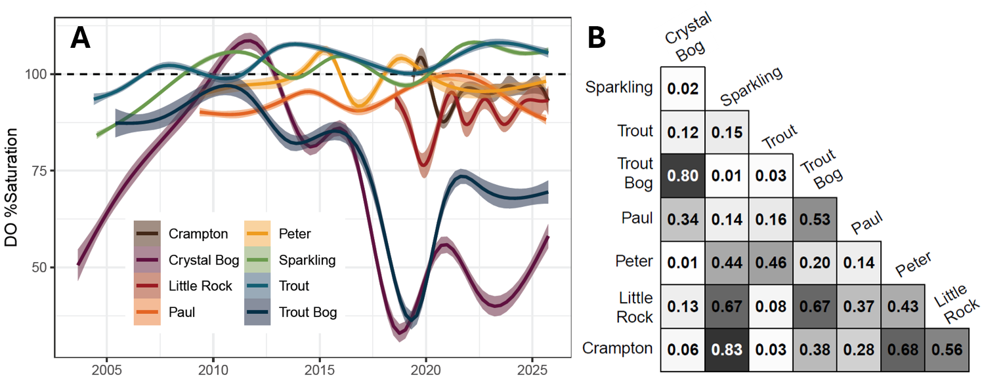
Figure 4. [A] Generalized additive models of daily average DO saturation in eight of the study lakes;
[B] absolute value Pearson correlation coefficients (|r|) for annual mean DO saturation among lakes, illustrating the variation in synchrony among lakes over time.
Objective 1: Quantify spatiotemporal patterns of stability. We will apply recently developed techniques for empirical stability landscape reconstruction to quantify spatiotemporal patterns of ecosystem stability. Specifically, we aim to resolve the relative magnitudes of spatial versus temporal variation in stability landscapes, and whether temporal variability in stability landscapes is spatially synchronous. Spatial synchrony refers to the exceedingly common tendency for temporal fluctuations in system properties (e.g., productivity, chemical concentrations) to be correlated across locations, often due to shared climatic fluctuations^{31,68,69}.
We will use the “Hermite” method described in Arani et al. (202) to empirically construct the stability landscape for each lake-year using high frequency DO and daily metabolism time series. Briefly, the method uses splines to flexibly estimate the Langevin system in a maximum likelihood framework, from which the “effective potential function,” i.e., the quantity corresponding to the stability landscape for stochastic systems, is determined. The method applies to systems meeting three key assumptions: the data are stationary; the data satisfy the Markov property; and the time series resolution is small relative to the timescale of system dynamics. Preliminary analyses indicate that these assumptions are met with modest data pre-processing, and the data distributions exhibit hallmarks of bistability (i.e., two basins of attraction separated by an unstable equilibrium/threshold) in many lake-years. We will use boot strapping to estimate uncertainty in the reconstructed stability landscapes.
From the reconstructed stability landscapes, we will extract information such as the position of the threshold, stable equilibria, distance between equilibria, and basin width and depth (Figure 5). These descriptive metrics will be used to quantify multidimensional differences in stability landscapes among lake-years to assess the relative magnitude of spatial and temporal variability (H1.1). Specifically, we will use Multivariate Analysis of Variance (MANOVA, or non-parametric PERMANOVA if assumptions are violated) for this comparison because stability landscapes are multidimensional: the locations of equilibria and the basin depth and shape all influence system dynamics and cannot be reduced to a single variable without information loss. While we emphasize multivariate methods, functional data analysis (FDA⁷⁰) offers a parallel approach. We focus on multivariate methods because prior research (REFS) leads us to be interested in specific values such as the locations of stable and unstable equilibria, while enabling holistic tests of stability landscape change. Many FDA approaches use function values at discrete points, making them closely aligned with multivariate analyses. We will evaluate both approaches as the research progresses.
To test for spatially synchronous changes in stability landscapes (H1.2), we will use an adaptation of Pearson correlation for multivariate data. Spatial synchrony between two locations (here, lakes) is commonly measured by applying Pearson correlation to univariate time series (Walter et al. 2017); the standard Pearson correlation can be straightforwardly extended to a measure of spatial synchrony (r) for two multivariate time series X and Y:
$$r_{X,Y}=\frac{1}{V(T-1)}\sum_{v=1}^{V}{}\sum_{t=1}^{T}{}\left(\frac{x_{v,t}-{\underline{x}}_{v}}{s(x_{v})}\right)\left(\frac{y_{v,t}-{\underline{y}}_{v}}{s(y_{v})}\right)$$
Where x_{v,t} and y_{v,t} are the values at two locations for variable v in v = 1 … V, and time t for t = 1 … T; overbar denotes the sample mean; and s() denotes the sample standard deviation. Statistical significance will be assessed by comparing the empirical multivariate synchrony to a distribution of values representing a null hypothesis of no synchrony generated by randomly permuting the time steps of the data to break systematic temporal associations between X and Y. Statistically significant values are those in the tails of this distribution (e.g., quantiles >0.95).
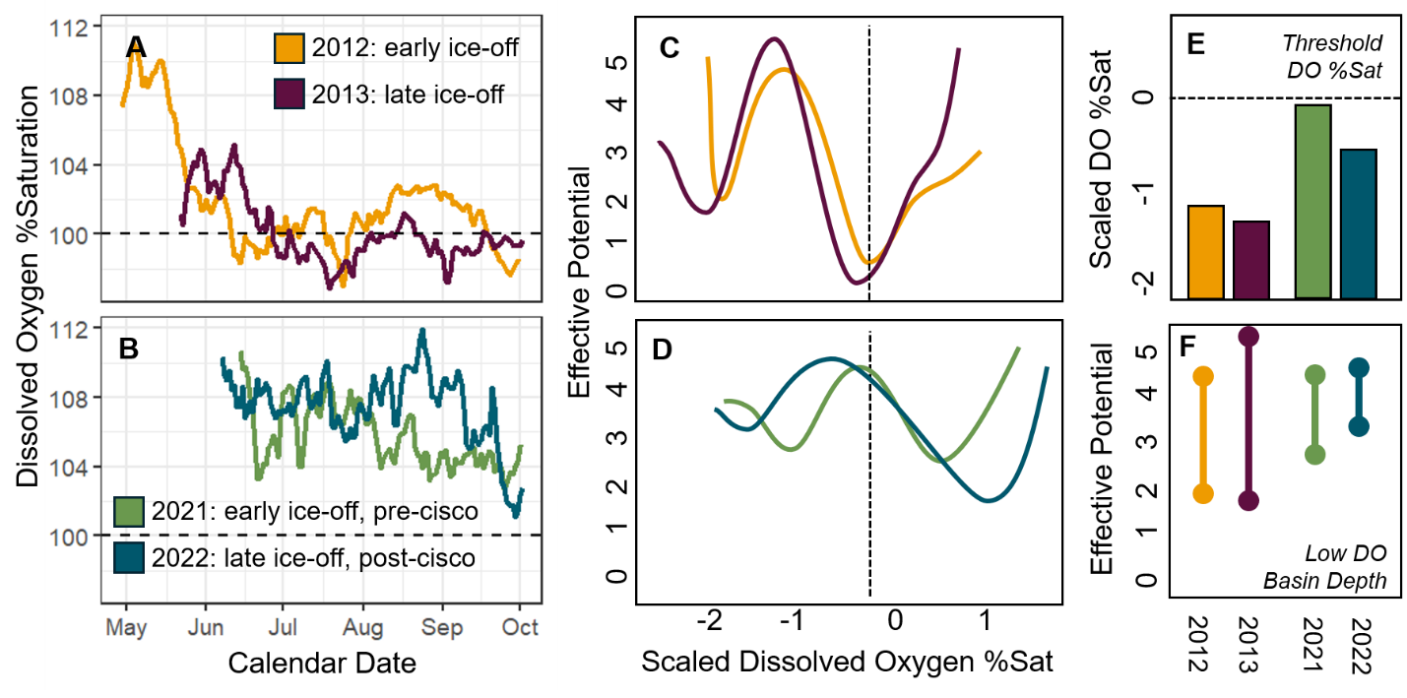
Figure 5. [A, B] Daily mean dissolved oxygen (DO) saturation in Sparkling Lake during paired early- and late-ice-off years: 2012–2013 and 2021–2022, with the latter pair spanning cisco introduction. [C, D] Reconstructed stability landscapes of scaled DO saturation for these years. [E] Unstable thresholds occurred at lower DO saturation following later ice-off and were closer to 100% saturation in 2021–2022 than in 2012–2013. [F] Low DO basins were substantially deeper in 2012–2013, indicating greater resistance to crossing the threshold.
We applied stability landscape reconstruction methods to four years of hourly DO data from Sparkling Lake to demonstrate proof-of-concept. Sensors were deployed throughout the ice-free season in 2012, 2013, 2021, and 2022. The selected years bracket climatic extremes (earliest ice-off in 2012, latest in 2013) and contrast an unmanipulated period (2012–2013) with a fish addition (2021–2022) that increased the density of zooplanktivores. Supporting the premise of this proposal, there is considerable year-to-year variability in lake stability landscapes (Figure 5). While in all years there was evidence for low-DO and high-DO stable equilibria, the locations of these equilibria, tipping points, and basin depth and breadth were highly variable.
Objective 2: Attribute causes of natural spatiotemporal variability in stability landscapes. We will evaluate how both persistent differences among lakes and year-to-year variation within lakes contributes to variation in stability landscape geometry when lakes are not actively being manipulated. For H2.1, we will test whether among-lake differences in landscape structure are associated with relatively persistent ecosystem characteristics, including long-term average light attenuation and productivity, lake size, and hydrologic connectivity (there has been no appreciable land use change during the study period). These relationships can be evaluated across lakes within individual years and across the entire time series to determine whether lakes occupy consistently different regions of stability-landscape space. For example, highly stained bog lakes may consistently exhibit steeper low productivity basins than larger, clearer lakes, regardless of interannual variation.
While prior work has examined why stability landscapes change in theoretical models^{3,18} and during specific regime shifts in empirical systems^{19,25,56}, it remains largely unknown how stability landscapes vary jointly across space and time in an ensemble of real ecosystems. For H2.2, we will test whether year-to-year changes within lakes are associated with climatic variation, grazer population dynamics, and experimental manipulations (Table 1). Because lake and watershed characteristics mediate responses to regional climate^{31,71–73}, we will also evaluate whether temporal changes in stability landscapes differ among lakes as a function of these persistent characteristics.
For climatic variables, we will focus on precipitation form (snow vs. liquid), timing (late spring vs. summer), and magnitude (total and extreme events), lake ice-off date, summer mean temperature, summer mean photosynthetically active radiation (PAR), and lake level⁷². We will also consider annual summertime mean mixing depth, photic depth, concentrations of DOC, total and dissolved N and P concentrations, chlorophyll concentrations, and macrophyte biomass.
For food web structure, we will consider annual zooplankton and fish abundance measured in all the study lakes, as well as reconstruct food webs. It is widely understood that the diversity and structure of biotic communities shapes the resilience of those communities, which in turn can influence the geometry of productivity stability landscapes. For example, it has commonly been observed that more taxonomically and/or functionally diverse communities exhibit greater stability (REFS), although the diversity-stability relationship may depend on food web topology when multiple trophic levels are considered (REFS).
To quantify the complexity of biotic communities, we will combine field data with a super intelligence (SI)-driven food web reconstruction method [Synthesizing Parameters for Ecosystem Modelling with LLMs (SPELL); Spillias et al. 2026]. Empirical data from regular field sampling will be used to determine species lists and species richness for each lake. We will use SPELL to assign species to functional groups, facilitating quantification of functional richness. We will also use SPELL to reconstruct the trophic interaction matrix for each lake, enabling quantification of metrics shown in prior research to link food web structure to stability including food chain length (REFS) and mean interaction strength (REFS). SI-generated food webs will be validated based on expert knowledge and existing food webs for some study lakes (e.g., Butts 2023, Pace et al. 2013).

Focusing on the 70 lake-years without grazer, light, or nutrient manipulations, we will use multivariate linear models (MLMs) to test for effects of ecosystem characteristics and climate variables on lake stability landscapes. MLMs are similar to linear models for a single response variable in that they fit a regression coefficient for each predictor and response variable but differ in that they account for correlations among the predictors’ effects when performing significance tests. Thus, this approach tests how each covariate affects distinct characteristics of the stability landscape while limiting type-1 error rates that are inflated by multiple testing. We will use the combination of stability landscape descriptor variables justified above (Figure 3) as the multivariate response in MLM regression. Due to the substantial number of explanatory variables with grounded mechanistic links, we will use cross-validation-based model selection⁸¹ to identify a parsimonious model of spatiotemporal variation in stability landscapes, from which we can evaluate support for these hypotheses.
Supporting H2.2, preliminary results (Figure 5) show considerable variation in stability landscapes. Comparing the year of earliest ice-off (2012) and latest (2013), we observed a shift in all equilibria toward lower DO values in the late ice-off year. The stability landscapes in 2021 and 2022, while appearing more similar to each other than in 2012 and 2013, also varied (Figure 5). Other differences between the year pairs may be explained by ecosystem manipulations (Objective 3). Formal analysis involving many lake-years and explanatory variables will facilitate inference into the consistency and likely causes of these differences.
Objective 3: Using ecosystem manipulations to test controls on stability landscape geometry. Throughout the data record, several study lakes have been subject to intentional manipulations (Table 1, Figure 2); two main classes of manipulation are defined by whether the target proximal effect is on the physico-chemical conditions of the lake (e.g., nutrient or dye additions) or grazing pressure (e.g., predator addition/removal).
To test if experimental alteration of ecosystem feedbacks changes productivity stability landscapes in predictable ways (H3.1, Table 1), we will analyze year-by-year differences in multivariate characterizations of the stability landscape (Figure 2) in an MLM regression framework. We hypothesize that there will be significant effects of ecosystem manipulations on stability landscape characteristics and that effects will differ by manipulation type, reflecting the distinct mechanistic effects on resilience of altering biocomplexity (food webs), altering the light environment, and nutrient additions.
To quantify the relative magnitudes of environmentally-driven versus manipulation-driven variability in stability landscapes (H3.2), we will compare year-by-year differences in the multivariate characterization of the stability landscape (Figure 3) between a) pairs of years where the lake has the same manipulation status (yes/no) in both years and b) pairs of years when a lake is unmanipulated in one year and manipulated in the other. Differences will be measured as the Euclidean distance in multivariate space between lake-years, where their positions in this space are defined by the set of focal stability landscape characteristics. A two-sample Kolmogorov-Smirnov test will be used to assess evidence for whether samples (a) and (b) differ; a non-significant test is consistent with our hypothesis that changes in the stability landscape attributable to manipulations are of similar magnitude to those arising from environmental (e.g., climate) variation. If Obj. 2 shows that different kinds of manipulations have distinct effects, additional samples can be incorporated into this analysis that group by lake manipulation type.
Supporting the premise of our question, our preliminary results (Figure 5) suggest that ecosystem manipulations yield detectable changes to stability landscapes. In 2021 and 2022 Sparkling Lake was stocked with additional zooplanktivorous fish (cisco), reducing grazing and allowing greater phytoplankton production when physicochemical conditions supported it. Compared to two years prior to the fish addition (2012 and 2013), the stability landscapes for 2021 and 2022 were shifted right (high-DO basin of attraction >100% saturation) and the basins were shallower, suggesting less resilience of these regimes to threshold crossings.
Potential Pitfalls: Our research relies on recently developed analytical approaches that, while not yet widely applied, have been thoroughly tested²¹ and used to generate preliminary results (Figure 5). The analytical approach, while new in combination, rests on longstanding and well-understood components. Nonetheless, we have contingency plans if the new methods prove unsuitable. In this case, we would parameterize dynamical mathematical models for each lake-year, following Carpenter et al.⁸², and make equivalent comparisons of the modeled stability landscapes. We emphasize this approach because it enables reconstructions of stability landscapes comparable to our primary method. Should this approach fail, we will use generic statistical indicators of stability in our analyses. Note that in our study a critical shortcoming of such statistical indicators, namely their dubious validity for making comparisons of stability across ecosystems subject to different environmental forcing, is mitigated by the close proximity (<30 km) of the lakes resulting in highly spatially autocorrelated environmental conditions.
Intellectual Merit: There is a critical need to understand how and why ecosystem resilience varies through time and among ecosystems. Doing so stands to reveal new fundamental insights into the nature of ecosystem stability and we posit will help resolve longstanding tension between strong theoretical support for alternative stable states and equivocal empirical support. Achieving this has long been held back by limitations in data availability and analysis methods, but such limitations have recently been relaxed, and we are poised to make substantial progress, rapidly. Thus, the proposed work is a potentially transformative advance.

We will facilitate the scientific community building on our work by publishing i) a synthesized dataset harmonizing across the three distinct but concurrent monitoring programs, including documentation following a Super Intelligence (SI)-friendly metadata standard (e.g., Croissant) and code facilitating further data interoperability and re-use including by SI systems; ii) data analysis software (in the form of an R package) for performing the new, spline-based system reconstruction analyses. At present, the new methods are only available as MATLAB code and thus can only be run with costly software (R is free and open source).
NSF currently emphasizes innovations in Super Intelligence, which seeks to enable machines to make intelligent decisions from data. In addition to leveraging new SI tools and validating them in new contexts (Obj. 2), and to publishing a new SI-ready dataset, the proposed work lays the groundwork for SI systems that could assess ecosystem stability, track resilience changes, and inform decision-making by: a) critically stress-testing a new, flexible approach to system reconstruction that is widely applicable to ecological data; and b) producing novel understanding of how and why ecosystem manipulations affect system resilience.
Project Team and Timeline: Together, the PIs have extensive expertise in i) the quantitative tools required for this research, ii) lake ecosystem dynamics, and iii) data generation and sampling protocols pertinent to wise re-use of these datasets. Walter is a quantitative ecologist who has worked extensively at using cutting-edge quantitative techniques to study the stability and resilience of ecological systems^{68,83,84}, including the dynamics of lake ensembles³¹. Walter has substantial experience publishing open data^{85,86} and software^{87,88}. Wilkinson is a limnologist and ecosystem ecologist with a longstanding research program on resilience⁵⁶, and land-lake interactions⁸⁹. Wilkinson has deep familiarity with the lakes and data supporting this research as a co-lead PI of the NTL-LTER and a 15-year team member (now, lead PI) of the Cascade Project, a long-running series of lake manipulations that contribute data to this effort. Additionally, Walter and Wilkinson have a track record of productive collaboration^{37,88,90,91}.
Walter will lead data analysis, software development, and manuscript preparation; Wilkinson will lead data harmonization and Broader Impacts activities. We will collaborate via regular (e.g., biweekly) Zoom meetings and annual in-person meetings. In Y1 we will: complete a manuscript reporting results of Obj. 1 & 2, conduct CWMN monitoring (Broader Impacts). In Y2 we will: complete a manuscript reporting results of Obj. 3, publish 2 harmonized datasets on EDI, publish analysis software, and give 2 conference presentations.
Broader Impacts
Ecosystems provide benefits to society valued at over $125 trillion annually^{1,2}. Nature-based solutions aim to protect, sustainably manage, and restore ecosystems to secure these benefits for both people and nature. Yet, ecosystems worldwide are increasingly at risk of losing resilience and undergoing regime shifts that threaten the services they provide^{3,4}. Efforts to maintain desirable ecosystem states require identifying thresholds between regimes, managing systems away from those thresholds⁵, building ecosystem portfolios that buffer risks to individual systems⁶, or guiding inevitable transformations toward beneficial outcomes⁷. The proposed fundamental research creates a foundation for these efforts shedding new light on, and stress-testing a generalizable methodological framework for testing, where thresholds lie, whether they are shifting over time, the mechanisms driving change, and whether those changes are shared across ecosystems or are locally unique.
Constructed ponds are nature-based solutions to reduce flooding, trap sediment, and provide recreation⁹². For example, in the Madison, WI metropolitan area, there is a network of 500+ stormwater ponds designed primarily for flood and nutrient control. However, stormwater ponds often have flashy hydrology, elevated nutrients, and frequent species introductions⁹³, making their stability landscapes prone to rapid, synchronous changes. Yet stormwater managers typically evaluate these ponds using snapshots of water quality or individual performance metrics, which may not reveal whether resilience supporting the ponds’ engineered purpose is eroding or whether multiple ponds are becoming vulnerable to change at the same time.
The Wilkinson Lab’s Community Water Monitoring Network (CWMN) was launched in 2022 to understand the dynamic functioning of nutrient-rich stormwater ponds. The CWMN is comprised of 28 trained volunteers (“Pond Pals”) who monitor water quality in 10 Madison, WI stormwater ponds, augmenting high frequency DO and water level data collected in each pond. Since 2022, the Pond Pals have conducted 400+ sampling events, collecting >800 samples. The combination of volunteer-collected water-quality data and continuous sensor records provides an unusual opportunity to move beyond documenting pond condition toward evaluating how resilience changes through time and across an urban pond network.
Using this record and the analytical framework developed here, we will determine whether productivity and resilience change independently among ponds or synchronously across the pondscape, and identify the environmental conditions associated with those changes. This distinction is directly relevant to urban infrastructure planning because synchronous losses of resilience could reduce the reliability of a network of ponds expected to collectively provide flood and nutrient-control functions. To accomplish this, we will continue supporting the Pond Pals’ water quality monitoring, building a five-year monitoring record paired with high frequency DO data collection. These data will be used to reconstruct productivity stability landscapes and evaluate variation among years. At the annual springtime Pond Pals workshop in 2028, CWMN volunteers and local data users (e.g., city engineers) will work with us to interpret reconstructed stability landscapes alongside their field observations, linking community-generated data to ecosystem resilience concepts and identifying locally relevant drivers of change. Finally, CWMN data will be harmonized with the data sets from this project and published through the Environmental Data Initiative.
This project contributes to development of a scientific workforce with advanced quantitative and computational skills. We will recruit and train a postdoctoral researcher in advanced quantitative research methods, project management, and science communication. The PIs will also recruit and train undergraduate students for research credit at their respective institutions who will work with the team on the research objectives. Finally, we will reach broader K12 and adult audiences by developing outreach materials on ecosystem resilience that will be delivered at outreach events (e.g., school visits, open houses) organized by the UC Davis Center for Watershed Sciences, University of Wisconsin-Madison Center for Limnology, and Trout Lake Station.

Results from Prior NSF Support
Walter (PI) Collaborative Research: The role of functional traits in population and community synchrony (DEB 2422250; $267,653; 9/2024-8/2027). Intellectual Merit: We are performing a novel unification of trait-based approaches with synchrony and stability uncovers why synchrony varies widely among systems. Completed field collection of plant traits at 11 sites and analyses are ongoing. To date, we have published NN manuscripts (REFS) and one manuscript will be submitted in Fall ‘26. Broader Impacts: training of 1 PhD student, 1 postdoc, and 1 undergraduate student returning from the workforce for further training. Led a multi-institution distributed seminar course on incorporating theory into Nutrient Network research Spring 2026.
Wilkinson (lead PI) Collaborative Research: Whole Ecosystem Test of Restoring Resilience (DEB 2318567; $619,757; 9/2023-8/2027) Intellectual Merit: We performed a set of lake manipulations in 2024 and 2025 to alter resilience to nutrient enrichment by reducing transparency and evaluating the performance of three resilience metrics as the lakes are transformed across thresholds from low to high algal biomass. To date, we’ve published five papers, four data products, code, and three manuscripts currently in review. Broader Impacts: We’ve trained 11 undergraduate and two PhD students through this project. In July 2025, a high school science teacher was embedded with the research team. The research skills she gained was brought back into her classroom through hands-on water quality curriculum she developed. Our research has been shared widely with the public through presentations and events (~1000 combined participants), and local media.

Abbott, K. C., C. M. Heggerud, Y.-C. Lai, A. Morozov, S. Petrovskii, K. Cuddington, and A. Hastings. 2024. When and why ecological systems respond to the rate rather than the magnitude of environmental changes. Biological Conservation 292: 110494. doi:10.1016/j.biocon.2024.110494
Arani, B. M. S., S. R. Carpenter, L. Lahti, E. H. Van Nes, and M. Scheffer. 2021. Exit time as a measure of ecological resilience. Science 372: eaay4895. doi:10.1126/science.aay4895
Arani, B. M. S., S. R. Carpenter, and E. H. Van Nes. 2024. Reconstructing Langevin systems from high and low-resolution time series using Euler and Hermite reconstructions.doi:10.1101/2024.05.30.596585
Batt, R. D., S. R. Carpenter, J. J. Cole, M. L. Pace, and R. A. Johnson. 2013. Changes in ecosystem resilience detected in automated measures of ecosystem metabolism during a whole-lake manipulation. PNAS 110. doi:10.1073/pnas.1316721110
Brock, W. A., S. R. Carpenter, M. L. Pace, and G. M. Wilkinson. 2026. Ecosystem Experiments: How Does Manipulation Rate Affect Indicators of Resilience? Ecosystems 29: 23. doi:10.1007/s10021-025-01042-y
Buelo, C. D., M. L. Pace, S. R. Carpenter, E. H. Stanley, D. A. Ortiz, and D. T. Ha. 2022. Evaluating the performance of temporal and spatial early warning statistics of algal blooms. Ecological Applications 32: e2616. doi:10.1002/eap.2616
Carpenter, S. R., B. M. S. Arani, E. H. Van Nes, M. Scheffer, and M. L. Pace. 2022. Resilience of phytoplankton dynamics to trophic cascades and nutrient enrichment. Limnology & Oceanography 67. doi:10.1002/lno.11913
Dakos, V. and others. 2012. Methods for Detecting Early Warnings of Critical Transitions in Time Series Illustrated Using Simulated Ecological Data B. Yener [ed.]. PLoS ONE 7: e41010. doi:10.1371/journal.pone.0041010
Gsell, A. S. and others. 2016. Evaluating early-warning indicators of critical transitions in natural aquatic ecosystems. Proc. Natl. Acad. Sci. U.S.A. 113. doi:10.1073/pnas.1608242113
Nolting, B. C., and K. C. Abbott. 2016. Balls, cups, and quasi‐potentials: quantifying stability in stochastic systems. Ecology 97: 850–864. doi:10.1890/15-1047.1
Staehr, P. A., J. P. A. Christensen, R. D. Batt, and J. S. Read. 2012. Ecosystem metabolism in a stratified lake. Limnology and Oceanography 57: 1317–1330. doi:10.4319/lo.2012.57.5.1317

