[http://goodingc5066.pythonanywhere.com/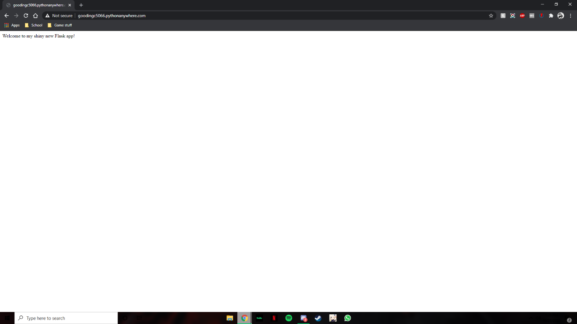](http://goodingc5066.pythonanywhere.com/#)

