Flink + Private Link Architecture
Confluent Cloud — Dedicated Cluster

Dedicated Cluster — Dual Private Link Gateway
Dedicated clusters require separate PrivateLink gateways for Kafka and Flink. Each gateway has its own Azure Private Endpoint and Private Link Service alias. Flink-to-Kafka traffic is routed internally within Confluent Cloud and never traverses the customer's Private Link connection.
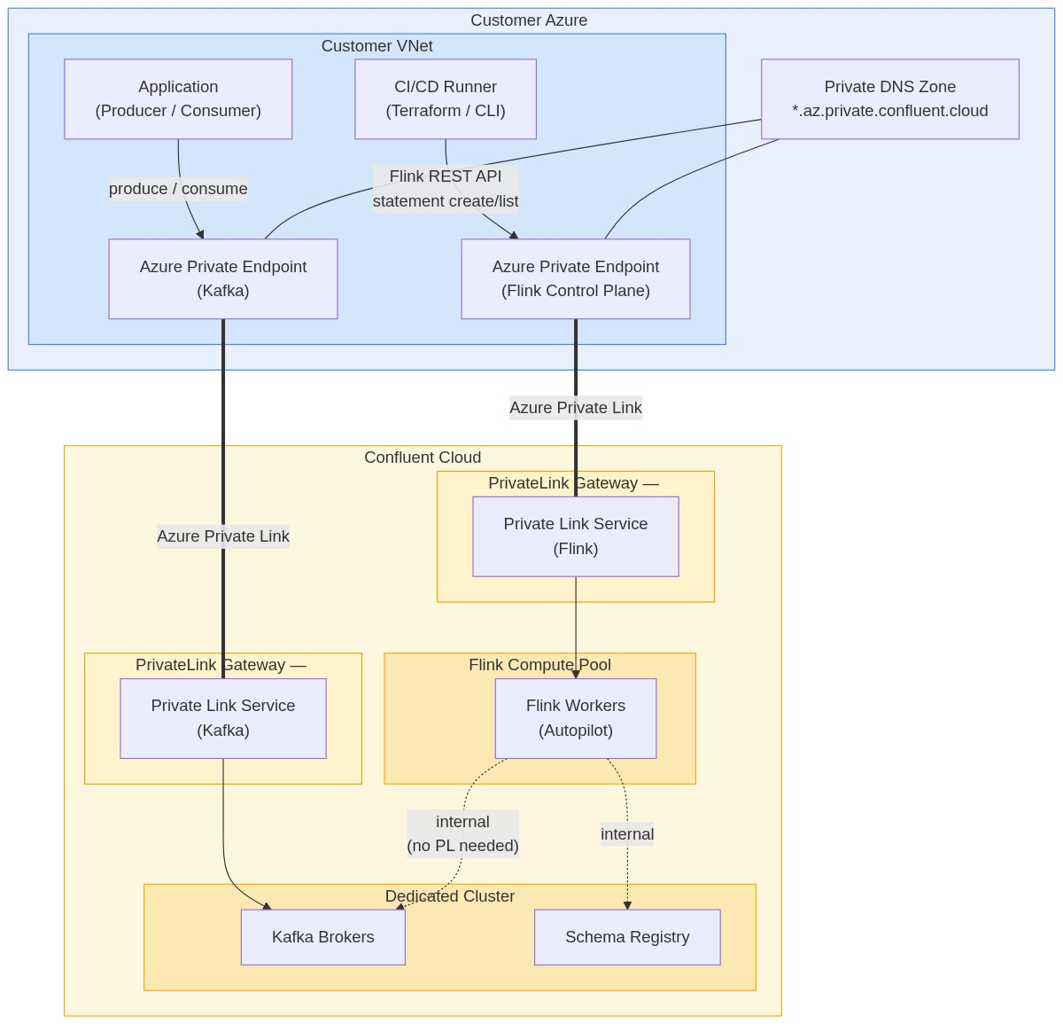

Key Points
- Two Azure Private Endpoints required — one targeting the Kafka PL Service alias, one targeting the Flink PL Service alias
- Both Private Endpoints share the same Azure Private DNS Zone (*.az.private.confluent.cloud)
- Flink compute pool reads from and writes to Kafka topics over Confluent's internal network — this path is always private regardless of networking configuration
- Applications produce/consume to Kafka via the Kafka Private Endpoint; CI/CD tooling submits Flink SQL via the Flink Private Endpoint
- Schema Registry traffic routes through the Kafka Private Endpoint on Dedicated clusters

DevOps Flow — Flink SQL Deployment via Private Link
Developers do not have direct access to the Confluent Cloud CLI or Console. All Flink SQL statements are version-controlled in Git and deployed through a CI/CD pipeline. The pipeline runner executes inside the customer VNet and reaches the Confluent Flink REST API over the Private Link connection.
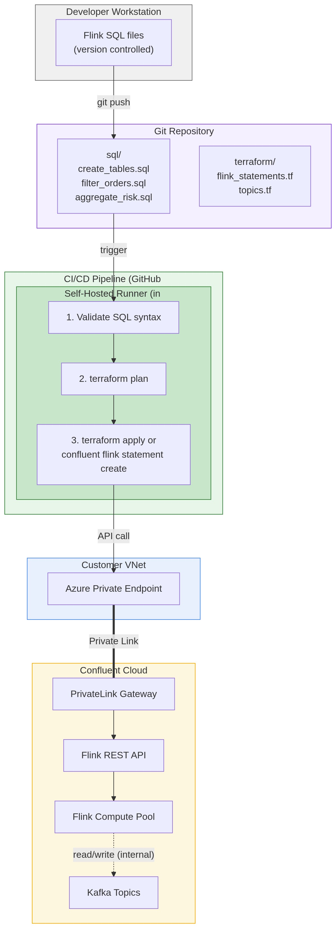

Deployment Options

Option A: Terraform (recommended)
Use the confluent_flink_statement Terraform resource. Statements are declared as IaC alongside topic and RBAC definitions. The Confluent Terraform provider handles authentication and API calls.
resource "confluent_flink_statement" "filter_orders" {
organization { id = var.confluent_org_id }
environment { id = var.confluent_env_id }
compute_pool { id = confluent_flink_compute_pool.prod.id }
principal { id = confluent_service_account.flink_sa.id }
statement = file("${path.module}/sql/filter_orders.sql")
statement_name = "filter-orders-prod"
properties = {
"sql.current-catalog" = var.confluent_env_id
"sql.current-database" = confluent_kafka_cluster.prod.id
}
}

Option B: CLI via CI/CD
The confluent flink statement create CLI command can be called directly from a CI/CD step. The runner must have the Confluent CLI installed and authenticated with a service account API key.

Key Points
- Self-hosted CI/CD runner must be deployed inside the customer VNet to reach the Azure Private Endpoint
- Flink SQL files are version-controlled in Git — standard PR review workflow applies to SQL changes
- Statements are immutable after creation — SQL changes require stopping the old statement and creating a new one
- For stateless operations (filter/projection), use carry-over offsets to avoid reprocessing when evolving statements
- Bind statements to service accounts, not user accounts, to prevent disruption from user status changes

