1.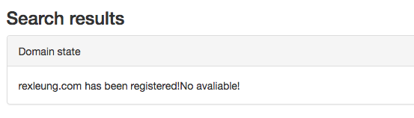

Domain state Change to Domain Status

XXXXX has been registered! Not available for registration!

2.

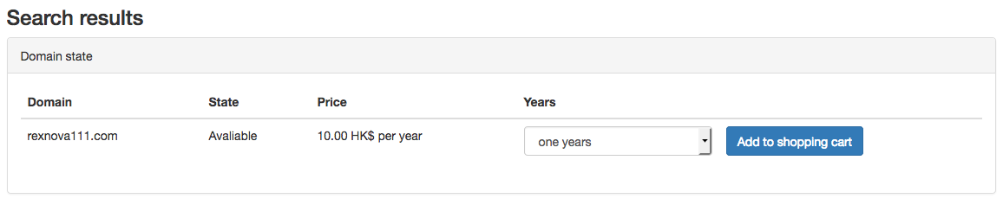

State change to Status

3.

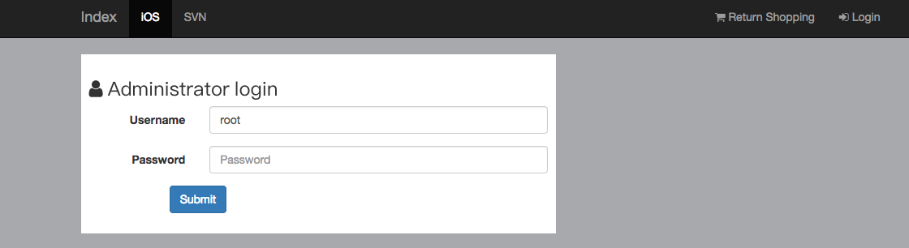

Admin 頁面，左上角是公司logo，about us , help, 右上角 是Return Homepage，Login. 如 user login 頁面設計應該一樣，如下圖：

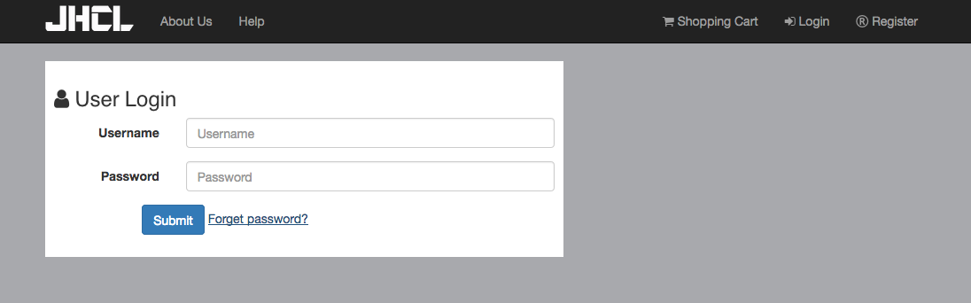

4. 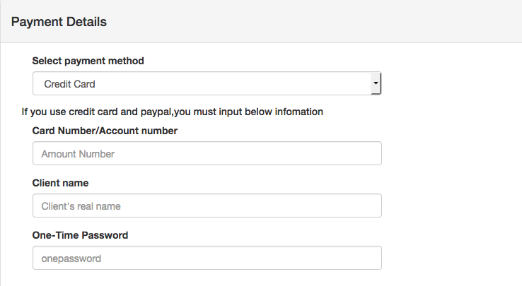

If you use Credit Card and PayPal, please input below information:

Card Number / Account Number

5.



所有cancle 改為Cancel

6.

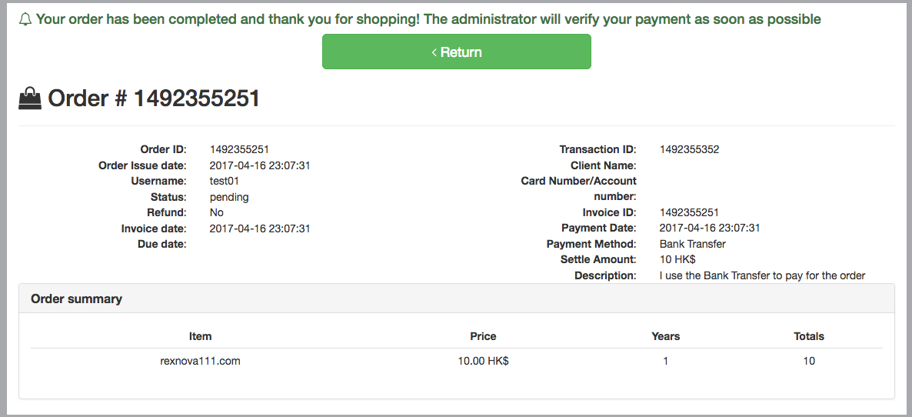

Your order has been completed and thank you for shopping! The administrator will verify your payment as soon as possible.

<br>

If you settle the payment by Bank Transfer / Cheque / E-Banking, please send the payment slip to [payment@jhcl.hk](mailto:payment@jhcl.hk) for verification.

**Card Number / Account number:**

7.

In user order page, 請在底部加多些5 cm 白色，因為與button 太接近。

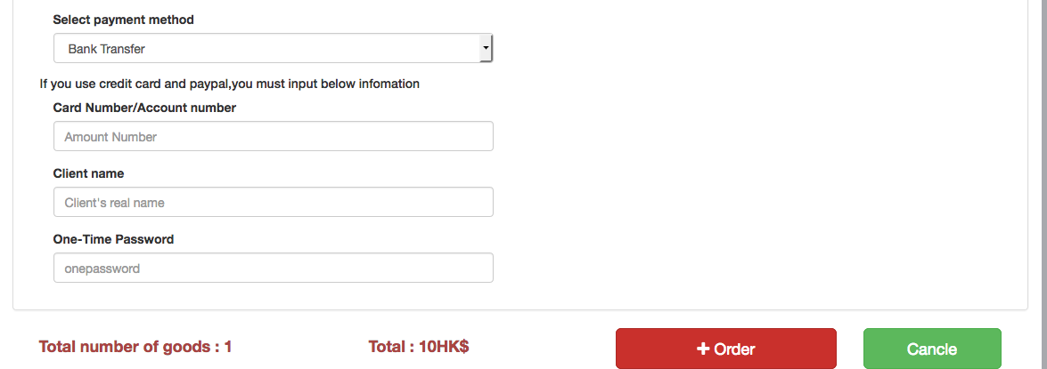

8.

User account page

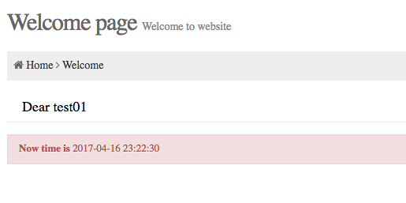

Welcome to JHCL User Page

9. Personal Info

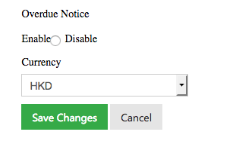

Enable，選項位及disable 瀏覧器顯示位置有問題，會與enable重疊

10. My orders (User & Admin Page)

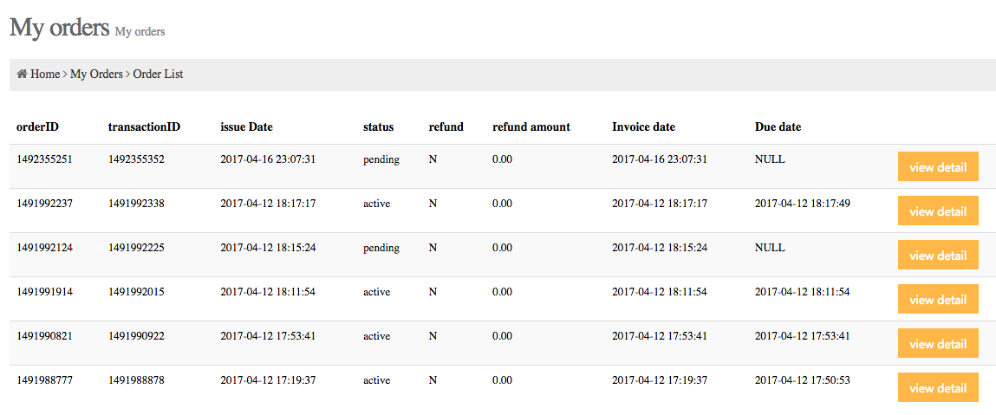

orderID transactionID issue Date status refund refund amount Invoice date Due date change to

OrderID Transaction ID Issue Date Status Refund Refund Amount Invoice date Due date

11. Domain List （User & Admin Page）

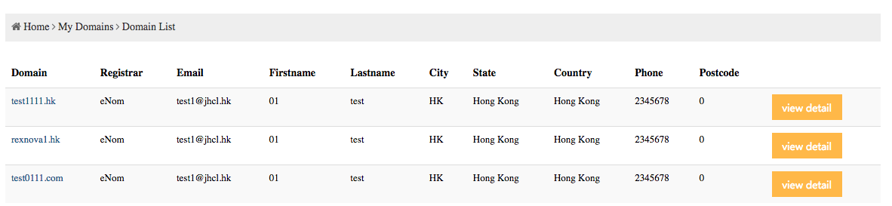

In this page, it should be also show domain status and expiry date

12. Admin Page

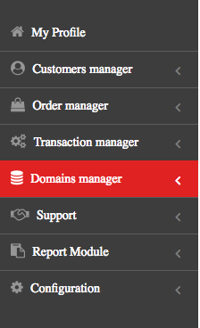

Customer Management

Order Management

Transaction Management

Domains Management

Support

Report

Configuration

13. Customer List

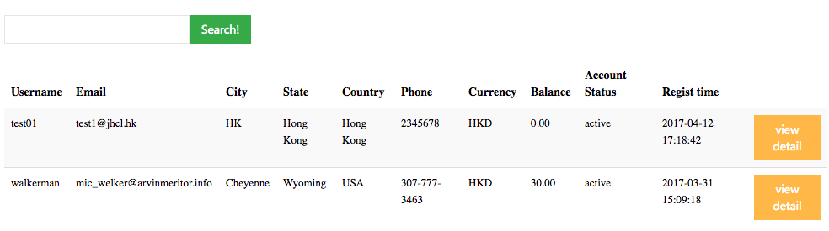

Username Email City State Country Phone Currency Balance Account Status Regist time

Only show Username Email City State Country Phone Status Reg time

14. Add customer

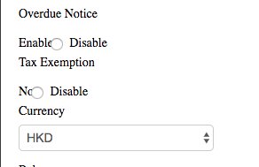

Enable，選項位及disable 瀏覧器顯示位置有問題，會與enable or no重疊

15. Account 及 Domain status 都要更改為以下：

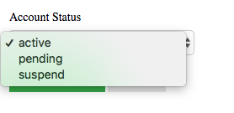

Active

Pending

Suspend

16. Each Order & transaction detail：

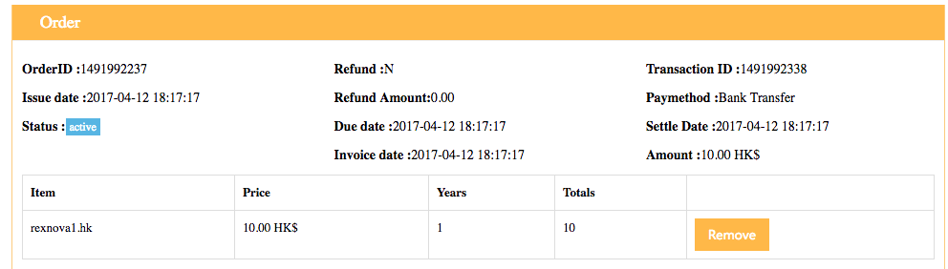

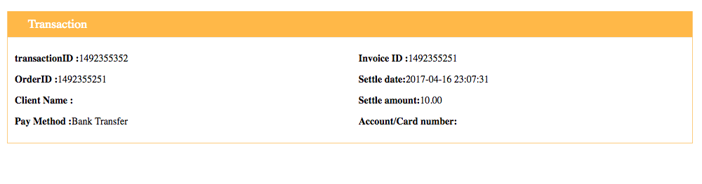

所有有：號後再加空格, 及首英文字是大楷，如：

Order ID: 1491992237 Refund: N Transaction ID: 1491992338