Front Page

**1) Website Title: JHCL Domain Registration**

**2) Please help me amend the web interface like below:**



The original pic is upload to the image folder called frontpage_v1.jpg

3) **All the page framework should similar below example: 很像一個box 在裡面, 外面就是灰色**

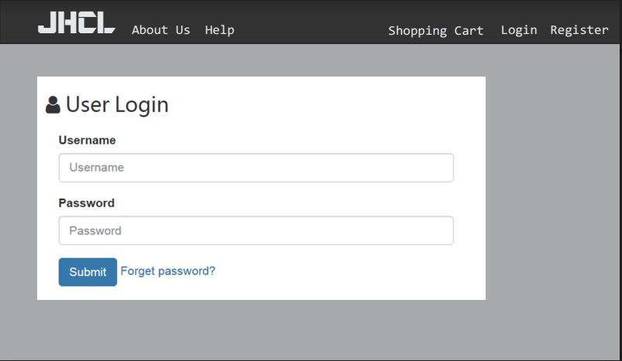

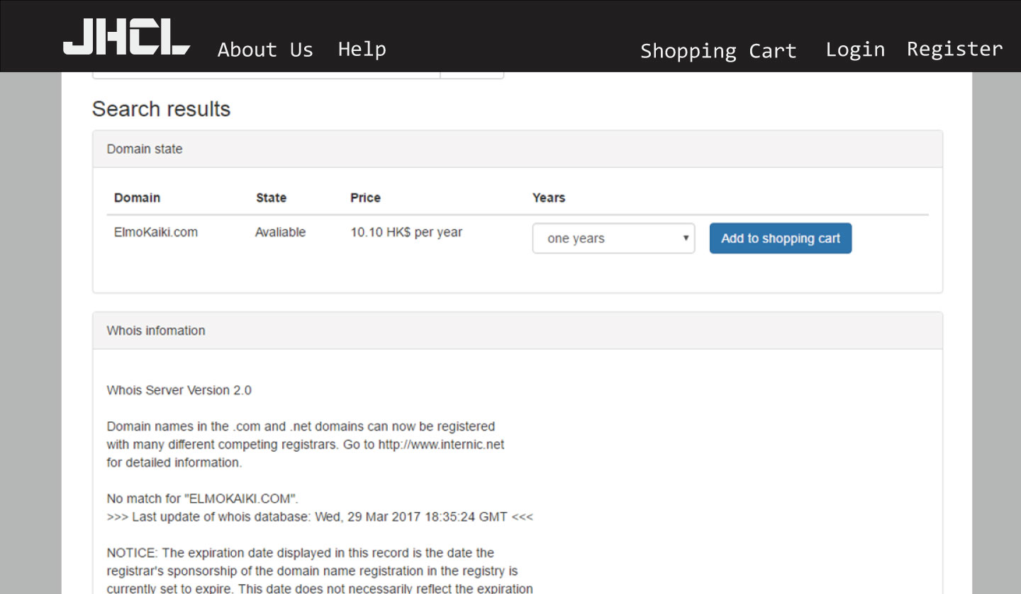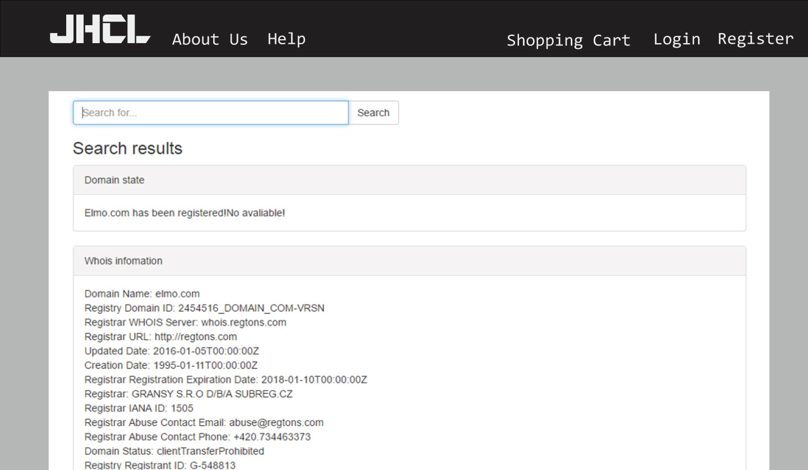

4) **In the registration page,**

1. the security question no need
2. the address 2 should be optional
3. Fax should be optional
4. Add Confirm password field under password

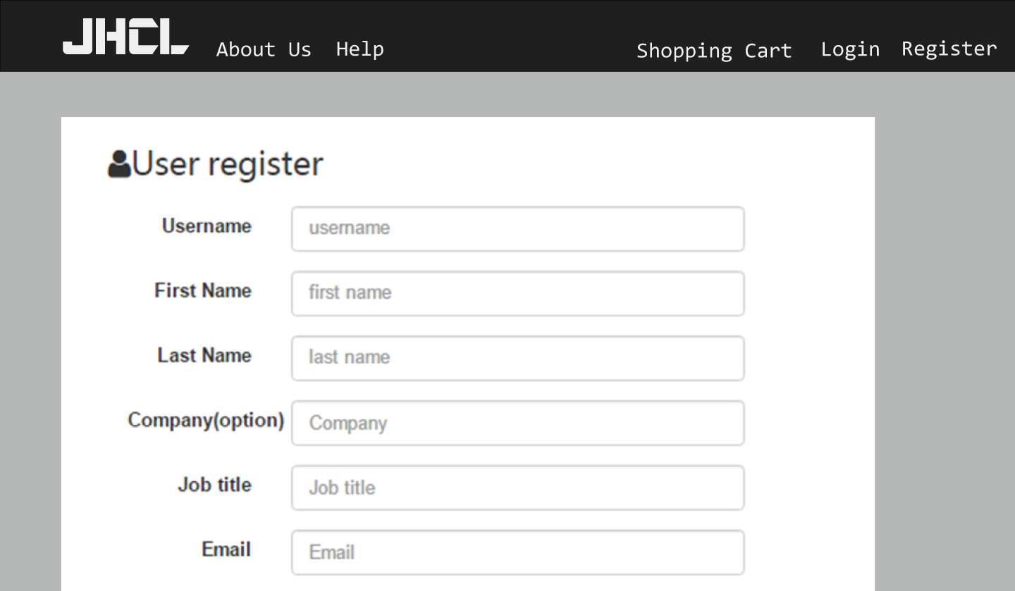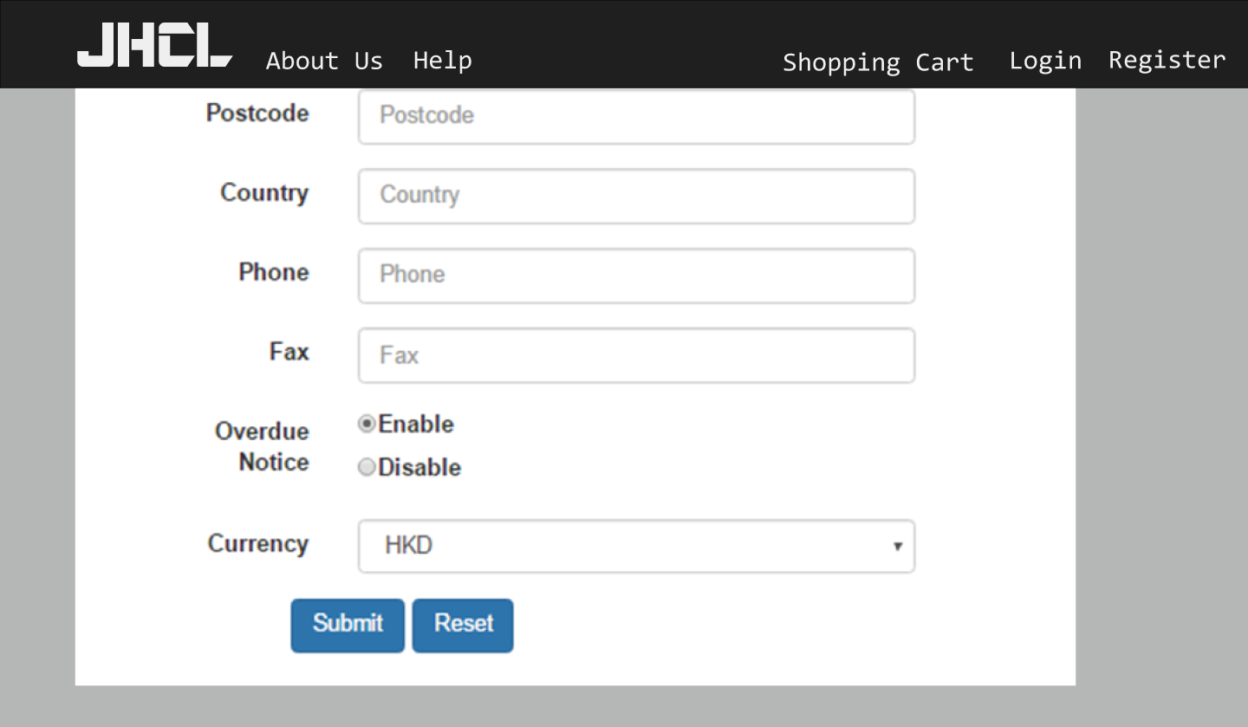

5) **In the domain order page, domain registration profile can**:

1. Default auto-fill the user customer service information
2. nameserver can describe:

“Set default nameservers for all domain registrations below.  
If you are unsure or would like to use our default nameservers, leave the fields blank.”

It means that customer can input or not input the nameserver. If they have not input, the system will auto-fill our default server “ns1.namserver.com, ns2.nameserver.com”

1. In the payment detail, the user only can input credit card and paypal information. For other payment, they don’t need to input anything, just select the method and click “Add order”

Customer Management Platform

6) In the My Domains -> Renew Domain

Problem: Generate invoice which is already settled the payment and domain expiry date has been changed to new date.

In my concept:

This field is generated the renewal invoice by user and they can choose credit card / paypal or bank.

After accept the order, the domain renewal will process and the domain expiry date will renew for one year.

Admin Backend Page

7) The Login page interface should be same as customer login interface.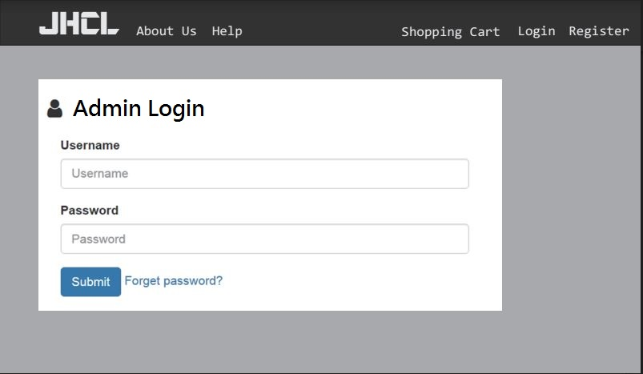

8) Backend welcome page:

The top of the left is the logo JHCL.

And show “Welcome to JHCL Admin Page”

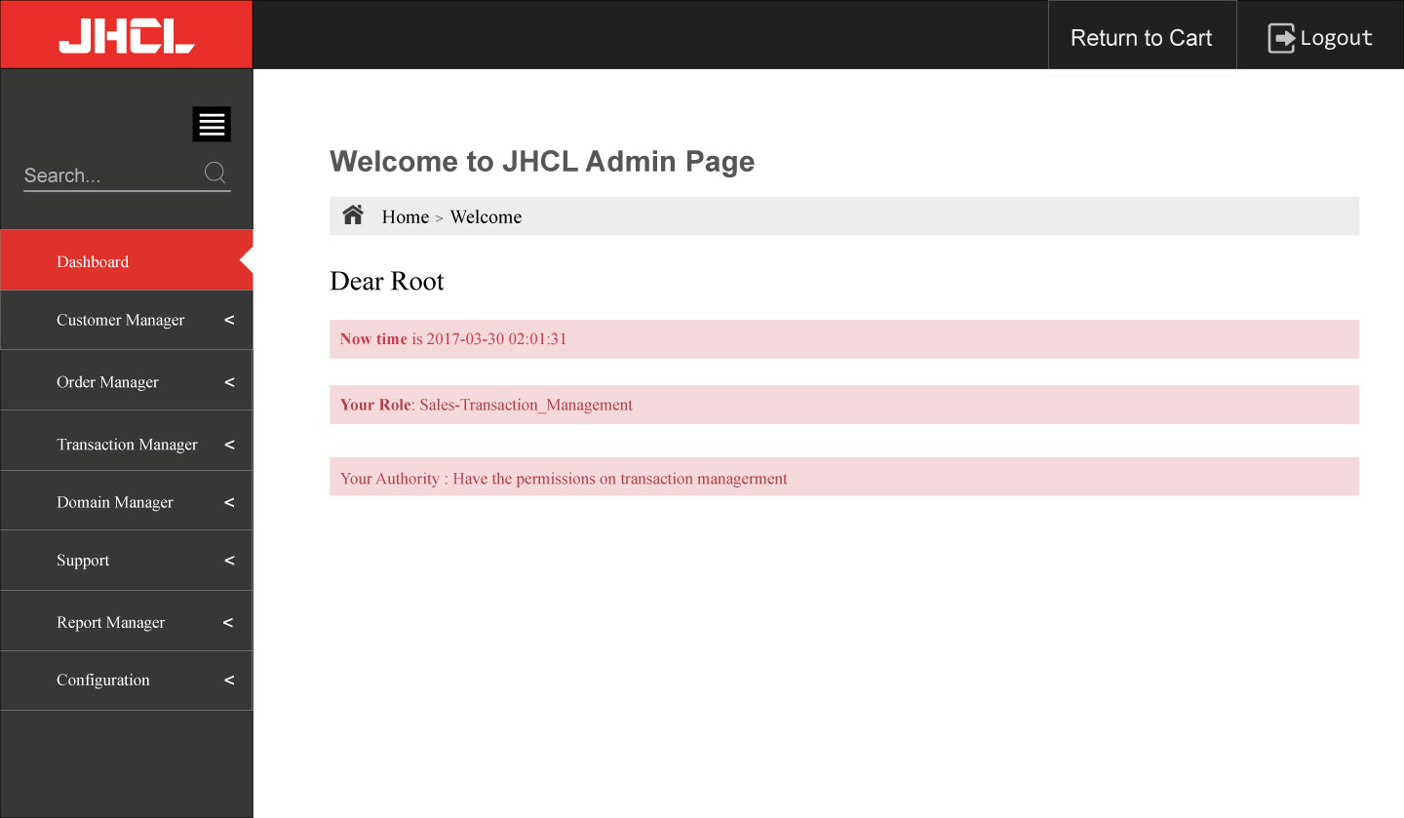

9) In the order manager,

1. I tried to add order in each order with invalid information and it shows program error page. I hope the error page show “The item information is incorrect.”
2. Should be have Add order item, not only in each order. So, I can help user to add order without login their account.
3. If I click refund, the domain status should be changed to suspend, not missing in the domain manager.
4. In each order, there is no action after I click “view transaction”. I think it should be redirected to that transaction record

10) In the transaction manager,

1. Whatever I click each transaction “view detail, it only show transaction ID “1490795808” detail.
2. For bank, cheque and e-banking payment, I should able to input the settle payment date and amount, the account number is not required. If the amount is not enough, the order should not be settled.

11) In the domain manager,

1. The expiry date and next due date only require show the date, the time is not required.
2. I should able to change the domain registrar in domain detail or in update

12) Domain Price

I can setup each tld original price and premium domain increase price %.

Premium Domain: baby.love, seoul.love, slim.club

When I search other .love domain, it should be show the original price. When I search baby.love, it should be show the premium increase price.

13) Domain Registrar

Provide change status and remove function.