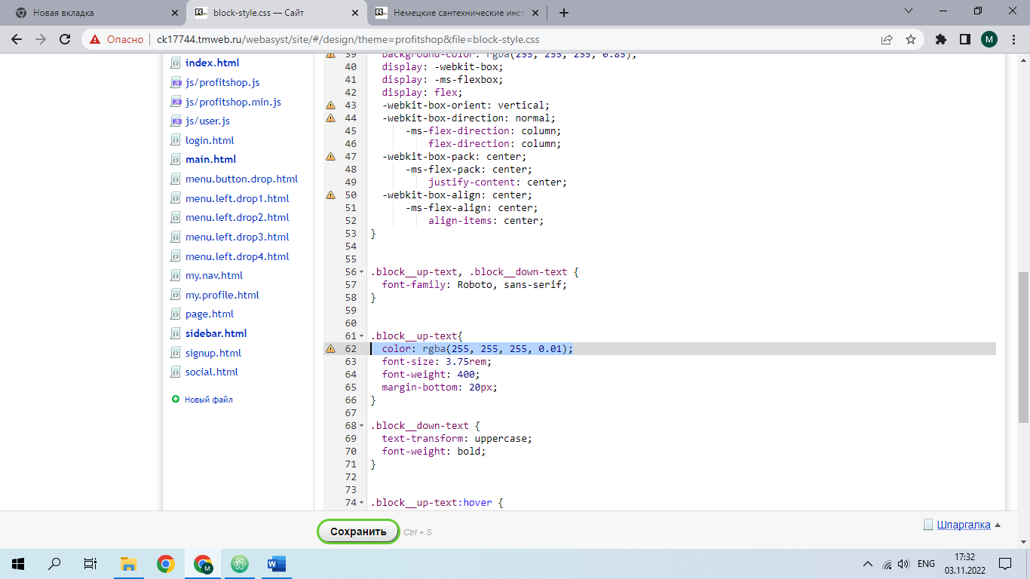

Block-style.css

color: rgba(255, 255, 255, 0.01);

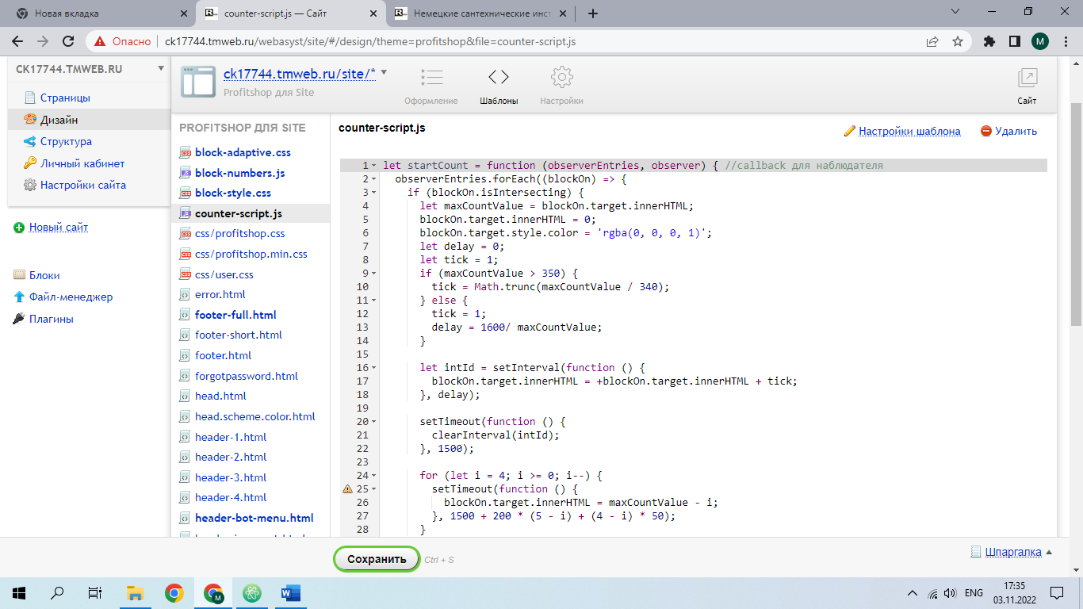

counter-script.js

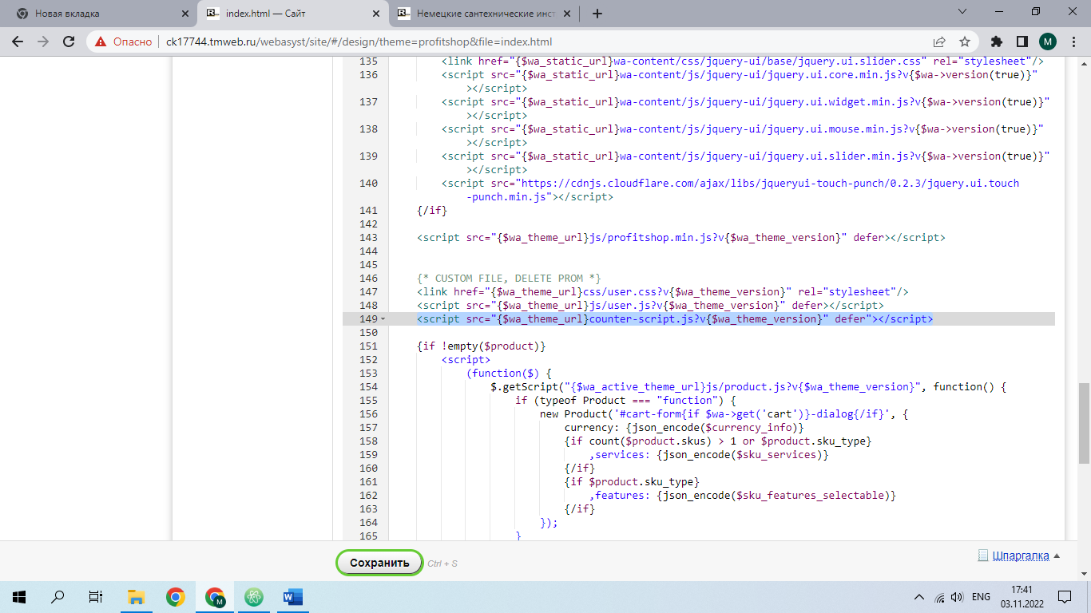

Index.html

<script src="{$wa_theme_url}counter-script.js?v{$wa_theme_version}" defer"></script>