**ASSIGNMENT COVER SHEET**

|  |  |
| --- | --- |
| Name | Aidan Barnsdale |
| Student number | 75701402 |
| Student email | aba177@uclive.ac.nz |
| Date of submission | / / 2020 |

Please complete your details above and include this cover sheet as the first page on your assignment submission.

Please also remember to upload your source file (Matlab or otherwise), in a format that can be executed to confirm functionality, i.e. ensure all support files are included, and files are logically names and commented. A ‘zip’ file with subdirectories for each question and/or a ‘README’ file is highly recommended.

The allocation of marks will be:

|  |  |  |
| --- | --- | --- |
| Question | Max [%] | Mark [%] |
| **Transmitter/20** | |  |
| a | 5 |  |
| b | 5 |  |
| c | 5 |  |
| d | 5 |  |
| **Receiver/40** | |  |
| e | 10 |  |
| f | 10 |  |
| g | 20 |  |
| **Equaliser/40** | |  |
| h | 20 |  |
| i | 10 |  |
| j | 10 |  |
| **TOTAL** | **100** |  |

a) In this case, a throughput of 1Mb/s is required, with a bandwidth of 500kHz. Three modulation types are available:

* Bipolar Signalling, or 2 PAM sends a stream of raised cosine shaped pulse of amplitude -1 or 1, representing the state of each individual bit. Hence, Rs = Rb. The essential bandwidth of the signal is therefore 1Mb/s. However, the transmitted signal of this method has only two voltage levels, making resilient to Inter-Symbol Interference (ISI).
* 4 PAM, like Bipolar Signalling, sends a series of shaped pulses. These are of amplitude -3, -1, 1, 3 however, representing the value of each set of two bits. Hence, two bits are transmitted for each pulse, so Rs=2Rb, giving an essential bandwidth of 500kHz for this case.
* 8 PAM is similar to 4 PAM, but with a symbol size of 8, giving a data rate of 1.5Mb/s for a symbol rate of 500kHz. Because of the decreased margins between levels in the transmitted signal, this is significantly more susceptible to ISI than 4 PAM.

Considering these characteristics, 4 PAM is considered the most suitable method of modulation as it’s bandwidth of 500kHz for a bit rate of 1Mb/s meets requirement. If 8 PAM were used, it would also meet these requirements, however, its increased susceptibility to noise makes it less reliable than 4 PAM.

b)

c)

d)

e)

f)

g)

h)

Taken from assignment specification:

The received signal can be represented in discrete time as

where w[i] is a sample of AWGN noise. Using the definition of the autocorrelation coefficients

we can derive the autocorrelation expression using the following steps:

Assuming sampling at the ideal sampling instants







i)

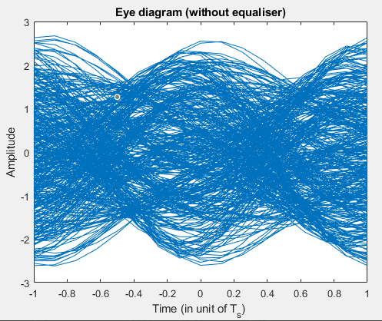

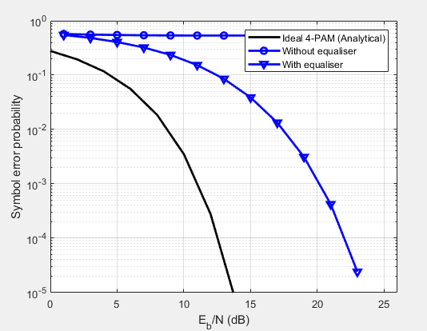

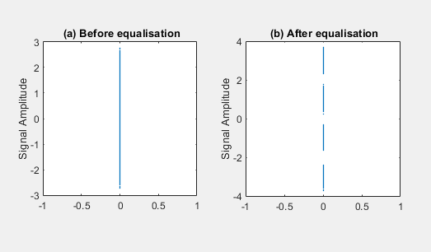

j)

First, the signal output must be fed into the oscilloscope. This is done by using a BNC lead to connect the output if the PAM generator to input 1 on the scope.

To display the signal, input 1 is tuned on. Creating an eye diagram requires the input signal to be triggered at the start of each symbol. Because of the variable level of PAM at the start of each symbol, an external trigger source must be used. A signal clock output is used for this.

Using a BNC lead, the clock signal is plugged into the external trigger input of the oscilloscope, which is then set to source its trigger signal from the external trigger input.

At this point, each symbol would be shown on the screen independently. To attain an eye diagram the persistence of an analogue oscilloscope must be simulated. To achieve this, the persistence setting is set to ‘high’ to show multiple modulated symbols overlayed, creating an eye diagram.