Paper Title* (use style: paper title)

Aidan Barnsdale

University of Canterbury

Christchurch, New Zealand

aba177@uclive.ac.nz

*Supervisor : Dr Richard Green*

*University of Canterbury*

*Christchurch, New Zealand*

*richard.green@canterbury.ac.nz*

*Abstract*—

Keywords—computer vision, path detection, Intel RealSense RGBD camera, morphology, contour detection

# Introduction (*Heading 1*)

Computational positioning and navigation has forever been a problem in the area of computer science and engineering. In emergency situations, inspections of buildings deemed unfit for human entry may be necessary. In this case, a reliable means of navigating through unfamiliar buildings will be needed. Traditionally, GNSS (Global Navigation Satellite System) has been used as a universal navigation system. However, when using traditional GNSS enabled devices, this is limited to outdoor use only due to the requirement for a reliable line of sight path to at least four GNSS satellites [1]. Navigation in an indoor environment is thus an important area of research in many areas of science and engineering.

The conducted work described in this report aims to accurately detect open doorways and offshoots to corridors in a building. This can then be used to navigate safely through a building without the need for real-time human control.

This paper aims to analyse previous research in the area of indoor positioning, particularly with regard to computer vision based solutions.

# Background

## Prior Research

Previously, several studies have been conducted in the area of indoor navigation. Reference [2] uses fiducial markers placed around a building to find the position and orientation of a camera. This is achieved through recognition of text characters of a known size placed at known points in an indoor environment.

Reference [3] describes a means of doorway detection using a combination of corner and line features in a two dimensional image.

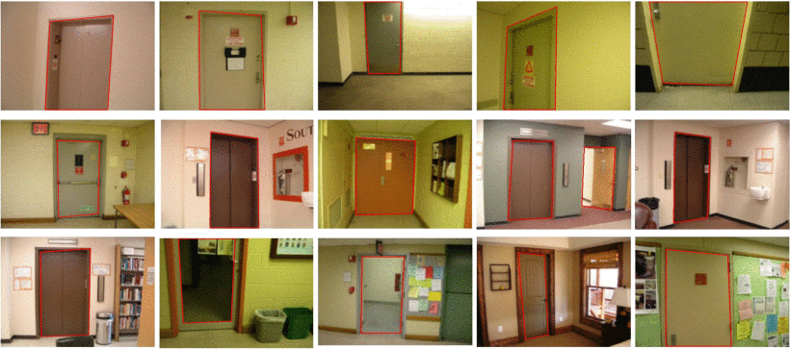  
Illustration 1.Doorway detection results from [3]

Despite having a stated detection accuracy of 91.7%, this method requires at least the top or base of a door to be visible in the image for a corner to be present.

N. Ferguson [4], implemented a computer vision based open doorway detection system using depth data from a commercially available RGBD camera.

# Solution

Use depth camera (gets all changes in depth to find pathways) With RGB to remove noise etc.

1. Results

In order to maximise adaptability, and for ease of implementation, the Python programming language was used in conjunction with the OpenCV library. An Intel Realsense 3D camera was used to collect both RGB images and a corresponding depth map of scene.

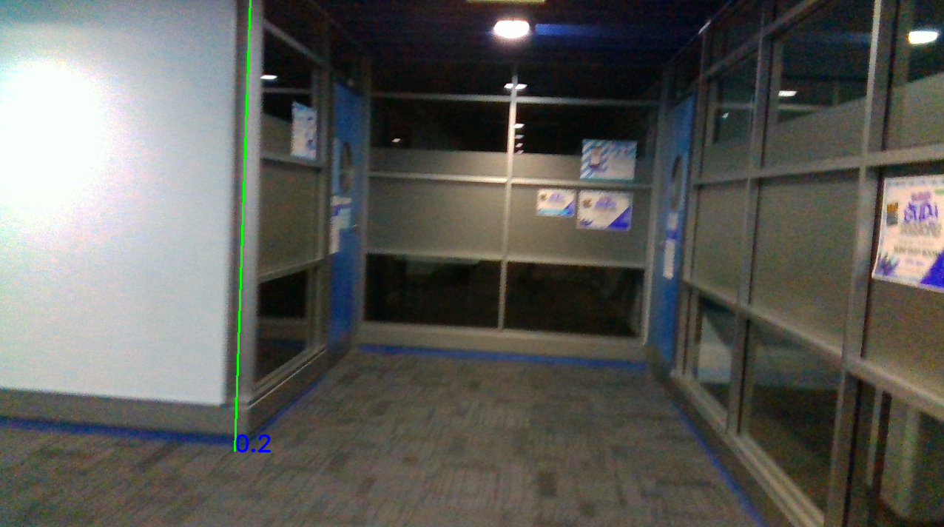

##### Acknowledgment *(Heading 5)*

##### References

1. A. Soloviev and J. Dickman, "Extending GPS carrier phase availability indoors with a deeply integrated receiver architecture," in IEEE Wireless Communications, vol. 18, no. 2, pp. 36-44, April 2011, doi: 10.1109/MWC.2011.5751294.
2. G. Kim and E. M. Petriu, "Fiducial marker indoor localization with Artificial Neural Network," 2010 IEEE/ASME International Conference on Advanced Intelligent Mechatronics, Montreal, ON, 2010, pp. 961-966, doi: 10.1109/AIM.2010.5695801.
3. X. Yang and Y. Tian, "Robust door detection in unfamiliar environments by combining edge and corner features," 2010 IEEE Computer Society Conference on Computer Vision and Pattern Recognition - Workshops, San Francisco, CA, 2010, pp. 57-64, doi: 10.1109/CVPRW.2010.5543830.
4. N Ferguson, “Doorway Detection for Assisted Wheelchair Control”, University of Canterbury, June 2018

[**https://patents.google.com/patent/US9251417B1/en**](https://patents.google.com/patent/US9251417B1/en)