%Final Exam
%Problem 3
%Part b->d
%This script demos BDF Eurler methods
%Created by: Patrick Good
%Source code from Dr. Z
%clear workspace
clc
clear
close all
% Define a 1D space and time grid in x for test problem
lx=64;
a=0; %here a,b are the endpoints of the x-domain
b=1; %use a square region for a test problem
x=linspace(a,b,lx);
dx=x(2)-x(1); %grid spacing
% Define parameters of the parabolic equation, time variable
lambda=2;
tau=1/(2*pi/(2*dx))^2/lambda; %diffusion time scale for the equation, based on smallest resolvable spatial mode
%dt=tau/5; %time step
dtmargin=1/lambda/2*dx^2;
dt=5*dtmargin;
tmin=0;
tmax=1024*tau; %go out to three times the diffusion time scale for the smallest possible mode
t=tmin:dt:tmax;
lt=numel(t);
% Trapezoidal implementation, note matrix solutions are more efficiently handled thru tri-diagonal solver; Matlab built-in will detect automatically
f2=zeros(lx,lt);
A=sparse(lx,lx); %allocate sparse array storage (this matrix is to be tridiag)
b=zeros(lx,1);
f2(:,1)=sin(2*pi*x)+sin(8*pi*x);
for n=2:lt
A(1,1)=1;
b(1)=0;
for ix=2:lx-1
%i-1 coeff
A(ix,ix-1)=-lambda/2/dx^2; %C
%i coeff
A(ix,ix)=1/dt+lambda/dx^2; %B
%i+1 coeff
A(ix,ix+1)=-lambda/2/dx^2; %A
b(ix)=(f2(ix,n-1))/dt+(f2(ix+1,n)-2*f2(ix,n)+f2(ix-1,n))/dx^2*lambda; %adjusted for Euler
end %for
A(lx,lx)=1;
b(lx)=0;
fnow=A\b;
f2(:,n)=fnow;
end %for
% Compare two solutions on plot
figure(1);
imagesc(t,x,f2);
colorbar;
axis xy;
xlabel('time (s)');
ylabel('x (m)');
title('1st Order BDF');
set(gca,'FontSize',16);
% Trapezoidal implementation, note matrix solutions are more efficiently handled thru tri-diagonal solver; Matlab built-in will detect automatically
f3=zeros(lx,lt);
A=sparse(lx,lx); %allocate sparse array storage (this matrix is to be tridiag)
b=zeros(lx,1);
f3(:,1)=sin(2*pi*x)+sin(8*pi*x);
for n=2:lt-1
A(1,1)=1;
b(1)=0;
for ix=2:lx-1
%i-1 coeff
A(ix,ix-1)=-lambda/2/dx^2; %C
%i coeff
A(ix,ix)=1/2/dt+lambda/dx^2; %B
%i+1 coeff
A(ix,ix+1)=-lambda/2/dx^2; %A
b(ix)=(3*f3(ix,n+1)-4*f3(ix,n)+f3(ix,n-1))/2/dt+(f3(ix+1,n)-2*f3(ix,n)+f3(ix-1,n))/dx^2*(lambda); %adjusted for Euler
end %for
A(lx,lx)=1;
b(lx)=0;
fnow=A\b;
f3(:,n)=fnow;
end %for
% Compare two solutions on plot
figure(2);
imagesc(t,x,f3);
colorbar;
axis xy;
xlabel('time (s)');
ylabel('x (m)');
title('2nd Order BDF');
set(gca,'FontSize',16);
% Compute and plot the analytical solution (see https://github.com/gemini3d/GEMINI-docs/blob/master/test_descriptions/GEMINItests.pdf for a derivation)
[T,X]=meshgrid(t,x);
tempexact=exp(-4*pi^2*lambda*T).*sin(2*pi*X)+exp(-64*pi^2*lambda*T).*sin(8*pi*X);
figure(3);
imagesc(t,x,tempexact);
colorbar;
axis xy;
xlabel('time (s)');
ylabel('x (m)');
title('Exact');
set(gca,'FontSize',16);
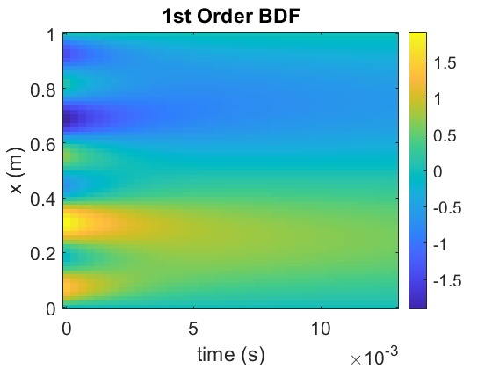
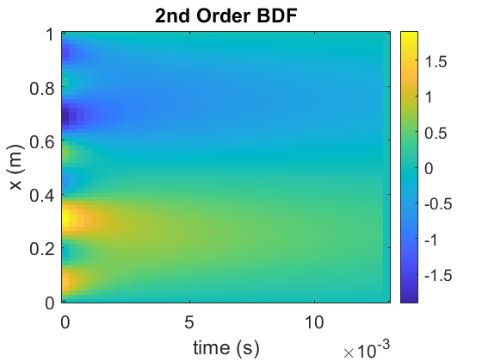
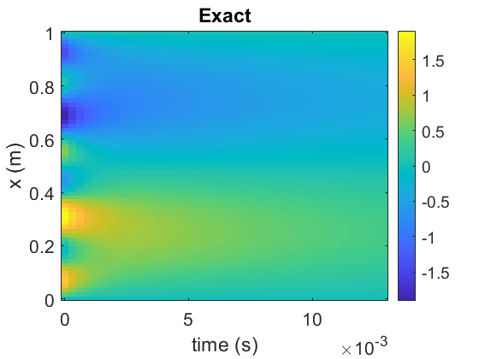
Published with MATLAB® R2020a

