This is a test for object linking and embedding.

Linking：
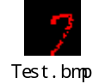

Embedding:


Linking:

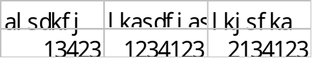

Embedding:
