1. Download Python 3.9 from this link:

<https://www.python.org/downloads/release/python-390/>

2. Install. Be sure to add Python to PATH!

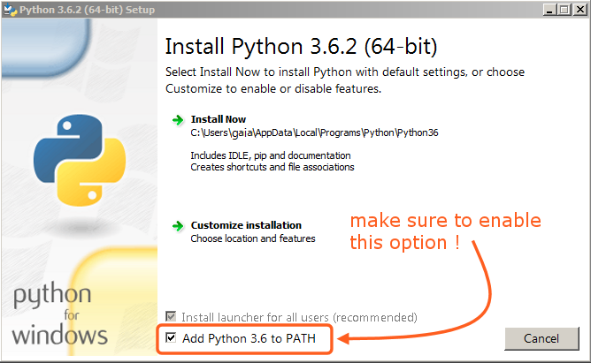

3. Open the program folder.

4. Open a command prompt in it.

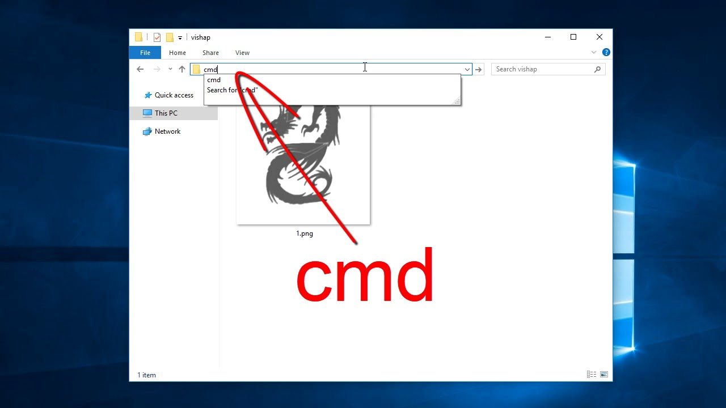

5. Copy the commands one by one to the command line,

pressing enter after each,

waiting for the previous command to complete.

python -m venv venv

venv\Scripts\activate.bat

pip install -r requirements.txt

6. Configuration is complete.

IMPORTANT! The file to be searched must always have the same structure and name "Sample_Web_Scrapping.csv".

(Desirable number of records 1000-5000. Approximate speed of the program 200-300 records per hour)

As a result, the file "result.csv" will appear in the folder.

Before each launch of the program, it is important to replace the file "Sample_Web_Scrapping.csv" with a new one

and delete the old file "result.csv".

7. To start the program, copy the following commands in turn to the command line:

venv\Scripts\activate.bat

python usa_companies_scraper.py

8. Wait until the end of the program. You should see an inscription:

=====================

The program has completed its work.

You can check the file "result.csv"

=====================