New Display Thread
- ThreadEx
Date: October 30, 2008
Revision: 0.1
Owner: Video Render Team
COREL CORP. CONFIDENTIAL

Revision History
Revision | Date | SDK ver. | Owner | Description
0.1 | Oct. 30 2008 | 1.0.0.1 | Louis.Chang | Initial document draft

Overview

Concepts of original display thread
The original display thread (Thread) controls rendering process by evaluating video and audio synchronization status.
When video frame is ready to be displayed and audio data of the same PTS is not ready, the original display thread holds the video frame and waits until audio is ready.
On the other hand, the original display thread invoke rendering call immediately when video falls behinds audio.

Limitation of original display thread
- Since the rendering process displays video without knowing when the video frame actually flips in hardware, the rendering performance isn’t pleasing, particularly when displaying video in 60 FPS.
- When video falls behind audio, the original display thread invokes rendering call whenever there has a video frame; this actually keeps GPU busy and quite unnecessary. Sometimes, the low-end GPU is not capable to handle these calls in a short time and causes the video jitter keeps happening.
- The audio data is not accurate sometimes and might cause some video jitter; especially when playing some AVCHD titles.
The goal of new display thread (ThreadEx) is to provide a better rendering control, in order to fulfill upcoming performance challenges and being capable of displaying videos with different frame rates on variety monitor refresh rates.

Concepts of ThreadEx

Aligning Vsync
The main concept of ThreadEx is to align video present call with vsync (monitor’s vertical signal). Since presenting calls and vertical signal are aligned, the video refreshes immediately on monitor as long as we dispatch a presenting call and we could control the video rendering more precisely.
Let’s explain this concept more detail by using GPUView, a tool of analyzing performance of graphics processing units (GPU).
Here is a snapshot of GPUView.
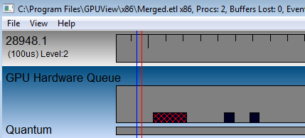

- VSync (vertical signal): There will have 60 vsyncs per seconds for a monitor with 60Hz refresh rates.
- Presenting Signal: The presenting signal invokes by DispSvr via IDirect3DDevice9::Present().
- Present Packet (Rectangle with red-cross): This packet comes along with a presenting signal and it represents when the presenting commands really executes in GPU.
This snapshot shows how the presenting calls align to display’s vsync. After the present packet is processed in GPU hardware queue, the updated buffer will be flipped and revealed on screen at next vsync.
For instance, ThreadEx invokes a present call whenever there is a vsync while displaying 60i content on monitor with 60Hz refresh rate. The video can be displayed smoothly and precisely without missing any frame.

Core Rendering Process of ThreadEx
The flow chart of ThreadEx is shown at next page. Let’s see the core rendering process of ThreadEx first, which consist of three stages: Prepare, Wait and Display.

Prepare Stage: Get Frames Ready
The first step is that ThreadEx will retrieve a video frame from display queue (if there has any), and preparing the video frame which involving de-interlacing, plane composition and post-processing.
According to driver’s suggestion, this stage cannot be omitted even if video frame is supposed to be dropped in order to keep A/V synchronizes.

Wait Stage: Frame rate control
Since the video frame is ready, ThreadEx still needs to hold the video frame for dispatching present calls according to frame rates. For example, the video frames should be dispatched for every 33 milliseconds when rendering 30p content on 60Hz monitor.
The frame rate and monitor’s refresh rate are used to evaluating how long ThreadEx should hold the video frame. The more detail of frame rate to refresh rate management (pull down) will be discussed later.
Since the final rendering process is done in DispSvr, the actual idle time for waiting stage will minus a conservation time for DispSvr to align vsync. This conservation time for DispSvr is defined as DISP_PRESENT_TIME.

Display Stage: Align VSync and Dispatch Rendering Calls
The final rendering procedure is actually done in DispSvr. DispSvr dispatches the presenting calls right after it receives a vsync via IDirect3DDevice9Ex::WaitForVBlank(). The rendering process will be scheduled and executed in GPU hardware queue. In the meantime, ThreadEx is preparing for next video frame which goes to the Preparing Stage.

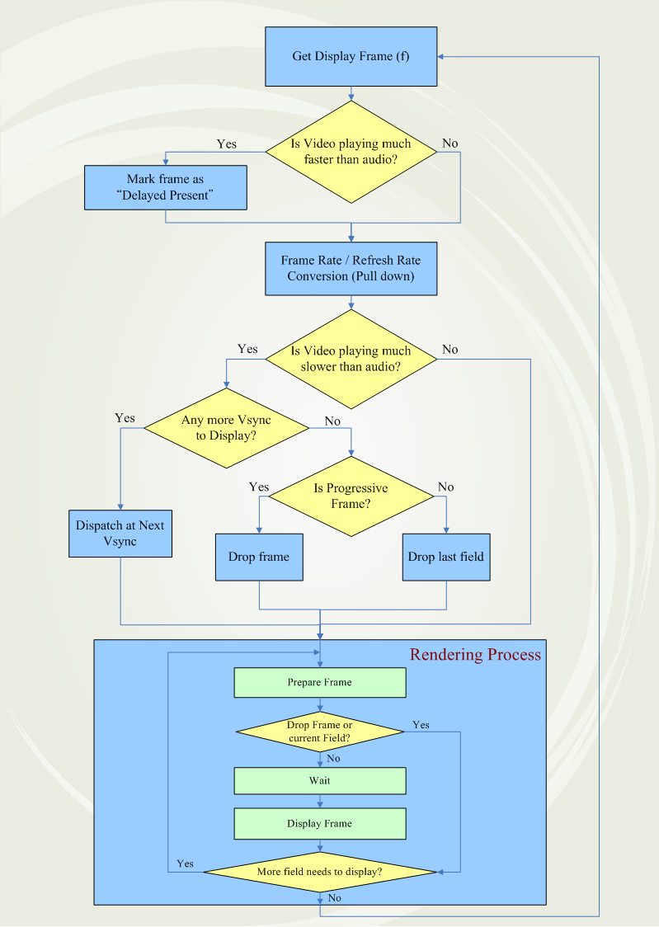
More to ThreadEx

Frame rate/Refresh rate Conversion (Pull down)
ThreadEx is focused on monitor with 60Hz refresh rates which is most commonly used display. For 30p and 60i contents, the conversion can be easily done by dispatch rendering calls for every 2 and 1 vsyncs.
[30p@60Hz display]
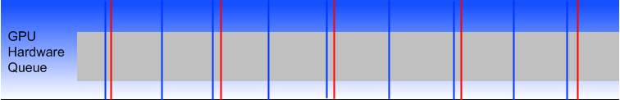

[60i @60Hz display]
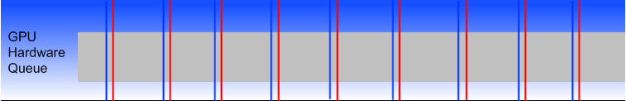

For 24p content, ThreadEx dispatches video frame for every 2 and 3 vsyncs.
[24p@60Hz display]
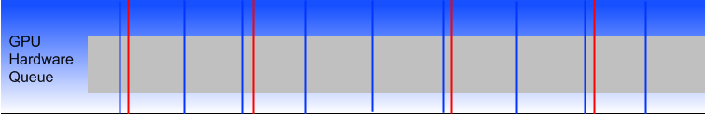

When displaying 24p content on 60Hz display, the video is expected to be a little unsmooth due to the frame rate to refresh rates conversion. The unsmooth issue could be easily seen at scenes when camera panning.
ThreadEx also support display 24p content on 24Hz displays. For monitors with other refresh rates (e.g. 75Hz) will also be supported in the future.

A/V Synchronization
Since ThreadEx dispatches rendering calls according to VSync, ThreadEx needs other mechanisms to keep A/V synchronized.
If the video is playing faster than audio, ThreadEx will mark the following frame as “Delayed Present”. The “Delayed Present” frame will be delayed one Vsync than it expected to be displayed.
If the video is playing slower than audio, ThreadEx will try to play faster if there has extra VSync for display. Otherwise, ThreadEx will drop a video frame (or field) in order to catch up with audio.
These mechanisms above will cause slight video jitter and that is unavoidable, since video and audio must be synchronized.

AMD PCOM
The technique of aligning video present call with display’s vsync doesn’t work on AMD PCOM API. Using IDirect3DDevice9Ex::WaitForVBlank() to receive vsync will stall GPU process on AMD platform. Therefore, ThreadEx has to handle not-aligning VSync case.
Since invoking present calls via PCOM API doesn’t wait for vsyncs, ThreadEx has to cover up the conservation time for DispSvr (DISP_PRESENT_TIME) after dispatch presenting calls.

Windows XP
ThreadEx is mainly stressed on Vista. Here listed the ThreadEx behaviors on XP system.
- Hardware Decoding Mode(DXVA1): ThreadEx takes the same action as orginal display thread (Thread) does by evaluating the AV sychonization status.
- Software Decoding Mode: IDirect3DDevice9Ex::WaitForVBlank() is one of D3D9Ex API and D3D9Ex is not supported on XP. Since there is no existing API on XP, the Vsync aligning mechanism is achieved by computing monitor scanlines in DispSvr.

Limitations of ThreadEx

Monitor Refresh Rates Inaccuracy
The actual monitor refresh rate will be closed to its expected refresh rate with a little inaccuracy and it is device-dependent. For instance, a display with 60Hz refresh rates might actually refresh screens in 59Hz or 61Hz according to panel’s capability.
Since ThreadEx aligns vsync, video will be played faster or slower than frame rates expected due to the actual monitor’s refresh rate. The A/V synchronization control will be raise more often and cause jitter more easily if displaying on monitors with inaccurate refresh rates.

Unstable AVSync after Seeking
The A/V synchronization status is quite unpredictable after seeking on WinDVD8. If video is much slower than audio right after seeking, ThreadEx will drop serveral frames or fields in order to catch up with audio. This operation will cause video jitter right after seeking.

