**Project Title**

Campaign Donations for the 2012 Presidential election in the state of New Hampshire

**Research questions and hypotheses**

The primary question I’d like to answer is how are individual Presidential campaign donations broken down by town and by party in the state of New Hampshire. I’d like to correlate this to the per capita income level in each of the New Hampshire towns and see if there are any patterns such as whether ‘rich’ towns give predominantly to one party or another.

My hypothesis is that the southern portion of the state will have the majority of the donations across both parties. I believe that the Democratic donations will be centered mostly around the seacoast and around Dartmouth College in Hanover, traditionally liberal and wealthy areas of the state. I think the Republican donations could also be high around the seacoast, but also further north around Lake Winnipesauke where there tend to be a lot of large vacation homes.

**Motivation**

My main motivation is just interest. I live in New Hampshire and am interested in politics (my undergraduate degree is in Political Science) especially campaign finance reform. I came across the data and thought I could apply it to a region where I live to see if any interesting patterns emerged.

**Data Source(s) and technical process:**

The main data source for this project will be the New York Times Campaign Finance API. Specifically I will be pulling the Presidential State/Zip totals: <http://developer.nytimes.com/docs/read/campaign_finance_api#h3-pres-state-zip>

To do this I will need to programmatically get a list of all the New Hampshire zip codes and pull the API data for each zip. From there I will need to map the town names to the zip codes. This could be done with a Python script or even a simple shell script. A data source for this exists here: <http://www.directorynh.com/NHReferenceDesk/ZipCodes.html>

The data for the per capita income of each town will come from the US Census Bureau site: <http://factfinder2.census.gov/faces/tableservices/jsf/pages/productview.xhtml?src=bkmk>

The same mapping of town to zip will be done to incorporate this data.

An additional piece of data might be geographic locations (latitude and longitude) for the towns so that the data could be represented on a map of the state.

I will most likely store this data in a csv format. Merging of the data could be done with a combination of shell scripts, Google Refine and Google Fusion Tables.

**Potential Visualizations**

The most obvious visualization that springs to mind is a map of New Hampshire. Each town on the map could be shaded in varying intensities (depending on the campaign donation in that town) of either red for the Republican party or Blue for the Democratic party, or a combination of the two depending on the data. The darker the color the more money the people in that town donated to a political campaign.

I’m not sure of the best way (yet) to represent the per capita income levels. A corresponding bar chart or some kind of indicator on the town that would show height based on income levels, such as the Time visualization below might be a possibility.

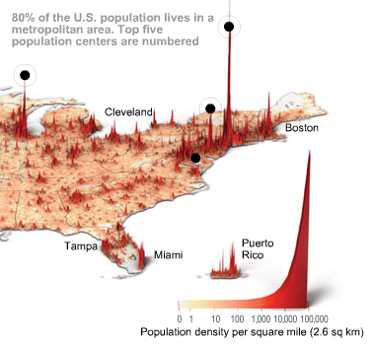

Figure 1: This is where we live, Time Magazine