**Part A:**

1. I think that the Word Tree visualization best answers the question of what President Faust sees in the future, which is that Harvard University must embrace change and be a leader in the face of that change.

The visualization analyzes a word or phrase and the phrases that appear after it. Highlighting also allows you to call out certain words.

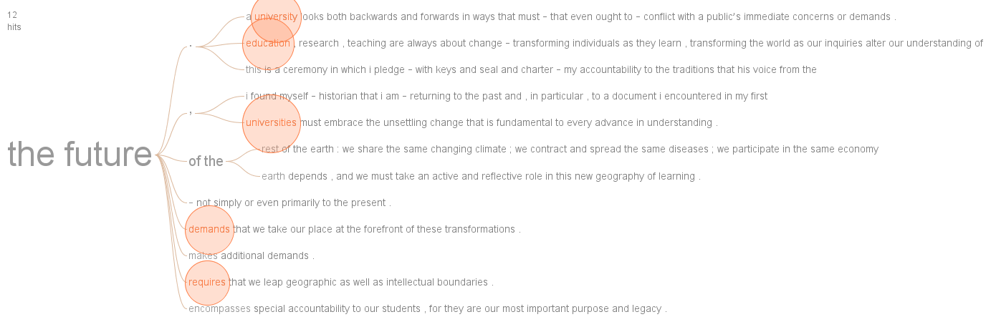

1. Again, I think that the Word Tree visualization best answers the question of what “we” must do. In this case Harvard must do many things including ensuring that talented students are able to attend and afford higher education, provide resources and organize accordingly for that education, as well as be accountable to each other. The visualization below really provides the full answer to this question in a very compelling way.

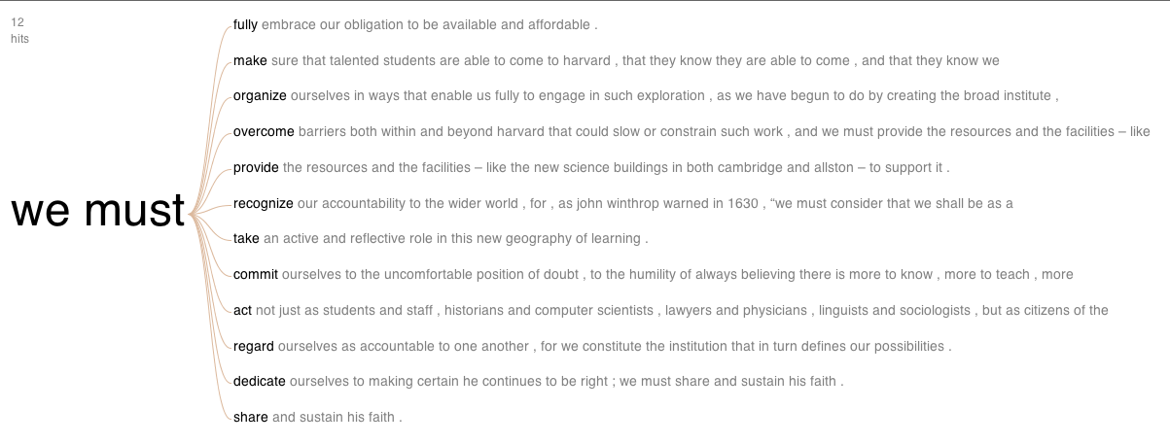

**Part B**

1. In the data sample Washington State produced the most apples and Delaware produced the least amount (zero). This is clearly visible in the grouped bar chart visualization below. I chose this grouped bar chart instead of a line graph because of the number of data points. Presenting all states for all years on a line graph would have been very difficult to read. The chart below gives the answer at a quick glance.

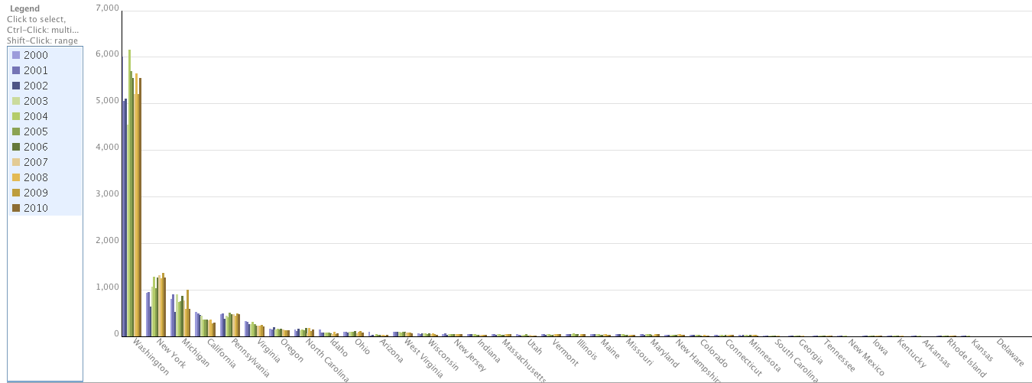

1. Using a line graph it is easy to see whether production increased or decreased for a particular state. Many Eyes has the ability to show all states at once, however the data becomes too confused with all states on one graph. As an example I’ve shown a graph below showing Wisconsin and West Virginia, both showing a decline in production.

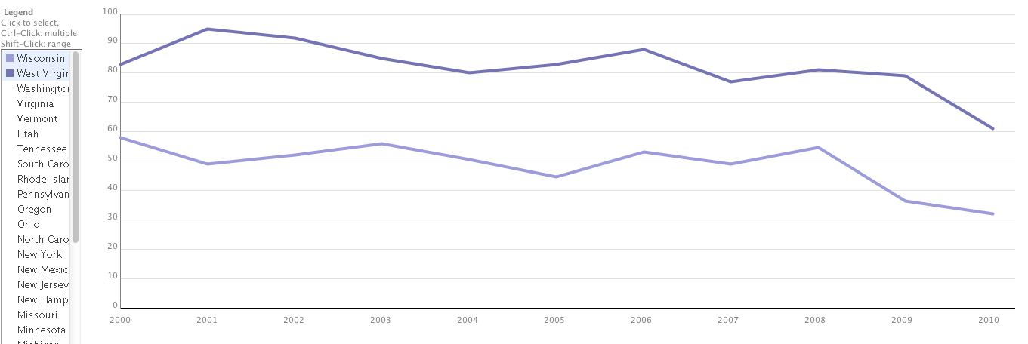

The following states show a decrease in production:

Arizona, Arkansas, California, Colorado, Georgia, Idaho, Indiana, Iowa, Kansas, Kentucky, Maine, Massachusetts, Michigan, Minnesota, Missouri, New Hampshire, New Jersey, New Mexico, North Carolina, Ohio, Oregon, South Carolina, Tennessee, Utah, Vermont, Virginia, Washington, West Virginia, Wisconsin

The following states show an increase in production:

Connecticut, Illinois, Maryland, New York, Rhode Island

Pennsylvania remained largely unchanged.

**Part C**

1. There are several levels where there are significant jumps in income depending on the category being measured, but the biggest benefit comes with the attainment of a Professional degree. As can be seen in the grouped bar chart below the Professional degree imparts a significant income benefit (in the categories it is measured in).

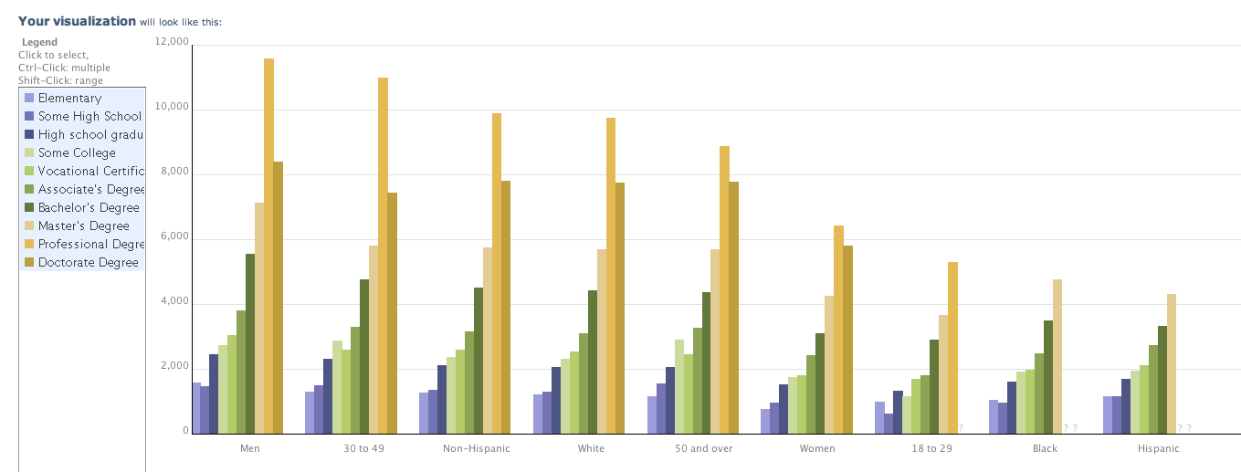

1. There is a definite disparity between genders across all educational levels, with the greatest disparity at the Professional degree level as can be seen below. The grouped bar chart below allows for a quick comparison of the values.

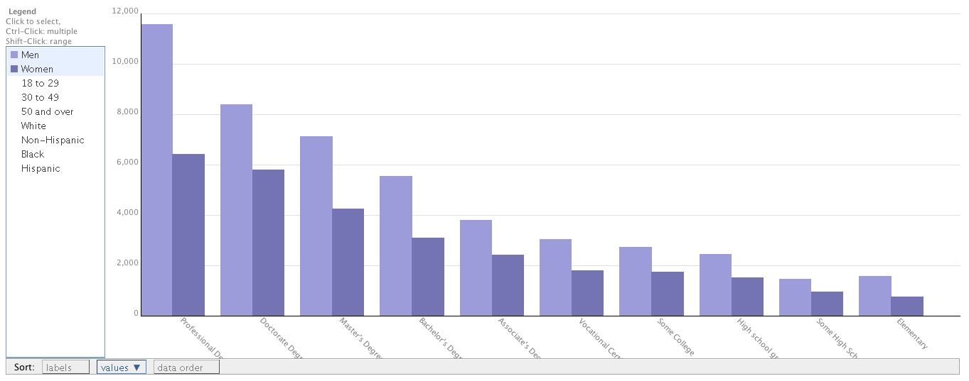

There are also income disparities between races, though not as great as with gender. In all levels of education, where data is present, Black and Hispanic races show lower income levels than White and Non-Hispanics. Again, a grouped bar chart quickly allows the user to compare the differences in data for the different races.

