1. For this question I have chosen Yahoo maps and Bing Maps.
   1. Bing Maps definitely promotes an easier search for buildings. The Yahoo Maps have the campus for Harvard University shaded slightly darker, but they do not provide enough contrast to the regular background to be immediately discernible. Also, the Yahoo maps, even at a high zoom level, do not display the names of all the buildings. Finally the buildings on the Yahoo Maps are barely distinct from the background color of the campus itself and only at a very high zoom level do you realize that the color for the buildings is just slightly different from the background.

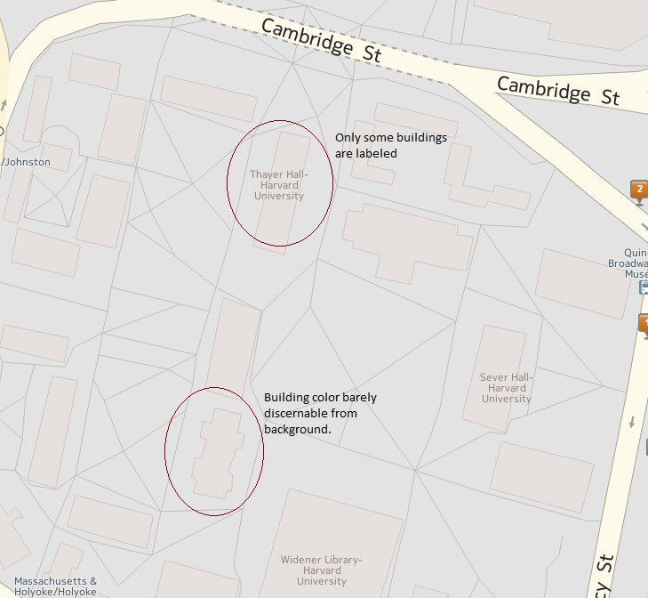

Figure 1: Yahoo Maps

Bing Maps on the other hand clearly outline the Harvard University buildings in a light purple color that ‘pops’ from the white background. Additionally if you hover over any of the Harvard University buildings on the map all Harvard University buildings are highlighted by being outlined with a black line instantly giving you a clear picture of the entire campus. Zooming in to a sufficient level also presents all the names of the buildings. The only odd thing about the Bing Maps is that at a high zoom level the purple shading of the buildings does not line up with the 3D image of the building.

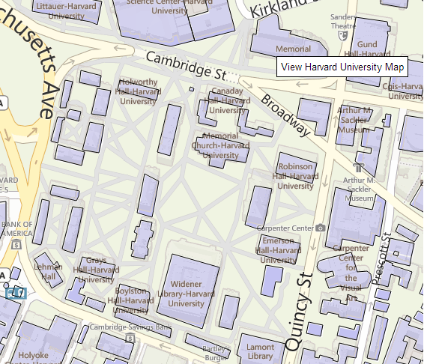

Figure 2: Bing Maps

* 1. Both maps do a decent job of highlighting a route from Fenway Park to Widener Library. The route on the map for both Yahoo and Bing is clearly highlighted with a thick line indicating the strength of the relationship between the starting and end points. I think that the Bing Map does a better job though because the starting point and end points are different colors unlike on the Yahoo Map.

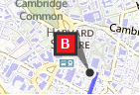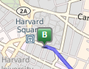

Figure 3: Bing Map and Yahoo Map End Points

* 1. Overall the Bing Map employs better visualization. As Ware states “there are two primary task supported by color in maps.”[1] The first is to allow people to perceive patterns, which the Bing Map does very well, with the outlining of buildings through the use of the black-white channel (black outline). The second task is quantitative and the Bing Map also does this well in its direction finding with the use of a red end point marker. This ‘pops’ the marker element off the page. Another example, such as the building colors also pop off the map.

Features such as different class roads (highway vs. secondary) are distinct through the use of different colors. The Yahoo Map does highlight highways, but the pale yellow color for smaller roads and white for back roads blends into the white background and makes it difficult to follow. The Bing Map also uses yellow for secondary roads, but the hue is not so pale that is blends into the background. The Bing Map also does a good job of labeling major streets even when zoomed out, unlike the Yahoo Map.

Additionally the Bing Map does a better job of having the important elements use high saturation (building color and roads) with the larger background areas being lighter in hue with low saturation.[2] The Yahoo Maps do not do a good job of using high saturation. For example the building colors blend into the background.

1. For the rainbow color map visualization I chose the following: <http://www.isgtw.org/visualization/dear-nasa-no-more-rainbows-please>
   1. The visualization’s objective is to show elevation in meters for an image of the far side of the Moon. The audience would be anyone interested in astronomy or the Moon. The graphic does a poor job of conveying the elevation of the surface of the Moon. The gradations of the coloring are meant to show ordering from low to high, however the colors of the rainbow have no perceptually inherent order.[3] Details are obscured with rainbow color maps and sharp transitions are also inadvertently introduced between the colors. In the image below it appears that there are sharp differences in elevation between the different colors instead of a steady progression. There is no good reason for this choice of color scheme.

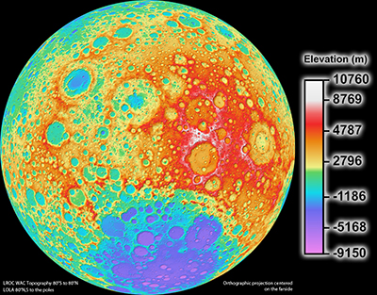

* 1. An alternative to the rainbow color map above would be an isoluminant color map where the elevation could be represented going from gray to red (or green).[4] An image such as the one below from the CDCconveys much more detail in terms of elevation than does the Nasa map above. **[5]**

The higher elevations are clearly represented by a darker red color and there are no sharp transitions between the different elevations.

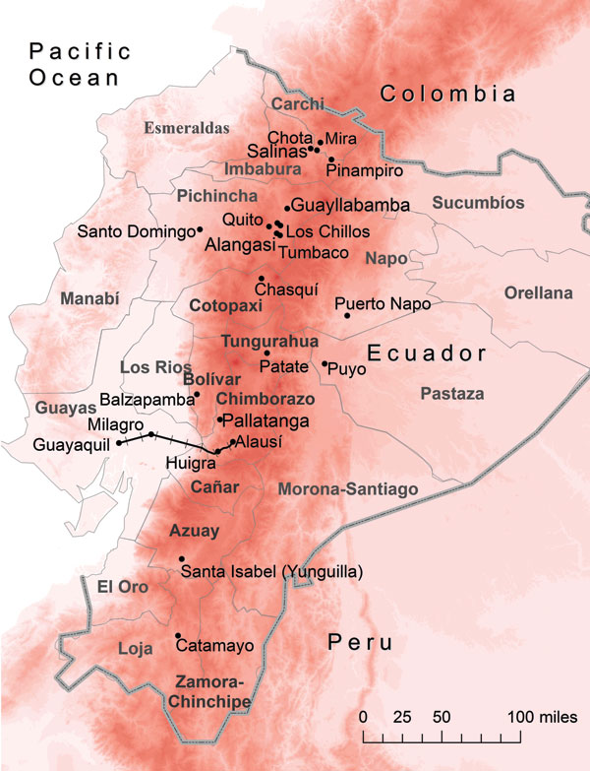

Figure 4: Isoluminant Color Map showing elevation

1. Colin Ware, *Visual Thinking for Design* (Morgan Kaufmann, 2008), 81.
2. Ware, *Visual Thinking for Design,* 79.
3. David Borland and Russell M. Taylor II, “Rainbow Color Map (Still) Considered Harmful,” editor Theresa-Marie Rhyne, *Visualization Viewpoints*, 2007, 14.
4. Borland and Taylor II, “Rainbow Color Map (Still) Considered Hamful,” 17.
5. # Lauren L. Pinault and Fiona F. Hunter, “Malaria in Highlands of Ecuador since 1900,” *Centers for Disease Control and Prevention,* 2012, accessed February 20, 2013, http://wwwnc.cdc.gov/eid/article/18/4/11-1267-f1.htm

  