1. At a high level, what is the purpose of HTML and CSS? How do the two differ?

HTML is meant for displaying content and to give it structure. CSS is meant for presenting that content with a defined style and appearance.

1. What is the purpose of assigning a "class" to an HTML element? What is the difference between a "class" and an "id"? How would one select a division (div) element with class "box" using CSS?

The class attribute allows for the application of a CSS style to an array of HTML elements. Class attributes can be applied to multiple HTML elements. ID attributes, or selectors, can only be applied to one unique element at a time. To select a div element with a class ‘box’ the syntax would be:

div.box {

…

}

1. List 5 different HTML elements and provide a short description of the function of each.

* **h1**: a block level element (one of six) that help users read a page by calling out a key identifier.
* **p**: defines a paragraph of text . Space is usually added around each p element, though this can be modified with CSS.
* **a**: an inline element that defines a hyperlink. The href attribute sets the URL or email address the link goes to. In HTML5 the a element is always a hyperlink. In HTML 4.01 it can also be used as an anchor.
* **br:** defines a line break.
* **header:** a HTML5 element that specifies a heading section for a document. Usually contains introductory text or navigational links. More than one header is allowed per document.

1. What is the difference between margin and padding?

Both margin and padding apply space to improve the legibility of elements. The main difference is that the margin is on the ‘outside’ of the element and padding adds space to the inside of the element. In the image below the element would consist of the gray and blue boxes. The border of the element is the thick black outline around the blue box.

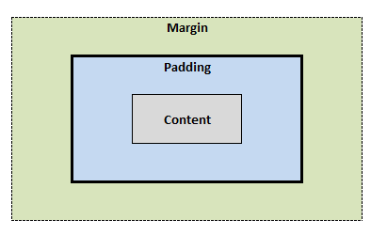

1. Consider the Gmail Inbox interface. How is the site functionally divided? Create a nested list representing this functional division. Don't worry about extremely fine details; this should help you start:

page

top bar

links to Google sites

header bar

Google logo

search field

search button

user name, share button, user button

sub-header bar

Gmail/Contacts/Tasks button

Select, refresh, more buttons, paging, tools

Left navigation

Compose button

Email folders

Contacts

Center pane

Ad banner

Email listing

Checkbox

Star

From

Subject

Date/Time

Footer

Ad banner

Usage data

Google Terms & Privacy

Account activity