1. According to Bostock et. al., what are the primary advantages of D3? Based on your reading of the article, please provide an example of a type of visualization that would be easier and better implemented in D3 as opposed to HTML5, JSON, and Javascript. Please list the pros and cons of choosing D3 over pure HTML5, JSON and Javascript.

According to Bostock et. al. the main advantages of D3 are many. Compatibility with existing toolsets is the first, followed by the ease of debugging in D3 mostly through the use of immediate evalulation. Another benefit of D3 is its animation and interactivity performance, though it was found that flash animations did have a higher frame rate with larger data sets. Many of these advantages are due to D3’s mapping of data attributes to the DOM (Document Object Model) as well as the fact that D3 is a domain specific language, which allows the creators of D3 to focus specifically on the visualization problem space. D3 also allows for easy transformation of the DOM and its use of native representation (namely SVG) means that the selections are easily retrieved from the document which makes the modification of the document simpler.

A visualization that would lend itself to D3 would be a dynamic graphic that was animated allowing for user interactivity. Coding this type of behavior with just HTML, CSS and JSON would be much more troublesome. The cons of using D3 are mainly that the user would need to learn a new tool and language.

1. Of the visualization figures presented in Heer et. al., which do you find the most difficult to comprehend? Does the complexity of the figure interfere with the goal of visualization as described in the article? Include a screenshot of the figure you have chosen in your response and use principles that you have learned so far (i.e., from design, perception, and cognition) to justify your choice.

The visualization that is the most difficult to understand, for me, is the horizon graph showing U.S. Unemployment rate. I think the complexity of the graph does interfere with the task of what the visualization is trying to convey. While it is possible to understand that this is showing data over time, it is not clear what data is being shown, especially as more bands are added. There are five different graphs, but it is really unknown what they are trying to show. I found that the previous two graphs showing the same unemployment information were much easier to understand.

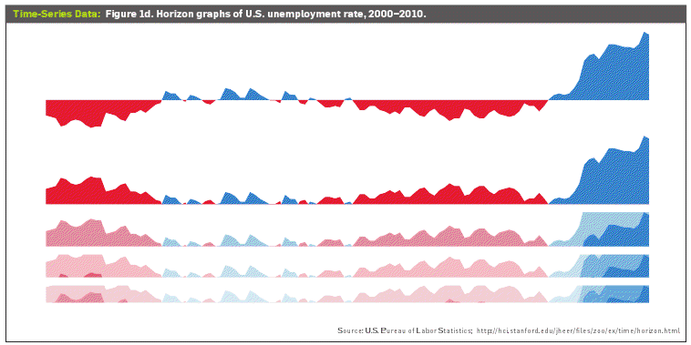

1. Play around with the interactive [graphs included in the Heer article](http://queue.acm.org/detail.cfm?id=1805128). You need to  open this page in a browser that runs Java. Focus on Figure 1A. To what extent do interactivity and transitions, elements that D3 optimizes, add to the clarity and message of the visualization? With the element of interactivity in mind, redesign and sketch the contents of figure 1A with one of the other visualization types described in the Heer article. Include a picture of a sketch of your idea, and describe how it supports comprehension and data exploration.

The ability to move the time line allows for the user to explore the stock prices as they change through time. This really allows the person viewing the data to have a much richer experience than if the visualization were just static through a shorter range of time. One thing that I do not like about the visualization is that the scale of the graph moves around which makes it difficult to see an overall picture, however it does allow the user to get a very good idea of how the stock prices compare over a given month.

This same data could also be encoded as a series of small multiples as shown below. Each stock value could have its own line graph with a slider control that would move the data through time. Each graph would update with new data as the slider was moved. Encoding this as small multiples would allow for the separation of the data so there would be fewer overlapping lines, but also allow for easy comparison due to the proximity of the graphs.