1. How can D3 access and change the DOM?  What do select and selectAll do?

D3 allows you to bind data to the DOM and through the select and selectAll it is possible to modify the DOM to apply data driven transformations. Select will select an element for manipulation, either style, attributes or properties. SelectAll will select *all*  of a particular element (i.e.: the paragraph tag) in a document and modify the style, attributes or properties of all the selected elements.

1. What are the d and i in function(d){} and function(d, i){} ?

The d refers to the data being bound, for example, in an array or other data structure. The i is an optional argument and refers to the index (zero based) of the element within its selection.

1. Write sample lines of JavaScript to add a div element with class “barChart1” and to add an svg element with class “barChart2” with square dimensions.

**var** data = [4, 8, 15, 16, 23, 42];

*// barChart1*

**var** divX = d3.scale.linear()

.domain([0, d3.max(data)])

.range(["0px", "420px"]);

**var** barChart1 = d3.select("body").append("div")

.attr("class", "barChart1");

barChart1.selectAll("div")

.data(data)

.enter().append("div")

.style("width", divX)

.style("height", "15px");

*// barChart2*

**var** barChart2 = d3.select("body").append("svg")

.attr("class", "barChart2")

.attr("width", 420) // square

.attr("height", 420); // dimensions

**var** svgX = d3.scale.linear()

.domain([0, d3.max(data)])

.range([0, 420]);

**var** svgY = d3.scale.ordinal()

.domain(data)

.rangeBands([0, 120]);

barChart2.selectAll("rect")

.data(data)

.enter().append("rect")

.attr("y", svgY)

.attr("width", svgX)

.attr("height", 20);

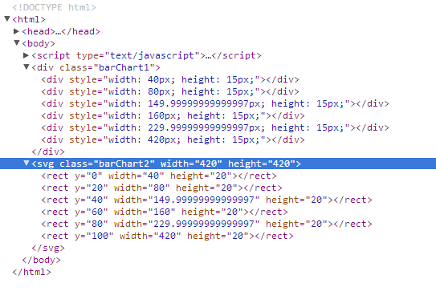

1. Describe append, update, enter, and exit at a high level.  What does “*selectAll + data + enter + append*” refer to?
   * **append**: appends or creates elements in the DOM
   * **update**: updates existing elements in the DOM
   * **enter**: allows data to enter to the “stage” by pairing a new element for all unmatched data items. Serves as a placeholder for data elements where no existing DOM element exists.
   * **exit**: exits, or removes, data elements from the “stage” (DOM) for which no new data element was found.

The “*selectAll + data + enter + append”* is a very common pattern in D3 and is used to add elements to the DOM where no existing elements previously existed. In this case all of the desired elements are selected (selectAll), the data is bound (data), since there are no existing elements the data enters up in the enter statement (enter) and finally added to the DOM (append).

1. What are the main differences between drawing a bar chart with HTML and SVG?

Because SVG is vector based you can rescale the images without losing image quality as you would with a HTML div image. SVG also allows for the use of percentages for relative positioning. Another difference is that SVG elements are positioned in the top left corner so the y coordinates and height need to be set. Other minor differences include changes with CSS and units being automatically set in pixels.

1. In drawing the simple bar chart with D3 and SVG, what elements were appended, and to what parts of the graph did these element correspond?

The <rect> elements were appended to the <svg> element and these corresponded to the horizontal bars in the graph.