# Section A:

## 1.

* Reduces / removes data duplication (due to relations established)
* Easy to access data as it is setup in a tree structure
* There is a high level of data integrity as each row follows its table structure, so all data can be used
* Flexibility and is easy to grow or shrink your data base
* Ability to implement new tables without effecting existing data

## **2.**

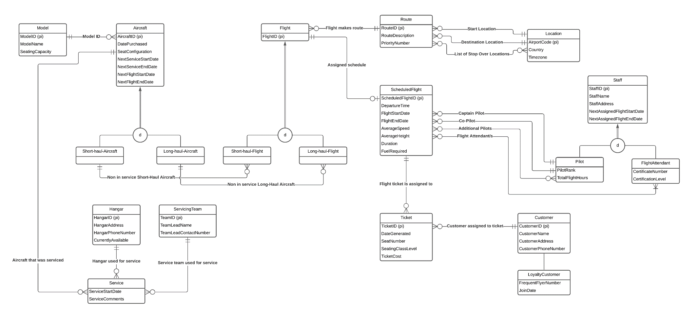

**Assumptions**:

* Service teams are not Dracarys Airlines staff and are not sub-types of Staff (3rd party company)
* When a Flight is created, it will choose a Route, then create a ScheduledFlight, then assign Aircraft to Flight through Flight sub-type (ORDERING IS IMPORTANT SO ALL DATA IS THERE FOR DECISION MAKING)
* Assigned dates included for staff for decision making around availability when assigning new flights
* ScheduledFlight dates must be created before assigning Staff and Aircraft for availability
* Flight start and end date kept in linked ScheduledFlight, this is used to determine assigned Aircraft

**Constraints**:

* Total Disjoint - SUPER: Aircraft, SUB: (Short-haul-Aircraft & Long-haul-Aircraft)
* Total Disjoint - SUPER: Flight, SUB: (Short-haul-Flight & Long-haul-Flight)
* Total Disjoint - SUPER: Staff, SUB: (Pilot & FlightAttendant)

These constraints exist as an entity of the super MUST be either of their sub types but NOT BOTH.

* Partial Disjoint – SUPER: Customer, SUB: LoyaltyCustomer

This constrain exists as a Customer entity can be a LoyaltyCustomer, but is NOT REQUIRED.

**Examples**:

* Flight
  + FlightID (PK): QF346
  + Route (FK): R534
  + ScheduledFlight (FK): SF375932
  + AssignedAircraft (FK): GH6579 (ASSIGNED BASED ON AIRCRAFT AVAILABILITY, FLIGHT TYPE, AND FLIGHT DATES)
* ScheduledFlight
  + ScheduledFlight (PK): SF375932
  + DepartureTime: 11 PM
  + FlightStartDate: 07/11/2021
  + FlightEndDate: 09/11/2021
  + AverageSpeed: 1000 KM/H
  + AverageHeight: 30000 ft
  + Duration: 37 Hours
  + FuelRequired: 20KL
  + FlightID (FK): QF346
  + AssignedAircraft (FK): GH6579
  + Captain (FK): SID4057
  + Co-Pilot (FK): SID4033
  + AdditionalPilots (FK): null
  + FlightsAttendants (FK): { SID3037, SID4999 }

## 3.

**Step 1 (Strong Entities):**

* MODEL (**ModelID (PK)**, ModelName, SeatingCapacity)
* AIRCRAFT (**AircraftID (PK)**, DatePurchased, SeatConfiguration, NextServiceStartDate, NextServiceEndDate, NextFlightStartDate, NextFlightEndDate)
* HANGAR (**HangarID (PK)**, HangarAddress, HangarPhoneNumber, CurrentlyAvailable)
* SERVICINGTEAM (**TeamID (PK)**, TeamLeadName, TeamLeadContactNumber)
* FLIGHT (**FlightID (PK)**)
* ROUTE (**RouteID (PK)**, RouteDescription, PriorityNumber)
* LOCATION (**AirportCode (PK)**, Country, Timezone)
* SCHEDULEDFLIGHT (**ScheduledFlightID (PK)**, DepartureTime, FlightStartDate, FlightEndDate, AverageSpeed, AverageHeight, Duration, FuelRequired)
* TICKET (**TicketID (PK)**, DateGenerated, SeatNumber, SeatingClassLevel, TicketCost)
* CUSTOMER (**CustomerID (PK)**, CustomerName, CustomerAddress, CustomerPhoneNumber)
* STAFF (**StaffID (PK)**, StaffName, StaffAddress, NextAssignedFlightStartDate, NextAssignedFlightEndDate)

**Step 2 (Weak Entities):**

* There are NO Weak Entities

**Step 3 (1:1 Relationships):**

* SCHEDULEDFLIGHT (**ScheduledFlightID (PK)**, DepartureTime, FlightStartDate, FlightEndDate, AverageSpeed, AverageHeight, Duration, FuelRequired, **FlightID (FK)**)

**Step 4 (1:N Relationships):**

* AIRCRAFT (**AircraftID (PK)**, DatePurchased, SeatConfiguration, NextServiceStartDate, NextServiceEndDate, NextFlightStartDate, NextFlightEndDate, **ModelID (FK)**)
* SERVICE (ServiceStartDate, ServiceComments, **AircraftID (FK), HangarID (FK), TeamID (FK)**)
* FLIGHT (**FlightID (PK), AircraftID (FK), RouteID (FK)**)
* ROUTE (**RouteID (PK)**, RouteDescription, PriorityNumber, **StartLocation (FK), DestinationLocation (FK)**)
* SCHEDULEDFLIGHT (**ScheduledFlightID (PK)**, DepartureTime, FlightStartDate, FlightEndDate, AverageSpeed, AverageHeight, Duration, FuelRequired, **CaptainID (FK), CoPilotID (FK)**)
* TICKET (**TicketID (PK)**, DateGenerated, SeatNumber, SeatingClassLevel, TicketCost, **ScheduledFlightID (FK), CustomerID (FK)**)

**Step 5 (M:N Relationships):**

* ADDITIONAL PILOTS (**StaffID (PK, FK), ScheduledFlightID (PK, FK)**)
* FLIGHT ATTENDANT/S (**StaffID (PK, FK), ScheduledFlightID (PK, FK)**)
* LIST OF STOP OVER LOCATIONS (**RouteID (PK, FK), AirportCode (PK, FK)**)

**Step 6 (Multi-valued Attributes):**

* There are NO Multi-valued attributes

**Step 7 (Associative Entities):**

* SERVICE (**AircraftID (FK), HangarID (FK), TeamID (FK)**, ServiceStartDate, ServiceComments)

**Final List**:

* MODEL (**ModelID (PK)**, ModelName, SeatingCapacity)
* AIRCRAFT (**AircraftID (PK)**, DatePurchased, SeatConfiguration, NextServiceStartDate, NextServiceEndDate, NextFlightStartDate, NextFlightEndDate, **ModelID (FK)**)
* HANGAR (**HangarID (PK)**, HangarAddress, HangarPhoneNumber, CurrentlyAvailable)
* SERVICINGTEAM (**TeamID (PK)**, TeamLeadName, TeamLeadContactNumber)
* FLIGHT (**FlightID (PK), AircraftID (FK), RouteID (FK)**)
* ROUTE (**RouteID (PK)**, RouteDescription, PriorityNumber, **StartLocation (FK), DestinationLocation (FK)**)
* LOCATION (**AirportCode (PK)**, Country, Timezone)
* SCHEDULEDFLIGHT (**ScheduledFlightID (PK)**, DepartureTime, FlightStartDate, FlightEndDate, AverageSpeed, AverageHeight, Duration, FuelRequired, **FlightID (FK), CaptainID (FK), CoPilotID (FK)**)
* TICKET (**TicketID (PK)**, DateGenerated, SeatNumber, SeatingClassLevel, TicketCost, **ScheduledFlightID (FK), CustomerID (FK)**)
* CUSTOMER (**CustomerID (PK)**, CustomerName, CustomerAddress, CustomerPhoneNumber)
* STAFF (**StaffID (PK)**, StaffName, StaffAddress, NextAssignedFlightStartDate, NextAssignedFlightEndDate)
* ADDITIONAL PILOTS (**StaffID (PK, FK), ScheduledFlightID (PK, FK)**)
* FLIGHT ATTENDANT/S (**StaffID (PK, FK), ScheduledFlightID (PK, FK)**)
* LIST OF STOP OVER LOCATIONS (**RouteID (PK, FK), AirportCode (PK, FK)**)
* SERVICE (**AircraftID (FK), HangarID (FK), TeamID (FK)**, ServiceStartDate, ServiceComments)

**Step 8A (Superclass and Subclasses):**

* AIRCRAFT **(AircraftID (PK),** DatePurchased, SeatConfiguration, NextServiceStartDate, NextServiceEndDate, NextFlightStartDate, NextFlightEndDate)
* SHORT-HAUL-AIRCRAFT **(AircraftID (PK))**
* LONG-HAUL-AIRCRAFT **(AircraftID (PK))**

**Step 8B (Just Subclasses):**

* SHORT-HAUL-AIRCRAFT **(AircraftID (PK),** DatePurchased, SeatConfiguration, NextServiceStartDate, NextServiceEndDate, NextFlightStartDate, NextFlightEndDate)
* LONG-HAUL-AIRCRAFT **(AircraftID (PK),** DatePurchased, SeatConfiguration, NextServiceStartDate, NextServiceEndDate, NextFlightStartDate, NextFlightEndDate)

## 4.

Given that the table here is already 1NF. PKs are StudentID, CourseID and EnrolDate.

**StudentID (PK, FK), CourseID (PK, FK), EnrolDate (PK) ->** StudentName, StudentGPA, CourseName, CourseDept

3 Tables:

**StudentID ->**

# Section B:

## 1.

SELECT aircraftid, aircraftpurdate

FROM aircraft a

WHERE a.aircraftseatcap > 150 AND (

MONTH(a.aircraftpurdate) = 10

OR

EXTRACT(YEAR FROM a.aircraftpurdate) = 2014

OR

EXTRACT(YEAR FROM a.aircraftpurdate) = 2015

OR

EXTRACT(YEAR FROM a.aircraftpurdate) = 2016)

ORDER BY a.aircraftseatcap DESC;

## 2.

SELECT a.aircraftid

FROM aircraft a JOIN aircrafttype a_type

USING(aircrafttypeid)

WHERE a_type.aircrafttypename = 'Airbus';

## 3.

SELECT DISTINCT a.aircraftid, a_type.aircrafttypename

FROM aircraft a JOIN aircrafttype a_type JOIN service s

ON a_type.aircrafttypeid = a.aircrafttypeid AND a.aircraftid = s.aircraftid AND s.hangarid = 'H4'

ORDER BY a_type.aircrafttypename;

## 4.

**-- ASSUMPTION Q3 REFERS TO AUSTRALIAN FINANCIAL YEAR Q3 (i.e. JAN, FEB, MAR)**

SELECT s.*

FROM service s

WHERE EXTRACT(YEAR FROM s.servicedate) = 2019

AND

(EXTRACT(MONTH FROM s.servicedate) >= 1 AND EXTRACT(MONTH FROM s.servicedate) <= 3)

AND

hangarid IN (

SELECT hangarid

FROM hangar h

WHERE h.hangarlocation = 'NSW'

);

## 5.

**-- ASSUMPTION Q3 REFERS TO AUSTRALIAN FINANCIAL YEAR Q3 (i.e. JAN, FEB, MAR)**

SELECT s.*

FROM service s JOIN hangar h

USING(hangarid)

WHERE EXTRACT(YEAR FROM s.servicedate) = 2019

AND (EXTRACT(MONTH FROM s.servicedate) >= 1 AND EXTRACT(MONTH FROM s.servicedate) <= 3)

AND h.hangarlocation = 'NSW';

## 6.

SELECT st.teamid, st.teamlevel, COUNT(st.teamid) AS 'number of services'

FROM serviceteam st

LEFT JOIN service s

ON st.teamid = s.teamid AND (st.teamlevel = 1 OR st.teamlevel = 3)

GROUP BY st.teamid

HAVING COUNT(st.teamid) < 4

ORDER BY COUNT(st.teamid) DESC;

## 7.

SELECT COUNT(s.serviceid)

FROM service s JOIN aircraft a

USING(aircraftid)

WHERE EXTRACT(YEAR FROM a.aircraftpurdate) > 2017 OR a.aircraftseatcap != 104;

# Section C:

## 1.