Title： | System Requirements Documents

Project: |  | Model:
Stage: |  | Doc ID:
OEM： |  | Platform：
Doc Version: |  | Doc Status:

Prepared by
Role | Name | Department | Date
Approved by
Role | Name | Department | Date

Document History
Version | Status | Date | Document Owner | Department | Changes
Table of Contents 目录
1 Document Information文档信息 8
1.1 Purpose of the document文档目的 8
1.2 Scope of the document文档范围 8
1.3 Acronyms, Abbreviations, Terminology缩略词术语 8
1.3.1 Abbreviation 缩略词 8
1.3.2 Term术语 9
2 System Overview系统概述 10
2.1 System Function系统功能描述 10
2.2 System Block Diagram 系统框图 11
2.3 Operational environment运行环境 11
2.3.1 Operation System 操作系统 11
2.3.2 Voltage Requirement 电压要求 12
2.3.3 Temperature Requirement 温度要求 12
2.3.4 Parameter Tolerances 参数容差 12
2.4 System Assumptions系统假设 12
2.5 Consideration of alternative options for the design对设计的替代选择的考虑 13
3 System requirements 系统需求 14
3.1 IR Intial Requirement Input IR初始需求输入 14
3.2 Use Case System Requirements Analysis UC系统需求分析 14
3.2.1 Display 显示 14
3.2.2 Power Management 电源管理 15
3.2.3 Interaction 触控 16
3.2.4 Dimming 亮度的控制 17
3.2.5 Diagnose 诊断 18
3.3 Functional Process Analysis 功能过程分析 19
3.3.1 Display Process 显示功能过程 19
3.3.2 Interaction Process 触控功能过程分析 20
3.3.3 Dimming Process 亮度控制功能过程分析 21
3.3.4 Diagnose Process 诊断功能过程分析 23
4 Functional Requirements功能需求 25
4.1 Power Management 25
4.1.1 Sleep [SyRD-FUNC-Power-0001] 25
4.1.2 Wakeup [SyRD-FUNC-Power-0002] 25
4.1.3 Normal [SyRD-FUNC-Power-0003] 26
4.1.4 State Transitions [SyRD-FUNC-Power-0004] 26
4.2 Interaction 28
4.2.1 Touch [SyRD-FUNC-Input-0002] 28
4.2.2 Slider [SyRD-FUNC-Input-0003] 28
4.2.3 HWR [SyRD-FUNC-Input-0003] 29
4.3 Dimming 29
4.3.1 Display illumination [SyRD-FUNC-Dimming-0001] 29
4.4 I2C 30
4.4.1 I2C Network topology [SyRD-FUNC-I2C-0001] 30
4.4.2 OTA via I2C[SyRD-FUNC-I2C-0002] 31
4.5 Diagnose 32
4.5.1 Diagnostic Table [SyRD-FUNC-Diagnose-0001] 32
4.5.2 电池电压检测 [SyRD-FUNC-Diagnose-0002] 34
4.5.3 背光温度检测 [SyRD-FUNC-Diagnose-0003] 37
5 System prototype系统原型 40
5.1 Physical Prototype 物理原型 40
5.1.1 Appearance Requirements外观要求 40
5.1.1.1 Panel Style [SyRD-PROTOTYPE-0001] 40
5.1.1.2 CSD Size [SyRD-PROTOTYPE-0002] 41
5.1.1.3 CSD Weight [SyRD-PROTOTYPE-0003] 41
5.1.1.4 几何&外观质量 [SyRD-PROTOTYPE-0004] 41
5.1.1.5 外观主要缺陷 [SyRD-PROTOTYPE-0005] 42
5.1.1.6 外观次要缺陷 [SyRD-PROTOTYPE-0006] 43
5.1.2 材料要求 44
5.1.2.1 原材料要求 [SyRD-PROTOTYPE-0007] 44
5.1.3 显示屏触控需求 45
5.1.3.1 触控技术选择 [SyRD-PROTOTYPE-0008] 45
5.1.3.2 标准触摸位置 [SyRD-PROTOTYPE-0009] 46
5.1.3.3 最小可检测对象[SyRD-PROTOTYPE-0010] 46
5.1.3.4 触摸报告检查[SyRD-PROTOTYPE-0011] 47
5.1.3.5 触摸一致性性能[SyRD-PROTOTYPE-0012] 47
5.1.3.6 鬼点[SyRD-PROTOTYPE-0013] 48
5.1.3.7 灰尘抑制[SyRD-PROTOTYPE-0014] 48
5.1.3.8 手套支持[SyRD-PROTOTYPE-0015] 49
5.1.3.9 长指甲支持[SyRD-PROTOTYPE-0016] 50
5.1.3.10 触控报点率[SyRD-PROTOTYPE-0017] 50
5.1.3.11 过点触控[SyRD-PROTOTYPE-0018] 51
5.1.3.12 多点触控[SyRD-PROTOTYPE-0019] 51
5.1.3.13 手指分开距离[SyRD-PROTOTYPE-0020] 52
5.1.3.14 单点触摸报告延迟[SyRD-PROTOTYPE-0021] 53
5.1.3.15 多点触摸报告延迟[SyRD-PROTOTYPE-0022] 53
5.1.3.16 多触点定位精度[SyRD-PROTOTYPE-0023] 54
5.1.3.17 单线精度[SyRD-PROTOTYPE-0024] 55
5.1.3.18 单弧精度[SyRD-PROTOTYPE-0025] 56
5.1.3.19 双弧精度[SyRD-PROTOTYPE-0026] 58
5.1.3.20 触摸空间抖动[SyRD-PROTOTYPE-0027] 58
5.1.3.21 触摸时抖动[SyRD-PROTOTYPE-0028] 59
5.1.4 Lighting Requirements灯光要求 59
5.1.4.1 显示亮度均匀性 [SyRD-PROTOTYPE-0029] 59
5.1.4.2 显示亮度可调性 [SyRD-PROTOTYPE-0030] 60
5.1.4.3 强光可视性 [SyRD-PROTOTYPE-0031] 60
5.1.4.4 高温保护策略 [SyRD-PROTOTYPE-0032] 61
5.1.5 Display Requirements显示屏要求 62
5.1.5.1 光学要求 [SyRD-PROTOTYPE-0033] 62
5.1.5.2 摩尔条纹 [SyRD-PROTOTYPE-0034] 63
5.1.5.3 最佳观看方向 [SyRD-PROTOTYPE-0035] 63
5.1.5.4 水平显示视角 [SyRD-PROTOTYPE-0036] 64
5.1.5.5 无挡风玻璃反射 [SyRD-PROTOTYPE-0037] 64
5.1.5.6 显示颜色空间 [SyRD-PROTOTYPE-0038] 64
5.1.5.7 显示器gamma曲线 [SyRD-PROTOTYPE-0039] 65
5.1.5.8 显示闪烁 [SyRD-PROTOTYPE-0040] 65
5.1.5.9 像素切换时间 [SyRD-PROTOTYPE-0041] 66
5.1.5.10 输入延迟 [SyRD-PROTOTYPE-0042] 66
5.1.5.11 暗室对比度 [SyRD-PROTOTYPE-0043] 66
5.1.5.12 没有条带效果 [SyRD-PROTOTYPE-0044] 67
5.1.5.13 空间抖动噪音 [SyRD-PROTOTYPE-0045] 68
5.1.5.14 压力不均匀效应 [SyRD-PROTOTYPE-0046] 68
5.1.5.15 屏幕参数要求 [SyRD-PROTOTYPE-0047] 69
5.1.5.16 屏幕性能要求 [SyRD-PROTOTYPE-0048] 72
5.2 User Interface Prototype用户界面原型 76
6 Interface Requirements接口需求 77
6.1 Video Connector [SyRD-INTERFACE-0001] 77
6.2 Main Connector [SyRD-INTERFACE-0002] 77
6.3 Battery链路要求 [SyRD-INTERFACE-0003] 79
6.4 视频链路要求 79
6.4.1 视频干扰[SyRD-INTERFACE-0004] 79
6.4.2 视频传输损耗[SyRD-INTERFACE-0005] 80
6.4.3 视频时序[SyRD-INTERFACE-0006] 80
6.4.4 信息的提出[SyRD-INTERFACE-0007] 80
6.4.5 Erroneous Video Signals错误的视频信号[SyRD-INTERFACE-0008] 81
7 Design Constraints 设计约束 82
7.1 芯片选型 [SyRD-Constraints-0001] 82
7.2 电气性能要求 [SyRD-Constraints-0002] 82
7.3 EMC电磁兼容性要求 [SyRD-Constraints-0003] 83
7.4 电平衡仿真要求[SyRD-Constraints-0004] 85
7.5 人机及座椅舒适性[SyRD-Constraints-0005] 86
7.6 安全设计要求[SyRD-Constraints-0006] 87
8 Quality Requirements质量需求 89
8.1 Performance 性能 89
8.1.1 Quiescent Current [SyRD-QUALITY-0001] 89
8.1.2 Wake Up To Normal Mode唤醒到正常模式 [SyRD-QUALITY-0002] 89
8.1.3 Operating Mode 操作模式[SyRD-QUALITY-0003] 90
8.1.4 Change Of Operating Mode工作模式改变[SyRD-QUALITY-0004] 91
8.1.5 Current Consumption - General 耗用电流-一般 [SyRD-QUALITY-0005] 91
8.2 Reliability 可靠性 93
8.2.1 System reliability [SyRD-QUALITY-0007] 93
8.2.2 Data storage [SyRD-QUALITY-0008] 93
8.3 Compatibility 兼容性 93
8.4 Functional Safety Requirement 功能安全需求 93
8.5 Cyber Security Requirements 网络安全需求 94
8.6 Maintainability 可维护性 94
8.6.1 Customer Upgrade [SyRD-QUALITY-0010] 94
8.7 Expandability可扩展性 94
8.8 Testability 可测试性 95
8.8.1 Test interface [SyRD-QUALITY-0011] 95
8.8.2 Trace port [SyRD-QUALITY-0012] 95
8.8.3 Internal fault code [SyRD-QUALITY-0013] 96
9 Implement Requirements实施需求 97
9.1 Verification and Validation 环境适应性要求 97
9.1.1 VOC&Odor /车内空气质量[SyRD-IMPLEMENT-0001] 97
9.1.2 Corrosion Protection/防腐[SyRD-IMPLEMENT-0002] 100
9.1.3 Aging/老化[SyRD-IMPLEMENT-0003] 102
9.1.4 Recyclability/回收 [SyRD-IMPLEMENT-0004] 108
9.1.5 Flame Retardance Requirement/阻燃要求 [SyRD-IMPLEMENT-0005] 112
9.1.6 Weight/轻量化 [SyRD-IMPLEMENT-0006] 113
9.2 NVH & Sealing NVH及密封性 114
9.2.1 NVH设计要求 [SyRD-IMPLEMENT-0007] 114
9.3 Verification and Validation 测试验证需求 118
9.3.1 Durability耐久性能 [SyRD-IMPLEMENT-0008] 118
9.3.2 DV/ECV性能验证 [SyRD-IMPLEMENT-0009] 120
9.3.3 PV性能验证[SyRD-IMPLEMENT-0010] 142
9.3.4 EMC test [SyRD-IMPLEMENT-0011] 148
9.4 Package Requirements 包装需求 [SyRD-IMPLEMENT-0012] 148
9.5 Production Requirements 生产需求 149
9.5.1 EOL Mode(TBC) 149
9.5.1.1 Read SW Information [SyRD-IMPLEMENT-0007] 149
9.5.1.2 Write and read HW version [SyRD-IMPLEMENT-0008] 151
9.5.1.3 Write and read product serial number [SyRD-IMPLEMENT-0009] 151
9.5.1.4 Write and read TFT Brightness value [SyRD-IMPLEMENT-0010] 152
9.5.1.5 Write and read Brightness Weight [SyRD-IMPLEMENT-0011] 152
9.5.1.6 Read ADC value [SyRD-IMPLEMENT-0012] 153
9.5.1.7 Read and clear IFC [SyRD-IMPLEMENT-0013] 153
9.5.1.8 Aging [SyRD-IMPLEMENT-0014] 154
9.5.1.9 Touch, slider and sensor key self-test [SyRD-IMPLEMENT-0015] 154
9.5.1.10 Write and read searching light Brightness value [SyRD-IMPLEMENT-0020] 155
9.5.1.11 Write and read searching light Weight [SyRD-IMPLEMENT-0021] 155
9.5.2 Offline burning [SyRD- IMPLEMENT-00xx] 156
9.6 Installation Requirements 安装需求 156
9.6.1 安装要求 [SyRD-IMPLEMENT-0013] 156
9.7 Adaptation Requirements 适配需求 158
9.7.1 标识和追溯要求 [SyRD-IMPLEMENT-0014] 158
9.7.2 车辆配置信息 [SyRD-IMPLEMENT-0015] 158
9.7.3 目标市场 [SyRD-IMPLEMENT-0016] 159
10 Special Characteristics 特殊特性 160
11 Legal constraints and Standards Compliance法律约束和标准遵从 164
11.1 Laws and Regulations法律法规[SyRD-LEGAL&STANDARDS-0001] 164
11.2 Standard Requirements标准要求[SyRD-LEGAL&STANDARDS-0002] 166
11.3 Authorization Requirements认证要求(TBC) 167
11.3.1 License [SyRD-LEGAL&STANDARDS-0003] 167
11.3.2 Process [SyRD-LEGAL&STANDARDS-0004] 168
11.3.3 CE certification [SyRD-LEGAL&STANDARDS-0005] 168
12 Related Documents 相关文档 168
12.1 Upstream documents上游文档 169
12.2 Reference documents参考文档 169
13 Traceability溯源性 170
13.1 Forward Traceability正向溯源 170
13.2 Backward Traceability逆向溯源 170
14 Template History模板历史 171

Document Information文档信息

Purpose of the document文档目的
The purpose of this document is to establish the identified system requirements to be satisfied by the system design. The system requirements are the input of software and hardware requirements. They are also intended to provide the basis for the system testing of the product.
本文档的目的是定义被识别到的系统需求，以满足系统设计。 系统需求是软件和硬件要求的输入。 它们还旨在为产品的系统测试提供基础。

Scope of the document文档范围
This document describes the system requirements for Geely 15.4inch display product, which includes the system functional requirements, prototype, interface, design constrains, quality requirements, implement requirements, legal constraints and standards compliance.
本文档描述了吉利15.4inch display产品的系统需求，包括系统的功能需求，原型，接口，设计约束，质量需求，实施需求以及法律法规和标准。

Acronyms, Abbreviations, Terminology缩略词术语

Abbreviation 缩略词
NO.  编号 | Abbreviation  缩略词 | Definition  定义
1 | CSD | Center Display | 显示屏
2 | CAN | Controller Area Network | 控制区域网络
3 | I2C | Inter Integrated Circuit | 内部集成电路
4 | DHU | Head Unit | 主机
5 | COG | Chip On Glass | 封装玻璃的IC
6 | SW | Software | 软件
7 | AUTOSAR | Automotive Open System Architecture | 汽车开发系统架构
8 | LVDS | Low-Voltage Differential Signaling | 低电压差分信号
9 | ICT | In-Circuit Test | 电路内检测
10 | PCB | Printed Circuit Board | 印刷电路板
11
12

Term术语
NO.  编号 | Term  术语 | Definition  定义
1 | D seat | Driver seat | 司机座位
2 | User | A generic term for a person (such as a driver or passenger) interacting with a feature. In a use case, the User is the human actor. | 与功能交互的人（例如驾驶员或乘客）的通用术语。 在用例中，用户是人类角色。

System Overview系统概述

System Function系统功能描述
The system to be developed consists of touch display which will be used by VW. The main features of the system are described in following table.
15.4中控显示屏，适配主机E04，实现通讯交互、图像显示、诊断反馈等功能;；
无MCU方案，车机平台软件不变，显示屏设计适配。
DHU compatibility主机兼容性
Requirement: The CSD and DHU must be compatible and support the specified functionality of each other completely.
要求：CSD 与主机需要相互兼容，相互能够完全的支持规定的功能。
CSD and DHU integration CSD与DHU集成
Requirement: Supplier shall investigate and propose solution of an integrated DHU and CSD solution that fulfill each ECU separate requirement.
要求：供应商需要了解，同时提供措施完成主机与CSD的集成，以满足ECU控制的要求.
Styling intent of CSD CSD的样式意图
The CSD cannot generate video on its own but rather rely on the DHU to supply it through an LVDS interface. Modern LVDS-chipsets support a bidirectional control channel using the same wires as the forward video channel. Using this embedded control channel to send temperature readings, brightness settings etc. reduces the number of contacts on the CSD to just one: LVDS .
CSD本身不能生成视频，而是依赖DHU通过LVDS接口提供视频，现代LVDS芯片组支持双向控制通道，使用与正向视频通道相同的电线。使用这种嵌入式控制通道发送温度读数、亮度设置等，将CSD上的接口数量减少到只有一个:LVDS。
A design intent for both variants should be to keep them as simple as possible. Reducing the number of parts in the video path should keep power consumption, temperatures at a low level.
变体的设计意图应该是使它们尽可能简单。减少视频路径中的部件数量应使功耗、温度保持在较低的水平。

Main Features | Overview
Power | System power state management
Touch | Capacitive touch on display
Slider | Volume and climate(temperature) control
Dimming | Display mode switch, searching light and display brightness adjustment
I2C | System supports communication with head unit
LVDS | FPD-LINK III between head unit and CSD, and transmitted via a 4-pin LVDS plug
Display | 15.4inch display, 2560*1600(16:10) resolution, AG+AR+AF coating

System Block Diagram 系统框图
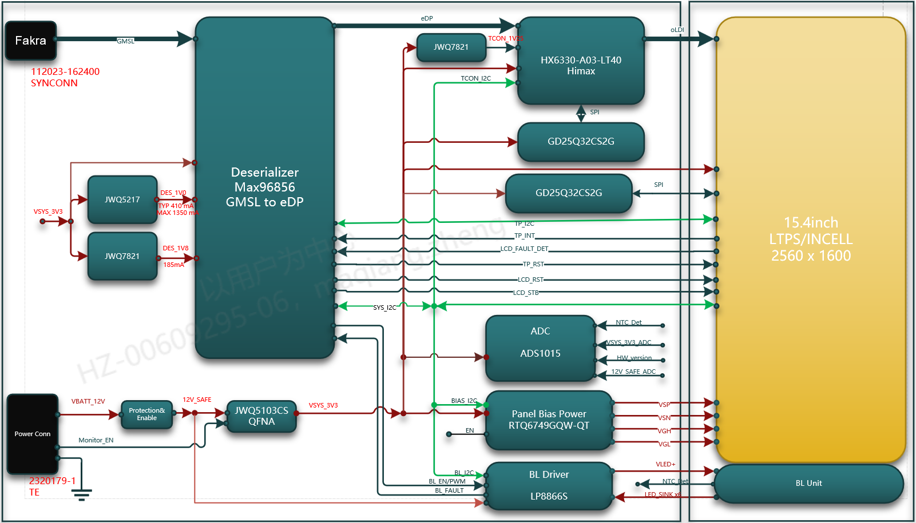
Figure1. System Block
The figure above shows the system connectivity to the available external devices. The external device shown above is only a representative diagram. It does not represent the actual end product.
CSD is connected to head unit via LVDS and I2C.

Operational environment运行环境

Operation System 操作系统
NA.

Voltage Requirement 电压要求
Type | Voltage | Definition
Current consumption | 12V | less than 2A
Quiescent current | 12V | less than 0.1mA
Performance assured voltage | 9~16V | Communication | GMSL3 |  |  | Assure performance
 |  |  | I2C
 |  | Display & backlight
 |  | Touch
 |  | Function operation
Operation assured voltage range ① | 6.5V~8V | Communication | GMSL3 |  |  | Assure performance
 |  |  | I2C | Communication component
 |  |  |  | Communication features |  | Assure Operation
 |  | Display & backlight |  |  |  | Black image
 |  | Touch |  |  |  | No function
 |  | Function operation |  |  |  | No function
Operation assured voltage range ② | <6.5V | Communication |  |  | GMSL3 | No function
 |  |  |  |  | I2C
 |  | Display & backlight
 |  | Touch
 |  | Function operation
Nondestructive voltage | 16V~18V | The system will not be destroyed within 1min.

Temperature Requirement 温度要求
Type | Temperature Value
Performance guaranteed temperature range | -30°C~+70°C
Operation guaranteed temperature range | -40°C~+85°C
Storage temperature range | -40°C~+90°C

Parameter Tolerances 参数容差
None parameter tolerance requirement for this project.

System Assumptions系统假设
None has been identified in this project.

Consideration of alternative options for the design对设计的替代选择的考虑

Alternative for touch system
Evaluation Item | Percentage | Current  In-cell touch | Score | Alternative  Out-cell touch | Score
Cost | 30% | Low, 30% cheaper than alternative | 10 | High | 3
Technical Feasibility | 20% | Better, higher transmittance and lower reflection | 8 | Good | 5
Maturity | 20% | Good, Mass production in display | 8 | Good, Mass production in display | 8
Reliability | 10% | Good, already validated in other OEM | 5 | Better, already validated in other OEM | 8
Maintainability | 10% | Good, TFT supplier support well | 8 | Good, cover glass supplier support well | 8
Scene conformity | 10% | Applicable | 8 | Applicable | 8
Summary |  |  | 8.3 |  | 5.9

Alternative for Backlight system
Evaluation Item | Percentage | Current  LP8866 | Score | Alternative  MPQ3367 | Score
Cost | 20% | Low, 20% cheaper than Proposal 2 | 10 | High | 3
Technical Feasibility | 20% | Good, support maximum 120mA/ch | 8 | Good, support maximum 120mA/ch | 8
Maturity | 20% | Good, Mass production in display | 8 | Not in Global OEM | 3
Reliability | 10% | Better, already validated in Global OEM | 8 | Good, already validated in VW80000 | 5
Maintainability | 20% | Good | 7 | Better, support higher current | 8
Scene conformity | 10% | Applicable | 8 | Applicable | 8
Summary |  |  | 8.2 |  | 5.7

Alternative for Power Supply
Evaluation Item | Percentage | Current  LMR33630 | Score | Alternative  JWQ5103 | Score
Cost | 20% | Medium cost, typical price for automotive-grade TI solution | 7 | Lower cost than TI solution, with obvious cost advantage | 9
Technical Feasibility | 20% | Fully meets required input/output voltage, current and efficiency specifications | 9 | Meets key electrical specs, with performance comparable to TI solution | 8
Maturity | 20% | Mature automotive-grade part, mass-produced in global OEM applications | 9 | Mass production ready, with limited global OEM experience | 6
Reliability | 10% | Automotive qualified with full validation, proven high reliability | 9 | Basic automotive qualification, with less extensive validation | 7
Maintainability | 20% | Stable supply from TI, with strong global technical support | 9 | Localized supply chain, fast technical support response | 9
Scene conformity | 10% | Compliant with automotive wide-temperature and EMC requirements | 8 | Compliant with automotive wide-temperature and EMC requirements | 8
Summary |  |  | 8.5 |  | 7.9

System requirements 系统需求

IR Intial Requirement Input IR初始需求输入
Please refer to the online IR table

Use Case System Requirements Analysis UC系统需求分析

Display 显示
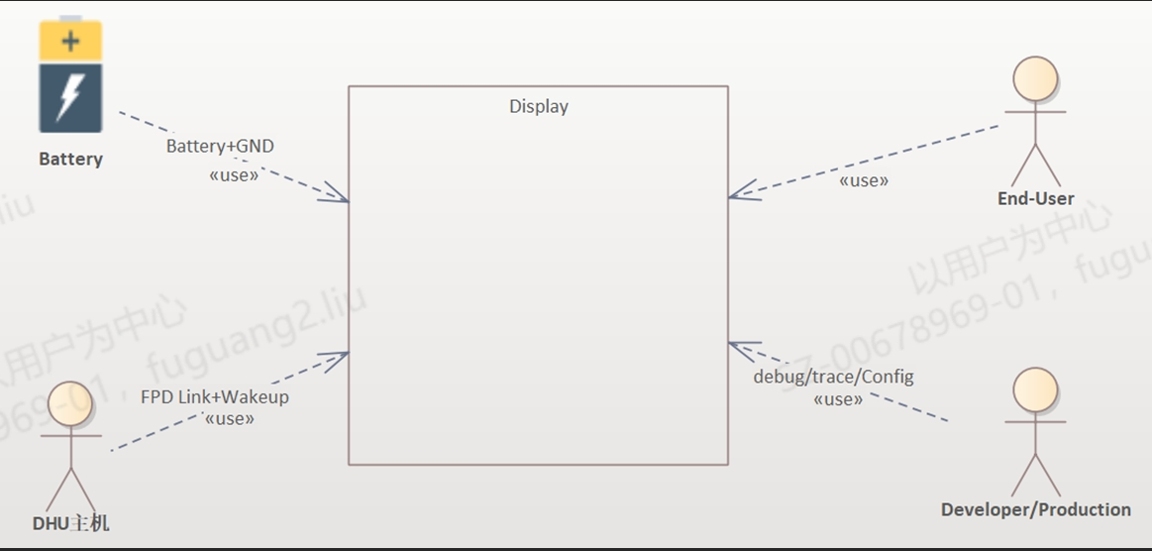
- The vehicle battery provides full-operation power supply to the automotive display via the power positive and ground link, acting as the primary power input for the display system.
- The vehicle DHU main unit communicates with the automotive display through FPD Link and wake-up signal links, enabling video transmission as well as sleep and wake-up control of the display.
- End users directly operate the automotive display to realize screen viewing, function control and human-machine interaction, which is the core application scenario for vehicle owners and passengers.
- R&D and production personnel perform parameter configuration, fault logging, function debugging, production line calibration and version management on the display via debug, trace and config access channels。
- 车载电池通过电源+接地链路，为车载显示屏提供整机工作供电，是显示屏运行的基础电源输入来源
- 车载DHU主机通过FPD Link + 唤醒信号链路与显示屏建立连接，实现视频画面传输、显示屏休眠/唤醒控制
- 终端用户直接使用车载显示屏，完成画面查看、功能操作、人机交互，是显示屏面向车主/乘客的核心使用场景
- 研发&生产人员通过debug/trace/config通道，对显示屏进行参数配置、故障抓取、功能调试、产线标定以及版本配置等操作

Power Management 电源管理
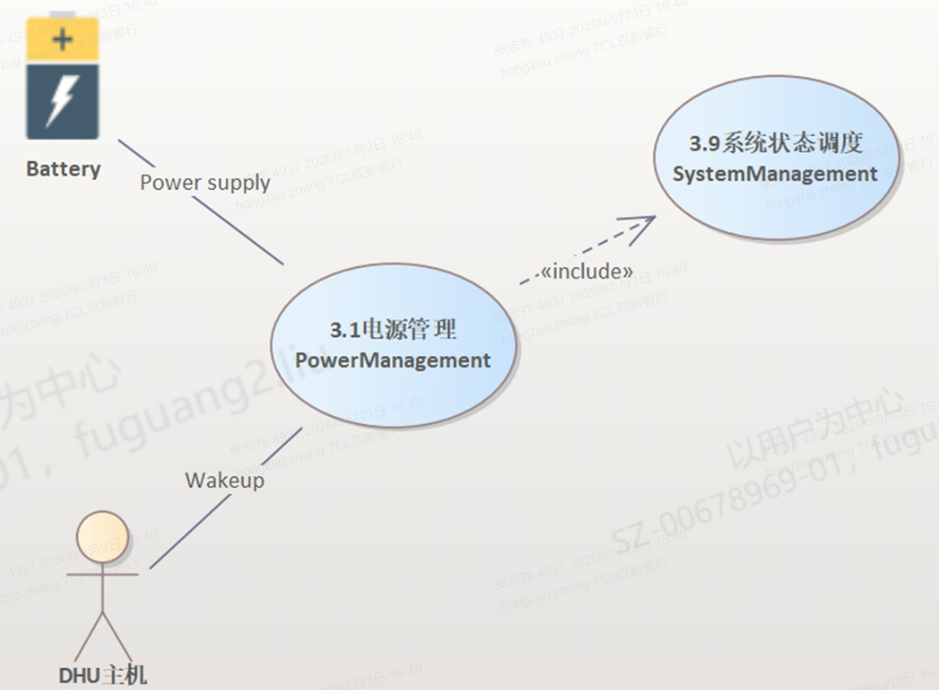
- The vehicle battery acts as the power supply source and serves as the power foundation for the operation of the power management function.
- The DHU main unit interacts with the power management module via Wakeup signals to implement the wake-up and sleep functions of the display.
- The power management rules shall cover the content specified in Chapter 4.1.
- 车载电池作为供电源，是电源管理功能运行的电力基础
- DHU主机通过Wakeup信号，与电源管理模块进行交互，实现显示屏唤醒/休眠功能
- 电源管理规则应包括4.1章节内容

Interaction 触控
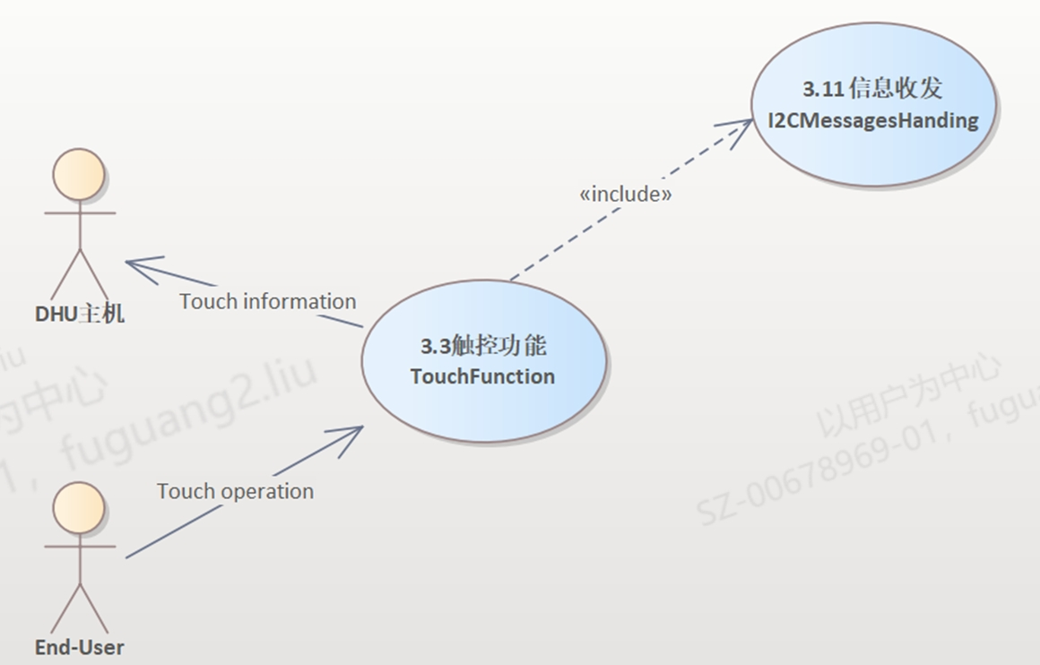
1. End users perform human-machine interaction with the automotive display through touch operations and issue touch commands, which serves as the service trigger source of the touch function.
2. After collecting touch information, the display uploads the touch data to the DHU main unit via the I2C communication bus.
- 终端用户通过触控操作，和车载显示屏进行人机交互，下发触摸操作指令，是触控功能的业务触发来源
- 显示屏采集到触控信息后，需要通过I2C通讯总线，将触控信息上传至DHU主机

Dimming 亮度的控制
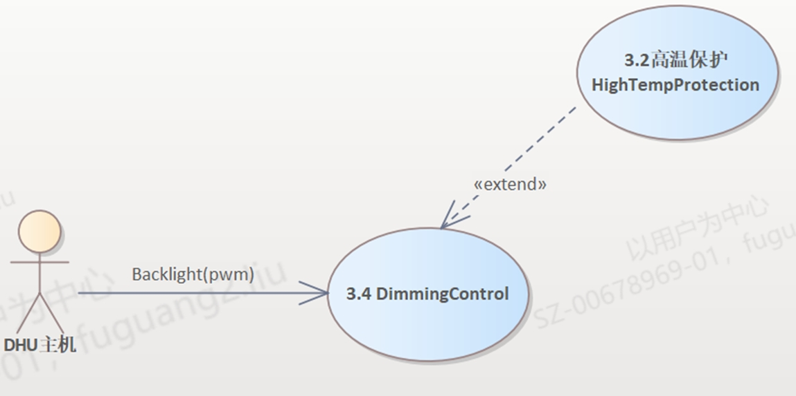
- The DHU main unit outputs backlight adjustment signals and transmits dimming commands to the display brightness control module, enabling active adjustment and control of the display brightness.
- After receiving the PWM dimming signal, the display brightness control module completes regular backlight brightness adjustment and brightness gear switching, and realizes brightness management under normal working conditions.
- According to the backlight temperature detection specified in Section 4.5.3, the DHU main unit reads the backlight temperature of the display, intervenes in brightness control, and implements overheating protection.
- DHU主机下发背光调节信号，向显示屏亮度控制模块传输调光指令，实现显示屏亮度的主动调节控制
- 显示屏亮度控制模块接收PWM调光信号后，完成显示屏常规背光亮度调节、亮度挡位切换，实现正常工况下的亮度管控功能
- 根据4.5.3章节的背光温度检测，DHU主机读取到显示屏背光温度后，实现介入亮度控制，实现过热保护

Diagnose 诊断
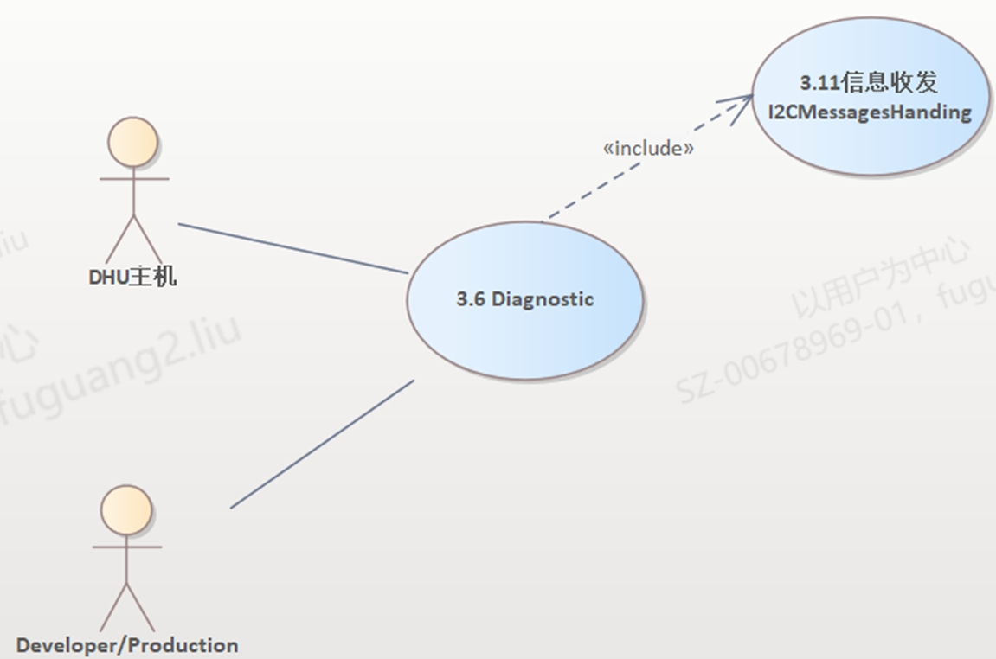
- The DHU main unit can access the diagnostic functions of the automotive display, send diagnostic query and status read commands, and acquire the display operating status and fault codes, realizing fault detection, reporting and interaction of the display.
- R&D and production personnel can invoke the diagnostic functions for factory offline inspection, hardware troubleshooting, function calibration and problem traceability analysis, to meet the requirements of R&D debugging and mass production quality inspection.
- DHU主机可访问显示屏诊断功能，下发诊断查询、状态读取指令，获取显示屏运行状态、故障码。实现显示屏的故障检测与上报交互
- 研发&生产人员可调用诊断功能，用于产线出场检测、硬件故障排查、功能标定、问题溯源分析，满足研发调试与量产质检需求

Functional Process Analysis 功能过程分析

Display Process 显示功能过程
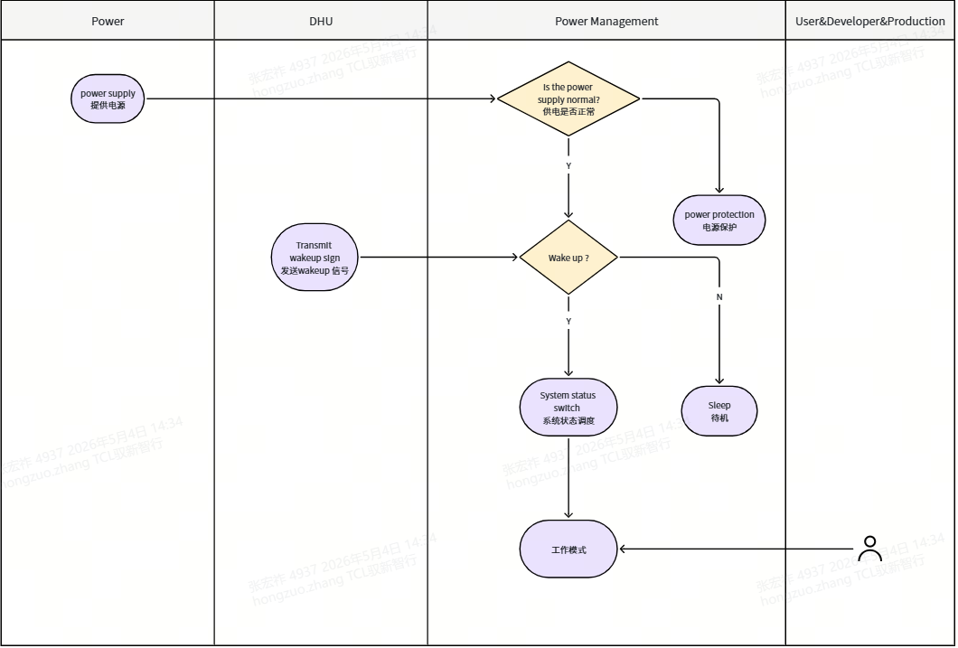
- The battery provides power to the power management module, which first verifies power supply health.
- If power is normal, the module checks for the Wakeup signal from the DHU host.
- On receiving the Wakeup signal, the module triggers system state scheduling to bring the display into active mode; otherwise, the display stays in standby; in case of power anomalies, the display enters protection mode.
- 电池为电源管理模块提供供电，模块首先检查电源是否正常。
- 若电源正常，继续判断是否收到 DHU 主机的 Wakeup 唤醒信号。
- 收到唤醒信号后调用系统状态调度，显示屏进入正常工作模式；未收到则保持待机；异常则进入保护。

Interaction Process 触控功能过程分析
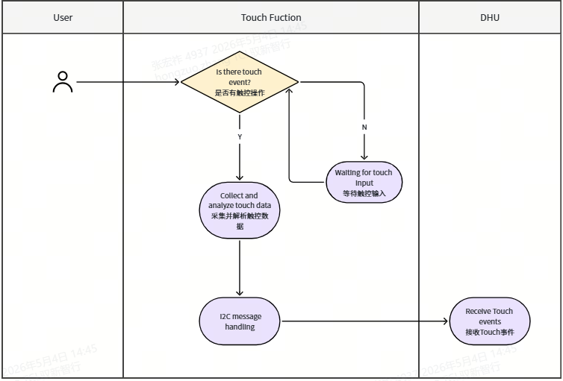
- User Input Trigger: End user touch operation activates the touch function module.
- Touch Data Acquisition: The module detects the touch, collects and parses data, and invokes I2CMessagesHanding.
- Data Reporting to Host: Touch information is packed via I2C and transmitted to the DHU host, completing the touch interaction.
- 用户输入触发：终端用户执行触控操作，触发触控功能模块启动。
- 触控数据采集：触控功能模块检测到操作后，采集并解析触控数据，调用I2CMessagesHanding信息收发模块。
- 数据上报主机：通过 I2C 通讯打包触控信息，并将数据发送给 DHU 主机，完成一次触控交互流程。

Dimming Process 亮度控制功能过程分析
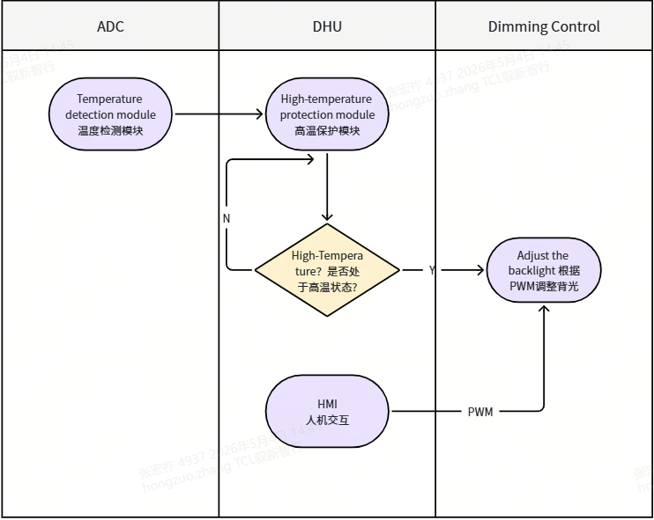
- Temperature Acquisition: The temperature detection module in the ADC unit collects real-time device temperature data and sends it to the high-temperature protection module in the DHU host.
- High-Temperature Status Check: The high-temperature protection module analyzes the temperature data to determine whether the device is in a high-temperature state: If the high-temperature condition is not met (N), temperature monitoring continues; If the condition is met (Y), the protection logic intervenes in the dimming control process.
- Backlight Adjustment: The HMI in the DHU host sends backlight adjustment commands to the Dimming Control module via PWM signals. When high-temperature protection is triggered, the dimming control module will limit or reduce the backlight brightness according to the thermal protection strategy to prevent overheating.
- 温度采集：ADC 模块中的温度检测模块实时采集设备温度数据，并将数据传输至 DHU 主机的高温保护模块。
- 高温状态判断：高温保护模块对温度数据进行分析，判断设备是否处于高温状态：若未触发高温（N），则持续进行温度监测；若触发高温（Y），则介入亮度控制流程。
- 亮度调节：DHU 主机的 HMI 人机交互模块通过 PWM 信号向 Dimming Control 模块下发背光调节指令；同时，高温保护触发时，亮度控制模块会根据高温策略限制 / 降低背光亮度，实现过热保护。

Diagnose Process 诊断功能过程分析
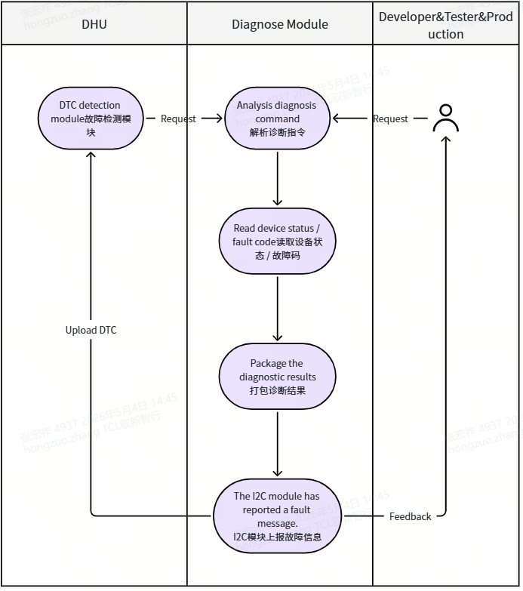
- Diagnostic Request Trigger: The DTC detection module in the DHU host, or developer/tester/production personnel, sends a diagnostic request to the Diagnose Module.
- Command Parsing and Status Reading: The Diagnose Module receives and parses the diagnostic command, then reads the device status and fault codes (DTC).
- Result Packaging and Feedback: The module packages the collected status and fault information, uploads the DTC to the DHU host via the I2C communication module, and feeds back the diagnostic results to the developer/tester/production personnel, completing the diagnostic process.
- 诊断请求触发：DHU 主机的故障检测模块或研发 / 产线人员，向诊断模块（Diagnose Module）下发诊断请求。
- 指令解析与状态读取：诊断模块接收并解析诊断指令，读取设备的运行状态与故障码（DTC）。
- 结果打包与反馈：诊断模块将读取到的设备状态与故障信息打包，通过 I2C 信息收发模块，向 DHU 主机上传故障码（DTC），并向研发 / 产线人员反馈诊断结果，完成诊断流程。

Functional Requirements功能需求

Power Management

Sleep [SyRD-FUNC-Power-0001]
概述/Overview | The CSD consumes quiescent current
输入/Input | NA
处理过程/Process | In this state, the CSD shall be processed as follow.  Function Status  Touch On  Display Off  TFT backlight Off
输出/Output | NA
性能要求/Performance | Maximum power consumption is 0.1mA.
对运行环境的依赖和影响/ Impact and dependence on the operating environment | Maximum power consumption is affected by temperature and voltage.
验证标准/Verification criteria | - The status of Display, Touch, Background lighting is consistent in definition.  - At Room temperature(+25°C±3°C), voltage 8V~18V, maximum power consumption is 100μA.  - When CSD stop communication with Head unit, CSD will enter Sleep mode.

Wakeup [SyRD-FUNC-Power-0002]
概述/Overview | In this state, the communication with HU is switched off.
输入/Input | NA
处理过程/Process | In this state, the CSD shall be processed as follow,  Function Status  Touch On  Display Off  TFT backlight Off
输出/Output | NA
性能要求/Performance | Maximum power consumption is 150mA.
对运行环境的依赖和影响/ Impact and dependence on the operating environment | Maximum power consumption is affected by temperature and voltage.
验证标准/Verification criteria | - The status of Display, Touch, Background lighting is consistent in definition.  - At Room temperature(+25°C±3°C), voltage 9V~18V, Maximum power consumption is 150mA.  - When CAN bus is prepared to sleep, CSD will enter CSD_Wake up mode.

Normal [SyRD-FUNC-Power-0003]
概述/Overview | The CSD communicates via I2C with the HU and the display is switched on. All functions are enabled.
输入/Input | NA
处理过程/Process | In this state, the CSD shall be processed as follow,  Function Status  Touch On  Display On  TFT backlight On
输出/Output | NA
性能要求/Performance | Maximum power consumption is 2A.
对运行环境的依赖和影响/ Impact and dependence on the operating environment | Maximum power consumption is affected by temperature and voltage.
验证标准/Verification criteria | - The status of Display, Touch, Background lighting is consistent in definition.  - At Room temperature(+25°C±3°C), voltage 13.4V, Maximum power consumption is 1.5A.  - When CAN bus is active and CSD receive lock signal, CSD will enter Disp_On mode.

State Transitions [SyRD-FUNC-Power-0004]
概述/Overview | Power on and power off behavior of the CSD system shall follow the state transitions table.
输入/Input | NA
处理过程/Process | - There are 3 states. The state transitions table is as follow, depending on the current state of the model, an event will transition to another state.  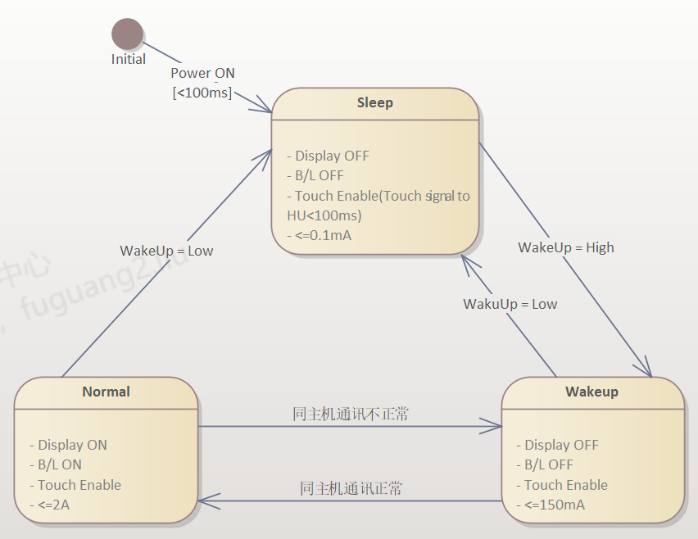  Comment  Event Sleep Wakeup Disp_On  Wake up = High To Wakeup Wakeup Normal  Wake up = Low Sleep To Sleep To Sleep  同主机通讯正常 Sleep To Normal Normal  同主机通讯错误 Sleep To Sleep To Wakeup
输出/Output | NA
性能要求/Performance | None
对运行环境的依赖和影响/ Impact and dependence on the operating environment | Dependence: None  Impact: None
验证标准/Verification criteria | The system can perform power state switching which defined in process.

Interaction

Touch [SyRD-FUNC-Input-0002]
概述/Overview | The CSD shall be able to detect touch event and send the touch coordinate status to HU.
输入/Input | User operation (single touch/multi-touch)
处理过程/Process | - The CSD receive touch screen event and read the touch coordinate status.  - The CSD send the touch coordinate status to HU via CAN.
输出/Output | corresponding parameters of touch event
性能要求/Performance | - The delay between a touch event and the transmission of the corresponding message to the HU shall be less than 100 ms.
对运行环境的依赖和影响/ Impact and dependence on the operating environment | Dependence: None  Impact: None
验证标准/Verification criteria | - The touch coordinate status shall be sent from CSD to HU successfully when user click the touch panel.  - The delay between a touch event and the transmission of the corresponding message to the HU shall be less than 100 ms.

Slider [SyRD-FUNC-Input-0003]
概述/Overview | The CSD shall detect slider event and send the slider coordinate status to HU.
输入/Input | User operation (single touch/multi-touch)
处理过程/Process | - The CSD receive slider event and read the slider coordinate status.  - The CSD send the slider coordinate status to HU via I2C.
输出/Output | corresponding parameters of touch event
性能要求/Performance | - The slider controller sample time shall be no more than 5 ms.  - The delay between a slider event and the transmission of the corresponding message on the I2C shall be less than 100 ms.
对运行环境的依赖和影响/ Impact and dependence on the operating environment | Dependence: None  Impact: None
验证标准/Verification criteria | - The slider coordinate status can be sent from CSD to HU successfully when user click the slider.  - The slider controller sample time shall be no more than 5 ms.  - The delay between a slider event and the transmission of the corresponding message on the I2C bus shall be less than 100 ms.

HWR [SyRD-FUNC-Input-0003]
No applicable.

Dimming

Display illumination [SyRD-FUNC-Dimming-0001]
概述/Overview | The dimming of backlight is controlled by HU via PWM signal.
输入/Input | PWM Signal(P54)
处理过程/Process | - The PWM output is in follow.  等级 IHU占空比（PWM） DIS亮度（Cd/m²）  0 1% 9  1 3% 27  2 5% 45  3 8% 63  4 10% 90  5 13% 117  6 17% 153  7 21% 189  8 26% 234  9 32% 288  10 39% 351  11 47% 423  12 55% 495  13 65% 585  14 76% 684  15 90% 810
输出/Output | Corresponding display dimming.
性能要求/Performance
对运行环境的依赖和影响/ Impact and dependence on the operating environment | Dependence:  - The I2C between the backlight driver and Deserialize is OK.  - The CSD is working under normal state.  - Impact: None
验证标准/Verification criteria | The dimming output of display can be changed with different value of CAN signal.  User can manually adjust screen brightness via brightness bar in display setting.

I2C

I2C Network topology [SyRD-FUNC-I2C-0001]
概述/Overview | The CSD shall support I2C Communication.
输入/Input | NA
处理过程/Process | 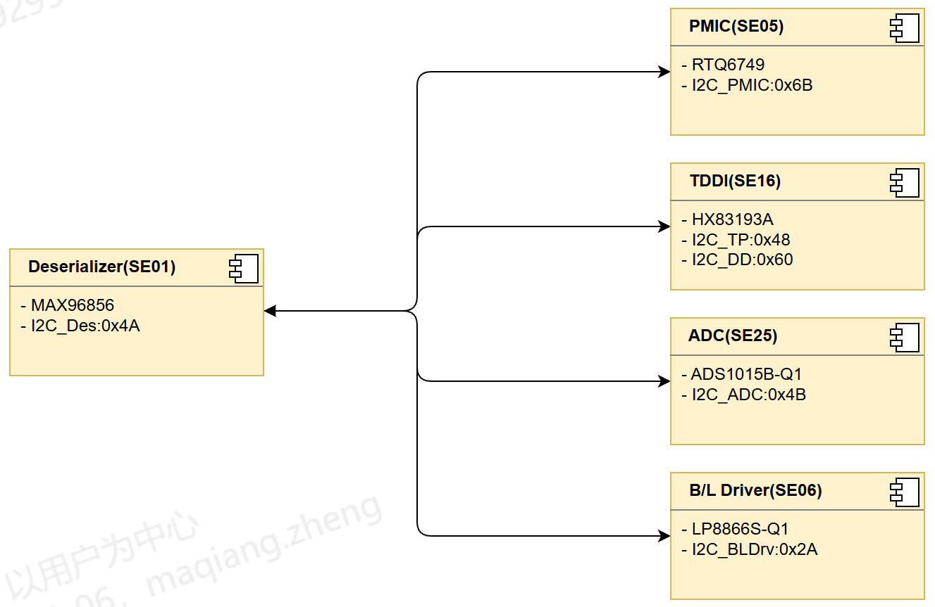  Name I2C Address(7bit) Remark  Deserializer 0x4A  PMIC 0x6B  TDDI_TP 0x48  TDDI_DD 0x60  BL Driver 0x2A  ADC 0x4B  - Baud rate: 500 kb ± 0.3%, Resulting bit time: tBIT = 2 µs ± 0.3%  - Bit timing and synchronization of CAN Communication.  - Bit sampling: 1 sample/bit  - Synchronization: only on signal edges from recessive to dominant  Sampling time: 80 - 83,3%  - BTL cycles: 10 - 20 tq  - CAN interfaces are defined in [U-3].  - CAN messages are defined in [R-2] and [R-3].  Remark: The requirement of CAN is from ‘LAH DUM.857.AG_Konzern_LAH_CAN_V6.7’.
输出/Output | NA
性能要求/Performance | NA.
对运行环境的依赖和影响/ Impact and dependence on the operating environment | Dependence: operation voltage shall be in the range of 6.5V~18V  Impact: None
验证标准/Verification criteria | - I2C communication is normal and the correct signals are used.

OTA via I2C[SyRD-FUNC-I2C-0002]
概述/Overview | The TDDI shall support OTA via I2C network.
输入/Input | 主机端发出TDDI升级请求
处理过程/Process | 1,TDDI可以通过OTA接收主机的推送新固件  2,升级固件中的Project+Customer+Ticket 信息字段必须正确，具体格式为：  Project字段为CSOT_154，Customer为TCL，Ticket字段为7215  3,该升级固件由TDDI供应商Himax提供。  注意：屏幕作为被动接收信息的器件，需要确保Project+Customer+Ticket 信息字段的正确。升级过程由主机完成，主机会首先检测显示屏中相关信息，该检测方式由主机通过IIC协议从屏端获取。
输出/Output | NA
性能要求/Performance | NA.
对运行环境的依赖和影响/ Impact and dependence on the operating environment | Dependence: operation voltage shall be in the range of 6.5V~18V  battery on 主机和屏正常运行  Impact: None
验证标准/Verification criteria | 主机通过I2C能够正常更新TDDI的固件。

Diagnose

Diagnostic Table [SyRD-FUNC-Diagnose-0001]
概述/Overview | There are 3 different components shall be diagnostic. The detail refers to [U-3].
输入/Input | Corresponding fault bit is active.
处理过程/Process | 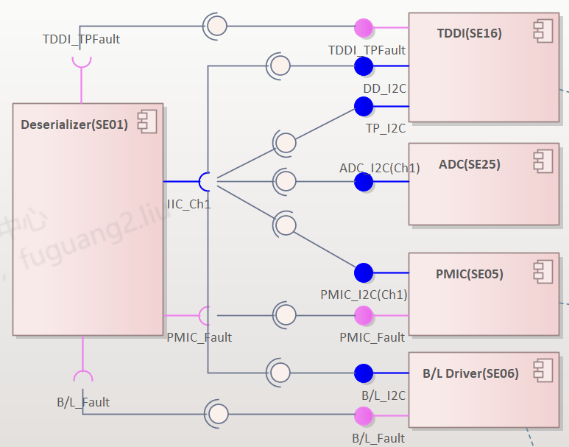  Fault Bit Definition Related Pin(Des side) Diagnostic Request Response  TDDI_TPFault DD or/and TP is/are under the error status P50/”H”:Error 0x48 E5h - Abnormal power off detection,"H"有效 VDD1 undervoltage:E5h/Bank0 PA2 bit[5], VSP undervoltage:E5h/Bank0 PA2 bit[6], VSN undervoltage:E5h/Bank0 PA2 bit[7] VGH undervoltage:E5h/Bank0 PA3 bit[0], VGL undervoltage:E5h/Bank0 PA3 bit[1], - OTP Reload Fail,"H"有效 OTP reload fail:E5h/Bank0 PA3 bit[6] - Over Voltage,"H"有效 VDD1 over-voltage:E5h/Bank0 PA4 bit[1], VSP over-voltage:E5h/Bank0 PA4 bit[2], VSN over-voltage:E5h/Bank0 PA4 bit[3], - Flash Reload Error,"H"有效 Flash reload fail:E5h/Bank0 PA4 bit[5] - WDT Error,"H"有效 FW Watch dog timeout:E5h/Bank0 PA6 bit[0] - LVDS Abnormal,"H"有效 Abonormal LVDS signal:E5h/Bank0 PA3 bit[2] - Overheat,"H"有效 Overheat Error:E5h/Bank0 PA4 bit[6] - TP Sensor-Short Test,"H"有效 FW TP sensor short:E5h/Bank0 PA6 bit[7] - TP Sensor-Open Test,"H"有效 FW TP sensor open:E5h/Bank0 PA7 bit[0]  PMIC_Fault PMIC is under the error status P63/”L”: Error 0x6B 1Dh - PMIC_FAULI="L"有效 PAVDD FAULT VGL FAULT VGH FAULT NAVDD FAULT  B/L_Fault Backlight Driver is under error status P60/”L”:Error 0x2A 12h - LED6~1_FAULT,"L"有效 Offset=12h-bit[5] Offset=12h-bit[4] Offset=12h-bit[3] Offset=12h-bit[2] Offset=12h-bit[1] Offset=12h-bit[0]
输出/Output | Diagnostic response will be issued according to the corresponding diagnostic request.
性能要求/Performance | None
对运行环境的依赖和影响/ Impact and dependence on the operating environment | Dependence: None  Impact: None
验证标准/Verification criteria | - When one of the supported errors happened, the corresponding fault bit must be set.  - When send diagnostic request, the corresponding response message with related diagnostic information must be send back via I2C network.  - The communication must follow I2C general protocol.

电池电压检测 [SyRD-FUNC-Diagnose-0002]
概述/Overview | The HU can detect battery voltage via I2C network.
输入/Input | 主机发出读取电池电压的请求
处理过程/Process | 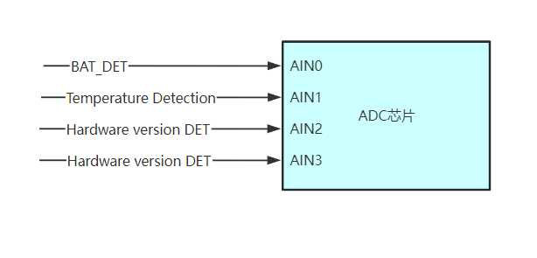  1,主机端在I2C网络发出电池电压读取请求  2,屏幕端将当前的电池电压值传回主机端
输出/Output | 屏幕依据电池电压，进入不同的工作模式。
性能要求/Performance | NA.
对运行环境的依赖和影响/ Impact and dependence on the operating environment | Dependence: operation voltage shall be in the range of 6.5V~18V  Impact: None
验证标准/Verification criteria | 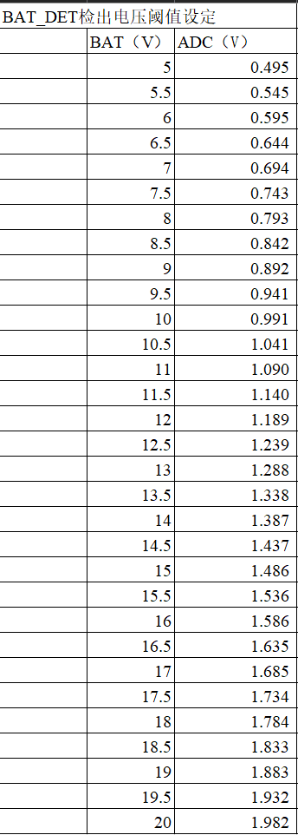  通过I2C总线读取到的电压值能够对应上当前的实际电池电压值，对应关系见上图的表格。

背光温度检测 [SyRD-FUNC-Diagnose-0003]
概述/Overview | The HU can detect the temperature of Display via I2C network.
输入/Input | 主机发出读取显示屏模组温度的请求
处理过程/Process |   1,主机端在I2C网络发出屏幕温度读取请求  2,屏幕端将当前的屏幕温度AD值传回主机端
输出/Output | 屏幕依据屏模组温度，采取温控策略，根据温升降低背光PWM
性能要求/Performance | NA.
对运行环境的依赖和影响/ Impact and dependence on the operating environment | Dependence: operation voltage shall be in the range of 6.5V~18V  Impact: None
验证标准/Verification criteria | 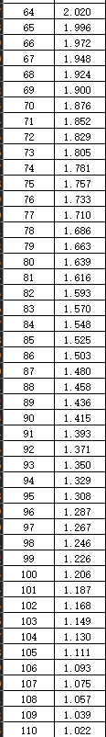  通过I2C总线读取到的屏幕温度值能够对应上当前的实际电池电压值，对应关系见上图的表格。

System prototype系统原型

Physical Prototype 物理原型

Appearance Requirements外观要求

Panel Style [SyRD-PROTOTYPE-0001]
需求描述/ Requirement Description | CSD:  - The panel style diagram of CSD is as follow.    - 14.6中控显示屏.  - The display and DHU must be compatible and support the specified functionality of each other completely. Supplier shall investigate and propose solution of an integrated DHU and display solution that fulfill each ECU separate requirement.显示屏与显示屏主机需要相互兼容，能够相互完全地支持规定的功能。供应商需要了解，同时提供措施完成主机与显示屏的集成，以满足ECU控制的要求。  - The display has no functions, all functions are integrated in DHU.显示屏没有功能，所有功能集成在DHU里面。
对运行环境的依赖和影响/Impact and dependence on the operating environment | Dependence: None  Impact: None
验证标准/Verification criteria | Check TFT and slider are on the panel, and their location distribution is correct.

CSD Size [SyRD-PROTOTYPE-0002]
需求描述/ Requirement Description | CSD System size(AA Size) is 323.136mm x 181.764 mm. (Tolerance：+/-2%)
对运行环境的依赖和影响/Impact and dependence on the operating environment | Dependence: None  Impact: None
验证标准/Verification criteria | Check the CSD size is right. (Tolerance：+/-2%)

CSD Weight [SyRD-PROTOTYPE-0003]
需求描述/ Requirement Description | The weight of all CSD variant shall be less than 1800 g.
对运行环境的依赖和影响/Impact and dependence on the operating environment | Dependence: None  Impact: None
验证标准/Verification criteria | Use the weight instrument to measure whether the weight of the display is ≤1.8KG.

几何&外观质量 [SyRD-PROTOTYPE-0004]
需求描述/ Requirement Description | Geometry & Appearance /几何&外观质量  The final evaluation shall be subject to the buyer's《Evaluation Specification of Vehicle Static Perceived Quality》.  最终以买方《整车静态感知质量评价规范》评价通过为准。
对运行环境的依赖和影响/Impact and dependence on the operating environment | Dependence: None  Impact: None
验证标准/Verification criteria | 1. Geometry & Appearance /几何&外观质量，画面感知质量评审要求：  A、颜色的一致性:为了避免在整车和CSD的颜色出现不一致的情况，CSD色调需要进行联调，并进行感知质量评价确认。  B、白色画面感知质量评价：白色画面无发黄现象，以实物评价为准。  2、Mura（漏光）感知质量评价：对所有主题界面进行感知质量评价，判断不允许出现显示不均（Mura），漏光，发白，发黄，亮点等肉眼可见的显示缺陷。评价环境：1，夜间模式；2，所有主题界面；3，在夜间环境中评价  3. Paint & Surface finish /油漆外观质量：  CSD parts shall be meet Q/JLY J7110550 E-2022《汽车塑料内饰涂层技术要求》  CSD零部件需要满足标准Q/JLY J 7110550 E-2022《汽车塑料内饰涂层技术要求》

外观主要缺陷 [SyRD-PROTOTYPE-0005]
需求描述/ Requirement Description | The following defects are not allowed:  不允许出现以下缺陷：  a) Incomplete or poor functionality (disorder, blank, blurred, flashing, abnormal display etc.);  功能缺失、功能性不良（乱显，无显，花屏，闪烁等异常显示）；  b) Image sticking, improper color, ripple;  残留影像、异常颜色、条纹；  c) Open circuit, short circuit;  开路、短路；  d) Broken glass and Crack;  破碎玻璃片和裂纹；  e) Touch control failure, delayed response or poor regional touch.  无触摸功能、触摸反应延迟、区域型触摸不良。
对运行环境的依赖和影响/Impact and dependence on the operating environment | Dependence: None  Impact: None
验证标准/Verification criteria | 目视外观检查

外观次要缺陷 [SyRD-PROTOTYPE-0006]
需求描述/ Requirement Description | Item 项目 Quantity 数量 Inspection field 检测画面  亮点bright dots ≤0 (W, D, R, G, B) Field  暗点（两点间隔大于10mm） Dark dots(distance between two dots) ≤3  连续暗点 continuous black dots ≤0  S/N序号 Item 项目 Index 指标 Note 图示  1 外来物质 Foreign material 点状 Dot shape D＜0.15mm, Ignore; 0.15mm ≤ D ≤ 0.35mm, N ≤ 3 (Distance between two points ≥20mm); D > 0.35mm, not allowed. D=（a+b）/2 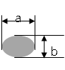  2 线状 Line shape L≤1mm, W≤0.05mm, N≤3; W>0.05mm, N=0. 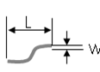  3 划痕 Scratch W＜0.05, Ignore; 0.5 ≤ L ≤ 3mm, W ≤ 0.1mm, N ≤ 3; W > 0.1mm, not allowed.  4 凹痕 Dent D＜0.15, Ignore; 0.15mm ≤ D ≤ 0.35mm, N ≤ 3; D > 0.35mm, not allowed. D=（a+b）/2   5 气泡 Bubble D＜0.15, Ignore; 0.15mm ≤ D ≤ 0.35mm, N ≤ 3; D > 0.35mm, not allowed.  6 Mura 6%ND filter不可见，或参照限度样本. Using 6%ND filter invisible, or refer to limit sample. 环境照度在200 cd/m2以下
对运行环境的依赖和影响/Impact and dependence on the operating environment | Dependence: None  Impact: None
验证标准/Verification criteria | The total number of above minor defects shall not be more than 8.  所有以上次要缺陷的总和不能超过8个。  Note1：Defective pixels–distance缺陷像素-距离  1. 要求：任何一双有缺陷的像素之间的距离应大于10mm。  Requirement: The distance between any pair of defective pixels shall be greater than 10 mm.

材料要求

原材料要求 [SyRD-PROTOTYPE-0007]

需求描述/ Requirement Description | 1 General requirements/通用要求 The Material Attributes Test of Parts have to be in compliance with the Design Verification Plan & Report and Material Engineering Requirements .所有材料属性的测试需满足《试验验证大纲和报告 DVP&R》和《材料工程要求》的要求。 All non-metallic raw materials involved are prohibited from using and adding returns,blow molding plastic leftover material can add <30% of the components,but performance needs to be reassessed.所有涉及到的非金属原材料禁止使用和添加回料；吹塑成型塑料件可以添加<30%的本部件边角料，但需要重新评估性能。  2 General requirement/一般要求 Material and production compliant design layout of the components for avoiding production related surface flaws/defects (tool parting points/lines, streaks, flow marks, wall thickness irregularities, stress zones etc.) 材料和产品必须满足零件的设计要求，避免产品相关的表面缺陷（工具分离点/线、条痕、流动痕、厚度不均、压力等） Ensuring correct material pairing, surfaces, structures and connection concepts with regard to disturbance noise. 确保正确的材料配对，表面、结构和连接避免噪音。 Free of disturbing noise and odour in contact with the environment at all temperature and driving conditions. 在任何环境中和驾驶工况下，不得扩散噪音和气味。 The option of all parts materials (including accessories, coating, etc) must meet the requirements of environmental recycling, in car air quality, aging, anti-corrision and material compatibility, and must meet the physical performance requirements listed in material list as per the matrial standard. 零部件所有材料（包括辅料、涂镀层等）的选择必须满足环保回收、车内空气、老化、防腐、材料兼容性等要求，并满足材料清单中各个材料标准或技术大纲规定的物理性能要求。  3 Material selection/选材要求 Parts suppliers give priority to material definition from material platform for material lean development. When the material platform does not meet the requirements, the parts suppliers can recommend the materials when they meet the development schedule, cost and performance requirements of the project and have mature candidate materials。 零件卖方优先从买方材料平台化中进行材料定义，用于材料精益开发；材料平台化不满足需求时，零部件卖方在满足该项目开发进度、成本、性能要求，并有成熟备选材料条件下，零件卖方可进行材料推荐应用。
对运行环境的依赖和影响/Impact and dependence on the operating environment | Dependence: None  Impact: None
验证标准/Verification criteria | 核实供应商提交的材料清单

显示屏触控需求

触控技术选择 [SyRD-PROTOTYPE-0008]
需求描述/ Requirement Description | Requirement: To achieve the Design requested flat center stack intention, capacitive touch is assumed. As well IR bezel touch could be applicable with a proven low design depth. The supplier shall investigate and report advantages, disadvantages, consequences and price for using different touch-technologies.  Purpose: No touch-sensing technology is superior in all aspects. The supplier shall investigate and report the feasibility in using several different techniques.  要求：为达到设计要求的中控堆叠意图，采用电容触控。此外，IR边框触摸可以适用于一个证明较低的设计深度。供应商应调查并报告使用不同触摸技术的优点、缺点、后果和价格。  目的：没有一项触摸感应技术是全能的。供方应调查并报告使用几种不同技术的可行性。
对运行环境的依赖和影响/Impact and dependence on the operating environment | Dependence: None  Impact: None
验证标准/Verification criteria | 核实供应商触控测试报告

标准触摸位置 [SyRD-PROTOTYPE-0009]
需求描述/ Requirement Description | Requirement: Several tests that evaluate the performance of the touch sensor shall be conducted at precise locations. The locations are defined by the figure below:  要求：在精确的位置进行几项评估触摸传感器性能的测试。具体位置如下图所示：  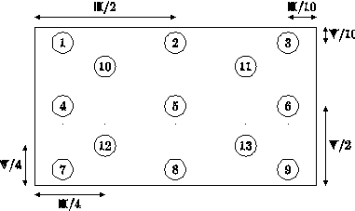  The locations are parameterized and may be computed for any display size. H = Horizontal length (width), V = Vertical length (height).  Purpose: To define standard touch locations for tests.  位置是参数化的，可以根据任何显示大小进行计算。H =水平长度（宽），V =垂直长度（高）  目的：定义标准的测试触摸位置。
对运行环境的依赖和影响/Impact and dependence on the operating environment | Dependence: None  Impact: None
验证标准/Verification criteria | 核实供应商触控测试报告

最小可检测对象[SyRD-PROTOTYPE-0010]
需求描述/ Requirement Description | Requirement: The display shall be able to detect and properly report the location of objects (made from suitable materials) with half-circle shaped tips whose diameter is 6 mm.  要求：显示屏须能探测及正确报告圆形铜柱位置（由合适的物料制成），而圆形铜柱的直径为6毫米。
对运行环境的依赖和影响/Impact and dependence on the operating environment | Dependence: None  Impact: None
验证标准/Verification criteria | 核实供应商触控测试报告

触摸报告检查[SyRD-PROTOTYPE-0011]
需求描述/ Requirement Description | Requirement: The display shall have two distinct modes for compiling and sending touch-reports describing what is happening above the touch sensor: A, The display is configured by the DHU to send touch reports whenever they are ready; B, The display is configured to send touch reports when the DHU requests it. The report shall be transmitted to the DHU as soon as the request has been received.  要求：显示屏应该有两种不同的模式来编译和发送触摸报告，描述触摸传感器上发生的事情：A，显示屏是由DHU配置的，只要准备好了就可以随时发送触摸报告；B，当DHU请求时，显示屏被设置为发送触摸报告。报告应在收到请求后立即反馈给DHU。
对运行环境的依赖和影响/Impact and dependence on the operating environment | Dependence: None  Impact: None
验证标准/Verification criteria | 核实供应商触控测试报告

触摸一致性性能[SyRD-PROTOTYPE-0012]
需求描述/ Requirement Description | Requirement: The touch-screen shall not require periodic coordinate-calibration from the customer.  Purpose: To ensure consistent behavior over time.  要求：触摸屏不需要客户定期配合校准。  目的：确保一段时间内触摸的一致性。
对运行环境的依赖和影响/Impact and dependence on the operating environment | Dependence: None  Impact: None
验证标准/Verification criteria | 核实供应商触控测试报告

鬼点[SyRD-PROTOTYPE-0013]
需求描述/ Requirement Description | Requirement: No data is allowed to be reported for locations where user contact is not made. Worst case condition with highest probability for ghost touch with the selected touch technology and panel solution shall be defined by the supplier and an appropriate test method for ghost touch evaluation shall be defined.  要求：对于未与用户接触的位置，不允许报告任何数据。对于所选择的触摸技术和面板解决方案，供应商应定义鬼触发生概率最高的最坏情况，并定义适当的鬼触评估测试方法。  Note: A simple test could be to move one finger from point 1 to 7 while at the same time moving a finger from 9 to 3. See image in requirement 3.2.6.2. Standard touch locations.  注意：一个简单的测试可以是将一个手指从1点移动到7点，同时将一个手指从9点移动到3点。见要求3.2.6.2.标准触摸位置中的图像。  Purpose: For different reasons some touch sensors and controllers may report contact points with coordinates different from where the user touches the surface. For instance some sensors measure X- and Y-coordinates separately thus making it difficult to correlate them rising an ambiguity issue on where the user actually touches the sensor. This will ruin the user experience and is this not allowed.  目的：由于不同的原因，一些触摸传感器和控制器可能报告的接触点坐标与用户接触表面的位置不同。例如，一些传感器分别测量x和y坐标，因此很难将它们关联起来，这就引起了用户实际接触传感器位置的模糊问题。这将破坏用户体验，这是不允许的。
对运行环境的依赖和影响/Impact and dependence on the operating environment | Dependence: None  Impact: None
验证标准/Verification criteria | 核实供应商触控测试报告

灰尘抑制[SyRD-PROTOTYPE-0014]
需求描述/ Requirement Description | Requirement: The touchscreen shall be able to identify static dirt or smudges on the touch area and refuse to report their coordinates as contact points.  Purpose：static dirt or smudges on the touch area shall not be interpreted as intentional contact points.  要求：触摸屏应能够识别触摸区域的静态污垢或污迹，并拒绝将其坐标报告为接触点。  目的：接触区域的静态污垢或污迹不能理解为有意的接触点（避免误触）。
对运行环境的依赖和影响/Impact and dependence on the operating environment | Dependence: None  Impact: None
验证标准/Verification criteria | Review

手套支持[SyRD-PROTOTYPE-0015]
需求描述/ Requirement Description | Requirement: The touchscreen shall be able to detect and report touch contacts made by a hand wearing thick gloves. Glove material can be considered to be leather or plastic with dielectric constant between 2 and 4 with a glove thickness of 3.5mm. Alternatively the attenuation of the touch signal can be assumed to decrease to 20% of the normal finger touch when wearing a winter leather glove. Glove feature support shall not result in a unsatisfactory user experience when not using gloves. Supplier shall present suggested glove support solution and any deviations must be agreed between GEELY/Supplier.  要求：触摸屏应能够检测和报告戴厚手套的手接触。手套材料可以认为是皮革或织物，介电常数在2到4之间，手套厚度3.5mm。另外，当你戴着冬天的皮手套时，触摸信号的衰减可以减少到正常手指触摸的20%。手套功能支持在不使用手套时不会导致不满意的用户体验。供应商应提供手套支持解决方案建议，任何偏差必须在吉利/供应商之间达成一致。  Purpose: Customers may prefer to use the touchscreen while wearing gloves in cold markets.  目的：在寒冷的环境，顾客可能更喜欢戴手套使用触摸屏。  备注：信号的衰减量需要在调试之后进行实测确认。
对运行环境的依赖和影响/Impact and dependence on the operating environment | Dependence: None  Impact: None
验证标准/Verification criteria | 触控实验验证

长指甲支持[SyRD-PROTOTYPE-0016]
需求描述/ Requirement Description | Requirement: The touch sensor should be able to capture gestures performed by fingers with 2 mm distal edges on their nails under normal operation and expected environmental/EMC conditions in accordance with agreed EMC test plan.  Purpose: Some customers have long finger nails and will expect the touchscreen to capture gestures performed by the nail tips on the touch surface.  要求：根据商定的EMC测试计划，在正常操作和预期的环境/EMC条件下，触摸传感器应能够捕捉指甲上远端边缘2mm的手指所做的手势。  目的：有些顾客的指甲很长，他们希望触屏能捕捉到指甲尖在触屏上所做的手势。
对运行环境的依赖和影响/Impact and dependence on the operating environment | Dependence: None  Impact: None
验证标准/Verification criteria | 触控实验验证

触控报点率[SyRD-PROTOTYPE-0017]
需求描述/ Requirement Description | Requirement: The touch panel shall be scanned for touch patterns with a programmable rate. Scans will result in reports describing the touch pattern on the screen that is sent to the DHU via the control channel. The report rate shall be possible to control at any time by sending a request over the control channel. The maximum report rate shall be at least 120 Hz, chosen programmatically.  要求：触摸屏触摸模式应在可编程速度下扫描。扫描将产生描述屏幕上的触摸模式的报告，并通过控制通道发送到DHU/ IHU。报告速率应该可以通过控制通道发送请求来控制。最大报告频率至少为120 Hz，可编程选择。  For any deviations it shall be considered that approximately 100mm/s is what you can expect from a human gesture, where it is still possible for the human to judge the performance. Also see 3.2.7.17. “Single line accuracy” and 3.2.7.18. “Single arc accuracy”.  一个人的手势速度期望是约100mm/s，应考虑任何偏差，其中可以由人来判断性能。请参阅3.2.7.17.“单线精度”和3.2.7.18.“单弧精度”。
对运行环境的依赖和影响/Impact and dependence on the operating environment | Dependence: None  Impact: None
验证标准/Verification criteria | 触控实验验证

过点触控[SyRD-PROTOTYPE-0018]
需求描述/ Requirement Description | Requirement: The following behavior modes are acceptable when the user makes too many contact points on the touchscreen: Fuse excess points and enlarge area of the resulting contact point accordingly.  要求：当用户在触摸屏上设置过多的接触点时，以下行为模式是可以接受的：熔断过量点，相应扩大接触点的面积。  Purpose: The user of the touch screen might, with or without intent, put more fingers on the touchscreen than the sensor can handle. The display shall respond to this situation with a predictable behavior.  目的：触摸屏的用户可能有意无意地将更多的手指放在触摸屏上，而传感器无法处理这些手指。显示器应以可预测的行为回应这种情况。  备注：报点的手指数最大是10，超过设定值的手指不会报告，按接触的时间顺序报告。
对运行环境的依赖和影响/Impact and dependence on the operating environment | Dependence: None  Impact: None
验证标准/Verification criteria | 触控实验验证

多点触控[SyRD-PROTOTYPE-0019]
需求描述/ Requirement Description | Requirement: The touchscreen shall be able to detect, distinguish, and report at least 2 simultaneous touch contacts moving completely independent of each other. Additionally it must support 5 simultaneous contacts and report their properties individually if they are separated by a certain distance. The behavior shall be consistent and predictable for static and dynamic events such as application, movement and removal of pointing device (including finger).  要求：触摸屏应该能够检测、区分和报告至少两个同时移动的触摸触点，它们之间完全独立。此外，它必须支持5个同时接触和报告各自的属性，他们是由一定的距离分开。对于静态和动态事件，如应用、移动和删除指向设备（包括手指），行为应该是一致和可预测的。
对运行环境的依赖和影响/Impact and dependence on the operating environment | Dependence: None  Impact: None
验证标准/Verification criteria | 触控实验验证

手指分开距离[SyRD-PROTOTYPE-0020]
需求描述/ Requirement Description | Requirement: The display shall report two contact points when two touch rods as defined in TREG- “Standard touch rod” (finger replicas) are placed further from each other than 15 mm. The test could be performed by placing one of the rods centered on one of the standard locations. Then a circle with a 15 mm radius shall be traced around it with the other rod. The test shall be conducted on all standard locations and contact point fusion are not allowed.  要求：当TREG-“标准触摸棒”（手指复制品）中定义的两个触摸棒放置的距离超过15mm时，显示器应报告两个接触点。测试可以通过将其中一根棒放置在一个标准位置的中心来进行。然后用另一根棒绕其画一个半径为15mm的圆。试验应在所有标准位置进行，接触点熔合是不允许的。  Purpose: Multiple simultaneous contact points must be seen as separate by the touch sensor and –controller as separate in order for the DHU/IHU to find gestures in their movement.  目的：多个同时接触点必须被触摸传感器和控制器视为独立的，以便DHU/IHU在其运动中找到手势。
对运行环境的依赖和影响/Impact and dependence on the operating environment | Dependence: None  Impact: None
验证标准/Verification criteria | 测试方式如下所示：  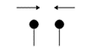

单点触摸报告延迟[SyRD-PROTOTYPE-0021]
需求描述/ Requirement Description | Requirement: Touch latency is measured from the time an object touches the screen until a report has been sent to the host. The latency shall be no more than 25 ms when any point in the standard mapping is pressed when the report rate is set to maximum.  要求：触摸延迟是从对象接触屏幕的时间开始测量，直到报告被发送到主机。当报告速率设置为最大值时，按下标准映射中的任意点时，延迟不超过25 ms。
对运行环境的依赖和影响/Impact and dependence on the operating environment | Dependence: None  Impact: None
验证标准/Verification criteria | 触控实验验证

多点触摸报告延迟[SyRD-PROTOTYPE-0022]
需求描述/ Requirement Description | Requirement: Touch latency is measured from the time an object touches the screen until a report has been sent to the host. The latency shall be no more than 25 ms when any combination in the 3.2.6.2. Standard touch locations is pressed when the report rate is set to maximum.  要求：触摸延迟是从对象接触屏幕的时间开始测量，直到报告被发送到主机。当报告速率设置为最大值时，按下3.2.6.2.标准触摸位置中的任意目标组合时，延迟不超过25 ms。  Targets:  1+3+7+9  10+11+12+13  4+5+6  2+5+8
对运行环境的依赖和影响/Impact and dependence on the operating environment | Dependence: None  Impact: None
验证标准/Verification criteria | 触控实验验证

多触点定位精度[SyRD-PROTOTYPE-0023]
需求描述/ Requirement Description | Requirement: The centroids of the recorded touches shall be confined in circles with radii of 2 mm centered on the targets. Every target shall be pressed and hold down with a standard touch for one second. Combination can be refered in the 3.2.6.2. Standard touch locations.  要求：记录的接触的中心点应被限制在以目标为中心的半径为2毫米的圆内。每一个目标都要按下并按下长达一秒钟。组合点位可在3.2.6.2.标准触摸位置中查询。  Targets:  1+2+3 (row行)  4+5+6 (row行)  7+8+9 (row行)  1+4+7 (column列)  2+5+8 (column列)  3+6+9 (column列)  1+9 (diagonal对角)  3+7 (diagonal对角)  10+5+13 (diagonal对角)  10+11+12+13 (shadowed point有阴影的点)  备注：机台单机械臂工作，每次只能打一个点，不支持多点触控。 产品可满足准确度：中心0.8mm/边缘1.0mm。能满足多点触摸操作，可通过人的手指触摸测试。
对运行环境的依赖和影响/Impact and dependence on the operating environment | Dependence: None  Impact: None
验证标准/Verification criteria | 触控实验验证

单线精度[SyRD-PROTOTYPE-0024]
需求描述/ Requirement Description | Requirement: The lines in the figures beneath shall be traced with the standard touch object pressing down at the surface with different forces and moving in different speeds.  The forces are: 1 N and 5 N.  The velocities are: 30 mm/s and 200 mm/s.  Bare copper column and column covered in glove shall be used. In total 8 recordings shall be made for every line.  要求：下面图形中的线条应由标准接触物体以不同的力和速度在表面按下进行描摹。  测试力：1N和5N  速度：30毫米/秒和200毫米/秒。  使用裸露的铜柱，每行共记录8次。  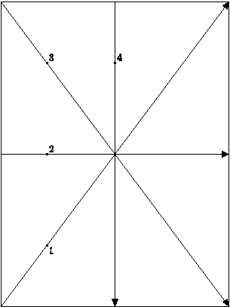  For every cloud of points recorded (for every line with every force and every velocity) a tendency line with the same slope as the target line shall be calculated using a least squares method.  The average distance, i.e. the distance from the tendency line to the traced line shall be no more than 2 mm. The maximum distance from a recorded point to the tendency line shall be no more than 0.5 mm.  Note: The maximum difference is measured differently from[IDMS]:part18.1.2  对于记录的每一团点（每一种力和每一种速度的每一条线），应使用最小二乘法计算与目标线斜率相同的趋势线。  平均距离，即趋势线到跟踪线的距离不超过2mm。从记录点到趋势线的最大距离不应超过0.5毫米。  注：最大差值的测量与 [IDMS]不同：第18.1.2部分
对运行环境的依赖和影响/Impact and dependence on the operating environment | Dependence: None  Impact: None
验证标准/Verification criteria | 触控实验验证

单弧精度[SyRD-PROTOTYPE-0025]
需求描述/ Requirement Description | Requirement: The lines in the figures beneath shall be traced with the standard touch object pressing down at the surface with different forces and moving in different speeds.  The forces are: 5 N and 1 N.  The velocities are: 30 mm/s and 200 mm/s.  Bare copper column and column covered in glove shall be used. In total 8 recordings shall be made for every line.  要求：下面图形中的线条应由标准接触物体以不同的力和速度在表面按下进行描摹。  测试力：1N和5N  速度：30毫米/秒和200毫米/秒。  使用裸露的铜柱和带手套的铜柱，每行共记录8次。  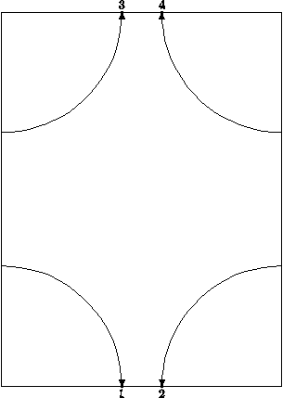  Each of these lines are quarter circles with center points located at the display corners. Every measurement will result in a cloud of N points, consisting of two coordinates, x and y.  每条线都是四分之一圆，中心点位于显示角上。每一次测量都会产生N个点的云，由x和y两个坐标组成。  For each line (cloud of points) the distance and angle from the center/display-corner to each point shall be computed. For line 1 the transform is:  对于每条线（点云），从中心/显示角到每个点的距离和角度都要计算。对于第1行，变换是：r=√(x^2+y^2 ),φ=tan^(-1)⁡〖y/x〗.  For the other lines the points must be linearly translated before the transform is applied. Then the mean value of the distance from the arc center can be computed for each line:  对于其他直线，在应用变换之前，这些点必须进行线性平移。然后计算每条直线到圆弧中心距离的平均值：<r>=1/N ∑_N▒r  For each measurement r should be plotted as dependent of φ. Ideally all points should be at the same distance from the arc center, i.e. r = R. At least one test shall be performed with R=6 cm (quarter-CD).  对于每一次测量，r应绘制成依赖于φ的曲线。理想情况下，所有点到圆弧中心的距离应该相同，即r = r。至少应进行一次r =6 cm的测试（quarter-CD）。  The mean value of the measured distances shall not differ more than 2 mm from the target, i.e. |<r>-R|≤2 mm. Additionally the maximum deviation from the tendency line must be less than 0.5 mm, i.e. |r-<r>|≤0.5 mm for all points for all lines.  测量距离的平均值与目标之间的差距不得超过2毫米。此外，所有点与趋势线的最大偏差必须小于0.5 mm。  Arc accuracy test is applicable when HMI functionality requires such movement, see [HMI Gestures]. Any deviation to the test procedure shall be defined in agreement with GEELY/supplier.  弧度精度测试适用于HMI功能需要这样的运动，参见[HMI手势]。测试程序的任何偏差应根据与吉利/供应商的协议确定。
对运行环境的依赖和影响/Impact and dependence on the operating environment | Dependence: None  Impact: None
验证标准/Verification criteria | 触控实验验证

双弧精度[SyRD-PROTOTYPE-0026]
需求描述/ Requirement Description | Requirement: A display shall be able to track 2 simultaneous arcs with the same precision as in 3.2.7.18.Single arc accuracy. Arc accuracy test is applicable when HMI functionality requires such movement, see [HMI Gestures]. Any deviation to the test procedure shall be defined in agreement with GEELY /supplier.  要求：显示器应能同时跟踪2条弧，精度与3.2.7.18.单弧精度相同。弧度精度测试适用于HMI功能需要这样的运动，参见[HMI手势]。测试程序的任何偏差应根据与吉利/供应商的协议确定。  备注：通过人触摸操作划双弧线测试。
对运行环境的依赖和影响/Impact and dependence on the operating environment | Dependence: None  Impact: None
验证标准/Verification criteria | 触控实验验证

触摸空间抖动[SyRD-PROTOTYPE-0027]
需求描述/ Requirement Description | Requirement: Every target in the standard mapping shall be pressed down with a standard touch and being held for 10 seconds. The centroids of the recorded contacts shall be confined in a circle with radius 2 mm located on the target.  Purpose: The coordinates that the touchscreen reports shall not drift or be noisy.  要求：标准映射中的每个目标都要按下标准触摸，并保持10秒。所记录的接触点的中心应限于一个半径为2毫米的圆内，该圆位于目标上。  目的：触摸屏报告的坐标不能漂移或有噪声。
对运行环境的依赖和影响/Impact and dependence on the operating environment | Dependence: None  Impact: None
验证标准/Verification criteria | 触控实验验证

触摸时抖动[SyRD-PROTOTYPE-0028]
需求描述/ Requirement Description | Requirement: The time between two consecutive touch reports is nominally T=1/f, where f is the touch report frequency. The actual time between two consecutive touch reports, t, shall not deviate more than ±20% from the nominal time T. I.e. |T-t|≤T*0.2 |.  要求：两个连续的触摸报告之间的时间名义上是T=1/f，其中f是触摸报告频率。两个连续的触摸报告之间的实际时间t与标称时间的偏差不得超过±20%，即|T-t|≤T*0.2。
对运行环境的依赖和影响/Impact and dependence on the operating environment | Dependence: None  Impact: None
验证标准/Verification criteria | 触控实验验证

Lighting Requirements灯光要求

显示亮度均匀性 [SyRD-PROTOTYPE-0029]
需求描述/ Requirement Description | Requirement: Deviation from complete uniformity shall not be noticeable to human observer. Uniformity shall be less than 1.2 LJND (Luminance Just Noticeable Difference).  Purpose: An even distribution of light intensity is needed to achieve high optical fidelity. Bright or dark spots can be disturbing the viewer.  要求：对于观察者来说，完全均匀性的偏差是不明显的。均匀度应小于1.2 LJND（亮度仅有明显差异）。  目的：为了达到高的光学保真度，需要均匀的光强分布。明亮或黑暗的斑点会干扰观察者。
对运行环境的依赖和影响/Impact and dependence on the operating environment | Dependence: None  Impact: None
验证标准/Verification criteria | 显示屏测试报告

显示亮度可调性 [SyRD-PROTOTYPE-0030]
需求描述/ Requirement Description | Requirement: It shall be possible to adjust the brightness of the display in the range of 0%-100% at least 1024 steps. The scale shall appear to be linear to human observer. The contrast of the displayed imagery shall not be affected when the luminance is adjusted.  Purpose: It is important that the brightness of the displayed image matches the ambient lighting in the car, otherwise the display content might not be readable enough. Typically the display will appear dimmer during night-driving than during the day.  要求：显示屏的亮度至少经1024个阶段调节0-100%的亮度。该比例尺对观察者来说应该是线性的。调整亮度不影响显示图像的对比度。  目的：重要的是显示图像的亮度要与车内的环境照明相匹配，否则显示内容可能不够清晰。通常情况下，夜间驾驶时的显示屏会比白天更暗。
对运行环境的依赖和影响/Impact and dependence on the operating environment | Dependence: None  Impact: None
验证标准/Verification criteria | 显示屏测试报告

强光可视性 [SyRD-PROTOTYPE-0031]
需求描述/ Requirement Description | Requirement: The display must have an ACR greater than 10:1 under 40k lux specular illumination and 32k lux diffuse illumination under simultaneous wash-out and white-shirt conditions, while measurement is made in a non-specular position.  Purpose: The display will be exposed to direct sunlight from multiple angles due to its position and angle. A certain ambient contrast ratio is required in order for the contents of the display to be readable.  要求：在40k勒克斯直接照明和32k勒克斯漫射照明条件下，在非镜面位置进行测量，显示屏的ACR必须大于10:1。  目的：由于所处的位置和角度不同，显示屏在多个角度都直接暴露在阳光下。为使显示内容可读，需要一定的环境对比度。
对运行环境的依赖和影响/Impact and dependence on the operating environment | Dependence: None  Impact: None
验证标准/Verification criteria | 显示屏测试报告

高温保护策略 [SyRD-PROTOTYPE-0032]
需求描述/ Requirement Description | The backlight PWM under different temperature conditions is shown in the following curve:  不同温度条件下背光的PWM如以下曲线所示：  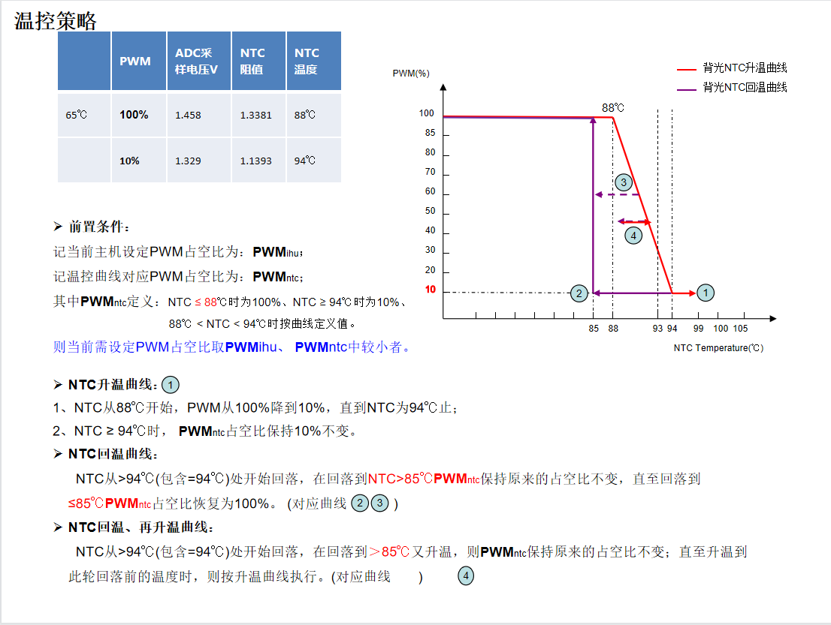  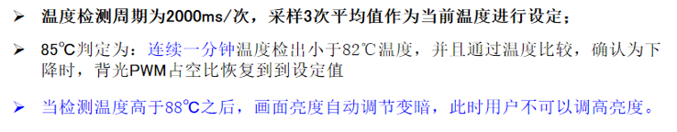  Note: The curve is for reference only, and will be adjusted according to the measured value of the product.  备注：曲线仅供参考，后续会根据产品实测值进行调整。
对运行环境的依赖和影响/Impact and dependence on the operating environment | Dependence: None  Impact: None
验证标准/Verification criteria | 按照以上的升温曲线和降温曲线进行验证

Display Requirements显示屏要求

光学要求 [SyRD-PROTOTYPE-0033]
需求描述/ Requirement Description | One of the core requirements for the display is that it must achieve readability in almost any realistic illumination. Typically, readability of a picture is closely related to the perceived contrast ratio. Datasheets for LCD-components always state contrast ratio in a dark room environment. However, a dark room environment is not the intended use case for this display. To ensure sunlight readability one needs to consider also the luminance level of the display, the environment illuminance and the reflective properties of the display as well.  When a display is deployed in a real world environment, the dark room contrast ratio is not an interesting feature anymore. Rather, one must consider the Ambient Contrast Ratio instead where the effects of disturbing light from the environment are also accounted for.  显示屏的核心要求之一是它必须在几乎任何实际的照明环境中实现可读性。通常，图像的可读性与感知到的对比度密切相关。LCD组件的数据表总是显示其在暗室环境中的对比度。然而，暗室环境不是此显示的预期用例。为了确保在阳光下的可读性，还需要考虑显示器的亮度水平、环境照度和显示器的反射特性。  当显示器部署在现实环境中时，暗室对比度不再是一个被关注的特性。相反，必须考虑环境对比度，而不是环境干扰光的影响也被考虑在内。  ACR=(L_White+L_Ambient)/(L_Black+L_Ambient )  Note, that L_White and L_Black are transmitted from the display and L_Ambient is reflected light from the environment.  注意，L_White和L_Black是通过显示器传输的，而L_Ambient是来自环境的反射光。  It is apparent from the formula that a high ACR can be achieved in two ways: either by increasing the white luminance or by reducing the reflections due to incoming light. Since most modern displays have dark room contrast ratios exceeding the hundreds it is not very fruitful to reduce the blackness level further. Of course, the dark room contrast must be high enough to give a pleasant viewing experience in low light conditions, for instance during night driving.  从公式中可以明显看出，高ACR可以通过两种方式实现：增加白色亮度或减少入射光的反射。由于大多数现代显示器的暗室对比度都超过了数百，因此进一步降低黑态亮度并不是很有效。当然，暗室的对比度必须足够高，以便在低光条件下，如夜间驾驶时，提供一个舒适的观看体验。  Notes，the display will be placed in the vehicle in such a way that it will be exposed to direct sunlight. The display will not be protected by a cap. However, due to specific geometry in the car, the driver will never experience a direct mirror image of the sun.  Thus the important cases to consider are:  - "Wash out" from lambertian reflection of direct sun illumination and diffuse sky illumination.  - "White shirt problem" from mirror reflections of illuminated occupants and car interior parts.  注意，显示器固定在车辆上的方式将使它直接暴露在阳光下。显示器没有顶盖保护。然而，由于汽车特定的几何形状，司机将永远不会感受到太阳的直接镜像。  因此，需要考虑的重要情况是：  - “冲洗”，太阳直射和天空漫反射的朗伯反射。  - “白衬衫问题”，停留人员和汽车内饰零件的镜面反射。  GEELY believes that the following requirements will give a display which has sufficient readability. However we are aware that some of the requirements are very tough and that the design could be very complicated due to heat and power consumption. Therefore GEELY wants to discuss possible ways to simplify the design, ease unwanted side effects and increase robustness if readability is only marginally reduced.  If nothing else is mentioned, then measurements are to be made on the complete unit.  GEELY认为，如下要求将提供一个具有足够可读性的显示器。然而，我们意识到，由于热量和电力消耗，一些要求是非常严格的，设计可能会非常复杂。因此，GEELY希望可以讨论一些可行的简化设计方案，在减轻不必要的副作用和保证稳定性的情况下，可读性只略微降低。  如果没有提到需求，那么这些测量将在完整的组件上进行。
对运行环境的依赖和影响/Impact and dependence on the operating environment | Dependence: None  Impact: None
验证标准/Verification criteria | 显示屏测试报告

摩尔条纹 [SyRD-PROTOTYPE-0034]
需求描述/ Requirement Description | Requirement: The display shall not have any visible moiré patterns.  要求：显示屏不得有任何可见的云纹图案。
对运行环境的依赖和影响/Impact and dependence on the operating environment | Dependence: None  Impact: None
验证标准/Verification criteria | 显示屏测试报告

最佳观看方向 [SyRD-PROTOTYPE-0035]
需求描述/ Requirement Description | Requirement: The display shall have optimal optical properties when viewed from the driver’s position and passenger side, display should secure decent readability and quality.  要求：显示屏应具有最佳的光学性能，当从司机侧和乘客侧观察时，显示屏应确保良好的可读性和质量。
对运行环境的依赖和影响/Impact and dependence on the operating environment | Dependence: None  Impact: None
验证标准/Verification criteria | 显示屏可视角度测试

水平显示视角 [SyRD-PROTOTYPE-0036]
需求描述/ Requirement Description | Requirement: The dark room contrast ratio shall be greater than 60:1 in the viewing angles defined by θH =±60°, θV=0°.  The dark room contrast ratio shall be greater than 10:1 in the viewing angles defined by θH=±80°, θV=0°.  Purpose: To ensure optical fidelity in important directions.  要求：视角为θH=±60°，θV=0°时，暗室对比度应大于60；视角为θH=±80°，θV=0°时，暗室对比度应大于10。  目的：保证重要方向的光学保真度。
对运行环境的依赖和影响/Impact and dependence on the operating environment | Dependence: None  Impact: None
验证标准/Verification criteria | 显示屏可视角度测试

无挡风玻璃反射 [SyRD-PROTOTYPE-0037]
需求描述/ Requirement Description | Requirement: The display（DIS/CSD/PSD） shall restrict its light emission in the upwards direction. A maximum of 1 cd/m^2 is allowed to be emitted for θH > TBD° when the display is dimmed to 50 cd/m^2 perpendicular.  Purpose: If the display emits light towards the windscreen, the driver could be distracted by the reflection.  要求：显示器应限制其向上发光。当显示器被调暗到50 cd/m^2时，θH > TBD°的亮度最大允许为1 cd/m^2。  目的：如果显示屏向挡风玻璃发射光线，驾驶员会被反射的光线分散注意力。
对运行环境的依赖和影响/Impact and dependence on the operating environment | Dependence: None  Impact: None
验证标准/Verification criteria | 显示屏可视角度测试

显示颜色空间 [SyRD-PROTOTYPE-0038]
需求描述/ Requirement Description | Requirement: The color gamut of the complete display unit shall conform to sRGB according to IEC 61966-2-1. Any deviation from target values will affect saturation and hue of the emitted color. Each primary color (R, G or B) can be allowed to deviate from sRGB spec along the saturation direction (the line that connects the primary color to the white point). The hue direction (perpendicular to the saturation direction) needs to be controlled tighter. Deviations will be judged against the complexity to color manage multiple source devices/multiple display devices. Deviation from saturation is less important than deviation from sRGB hue.  Purpose: The sRGB standard color space was chosen in order to harmonize color appearance across multiple displays in the car, and in order to simplify color management of multiple graphics sources.  要求：整个显示屏的色域应符合IEC 61966-2-1的sRGB要求。任何偏离目标值都会影响颜色的饱和度和色调。每个原色（R, G或B）可以允许沿饱和度方向（连接原色到白点的线）偏离sRGB规格。色调方向（垂直于饱和度方向）需要更严格的把控。偏差将根据色彩管理多源设备/多显示设备的复杂性来判断。饱和度的偏差比sRGB色相的偏差更重要。  目的：选择sRGB标准颜色空间是为了协调车内多个显示器的颜色外观，并简化多个图形源的颜色管理。
对运行环境的依赖和影响/Impact and dependence on the operating environment | Dependence: None  Impact: None
验证标准/Verification criteria | 显示屏色域测试报告

显示器gamma曲线 [SyRD-PROTOTYPE-0039]
需求描述/ Requirement Description | Requirement: The display shall conform to the gamma curve defined in IEC-61966-2-1.  要求：显示屏应符合IEC-61966-2-1中规定的gamma曲线。
对运行环境的依赖和影响/Impact and dependence on the operating environment | Dependence: None  Impact: None
验证标准/Verification criteria | 显示屏gamma测试报告

显示闪烁 [SyRD-PROTOTYPE-0040]
需求描述/ Requirement Description | Requirement: The display must not flicker when displaying any screen, including the flickering of streaks when shooting the display with the phone.  要求：显示屏在显示任何画面时都不能有闪烁问题，包括手机拍摄显示屏时不能出现条纹闪烁等异常现象。
对运行环境的依赖和影响/Impact and dependence on the operating environment | Dependence: None  Impact: None
验证标准/Verification criteria | 显示屏测试报告

像素切换时间 [SyRD-PROTOTYPE-0041]
需求描述/ Requirement Description | Requirement: The supplier shall provide a matrix showing all possible transitions from one gray value to another. The times shall be measured from 10-90% of the transition.  Purpose: Long pixel switching times will introduce unwanted ghosting artifacts when objects move rapidly across the screen.  要求：供应商应提供一个从一个灰度值到另一个灰度值的所有可能转换的矩阵。时间应该从转变的10%-90%开始测量。  目的：当物体在屏幕上快速移动时，长时间的像素切换会引入不必要的重影现象。
对运行环境的依赖和影响/Impact and dependence on the operating environment | Dependence: None  Impact: None
验证标准/Verification criteria | 显示屏测试报告

输入延迟 [SyRD-PROTOTYPE-0042]
需求描述/ Requirement Description | Requirement: The input lag, i.e. the time measured from the start of the vertical blanking until the display has been completely updated must be less than 5 ms. In case the display does support real time image enhancement it must be possible to bypass.  Purpose: In order to improve image quality some displays perform extensive processing. This could introduce unwanted severe latencies.  要求：输入延迟，即从垂直消影开始到显示完全更新的时间必须小于5 ms。如果显示屏确实支持实时图像增强，则必须能够绕过它。  目的：为了提高图像质量，一些显示器进行大量的运算。这可能会导致不必要的严重延迟。
对运行环境的依赖和影响/Impact and dependence on the operating environment | Dependence: None  Impact: None
验证标准/Verification criteria | 显示屏测试报告

暗室对比度 [SyRD-PROTOTYPE-0043]
需求描述/ Requirement Description | Requirement: The display shall have a minimum Dark Room Contrast Ratio of 1000:1 for the Design Viewing Direction (not perpendicular).  Purpose: The contrast ratio must be high to give a good video quality in low light environments. Too low ratio will result in insufficiently low blackness level.  要求：显示器的设计观察方向（不垂直）的暗室对比度至少为1000:1。  目的：在弱光环境下，对比度必须高才能保证视频质量。过低的比例会导致黑度不够低。
对运行环境的依赖和影响/Impact and dependence on the operating environment | Dependence: None  Impact: None
验证标准/Verification criteria | 显示屏对比度测试报告

没有条带效果 [SyRD-PROTOTYPE-0044]
需求描述/ Requirement Description | Requirement: A set of test images must be generated and shown on the display. The set must contain the following images: Linear gradient 0% gray → 100% gray; Linear gradient 0% red → 100% red; Linear gradient 0% green → 100% green; Linear gradient 0% blue → 100% blue.  要求：必须生成一组测试图像并显示在显示器上。该套必须包含以下图像：线性梯度0%灰→100%灰，线性梯度0%红→100%红，线性梯度0%绿→100%绿，线性梯度0%蓝→100%蓝。  The displayed images must be recorded with a imaging photometer. Bands, such as those in the following picture must not be visible.  Purpose: If graphics with smooth color gradients is shown on a display with a too limited color depth, then visually disturbing bands will appear.  显示的图像必须用成像光度计记录。例如下图中的那些条带不能被看见。  目的：如果在颜色深度很有限的显示器上显示平滑的颜色梯度图形，则会出现视觉干扰条带。  
对运行环境的依赖和影响/Impact and dependence on the operating environment | Dependence: None  Impact: None
验证标准/Verification criteria | 显示屏测试报告

空间抖动噪音 [SyRD-PROTOTYPE-0045]
需求描述/ Requirement Description | Requirement: A set of test images must be generated and shown on the display. The set must contain the following images: Linear gradient 0% gray → 100% gray; Linear gradient 0% red → 100% red; Linear gradient 0% green → 100% green; Linear gradient 0% blue → 100% blue.  要求：必须生成一组测试图像并显示在显示器上。该套必须包含以下图像：线性梯度0%灰→100%灰，线性梯度0%红→100%红，线性梯度0%绿→100%绿，线性梯度0%蓝→100%蓝。  Visual artifacts due to spatial dithering, such as those in the following picture, must not be visible.  Purpose: If spatial dithering is used to improve the HW color depth, then the noise of a picture will increase. This is not acceptable beyond a certain level.  由于空间抖动造成的视觉效果，例如下图中的那些抖动必须是不可见的。  目的：如果使用空间抖动来提高HW颜色深度，则会增加图像的噪声。超过一定的标准是不能接受的。  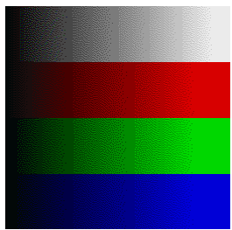
对运行环境的依赖和影响/Impact and dependence on the operating environment | Dependence: None  Impact: None
验证标准/Verification criteria | 显示屏测试报告

压力不均匀效应 [SyRD-PROTOTYPE-0046]
需求描述/ Requirement Description | Requirement: No visible disturbance is allowed when a force of 10 N is applied to the touch surface. The standard touch object shall be used at the standard touch locations.  Purpose: When pressure is applied to an LCD-screen, visible artifacts may appear.  要求：当10N的力作用于接触表面时，不允许有可见的扰动。标准触摸对象应使用在标准触摸位置。  目的：当压力施加到液晶显示屏上时，可能会出现可见的伪影。
对运行环境的依赖和影响/Impact and dependence on the operating environment | Dependence: None  Impact: None
验证标准/Verification criteria | 显示屏测试报告

屏幕参数要求 [SyRD-PROTOTYPE-0047]
需求描述/ Requirement Description | 序号NO. Part / Requirement 零件/要求 'Minimum requirements Display 显示屏最低要求  1 Size尺寸 14.6"（横屏 Landscape Mode）  2 Pixel density像素密度 151 PPI  3 Display active area有效显示区域 323.136mm x 181.764 mm  4 Aspect ratio横纵比 16:9  5 Image resolution 图像分辨率 1920 RGB(H)x 1080(V)  6 显示模式 （Display mode） LTPS Incell /Normally Black  7 Cover lens material玻璃盖板材料 Strengthened aluminosilicate glass 加强铝硅酸盐玻璃  8 Cover lens edge玻璃盖板边缘 No sharp edges are allowed on glass edges to avoid scratching fingers 玻璃边缘不允许有锋利边，避免刮伤手指。 （盖板四周加0.5R角并抛光，抛光效果后续主观评审0.5R Angle is added around the cover plate and polished, and the polishing effect is subject to subsequent review）  9 Touch触摸 Capacitive Multi touch 电容式多点触摸  10 Wide View Film视角补偿膜 With有  11 - Privacy film防窥膜 Without没有  12 Display surface appearance 显示表面外观 Glossy 光滑的  13 Rear cover surface appearance 后盖表面外观 According to the color definition file requirements 按色彩定义文件要求执行  14 Coating涂层 Anti Reflective, easy to clean 防反光，易清洁  15 Display surface scratch resistance 显示器表面耐划伤性 The display surface shall have sufficient scratch resistance for in-vehicle touchscreen usage. 显示器表面应具有足够的抗划伤能力，以适应车内触摸屏的使用。  16 Display Anti-Smudge Treatment显示屏防污迹处理 The display must have an easy to clean coating such that fingerprints can be easily wiped off with a dry micro fiber cloth 显示屏必须有易于清洁的涂层，这样指纹就可以很容易地用一块干燥的纤维布擦拭掉  17 Frame Rate帧率 Minimum: 60 Hz  18 Gamma伽玛 Gamma: 2.2 @ VESA 标准  19 Image Sticking图像残留 No visible image sticking 无可见图像残留  20 Pixel Aspect Ratio像素比 1:1  21 Vcom tuning360全景画面 Vcom tuning required to minimize flicker 360全景画面要求无闪烁  22 Color depth颜色深度 16.7M  23 Touch Information触点检测 Touch interaction shall feel fluid and instant and precise and support multi touch points 触摸交互应当感到流畅，即时和准确,支持同时10个触摸点  24 Touch Area触摸区域 Touch area corresponding to CSD part of active area, DIM part of active area is not intended to have touch interaction. 触摸区对应于有效区CSD部分，有效区昏暗部分（黑边）没有触摸交互。  25 Touch Glove Support支持手套触摸 Display shall support use with gloves up to 3.5mm thickness. 显示屏应当支持使用3.5毫米厚度手套触摸。  26 Interaction technology交互技术 1. Touch； 1. 触摸；  27 Video throughput视频处理能力 The LVDS GMSL link shall support a capacity of 6Gbps including overhead。 LVDS GMSL连接必须支持6 G bps的能力包括正常的输出。
对运行环境的依赖和影响/Impact and dependence on the operating environment | Dependence: None  Impact: None
验证标准/Verification criteria | Review显示屏规格报告

屏幕性能要求 [SyRD-PROTOTYPE-0048]
需求描述/ Requirement Description | 序号 参数 性能指标  S/N Parameter Performance indexes  1 亮度 Luminance（L）（cd/m²） Perpendicular Min. 800  A+ area: H +/- 10°, V +8/-4° Min. 700  A: area: H +/- 40°, V +20/-10° Min. 400  B: area: H +/- 50°, V +20/-10° Min. 300  2 对比度（CR） Perpendicular Min:1200/Typ: 1500  A+ area: H +/- 10°, V +8/-4° Min.800 Typ 1000  A: area: H +/- 40°, V +20/-10° Min. 500 Typ 800  B: area: H +/- 50°, V +20/-10° Min. 300 Typ 500  3 显示区亮度均一性 , (9 points) Active area Luminance uniformity (9 points) 255 灰阶 255 grey Min.80%,Typ:85%  零灰阶 Min.50%  0 grey  4 色度 Chromaticity Wx 0.300±0.03  Wy 0.320±0.03  Rx 0.676±0.03  Ry 0.319±0.03  Gx 0.297±0.03  Gy 0.660±0.03  Bx 0.148±0.03  By 0.066±0.03  5 色饱和度NTSC Color gamut (NTSC) 色温 CCT Min 80% Typ 85%  CCT: 7000K+/-500  6 响应时间（Ton/Toff） Response time (Ton/Toff) +25℃(ms) Typ.22，Max.25  0℃(ms) Typ:45,Max.60  –20℃(ms) Typ:135,Max.200  –30℃(ms) Typ:300,Max.350  7 颜色数量（bit） Color depth (bit) 3 x 8 bit 16.7M  8 可视角度 （CR≥10:1） Viewing angle (CR≥10:1) （无防窥膜，without LCF） 左视角（ф=0度） ≥85，typ88  Left viewing angle (ф = 0°)  右视角（ф=180度） ≥85，typ88  Right viewing angle (ф = 180°)  上视角（ф=90度） ≥85，typ88  Up viewing angle (ф = 90°）  下视角（ф=270度） ≥85，typ88  Down viewing angle (ф = 270°）  9 表面反射率（SCI） AR ＜2%  Surface reflection (SCI)  10 表面处理（Surface Treatment） AG 5% or less+主观评价  AF水滴角23℃，≤30%RH ≥110°+主观评价  11 一体黑 ΔE＜2  12 表面硬度 Surface hardness ≥3H Uncoated aluminum-silicon glass 未贴膜铝硅玻璃：≥6H  13 显示模式（Display mode） LTPS Incell /Normally Black 常黑  14 Gamma（25°C） г = 2.2 ±0.2  15 色偏 Color shift 全视角无色偏现象  No color shift in full viewing angle  17 表面温度 Surface Temperature Max 45℃+主观评测，PWM 100%, 25℃ AA区9点测试  18 工作电压 Operating Voltage 9 - 16V  19 标称电压 Nominal Voltage 12V  16 发光性寿命（+25°C） 10，000h 后衰减到不小于80%  Luminescence lifetime (+25°C) Attenuation to less 80% after 10,000 h  17 最低亮度变暗（cd/m²） ＜1  Dimming minimum brightness（cd/m²）  18 闪烁性（JEITA 测试）（dB） Flicker (JEITA test) (dB) Max.-30  19 触控性 线性度（mm） Center ±1，Edge ±2 Coupper size @8mm直径8mm铜柱进行测量  Linearity (mm)  精确度（mm） Center ±1，Edge ±2 Coupper size @8mm直径8mm铜柱进行测量  Accuracy (mm)  两指分离度（mm） 14(Center) Coupper size @8mm直径8mm铜柱进行测量  Two finger separation (mm)  20 残影测试 Image sticking 老化时间:2H, Burn-in time, 2H 环境温度:65℃ Ta=65℃ 老化画面 Pattern: 棋盘格 H/8*V/6 Burn-in pattern, chess H/8*V/6 判定画面：50% Gray Judge pattern: 50% Gray 5min后：不可见或轻微可见， 观察距离10cm到50 cm。 Judge after 5min Invisible or Slightly visible at distance 10cm to 50 cm.
对运行环境的依赖和影响/Impact and dependence on the operating environment | Dependence: None  Impact: None
验证标准/Verification criteria | Review显示屏测试报告

User Interface Prototype用户界面原型
NA

Interface Requirements接口需求

Video Connector [SyRD-INTERFACE-0001]
需求描述/ Requirement Description | - Connector Layout  连接器布局  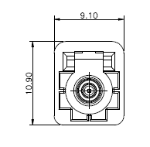  脚位* 功能* 额定电流(mA)*  1 同轴输入 0.1  2 Shield_GND 0.1
对运行环境的依赖和影响/Impact and dependence on the operating environment | Dependence: None  Impact: None
验证标准/Verification criteria | Check pin definition in product drawing

Main Connector [SyRD-INTERFACE-0002]
需求描述/ Requirement Description | - Main Connector, 8 Pins  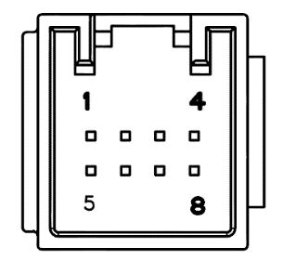  脚位* 功能* 额定电流(A)*  1 B+ 2  2 NC -  3 Monitor_EN 0.1  4 NC -  5 GND 2  6 NC -  7 powerkey（预留） 0.1  8 NC -
对运行环境的依赖和影响/Impact and dependence on the operating environment | Dependence: None  Impact: None
验证标准/Verification criteria | Check pin definition in product drawing

Battery链路要求 [SyRD-INTERFACE-0003]
需求描述/ Requirement Description | Requirement: All internal voltage regulators shall be protected against over temperature and overcurrent. Internal voltage regulators shall be of switch mode type (PWM) with efficiency above 85%. The number of regulators shall be minimized as much as possible. The protection circuit shall not be activated within the normal operating range of the specified unit.  要求：所有内部电压调整器应保护过温和过电流。内部调压器应采用开关式（PWM），效率85%以上。应尽量减少调节器的数量。保护电路不得在本规定的单元正常工作范围内激活。
对运行环境的依赖和影响/Impact and dependence on the operating environment | Dependence: None  Impact: None
验证标准/Verification criteria | Review电气测试报告

视频链路要求

视频干扰[SyRD-INTERFACE-0004]
需求描述/ Requirement Description | Requirement: The display shall under no circumstances show distorted imagery.  要求：显示屏在任何情况下均不得出现扭曲的图像。
对运行环境的依赖和影响/Impact and dependence on the operating environment | Dependence: None  Impact: None
验证标准/Verification criteria

视频传输损耗[SyRD-INTERFACE-0005]
需求描述/ Requirement Description | Requirement: In case video transmission from the DHU/IHU is lost, then a black static image or other controlled graphic shall be shown.  Purpose: To ensure perception of quality.  要求：如果DHU/IHU的视频传输丢失，则应显示黑色静态图像或其他受控图形。  目的：确保感知质量。
对运行环境的依赖和影响/Impact and dependence on the operating environment | Dependence: None  Impact: None
验证标准/Verification criteria

视频时序[SyRD-INTERFACE-0006]
需求描述/ Requirement Description | Requirement: The display shall accept a video signal with timing as defined by VESA Coordinated Video Timing with reduced blanking.  要求：显示屏应接受VESA（视频电子标准协会）定义的定时视频信号，调节视频时序，减少消隐。
对运行环境的依赖和影响/Impact and dependence on the operating environment | Dependence: None  Impact: None
验证标准/Verification criteria

信息的提出[SyRD-INTERFACE-0007]
需求描述/ Requirement Description | Requirement: The use of EDID is not required. However, in case the LCD-panel does contain EDID-information then it must be correct and it shall be possible to pass it to the video host through the control channel.  Purpose: An LCD-element may contain preferred timing-information stored in a memory called EDID.  要求：不要求使用EDID。但如果液晶显示屏确实包含EDID信息，那它必须正确并可以通过控制通道传递给视频主机。  用途：LCD元件可以包含存储在名为EDID的内存中的首选定时信息。
对运行环境的依赖和影响/Impact and dependence on the operating environment | Dependence: None  Impact: None
验证标准/Verification criteria

Erroneous Video Signals错误的视频信号[SyRD-INTERFACE-0008]
需求描述/ Requirement Description | Requirement: The display shall show a black static image in case faulty video signal is received. Operation shall return to normal when a proper signal is received again.  Purpose: A video signal with faulty synchronization signals shall not damage the display.  要求：如果接收到错误的视频信号，显示屏应显示黑色静态图像。当再次收到正确的信号时，应恢复正常显示。  目的：同步信号有问题的视频信号不应损坏显示器。
对运行环境的依赖和影响/Impact and dependence on the operating environment | Dependence: None  Impact: None
验证标准/Verification criteria

Design Constraints 设计约束

芯片选型 [SyRD-Constraints-0001]
需求描述/ Requirement Description | Full AUTOSAR architecture shall be used. And AUTOSAR stack 4.3 shall be implemented.  序号 No. 对应的供货级零件号 芯片代码（三级代码） 规格型号 是否车规级(Y/N) 单件用量 芯片供应商/生产地点/代理商 备选芯片（按需） 备注  芯片的规格型号需得到买方认可  chip specifications need to be recognised by the buyer*
对运行环境的依赖和影响/Impact and dependence on the operating environment
验证标准/Verification criteria

电气性能要求 [SyRD-Constraints-0002]
需求描述/ Requirement Description | ELP/电器性能  1)LV electronic components should meet the requirement of Q/JLY J7210928D-2024 General technical requirements and test methods of automotive electronics and electronic components  低压电子零部件需满足Q/JLY J7111029E-2024《汽车电气和电子部件通用技术要求和试验方法》规范要求;  2)High voltage and Middle voltage electronic components should meet the requirement of “ELP requirement”;  高压和中压产品满足《ELP要求》的要求  ELP/电器性能  1. ELP Component Subsystem Requirements ELP 零部件系统要求  1) LV electronic components should meet the requirement of Q/JLY J7210928D-2024 General technical requirements and test methods of automotive electronics and electronic components  低压电子零部件需满足Q/JLY J7210928D-2024《汽车电气和电子部件通用技术要求和试验方法》规范要求;  2) High voltage and Middle voltage electronic components should meet the requirement of “ELP requirement”;  高压和中压产品满足《ELP要求》的要求;  3) ELP test items should be confirmed and signed by ELP engineer which define in DVP document.  DVP里面定义的ELP测试项目必须和ELP工程师达成一致，并由ELP工程师签字。  2. Complete vehicle ELP requirements 整车ELP要求  1) OEMs will perform complete vehicle verification test. Supplier should cooperate to resolve any non-compliance issues on complete vehicle level.  主机厂会进行整车验证试验，卖方应配合ELP设计人员解决整车级任何不符合的问题。  2) In cases where the root cause module or system has not demonstrated compliance with component level requirements, the supplier shall fund subsequent vehicle level investigations and sign-off tests for the associated failure.  在问题模块及零部件无法满足零部件要求的情况下，卖方应提供资金满足后续的整车排查所发生的费用。  3) During the vehicle development cycle and after mass production, whether the ELP test results of electronic components are qualified or not, if there is any ELP incompatibility problem in the whole vehicle level, the seller should cooperate unconditionally with the buyer to solve the ELP problem.  在车型开发周期内及量产之后，不管电子零部件ELP测试结果是否合格，如果在整车级别出现任何的ELP不符合问题，卖方应无条件配合买方解决ELP不符合问题。
对运行环境的依赖和影响/Impact and dependence on the operating environment | Dependence: None  Impact: None
验证标准/Verification criteria | Design Review

EMC电磁兼容性要求 [SyRD-Constraints-0003]
需求描述/ Requirement Description | EMC/电磁兼容  Electronic components should meet the requirement of Q/JLY J7110779E-2023电子零部件需满足Q／JLY J7110779E-2023《乘用车电气／电子零部件电磁兼容规范》规范要求;  1)High voltage components should meet the requirement of Q/JLY J7110779E-2023& Q/JLY J7110922D-2024;  高压产品满足标准Q/JLY J7110779E-2023和Q/JLY J7110922D-2024《电驱动乘用车高压零部件电磁兼容规范》要求;  2)High voltage driven motor and control unit should be test with real load and as a system .E-chamber/Bluebox is recommend for load device.  高压驱动电机及电机控制器必须作为一个系统而且带真实的负载测试,推荐使用E-chamber/Bluebox加载。  3)In addition to separate test of high voltage charger and charging gun, additional test of charging system is needed.  高压充电机和充电枪除了单独测试之外，还需要增加充电系统模式测试。  EMC/电磁兼容  1. EMC Component Subsystem Requirements EMC 零部件系统要求  1) All components shall meet all the related EMC legal requirements and regulations specified by the target market including China, US, EU, UK and ROW. When there is component EMC certification requirement from the related target market, supplier must obtain the accreditation, including but not limited to E-MARK, FCC Certification, CCC Certification, etc.  所有零部件应满足目标市场的所有相关的EMC标准法规的要求。目标市场包括中国市场、美国市场、欧洲市场、英国市场及其他市场等。如果目标市场有相应零部件EMC认证要求的，则卖方品必须取得该认证资格，包括但不限于E-MARK认证，FCC认证，CCC认证等。  Electronic components should meet the requirement of Q/JLY J7110779E-2023电子零部件需满足Q／JLY J7110779E-2023《乘用车电气／电子零部件电磁兼容规范》规范要求;  2) High voltage components should meet the requirement of Q/JLYJ7110779E-2023&Q／JLY Q/JLY J7110922D-2024;  高压产品满足标准Q/JLYJ7110779E-2023和Q/JLY J7110922D-2024《电驱动乘用车高压零部件电磁兼容规范》要求;  3) EMC test items should be confirmed and signed by EMC engineer which define in DVP document.  DVP里面定义的EMC测试项目必须和EMC工程师达成一致，并由EMC工程师签字。  4) EMC test Plan should be submit to EMC engineer before two months base on PA stage, test plan should be signed in PA stage. supplier should do the test in authorized lab by Buyer after EMC test plan signature by both side, and test report should be submit to EMC engineer before VP1 building ;  卖方在PA节点前两个月提交EMC测试计划给EMC工程师审核，在PA节点之前签订测试计划，审核通过后双方签字，才能到买方指定的第三方实验室测试, 并在VP1造车之前提交合格的EMC报告给EMC工程师。  5) High voltage driven motor and control unit should be test with real load and as a system .E-chamber/Bluebox is recommend for load device.  高压驱动电机及电机控制器必须作为一个系统而且带真实的负载测试,推荐使用E-chamber/Bluebox加载。  6) In addition to separate test of high voltage charger and charging gun, additional test of charging system is needed.  高压充电机和充电枪除了单独测试之外，还需要增加充电系统模式测试。  2. Complete vehicle EMC Requirements 整车EMC要求  1) OEMs will perform complete vehicle verification test. Supplier should cooperate to resolve any non-compliance issues on complete vehicle level.  主机厂会进行整车验证试验，卖方应配合EMC设计人员解决整车级任何不兼容的问题。  2) In cases where the root cause module or system has not demonstrated compliance with component level requirements, the supplier shall fund subsequent vehicle level investigations and sign-off tests for the associated failure.  在问题模块及零部件无法满足零部件要求的情况下，卖方应提供资金满足后续的整车排查和行业相关认证失败所发生的费用。  3) During the vehicle development cycle and after mass production, whether the EMC test results of electronic components are qualified or not, if there is any EMC incompatibility problem in the whole vehicle level, the seller should cooperate unconditionally with the buyer to solve the EMC problem.  在车型开发周期内及量产之后，不管电子零部件EMC测试结果是否合格，如果在整车级别出现任何的EMC不兼容问题，卖方应无条件配合买方解决EMC不兼容问题。
对运行环境的依赖和影响/Impact and dependence on the operating environment | Dependence: None  Impact: None
验证标准/Verification criteria | Design Review

电平衡仿真要求[SyRD-Constraints-0004]
需求描述/ Requirement Description | The final vehicle verification shall prevail最终以整车验证通过为准 EBS Requirement / 电平衡仿真要求  EBS Requirement / 电平衡仿真要求  Supplier should provide the related information of central stack display, including nominal voltage, nominal power ,Max Voltage,Current curve @ start phase,Quiescent Current,Max Current,Norminal Current,Norminal Current,Temperature-Resistance Curve,etc. to meet the requirement of OEM for evaluation of power consumption and whole vehicle electrical balance. 卖方需要提供中控显示屏的相关信息，包括 额定电压、额定功率 最大工作电压,启动瞬时电流(动态曲线),静态电流，最大工作电流，额定电流，温度-电阻变化曲线等参数，以满足主机厂对于零部件电耗及整车电平衡的评估。
对运行环境的依赖和影响/Impact and dependence on the operating environment | Dependence: None  Impact: None
验证标准/Verification criteria | Design Review

人机及座椅舒适性[SyRD-Constraints-0005]
需求描述/ Requirement Description | Ergonomics /整车人机工程  The final evaluation shall be subject to the buyer's 《Ergonomic Assessment Standard》.  最终以买方《人机工程评价规范》评价通过为准。  Serviceability /使用维护性  - The vehicle shall not require the development of any new "Special Service Tools". IF necessary, New Special Service Tools shall be possible to use in other vehicle of Buyer. And please provide the special tools design drawing.本车型应不需要开发新的专用工具。如果必须开发，新开发的专用工具应适用于买方其他车型，并提供专用工具的设计图纸。  - The basic requirements for "Special Service Tools" is must still feasible and durable with standard tools,and rationalization for the working procedure.对于专用工具最基本的要求是必须与普通工具一样便于操作、耐用和操作的合理性。  - The technical requirement must be provided, if this part need special technology, special procedures, special temperature and special operating condition to service and repair, and if not according to some sequence or method to disassembly and installation will damage the part or wounded people,  如果该零部件的售后维修需要特殊的技术要求、操作步骤、温度要求和操作规范，以及如没有按照特定拆装顺序、拆装方法会造成零部件损坏或人员伤亡的情况，则必须需要提供相关技术要求  - The correct performed service and repair procedures shall not subject the individual performing the task to unreasonable risk of injury.  正确执行的售后维修操作步骤不能出现不合理的人员受伤。  - It must be convenient for inspection and disassembly during warranty maintenance( satisfy the space requirements of maintenance tools or maintenance personnel hand ), if this part is a daily warranty maintenance parts.  如果该零部件为售后日常保修保养零部件，则必须便于保修保养时检查和拆装(满足维修工具或维修人员手部空间要求)。  - The connector of the wiring harness and pipes(hoses) must be convenient for sight check when it is designed.  线束连接器和管路的接头在设计时，必须便于售后目视检查。  - The Quality/failure history must be provide, which is recorded from all test and experiment of this part when it developed and manufacture, and let it failure or fault.  该零部件在研发和制造过程所做的测试和试验并使之故障或失效的历史，必须提供给买方。  - The Design Specification must be provided, if this part is eletronic component or vehicle feature function parts.  如果该零部件是电器元件或车辆配置功能部件，则必须提供该零部件的设计规格书。
对运行环境的依赖和影响/Impact and dependence on the operating environment | Dependence: None  Impact: None
验证标准/Verification criteria | Design Review

安全设计要求[SyRD-Constraints-0006]
需求描述/ Requirement Description | Crash Requirements碰撞要求  All parts of the vehicle must be designed to provide maximum safety for the passenger in the event of a crash.  车辆的所有部件都必须设计成在发生事故时为乘客提供最大限度的安全。  Occupant protection general 乘员保护：  The interior decorations should not fall off during the collision碰撞过程中内部装饰物不能脱落。  There should be no sharp edges to the interior trim in the collision that may cause damage to the occupant碰撞中内饰件不能出现对乘员可能造成伤害的锋利锐边。
对运行环境的依赖和影响/Impact and dependence on the operating environment | Dependence: None  Impact: None
验证标准/Verification criteria | Design Review

Quality Requirements质量需求

Performance 性能

Quiescent Current [SyRD-QUALITY-0001]
需求描述/ Requirement Description | Requirement: The current consumption for a touchscreen unit shall not exceed the figures in the table below. All figures are averages over 10 minutes.  要求：触屏设备的当前耗电量不能超过下表中的数字。所有数据均为10分钟以上的平均值。  Operating mode Current  当前工作模式  Sleep睡眠 t≤100µA  Wake up唤醒 t≤150mA  Normal正常 t≤2 A
对运行环境的依赖和影响/Impact and dependence on the operating environment | Quiescent current is affected by temperature and voltage.
验证标准/Verification criteria | The system connects to Head unit.  When battery voltage is 9V to 18V, quiescent current shall be less than 0.1mA in CSD_Off state.

Wake Up To Normal Mode唤醒到正常模式 [SyRD-QUALITY-0002]
需求描述/ Requirement Description | Requirement: When power is applied to the display it shall enter its low power mode within 100 ms.When the DHU establishes a communication channel and sends a wakeup command, the display must enter its normal mode and be able to receive and display video within 500 ms.This means that in the case power is supplied at time 0 and the DHU sends a wakeup command at 100 ms then the display shall have full functionality within 600 ms.Backlight shall be available at 90% maximum intensity.  Purpose: A fast start-up time is required in order to give a premium impression.  要求：当电源应用于显示屏时，显示屏应在100毫秒内进入低功耗模式。当DHU建立通信通道并发送唤醒命令时，显示屏必须进入正常模式，并能够在500毫秒内接收和显示视频。这意味着，如果在0时刻提供电源，DHU在100毫秒发送唤醒命令，那么显示屏将在600毫秒内完成全部功能。背光应在90%最大强度下可用。  目的：快速启动时间是必要的，以给人一个良好的印象。
对运行环境的依赖和影响/Impact and dependence on the operating environment | Dependence: None  Impact: None
验证标准/Verification criteria

Operating Mode 操作模式[SyRD-QUALITY-0003]
需求描述/ Requirement Description | Sleep: This mode is entered automatically when power is supplied to the display. In this mode the display has the lowest possible power consumption. The screen must be dark. The display is in a mode that allows it to detect when the DHU establishes a link.  睡眠：当电源供应给显示屏时，将自动输入此模式。在这种模式下，显示屏的功耗可能是最低的。屏幕一定是暗的。显示屏的模式允许它检测DHU何时建立链接。  Touch: In this mode the parts of the display that make up the touch functionality are active in low power mode. This means that the display will be able to detect a user interaction and forward it to the DHU. The latency (measured from start of user interaction until a report has been sent to the DHU) must be less than 100 ms. In this mode there must be a control communication link established between the DHU and the display.  触摸：在这种模式下，组成触摸功能的显示屏部分在低功耗模式下是活动的。这意味着显示屏将能够检测用户交互并将其转发给DHU/IHU。延迟（从用户交互开始到向DHU/IHU发送报告为止）必须小于100 ms。在这种模式下，DHU/IHU和显示屏之间必须建立控制通信连接。  Normal: In this mode the display has full functionality. This means that video is received and shown on the display, possibly with 100% backlight and that the touch interface has full performance.  正常：在这种模式下，显示屏具有完整的功能。这意味着视频被接收并显示在显示器上，可能是100%背光，触摸界面具有完全的性能。  The display moves between the operating modes when certain commands are sent from the DHU through the LVDS control link.  当某些命令从DHU/IHU通过LVDS控制连接发送时，显示屏在操作模式之间移动。
对运行环境的依赖和影响/Impact and dependence on the operating environment | Dependence: None  Impact: None
验证标准/Verification criteria

Change Of Operating Mode工作模式改变[SyRD-QUALITY-0004]
需求描述/ Requirement Description | Requirement: The display must be able to do the following mode-switches within the following frames: Power → Touch ≤200 ms.  Purpose: In order to achieve good responsiveness, the display must be able to change operating mode quickly.  要求：显示屏必须在下列时限内完成下列模式转换：上电→触摸≤200毫秒。  目的：为了达到良好的反应能力，显示屏必须能够迅速改变工作模式。
对运行环境的依赖和影响/Impact and dependence on the operating environment | Dependence: None  Impact: None
验证标准/Verification criteria

Current Consumption - General 耗用电流-一般 [SyRD-QUALITY-0005]
需求描述/ Requirement Description | Requirement: To enable energy and power availability, safe operation of the vehicle, low CO2 impact and battery service life, the unit must be designed to minimize the current consumption.Functions and components shall be optimized to have minimum electrical power consumption at all driving cycles.  要求：为了保证能源和电力的可用性，车辆的安全运行，低二氧化碳的影响和电池的使用寿命，该装置的设计必须使电流消耗最小化。功能和部件应优化，使其在所有驱动循环中具有最小的电力消耗。  General electric current consumption requirement: No function, no consumption.  通用电流消耗要求：无功能，无消耗。  Functions and systems can be ordered to reduce or shut down functionality (electrical power) to ensure power availability to Function Importance Class B and C functions, e.g. climate functions, some infotainment functions, interior light.  功能和系统可以被命令减少或关闭功能（电力），以确保电力可用性，以发挥重要的B类和C类功能，如气候功能，一些信息娱乐功能，室内照明。  When not in driving-enabled mode the unit is not allowed to be active and consume any electrical power unless a function is activated by the customer or if certain features needs to be active due to functional demands.  在未启用驱动模式时，除非客户激活某个功能，或者由于功能需求某些功能需要激活，否则不允许该单元处于激活状态并消耗任何电能。  Nodes connected to any network, not activated by the driver, are not allowed to consume more electrical power than needed not to handle with communication.  连接到任何网络的节点，不被驱动程序激活，不允许消耗比不处理通信所需更多的电能。  Automatically activated functions must be avoided when not in driving-enabled mode. Approval of automatically activated functions must be obtained from department for electrical system architecture. If no electrical function is activated by the customer the vehicle is regarded as being parked and the requirements for long time parking is valid.  在未启用驾驶模式时，必须避免自动激活的功能。自动激活功能必须获得电气系统架构部门的批准。如果客户未激活任何电气功能，则视为车辆正在停放，长时间停车的要求是有效的。
对运行环境的依赖和影响/Impact and dependence on the operating environment | Screen display refresh rate is affected by temperature.
验证标准/Verification criteria

Reliability 可靠性

System reliability [SyRD-QUALITY-0007]
需求描述/ Requirement Description | - The system shall be functional at temperature range: -40°C ~+85°C.  - If the temperature is too high or too low, the system shall take protective measures. For example: reduce brightness, turn off the screen, turn off the system, etc.
对运行环境的依赖和影响/Impact and dependence on the operating environment | Dependence: None  Impact: None
验证标准/Verification criteria | Detect TFT temperature, if it is exceeded 85°C, the system reduces brightness.  Detect PCB temperature, if it is exceeded 90°C, the system goes to CSD_off mode.

Data storage [SyRD-QUALITY-0008]
需求描述/ Requirement Description | The following data shall be stored in non-volatile memory,  - Touch adjustment values  - Slider and sensor key adjustment values  - HWR parameter  - Diagnostic data  - Illumination parameters
对运行环境的依赖和影响/Impact and dependence on the operating environment | Dependence: None  Impact: None
验证标准/Verification criteria | Touch adjustment values, Slider and sensor key adjustment values, HWR parameter, Diagnostic data, Illumination parameters are stored in non-volatile memory.

Compatibility 兼容性

Functional Safety Requirement 功能安全需求
No function safety requirement for CSD project.

Cyber Security Requirements 网络安全需求
No Cyber safety requirement for CSD project.

Maintainability 可维护性

Customer Upgrade [SyRD-QUALITY-0010]
需求描述/ Requirement Description | 软件升级：要求:CSD底层软件可以通过专用工具进行刷写升级.
对运行环境的依赖和影响/Impact and dependence on the operating environment | Dependence: None  Impact: None
验证标准/Verification criteria | Perform an upgrade test to check whether the upgrade can be successful.

Expandability可扩展性
需求描述/ Requirement Description | Future Growth Requirements未来的增长需求  Requirement: The unit shall be able to cope with 30% growth. This applies to hardware (memories, CPU performance) and user-interface.  要求:该单位应能应付30%的增长。这适用于硬件(内存、CPU性能)和用户界面。  Purpose: To allow for future functional growth, the design shall from the beginning reserve space for upgrades.  目的:为了未来功能的增长，设计从一开始就应该预留空间进行升级。
对运行环境的依赖和影响/Impact and dependence on the operating environment | Dependence: None  Impact: None
验证标准/Verification criteria | Design review.

Testability 可测试性

Test interface [SyRD-QUALITY-0011]
需求描述/ Requirement Description | CSD is activated to automate test via remote control message.  Blow messages are used for test mode.  DEV_CSD_1_Req_04  DEV_CSD_1_Resp_04  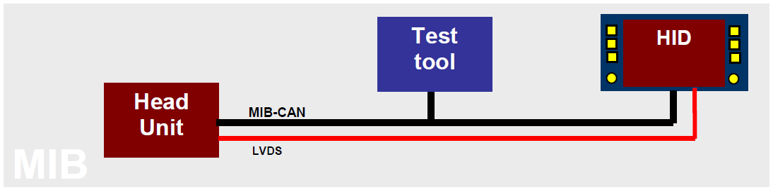  Remark: The requirement of test interface is from ‘MIB_Testinterface_v1.14E_20200619_SK’.
对运行环境的依赖和影响/Impact and dependence on the operating environment | Dependence: None  Impact: None
验证标准/Verification criteria | Use test tool to enter test mode to run automate test.

Trace port [SyRD-QUALITY-0012]
需求描述/ Requirement Description | Software developer can access trace data through trace port.
对运行环境的依赖和影响/Impact and dependence on the operating environment | Dependence: None  Impact: None
验证标准/Verification criteria | The host computer obtained related information through trace port.

Internal fault code [SyRD-QUALITY-0013]
需求描述/ Requirement Description | MCU record internal fault code when display have errors.  Software developer can access IFC through trace port.
对运行环境的依赖和影响/Impact and dependence on the operating environment | Dependence: None  Impact: None
验证标准/Verification criteria | The host computer obtained IFC through trace port.

Implement Requirements实施需求

Verification and Validation 环境适应性要求

VOC&Odor /车内空气质量[SyRD-IMPLEMENT-0001]
需求描述 /Requirement Description | VOC&Odor /车内空气质量  Part test requirementSee chapter 5零部件测试要求见第5章节  The final vehicle verification shall prevail最终以整车验证通过为准  VOC&Odor /车内空气质量  1、Odor requirements/气味要求  CSD components and materials shall be met the standard for Q/JLY J7111031D-2023 Technical Specifications for Limits of Odor Ratings of Automobile Interior Nonmetal Parts and Materials  CSD 零部件部位材料气味需满足Q/JLY J7111031D-2023《车内非金属件部位及材料气味等级限值》 (Ⅰ类) 要求  2、VOC emission requirements /VOC要求  NA  3、Fogging requirements/雾化要求  CSD parts shall be met Q/JLY J7110341D-2020《Requirements for the Fogging and Test Method for vehicle interior Non-metallic components and materials》  CSD零部件需要满足标准 Q/JLY J7110341D-2020《车内非金属材料雾化性限值要求及试验方法》的要求。  4、VIAQ key parts Material/Process/Storage/Logistics general requirements/关重零部件配方&工艺&仓储流转通用要求  According to the parts requirements in ESOW Annex Air Quality Requirements, the parts are screened according to the actual situation.按照ESOW附件《空气质量要求》中零件要求，根据零部件实际情况筛选。  必须要求must requirements  供应商需要对零件生产仓储物流过程中的污染风险进行先期分析并提出解决方案  Suppliers need to analyze and propose solutions to the pollution risks in the process of parts production , storage and transfer.  供应商需配合吉利进行关重零部件冻结资料的锁定工作，提供材料、工艺、包装仓储物流、验证报告等信息  Suppliers need to cooperate with Geely to lock in the freezing of key parts, and provide materials, processes, packaging and warehousing logistics, verification reports and other information.  零件制造过程中需遵循“先进先出”原则，并将仓储及物流工艺作为生产管控的一部分  The principle of "first in, first out" must be followed in the manufacturing process of the parts, and the storage and transfer processes should be part of the production control.  零件的包装及仓储条件需要能够满足零件充分通风散发的需求，必要的时候采取零件成品通风放置处理并固化为生产工艺的一部分  The packaging and storage conditions of the parts need to meet the requirements of adequate ventilation, the production process of the finished parts with ventilated should be cured when necessary.  车内关重件塑料件制造禁止使用回料  Do not use waste materials for the manufacture about car interior plastic key parts.  车内关重件塑料件量产过程中禁止使用脱模剂。零件生产开始的首20模，或者使用脱模剂后的20模需要报废处理  Do not use mold stripper during the mass production of car interior plastic key parts. Scrap disposal of the first 20 molds for the production of parts, or the 20 molds after using the mold stripper.  车内关重件塑料件量产过程中禁止使用自喷漆，鞋油等材料进行表面修复  Do not use self - spray paint , shoe polish and other materials for surface repair during the mass production of car interior plastic key parts.  车内关重件塑料件进行模流分析及模具设计时需充分考虑到工艺温度对气味的影响，确保改性PP类材料注塑温度<210℃，复合纤维PP类材料注塑温度<230℃，ABS类材料<230℃，PC/ABS类材料<250℃  The mold flow analysis and mold design of the car interior key parts must fully consider the influence of process temperature on the smell, ensure the injection temperature less than 210℃ of the modified PP , and the composite fiber PP less than 230 °C, ABS less than 230°C, PC/ABS less than 250°C.  车内关重件塑料件注塑前需充分烘干并通风，并将该措施纳入工艺文件管控范围内  The car interior plastic key parts must be fully dried and ventilated before injection molding,and the measures should be included in the scope of control of the process documents.  车辆内饰、空调、电器部件所使用的聚甲醛材料（POM）需使用吉利认可的低散发牌号  The vehicle interiors, air conditioners, and electrical components should use Polyoxymethylene (POM) , which must bu required to use Geely-approved low-emission grades.  为保证产品材料稳定性并利于气味散发，车内空气关重件所使用PU发泡材料发泡工艺后需设置48小时以上的熟化时间并良好通风  In order to ensure the stability of the material of the product and facilitate the emission of smell, it is necessary for the in-air car key parts to set the curing time above 48 hours after the foaming process of the PU foam material.  车内空气关重件上所使用PU发泡材料需使用反应型的反应型催化剂，禁止使用BHT抗氧化剂  The PU foam material must be used in the in-air car key parts with reactive amine-free catalyst, and it is forbidden to use BHT antioxidant.  车内面料的火焰复合工艺作为影响气味的一项关键工艺，火焰复合厂家需在吉利认可范围内  The flame composite process of the interior fabric is a key process affecting the smell. The flame composite manufacturer needs to be within the scope of Geely's accreditation.  注塑前塑料粒子进行烘料（温度 ≥80℃，干燥时间≥ 2H），注塑过程中尽量降低注塑温度及压力（温度≤220℃）  Baking of plastic partiles before injection is required, baking temperature is above 80°C and baking time is above 2 hours; during injection, temperautre and presuure should be monitored and controlled to below 220°C.  车内面料的背覆PU海绵作为影响气味的一项关键材料，PU海绵供应商需在吉利认可范围内  The PU back cover sponge of the interior fabric is a key material affecting the smell. The PU sponge supplier needs to be within the scope of Geely's accreditation.  禁止在车内使用木质密度板材料  Inside the car, do not use medium-density fibreboard.  禁止使用激光工艺切割面料  Laser cutting of fabrics is prohibited.  5、Others/其他  On the precondition of meeting parts in-car limit value, parts shall be met the vehicle in-car limit requirement. When the later results cannot match with the design requirement, the supplier should improve the parts in-car environment index as per the vehicle in-car environment target set by Party A.  在满足零部件车内环境限值要求的前提下，还需要满足整车车内环境限值的要求，当整车车内环境试验结果不满足设计要求时，供应商应按照甲方整车车内环境目标改进零部件车内环境指标。  The pass of Supplier VIAQ control capability audit is a necessary stage before defining VIAQ key part supplier.  车内空气关重件的供应商定点需经过材料部门认可，满足供应商气味控制能力评审达标。  Supplier should sign Commitment to VOC and odor with buyer, and sign the VIAQ key parts material and process detailed list after finishing the development of VIAQ key parts  供应商需与买方签订VOC气味承诺书，并在项目开发后期配合买方完成关重件材料工艺清单的冻结与签订。
对运行环境的依赖和影响/Impact and dependence on the operating environment | Dependence: None  Impact: None
验证标准/ Verification criteria | Design validation

Corrosion Protection/防腐[SyRD-IMPLEMENT-0002]
需求描述 /Requirement Description | Corrosion Protection/防腐  For general requirements, see.一般要求见Q/JL J160003-2024《乘用车零部件防腐技术要求》  Part test requirementSee chapter 5.零部件测试要求见第5章节  The final vehicle verification shall prevail.最终以整车验证通过为准  Corrosion Protection/防腐  1. Corrosive Environment Description/腐蚀环境描述  CSD is inside the vehicle body. Metallic parts are invisible, they belong to slight corrosion (F1) that should not contact with water and sweat, should not be soaked. Buttons and other central console parts are non-metallic electroplating parts that belong to general corrosion (F2) that can contract with water and sweat, may be soaked.  CSD 位于车身内部，金属部件为不可见零部件，不接触水、汗液、污渍等，属于轻微腐蚀（F1），中控按钮等非金属电镀件为可见零部件，可能接触水、汗液、污渍等，属于一般腐蚀（F2）。  Table 1 Classification and Definition of Parts Corrosion Level  表1 零部件腐蚀等级划分及定义  Corrosion grade  腐蚀级别 Corrosivity position  区域腐蚀性 Vehicle area  整车区域 Area corrosion environment description  区域腐蚀性定义 Example of body distribution  车身分布示例  F1 Low corrosivity  轻微腐蚀 Inside body  车身内部 Used when the position is not affected by macro wetness, mud/ dirt, road (deicing) salts;  不会受到液体、泥污、道路盐侵害的区域； drive cab;  驾驶室内;  F2 Medium corrosivity  中等腐蚀 Outside body  车身外部 when the position is at most moderately affected by macro wetness, mud/ dirt, road (deicing) salts, invisible area;  受到中等程度（非直接溅射）液体、泥污、道路盐侵害的区域，不可见区域。 inside door (outside waterproof film) /(inside tailgate/hood)  车门内部(防水膜外)/ 后背门/机罩内部  F3 High corrosivity  高等腐蚀 Outside body  车身外部 when the position is at most moderately affected by macro wetness, mud/ dirt, road (deicing) salts, open visible area;  受到中等程度（非直接溅射）液体、泥污、道路盐侵害的区域，开启可见区域； upper compartment(above upper edge of front longitudinal)、door/ tailgate/ hood open visible area  机舱上部(以纵梁上表面为界)、车门/后背门/机罩开启可见区域  F4 Severe corrosivity  严重腐蚀 Inside body  车身外部 Default for all positions directly affected by rain, road spray, stone chipping and dirt accumulation, chassis and exterior directly visible area;  直接受到雨水冲击、道路溅射、石击和泥污累积的区域，底盘和外部直接可见区域； bottom compartment(under upper edge of front longitudinal)、chassis area、body exterior  机舱下部(以纵梁上表面为界)、底盘区域、车身外饰  Note: If a part belongs to different corrosive areas, corrosion protection of the part shall be carried out according to the highly corrosive area.  注：如果某个零部件同时属于不同腐蚀区域，该零部件防腐要求按照高腐蚀区域执行。  2. Appearance requirement of coating/涂镀层外观要求  Appearance of coating shall be smooth, even and continuousl, there shall not be visible coating defects, e.g blister, pore, crack, flaking, pitting, granule, wrinkling, bruise or partial uncoated layer, except the inevitable defects caused by the basic material defect.  涂镀层外观应平整光滑、均匀、连续，无明显可见的涂镀层缺陷，如起泡、孔隙、裂纹、剥落、麻点、颗粒、起皱、划碰伤或局部无涂镀层等，但因基体材料缺陷引起的不可避免的缺陷除外。  3. Parts Corrosion Protection Requirement/零件防腐要求  Parts anti-corrosion requirement/零件防腐要求  CSD parts shall be meet Q/JL J160003-2024《vehicle parts anti-corrosion technical requirements 》  CSD零部件需要满足标准Q/JL J160003-2024《乘用车零部件防腐技术要求》。  4. Complete Vehicle Corrosion Protection Requirements/整车防腐要求  On the condition of meeting the components anti-corrosion requirements, the requirements of vehicle road strengthening corrosion test shall be met as well. In case of different results between vehicle test and components test, the vehicle test results prevail. Supplier shall improve the anti-corrosion performance based on the vehicle test targets provided by Buyer.在满足零部件耐腐蚀的前提下，还需要满足整车道路强化腐蚀试验要求，当整车试验结果与零部件耐腐蚀结果出现不一致时，以整车试验结果为准，卖方应按照买方整车试验目标改进耐腐蚀性能.
对运行环境的依赖和影响/Impact and dependence on the operating environment | Dependence: None  Impact: None
验证标准/ Verification criteria | Design validation

Aging/老化[SyRD-IMPLEMENT-0003]
需求描述 /Requirement Description | Aging /老化  For general requirements, see.一般要求见Q/JL J160004-2023《乘用车非金属零部件耐光老化性能技术要求》  Q/JLY J7110192E-2022《乘用车内外饰非金属零部件耐温性老化性能技术要求》  Q/JLY J7111521A-2020《乘用车橡胶部件耐臭氧老化性能要求和试验方法》  Test requirementSee chapter 5.测试要求见第5章节  The final vehicle verification shall prevail.最终以整车验证通过为准  Aging /老化  1、Environment Description/环境描述  CSD is inside the vehicle body , the IP top cover is impacted greatly by the sunshine but the bottom cover is relative less impacted.  CSD 位于车身内部，仪表板上罩受阳光影响较大，仪表板下罩受阳光影响相对较小。  2、Resistance to light aging/耐光老化  CSD parts shall be meet Q/JL J160004-2023  CSD零部件需要满足标准Q/JL J160004-2023  3、Resistance to long term heat /耐长周期热老化要求  CSD parts shall be meet Q/JLY J7111037C-2024乘用车车载屏幕总成技术条件  CSD零部件需要满足标准Q/JLY J7111037C-2024乘用车车载屏幕总成技术条件  1，高温工作耐久 High temperature operation endurance.  产品经5.4.10试验后，应符合 4.2、4.3条规定，功能等级满足A类要求。前500小时，技术性能和参数必须满足要求，后500小时允许技术性能下降，但不允许功能失效。  After the product has been tested according to 5.4.10, it shall meet the specified in 4.2 and 4.3, and its functional status shall meet the requirements of Class A. Performance and parameters shall meet requirements for 0-500hrs, performance and parameters could be decreased for the last 500hrs but function failure is not allowed.  1.1高温工作耐久  High temperature operation endurance.  A级，温度85℃，测试周期1000小时。Grade A, Temperature 85℃，test time 1000hrs.  1.2功能等级定义Definition of functional status.  A级 ：试验中和试验后，装置/系统所有功能满足设计要求。  Class A: During and after the test, all functions of the device/system meet the design requirements.  外观评价要求：试验后 灰度等级≥4级，外观无可视缺陷。  Appearance evaluation requirements: the gray level ≥4 after the test, and the appearance has no visible defects.  4、Resistance to short term heat/耐短周期热老化要求  CSD parts shall be meet Q/JLY J7111037C-2024乘用车车载屏幕总成技术条件  CSD零部件需要满足标准Q/JLY J7111037C-2024乘用车车载屏幕总成技术条件  1，高温工作High temperature work  产品经5.4.1试验后，应符合4.2、4.3条规定，功能等级满足A类要求。  After the product has been tested according to 5.4.1, it shall meet the requirements specified in 4.2 and 4.3, and its functional status shall meet the requirements of Class A.  1.1高温工作 High temperature work  在85℃下工作96H  Work for 96 h at 85℃  1.2 功能等级定义Definition of functional status  A级 ：试验中和试验后，装置/系统所有功能满足设计要求。  Class A: During and after the test, all functions of the device/system meet the design requirements.  5、Resistance to impact at low temperature/耐低温冲击  CSD parts shall be meet Q/JLY J7111037C-2024乘用车车载屏幕总成技术条件  CSD零部件需要满足标准Q/JLY J7111037C-2024乘用车车载屏幕总成技术条件  1，耐冷热冲击Thermal shock  产品经过5.4.8试验后，应符合4.2、4.3条规定，功能等级满足C类要求。  After the product has been tested according to 5.4.8, it shall meet the requirements specified in 4.2 and 4.3, and its functional status shall meet the requirements of Class C.  1.1冷热冲击Thermal shock  参考ISO 16750-4 2010 5.3.2.2 将产品放置在试验箱中，处于不工作状态，产品在按照表7进行200个循环，试验后在室温下放置2h后，进行外观、机械结构和功能检查及主要性能测试。  Refer to ISO 16750-4 2010 5.3.2.2, place the product (not work) in the test chamber and conduct the thermal shock test according to Table 6. After the test, condition the product at room temperature for 2h. And then check the product for appearance, mechanical structure, functions and main performances.  表5 温度定义  Table 5 temperature definition of Tmin and Tmax  Tmin Tmax  B级 Grade B -40℃ 85℃  表7 冷热冲击试验条件  Table 7 Conditions for thermal shock test  参数 Parameter 总成 Assembly  低温（Tmin） Low temperature (Tmin) See table 5  高温（Tmax） High temperature (Tmax) See table 5  高低温转换时间 Time for switching from high temperature to low temperature ＜ 30s  循环数量 Cycles 200  高或低温保存时间 Duration of being stored at high/low temperature 1h  1.2功能等级定义Definition of functional status  C级 ：试验中装置/系统一个或多个功能不满足设计要求，但试验后所有功能能自动恢复到正常运行。  Class C: During the test, one or more functions of the device/system do not meet the design requirements, but all functions can be automatically restored to normal operation after the test.  外观评价要求：试验后 灰度等级≥4级，外观无可视缺陷。  Appearance evaluation requirements: the gray level ≥4 after the test, and the appearance has no visible defects.  6、Resistance to storage at low temperature/耐低温存放  CSD parts shall be meet Q/JLY J7111037C-2024乘用车车载屏幕总成技术条件  CSD零部件需要满足标准 Q/JLY J7111037C-2024乘用车车载屏幕总成技术条件  1，低温贮存Low temperature storage  产品经5.4.4试验后，应符合4.2、4.3条规定，功能等级满足C类要求。要求：试验前后外观功能正常，恢复到室温过程中无异响。  After the product has been tested according to 5.4.4, it shall meet the requirements specified in 4.2 and 4.3, and its functional status shall meet the requirements of Class C.  1.1低温贮存Low temperature storage  在-40℃，贮存24H  Storage for 24 h at -40℃  1.2 功能等级定义Definition of functional status  C级 ：试验中装置/系统一个或多个功能不满足设计要求，但试验后所有功能能自动恢复到正常运行。  Class C: During the test, one or more functions of the device/system do not meet the design requirements, but all functions can be automatically restored to normal operation after the test.  7、Resistance to climate variation/耐环境交变  CSD parts shall be meet Q/JLY J7111037C-2024乘用车车载屏幕总成技术条件  CSD零部件需要满足标准 Q/JLY J7111037C-2024乘用车车载屏幕总成技术条件  1， 温度循环耐久Temperature cycling endurance  产品经5.4.11试验后，应符合 4.2、4.3条规定，功能等级满足A类要求。前245循环，技术性能和参数必须满足要求，后243循环允许技术性能下降，但不允许功能失效。  After the product has been tested according to 5.4.10, it shall meet the specified in 4.2 and 4.3, and its functional status shall meet the requirements of Class A. Performance and parameters shall meet requirements for the first 245 cycles, performance and parameters could be decreased for the last 243 cycles but function failure is not allowed.  1.1 温度循环耐久Temperature cycling endurance  温度循环曲线如图3，节点c-d和e-g正常工作模式，其余加电不工作；温变速率4℃/min；高低温保持时间30min，低温最后五分钟唤醒。按照表8进行试验，循环数488。  Temperature cycling curve as below figure 3. Operation mode for slot c-d and e-g, the other slots powered but not work. Temperature change rate 4℃/min, keep the DUT at Tmax. and Tmin. for 30min.The Tmin. last 5 min is on active mode. perform the test as table 8, 488 cycles.  表5 温度定义  Table 5 temperature definition of Tmin and Tmax  Tmin Tmax  B级 Grade B -40℃ 85℃  图3 温度循环  Fig. 3 Temperature cycling  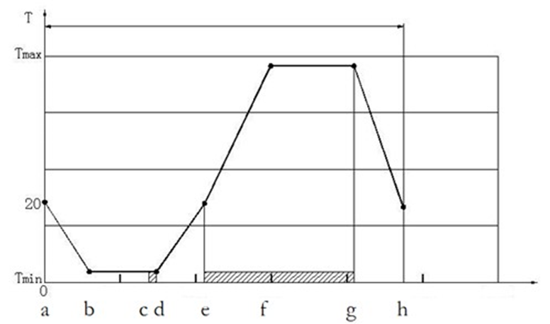  表8 温度和持续时间  Table 8 Temperature and Duration  节点 Slot 时间min Duration min 温度℃ Temperature, °C  a 0 20  b 15 Tmin see table 5  c 40 Tmin see table 5  d 45 Tmin see table 5  e 60 20  f 76.25 Tmax see table 5  g 106.25 Tmax see table 5  h 122.25 20  1.2 功能等级定义Definition of functional status  A级 ：试验中和试验后，装置/系统所有功能满足设计要求。  Class A: During and after the test, all functions of the device/system meet the design requirements.  外观评价要求：试验后 灰度等级≥4级，外观无可视缺陷。  Appearance evaluation requirements: the gray level ≥4 after the test, and the appearance has no visible defects.  8、Resistance to humidity aging/耐湿热老化要求  CSD parts shall be met Q/JLY J7111037C-2024乘用车车载屏幕总成技术条件  CSD零部件需要满足标准Q/JLY J7111037C-2024乘用车车载屏幕总成技术条件  1，稳态湿热Damp heat steady-state  产品经5.4.9试验后，应符合 4.2、4.3条规定，功能等级满足A类要求。  After the product has been tested according to 5.4.9, it shall meet the specified in 4.2 and 4.3, and its functional status shall meet the requirements of Class A.  1.1 稳态湿热Damp heat steady-state  A级, 温度(60±2)℃；相对湿度：(93%±3%)RH；一个循环24小时，前23小时加电不工作，最后一个小时工作；共21个循环。  Grade A, Temperature (60±2)℃; Relative humidity (93%±3%)RH; 24 hrs for one cycle, 23 hrs powered but not work, the last hour operation, totally 21 cycles.  1.2 功能等级定义Definition of functional status  A级 ：试验中和试验后，装置/系统所有功能满足设计要求。  Class A: During and after the test, all functions of the device/system meet the design requirements.  外观评价要求：试验后 灰度等级≥4级，外观无可视缺陷。  Appearance evaluation requirements: the gray level ≥4 after the test, and the appearance has no visible defects.  9、Resistance to ozone aging/耐臭氧老化要求  Ozone aging requirement is only for rubber material  臭氧老要求化只适用于橡胶材料。  NA  10、Complete Vehicle Aging Requirements/整车老化要求  On the condition of meeting the components aging requirements, the requirements of vehicle natural exposure and vehicle sunlight simulation shall be met as well. In case of different results between vehicle test and components test, the vehicle test results prevail. Supplier shall improve the aging performance based on the vehicle test targets provided by Buyer.  在满足零部件耐老化的前提下，还需要满足整车自然曝晒或整车日光模拟的试验要求，当整车试验结果与零部件耐光老化结果出现不一致时，以整车试验结果为准，卖方应按照买方整车试验目标改进老化性能。
对运行环境的依赖和影响/Impact and dependence on the operating environment | Dependence: None  Impact: None
验证标准/ Verification criteria | Design validation

Recyclability/回收 [SyRD-IMPLEMENT-0004]
需求描述 /Requirement Description | Recyclability /回收  For general requirements, see.一般要求见Q/JL J160002-2021《汽车回收利用管理规范》  Test requirementSee chapter 5.测试要求见第5章节  Recyclability /回收  1、 Recyclability /回收  Parts shall be met the following requirements:  零部件回收需满足：  1) CN-market&other non-EU and US market/中国市场/其他非欧美市场：  Requirements on hazardous subtances and recoverability control in Automotive“, Ministry of industry and information technology Announcement No. 38 of 2015.  《汽车有害物质和可回收利用率管理要求》中华人民共和国工业和信息化部2015年第38号公告。  The requirements haven’t been specified in ESOW shall be executed in accordance with the latest status of the relevant laws and regulations in the sales area.  ESOW中未规定部分，依照产品销售地区相关法规的最新状态执行。  2) EU-market/欧盟市场：  Directive 2000/53/EC of the European Parliament and of the Council of 18 September 2000 on end-of life vehicles and its legislation  欧盟汽车报废指令2000/53/EC及其修订指令。  DIRECTIVE 2005/64/EC OF THE EUROPEAN PARLIAMENT AND OF THE COUNCIL of 26 October 2005 on the type-approval of motor vehicles with regard to their reusability, recyclability and recoverability and amending Council Directive  70/156/EEC 车型型式认证关于RRR指令2005/64/EC及70/156/EEC修订指令  Kinds of battery,accumulator and power battery must comply with DIRECTIVE 2006/66/EC and the latest amending directive.The battery suppliers shall complete the battery registration obiligation and reg.info.(including battery type,reg.No.,reg.unit,producer orgnization, reg.country and etc.).  各种电池、蓄电池、动力电池满足指令2006/66/EC及其最新修订指令的要求。电池供应商需完成电池注册的义务，并提供注册信息（电池类型、注册号、注册单位、生产单位、注册国家等）。  For products exported to the European Union，the battery symbol shall be met the requirements of directive 2006/66/EC.：The symbol shown in Annex II shall cover at least 3 % of the area of the largest side of the battery, accumulator or battery pack, up to a maximum size of 5 × 5 cm. In the case of cylindrical cells, the symbol shall cover at least 1,5 % of the surface area of the battery or accumulator and shall have a maximum size of 5 × 5 cm. Where the size of the battery, accumulator or battery pack is such that the symbol would be smaller than 0,5 × 0,5 cm, the battery, accumulator or battery pack need not be marked but a symbol measuring at least 1 × 1 cm shall be printed on the packaging. Symbols shall be printed visibly, legibly and indelibly. Batteries, accumulators containing more than 0,0005 % mercury, more than 0,002 % cadmium or more than 0,004 % lead, shall be marked with the chemical symbol for the metal concerned: Hg, Cd or Pb. The symbol indicating the heavy metal content shall be printed beneath the symbol shown in Annex II and shall cover an area of at least one-quarter the size of that symbol.  出口欧盟地区产品，其电池标识应满足2006/66/EC指令的要求：符号附录II带有划叉的带轮垃圾箱标识；标识符号大小应覆盖电池、蓄电池或电池包最大侧面积的3%，且不得大于5cm×5cm；如果电池为圆柱形，则符号应覆盖电池或蓄电池表面面积的1.5%，并且不大于5cm×5cm；如果电池、蓄电池或电池包面积所限符号尺寸可能小于0.5cm×0.5cm，则电池、蓄电池或电池包本身无需标识，需在包装上打印面积不小于1cm×1cm的标识；标识应清晰，可见，不易擦掉。汞含量超过5ppm，或镉含量超过20ppm，或铅含量超过40ppm的应标识元素化学符号（Hg，Cd，Pb），需在标识下打印重金属浓度，尺寸不小于垃圾箱标识的四分之一；  REGULATION (EC) No 1907/2006 OF THE EUROPEAN PARLIAMENT AND OF THE COUNCIL of 18 December 2006欧盟REACH法规的要求（No 1907/2006）  Classification, LABELING and packaging (CLP), EU Regulation 1272/2008. Chemicals, dangerous goods (e.g. oil, batteries, gas generators, etc.) shall be provided with safety data sheets in all exporting member languages and English labels（Fetal fluid labels are required in all member languages）.  CLP法规(Classification，labeling and packaging)，即欧盟1272/2008号法规。化学品、危险品（如油液，电池，气体发生器等）需提供所有出口成员国语言的安全数据表和英文标签（补胎液标签需要所有成员国语言）。  The requirements haven’t been specified in ESOW shall be executed in accordance with the latest status of the relevant laws and regulations in the sales area.  ESOW中未规定部分，依照产品销售地区相关法规的最新状态执行。  3) US-market/美国市场：  Federal guide End-of-Life Recycling for Vehicles of the Future  联邦指南 未来报废汽车回收利用指南  The requirements haven’t been specified in ESOW shall be executed in accordance with the latest status of the relevant laws and regulations in the sales area.  ESOW中未规定部分，依照产品销售地区相关法规的最新状态执行。  2、 Prohibitted & Restricted Substances/禁用、限用物质  Requirements/要求:  All parts must comply with the Buyer standard Q/JL J160001-2024 which is latest. Test sample type must be assembly component. Suppliers are responsible for ensuring their parts conform to the End of Life Vehicle (ELV) legislation in target market. Material phase-out strategies have to be supported, with details as follows:.  所有的零部件产品应当满足最新的买方企标Q/JL J160001-2024要求。检测样件类型要求为供货总成件；卖方有责任确认其所供产品符合目标市场ELV法规及其后续修订要求的要求。为了符合ELV法规及其后续修订要求，卖方应当制定相关材料逐步淘汰策略。  1) China market complys with category I (table 1) requirements of Q/JL J160001-2024;  中国市场满足Q/JL J160001-2024I类（表1）要求；  2) EU market complys with category I (table 1) and II (table 2) requirements of Q/JL J160001-2024;  欧盟市场满足Q/JL J160001-2024 I类（表1）+II类（表2）要求；  3) US market complys with category I (table 1), II (table 2) and III (table 3) requirements of Q/JL J160001-2024;  美国市场满足Q/JL J160001-2024 I类（表1）+II类（表2）+III类（表3）要求；  4) Other markets（non-EU&US） comply with category I (table 1) of Q/JL J160001-2024and local special requirements (if any).  其它市场（非欧美）满足Q/JL J160001-2024 I类（表1）要求及当地特殊要求（如有）。  3、 CAMDS/IMDS  3.1 CAMDS  1）Component material and ingredient(s) must be reported in CAMDS - China Automotive Material Data System.  零部件材料及成分信息必须在CAMDS（中国汽车材料数据系统）中进行提报。  2）Suppliers must submit component’s actual structure, weigiht , material(s) and substances to CAMDS also agree with“Buyer component & material sub-supplier list”.  卖方必须在CAMDS中提报其供货总成零部件的实际结构、重量、材料和物质并与“买方汽车零部件及材料分供方清单”一致。  3）Satisfying the standard of Q/JL J180019-2022 Specification for CAMDS Data Filling.  满足Q/JL J180019-2022《CAMDS数据填报规范》。  4）Recipient account information/接收方账号信息  Geely CAMDS account ID: Zhejiang Geely Holding Group CO.，LTD ID:CA_3_3762；  Lotus CAMDS account ID: Zhejiang Geely Holding Group CO.，LTD ID:CA_3_3762；  smart CAMDS account ID: Zhejiang Geely Holding Group CO.，LTD ID:CA_3_3762；  吉利CAMDS接收方：浙江吉利控股集团有限公司 ID:CA_3_3762；  路特斯 CAMDS接收方：浙江吉利控股集团有限公司 ID:CA_3_3762；  智马达 CAMDS接收方：浙江吉利控股集团有限公司 ID:CA_3_3762；  5）CAMDS Website CAMDS网址  CAMDS:www.camds.org.cn  3.2 IMDS  1）Component material and ingredient(s) must be reported in IMDS- International Material Data System.  零部件材料及成分信息必须在IMDS（中国汽车材料数据系统/国际材料数据系统）中进行提报。  2）Suppliers must submit component’s actual structure, weigiht , material(s) and substances to IMDS also agree with“Buyer component & material sub-supplier list”.  卖方必须在IMDS中提报其供货总成零部件的实际结构、重量、材料和物质并与“买方汽车零部件及材料分供方清单”一致。  3）Satisfying the standard of Q/JLY J180028-2021 Specification for IMDS Data Filling.  满足Q/JLY J180028-2021《IMDS数据填报规范》。  4）Recipient account information/接收方账号信息  Lynk & Co IMDS account ID: Lynk & Co International AB ID: 211740  领克 IMDS接收方：Lynk & Co International AB ID: 211740  GRI IMDS account ID:Geely automotive Research Institute Co.Ltd（ID:223649）  吉利汽车研究院IMDS账号：吉利汽车研究院有限公司（ID:223649）  Volvo IMDS account ID: Volvo Car Corporation [ID：106]  沃尔沃汽车IMDS账号：沃尔沃汽车公司[ID：106]  5）IMDS Website IMDS网址  IMDS:www.mdsystem.com  4、Sustainability requirements 可持续要求  1）Design For The Environment (DFE). When requested, suppliers shall provide Life Cycle Assessment (LCA) report comply with ISO 14044& 14040, Design for Recycling (DFR) and Design for Disassembly 产品应当为环境而设计，即“生态设计”。当（买方）有要求时，卖方应当提供满足ISO14044&ISO14040方法要求的产品全生命周期评价（LCA）报告。产品应当考虑可回收利用设计和易拆解设计。  2）According to project demand, suppliers shall incorporate post consumer (PCR), post industrial (PIR) recycled material content and renewable materials into appropriate components. Recycled content of Steel no less than 15% in weight,recycled content of Aluminum no less than 25% in weight, recycled content of Plastics no less than xx% in weight,recycled material content must be disclosed by CAMDS or IMDS , closed-loop of recycled materials must be established（provide evidence of where recycled material comes from and scrap treatment process） and recycled percentage shall be accepted by the relevant material Engineer.  在合适的部件中，根据项目需求，卖方应当引入和使用消费后和工业使用后可再循环材料（PCR和PIR）、可再生资源材料。循环钢比例不少于15%（以重量计），循环铝比例不少于25%（以重量计），循环塑料比例不少于xx%（以重量计）;循环材料比例必须通过CAMDS或IMDS进行披露。建立的循环材料闭环路径(提供循环材料来源和废物处理的过程)，及循环材料比例需由相关材料工程师进行验收。  3）Suppliers of interior components must fullfill vehicle requirement regarding emissions, fogging, smell, additives, Ni-leakage e.t.c. and minimize substances that could lead to clean compartment issues / allergies .内饰部件卖方应当满足车型关于散发性物质、雾化、气味、添加剂、镍释放等要求，并尽可能最少地使用可能引起洁净度和过敏问题的化学物质。  4）Hexavalent chromium process is prohibited in passivation process.  钝化工艺禁止使用六价铬工艺;  5）Renewable energy requirement: T1 supplier renewable energy percentage no less than xx%; Supplier chain below T1 reneable energy percentage no less than xx% ; 可再生能源要求:T1供应商可再生能源比例不少于xx%，T1以下供应链可再生能源比例不少于xx%;  6）Optimize and minimize logistics and transports’ CO2 emissions,decrease year by year x%；优化和减少物流运输的二氧化碳排放，逐年减少x%；  7）Reduce scrap discharge decrease year by year x%, energy consumption decrease year by year x%, water consumption decrease year by year x% ；逐年减少x%废物排放, 逐年减少x%能源消耗，逐年减少x%水消耗；  8）Secure leather’s responsible sourcing down to farmer’s end to ensure cruelty free and respect animal welfare；要做到皮革来源追溯到农场主，确保无残暴和尊重动物福利；  9）Cobalt, Lithium, Nickel and 3TG elements should be transparent and traceable in supply chain for battery，blockchain to be used to trace and confirm a compliant supply chain。电池钴,锂,镍和3TG元素要做供应链到百分百透明及可追溯，区块链技术应当被应用来追溯和确认卖方的合规性。
对运行环境的依赖和影响/Impact and dependence on the operating environment | Dependence: None  Impact: None
验证标准/ Verification criteria | Design validation

Flame Retardance Requirement/阻燃要求 [SyRD-IMPLEMENT-0005]
需求描述 /Requirement Description | Flame Retardance Requirement/阻燃要求  For general requirements, see一般要求见Q/JLY J7110335C-2022《汽车非金属材料阻燃性限值要求及试验方法》  Test requirementSee chapter 5测试要求见第5章节  Flame Retardance Requirement/阻燃要求  1、Parts flame retardance requirement/零件阻燃要求  CSD parts shall be meet Q/JLY Q/JLY J7110335C-2022  CSD零部件需要满足标准Q/JLY J7110335C-2022  燃烧速率≤80mm/min  combustion rate≤80mm/min  2、Others/其他  Under the premise of not significantly affecting the test results, if there is any deviation between the sample size and Q/JLY J7110335C-2022 Limit requirements and test methods for flame retardancy of automotive non-metallic materials requirements, （for example, rubber tube and sealing strip，Coating materials and so on）, it can be evaluated and confirmed by the design and attribute engineer.  在不显著影响试验结果的前提下，试样尺寸（例如橡胶管、密封条、胶带等试样）如果与Q/JLY J7110335C-2022《汽车非金属材料阻燃性限值要求及试验方法》的要求有偏差，可以由设计和属性工程师评估确认。
对运行环境的依赖和影响/Impact and dependence on the operating environment | Dependence: None  Impact: None
验证标准/ Verification criteria | Design validation

Weight/轻量化 [SyRD-IMPLEMENT-0006]
需求描述 /Requirement Description | 1、Weight Target重量目标  Requirement See chapter 6.要求见第6章节  2、Weight Optimization重量优化  Ensure the buyer gets the parts with the lowest weight and the best solution.  确保买方得到的零部件为最轻的重量和最优的方案。  1、Weight Target重量目标  Throughout the project attention must be paid that the component package’s design is always weight-optimized. The target weight has to be defined during the concept phase.  在整个项目开发过程中，零部件需保证重量优化设计。因此，在概念设计阶段应定义重量目标。  SerialNum. 序号 Commodity Num. 商品件号 Commodity Name 商品名称 Single Part Weight Target /g 单件重量目标（g） Quantity/Veh 数量 Total Weight Target/g 总重量目标/g  1 TBD 中控显示屏 1.80kg(预估) 1 1.80kg(预估)  2、Weight Optimization重量优化  PURPOSE:  目的：  Ensure the buyer gets the parts with the lowest weight and the best solution.  确保买方得到的零部件为最轻的重量和最优的方案。  This is to reach company goals on sustainability. At the same time in order to meet the vehicle weight target requirements and reduce fuel consumption and CO2 emissions.  为满足整车重量目标要求，降低油耗和CO2排放，这是符合公司可持续发展的战略目标的。  The optimal design and minimum weight of components is not only one of the buyer's criteria for selecting suppliers, but also an indication of the supplier's capability.  零部件最优的设计和最低的重量不仅仅是买方选择供应商条件之一也是供应商能力水平的展现。  HIGH LEVEL REQUIREMENTS ：Parts optimization and weight solution.  更高的标准要求：零部件优化和减重  The supplier is expected to present a product solution that is optimized for low weight still with all attribute requirements fulfilled.  供应商应确保所开发零部件满足所有的属性要求且是最优的方案。  In case the weight optimized solution is different from the cost optimized solution the supplier is expected to present both solutions.  在开发过程中成本和减重优化产生分歧，供应商应至少提供两个以上的分析方案。  Weight Optimization methods: The supplier shall present which measures and methods will be used to reach minimized weight.  重量优化方案：供应商应解释说明是怎样达到重量最优的方案的
对运行环境的依赖和影响/Impact and dependence on the operating environment | Dependence: None  Impact: None
验证标准/ Verification criteria | Design validation

NVH & Sealing NVH及密封性

NVH设计要求 [SyRD-IMPLEMENT-0007]
需求描述 /Requirement Description | NVH  Part test requirementSee chapter 5零部件测试要求见第5章节  The final vehicle verification shall prevail最终以整车验证通过为准  NVH:  The car must be free from squeak & rattle in specified temperatures, specified humidity and road surfaces.  特定温度、特定湿度和路面下，车辆不得有何异响声。  Temperature interval:温度间隔 -30°C to 50°C  Relative humidity:相对湿度 5% to >80 %  The car is during evaluation not allowed to have any squeak & rattle remarks.  车辆在测试时不能有任何异响  Test method/方法:  posters shaker rig with sun and climate, referring test procedure Q/JLY J7210928D-2024  带光照的环境舱四立柱，参考测试规范Q/JLY J7210928D-2024  2、The car is during evaluation not allowed to have any squeak & rattle remarks.  评价中的车辆不允许有任何异响声的评论。  Test method refer to the: Q/JLY J7210928D-2024。  测试方法参考： Q/JLY J7210928D-2024。  3、 Interior S&R induced by music playing./播放音乐诱发的内饰S&R  The complete stationary vehicle is tested by playing S&R test CD or music through the vehicle audio system. Vehicles with all different audio specifications should be tested.  通过车内音响系统播放S&R测试CD或音乐来测试车辆部件是否存在异响。应测试不同音频规格的音乐。  Test method refer to the: Q/JLY J7210928D-2024。  测试方法参考： Q/JLY J7210928D-2024。  4、Vehicle material compatibility for S&R avoidance/材料兼容性来规避异响  Definition: Squeak - noise created by frictional sliding instability between material pairs.  定义：摩擦异响——材料间不稳定滑动摩擦产生的噪音。  System, subsystem and component interfaces from minus 3 mm of interference to plus 2 mm of clearance must meet Material compatibility requirements. The play between the different materials (-3 to +2 mm) is valid in all different temperatures. Materials can be checked for compatibility by using the Material Compatibility Matrix (see link below) considering both static and dynamic vehicle conditions. If the material pair in question is not listed in the Material Compatibility Matrix, samples are to be provided to the Squeak and Rattle Team for compatibility testing.  系统、子系统和零部件界面在过盈量-3mm到+2mm间隙范围内时，需要相邻两种材料满足材料兼容性要求。不同材料间(-3到+2 mm)的运动需要在所有温度条件下都有效。可通过“材料兼容性矩阵”检查材料兼容性，须兼顾车辆静态和动态条件。如果有问题的两种材料不在“材料兼容性矩阵”中，则需提供样件给S&R团队进行兼容性检测。  Avoid PVC sheathing for cables in the passenger compartment.  避开乘员舱中的线束PVC护套。  When attaching cables to the head lining, tape which does not cause adhesion noise must be used.  将线缆固定在顶板上时，必须使用不会产生附着噪音的胶带。  When using foam on cables it must not squeak against adjacent materials.  线缆使用泡沫时，禁止造成周边材料嘎吱声。  l If an interface of two components does not meet material compatibility requirements any of the following options exist:  如果两个零部件不满足材料兼容性要求，则需要满足下列任一选项：  1) Material Change for compatibility.  更改材料，满足兼容性。  2) Increase clearance between interfacing components  增加零件接口间隙。  3) The use of approved Squeak isolation methods between two components to achieve material compatibility is acceptable based on successful no wear through results from durability and/or key life testing. Examples of isolation are: felt or textile tape, PD tape, anti-squeak coatings, graining and lubricants.  耐久和/或关键寿命测试结果显示没有磨损，则可接受在两零部件间使用经批准的消声方式来实现材料兼容性。消声实例有：毛毡胶带或纺织带、PD胶带、消声涂层、漆纹理和润滑剂。  4) Interfacing components must be rigidly attached so that no relative movement occurs under vehicle vibrational input. Joint Integrity must be proven over life of the vehicle to verify clamp force (e.g. potential soft joints or those with a high creep risk).  过赢零部件必须刚性链接，从而在整车抖动时不会产生相对运动。必须在整车寿命期内保证连接处完整性，验证夹紧力（如，潜在软连接或有高蠕动风险）。  Reference/参考:  The Material Compatibility Matrix  材料兼容性矩阵  5、Vehicle clearance & isolation for S&R avoidance车辆部件间隙&隔离来避免S&R  Definitions定义:  Rattle - noise created by impacting events between two surfaces  Rattle-在两个平面间碰撞产生的异响  Buzz - noise created by vibrating components/surfaces  嗡嗡声-零部件/表面抖动产生的异响  All EDS wiring harnesses:  所有EDS线束  Use fastening methods to avoid any movement of the cable that could cause squeak and rattle, recommended distance of fastening cables is every 150-200 mm. When excessive cables are required for assembly it must be insulated.  利用能避免线束运动造成异响的紧固方法，建议的线束紧固间距是每隔150-200 mm。如果很多线束集成在一起，必须进行隔离  Prevent rattling by cables in the head lining by minimising the length of cable, providing adequate restraint, or by using insulation.  通过缩短线束长度、提供充分约束或利用消声来防止顶蓬线束发生撞击异响。  Component interfaces must meet the existing specified requirements under both static and dynamic vehicle conditions. Designed in interference is acceptable as long as there is no relative movement or if the materials are compatible between the mating parts. If by design an interface between two components is 0 mm to +5 mm, then the potential for a rattle exists. Any of the following corrective actions must be taken to prevent a failure mode:  零部件界面必须满足整车静态和动态条件下的现有特定要求。只要没有相对运动，或相对应零件间材料兼容，则过盈量设计可接受。如果设计的两零部件间接口是0 mm到+5 mm，则存在潜在撞击异响声（Rattle）。必须采取下列任一纠正措施来防止失效。  1) Increase clearance between interfacing components  增加零件界面的间隙。  2) The parts must be restrained with additional attachments in areas of interaction to prevent possible contact between two surfaces or increase pre load between the two surfaces to prevent relative movement.  在干涉区域增加附着物来约束零部件，防止两表面接触，或增加两表面的预载来防止出现相对运动。  3) Isolation with appropriate materials (e.g., textile tape, foam, etc.) must be released to prevent part-to-part contact resulting in an objectionable unexpected S&R noise.  必须使用合适的消声措施进行隔离（例如，纺织带、泡沫等），防止零件-零件接触造成S&R噪音。  6、System requirements 系统要求  Engineering is responsible to choose materials and mechanical design in a way rendering that the requirement is met.  工程师负责选择能满足要求的材料和机械设计方式。  No noise shall be emitted from the component during driving in different conditions and normal use with the unit mounted in the original fixation/bracket. The tests shall also be performed with the component mounted in correct angle as when mounted in car.  各种正常驾驶工况时，原件单元安装在固定位置/支架上正常使用时，不应出现噪音。应将零部件安装在与车上相同的正确角度进行试验。  Test shall be performed on different cases that applies to customer use and intended functionality.  须在符合客户实际用途和预期功能性的不同条件下进行试验。  (Ex. CD inserted, armrest open/closed, electrical powered)  (例如：插入CD、打开/闭合扶手、电器充电)  Design guidelines to be used  按照操作指导书来使用各种操作  The part should be designed to impart a feeling of solidity.  零部件设计应能传递坚固的感觉。  7、Desk top test （用手摇晃小部件/零件，测试是否存在异响，如存在异响为NOK）  A)Hold the component in your hand, 150 mm +/- 50 mm from your head (ear).  手持零件，离耳朵150 mm +/- 50 mm  B)Shake the component repeatable, forward and rearward 150 mm +/- 75 mm, with a frequency of 3 times per second +/- 2 times.  重复晃动零件，每秒3+/- 2次的频次前后方向150 mm +/- 75 mm的行程晃动  C)Hold the component and tap on it in an adequate way, avoid damping outer surfaces.  手持零件，在不损坏零件表面的情况下，用手轻敲零件  If rattle, clonk, click, squeak or another noise occurs, then there is a big risk that it will be present/heard in the car.  如果出现各种异响，视为此零件装车后将有非常大的风险出现异响  Room temperature 20°C +/- 5°
对运行环境的依赖和影响/Impact and dependence on the operating environment | Dependence: None  Impact: None
验证标准/ Verification criteria | Design validation

Verification and Validation 测试验证需求

Durability耐久性能 [SyRD-IMPLEMENT-0008]
需求描述 /Requirement Description | Durability /耐久  The final vehicle verification shall prevail最终以整车验证通过为准  耐久：  CSD parts shall be meet Q/JLY J7111037C-2024.  CSD零部件需要满足标准 Q/JLY J7111037C-2024。  1，高温工作耐久 High temperature operation endurance  产品经5.4.10试验后，应符合 4.2、4.3条规定，功能等级满足A类要求。前500小时，技术性能和参数必须满足要求，后500小时允许技术性能下降，但不允许功能失效。  After the product has been tested according to 5.4.10, it shall meet the specified in 4.2 and 4.3, and its functional status shall meet the requirements of Class A. Performance and parameters shall meet requirements for 0-500hrs, performance and parameters could be decreased for the last 500hrs but function failure is not allowed.  1.1 高温工作耐久 High temperature operation endurance  A级，温度85℃，测试周期1000小时。  Grade A, Temperature 85℃，test time 1000hrs.  2，温度循环耐久 Temperature cycling endurance  产品经5.4.11试验后，应符合 4.2、4.3条规定，功能等级满足A类要求。前245循环，技术性能和参数必须满足要求，后243循环允许技术性能下降，但不允许功能失效。  After the product has been tested according to 5.4.10, it shall meet the specified in 4.2 and 4.3, and its functional status shall meet the requirements of Class A. Performance and parameters shall meet requirements for the first 245 cycles, performance and parameters could be decreased for the last 243 cycles but function failure is not allowed.  2.1 温度循环耐久Temperature cycling endurance  温度循环曲线如图3，节点c-d和e-g正常工作模式，其余加电不工作；温变速率4℃/min；高低温保持时间30min，低温最后五分钟唤醒。按照表8进行试验，循环数488。  Temperature cycling curve as below figure 3. Operation mode for slot c-d and e-g, the other slots powered but not work. Temperature change rate 4℃/min, keep the DUT at Tmax. and Tmin. for 30min.The Tmin. last 5 min is on active mode. perform the test as table 8, 488 cycles.  B级（表5 温度定义）grade B.  图3 温度循环  Fig. 3 Temperature cycling  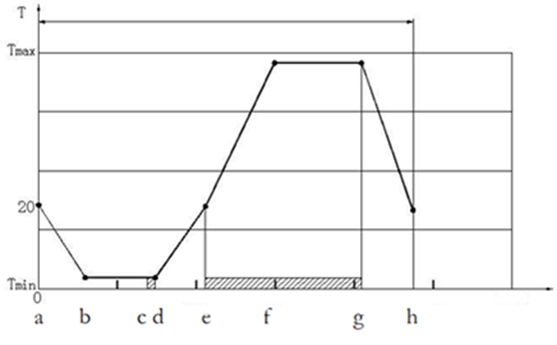  表8 温度和持续时间  Table 8 Temperature and Duration  节点 Slot 时间min Duration min 温度℃ Temperature, °C  a 0 20  b 15 Tmin see table 5  c 40 Tmin see table 5  d 45 Tmin see table 5  e 60 20  f 76.25 Tmax see table 5  g 106.25 Tmax see table 5  h 122.25 20
对运行环境的依赖和影响/Impact and dependence on the operating environment | Dependence: None  Impact: None
验证标准/ Verification criteria | Design validation

DV/ECV性能验证 [SyRD-IMPLEMENT-0009]
需求描述 /Requirement Description | 序号 No. 试验项目 Test Name 试验标准号及名称 Test Spec. 目标要求 （评定依据） Test Criteria 试验类型 Test Type 样品数量 Quantity 试验地点 Test Site （须得到吉利方认可） 计划开始时间 Plan Start 计划结束时间 Plan Comp. 试验周期 Test Duration 样件状态 Sample 认可型式 Approval Mode 认可说明 Remarks 试验完成是否要拆解 Tearing down needed once test finished 备注  试验矩阵1  Test Matrix 1  1 外观检查 Visual inspection QJLY J7111037C-2024乘用车车载屏幕总成技术条件 4.2 QJLY J7111037C-2024乘用车车载屏幕总成技术条件 4.2 ECV 3 / / / / / / / / /  2 性能测试 Performance test QJLY J7111037C-2024乘用车车载屏幕总成技术条件 4.3.1、4.3.2 QJLY J7111037C-2024乘用车车载屏幕总成技术条件 4.3.1 ECV 3 / / / / / / / / /  3 预处理 Precondition QJLY J7111037C-2024乘用车车载屏幕总成技术条件 5.4.4 QJLY J7111037C-2024乘用车车载屏幕总成技术条件 4.3.2 ECV 3 / / / / / / / / /  4 五点功能测试 Test of five functional parameters QJLY J7111037C-2024乘用车车载屏幕总成技术条件 5.1.4 QJLY J7111037C-2024乘用车车载屏幕总成技术条件 4.3.2 ECV 3 / / / / / / / / /  5 高温存储 High temperature storage test QJLY J7111037C-2024乘用车车载屏幕总成技术条件 4.3.8 QJLY J7111037C-2024乘用车车载屏幕总成技术条件 4.3.8 ECV 3 / / / / / / / / /  6 温度循环 Temperature cycle test QJLY J7111037C-2024乘用车车载屏幕总成技术条件 4.3.12 QJLY J7111037C-2024乘用车车载屏幕总成技术条件 4.3.12 ECV 3 / / / / / / / / /  7 规定转换时间的快速温度变化 QJLY J7111037C-2024乘用车车载屏幕总成技术条件 4.3.14 QJLY J7111037C-2024乘用车车载屏幕总成技术条件 4.3.14 ECV 3 / / / / / / / / /  8 温度循环随机振动 Random vibration of temperature cycle QJLY J7111037C-2024乘用车车载屏幕总成技术条件 4.3.19 QJLY J7111037C-2024乘用车车载屏幕总成技术条件 4.3.19 ECV 3 / / / / / / / / /  9 湿热循环 Composite temperature/humidity cycle test QJLY J7111037C-2024乘用车车载屏幕总成技术条件 4.3.13 QJLY J7111037C-2024乘用车车载屏幕总成技术条件 4.3.13 ECV 3 / / / / / / / / /  10 低温贮存 Low temperature storage test QJLY J7111037C-2024乘用车车载屏幕总成技术条件4.3.10 QJLY J7111037C-2024乘用车车载屏幕总成技术条件4.3.10 ECV 3 / / / / / / / / /  11 性能测试 Performance test QJLY J7111037C-2024乘用车车载屏幕总成技术条件 4.3.1、4.3.2 QJLY J7111037C-2024乘用车车载屏幕总成技术条件 4.3.1 ECV 3 / / / / / / / / /  12 五点功能测试 Test of five functional parameters QJLY J7111037C-2024乘用车车载屏幕总成技术条件 5.1.4 QJLY J7111037C-2024乘用车车载屏幕总成技术条件 4.3.2 ECV 3 / / / / / / / / /  13 外观检查&测试后拆解检查 QJLY J7111037C-2024乘用车车载屏幕总成技术条件 4.2 Q/JLY J7111029E-2024《汽车电气和电子零部件通用技术规范》 5.1.27.2 QJLY J7111037C-2024乘用车车载屏幕总成技术条件 4.2 Q/JLY J7111029E-2024《汽车电气和电子零部件通用技术规范》 5.1.27.3 ECV 3 / / / / / / / / /  试验矩阵2 Test Matrix 2 / / / / / / / / /  14 外观检查 Visual inspection QJLY J7111037C-2024乘用车车载屏幕总成技术条件 4.2 QJLY J7111037C-2024乘用车车载屏幕总成技术条件 4.2 ECV 3 / / / / / / / / /  15 性能测试 Performance test QJLY J7111037C-2024乘用车车载屏幕总成技术条件 4.3.1、4.3.2 QJLY J7111037C-2024乘用车车载屏幕总成技术条件 4.3.1 ECV 3 / / / / / / / / /  16 预处理 Precondition QJLY J7111037C-2024乘用车车载屏幕总成技术条件 5.4.4 QJLY J7111037C-2024乘用车车载屏幕总成技术条件 4.3.2 ECV 3 / / / / / / / / /  17 五点功能测试 Test of five functional parameters QJLY J7111037C-2024乘用车车载屏幕总成技术条件 5.1.4 QJLY J7111037C-2024乘用车车载屏幕总成技术条件 4.3.2 ECV 3 / / / / / / / / /  18 温度梯度 Step temperature test QJLY J7111037C-2024乘用车车载屏幕总成技术条件4.1.4.3 QJLY J7111037C-2024乘用车车载屏幕总成技术条件4.1.4.3 ECV 3 / / / / / / / / /  19 表面温度 Surface temperature QJLY J7111037C-2024乘用车车载屏幕总成技术条件4.3.11 QJLY J7111037C-2024乘用车车载屏幕总成技术条件4.3.11 ECV 3 / / / / / / / / /  20 高温工作 High temperature operation test QJLY J7111037C-2024乘用车车载屏幕总成技术条件4.3.7 QJLY J7111037C-2024乘用车车载屏幕总成技术条件4.3.7 ECV 3 / / / / / / / / /  21 低温工作 Low temperature operation test QJLY J7111037C-2024乘用车车载屏幕总成技术条件4.3.9 QJLY J7111037C-2024乘用车车载屏幕总成技术条件4.3.9 ECV 3 / / / / / / / / /  22 防尘 Dust test QJLY J7111037C-2024乘用车车载屏幕总成技术条件4.3.30 QJLY J7111037C-2024乘用车车载屏幕总成技术条件4.3.30 ECV 3 / / / / / / / / /  23 防水防尘 Waterproof Test QJLY J7111037C-2024乘用车车载屏幕总成技术条件4.3.31 QJLY J7111037C-2024乘用车车载屏幕总成技术条件4.3.31 ECV 3 / / / / / / / / /  24 性能测试 Performance test QJLY J7111037C-2024乘用车车载屏幕总成技术条件 4.3.1、4.3.2 QJLY J7111037C-2024乘用车车载屏幕总成技术条件 4.3.1 ECV 3 / / / / / / / / /  25 五点功能测试 Test of five functional parameters QJLY J7111037C-2024乘用车车载屏幕总成技术条件 5.1.4 QJLY J7111037C-2024乘用车车载屏幕总成技术条件 4.3.2 ECV 3 / / / / / / / / /  26 外观检查&测试后拆解检查 QJLY J7111037C-2024乘用车车载屏幕总成技术条件 4.2 Q/JLY J7111029E-2024《汽车电气和电子零部件通用技术规范》 5.1.27.2 QJLY J7111037C-2024乘用车车载屏幕总成技术条件 4.2 Q/JLY J7111029E-2024《汽车电气和电子零部件通用技术规范》 5.1.27.3 ECV 3 / / / / / / / / /  试验矩阵3 Test Matrix 3 / / / / / / / / /  27 外观检查 Visual inspection QJLY J7111037C-2024乘用车车载屏幕总成技术条件 4.2 QJLY J7111037C-2024乘用车车载屏幕总成技术条件 4.2 ECV 3 / / / / / / / / /  28 性能测试 Performance test QJLY J7111037C-2024乘用车车载屏幕总成技术条件 4.3.1、4.3.2 QJLY J7111037C-2024乘用车车载屏幕总成技术条件 4.3.1 ECV 3 / / / / / / / / /  29 预处理 Precondition QJLY J7111037C-2024乘用车车载屏幕总成技术条件 5.4.4 QJLY J7111037C-2024乘用车车载屏幕总成技术条件 4.3.2 ECV 3 / / / / / / / / /  30 五点功能测试 Test of five functional parameters QJLY J7111037C-2024乘用车车载屏幕总成技术条件 5.1.4 QJLY J7111037C-2024乘用车车载屏幕总成技术条件 4.3.2 ECV 3 / / / / / / / / /  31 稳态湿热 Damp heat steady state QJLY J7111037C-2024乘用车车载屏幕总成技术条件4.3.15 QJLY J7111037C-2024乘用车车载屏幕总成技术条件4.3.15 ECV 3 / / / / / / / / /  32 性能测试 Performance test QJLY J7111037C-2024乘用车车载屏幕总成技术条件 4.3.1、4.3.2 QJLY J7111037C-2024乘用车车载屏幕总成技术条件 4.3.1 ECV 3 / / / / / / / / /  33 五点功能测试 Test of five functional parameters QJLY J7111037C-2024乘用车车载屏幕总成技术条件 5.1.4 QJLY J7111037C-2024乘用车车载屏幕总成技术条件 4.3.2 ECV 3 / / / / / / / / /  34 外观检查&测试后拆解检查 QJLY J7111037C-2024乘用车车载屏幕总成技术条件 4.2 Q/JLY J7111029E-2024《汽车电气和电子零部件通用技术规范》 5.1.27.2 QJLY J7111037C-2024乘用车车载屏幕总成技术条件 4.2 Q/JLY J7111029E-2024《汽车电气和电子零部件通用技术规范》 5.1.27.3 ECV 3 / / / / / / / / /  试验矩阵4 Test Matrix 4 / / / / / / / / /  35 外观检查 Visual inspection QJLY J7111037C-2024乘用车车载屏幕总成技术条件 4.2 QJLY J7111037C-2024乘用车车载屏幕总成技术条件 4.2 ECV 3 / / / / / / / / /  36 性能测试 Performance test QJLY J7111037C-2024乘用车车载屏幕总成技术条件 4.3.1、4.3.2 QJLY J7111037C-2024乘用车车载屏幕总成技术条件 4.3.1 ECV 3 / / / / / / / / /  37 预处理 Precondition QJLY J7111037C-2024乘用车车载屏幕总成技术条件 5.4.4 QJLY J7111037C-2024乘用车车载屏幕总成技术条件 4.3.2 ECV 3 / / / / / / / / /  38 五点功能测试 Test of five functional parameters QJLY J7111037C-2024乘用车车载屏幕总成技术条件 5.1.4 QJLY J7111037C-2024乘用车车载屏幕总成技术条件 4.3.2 ECV 3 / / / / / / / / /  39 寿命测试 Life Test QJLY J7111037C-2024乘用车车载屏幕总成技术条件4.3.16 QJLY J7111037C-2024乘用车车载屏幕总成技术条件4.3.16 ECV 3 / / / / / / / / /  40 性能测试 Performance test QJLY J7111037C-2024乘用车车载屏幕总成技术条件 4.3.1、4.3.2 QJLY J7111037C-2024乘用车车载屏幕总成技术条件 4.3.1 ECV 3 / / / / / / / / /  41 五点功能测试 Test of five functional parameters QJLY J7111037C-2024乘用车车载屏幕总成技术条件 5.1.4 QJLY J7111037C-2024乘用车车载屏幕总成技术条件 4.3.2 ECV 3 / / / / / / / / /  42 外观检查&测试后拆解检查 QJLY J7111037C-2024乘用车车载屏幕总成技术条件 4.2 Q/JLY J7111029E-2024《汽车电气和电子零部件通用技术规范》 5.1.27.2 QJLY J7111037C-2024乘用车车载屏幕总成技术条件 4.2 Q/JLY J7111029E-2024《汽车电气和电子零部件通用技术规范》 5.1.27.3 ECV 3 / / / / / / / / /  试验矩阵5 Test Matrix 6 / / / / / / / / /  43 外观检查 Visual inspection QJLY J7111037C-2024乘用车车载屏幕总成技术条件 4.2 QJLY J7111037C-2024乘用车车载屏幕总成技术条件 4.2 ECV 3 / / / / / / / / /  44 性能测试 Performance test QJLY J7111037C-2024乘用车车载屏幕总成技术条件 4.3.1、4.3.2 QJLY J7111037C-2024乘用车车载屏幕总成技术条件 4.3.1 ECV 3 / / / / / / / / /  45 预处理 Precondition QJLY J7111037C-2024乘用车车载屏幕总成技术条件 5.4.4 QJLY J7111037C-2024乘用车车载屏幕总成技术条件 4.3.2 ECV 3 / / / / / / / / /  46 五点功能测试 Test of five functional parameters QJLY J7111037C-2024乘用车车载屏幕总成技术条件 5.1.4 QJLY J7111037C-2024乘用车车载屏幕总成技术条件 4.3.2 ECV 3 / / / / / / / / /  47 运输振动 Transportation vibration QJLY J7111037C-2024乘用车车载屏幕总成技术条件4.3.19.3 QJLY J7111037C-2024乘用车车载屏幕总成技术条件4.3.19.3 ECV 3 / / / / / / / / /  48 包装跌落 Packaging drop QJLY J7111037C-2024乘用车车载屏幕总成技术条件4.3.26 QJLY J7111037C-2024乘用车车载屏幕总成技术条件4.3.26 ECV 3 / / / / / / / / /  49 机械冲击 Mechanical shock QJLY J7111037C-2024乘用车车载屏幕总成技术条件4.3.20； QJLY J7111037C-2024乘用车车载屏幕总成技术条件4.3.20； ECV 3 / / / / / / / / /  50 系统开闭耐久 屏幕状态：闭合—打开—闭合为一个循环， 循环次数：15000次 试验方法见下表： 功能等级应满足A,试验后屏幕可以正常打开/关闭，不能出现屏幕晃动、异响、显著变形、零件松脱、外壳破损等，屏幕打开速率符合要求。 ECV 3 / / / / / / / / /  51 噪声特性 Noise characteristics Q/JLY J7110604E-2022《乘用车车用控制开关技术条件》中6.5.5执行 Q/JLY J7110604E-2022《Technical Specifications of Passenger Car Control Switch 》6.5.5 implementation Q/JLY J7110604E-2022《乘用车车用控制开关技术条件》中5.4.5要求 Q/JLY J7110604E-2022《Technical Specifications of Passenger Car Control Switch 》5.4.5 requirements ECV 30 / / / / / / / / /  52 性能测试 Performance test QJLY J7111037C-2024乘用车车载屏幕总成技术条件 4.3.1、4.3.2 QJLY J7111037C-2024乘用车车载屏幕总成技术条件 4.3.1 ECV 3 / / / / / / / / /  53 五点功能测试 Test of five functional parameters QJLY J7111037C-2024乘用车车载屏幕总成技术条件 5.1.4 QJLY J7111037C-2024乘用车车载屏幕总成技术条件 4.3.2 ECV 3 / / / / / / / / /  54 外观检查&测试后拆解检查 QJLY J7111037C-2024乘用车车载屏幕总成技术条件 4.2 Q/JLY J7111029E-2024《汽车电气和电子零部件通用技术规范》 5.1.27.2 QJLY J7111037C-2024乘用车车载屏幕总成技术条件 4.2 Q/JLY J7111029E-2024《汽车电气和电子零部件通用技术规范》 5.1.27.3 ECV 3 / / / / / / / / /  55 自由跌落 Free fall QJLY J7111037C-2024乘用车车载屏幕总成技术条件4.3.27 QJLY J7111037C-2024乘用车车载屏幕总成技术条件4.3.27 ECV 3 / / / / / / / / /  试验矩阵6 Test Matrix 7 / / / / / / / / /  56 外观检查 Visual inspection QJLY J7111037C-2024乘用车车载屏幕总成技术条件 4.2 QJLY J7111037C-2024乘用车车载屏幕总成技术条件 4.2 ECV 3 / / / / / / / / /  57 性能测试 Performance test QJLY J7111037C-2024 乘用车车载屏幕总成技术条件 4.3.1、4.3.2 QJLY J7111037C-2024 乘用车车载屏幕总成技术条件 4.3.1 ECV 3 / / / / / / / / /  58 预处理 Precondition QJLY J7111037C-2024 乘用车车载屏幕总成技术条件 5.5.4 QJLY J7111037C-2024 乘用车车载屏幕总成技术条件 4.3.2 ECV 3 / / / / / / / / /  59 五点功能测试 Test of five functional parameters QJLY J7111037C-2024 乘用车车载屏幕总成技术条件 5.1.1 QJLY J7111037C-2024 乘用车车载屏幕总成技术条件 4.3.2 ECV 3 / / / / / / / / /  60 触摸屏耐久性 Durabi l ity test on touch screen QJLY J7111037C-2024 乘用车车载屏幕总成技术条件4.3.21 QJLY J7111037C-2024 乘用车车载屏幕总成技术条件4.3.21 ECV 3 / / / / / / / / /  61 触摸屏耐磨性 Abrasion resistance test on touch screen QJLY J7111037C-2024 乘用车车载屏幕总成技术条件4.3.22 QJLY J7111037C-2024 乘用车车载屏幕总成技术条件4.3.22 ECV 3 / / / / / / / / /  62 触摸屏落球 BalI drop test on touch screen QJLY J7111037C-2024 乘用车车载屏幕总成技术条件4.3.23 QJLY J7111037C-2024 乘用车车载屏幕总成技术条件4.3.23 ECV 3 / / / / / / / / /  63 触摸屏耐压性强度 Crush strength of touch screen QJLY J7111037C-2024 乘用车车载屏幕总成技术条件4.3.24 QJLY J7111037C-2024 乘用车车载屏幕总成技术条件4.3.24 ECV 3 / / / / / / / / /  64 触摸屏表面硬度 Surface hardness of touch screen QJLY J7111037C-2024 乘用车车载屏幕总成技术条件4.3.25 QJLY J7111037C-2024 乘用车车载屏幕总成技术条件4.3.25 ECV 3 / / / / / / / / /  65 表面肘击负荷 Elbow impact on surface QJLY J7111037C-2024 乘用车车载屏幕总成技术条件4.3.28 QJLY J7111037C-2024 乘用车车载屏幕总成技术条件4.3.28 ECV 3 / / / / / / / / /  66 结露要求 Dewing QJLY J7111037C-2024 乘用车车载屏幕总成技术条件4.3.33 QJLY J7111037C-2024 乘用车车载屏幕总成技术条件4.3.33 ECV 3 / / / / / / / / /  67 冷凝试验 Cobdensation test QJLY J7111037C-2024 乘用车车载屏幕总成技术条件4.3.34 QJLY J7111037C-2024 乘用车车载屏幕总成技术条件4.3.34 ECV 3 / / / / / / / / /  68 化学负荷 Chemical load QJLY J7111037C-2024乘用车车载屏幕总成技术条件5.7.2 QJLY J7111037C-2024乘用车车载屏幕总成技术条件4.3.32 ECV 3 / / / / / / / / /  69 外观检查 Visual inspection QJLY J7111037C-2024乘用车车载屏幕总成技术条件 5.2 QJLY J7111037C-2024乘用车车载屏幕总成技术条件 4.2 ECV 3 / / / / / / / / /  70 性能测试 Performance test QJLY J7111037C-2024乘用车车载屏幕总成技术条件 4.3.1、4.3.2 QJLY J7111037C-2024乘用车车载屏幕总成技术条件 4.3.1 ECV 3 / / / / / / / / /  71 五点功能测试 Test of five functional parameters QJLY J7111037C-2024乘用车车载屏幕总成技术条件 5.1.1 QJLY J7111037C-2024乘用车车载屏幕总成技术条件 4.3.2 ECV 3 / / / / / / / / /  试验矩阵7 Test Matrix 8 / / / / / / / / /  72 外观检查 Visual inspection QJLY J7111037C-2024乘用车车载屏幕总成技术条件 4.2 QJLY J7111037C-2024乘用车车载屏幕总成技术条件 4.2 ECV 3 / / / / / / / / /  73 五点功能测试 Test of five functional parameters Q/JLY J7111029E-2024 4.8.2.1 Q/JLY J7111029E-2024 4.8.2.1 ECV 3 / / / / / / / / /  74 启动脉冲 Start pulses Q/JLY J7111029E-2024 5.1.5 Q/JLY J7111029E-2024 5.1.5 ECV 3 / / / / / / / / /  75 在欠压和过压情况下的功能 Function requirements of undervoltage and overvoltage conditi- ons Q/JLY J7111029E-2024 5.1.6 Q/JLY J7111029E-2024 5.1.6 ECV 3 / / / / / / / / /  76 静态电流 Closed-circuit current Q/JLY J7111029E-2024 5.1.7 Q/JLY J7111029E-2024 5.1.7 ECV 3 / / / / / / / / /  77 反极性 Reverse polarity Q/JLY J7111029E-2024 5.1.8 Q/JLY J7111029E-2024 5.1.8 ECV 3 / / / / / / / / /  78 过高电流 Overcurrents Q/JLY J7111029E-2024 5.1.9 Q/JLY J7111029E-2024 5.1.9 ECV 3 / / / / / / / / /  79 长时间过压 Long-term overvoltage Q/JLY J7111029E-2024 5.1.10 Q/JLY J7111029E-2024 5.1.10 ECV 3 / / / / / / / / /  80 跳跃启动 Jump start Q/JLY J7111029E-2024 5.1.11 Q/JLY J7111029E-2024 5.1.11 ECV 3 / / / / / / / / /  81 供给电压缓降和缓升 Slow decrease and increase of the supply voltage Q/JLY J7111029E-2024 5.1.12 Q/JLY J7111029E-2024 5.1.12 ECV 3 / / / / / / / / /  82 供给电压缓降和快升 Slow decrease, quick increase of the supply voltage Q/JLY J7111029E-2024 5.1.13 Q/JLY J7111029E-2024 5.1.13 ECV 3 / / / / / / / / /  83 清零重设行为 Reset behavior Q/JLY J7111029E-2024 5.1.14 Q/JLY J7111029E-2024 5.1.14 ECV 3 / / / / / / / / /  84 信号线和负载回路的短路保护 Short circuit in signal circuit and load circuits Q/JLY J7111029E-2024 5.1.15 Q/JLY J7111029E-2024 5.1.15 ECV 3 / / / / / / / / /  85 耐电压 Withstand voltage Q/JLY J7111029E-2024 5.1.16 Q/JLY J7111029E-2024 5.1.16 ECV 3 / / / / / / / / /  86 绝缘电阻 Insulation resistance Q/JLY J7111029E-2024 5.1.17 Q/JLY J7111029E-2024 5.1.17 ECV 3 / / / / / / / / /  87 Pin 断路和插头断路 Pin interruption and connector interruption Q/JLY J7111029E-2024 5.1.18 Q/JLY J7111029E-2024 5.1.18 ECV 3 / / / / / / / / /  88 重叠的交流电压 Superimposed alternating voltage Q/JLY J7111029E-2024 5.1.19 Q/JLY J7111029E-2024 5.1.19 ECV 3 / / / / / / / / /  89 接地偏移 Ground offset Q/JLY J7111029E-2024 5.1.20 Q/JLY J7111029E-2024 5.1.20 ECV 3 / / / / / / / / /  90 短暂的低电压 Transient undervoltage Q/JLY J7111029E-2024 5.1.21 Q/JLY J7111029E-2024 5.1.21 ECV 3 / / / / / / / / /  91 抛负载 Load dump Q/JLY J7111029E-2024 5.1.22 Q/JLY J7111029E-2024 5.1.22 ECV 3 / / / / / / / / /  92 智能控制的电压波形 Voltage curve with electric system control Q/JLY J7111029E-2024 5.1.23 Q/JLY J7111029E-2024 5.1.23 ECV 3 / / / / / / / / /  93 短暂过压 Transient overvoltage Q/JLY J7111029E-2024 5.1.24 Q/JLY J7111029E-2024 5.1.24 ECV 3 / / / / / / / / /  94 短暂的断路 Short interruptions Q/JLY J7111029E-2024 5.1.25 Q/JLY J7111029E-2024 5.1.25 ECV 3 / / / / / / / / /  95 五点功能测试 Test of five functional parameters Q/JLY J7111029E-2024 4.8.2.1 Q/JLY J7111029E-2024 4.8.2.1 ECV 3 / / / / / / / / /  96 外观检查&测试后拆解检查 QJLY J7111037C-2024乘用车车载屏幕总成技术条件 4.2 Q/JLY J7111029E-2024《汽车电气和电子零部件通用技术规范》 5.1.27.2 QJLY J7111037C-2024乘用车车载屏幕总成技术条件 4.2 Q/JLY J7111029E-2024《汽车电气和电子零部件通用技术规范》 5.1.27.3 ECV 3 / / / / / / / / /  试验矩阵8 Test Matrix 9 / / / / / / / / /  97 瞬态传导发射（CE01） Transient Emission (CE01) Q/JLY J7110779E-2023《乘用车电气/电子零部件电磁兼容规范》6.2执行 Q/JLY J7110779E-2023《乘用车电气/电子零部件电磁兼容规范》6.1要求 ECV 2 / / / / / / / / /  98 电磁传导发射（CE02） Conducted Emission (CE02) Q/JLY J7110779E-2023《乘用车电气/电子零部件电磁兼容规范》7.2执行 Q/JLY J7110779E-2023《乘用车电气/电子零部件电磁兼容规范》7.1要求 ECV 2 / / / / / / / / /  99 磁场近场发射（RE01） Magnetic Near Field Requi rement (RE01) Q/JLY J7110779E-2023《乘用车电气/电子零部件电磁兼容规范》8.2执行 Q/JLY J7110779E-2023《乘用车电气/电子零部件电磁兼容规范》8.1要求 ECV 2 / / / / / / / / /  100 电磁场远场发射（RE02） Q/JLY J7110779E-2023《乘用车电气/电子零部件电磁兼容规范》9.2执行 Q/JLY J7110779E-2023《乘用车电气/电子零部件电磁兼容规范》9.1要求 ECV 2 / / / / / / / / /  101 电磁辐射发射（RE03） Radiation Emission (RE03) Q/JLY J7110779E-2023《乘用车电气/电子零部件电磁兼容规范》10.2执行 Q/JLY J7110779E-2023《乘用车电气/电子零部件电磁兼容规范》10.1要求 ECV 2 / / / / / / / / /  102 瞬态传导抗扰度（CI01） Transient Immunity On Power Lines (CI01) Q/JLY J7110779E-2023《乘用车电气/电子零部件电磁兼容规范》11.2执行 Q/JLY J7110779E-2023《乘用车电气/电子零部件电磁兼容规范》11.1要求 ECV 2 / / / / / / / / /  103 瞬态耦合抗扰度（CI02） Transient Immunity On Signal Lines (CI02) Q/JLY J7110779E-2023《乘用车电气/电子零部件电磁兼容规范》12.2执行 Q/JLY J7110779E-2023《乘用车电气/电子零部件电磁兼容规范》12.1要求 ECV 2 / / / / / / / / /  104 磁场抗扰度（RI01） Q/JLY J7110779E-2023《乘用车电气/电子零部件电磁兼容规范》13.2执行 Q/JLY J7110779E-2023《乘用车电气/电子零部件电磁兼容规范》13.1要求 ECV 2 / / / / / / / / /  105 电磁辐射抗扰度（BCI）（RI02） Radiation Immunity (BCI) (RI02) Q/JLY J7110779E-2023《乘用车电气/电子零部件电磁兼容规范》14.2执行 Q/JLY J7110779E-2023《乘用车电气/电子零部件电磁兼容规范》14.1要求 ECV 2 / / / / / / / / /  106 电磁辐射抗扰度（ALSE）（RI03） Radiation Immunity (ALSE) (RI03) Q/JLY J7110779E-2023《乘用车电气/电子零部件电磁兼容规范》15.2执行 Q/JLY J7110779E-2023《乘用车电气/电子零部件电磁兼容规范》15.1要求 ECV 2 / / / / / / / / /  107 手持发射机抗扰度（RI04） Portable Transmitters Immunity (RI04) Q/JLY J7110779E-2023《乘用车电气/电子零部件电磁兼容规范》16.2执行 Q/JLY J7110779E-2023《乘用车电气/电子零部件电磁兼容规范》16.1要求 ECV 2 / / / / / / / / /  108 静电放电（ESD01） Electrostatic Discharge (ESD01) Q/JLY J7110779E-2023《乘用车电气/电子零部件电磁兼容规范》17.2执行 Q/JLY J7110779E-2023《乘用车电气/电子零部件电磁兼容规范》17.1要求 ECV 2 / / / / / / / / /  试验矩阵9 Test Matrix 10 其他 / / / / / / / / /  109 禁限用物质 Prohibited and restricted substances （1）所有的件都需要测试ELV六项，测试标准为：Q/JLY J7110845C-2022① (1) All products need to tset si01-00-V1.0 items of ELV,test standard:Q/JLY J7110845C-2022 （2）内饰部分、动力系统的隔热垫片、离合器衬片、刹车衬片石棉为强制测试项。其他部位为非强制测试。测试标准为：Q/JLY J7110808B-2016 (2) Interior trim parts, power system insulation pads,clutch liner,brake lining asbestos for compulsory test items.Other parts is a mandatory testing.test standard:Q/JLY J7110808B-2016 （3）多环芳烃，内饰可触及部分为强制测试项。内饰不可触及部位为非强制。非内饰/非可触碰件不用测试多环芳烃。测试标准为：Q/JLY J7111013C-2022① (3) Polycyclic aromatic hydrocarbons, interior can hit partly for compulsory test items.Interior not hit a part is optional.Not interior/not to touch a need not test polycyclic aromatic hydrocarbons.test standard:Q/JLY J7111013C-2022① （4）针对纺织品，需要测试偶氮染料。测试标准为：GB/T 17592-2011《纺织品 禁用偶氮染料的测定》和GB/T 23344-2009《纺织品 4-氨基偶氮苯的测定》 (4) In accordance with the need of te01-00-V1.0tiles, azo dye test.test standard:GB/T 17592-2011 and GB/T 23344-2009 Q/JL J160001-2024《《汽车产品禁用、限用物质要求》 ECV 1 / / / / / / / / /  110 禁限用物质（REACH的 SVHC，附录01-00-V1.0VII；POPs） Prohibited & restricted substances （(SVHC and Anne01-00-V1.0 01-00-V1.0VII of REACH；POPs) 按Q/JL J160001执行 满足Q/JL J160001 II类 Satisfy Q/JL J160001 category II ECV 1 / / / / / / / / /  111 致癌性或生殖毒性的物质（最新加州65提案清单） Carcinogenicity or reproductive to01-00-V1.0icity substances 按Q/JL J160001执行 不得含有（含有须加警告标签或标记），满足Q/JL J160001 III类 Not detectable (contains need add warning label or mark),Satisfy Q/JL J160001 category III ECV 1 / / / / / / / / /  112 阻燃性 Q/JLY J7110335C-2022《汽车非金属材料阻燃性限值要求及试验方法》 Q/JLY J7110335C-2022 《汽车非金属材料阻燃性限值要求及试验方法》 ECV 5 / / / / / / / / /  113 耐光老化性能 Light aging resistance 按照Q/JLY J7110279B-2014②《汽车内外饰非金属件耐光老化试验规范 》执行 满足Q/JL J160004要求 ECV 3 / / / / / / / / /  114 雾化试验 Atomization Q/JLY J7110341D-2020-车内非金属材料雾化性限值要求及试验方法 Q/JLY J7110341D-2020-车内非金属材料雾化性限值要求及试验方法 ECV 1 / / / / / / / / /  115 气味性 Odor Q/JLY J7110538E-2020《车内非金属部位及材料气味性试验方法》 Q/JLY J7111031D-2023《车内非金属件部位及材料气味等级限值技术条件》 ECV 1 / / / / / / / / /  116 电镀性能要求 Decorative electroplated chromium coating technical requirements Q/JLY J7111591B-2022 乘用车零部件装饰性电镀铬镀层技术要求 Q/JLY J7111591B-2022 乘用车零部件装饰性电镀铬镀层技术要求 ECV 3 / / / / / / / / /  117 耐刮擦试验 Scratch resistance test Q/JLY J7110536D-2022 乘用车内外饰塑料件耐刮擦性试验规范 Q/JLY J7110965B-2023 乘用车内外饰塑料件耐刮擦性能技术要求 ECV 3 / / / / / / / / /  118 盐雾试验 Salt spray test Q/JL J160003《乘用车零部件防腐技术要求》 Q/JL J160003《乘用车零部件防腐技术要求》 ECV 3 / / / / / / / / /  119 接插件匹配测试 Connector matching test Q/JLY J7110195E-2021《汽车电线束低压连接器技术条件》 Q/JLY J7110195E-2021《汽车电线束低压连接器技术条件》 ECV 5 / / / / / / / / /  试验矩阵10 Test Matrix 11 / / / / / / / / /  120 膜厚 Paint film thickness 依据Q/JLY J7110550E-2022中5.4 满足Q/JLY J7110550E-2022中4.1.3的要求 ECV 3 / / / / / / / / /  121 附着力 Adhesion 依据Q/JLY J7110550E-2022中5.5 满足Q/JLY J7110550E-2022中表1要求 ECV 3 / / / / / / / / /  122 耐刮伤 Scratch resistance 依据Q/JLY J7110550E-2022中5.6 满足Q/JLY J7110550E-2022中表1要求 ECV 3 / / / / / / / / /  123 高温热老化 High Temperature Heat Aging 依据Q/JLY J7110550E-2022中5.7 满足Q/JLY J7110550E-2022中表1要求 ECV 3 / / / / / / / / /  124 高低温交变 High-Low Temperature Alternation 依据Q/JLY J7110550E-2022中5.8 满足Q/JLY J7110550E-2022中表1要求 ECV 3 / / / / / / / / /  125 冷凝水试验 Condensate Water Test 依据Q/JLY J7110550E-2022中5.9 满足Q/JLY J7110550E-2022中表1要求 ECV 3 / / / / / / / / /  126 耐光照性 Light Fastness 依据Q/JLY J7110550E-2022中5.10 满足Q/JLY J7110550E-2022中表1要求 ECV 3 / / / / / / / / /  127 耐水解 Hydrolysis resistance 依据Q/JLY J7110550E-2022中5.11 满足Q/JLY J7110550E-2022中表1要求 ECV 3 / / / / / / / / /  128 耐干摩擦色牢度（100次） Color Fastness Resistant to Dry Abrasion 依据Q/JLY J7110550E-2022中5.12.2 满足Q/JLY J7110550E-2022中表1要求 ECV 3 / / / / / / / / /  129 耐湿摩擦色牢度（100次） Color Fastness Resistant to Wet Abrasion 依据Q/JLY J7110550E-2022中5.12.3 满足Q/JLY J7110550E-2022中表1要求 ECV 3 / / / / / / / / /  130 特殊干摩（2000次） Special dry rubbing 依据Q/JLY J7110550E-2022中5.12.4 满足Q/JLY J7110550E-2022中表1要求 ECV 3 / / / / / / / / /  131 耐化学试剂点滴法 Chemical resistance-Drop method 依据Q/JLY J7110550E-2022中5.13.1 满足Q/JLY J7110550E-2022中表1要求 ECV 15 / / / / / / / / /  132 耐化学试剂擦拭法 Chemical resistance-Wiping method 依据Q/JLY J7110550E-2022中5.13.2 满足Q/JLY J7110550E-2022中表1要求 ECV 12 / / / / / / / / /  133 耐化学试剂耐香水试验 Perfume resistance test 依据Q/JLY J7110550E-2022中5.13.3 满足Q/JLY J7110550E-2022中表1要求 ECV 3 / / / / / / / / /  134 耐护手霜 Hand Cream Resistance 依据Q/JLY J7110550E-2022中5.14.2 满足Q/JLY J7110550E-2022中表1要求 ECV 3 / / / / / / / / /  135 耐防晒霜 Sun Cream Resistance 依据Q/JLY J7110550E-2022中5.14.3 满足Q/JLY J7110550E-2022中表1要求 ECV 3 / / / / / / / / /  136 耐盐雾性能（金属基材） Salt spray resistance (metallic substrate) 依据Q/JLY J7110550E-2022中5.16 满足Q/JLY J7110550E-2022中表1要求 ECV 3 / / / / / / / / /  137 铅笔硬度 PenciI hardness (only suitable for high light area samples) 依据Q/JLY J7110550E-2022中5.17 满足Q/JLY J7110550E-2022中表1要求 ECV 3 / / / / / / / / /
对运行环境的依赖和影响/Impact and dependence on the operating environment | Dependence: None  Impact: None
验证标准/ Verification criteria | Design validation

PV性能验证[SyRD-IMPLEMENT-0010]
需求描述 /Requirement Description
序号  No. | 试验项目  Test Name | 试验标准号及名称  Test Spec. | 目标要求（评定依据）  Test Criteria | 试验类型  Test Type | 样品数量  Quantity | 试验地点  Test Site  （须得到买方认可） | 计划开始时间  Plan Start Timing | 计划结束时间  Plan Comp.Timing | 试验周期  Test Duration | 样件状态  Sample Status | 认可型式  Approval Mode | 认可说明  Remarks | 备注  Notes
试验矩阵1
Test Matrix 1
1 | 外观检查  Visual inspection | QJLY J7111037C-2024乘用车车载屏幕总成技术条件 4.2 | QJLY J7111037C-2024乘用车车载屏幕总成技术条件 4.2 | PV | 3
2 | 性能测试  Performance test | QJLY J7111037C-2024乘用车车载屏幕总成技术条件 4.3.1、4.3.2 | QJLY J7111037C-2024乘用车车载屏幕总成技术条件  4.3.1 | PV | 3
3 | 预处理  Precondition | QJLY J7111037C-2024乘用车车载屏幕总成技术条件 5.4.4 | QJLY J7111037C-2024乘用车车载屏幕总成技术条件  4.3.2 | PV | 3
4 | 五点功能测试  Test of five functional parameters | QJLY J7111037C-2024乘用车车载屏幕总成技术条件 5.1.4 | QJLY J7111037C-2024乘用车车载屏幕总成技术条件  4.3.2 | PV | 3
5 | 高温存储  High temperature storage test | QJLY J7111037C-2024乘用车车载屏幕总成技术条件 4.3.8 | QJLY J7111037C-2024乘用车车载屏幕总成技术条件 4.3.8 | PV | 3
6 | 温度循环  Temperature cycle test | QJLY J7111037C-2024乘用车车载屏幕总成技术条件 4.3.12 | QJLY J7111037C-2024乘用车车载屏幕总成技术条件 4.3.12 | PV | 3
7 | 规定转换时间的快速温度变化 | QJLY J7111037C-2024乘用车车载屏幕总成技术条件 4.3.14 | QJLY J7111037C-2024乘用车车载屏幕总成技术条件 4.3.14 | PV | 3
8 | 温度循环随机振动  Random vibration of temperature cycle | QJLY J7111037C-2024乘用车车载屏幕总成技术条件 4.3.19 | QJLY J7111037C-2024乘用车车载屏幕总成技术条件 4.3.19 | PV | 3
9 | 湿热循环  Composite temperature/humidity cycle test | QJLY J7111037C-2024乘用车车载屏幕总成技术条件 4.3.13 | QJLY J7111037C-2024乘用车车载屏幕总成技术条件 4.3.13 | PV | 3
10 | 低温贮存  Low temperature storage test | QJLY J7111037C-2024乘用车车载屏幕总成技术条件4.3.10 | QJLY J7111037C-2024乘用车车载屏幕总成技术条件4.3.10 | PV | 3
11 | 性能测试  Performance test | QJLY J7111037C-2024乘用车车载屏幕总成技术条件 4.3.1、4.3.2 | QJLY J7111037C-2024乘用车车载屏幕总成技术条件  4.3.1 | PV | 3
12 | 五点功能测试  Test of five functional parameters | QJLY J7111037C-2024乘用车车载屏幕总成技术条件 5.1.4 | QJLY J7111037C-2024乘用车车载屏幕总成技术条件  4.3.2 | PV | 3
13 | 外观检查&测试后拆解检查 | QJLY J7111037C-2024乘用车车载屏幕总成技术条件 4.2  Q/JLY J7111029E-2024《汽车电气和电子零部件通用技术规范》 5.1.27.2 | QJLY J7111037C-2024乘用车车载屏幕总成技术条件 4.2  Q/JLY J7111029E-2024《汽车电气和电子零部件通用技术规范》 5.1.27.3 | PV | 3
试验矩阵2
Test Matrix 2
14 | 外观检查  Visual inspection | QJLY J7111037C-2024乘用车车载屏幕总成技术条件 4.2 | QJLY J7111037C-2024乘用车车载屏幕总成技术条件 4.2 | PV | 3
15 | 性能测试  Performance test | QJLY J7111037C-2024乘用车车载屏幕总成技术条件 4.3.1、4.3.2 | QJLY J7111037C-2024乘用车车载屏幕总成技术条件  4.3.1 | PV | 3
16 | 预处理  Precondition | QJLY J7111037C-2024乘用车车载屏幕总成技术条件 5.4.4 | QJLY J7111037C-2024乘用车车载屏幕总成技术条件  4.3.2 | PV | 3
17 | 五点功能测试  Test of five functional parameters | QJLY J7111037C-2024乘用车车载屏幕总成技术条件 5.1.4 | QJLY J7111037C-2024乘用车车载屏幕总成技术条件  4.3.2 | PV | 3
18 | 温度梯度  Step temperature test | QJLY J7111037C-2024乘用车车载屏幕总成技术条件4.1.4.3 | QJLY J7111037C-2024乘用车车载屏幕总成技术条件4.1.4.3 | PV | 3
19 | 表面温度  Surface temperature | QJLY J7111037C-2024乘用车车载屏幕总成技术条件4.3.11 | QJLY J7111037C-2024乘用车车载屏幕总成技术条件4.3.11 | PV | 3
20 | 高温工作  High temperature operation test | QJLY J7111037C-2024乘用车车载屏幕总成技术条件4.3.7 | QJLY J7111037C-2024乘用车车载屏幕总成技术条件4.3.7 | PV | 3
21 | 低温工作  Low temperature operation test | QJLY J7111037C-2024乘用车车载屏幕总成技术条件4.3.9 | QJLY J7111037C-2024乘用车车载屏幕总成技术条件4.3.9 | PV | 3
22 | 防尘  Dust test | QJLY J7111037C-2024乘用车车载屏幕总成技术条件4.3.30 | QJLY J7111037C-2024乘用车车载屏幕总成技术条件4.3.30 | PV | 3
23 | 防水防尘  Waterproof Test | QJLY J7111037C-2024乘用车车载屏幕总成技术条件4.3.31 | QJLY J7111037C-2024乘用车车载屏幕总成技术条件4.3.31 | PV | 3
24 | 性能测试  Performance test | QJLY J7111037C-2024乘用车车载屏幕总成技术条件 4.3.1、4.3.2 | QJLY J7111037C-2024乘用车车载屏幕总成技术条件  4.3.1 | PV | 3
25 | 五点功能测试  Test of five functional parameters | QJLY J7111037C-2024乘用车车载屏幕总成技术条件 5.1.4 | QJLY J7111037C-2024乘用车车载屏幕总成技术条件  4.3.2 | PV | 3
26 | 外观检查&测试后拆解检查 | QJLY J7111037C-2024乘用车车载屏幕总成技术条件 4.2  Q/JLY J7111029E-2024《汽车电气和电子零部件通用技术规范》 5.1.27.2 | QJLY J7111037C-2024乘用车车载屏幕总成技术条件 4.2  Q/JLY J7111029E-2024《汽车电气和电子零部件通用技术规范》 5.1.27.3 | PV | 3
试验矩阵3
Test Matrix 3
27 | 外观检查  Visual inspection | QJLY J7111037C-2024乘用车车载屏幕总成技术条件 4.2 | QJLY J7111037C-2024乘用车车载屏幕总成技术条件 4.2 | PV | 3
28 | 性能测试  Performance test | QJLY J7111037C-2024乘用车车载屏幕总成技术条件 4.3.1、4.3.2 | QJLY J7111037C-2024乘用车车载屏幕总成技术条件  4.3.1 | PV | 3
29 | 预处理  Precondition | QJLY J7111037C-2024乘用车车载屏幕总成技术条件 5.4.4 | QJLY J7111037C-2024乘用车车载屏幕总成技术条件  4.3.2 | PV | 3
30 | 五点功能测试  Test of five functional parameters | QJLY J7111037C-2024乘用车车载屏幕总成技术条件 5.1.4 | QJLY J7111037C-2024乘用车车载屏幕总成技术条件  4.3.2 | PV | 3
31 | 稳态湿热  Damp heat steady state | QJLY J7111037C-2024乘用车车载屏幕总成技术条件4.3.15 | QJLY J7111037C-2024乘用车车载屏幕总成技术条件4.3.15 | PV | 3
32 | 性能测试  Performance test | QJLY J7111037C-2024乘用车车载屏幕总成技术条件 4.3.1、4.3.2 | QJLY J7111037C-2024乘用车车载屏幕总成技术条件  4.3.1 | PV | 3
33 | 五点功能测试  Test of five functional parameters | QJLY J7111037C-2024乘用车车载屏幕总成技术条件 5.1.4 | QJLY J7111037C-2024乘用车车载屏幕总成技术条件  4.3.2 | PV | 3
34 | 外观检查&测试后拆解检查 | QJLY J7111037C-2024乘用车车载屏幕总成技术条件 4.2  Q/JLY J7111029E-2024《汽车电气和电子零部件通用技术规范》 5.1.27.2 | QJLY J7111037C-2024乘用车车载屏幕总成技术条件 4.2  Q/JLY J7111029E-2024《汽车电气和电子零部件通用技术规范》 5.1.27.3 | PV | 3
试验矩阵4
Test Matrix 4
35 | 外观检查  Visual inspection | QJLY J7111037C-2024乘用车车载屏幕总成技术条件 4.2 | QJLY J7111037C-2024乘用车车载屏幕总成技术条件 4.2 | PV | 3
36 | 性能测试  Performance test | QJLY J7111037C-2024乘用车车载屏幕总成技术条件 4.3.1、4.3.2 | QJLY J7111037C-2024乘用车车载屏幕总成技术条件  4.3.1 | PV | 3
37 | 预处理  Precondition | QJLY J7111037C-2024乘用车车载屏幕总成技术条件 5.4.4 | QJLY J7111037C-2024乘用车车载屏幕总成技术条件  4.3.2 | PV | 3
38 | 五点功能测试  Test of five functional parameters | QJLY J7111037C-2024乘用车车载屏幕总成技术条件 5.1.4 | QJLY J7111037C-2024乘用车车载屏幕总成技术条件  4.3.2 | PV | 3
39 | 寿命测试  Life Test | QJLY J7111037C-2024乘用车车载屏幕总成技术条件4.3.16 | QJLY J7111037C-2024乘用车车载屏幕总成技术条件4.3.16 | PV | 3
40 | 性能测试  Performance test | QJLY J7111037C-2024乘用车车载屏幕总成技术条件 4.3.1、4.3.2 | QJLY J7111037C-2024乘用车车载屏幕总成技术条件  4.3.1 | PV | 3
41 | 五点功能测试  Test of five functional parameters | QJLY J7111037C-2024乘用车车载屏幕总成技术条件 5.1.4 | QJLY J7111037C-2024乘用车车载屏幕总成技术条件  4.3.2 | PV | 3
42 | 外观检查&测试后拆解检查 | QJLY J7111037C-2024乘用车车载屏幕总成技术条件 4.2  Q/JLY J7111029E-2024《汽车电气和电子零部件通用技术规范》 5.1.27.2 | QJLY J7111037C-2024乘用车车载屏幕总成技术条件 4.2  Q/JLY J7111029E-2024《汽车电气和电子零部件通用技术规范》 5.1.27.3 | PV | 3
试验矩阵5
Test Matrix 6
43 | 外观检查  Visual inspection | QJLY J7111037C-2024乘用车车载屏幕总成技术条件 4.2 | QJLY J7111037C-2024乘用车车载屏幕总成技术条件 4.2 | PV | 3
44 | 性能测试  Performance test | QJLY J7111037C-2024乘用车车载屏幕总成技术条件 4.3.1、4.3.2 | QJLY J7111037C-2024乘用车车载屏幕总成技术条件  4.3.1 | PV | 3
45 | 预处理  Precondition | QJLY J7111037C-2024乘用车车载屏幕总成技术条件 5.4.4 | QJLY J7111037C-2024乘用车车载屏幕总成技术条件  4.3.2 | PV | 3
46 | 五点功能测试  Test of five functional parameters | QJLY J7111037C-2024乘用车车载屏幕总成技术条件 5.1.4 | QJLY J7111037C-2024乘用车车载屏幕总成技术条件  4.3.2 | PV | 3
47 | 运输振动  Transportation vibration | QJLY J7111037C-2024乘用车车载屏幕总成技术条件4.3.19.3 | QJLY J7111037C-2024乘用车车载屏幕总成技术条件4.3.19.3 | PV | 3
48 | 包装跌落  Packaging drop | QJLY J7111037C-2024乘用车车载屏幕总成技术条件4.3.26 | QJLY J7111037C-2024乘用车车载屏幕总成技术条件4.3.26 | PV | 3
49 | 机械冲击  Mechanical shock | QJLY J7111037C-2024乘用车车载屏幕总成技术条件4.3.20； | QJLY J7111037C-2024乘用车车载屏幕总成技术条件4.3.20； | PV | 3
50 | 系统开闭耐久 | 屏幕状态：闭合—打开—闭合为一个循环，  循环次数：15000次  试验方法见下表： | 功能等级应满足A,试验后屏幕可以正常打开/关闭，不能出现屏幕晃动、异响、显著变形、零件松脱、外壳破损等，屏幕打开速率符合要求。 | PV | 3
51 | 噪声特性  Noise characteristics | Q/JLY J7110604E-2022《乘用车车用控制开关技术条件》中6.5.5执行  Q/JLY J7110604E-2022《Technical Specifications of Passenger Car Control Switch 》6.5.5 implementation | Q/JLY J7110604E-2022《乘用车车用控制开关技术条件》中5.4.5要求  Q/JLY J7110604E-2022《Technical Specifications of Passenger Car Control Switch 》5.4.5 requirements | PV | 30
52 | 性能测试  Performance test | QJLY J7111037C-2024乘用车车载屏幕总成技术条件 4.3.1、4.3.2 | QJLY J7111037C-2024乘用车车载屏幕总成技术条件  4.3.1 | PV | 3
53 | 五点功能测试  Test of five functional parameters | QJLY J7111037C-2024乘用车车载屏幕总成技术条件 5.1.4 | QJLY J7111037C-2024乘用车车载屏幕总成技术条件  4.3.2 | PV | 3
54 | 外观检查&测试后拆解检查 | QJLY J7111037C-2024乘用车车载屏幕总成技术条件 4.2  Q/JLY J7111029E-2024《汽车电气和电子零部件通用技术规范》 5.1.27.2 | QJLY J7111037C-2024乘用车车载屏幕总成技术条件 4.2  Q/JLY J7111029E-2024《汽车电气和电子零部件通用技术规范》 5.1.27.3 | PV | 3
试验矩阵6
Test Matrix 7
55 | 外观检查  Visual inspection | QJLY J7111037C-2024乘用车车载屏幕总成技术条件 4.2 | QJLY J7111037C-2024乘用车车载屏幕总成技术条件 4.2 | PV | 3
56 | 性能测试  Performance test | QJLY J7111037C-2024 乘用车车载屏幕总成技术条件 4.3.1、4.3.2 | QJLY J7111037C-2024 乘用车车载屏幕总成技术条件  4.3.1 | PV | 3
57 | 预处理  Precondition | QJLY J7111037C-2024 乘用车车载屏幕总成技术条件 5.5.4 | QJLY J7111037C-2024 乘用车车载屏幕总成技术条件  4.3.2 | PV | 3
58 | 五点功能测试  Test of five functional parameters | QJLY J7111037C-2024 乘用车车载屏幕总成技术条件 5.1.1 | QJLY J7111037C-2024 乘用车车载屏幕总成技术条件  4.3.2 | PV | 3
59 | 触摸屏耐久性  Durabi l ity test on touch screen | QJLY J7111037C-2024 乘用车车载屏幕总成技术条件4.3.21 | QJLY J7111037C-2024 乘用车车载屏幕总成技术条件4.3.21 | PV | 3
60 | 触摸屏耐磨性  Abrasion resistance test on touch screen | QJLY J7111037C-2024 乘用车车载屏幕总成技术条件4.3.22 | QJLY J7111037C-2024 乘用车车载屏幕总成技术条件4.3.22 | PV | 3
61 | 触摸屏落球  BalI drop test on touch screen | QJLY J7111037C-2024 乘用车车载屏幕总成技术条件4.3.23 | QJLY J7111037C-2024 乘用车车载屏幕总成技术条件4.3.23 | PV | 3
62 | 触摸屏耐压性强度  Crush strength of touch screen | QJLY J7111037C-2024 乘用车车载屏幕总成技术条件4.3.24 | QJLY J7111037C-2024 乘用车车载屏幕总成技术条件4.3.24 | PV | 3
63 | 触摸屏表面硬度  Surface hardness of touch screen | QJLY J7111037C-2024 乘用车车载屏幕总成技术条件4.3.25 | QJLY J7111037C-2024 乘用车车载屏幕总成技术条件4.3.25 | PV | 3
64 | 表面肘击负荷  Elbow impact on surface | QJLY J7111037C-2024 乘用车车载屏幕总成技术条件4.3.28 | QJLY J7111037C-2024 乘用车车载屏幕总成技术条件4.3.28 | PV | 3
65 | 结露要求  Dewing | QJLY J7111037C-2024 乘用车车载屏幕总成技术条件4.3.33 | QJLY J7111037C-2024 乘用车车载屏幕总成技术条件4.3.33 | PV | 3
66 | 冷凝试验  Cobdensation test | QJLY J7111037C-2024 乘用车车载屏幕总成技术条件4.3.34 | QJLY J7111037C-2024 乘用车车载屏幕总成技术条件4.3.34 | PV | 3
67 | 化学负荷  Chemical load | QJLY J7111037C-2024乘用车车载屏幕总成技术条件5.7.2 | QJLY J7111037C-2024乘用车车载屏幕总成技术条件4.3.32 | PV | 3
68 | 外观检查  Visual inspection | QJLY J7111037C-2024乘用车车载屏幕总成技术条件 5.2 | QJLY J7111037C-2024乘用车车载屏幕总成技术条件 4.2 | PV | 3
69 | 性能测试  Performance test | QJLY J7111037C-2024乘用车车载屏幕总成技术条件 4.3.1、4.3.2 | QJLY J7111037C-2024乘用车车载屏幕总成技术条件  4.3.1 | PV | 3
70 | 五点功能测试  Test of five functional parameters | QJLY J7111037C-2024乘用车车载屏幕总成技术条件 5.1.1 | QJLY J7111037C-2024乘用车车载屏幕总成技术条件  4.3.2 | PV | 3
试验矩阵7
Test Matrix 8
71 | 外观检查  Visual inspection | QJLY J7111037C-2024乘用车车载屏幕总成技术条件 4.2 | QJLY J7111037C-2024乘用车车载屏幕总成技术条件 4.2 | PV | 3
72 | 五点功能测试  Test of five functional parameters | Q/JLY J7111029E-2024 4.8.2.1 | Q/JLY J7111029E-2024 4.8.2.1 | PV | 3
73 | 启动脉冲  Start pulses | Q/JLY J7111029E-2024 5.1.5 | Q/JLY J7111029E-2024 5.1.5 | PV | 3
74 | 在欠压和过压情况下的功能  Function requirements of undervoltage and overvoltage conditi-  ons | Q/JLY J7111029E-2024 5.1.6 | Q/JLY J7111029E-2024 5.1.6 | PV | 3
75 | 静态电流  Closed-circuit current | Q/JLY J7111029E-2024 5.1.7 | Q/JLY J7111029E-2024 5.1.7 | PV | 3
76 | 反极性  Reverse polarity | Q/JLY J7111029E-2024 5.1.8 | Q/JLY J7111029E-2024 5.1.8 | PV | 3
77 | 过高电流  Overcurrents | Q/JLY J7111029E-2024 5.1.9 | Q/JLY J7111029E-2024 5.1.9 | PV | 3
78 | 长时间过压  Long-term overvoltage | Q/JLY J7111029E-2024 5.1.10 | Q/JLY J7111029E-2024 5.1.10 | PV | 3
79 | 跳跃启动  Jump start | Q/JLY J7111029E-2024 5.1.11 | Q/JLY J7111029E-2024 5.1.11 | PV | 3
80 | 供给电压缓降和缓升  Slow decrease and increase of the supply voltage | Q/JLY J7111029E-2024 5.1.12 | Q/JLY J7111029E-2024 5.1.12 | PV | 3
81 | 供给电压缓降和快升  Slow decrease, quick increase of the supply voltage | Q/JLY J7111029E-2024 5.1.13 | Q/JLY J7111029E-2024 5.1.13 | PV | 3
82 | 清零重设行为  Reset behavior | Q/JLY J7111029E-2024 5.1.14 | Q/JLY J7111029E-2024 5.1.14 | PV | 3
83 | 信号线和负载回路的短路保护  Short circuit in signal circuit and load circuits | Q/JLY J7111029E-2024 5.1.15 | Q/JLY J7111029E-2024 5.1.15 | PV | 3
84 | 耐电压  Withstand voltage | Q/JLY J7111029E-2024 5.1.16 | Q/JLY J7111029E-2024 5.1.16 | PV | 3
85 | 绝缘电阻  Insulation resistance | Q/JLY J7111029E-2024 5.1.17 | Q/JLY J7111029E-2024 5.1.17 | PV | 3
86 | Pin 断路和插头断路  Pin interruption and connector interruption | Q/JLY J7111029E-2024 5.1.18 | Q/JLY J7111029E-2024 5.1.18 | PV | 3
87 | 重叠的交流电压  Superimposed alternating voltage | Q/JLY J7111029E-2024 5.1.19 | Q/JLY J7111029E-2024 5.1.19 | PV | 3
88 | 接地偏移  Ground offset | Q/JLY J7111029E-2024 5.1.20 | Q/JLY J7111029E-2024 5.1.20 | PV | 3
89 | 短暂的低电压  Transient undervoltage | Q/JLY J7111029E-2024 5.1.21 | Q/JLY J7111029E-2024 5.1.21 | PV | 3
90 | 抛负载  Load dump | Q/JLY J7111029E-2024 5.1.22 | Q/JLY J7111029E-2024 5.1.22 | PV | 3
91 | 智能控制的电压波形  Voltage curve with electric system control | Q/JLY J7111029E-2024 5.1.23 | Q/JLY J7111029E-2024 5.1.23 | PV | 3
92 | 短暂过压  Transient overvoltage | Q/JLY J7111029E-2024 5.1.24 | Q/JLY J7111029E-2024 5.1.24 | PV | 3
93 | 短暂的断路  Short interruptions | Q/JLY J7111029E-2024 5.1.25 | Q/JLY J7111029E-2024 5.1.25 | PV | 3
94 | 五点功能测试  Test of five functional parameters | Q/JLY J7111029E-2024 4.8.2.1 | Q/JLY J7111029E-2024 4.8.2.1 | PV | 3
95 | 外观检查&测试后拆解检查 | QJLY J7111037C-2024乘用车车载屏幕总成技术条件 4.2  Q/JLY J7111029E-2024《汽车电气和电子零部件通用技术规范》 5.1.27.2 | QJLY J7111037C-2024乘用车车载屏幕总成技术条件 4.2  Q/JLY J7111029E-2024《汽车电气和电子零部件通用技术规范》 5.1.27.3 | PV | 3
试验矩阵9  Test Matrix 10 | 其他
96 | 耐光老化性能  Light aging resistance | 按照Q/JLY J7110279B-2014②《汽车内外饰非金属件耐光老化试验规范 》执行 | 满足Q/JL J160004要求 | PV | 3
97 | 气味性  Odor | Q/JLY J7110538E-2020《车内非金属部位及材料气味性试验方法》 | Q/JLY J7111031D-2023《车内非金属件部位及材料气味等级限值技术条件》 | PV | 1
98 | 电镀性能要求  Decorative electroplated chromium coating technical requirements | Q/JLY J7111591B-2022 乘用车零部件装饰性电镀铬镀层技术要求 | Q/JLY J7111591B-2022 乘用车零部件装饰性电镀铬镀层技术要求 | PV | 3
试验矩阵10
Test Matrix 11
99 | 膜厚  Paint film thickness | 依据Q/JLY J7110550E-2022中5.4 | 满足Q/JLY J7110550E-2022中4.1.3的要求 | PV | 3
100 | 附着力  Adhesion | 依据Q/JLY J7110550E-2022中5.5 | 满足Q/JLY J7110550E-2022中表1要求 | PV | 3
101 | 耐刮伤  Scratch resistance | 依据Q/JLY J7110550E-2022中5.6 | 满足Q/JLY J7110550E-2022中表1要求 | PV | 3
102 | 高温热老化  High Temperature Heat Aging | 依据Q/JLY J7110550E-2022中5.7 | 满足Q/JLY J7110550E-2022中表1要求 | PV | 3
103 | 高低温交变  High-Low Temperature Alternation | 依据Q/JLY J7110550E-2022中5.8 | 满足Q/JLY J7110550E-2022中表1要求 | PV | 3
104 | 冷凝水试验  Condensate Water Test | 依据Q/JLY J7110550E-2022中5.9 | 满足Q/JLY J7110550E-2022中表1要求 | PV | 3
105 | 耐光照性  Light Fastness | 依据Q/JLY J7110550E-2022中5.10 | 满足Q/JLY J7110550E-2022中表1要求 | PV | 3
106 | 耐水解  Hydrolysis resistance | 依据Q/JLY J7110550E-2022中5.11 | 满足Q/JLY J7110550E-2022中表1要求 | PV | 3
107 | 耐干摩擦色牢度（100次）  Color Fastness Resistant to Dry Abrasion | 依据Q/JLY J7110550E-2022中5.12.2 | 满足Q/JLY J7110550E-2022中表1要求 | PV | 3
108 | 耐湿摩擦色牢度（100次）  Color Fastness Resistant to Wet Abrasion | 依据Q/JLY J7110550E-2022中5.12.3 | 满足Q/JLY J7110550E-2022中表1要求 | PV | 3
109 | 特殊干摩（2000次）  Special dry rubbing | 依据Q/JLY J7110550E-2022中5.12.4 | 满足Q/JLY J7110550E-2022中表1要求 | PV | 3
110 | 耐化学试剂点滴法  Chemical resistance-Drop method | 依据Q/JLY J7110550E-2022中5.13.1 | 满足Q/JLY J7110550E-2022中表1要求 | PV | 15
111 | 耐化学试剂擦拭法  Chemical resistance-Wiping method | 依据Q/JLY J7110550E-2022中5.13.2 | 满足Q/JLY J7110550E-2022中表1要求 | PV | 12
112 | 耐化学试剂耐香水试验  Perfume resistance test | 依据Q/JLY J7110550E-2022中5.13.3 | 满足Q/JLY J7110550E-2022中表1要求 | PV | 3
113 | 耐护手霜  Hand Cream Resistance | 依据Q/JLY J7110550E-2022中5.14.2 | 满足Q/JLY J7110550E-2022中表1要求 | PV | 3
114 | 耐防晒霜  Sun Cream Resistance | 依据Q/JLY J7110550E-2022中5.14.3 | 满足Q/JLY J7110550E-2022中表1要求 | PV | 3
115 | 耐盐雾性能（金属基材）  Salt spray resistance (metallic substrate) | 依据Q/JLY J7110550E-2022中5.16 | 满足Q/JLY J7110550E-2022中表1要求 | PV | 3
116 | 铅笔硬度  PenciI hardness (only suitable for high light area samples) | 依据Q/JLY J7110550E-2022中5.17 | 满足Q/JLY J7110550E-2022中表1要求 | PV | 3
对运行环境的依赖和影响/Impact and dependence on the operating environment | Dependence: None  Impact: None
验证标准/ Verification criteria | Design validation

EMC test [SyRD-IMPLEMENT-0011]
需求描述 /Requirement Description | 序号 No. 试验项目 Test Name 试验标准号及名称 Test Spec. 目标要求 （评定依据） Test Criteria 试验类型 Test Type 样品数量 Quantity 试验地点 Test Site （须得到吉利方认可） 计划开始时间 Plan Start 计划结束时间 Plan Comp. 试验周期 Test Duration 备注 样件状态 Sample 认可型式 Approval Mode 认可说明 Remarks 试验完成是否要拆解 Tearing down needed once test finished  试验矩阵8 Test Matrix 8 EMC  97 瞬态传导发射（CE01） Transient Emission (CE01) Q/JLY J7110779E-2023《乘用车电气/电子零部件电磁兼容规范》6.2执行 Q/JLY J7110779E-2023《乘用车电气/电子零部件电磁兼容规范》6.1要求 ECV 2 / / / / / / / / /  98 电磁传导发射（CE02） Conducted Emission (CE02) Q/JLY J7110779E-2023《乘用车电气/电子零部件电磁兼容规范》7.2执行 Q/JLY J7110779E-2023《乘用车电气/电子零部件电磁兼容规范》7.1要求 ECV 2 / / / / / / / / /  99 磁场近场发射（RE01） Magnetic Near Field Requi rement (RE01) Q/JLY J7110779E-2023《乘用车电气/电子零部件电磁兼容规范》8.2执行 Q/JLY J7110779E-2023《乘用车电气/电子零部件电磁兼容规范》8.1要求 ECV 2 / / / / / / / / /  100 电磁场远场发射（RE02） Q/JLY J7110779E-2023《乘用车电气/电子零部件电磁兼容规范》9.2执行 Q/JLY J7110779E-2023《乘用车电气/电子零部件电磁兼容规范》9.1要求 ECV 2 / / / / / / / / /  101 电磁辐射发射（RE03） Radiation Emission (RE03) Q/JLY J7110779E-2023《乘用车电气/电子零部件电磁兼容规范》10.2执行 Q/JLY J7110779E-2023《乘用车电气/电子零部件电磁兼容规范》10.1要求 ECV 2 / / / / / / / / /  102 瞬态传导抗扰度（CI01） Transient Immunity On Power Lines (CI01) Q/JLY J7110779E-2023《乘用车电气/电子零部件电磁兼容规范》11.2执行 Q/JLY J7110779E-2023《乘用车电气/电子零部件电磁兼容规范》11.1要求 ECV 2 / / / / / / / / /  103 瞬态耦合抗扰度（CI02） Transient Immunity On Signal Lines (CI02) Q/JLY J7110779E-2023《乘用车电气/电子零部件电磁兼容规范》12.2执行 Q/JLY J7110779E-2023《乘用车电气/电子零部件电磁兼容规范》12.1要求 ECV 2 / / / / / / / / /  104 磁场抗扰度（RI01） Magnetic Immunity Q/JLY J7110779E-2023《乘用车电气/电子零部件电磁兼容规范》13.2执行 Q/JLY J7110779E-2023《乘用车电气/电子零部件电磁兼容规范》13.1要求 ECV 2 / / / / / / / / /  105 电磁辐射抗扰度（BCI）（RI02） Radiation Immunity (BCI) (RI02) Q/JLY J7110779E-2023《乘用车电气/电子零部件电磁兼容规范》14.2执行 Q/JLY J7110779E-2023《乘用车电气/电子零部件电磁兼容规范》14.1要求 ECV 2 / / / / / / / / /  106 电磁辐射抗扰度（ALSE）（RI03） Radiation Immunity (ALSE) (RI03) Q/JLY J7110779E-2023《乘用车电气/电子零部件电磁兼容规范》15.2执行 Q/JLY J7110779E-2023《乘用车电气/电子零部件电磁兼容规范》15.1要求 ECV 2 / / / / / / / / /  107 手持发射机抗扰度（RI04） Portable Transmitters Immunity (RI04) Q/JLY J7110779E-2023《乘用车电气/电子零部件电磁兼容规范》16.2执行 Q/JLY J7110779E-2023《乘用车电气/电子零部件电磁兼容规范》16.1要求 ECV 2 / / / / / / / / /  108 静电放电（ESD01） Electrostatic Discharge (ESD01) Q/JLY J7110779E-2023《乘用车电气/电子零部件电磁兼容规范》17.2执行 Q/JLY J7110779E-2023《乘用车电气/电子零部件电磁兼容规范》17.1要求 ECV 2 / / / / / / / / /
对运行环境的依赖和影响/Impact and dependence on the operating environment | Dependence: None  Impact: None
验证标准/ Verification criteria | Design validation

Package Requirements 包装需求 [SyRD-IMPLEMENT-0012]
需求描述/ Requirement Description | 小于1000km供货距离的供应商均需使用全程循环包装，一次性包装必须翻包为循环箱后入厂。包装箱的选型优先级、式样、制作、质量要求以SRM系统内《Q/JL J188004 零部件包装技术要求》为准。  防护重点：  1.零件需套袋，可选用珍珠棉袋、无纺布、气泡袋，不能直接与限位接触。  2.零件需分隔防护，纸刀卡、纸浆等材料，防止挤压损坏，内衬应便于取件。  3.包装单元需能满足机械卸货。  4.循环塑料箱必须匹配塑料托盘供货，一次性包装匹配木托盘供货。
对运行环境的依赖和影响/Impact and dependence on the operating environment | Dependence: None  Impact: None
验证标准/Verification criteria | 娱乐系统需根据零件尺寸、零件特性选用合适规格的包装箱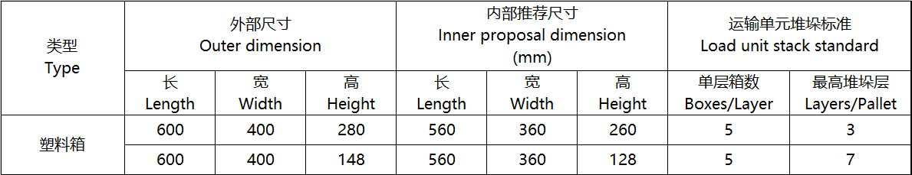  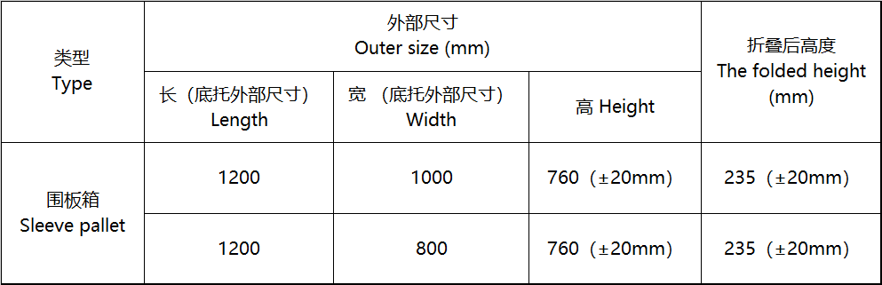

Production Requirements 生产需求

EOL Mode(TBC)
需求描述 /Requirement Description | The system support engineering test mode for production line.  1. When the display stays at APP mode, and send/received the CAN message apply for enter the EOL mode, then display shall enter EOL mode. Then MCU shall send the responds message.  2. When the display send/received the CAN message, then display shall exit EOL mode. Then MCU shall send the responds message.
对运行环境的依赖和影响/Impact and dependence on the operating environment | Dependence: None  Impact: None
验证标准/ Verification criteria | Apply for entering EOL mode:  1. send message 5A 05 08 02 31 01 9B  2. receive message 5A 06 08 03 31 01 00 9D  Enter EOL mode:  1. send message 5A 05 08 02 31 02 9C  2. receive message 5A 06 08 03 31 02 00 9E  Exit EOL mode:  1. send message 5A 05 08 02 31 FF 99  2. receive message 5A 06 08 03 31 FF 00 9B

Read SW Information [SyRD-IMPLEMENT-0007]
需求描述 /Requirement Description | Support to read software Information  The customer software version, internal software version(MCU, touch, slider, sensor key, HWR) and software checksum(MCU, touch, slider, sensor key, HWR) shall be pre-written in MCU.  When the system stays at EOL mode, display shall can report customer software version, internal software version and software checksum when received the CAN message to read the software information.
对运行环境的依赖和影响/Impact and dependence on the operating environment | Dependence: None  Impact: None
验证标准/ Verification criteria | Read customer software version:  1. send message 5A 05 0D 03 30 00 00 9F  2. receive message 5A 06 0D 08 30 00 00 00 XX XX XX XX CS  Read internal software version: MCU  1. send message 5A 05 19 03 30 00 01 AC  2. receive message 5A 06 19 14 30 00 01 XX XX...CS  Read software checksum: MCU  1. send message 5A 05 0D 03 30 00 04 A1  2. receive message 5A 06 0D 08 30 00 04 XX XX.. CS  Read internal software version: touch  1. send message 5A 05 0B 03 30 02 03 A2  2. receive message 5A 06 0B 06 30 02 03 XX XX ... CS  Read software checksum: touch  1. send message 5A 05 0B 03 30 02 01 A0  2. receive message 5A 06 0B 06 30 02 01 XX XX...CS  Read internal software version: slider  1. send message 5A 05 0D 03 30 04 00 CS  2. receive message 5A 05 0D 08 30 04 00 XX XX... CS  Read software checksum: slider  1. send message 5A 05 XX 03 30 04 09 CS  2. receive message 5A 06 XX XX 30 04 09 00 XX... CS  Read internal software version: sensor key  1. send message 5A 06 XX XX 30 05 00 00 XX...CS  2. receive message 5A 05 XX 03 30 05 01 CS  Read software checksum: sensor key  1. send message 5A 05 0D 03 30 00 04 A1  2. receive message 5A 06 0D 08 30 00 04 XX XX.. CS  Read internal software version: HWR  1. send message 5A 05 19 03 30 00 01 AC  2. receive message 5A 06 19 14 30 00 01 XX XX...CS  Read software checksum: HWR  1. send message 5A 05 0D 03 30 00 04 A1  2. receive message 5A 06 0D 08 30 00 04 XX XX.. CS

Write and read HW version [SyRD-IMPLEMENT-0008]
需求描述 /Requirement Description | Support write and read hardware version  When the system stayed at EOL mode, display shall write the hardware version to the Data-flash in the MCU when received the CAN message to write the hardware version.  When the system stay at EOL mode, display shall report the hardware version when received the CAN message to read the hardware version.
对运行环境的依赖和影响/Impact and dependence on the operating environment | Dependence: None  Impact: None
验证标准/ Verification criteria | Write hardware version:  1. send message 5A 05 09 06 30 00 02 XX XX XX CS  2. receive message 5A 06 09 04 30 00 02 XX CS  Read hardware version:  1. send message 5A 05 0C 03 30 00 03 A1  2. receive message 5A 06 0C 07 30 00 03 XX XX XX XX.CS

Write and read product serial number [SyRD-IMPLEMENT-0009]
需求描述 /Requirement Description | Support Write and read product serial number  When the system stay at EOL mode, display shall write the product serial number to the Data-flash in the MCU when received the CAN message to write the product serial number.  When the system stay at EOL mode, display shall report the product serial number when received the CAN message to read it.
对运行环境的依赖和影响/Impact and dependence on the operating environment | Dependence: None  Impact: None
验证标准/ Verification criteria | Write product serial number:  1. send message 5A 05 09 17 30 00 0C XX...CS  2. receive message 5A 06 09 04 30 00 0C XX CS  Read product serial number:  1. send message 5A 05 1D 03 30 00 0D BC  2. receive message 5A 06 1D 18 30 00 0D XX XX... CS

Write and read TFT Brightness value [SyRD-IMPLEMENT-0010]
需求描述 /Requirement Description | Support Write and read TFT brightness value  When the system stay at EOL mode, display shall write the brightness value to the Data-flash in the MCU when received the CAN message to write the brightness value  When the system stay at EOL mode, display shall report the brightness value, when received the CAN message to read it
对运行环境的依赖和影响/Impact and dependence on the operating environment | Dependence: None  Impact: None
验证标准/ Verification criteria | Write TFT brightness value:  1. send message 5A 05 09 05 30 01 02 XX XX CS  2. receive message 5A 06 09 04 30 01 02 XX CS  Read TFT brightness value:  1. send message 5A 05 0B 03 30 01 03 A1  2. receive message 5A 06 0B 06 30 01 03 XX XX XX CS

Write and read Brightness Weight [SyRD-IMPLEMENT-0011]
需求描述 /Requirement Description | Support Write and read brightness weight value  When the system stay at EOL mode, display shall write the Brightness Weight to the Data-flash in the MCU when received the CAN message to write the Brightness Weight.  When the system stay at EOL mode, display shall report the Brightness Weight when received the CAN message to read it.
对运行环境的依赖和影响/Impact and dependence on the operating environment | Dependence: None  Impact: None
验证标准/ Verification criteria | Write TFT brightness Weight value:  1. send message 5A 05 09 04 30 01 05 XX CS  2. receive message 5A 06 09 04 30 01 05 XX CS  Read TFT brightness Weight value:  1. send message 5A 05 0A 03 30 01 06 A3  2. receive message 5A 06 0A 05 30 01 06 XX XX CS

Read ADC value [SyRD-IMPLEMENT-0012]
需求描述 /Requirement Description | Support read ADC detected value  When the system stay at EOL mode, display shall report the all ADC detected value when received the CAN message to read it.
对运行环境的依赖和影响/Impact and dependence on the operating environment | Dependence: None  Impact: None
验证标准/ Verification criteria | Read ADC detected value:  1. send message 5A 05 1B 03 30 00 05 CS  2. receive message 5A 06 1B 16 30 00 05 XX XX... CS

Read and clear IFC [SyRD-IMPLEMENT-0013]
需求描述 /Requirement Description | Support Read and clear IFC function  When the system stayed at EOL mode, display shall read the amount and value of IFC when received the CAN message to read the IFC information.  When the system stay at EOL mode, display shall clear IFC value when received the CAN message to clear it.
对运行环境的依赖和影响/Impact and dependence on the operating environment | Dependence: None  Impact: None
验证标准/ Verification criteria | Read IFC quantity:  1. send message 5A 05 0A 03 30 00 0E AA  2. receive message 5A 06 0A 05 30 00 0E 00 XX CS  Read IFC value:  1. send message 5A 05 11 04 30 00 0F XX CS  2. receive message 5A 06 11 0C 30 00 0F 00 XX... CS  Clear IFC:  1. send message 5A 05 09 03 30 00 10 AB  2. receive message 5A 06 09 04 30 00 10 00 AD

Aging [SyRD-IMPLEMENT-0014]
需求描述 /Requirement Description | Support aging function  When the system stayed at EOL mode, display shall be controlled into aging state by CAN.  Aging time shall be controlled and recorded.
对运行环境的依赖和影响/Impact and dependence on the operating environment | Dependence: None  Impact: None
验证标准/ Verification criteria | Write aging time:  1. send message 5A 05 09 04 30 00 07 XX CS  2. receive message 5A 06 09 04 30 00 07 XX CS  Read aging time:  1. send message 5A 05 0A 03 30 00 08 A4  2. receive message 5A 06 0A 05 30 00 08 XX XX CS  Start aging function:  1. send message 5A 05 09 03 30 00 09 A4  2. receive message 5A 06 09 04 30 00 09 XX CS  Exit aging function:  1. send message 5A 05 09 03 30 00 0A A5  2. receive message 5A 06 09 04 30 00 0A XX CS  Read aging status:  1. send message 5A 05 0A 03 30 00 0B A7  2. receive message 5A 06 0A 05 30 00 0B XX XX CS

Touch, slider and sensor key self-test [SyRD-IMPLEMENT-0015]
需求描述 /Requirement Description | Support Touch, slider and sensor key self-test function  When the system stayed at EOL mode, display shall send Touch, slider and sensor key self-test command by CAN.  After touch driver, slider driver and sensor key driver finished self-test, display will return the result of self-test.
对运行环境的依赖和影响/Impact and dependence on the operating environment | Dependence: None  Impact: None
验证标准/ Verification criteria | Touch driver self-test:  1. send message 5A 05 0C 03 30 02 02 A2  2. receive message 5A 06 0C 07 30 02 02 XX XX... CS  Slider driver self-test:  1. send message 5A 05 08 03 30 04 01 CS  2. receive message 5A 05 08 03 30 04 01 XX CS  Slider driver self-test information:  1. send message 5A 05 0D 03 30 04 02 CS  2. receive message 5A 06 0D 08 30 04 02 00 XX... CS  Sensor key driver self-test:  1. send message 5A 05 XX 03 30 05 01 CS  2. receive message 5A 06 XX XX 30 05 01 00 XX CS

Write and read searching light Brightness value [SyRD-IMPLEMENT-0020]
需求描述 /Requirement Description | Support Write and read searching light brightness value  When the system stay at EOL mode, display shall write the brightness value to the Data-flash in the MCU when received the CAN message to write the brightness value  When the system stay at EOL mode, display shall report the brightness value, when received the CAN message to read it
对运行环境的依赖和影响/Impact and dependence on the operating environment | Dependence: None  Impact: None
验证标准/ Verification criteria | Write searching light brightness value:  1. send message 5A 05 09 2B 30 03 01 XX XX ..CS  2. receive message 5A 06 09 04 30 03 01 XX CS  Read searching light brightness value:  1. send message 5A 05 31 03 30 03 02 C8  2. receive message 5A 06 31 2C 30 03 02 XX XX ..CS

Write and read searching light Weight [SyRD-IMPLEMENT-0021]
需求描述 /Requirement Description | Support Write and read searching light brightness weight value  When the system stay at EOL mode, display shall write the Brightness Weight to the Data-flash in the MCU when received the CAN message to write the Brightness Weight.  When the system stay at EOL mode, display shall report the Brightness Weight when received the CAN message to read it.
对运行环境的依赖和影响/Impact and dependence on the operating environment | Dependence: None  Impact: None
验证标准/ Verification criteria | Write searching light brightness Weight value:  1. send message 5A 05 09 2B 30 03 04 XX XX.. CS  2. receive message 5A 06 09 04 30 03 04 XX CS  Read searching light brightness Weight value:  1. send message 5A 05 31 03 30 03 05 CB  2. receive message 5A 06 31 2C 30 03 05 XX XX .. CS

Offline burning [SyRD- IMPLEMENT-00xx]
NA

Installation Requirements 安装需求

安装要求 [SyRD-IMPLEMENT-0013]
需求描述/ Requirement Description | Describe the layout of all parts area, ask the seller in accordance with the requirements for decorate design, avoid interference or influence on aesthetics  描述零件所在区域的布置要求，要求卖方按照布置要求设计，避免干涉或对美观的影响  Purpose目的:To ensure ergonomic assembly.确保符合人体工程学的装配  Requirement要求:It is a prerequisite that assembly of the unit can be done in an ergonomically correct stance and that that there are guide pins etc.  to aid assembly. Materials must be chosen giving consideration to requirements regarding the working environment.零件的组装符合人体工程学，  并有引导设计来帮助工人进行组装工作，这是一个先决条件。材料的选择必须考虑到工作环境的要求。  Dimension 尺寸  Purpose目的: To specify the maximum size for the CSD.指定CSD的最大尺寸。  To ensure proper size for the CSD and compatibility to the car structure.  确保CSD的尺寸合适，并与车辆其他结构兼容  Requirement要求: Layout and appearance according to styling CAS.Package according to CAS released at Geely.  根据造型CAS设计布局和外观。根据Geely发布的CAS完成包装  Qualification Method Drawing and documentation.  合格认证方法:图纸和文件。  Fixing points of CSD/CSD的固定点  Reference参考: CATIA models.CATIA模型。  Purpose目的: To secure fixing of CSD into the instrument panel, in order to get a solid fixing and fulfill crash requirements.  确保将CSD固定到仪表板上，以获得牢固的固定并满足碰撞要求。  Requirement要求: The CSD shall be fixed into the instrument panel by using screws and possibly clips. All CSD variants shall have exactly the same fixing points and interface to the IP.  CSD应通过螺钉和卡扣固定在仪表板中。所有CSD变体应具有与IP完全相同的固定点和接口。  Qualification Method资格认定方法: Demonstration by drawing/model.通过图纸/模型进行演示。  Avoidance clearance requirements避让间隙要求：CSD和IP之间的避让间隙为≥3mm。避免干涉。
对运行环境的依赖和影响/Impact and dependence on the operating environment | Dependence: None  Impact: None
验证标准/Verification criteria | Design review

Adaptation Requirements 适配需求

标识和追溯要求 [SyRD-IMPLEMENT-0014]
需求描述/ Requirement Description | Here are requirements concerning the marking of parts with text, symbols and colour identification, etc. by reference to the valid Buyer standard. As an alternative, a marking already chosen can be indicated here together with its location.. Make it clear that manufacturer/supplier must not have his trademark/logotype, part number, or any other information. Product identification, traceability plan and technical requirements shall be described in detail.  这里是关于用文字、符号、颜色等识别标记部件的要求，参考买方有效标准。作为一个代替方案，已经选择的标识在这和位置一起描述。明确说明制造商/卖方不能有他的商标/标识、零件号、或任何零部件的其他信息。须详细描述产品标识、追溯方案和技术要求。  Traceability protocols and technical requirements  追溯方案和技术要求。  Q/JL J180027-2020 Management specifications for traceability requirement/追溯要求的管理规范  Q/JL J100003-2021 Marking of Automobile Parts Text marking on parts/汽车零部件永久性标识规定  Q/JL J100013-2023 Parts marking with bar codes and 2-D symbologies/汽车零部件条形码和二维码管理规则  标识的具体内容、位置、尺寸需要参见FDJ后的产品图纸或3DPMI
对运行环境的依赖和影响/Impact and dependence on the operating environment | Dependence: None  Impact: None
验证标准/Verification criteria | Review

车辆配置信息 [SyRD-IMPLEMENT-0015]
需求描述/ Requirement Description | 项目 配置 覆盖率  / / /  / / /
对运行环境的依赖和影响/Impact and dependence on the operating environment | Dependence: None  Impact: None
验证标准/Verification criteria | Design review

目标市场 [SyRD-IMPLEMENT-0016]
需求描述/ Requirement Description | No. 序号 Target market 目标市场 Parts accreditation requirements 零部件认证要求 Remarks 备注  1 中国 NA
对运行环境的依赖和影响/Impact and dependence on the operating environment | Dependence: None  Impact: None
验证标准/Verification criteria | Design review

Special Characteristics 特殊特性
序号 | 特殊特性名称/描述 | 规范&公差 | 特殊特性类型 | 特性等级 | 是否为CR特性
1 | 汽车产品禁用、限用物质要求 | 材料满足Q/LJ160001-2020的要求铅：0.1%；汞：0.1%；镉：0.1%六价铬：0.1%金属涂镀层：<0.10 ug/cm2所有非金属零部件及材料：0.1%多溴联苯：0.1%多溴二苯醚：0.1% | 产品特性 | [1] | N/A
2 | EMC | 符合Q/JLY110779E-2023①标准中限值要求 | 产品特性 | [3] | N/A
3 | 气味性 | 满足Q/JLY111031C-2020《车内非金属部件及材料气味等级限值技术条件》要求气味等级，干法≥5级，湿法≥5.5级 | 产品特性 | [3] | N/A
4 | 产品外观一体黑效果 | 产品整体色差Typ △E≤2.0 | 产品特性 | [3] | N/A
5 | 屏幕显示色坐标 | Wx θ= 0° 0.305±0.03  Wy θ= 0° 0.320±0.03  Rx θ= 0° 0.666±0.03  Ry θ= 0° 0.310±0.03  Gx θ= 0° 0.274±0.03  Gy θ= 0° 0.667±0.03  Bx θ= 0° 0.154±0.03  By θ= 0° 0.059±0.03 | 产品特性 | [3] | N/A
6 | 表面反射率 | ≤1.5%（涉及到防爆膜的，实测后重新确认基准） | 产品特性 | [3] | N/A
7 | 对比度 | Min.:1200：1 | 产品特性 | [3] | N/A
8 | 亮度 | Min.:800nits | 产品特性 | [3] | N/A
9 | 亮点，暗点 | 像素亮点数量：0  像素暗点数量：≤3  连续暗点：0 | 产品特性 | [3] | N/A
10 | 间隙 | 屏幕与外壳间隙要求: 0.4±0.3mm | 产品特性 | [3] | N/A
11 | 屏幕与外壳面差 | 面差要求：0.5±0.5mm | 产品特性 | [3] | N/A
12 | 中控显示屏装配尺寸 | 下排左右侧卡扣和上排左侧卡扣中心距：40.2±0.8  上排卡扣中心距：101.6±0.8  下排卡扣中心距：179.3±0.8  下排中间卡扣和上排右侧卡扣中心距：41.6±0.8 | 产品特性 | [3] | N/A
13 | 耐久性 | 满足企标 L品牌: Q/JLYJ7210899A-2019① 整车LPT耐久性试验规范(盐城)试验过程功能满足设计要求 参考标准7.16 Vehicle LPT DurabilityTest G品牌:Q/JLYJ7210834B-2019-整车GP1耐久性试验规范(盐城)Vehicle GPT DurabilityTest 试验过程功能满足设计要求 参考标准5.12(具体要求按实际项目为准) | 产品特性 | [3] | N/A
14 | 接插件性能 | PIN脚定义及接插件型号符合图纸要求;接插件满足Q/JLY J7110195E-2021试验标准要求 | 产品特性 | [3] | N/A
15 | 对于产品标识、标签及产品追溯的要求 | 标识规则满足Q/LJ J10003-2021《汽车零部件永久性标识规定》要求；追溯要求（满足Q/LJ J10013-2018《汽车零部件条形码和二维码管理规则》 | 产品特性 | [3] | N/A
16 | 静态电流（暗电流） | 静态电流≤0.1mA | 产品特性 | [3] | N/A
17 | 防水防尘要求 | 防水防尘要求：IP5K2；并符合标准GB/T 4208-2017的测试要求 | 产品特性 | [3] | N/A
18 | mura | 环境照度在100 cd/m2以下，5%ND filter不可见 | 产品特性 | [3] | N/A
19 | 阻燃性 | 燃烧速度≤80mm/min | 产品特性 | [3] | N/A
20 | 表面硬度 | CG表面镀AG/AR/AF，表面硬度满足7H  CG表面贴膜AG，表面硬度满足3H | 产品特性 | [3] | N/A
21 | SPI检查 | 锡膏印刷高度/体积 70%～150% | 过程特性 | // | N/A
22 | 回流炉温 | 恒温（150℃～180℃），时间60s～120s，220℃以上时间40s～90s，最高温度（235℃～250℃），峰值温差≤8℃。 | 过程特性 | // | N/A
23 | 振动测试 | 频率：50Hz，时间：2min | 过程特性 | // | N/A
24 | 老化 | 70±5℃，2H，自动上下电 | 过程特性 | // | N/A

Healthy and Safety environment requirements健康安全环境需求

Healthy requirements健康要求 [SyRD-HSE-0001]
需求描述 /Requirement Description | - Odor requirements/气味要求  CSD components and materials shall be met the standard for Q/JLY J7111031D-2023 The Odor Technical requirements for vehicle interior Non-metallic components and materials(**level)  CSD 零部件部位材料气味需满足Q/JLY J7111031D-2023《车内非金属件部位及材料气味等级限值》 (Ⅰ类) 要求  - 车内关重件塑料件量产过程中禁止使用自喷漆，鞋油等材料进行表面修复  Do not use self - spray paint , shoe polish and other materials for surface repair during the mass production of car interior plastic key parts.  - 车内关重件塑料件进行模流分析及模具设计时需充分考虑到工艺温度对气味的影响，确保改性PP类材料注塑温度<210℃，复合纤维PP类材料注塑温度<230℃，ABS类材料<230℃，PC/ABS类材料<250℃  The mold flow analysis and mold design of the car interior key parts must fully consider the influence of process temperature on the smell, ensure the injection temperature less than 210℃ of the modified PP , and the composite fiber PP less than 230 °C, ABS less than 230°C, PC/ABS less than 250°C.  - 车内关重件塑料件注塑前需充分烘干并通风，并将该措施纳入工艺文件管控范围内  The car interior plastic key parts must be fully dried and ventilated before injection molding,and the measures should be included in the scope of control of the process documents.  - 车辆内饰、空调、电器部件所使用的聚甲醛材料（POM）需使用吉利认可的低散发牌号  The vehicle interiors, air conditioners, and electrical components should use Polyoxymethylene (POM) , which must bu required to use Geely-approved low-emission grades.  - 为保证产品材料稳定性并利于气味散发，车内空气关重件所使用PU发泡材料发泡工艺后需设置48小时以上的熟化时间并良好通风  In order to ensure the stability of the material of the product and facilitate the emission of smell, it is necessary for the in-air car key parts to set the curing time above 48 hours after the foaming process of the PU foam material.  - 车内空气关重件上所使用PU发泡材料需使用反应型的反应型催化剂，禁止使用BHT抗氧化剂  The PU foam material must be used in the in-air car key parts with reactive amine-free catalyst, and it is forbidden to use BHT antioxidant.  - 车内面料的火焰复合工艺作为影响气味的一项关键工艺，火焰复合厂家需在吉利认可范围内  The flame composite process of the interior fabric is a key process affecting the smell. The flame composite manufacturer needs to be within the scope of Geely's accreditation.  - 注塑前塑料粒子进行烘料（温度 ≥80℃，干燥时间≥ 2H），注塑过程中尽量降低注塑温度及压力（温度≤220℃）  Baking of plastic partiles before injection is required, baking temperature is above 80°C and baking time is above 2 hours; during injection, temperautre and presuure should be monitored and controlled to below 220°C.  - 车内面料的背覆PU海绵作为影响气味的一项关键材料，PU海绵供应商需在吉利认可范围内  The PU back cover sponge of the interior fabric is a key material affecting the smell. The PU sponge supplier needs to be within the scope of Geely's accreditation.  - 禁止在车内使用木质密度板材料  Inside the car, do not use medium-density fibreboard.  - 禁止使用激光工艺切割面料  Laser cutting of fabrics is prohibited.
对运行环境的依赖和影响/Impact and dependence on the operating environment | Dependence: None  Impact: None
验证标准/ Verification criteria | Design validation

Safe requiremtns 安全要求[SyRD-HSE-0002]
Since the product adopts ASIL QM safety level, functional safety requirements are not applicable to this chapter.

Environment requirements环境要求[SyRD-HSE-0003]
需求描述 /Requirement Description | - 原材料要求  The Material Attributes Test of Parts have to be in compliance with the Design Verification Plan & Report and Material Engineering Requirements .所有材料属性的测试需满足《试验验证大纲和报告 DVP&R》和《材料工程要求》的要求。  All non-metallic raw materials involved are prohibited from using and adding returns,blow molding plastic leftover material can add <30% of the components,but performance needs to be reassessed.所有涉及到的非金属原材料禁止使用和添加回料；吹塑成型塑料件可以添加<30%的本部件边角料，但需要重新评估性能。  Free of disturbing noise and odour in contact with the environment at all temperature and driving conditions.  在任何环境中和驾驶工况下，不得扩散噪音和气味。  - Recyclability /回收  For general requirements, see.一般要求见Q/JL J160002-2021《汽车回收利用管理规范》  Recyclability /回收  1、 Recyclability /回收  Parts shall be met the following requirements:  零部件回收需满足：  1) CN-market&other non-EU and US market/中国市场/其他非欧美市场：  Requirements on hazardous subtances and recoverability control in Automotive“, Ministry of industry and information technology Announcement No. 38 of 2015.  《汽车有害物质和可回收利用率管理要求》中华人民共和国工业和信息化部2015年第38号公告。  The requirements haven’t been specified in ESOW shall be executed in accordance with the latest status of the relevant laws and regulations in the sales area.  ESOW中未规定部分，依照产品销售地区相关法规的最新状态执行。  2) EU-market/欧盟市场：  Directive 2000/53/EC of the European Parliament and of the Council of 18 September 2000 on end-of life vehicles and its legislation  欧盟汽车报废指令2000/53/EC及其修订指令。  DIRECTIVE 2005/64/EC OF THE EUROPEAN PARLIAMENT AND OF THE COUNCIL of 26 October 2005 on the type-approval of motor vehicles with regard to their reusability, recyclability and recoverability and amending Council Directive  70/156/EEC 车型型式认证关于RRR指令2005/64/EC及70/156/EEC修订指令  Kinds of battery,accumulator and power battery must comply with DIRECTIVE 2006/66/EC and the latest amending directive.The battery suppliers shall complete the battery registration obiligation and reg.info.(including battery type,reg.No.,reg.unit,producer orgnization, reg.country and etc.).  各种电池、蓄电池、动力电池满足指令2006/66/EC及其最新修订指令的要求。电池供应商需完成电池注册的义务，并提供注册信息（电池类型、注册号、注册单位、生产单位、注册国家等）。  For products exported to the European Union，the battery symbol shall be met the requirements of directive 2006/66/EC.：The symbol shown in Annex II shall cover at least 3 % of the area of the largest side of the battery, accumulator or battery pack, up to a maximum size of 5 × 5 cm. In the case of cylindrical cells, the symbol shall cover at least 1,5 % of the surface area of the battery or accumulator and shall have a maximum size of 5 × 5 cm. Where the size of the battery, accumulator or battery pack is such that the symbol would be smaller than 0,5 × 0,5 cm, the battery, accumulator or battery pack need not be marked but a symbol measuring at least 1 × 1 cm shall be printed on the packaging. Symbols shall be printed visibly, legibly and indelibly. Batteries, accumulators containing more than 0,0005 % mercury, more than 0,002 % cadmium or more than 0,004 % lead, shall be marked with the chemical symbol for the metal concerned: Hg, Cd or Pb. The symbol indicating the heavy metal content shall be printed beneath the symbol shown in Annex II and shall cover an area of at least one-quarter the size of that symbol.  出口欧盟地区产品，其电池标识应满足2006/66/EC指令的要求：符号附录II带有划叉的带轮垃圾箱标识；标识符号大小应覆盖电池、蓄电池或电池包最大侧面积的3%，且不得大于5cm×5cm；如果电池为圆柱形，则符号应覆盖电池或蓄电池表面面积的1.5%，并且不大于5cm×5cm；如果电池、蓄电池或电池包面积所限符号尺寸可能小于0.5cm×0.5cm，则电池、蓄电池或电池包本身无需标识，需在包装上打印面积不小于1cm×1cm的标识；标识应清晰，可见，不易擦掉。汞含量超过5ppm，或镉含量超过20ppm，或铅含量超过40ppm的应标识元素化学符号（Hg，Cd，Pb），需在标识下打印重金属浓度，尺寸不小于垃圾箱标识的四分之一；  REGULATION (EC) No 1907/2006 OF THE EUROPEAN PARLIAMENT AND OF THE COUNCIL of 18 December 2006欧盟REACH法规的要求（No 1907/2006）  Classification, LABELING and packaging (CLP), EU Regulation 1272/2008. Chemicals, dangerous goods (e.g. oil, batteries, gas generators, etc.) shall be provided with safety data sheets in all exporting member languages and English labels（Fetal fluid labels are required in all member languages）.  CLP法规(Classification，labeling and packaging)，即欧盟1272/2008号法规。化学品、危险品（如油液，电池，气体发生器等）需提供所有出口成员国语言的安全数据表和英文标签（补胎液标签需要所有成员国语言）。  The requirements haven’t been specified in ESOW shall be executed in accordance with the latest status of the relevant laws and regulations in the sales area.  ESOW中未规定部分，依照产品销售地区相关法规的最新状态执行。  3) US-market/美国市场：  Federal guide End-of-Life Recycling for Vehicles of the Future  联邦指南 未来报废汽车回收利用指南  The requirements haven’t been specified in ESOW shall be executed in accordance with the latest status of the relevant laws and regulations in the sales area.  ESOW中未规定部分，依照产品销售地区相关法规的最新状态执行。  2、 Prohibitted & Restricted Substances/禁用、限用物质  Requirements/要求:  All parts must comply with the Buyer standard Q/JL J160001-2024 which is latest. Test sample type must be assembly component. Suppliers are responsible for ensuring their parts conform to the End of Life Vehicle (ELV) legislation in target market. Material phase-out strategies have to be supported, with details as follows:.  所有的零部件产品应当满足最新的买方企标Q/JL J160001-2024要求。检测样件类型要求为供货总成件；卖方有责任确认其所供产品符合目标市场ELV法规及其后续修订要求的要求。为了符合ELV法规及其后续修订要求，卖方应当制定相关材料逐步淘汰策略。  1) China market complys with category I (table 1) requirements of Q/JL J160001-2024;  中国市场满足Q/JL J160001-2024I类（表1）要求；  2) EU market complys with category I (table 1) and II (table 2) requirements of Q/JL J160001-2024;  欧盟市场满足Q/JL J160001-2024 I类（表1）+II类（表2）要求；  3) US market complys with category I (table 1), II (table 2) and III (table 3) requirements of Q/JL J160001-2024;  美国市场满足Q/JL J160001-2024 I类（表1）+II类（表2）+III类（表3）要求；  4) Other markets（non-EU&US） comply with category I (table 1) of Q/JL J160001-2024and local special requirements (if any).  其它市场（非欧美）满足Q/JL J160001-2024 I类（表1）要求及当地特殊要求（如有）。  3、 CAMDS/IMDS  3.1 CAMDS  1）Component material and ingredient(s) must be reported in CAMDS - China Automotive Material Data System.  零部件材料及成分信息必须在CAMDS（中国汽车材料数据系统）中进行提报。  2）Suppliers must submit component’s actual structure, weigiht , material(s) and substances to CAMDS also agree with“Buyer component & material sub-supplier list”.  卖方必须在CAMDS中提报其供货总成零部件的实际结构、重量、材料和物质并与“买方汽车零部件及材料分供方清单”一致。  3）Satisfying the standard of Q/JL J180019-2022 Specification for CAMDS Data Filling.  满足Q/JL J180019-2022《CAMDS数据填报规范》。  4）Recipient account information/接收方账号信息  Geely CAMDS account ID: Zhejiang Geely Holding Group CO.，LTD ID:CA_3_3762；  Lotus CAMDS account ID: Zhejiang Geely Holding Group CO.，LTD ID:CA_3_3762；  smart CAMDS account ID: Zhejiang Geely Holding Group CO.，LTD ID:CA_3_3762；  吉利CAMDS接收方：浙江吉利控股集团有限公司 ID:CA_3_3762；  路特斯 CAMDS接收方：浙江吉利控股集团有限公司 ID:CA_3_3762；  智马达 CAMDS接收方：浙江吉利控股集团有限公司 ID:CA_3_3762；  5）CAMDS Website CAMDS网址  CAMDS:www.camds.org.cn  3.2 IMDS  1）Component material and ingredient(s) must be reported in IMDS- International Material Data System.  零部件材料及成分信息必须在IMDS（中国汽车材料数据系统/国际材料数据系统）中进行提报。  2）Suppliers must submit component’s actual structure, weigiht , material(s) and substances to IMDS also agree with“Buyer component & material sub-supplier list”.  卖方必须在IMDS中提报其供货总成零部件的实际结构、重量、材料和物质并与“买方汽车零部件及材料分供方清单”一致。  3）Satisfying the standard of Q/JLY J180028-2021 Specification for IMDS Data Filling.  满足Q/JLY J180028-2021《IMDS数据填报规范》。  4）Recipient account information/接收方账号信息  Lynk & Co IMDS account ID: Lynk & Co International AB ID: 211740  领克 IMDS接收方：Lynk & Co International AB ID: 211740  GRI IMDS account ID:Geely automotive Research Institute Co.Ltd（ID:223649）  吉利汽车研究院IMDS账号：吉利汽车研究院有限公司（ID:223649）  Volvo IMDS account ID: Volvo Car Corporation [ID：106]  沃尔沃汽车IMDS账号：沃尔沃汽车公司[ID：106]  5）IMDS Website IMDS网址  IMDS:www.mdsystem.com  4、Sustainability requirements 可持续要求  1）Design For The Environment (DFE). When requested, suppliers shall provide Life Cycle Assessment (LCA) report comply with ISO 14044& 14040, Design for Recycling (DFR) and Design for Disassembly 产品应当为环境而设计，即“生态设计”。当（买方）有要求时，卖方应当提供满足ISO14044&ISO14040方法要求的产品全生命周期评价（LCA）报告。产品应当考虑可回收利用设计和易拆解设计。  2）According to project demand, suppliers shall incorporate post consumer (PCR), post industrial (PIR) recycled material content and renewable materials into appropriate components. Recycled content of Steel no less than 15% in weight,recycled content of Aluminum no less than 25% in weight, recycled content of Plastics no less than xx% in weight,recycled material content must be disclosed by CAMDS or IMDS , closed-loop of recycled materials must be established（provide evidence of where recycled material comes from and scrap treatment process） and recycled percentage shall be accepted by the relevant material Engineer.  在合适的部件中，根据项目需求，卖方应当引入和使用消费后和工业使用后可再循环材料（PCR和PIR）、可再生资源材料。循环钢比例不少于15%（以重量计），循环铝比例不少于25%（以重量计），循环塑料比例不少于xx%（以重量计）;循环材料比例必须通过CAMDS或IMDS进行披露。建立的循环材料闭环路径(提供循环材料来源和废物处理的过程)，及循环材料比例需由相关材料工程师进行验收。  3）Suppliers of interior components must fullfill vehicle requirement regarding emissions, fogging, smell, additives, Ni-leakage e.t.c. and minimize substances that could lead to clean compartment issues / allergies .内饰部件卖方应当满足车型关于散发性物质、雾化、气味、添加剂、镍释放等要求，并尽可能最少地使用可能引起洁净度和过敏问题的化学物质。  4）Hexavalent chromium process is prohibited in passivation process.  钝化工艺禁止使用六价铬工艺;  5）Renewable energy requirement: T1 supplier renewable energy percentage no less than xx%; Supplier chain below T1 reneable energy percentage no less than xx% ; 可再生能源要求:T1供应商可再生能源比例不少于xx%，T1以下供应链可再生能源比例不少于xx%;  6）Optimize and minimize logistics and transports’ CO2 emissions,decrease year by year x%；优化和减少物流运输的二氧化碳排放，逐年减少x%；  7）Reduce scrap discharge decrease year by year x%, energy consumption decrease year by year x%, water consumption decrease year by year x% ；逐年减少x%废物排放, 逐年减少x%能源消耗，逐年减少x%水消耗；  8）Secure leather’s responsible sourcing down to farmer’s end to ensure cruelty free and respect animal welfare；要做到皮革来源追溯到农场主，确保无残暴和尊重动物福利；  9）Cobalt, Lithium, Nickel and 3TG elements should be transparent and traceable in supply chain for battery，blockchain to be used to trace and confirm a compliant supply chain。电池钴,锂,镍和3TG元素要做供应链到百分百透明及可追溯，区块链技术应当被应用来追溯和确认卖方的合规性。
对运行环境的依赖和影响/Impact and dependence on the operating environment | Dependence: None  Impact: None
验证标准/ Verification criteria | Design validation

Embedded Software Requirements嵌入式软件要求
No applicable.

Legal constraints and Standards Compliance法律约束和标准遵从

Laws and Regulations法律法规[SyRD-LEGAL&STANDARDS-0001]
需求描述 /Requirement Description | QC/T 413-2002 汽车电气设备基本技术条件  QC/T 29017-2023 汽车摸制塑料零件未注公差尺寸极限偏差  GB/T 191-2008 包装储运图示标志  GB 11552-2009 乘用车内部凸出物  GB/T 30512-2014 汽车禁用物质要求  GB/T 3880.3-2012 一般工业用铝及铝合金板、带材  GB/T 23986.2-2023 色漆和清漆 挥发性有机化合物(VOC)含量的测定 气相色谱法  GB 34660-2017 道路车辆 电磁兼容性要求和试验方法  GB/T 18387-2017 电动车辆的电磁场发射强度的限制和测量方法  GB/T 18655-2018 车辆、船和内燃机 无线电骚扰特性 用于保护车载接收机的限值和测量方法  GB/T 2423.1-2008 电工电子产品环境试验 第2部分试验方法 试验A：低温  GB/T 2423.2-2008 电工电子产品环境试验 第2部分试验方法 试验B：高温  GB/T 2423.3-2016 电工电子产品环境试验 第2部分试验方法 试验Cab：恒定湿热试验  GB/T 2423.17-2008 电工电子产品环境试验 第2部分试验方法 试验Ka：盐雾  GB/T 2423.18-2021 电工电子产品环境试验 第2部分试验方法 试验Kb：盐雾，交变(氯化钠溶液)  GB/T 2828.1-2012 计数抽样检验程序 第1部分：按接收质量限（AQL）检索的逐批检验抽样计划  GB/T 28046.1-2011 道路车辆 电气及电子设备的环境条件和试验 第1部分：一般规定  GB/T 28046.2-2019 道路车辆 电气及电子设备的环境条件和试验 第2部分：电气负荷  GB/T 28046.3-2011 道路车辆 电气及电子设备的环境条件和试验 第3部分：机械负荷  GB/T 28046.4-2011 道路车辆 电气及电子设备的环境条件和试验 第4部分：气候负荷  GB/T 28046.5-2013 道路车辆 电气及电子设备的环境条件和试验 第5部分：化学负荷  GB/T 30038-2013 道路车辆 电气电子设备防护等级（IP代码）  ISO 3208-1974 道路车辆 乘用车内部凸出物的评价  ISO 26262-11-2018 道路车辆 功能安全  ISO 105-A02-1993 纺织品 色牢度试验 第A02部分:评定颜色变化的灰度表  ISO 188-2011 硫化或热塑橡胶.加速老化和耐热性试验  ISO 13400-3-2016 道路车辆 基于互联网协议（DoIP）的诊断通信-第3部分：基于IEEE802 第二版的有线车辆接口  ISO 16750-1-2023 道路车辆 电气和电子设备的环境条件和测试 第1部分：一般规定  ISO 16750-2-2023 道路车辆 电气和电子设备的环境条件和测试 第2部分：电气载荷  ISO 16750-3-2023 道路车辆 电气和电子设备的环境条件和测试 第3部分：机械载荷  ISO 16750-4-2023 道路车辆 电气和电子设备的环境条件和测试 第4部分：气候负荷  ISO 16750-5-2023 道路车辆 电气和电子设备的环境条件和测试 第5部分：化学负荷  ISO 11452-1-2015 道路车辆 窄带辐射的电磁能量进行电子干扰 部件试验方法 第1部分:总则和定义  ISO 11452-2-2019 道路车辆 窄带辐射的电磁能量产生的电干扰 部件试验方法 第2部分:吸波屏蔽外壳  ISO 11452-3-2016 道路车辆 窄带辐射的电磁能量产生的电干扰 部件试验方法 第3部分:横向电磁模式(TEM)元件  ISO 11452-4-2020 道路车辆窄带辐射的电磁能量产生的电干扰 部件试验方法 第4部分:束激励方法  ISO 11452-8-2015 道路车辆窄带辐射的电磁能量产生的电干扰 部件试验方法 第8部分: 抗磁场能力  ISO 11452-9-2012 道路车辆窄带辐射的电磁能量产生的电干扰 部件试验方法 第9部分: 便携式发射器  SAE/USCAR-2-2013 汽车电气连接器系统性能规范  SAE J1812-2018 EMC抗扰度测试的功能性能状态分类  2000/53/EC 欧洲议会及理事会2000/53/EC报废车辆技术指令  (EC)2005/64 可复用性、可循环利用性和可回收利用性  (EU)2018/858 关于车辆及其拖车，以及拟用于该类车辆的系统、组件及独立技术组件的认证和市场监察的法规  70/156/EEC 机动车辆及其拖车型号许可  2006/66/EC 电池和蓄电池及废电池和蓄电池指令  Q/BQB 430-2018 电镀锌钢板及钢带  Q/BQB 408-2018 冷成形用冷轧低碳钢板及钢带  2008/98/EC 废物框架指令
对运行环境的依赖和影响/Impact and dependence on the operating environment | Dependence: None  Impact: None
验证标准/ Verification criteria | Design review

Standard Requirements标准要求[SyRD-LEGAL&STANDARDS-0002]
需求描述 /Requirement Description | No. Document Code文档编号 Document Name文档名称 Note备注  1 Q/JLY J7110335C-2022 汽车非金属材料阻燃性限值要求及试验方法  2 Q/JLY J7111031D-2023 Technical Specifications for Limits of Odor Ratings of Automobile Interior Nonmetal Parts and Materials车内非金属件部位及材料气味等级限值  3 Q/JLY J7110341D-2020 Limits and test methods for fogging characteristics of automobile interior nonmetallic materials车内非金属材料雾化性限值要求及试验方法  4 Q/JL J160003-2024 Vehicle parts anti-corrosion technical requirements乘用车零部件防腐技术要求  5 Q/JL J160004-2023 Technical requirements for light aging performance of passenger vehicle non-metal parts乘用车非金属零部件耐光老化性能技术要求  6 Q/JLY J7110192E-2022 Temperature resistance of vehicle interior and exterior non-metallic trim system technical requirements乘用车内外饰非金属零部件耐温老化性能技术要求  7 Q/JLY J7111521A-2020 Ozone aging resistance requirements and test methods of passenger vehicle rubber components乘用车橡胶部件耐臭氧老化性能要求和试验方法  8 Q/JL J160002-2021 Management specification of automobile recycling汽车回收利用管理规范  9 Q/JL J160001-2024 Requirements for Prohibited and Restricted Substances of Automobile Parts and Materials汽车零部件和材料禁用、限用物质要求  10 Q/JLY J180028-2021 IMDS数据填报规范  11 Q/JLY J7111029E-2024 General technical specification of automotive electrical and electronic components汽车电气和电子零部件通用技术规范  12 Q/JLY J7110779E-2023 EMC SPECIFICATIONS OF ELECTRICAL AND ELECTRONIC COMPONENTS乘用车电气/电子零部件电磁兼容规范  13 Q/JLY J7210928D-2024 Full vehicle four-poster environmental squeak and rattle test specification 整车四立柱高低温异响测试规范  14 Q/JL J180027-2020 Management specifications for traceability requirements追溯要求的管理规范  15 Q/JL J100003-2021 Marking of Automobile Parts Text marking on parts汽车零部件永久性标识规定  16 Q/JL J100013-2023 汽车零部件条形码和二维码管理规则  17 Q/JLY J7111037C-2024 Technical conditions for passenger car on-board screen assembly乘用车车载屏幕总成技术条件  18 Q/JLY J7110550E-2022 Specifications for Coatings of Automobile Interior Trim汽车内饰涂层技术要求  19 Q/JLY J7110922D-2024 EMC specification for high voltage components of electrically driven passenger vehicles电驱动乘用车高压零部件电磁兼容规范  20 Q/JL J180019-2022 Specification for CAMDS Data Filling CAMDS 数据填报规范
对运行环境的依赖和影响/Impact and dependence on the operating environment | Dependence: None  Impact: None
验证标准/ Verification criteria | Design review

Authorization Requirements认证要求(TBC)

License [SyRD-LEGAL&STANDARDS-0003]
需求描述 /Requirement Description | The copyright of the handwriting recognition algorithm is Hanvon.  The copyright of Autosar architecture is Vector.
对运行环境的依赖和影响/Impact and dependence on the operating environment | Dependence: None  Impact: None
验证标准/ Verification criteria | Hanvon license: Check if the license is included in BOM  Autosar license: CQA process

Process [SyRD-LEGAL&STANDARDS-0004]
需求描述 /Requirement Description | The system shall comply with the ASPICE Level 2 Certify.
对运行环境的依赖和影响/Impact and dependence on the operating environment | Dependence: None  Impact: None
验证标准/ Verification criteria | Audit

CE certification [SyRD-LEGAL&STANDARDS-0005]
需求描述 /Requirement Description | The system shall comply with CE Certification(CONFORMITE EUROPEENNE).
对运行环境的依赖和影响/Impact and dependence on the operating environment | Dependence: None  Impact: None
验证标准/ Verification criteria | Audit

Related Documents 相关文档
The following referenced documents are indispensable for the application of this document. For dated references, only the edition cited applies. For undated references, the latest edition of the referenced document (including any amendments) applied.

Upstream documents上游文档
FS21中控显示屏包 ESOW
FX11-A2 15.4寸 CSDTREG
FX11-A2-15.4寸项目-主机与CSD屏交互文档-20250613
FX11-A2-15.4-供应商特殊特性清单-20260206
FX11-A2 15.4 INCH CID生产测试规范-20260129

Reference documents参考文档
YX-COP01-02-01 顾客需求分解TR管理规范
YX-COP02-02-10 系统需求分析流程

Traceability溯源性

Forward Traceability正向溯源
The traceability is realized in ALM system.

Backward Traceability逆向溯源
The traceability is realized in ALM system.

Template History模板历史
Version  版本 | Status  状态 | Date  日期 | Document Owner  作者 | Department  部门 | Change Points  更改点
V01 | Release | 2026-2-11 | Liu Fuguang | SYS | 首版发布
V02 | Release | 2026-4-30 | Zhang Hongzuo | SYS | - 新增2.5章节，设计替代方案章节  - 新增系统需求章节（3章节）  - 4.5.3章节（原3.5.3章节）。勘误【Output】描述  - 9.4 章节（原8.4章节），补充包装需求  - 新增补充产品特殊特性章节（章节10）  - 12.1章节（原10章节），补充上游文档  12.2章节，补充参考文档
V03 | Release | 2026-05-11 | Zhang Hongzuo | SYE | - 新增11章，健康安全环境需求  - 新增12章，补充嵌入式软件要求章节

