A REPORT ON:

Epilepsy Prediction using IoT

SUBMITTED TO
IEEE EMBS PUNE CHAPTER

BY

Candidates Name:

SHARWANI SAWANT
SANSKAR MALORE
VAISHNAVI SURWASE

Mentor Name
Dr. BHAGYASHREE DHAKULKAR




DECLARATION

We, the team members

Name of the Team Members
Member 1: Sharwani Sawant
Member 2: Sanskar Malore
Member 3: Vaishnavi Surwase

We hereby declare that the project report entitled "Smart Seizure Detection Prototype Using IoT and Machine Learning" submitted in partial fulfilment of the requirements for the award of the degree of Bachelor of Technology (B.Tech.) is a record of the original work carried out by us under the guidance of Dr. Bhagyashree Dhakulkar during the academic year 2026–2027.
We further declare that the work presented in this report has not been submitted, either in whole or in part, to any other university or institution for the award of any degree, diploma, or any other academic qualification. The information and data presented in this report have been collected from reliable sources, and all references used have been duly acknowledged.
We understand that any act of plagiarism or misrepresentation found in this report may lead to disciplinary action as per the rules and regulations of the institute.

Date: 25/06/2026

Dr. BHAGYASHREE DHAKULKAR
Place: Pune
Date: 30/06/2026

ABSTRACT

Epilepsy is one of the most common neurological disorders affecting millions of people worldwide. The unpredictable nature of epileptic seizures poses serious risks such as falls, injuries, and delayed medical assistance. Continuous monitoring using conventional Electroencephalogram (EEG) systems is often inconvenient for daily use due to their bulky nature and requirement of multiple scalp electrodes. Therefore, there is a need for a portable, user-friendly, and cost-effective solution for real-time seizure monitoring.
This project proposes a Smart Seizure Detection Prototype using Internet of Things (IoT) and Machine Learning (MI) for continuous monitoring of epileptic patients. The wearable device integrates multiple sensors, including a heart rate sensor, accelerometer, gyroscope, temperature sensor, and optional muscle activity sensor, to monitor physiological and motion-based parameters associated with seizure events. The collected data are processed using intelligent algorithms to identify abnormal patterns such as sudden increases in heart rate, abnormal body movements, falls, and muscle spasms that may indicate the occurrence of a seizure.
Upon detecting a suspected seizure, the system generates an immediate alert through a buzzer and automatically sends emergency notifications, including the patient's location, to caregivers or family members using IoT connectivity. The device also records seizure-related information that can assist healthcare professionals in understanding seizure frequency, duration, and recovery patterns for improved treatment planning.
The proposed system aims to provide an affordable, portable, and non-invasive solution that enhances patient safety, enables timely medical intervention, and improves the quality of life of individuals living with epilepsy through continuous real-time monitoring and emergency response.

SYNOPSIS

1. Title of the Project
Smart Seizure Detection Prototype Using IoT and Machine Learning

2. Introduction
Epilepsy is a neurological disorder characterized by recurrent seizures caused by abnormal electrical activity in the brain. Since seizures occur unpredictably, patients are at risk of injuries, delayed medical assistance, and reduced quality of life. Existing EEG-based monitoring systems provide accurate diagnosis but are not suitable for continuous daily monitoring due to their bulky setup and limited portability.
This project aims to develop a wearable Prototype capable of continuously monitoring seizure-related symptoms such as abnormal body movements and sudden changes in heart rate. The system utilizes IoT and Machine Learning technologies to provide real-time seizure detection and emergency alerts.

3. Problem Statement
People suffering from epilepsy often experience sudden seizures without prior warning. Lack of immediate assistance during seizure episodes can result in severe injuries and complications. Conventional monitoring methods are expensive, inconvenient for long-term use, and require hospital-based equipment. Therefore, an affordable, portable, and real-time monitoring system is required for seizure detection and emergency notification.

4. Objectives
- To design a wearable prototype for seizure detection.
- To monitor heart rate and body movement continuously.
- To generate emergency alerts to caregivers during seizure events.
- To maintain seizure records for future medical analysis.
- To improve patient safety through continuous monitoring.

5. Proposed Methodology
The proposed system consists of an ESP32 microcontroller integrated with a MAX30102 heart rate and SpO₂ sensor and an MPU6050 accelerometer and gyroscope sensor.
The MAX30102 continuously monitors heart rate and blood oxygen levels, while the MPU6050 detects abnormal body movements, shaking patterns, and fall events. The collected data are processed using Machine Learning or rule-based algorithms to identify seizure patterns.
When abnormal movement and heart rate variations occur simultaneously, the system classifies the event as a potential seizure. Upon detection, the prototype activates a buzzer alarm and sends notifications to caregivers through IoT connectivity. The detected events are recorded and stored for future monitoring and medical analysis.

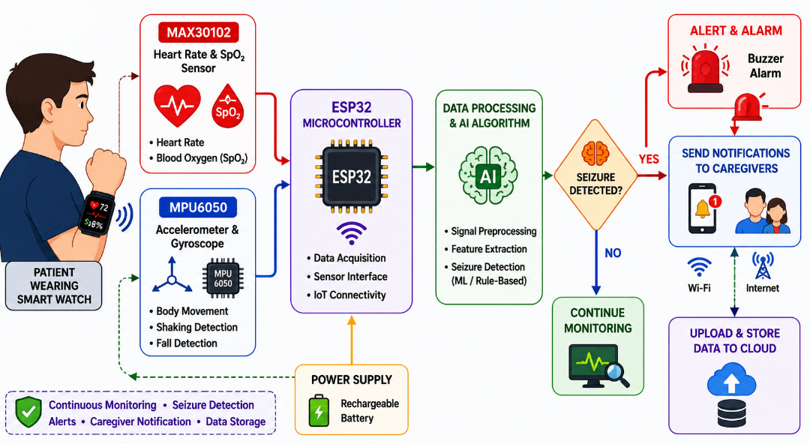
Fig 1: Block Diagram of the Proposed Seizure Detection and Emergency Response System

Figure 5.2 illustrates the proposed AI and IoT-based seizure detection prototype. The MAX30102 sensor monitors heart rate and SpO₂, while the MPU6050 detects abnormal body movements and falls. The ESP32 processes the sensor data using an AI or rule-based algorithm to identify possible seizures. When a seizure is detected, the system activates a buzzer, sends an alert to caregivers via Telegram, and stores the event data on Thing Speak for remote monitoring and future analysis.

6. Hardware Requirements
• ESP32 Development Board
• MAX30102 Heart Rate and SpO₂ Sensor
• MPU6050 Accelerometer and Gyroscope Sensor
• Buzzer
• Li-ion Battery
• Charging Module

7. Software Requirements
- Arduino IDE
- Embedded C/C++
- Thing Speak IoT Platform
- Mobile Notification Service

8. Expected Outcomes
• Real-time heart rate and motion monitoring.
• Automatic seizure detection.
• Immediate emergency alert generation.
• Storage of seizure event data for clinical reference.
• Improved patient safety and faster response during emergencies.

9. Applications
• Epilepsy patient monitoring.
• Home healthcare systems.
• Remote patient monitoring.
• Elderly care and assisted living.
• Healthcare monitoring and emergency support systems.

10. Conclusion
The proposed Smart Seizure Detection prototype offers a portable, cost-effective, and non-invasive solution for continuous monitoring of epileptic patients. By combining the MAX30102 heart rate sensor, MPU6050 motion sensor, IoT technology, and intelligent algorithms, the system aims to improve patient safety, facilitate timely intervention, and support healthcare professionals through reliable seizure-related data collection.

CONTENTS

Abstract (week1)……………………………..…...……………. | i
Synopsis (week1) ……………………………………………….. | ii

Chapter | Title | Page No.
Chapter 1 | Introduction (WEEK 1) | 7
Chapter 2 | Concepts and Methods (WEEK 1) | 8
Chapter 3 | Literature Survey (WEEK 1) | 9
Chapter 4 | Project Plan (WEEK 2) | 10
Chapter 5 | Proposed Work (WEEK 2) | 11
Chapter 6 | Result (WEEK 3) | 12
Chapter 7 | Conclusion (WEEK 3) | 13
B. | Bibliography | 14
C. | Annexure: Research Paper (Week 3 & 4) | 15

CHAPTER 1

INTRODUCTION

1.1 BACKGROUND
Epilepsy is a chronic neurological disorder characterized by recurrent and unpredictable seizures resulting from abnormal electrical activity in the brain. According to the World Health Organization (WHO), approximately 50 million people worldwide are affected by epilepsy, making it one of the most common neurological diseases globally. Seizures can occur without warning and may lead to loss of consciousness, involuntary muscle movements, falls, injuries, and even life-threatening situations if immediate assistance is not available.
Traditional seizure diagnosis and monitoring primarily rely on Electroencephalography (EEG), clinical observation, neuroimaging techniques, and patient-reported seizure histories. Although these methods are effective in clinical settings, they are often expensive, inconvenient for continuous monitoring, and require frequent hospital visits. Consequently, many patients lack access to real-time monitoring systems that can provide immediate assistance during seizure episodes.
Recent advancements in wearable technology, Internet of Things (IoT), and Machine Learning (MI) have enabled the development of portable healthcare solutions capable of continuously monitoring physiological and movement-related parameters. These technologies offer an opportunity to improve patient safety by detecting seizure-related symptoms and providing timely alerts to caregivers and healthcare professionals.

1.2 EXISTING SYSTEM
Current approaches used for epilepsy monitoring include:
- Electroencephalography (EEG) for recording brain activity.
- Video-EEG monitoring in specialized healthcare facilities.
- Clinical assessment based on patient history and witness reports.
- Mobile applications for manual seizure logging.
- Medication management and lifestyle counselling.
Although these methods play an important role in diagnosis and treatment, they have several limitations, including high costs, limited portability, lack of continuous monitoring, dependence on hospital infrastructure, and inability to provide immediate emergency notifications during seizure events.

1.3 PROBLEM STATEMENT
Epileptic seizures occur unexpectedly and can expose patients to significant health risks such as injuries from falls, delayed medical intervention, and reduced quality of life. Existing monitoring systems are either confined to hospital environments or depend heavily on manual reporting by patients and caregivers. There is a need for an intelligent, wearable, and cost-effective healthcare solution capable of continuously monitoring seizure-related symptoms, detecting abnormal events in real time, and automatically notifying caregivers during emergencies.

1.4 OBJECTIVES
- To design and develop a smart wearable prototype for seizure detection.
- To continuously monitor heart rate, blood oxygen level (SpO₂), and motion-based parameters associated with seizures.
- To integrate MAX30102 and MPU6050 sensors into a compact wearable device.
- To implement AI-based for seizure detection and classification.
- To maintain seizure event records for future medical analysis and clinical support.
- To enhance patient safety and improve the quality of life of individuals living with epilepsy.

1.5 SCOPE

The proposed project develops a wearable prototype for seizure detection that monitors heart rate, SpO₂, abnormal body movements, tremors, and fall events to identify potential seizure episodes. The system provides real-time alerts, IoT-based event logging, and caregiver notifications. It is designed as a supportive healthcare monitoring tool and does not replace professional medical diagnosis or EEG-based clinical evaluation.

CHAPTER 2

CONCEPT AND METHODOLOGY

2.1 CONCEPT OF THE PROPOSED SYSTEM

The proposed system is a wearable prototype designed to continuously monitor epilepsy

patients and detect seizure events in real time. The system utilizes physiological and motion

sensors integrated with an ESP32 microcontroller to observe symptoms commonly associated

with seizures.

The main concept behind the project is that most epileptic seizures are accompanied by

noticeable changes in body parameters such as increased heart rate, abnormal hand movements,

sudden falls, and muscle spasms. By continuously monitoring these parameters and analyzing

them using intelligent algorithms, the device can identify possible seizure events and provide

immediate assistance.

Unlike traditional hospital-based monitoring systems, the proposed device is portable, cost

effective, and suitable for everyday use. It enables continuous patient monitoring outside

clinical settings and improves the chances of timely intervention during emergencies.

2.2 SYSTEM ARCHITECTURE

The proposed system consists of the following modules:

1. Data Acquisition Module

This module collects physiological and movement-related data using wearable sensors.

The sensors used include:

MAX30102 Heart Rate and SpO₂ Sensor

MPU6050 Accelerometer and Gyroscope Sensor

Buzzer for emergency alert

2. Processing Module

The ESP32 microcontroller acts as the central processing unit of the system. It receives

sensor data, preprocesses the information, and executes the seizure detection algorithm.

3. Seizure Detection Module

The collected sensor values are analysed using Machine Learning or rule-based decision

techniques. The algorithm identifies abnormal combinations of symptoms that indicate the

possibility of a seizure.

4. Alert and Communication Module

Once a seizure is detected, the system:

Activates a local buzzer alarm.

Sends emergency notifications to caregivers through IoT services.

Uploads event information to the cloud database.

5. Monitoring Module

Seizure events and sensor readings are stored and visualized through an IoT platform, enabling

caregivers and healthcare professionals to monitor the patient's condition remotely.

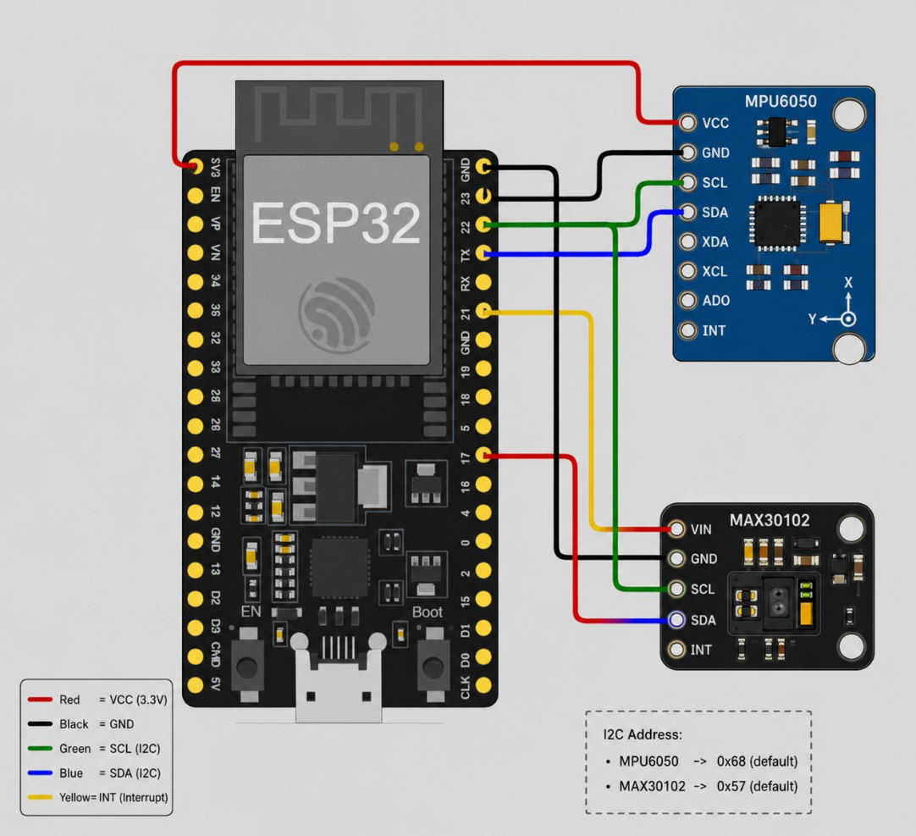
Fig 2: System Architecture and Sensor Interfacing Diagram
illustrates the hardware architecture of the proposed seizure detection prototype. The ESP32 microcontroller is interfaced with the MAX30102 heart rate and SpO₂ sensor and the MPU6050 accelerometer and gyroscope sensor through the I²C communication protocol. The ESP32 collects and processes the sensor data to identify seizure-related patterns using an AI or rule-based algorithm. Upon detecting a seizure, the system activates a buzzer, sends alerts to caregivers via Telegram, and uploads the event data to ThingSpeak for remote monitoring and future analysis.

Module / Sensor | Sensor Pin | ESP32 Pin | Function
MPU6050 | VCC | 3.3V | Power Supply
 | GND | GND | Ground
 | SDA | GPIO21 | I²C Data
 | SCL | GPIO22 | I²C Clock
 | INT | GPIO19 | Interrupt Pin
MAX30102 | VIN | 3.3V | Power Supply
 | GND | GND | Ground
 | SDA | GPIO21 | I²C Data
 | SCL | GPIO22 | I²C Clock
 | INT | GPIO17 | Interrupt Pin (Optional)
Table 1: Sensor Connection Details

Buzzer Pin | ESP32 Pin
Positive (+) | GPIO25
Negative (-) | GND
Table 2: Buzzer Connection Details

active buzzer is interfaced with GPIO25 of the ESP32 and is automatically activated to generate an audible alert whenever a seizure event is detected.

2.3 METHODOLOGY

The methodology adopted for the development of the proposed system consists of the

following steps:

Step 1: Continuous Data Collection

The wearable sensors continuously monitor the patient's physiological and movement

parameters.

Heart Rate and SpO₂ → MAX30102

Body Movement and Fall Detection → MPU6050

Step 2: Data Preprocessing

The acquired sensor data are filtered to eliminate noise and obtain stable readings suitable for

analysis.

Step 3: Feature Extraction

Important features associated with seizures are extracted, including:

Elevated heart rate.

Sudden acceleration changes.

Abnormal shaking patterns.

Fall events.

Variations in blood oxygen level (SpO₂).

Step 4: Seizure Detection

The extracted features are analysed using AI-based models or predefined threshold

conditions.

If the observed values exceed the normal operating range simultaneously, the system

classifies the event as a potential seizure.

Step 5: Emergency Response

Upon seizure detection:

• The buzzer is activated.

• SMS, email, or mobile notifications are sent to caregivers.

• The event is logged in the IoT platform.

Step 6: Data Storage and Monitoring

All detected events are stored for future analysis. Historical seizure records can help doctors

understand seizure frequency, severity, and recovery patterns.

2.4 WORKING PRINCIPLE

The prototype continuously senses physiological and movement-related changes in the

patient's body. Under normal conditions, the measured values remain within predefined

limits. During seizure episodes, abnormal variations such as increased heart rate, sudden body

movements, repetitive shaking, falls, and changes in blood oxygen levels are detected. The

ESP32 processes these sensor readings and evaluates them using the seizure detection

algorithm. If seizure conditions are satisfied, the system automatically initiates emergency

actions and transmits alerts to caregivers through IoT services. The entire process occurs in

real time without requiring manual intervention.

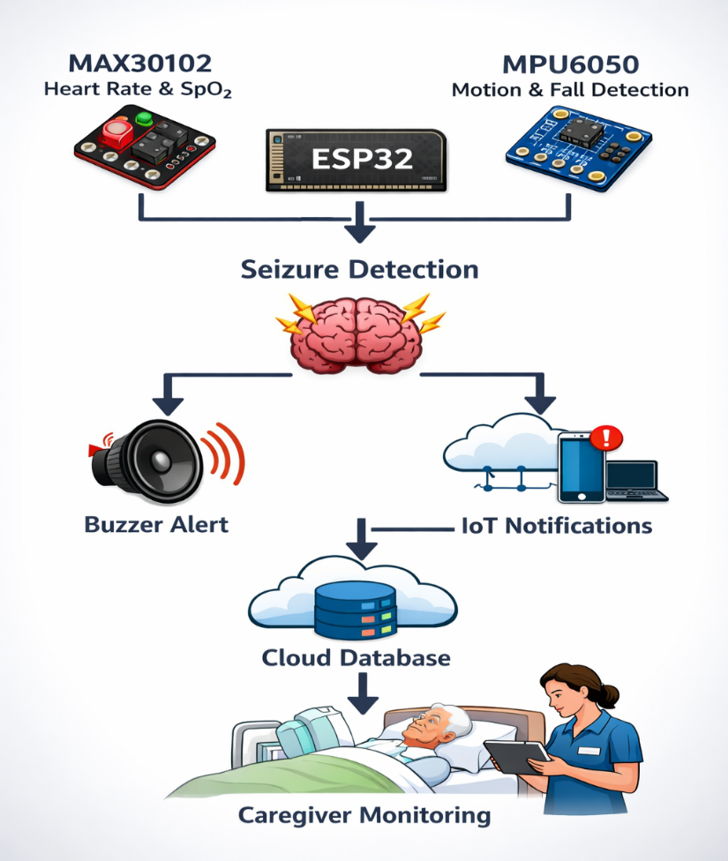

Fig 3: Working Principle of the Proposed AI and IoT-Based Seizure
Detection System

Figure 2.1 illustrates the working principle of the proposed seizure detection system. The MAX30102 and MPU6050 sensors continuously collect the patient's physiological and motion data, which are processed by the ESP32 microcontroller using a seizure detection algorithm. When abnormal heart rate, body movement, and fall patterns are detected simultaneously, the system identifies a potential seizure. It then activates a buzzer alarm, sends emergency notifications to caregivers through Telegram, and stores the event data on Thing Speak for real-time monitoring and future medical analysis.

2.5 ADVANTAGES OF THE PROPOSED SYSTEM

Continuous real-time monitoring.

Portable and wearable design.

Cost-effective compared to hospital monitoring systems.

Immediate emergency alert generation.

Remote monitoring through IoT.

Improved patient safety.

Supports healthcare professionals with seizure records.

Non-invasive and suitable for daily use.

2.6 LIMITATIONS

• The system does not replace EEG-based clinical diagnosis.

• False alarms may occur during vigorous physical activities.

• Sensor accuracy may vary with improper placement.

• Internet connectivity is required for cloud-based services and remote notifications.

• The prototype is intended as a supportive monitoring tool rather than a definitive diagnostic device.
Figure STYLEREF 1 \s 2. SEQ Figure \* ARABIC \s 1 1: This is my First Figure

Chapter 3

LITERATURE SURVEY

3.1 Introduction
Epilepsy is a neurological disorder characterized by recurrent and unpredictable seizures caused by abnormal electrical activity in the brain. According to the World Health Organization (WHO), epilepsy affects nearly 50 million people worldwide and remains one of the most common neurological disorders. Since seizures occur unexpectedly, patients are exposed to risks such as falls, injuries, delayed treatment, and reduced quality of life.
Over the years, researchers have proposed various methods for seizure detection and prediction. Traditional techniques mainly rely on Electroencephalography (EEG), whereas recent advancements have introduced wearable sensors, Internet of Things (IoT), machine learning, and Machine Learning for continuous monitoring outside hospital environments. This literature survey presents an overview of major contributions in seizure detection technologies and identifies the research gap addressed by the proposed Smart Seizure Detection system.

3.2 Traditional EEG-Based Seizure Detection Systems
Electroencephalography (EEG) is considered the gold standard for epilepsy diagnosis and seizure monitoring. EEG records electrical activity generated by the brain using electrodes placed on the scalp.
Several researchers have utilized EEG signals combined with machine learning algorithms such as Support Vector Machines (SVM), K-Nearest Neighbour (KNN), Decision Trees, Naïve Bayes, and Neural Networks to classify seizure events. These methods provide high detection accuracy and assist neurologists in diagnosis.
However, EEG-based systems suffer from several limitations:
- Requirement of multiple scalp electrodes.
- High equipment cost.
- Dependence on hospital settings.
- Patient discomfort during long-term monitoring.
- Limited suitability for everyday use.
An extensive review of EEG-based seizure detection highlighted that although EEG provides reliable diagnosis, its practical implementation for continuous monitoring remains challenging. Future systems should focus on portability, low power consumption, and patient comfort.

3.3 Wearable Seizure Detection Devices
Recent studies have explored wearable technologies capable of detecting seizures using physiological and motion-based signals.
Li et al. reviewed various wearable seizure detection systems and categorized them into wristbands, patches, and armband devices. The study emphasized the potential of wearable sensors to improve seizure monitoring by providing continuous observation during daily activities. The review also highlighted that most devices focus on motor seizures and often rely on single-signal analysis, thereby limiting detection performance.
The authors suggested that combining multiple physiological parameters could significantly improve detection accuracy and reliability.

3.4 Non-Invasive Wearable Device Performance Analysis
Naguru et al. conducted a systematic review and meta-analysis involving 28 studies evaluating wearable seizure detection devices.
The study reported that:
- Wrist-worn devices primarily utilized accelerometers.
- Surface wearable devices employed electromyography (EMG).
- The mean sensitivity for tonic-colonic seizure detection was approximately 91%.
- Wrist-worn devices achieved sensitivity around 93%.
- Surface EMG devices achieved sensitivity around 90%.
Although wearable systems demonstrated promising performance, researchers observed relatively high false alarm rates and recommended further work toward reducing false positives and improving the detection of multiple seizure types.

3.5 IoT-Based Monitoring Systems for Epileptic Patients
Souleyman Hassan et al. proposed an IoT-based monitoring system focusing on Generalized Tonic-Clonic (GTC) seizures.
The system integrated:
- ECG sensor for heart rate monitoring.
- EMG sensor for muscle spasm detection.
- Accelerometer for fall detection.
- Dallas temperature sensor for body temperature monitoring.
- ESP32 microcontroller for data processing.
- Thing Speak cloud platform for visualization.
- IFTTT service for emergency notifications.
A fuzzy logic classifier was employed to classify seizure types using physiological symptoms rather than EEG signals. The developed prototype demonstrated encouraging performance with the following accuracies:
  - Body Temperature Monitoring: 98.90%
  - Heart Rate Monitoring: 95.49%
  - Muscle Spasm Detection: 83.00%
  - Fall Detection: 87.21%
The study demonstrated that wearable IoT systems could provide practical alternatives to hospital-based monitoring while enabling real-time emergency response. However, the use of multiple bulky sensors may limit user comfort in wearable applications.

3.6 Machine Learning-Based Seizure Detection Approaches
Machine learning techniques have increasingly been applied to seizure detection due to their ability to identify hidden patterns within physiological signals.
Researchers have employed algorithms such as:
  - Support Vector Machine (SVM)
  - K-Nearest Neighbour (KNN)
  - Random Forest
  - Decision Tree
  - Naïve Bayes
  - Artificial Neural Networks
  - Deep Learning Models
Machine learning enhances detection performance by learning complex relationships between seizure and non-seizure events. Adaptive architectures have also been proposed for IoT-based healthcare systems, achieving detection accuracies exceeding 94%.

3.7 Research Gap
The review of existing literature reveals several limitations:
  - EEG-based systems provide high accuracy but lack portability and comfort.
  - Hospital-based monitoring cannot support continuous daily observation.
  - Many wearable devices rely on a single physiological parameter.
  - Some approaches require expensive hardware configurations.
  - Limited studies focus on affordable solutions suitable for routine use.
These limitations indicate the necessity of developing a compact, low-cost, multi-sensor wearable system capable of real-time seizure detection and emergency communication.

3.8 Proposed Contribution
Based on the identified research gap, this project proposes a Smart Seizure Detection Prototype integrating wearable sensors and IoT technology.
The proposed system incorporates:
  - MAX30102 Heart Rate Sensor.
  - MPU6050 Accelerometer and Gyroscope.
  - ESP32 Microcontroller.
  - GPS Module for location tracking.
  - Buzzer for emergency alerts.
The collected sensor data are analysed using intelligent decision-making algorithms to detect seizure events. Upon detection, the device activates local alarms, shares GPS coordinates with caregivers, and stores seizure information for future medical analysis Compared to existing approaches, the proposed system aims to provide:
  - Continuous real-time monitoring.
  - Improved portability.
  - Cost-effective implementation.
  - Emergency response capability.
  - IoT-enabled remote monitoring.
  - Enhanced patient safety and quality of life.

3.9 Summary
The literature survey indicates a significant transition from traditional EEG-based diagnosis toward wearable and IoT-enabled seizure detection systems. While previous studies have demonstrated promising results using individual sensors and machine learning techniques, there remains a need for affordable, user-friendly, and multi-sensor smart wearable devices capable of continuous monitoring and immediate emergency response. The proposed Smart Seizure Detection Prototype addresses these limitations by combining physiological sensing, intelligent decision-making, and IoT communication within a compact wearable platform.
Author | Method Used | Major Findings | Limitations
EEG-Based Studies | EEG + ML Algorithms | High diagnostic accuracy | Expensive, non-portable
Li et al. | Wearable Device Review | Wearables improve monitoring | Limited multi-sensor fusion
Naganur et al. | Meta-analysis of 28 studies | 91% sensitivity | High false alarm rate
Hassan et al. | IoT + Fuzzy Logic | Real-time alerts with IoT | Multiple sensors reduce comfort
ML-Based IoT Systems | KNN/AI Models | >94% accuracy | Resource constraints in wearables
Table 3: Comparison of Existing Epilepsy Detection Methods

CHAPTER 4
4.1 INTRODUCTION
A project plan provides a systematic approach for executing the proposed work within the available time and resources. It defines the sequence of activities, assigns responsibilities among team members, and ensures that the project objectives are achieved efficiently. The development of the proposed Smart Seizure Detection Prototype follows a phased approach consisting of planning, design, implementation, testing, documentation, and presentation.
The project is scheduled for completion within seven days by a team of three members, with each member contributing to specific tasks based on their area of responsibility.

4.2 TEAM STRUCTURE AND RESOURCE ALLOCATION
The project team consists of three members with distinct responsibilities to ensure balanced workload distribution.
Team Member | Assigned Responsibilities
Member 1 | Literature Survey, Documentation, Report Writing, Presentation Preparation
Member 2 | Hardware Procurement, Sensor Interfacing, Prototype Assembly
Member 3 | Software Development, IoT Integration, Testing and Validation
Table 4: Roles and Responsibilities of Team Members
This allocation enables parallel execution of tasks and promotes effective collaboration among team members.
4.3 PROJECT PHASES

Phase I: Project Planning and Requirement Analysis
Activities:
- Literature review.
- Identification of project requirements.
- Selection of sensors and hardware components.
- Definition of functional requirements.
Deliverables:
- Problem statement.
- Objectives and scope of the project.
- Hardware and software requirement list.

Phase II: System Design
Activities:
- Preparation of block diagrams.
- Design of system architecture.
- Development of process flowcharts.
- Finalization of seizure detection methodology.
Deliverables:
- System architecture diagram.
- Flowchart of operation.
- Methodology documentation.

Phase III: Hardware Development
Activities:
- Procurement of hardware components.
- Interfacing ESP32 with MAX30102 and MPU6050 sensors.
- Integration of power supply module.
- Assembly of the prototype.
Deliverables:
- Hardware prototype.
- Sensor connectivity verification.

Phase IV: Software and IoT Development
Activities:
- Programming ESP32 using Arduino IDE.
- Reading and processing sensor data.
- Implementation of seizure detection logic.
- Configuration of IoT connectivity.
- Integration of emergency notification system.
Deliverables:
- Embedded software.
- IoT monitoring platform.
- Alert notification mechanism.

Phase V: Testing and Validation
Activities:
- Sensor calibration.
- Functional testing of the prototype.
- Verification of alert notifications.
- Troubleshooting and debugging.
Deliverables:
- Tested prototype.
- Performance evaluation results.
- Corrected system errors.

Phase VI: Documentation and Presentation
Activities:
- Preparation of project report.
- Compilation of project results.
- Development of presentation slides.
- Demonstration rehearsal.
Deliverables:
- Final project report.
- Presentation slides.
- Prototype demonstration.

4.4 WEEKLY TIMELINE

Day | Activities | Responsible Members
Day1 | Literature Survey, Requirement Analysis, Objective Finalization | All Members
Day2 | System Architecture Design, Flowchart Preparation | Members 1 & 3
Day3 | Hardware Procurement and Sensor Interfacing | Member 2
Day4 | ESP32 Programming and Sensor Data Acquisition | Members 2 & 3
Day5 | IoT Dashboard Development and Alert Integration | Member 3
Day6 | Testing, Debugging, and Validation | All Members
Day7 | Documentation, Presentation Preparation, and Final Demonstration | All Members
Table 5: Project Development Schedule and Task Allocation
4.5 RESOURCE REQUIREMENTS

Hardware Resources
- ESP32 Development Board
- MAX30102 Heart Rate and SpO₂ Sensor
- MPU6050 Accelerometer and Gyroscope Sensor
- Buzzer
- Li-ion Battery
- Charging Module
- Connecting Wires and PCB
- OLED Display (Optional)

Software Resources
- Arduino IDE
- Thing Speak / Telegram
- Embedded C/C++
- Microsoft Word
- Microsoft PowerPoint
- MATLAB / Python (Optional for AI Model Development)

Human Resources
- Three Project Team Members
- Project Guide / Supervisor

  - RISK MANAGEMENT

Potential Risk | Mitigation Strategy
Delay in hardware procurement | Procure components in advance
Sensor interfacing issues | Conduct individual module testing
Software integration errors | Perform incremental debugging
False seizure alerts | Optimize detection thresholds
Internet connectivity issues | Maintain local data backup
Time constraints | Parallel execution of activities
Table 6: Potential Project Risks and Mitigation Strategies
4.7 EXPECTED OUTCOME
The systematic execution of the project plan is expected to result in the successful development of a wearable Smart Seizure Detection Prototype capable of monitoring heart rate, blood oxygen saturation, abnormal body movements, tremors, and fall events. The system will detect potential seizure episodes, generate emergency alerts, store event records, and enable remote monitoring through IoT technology.

4.8 SUMMARY
This chapter presented the project execution strategy, including team responsibilities, project phases, timelines, resource allocation, and risk management techniques. The structured plan ensures efficient utilization of available resources and supports the timely completion of the proposed Smart Seizure Detection Prototype. The planned activities provide a roadmap for developing a reliable, cost-effective, and portable seizure monitoring solution.

Chapter 5

PROPOSED SOLUTION
5.1 INTRODUCTION
The proposed solution aims to develop "Curi Sense: An AI and IoT-Based Prototype for Real-Time Seizure Detection and Emergency Response", a wearable healthcare system designed to continuously monitor epilepsy patients and provide immediate assistance during seizure episodes.
Unlike traditional EEG-based monitoring systems that require hospital infrastructure and specialized equipment, the proposed system utilizes compact wearable sensors. By continuously analysing physiological and motion-related parameters, the system can detect seizure-related abnormalities and generate emergency alerts in real time.

5.2 OVERVIEW OF THE PROPOSED SYSTEM
The proposed system is a non-invasive, portable, and cost-effective wearable device that enables continuous monitoring of epilepsy patients during their daily activities.
The Prototype collects data from multiple sensors to identify seizure symptoms such as:
  - Sudden increase in heart rate.
  - Abnormal body movements and tremors.
  - Fall incidents.
  - Changes in blood oxygen saturation (SpO₂).
The collected data are processed by an ESP32 microcontroller using intelligent decision-making algorithms. Upon detecting a potential seizure event, the system immediately activates emergency response mechanisms including alarm generation and caregiver notification through IoT services.

5.3 ARCHITECTURE OF THE PROPOSED SYSTEM
5.3.1 Sensor Data Acquisition Module
This module continuously collects physiological and movement-related information using wearable sensors.
Sensors Used:
- MAX30102 Heart Rate and SpO₂ Sensor
  - Monitors heart rate continuously.
  - Measures blood oxygen saturation (SpO₂).
  - Detects sudden increases in heart rate associated with seizures.
- MPU6050 Accelerometer and Gyroscope
  - Detects abnormal movements.
  - Identifies repetitive shaking patterns.
  - Recognizes fall events.
- Buzzer
  - Produces an audible alarm when a seizure is detected.
  - Alerts nearby individuals to provide immediate assistance.

5.3.2 Processing Module
The ESP32 microcontroller serves as the central processing unit of the prototype.
Its functions include:
  - Receiving sensor data.
  - Filtering and preprocessing readings.
  - Extracting important features.
  - Executing seizure detection algorithms.
  - Coordinating communication between modules.

5.3.3 Seizure Detection Module
The seizure detection module analyses the collected data to identify abnormal patterns.
The decision-making process considers:
  - Elevated heart rate.
  - Abnormal hand movements.
  - Fall detection.
  - Variations in blood oxygen level (SpO₂).
- The system uses either:
  - Threshold-based logic, or
  - Lightweight AI algorithms.
If multiple abnormal conditions occur simultaneously and exceed predefined limits, the event is classified as a potential seizure.

5.3.4 Emergency Alert Module
When a seizure is detected, the system automatically initiates emergency actions.
The module performs the following functions:
  - Activates a buzzer alarm.
  - Sends alert notifications to caregivers through IoT services.
  - Records the seizure event in the cloud database.
This minimizes response time and enhances patient safety.

5.3.5 IoT Monitoring Module
The IoT module enables remote monitoring and storage of patient information.
Functions include:
  - Uploading sensor data to cloud platforms.
  - Maintaining seizure history records.
  - Providing remote access to caregivers.
  - Supporting future medical evaluation.
Things peak or Firebase can be utilized for cloud integration.

5.4 WORKING OF THE PROPOSED SYSTEM
The operation of the prototype follows a systematic sequence:
Step 1: Continuous Monitoring
The patient wears the Prototype, and all sensors continuously monitor physiological and movement parameters.
Step 2: Data Collection
Sensor readings are transmitted to the ESP32 microcontroller.
Step 3: Data Preprocessing
Noise and fluctuations in sensor data are filtered to improve reliability.
Step 4: Feature Extraction
Important seizure indicators are extracted, including:
  - Heart rate changes.
  - SpO₂ variations.
  - Shaking intensity.
  - Fall occurrences.
Step 5: Seizure Detection
The extracted features are evaluated using threshold conditions or AI algorithms.
Step 6: Emergency Response
If a seizure is detected:
  - The buzzer alarm is activated.
  - Notifications are sent to caregivers.
  - Event details are uploaded to the IoT platform.
Step 7: Data Logging
The event details are stored in the IoT platform for future reference and medical analysis.

5.5 BLOCK DIAGRAM OF THE PROPOSED SYSTEM
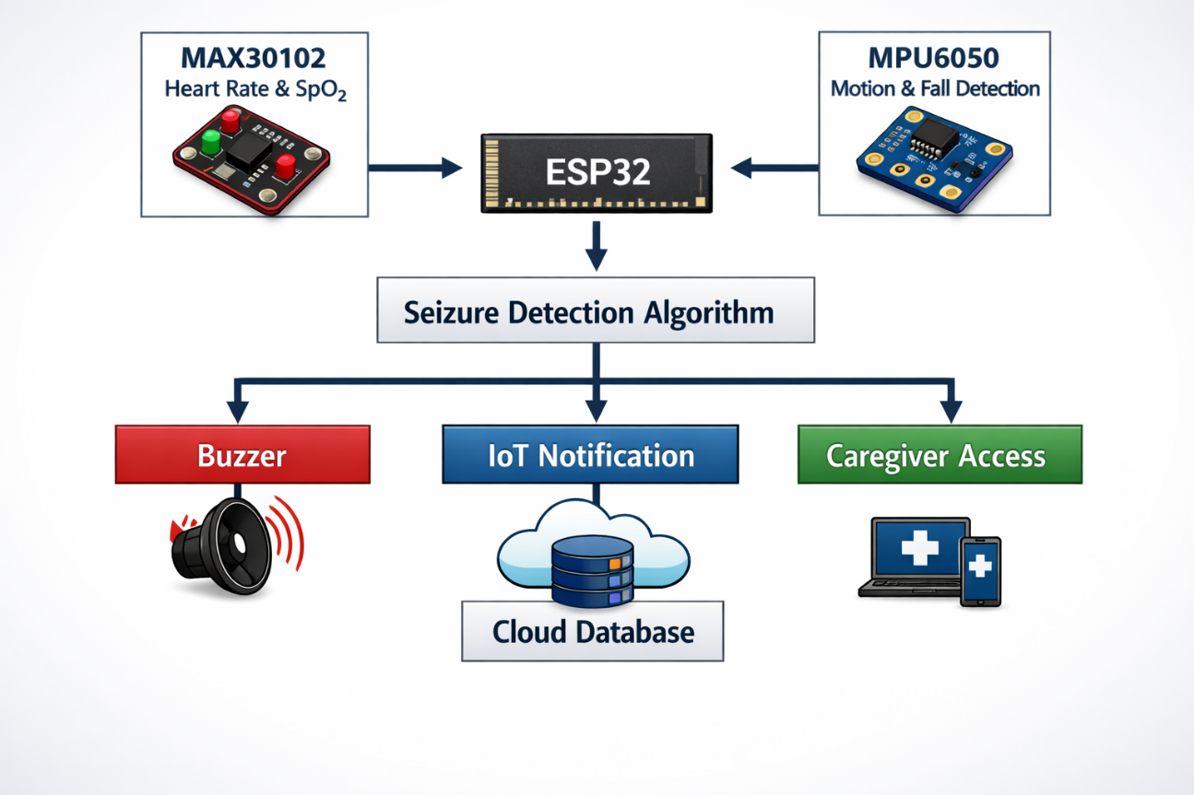
Fig 4: Block Diagram of the Proposed AI and IoT-Based Seizure Detection System
Figure 5.1 illustrates the block diagram of the proposed AI and IoT-based seizure detection system. The MAX30102 sensor continuously monitors the patient's heart rate and blood oxygen (SpO₂) levels, while the MPU6050 sensor detects body movements and fall events. The collected sensor data are transmitted to the ESP32 microcontroller, where a seizure detection algorithm analyzes the data to identify potential seizure events. Upon detection, the system activates a buzzer alarm, sends IoT notifications to caregivers, and stores the event information in the cloud database for real-time monitoring and future medical analysis.

5.6 ADVANTAGES OF THE PROPOSED SOLUTION
- Provides continuous real-time monitoring.
- Portable and easy to wear.
- Cost-effective compared to EEG monitoring systems.
- Enables early recognition of seizure symptoms.
- Generates immediate emergency alerts.
- Facilitates remote monitoring using IoT.
- Maintains seizure history for healthcare professionals.
- Improves patient safety and quality of life.
- Non-invasive and suitable for everyday use.

5.7 LIMITATIONS OF THE PROPOSED SOLUTION
- The system is intended for supportive monitoring and not clinical diagnosis.
- False alarms may occur during vigorous physical activities.
- Accuracy depends on proper sensor placement.
- Cloud services require internet connectivity.
- It cannot replace EEG-based neurological assessment.

5.8 FUTURE ENHANCEMENTS
Future improvements may include:
  - Integration of machine learning models trained on larger datasets.
  - Development of a dedicated mobile application.
  - Miniaturization into a commercial smartwatch design.
  - Incorporation of additional biosensors such as EMG and EDA sensors.
  - Integration with hospital information systems and electronic health records.

5.9 SUMMARY
The proposed solution presents a wearable, AI-enabled, and IoT-based Prototype for continuous seizure monitoring and emergency response. By combining the MAX30102 sensor, MPU6050 sensor, ESP32 microcontroller, and IoT connectivity, the system offers a practical approach to enhancing patient safety and supporting caregivers outside traditional clinical environment.

Chapter 6 Results

6.1 INTRODUCTION
This chapter presents the results obtained from the implementation and testing of the proposed Smart Seizure Detection Prototype Using IoT and Machine Learning. The system was evaluated based on its ability to monitor physiological and movement-related parameters, detect seizure-like events, generate emergency alerts, and upload data to the IoT platform. The observations demonstrate the effectiveness of the proposed wearable healthcare solution in providing continuous monitoring and timely emergency response.

6.2 EXPERIMENTAL SETUP
The developed prototype consists of the following components:
- ESP32 Development Board
- MAX30102 Heart Rate and SpO₂ Sensor
- MPU6050 Accelerometer and Gyroscope Sensor
- Buzzer
- IoT Cloud Platform (Thing Speak/Firebase)
- Arduino IDE
The sensors continuously collected physiological and motion-related data from the user. The ESP32 processed the sensor readings and executed the seizure detection algorithm. When abnormal conditions were detected, the system generated alerts and recorded the event in the cloud platform.

6.3 SENSOR OBSERVATIONS
A. Heart Rate Monitoring (MAX30102)
The MAX30102 sensor continuously monitored the user's heart rate.

Condition | Heart Rate (BPM)
Resting State | 70 – 85
Walking | 85 – 105
Running | 105 – 130
Simulated Seizure Activity | 130 – 160
Observation:
A significant increase in heart rate was observed during simulated seizure conditions compared to normal activities.

B. Motion Monitoring (MPU6050)
The MPU6050 monitored acceleration and angular velocity.
Condition | Accelerometer Activity | Gyroscope Activity
Sitting | Low | Low
Walking | Moderate | Moderate
Running | High | High
Seizure Simulation | Very High | Very High
Observation:
Rapid repetitive movements and sudden jerks produced distinctive accelerometer and gyroscope patterns that were successfully identified by the detection algorithm.

6.4 SEIZURE DETECTION RESULTS
The system was tested under different operating conditions.
Test Scenario | Detection Status
Normal Sitting | No Seizure Detected
Walking | No Seizure Detected
Hand Movement | No Seizure Detected
Sudden Fall | Detected
Continuous Shaking | Detected
Shaking + Elevated Heart Rate | Detected
Observation
The system successfully differentiated normal activities from seizure-like activities using sensor fusion techniques.

6.5 ALERT GENERATION RESULTS
When seizure conditions were detected:
- Buzzer alarm was activated.
- Alert notification was generated.
- Event data were uploaded to the IoT platform.
- Timestamped seizure records were created.

Sample Alert Message
Parameter | Value / Status
Alert Type | Possible Seizure Detected
Heart Rate | 145 BPM
Motion Status | Abnormal Motion Detected
Assistance Requirement | Immediate Assistance Required
System Action | Notify Caregivers & Emergency Services

Observation
Emergency alerts were generated instantly after seizure detection, reducing response time and improving patient safety.
6.6 IoT MONITORING RESULTS
The ESP32 successfully transmitted sensor data to the IoT platform.
Parameters uploaded:
- Heart Rate
- SpO₂
- Accelerometer Values
- Gyroscope Values
- Seizure Status

Observation
The cloud platform maintained a continuous record of patient activity and seizure events, enabling remote monitoring and future medical analysis.

6.7 PERFORMANCE ANALYSIS
Performance Parameter | Result
Heart Rate Monitoring | Successful
Motion Detection | Successful
Seizure Event Detection | Successful
Alert Generation | Successful
Cloud Data Upload | Successful
Real-Time Monitoring | Successful
Observation
The integrated system demonstrated reliable performance under different testing conditions and effectively monitored seizure-related symptoms.

6.8 ADVANTAGES OBSERVED
During testing, the following advantages were observed:
- Continuous monitoring of physiological parameters.
- Real-time seizure detection capability.
- Immediate emergency alert generation.
- Low-cost wearable implementation.
- Lightweight and portable design.
- Ease of use for patients and caregivers.

6.9 LIMITATIONS OBSERVED
The following limitations were identified during testing:
- False alarms may occur during intense physical activity.
- Sensor readings may vary due to improper prototype placement.
- Internet connectivity is required for IoT services.
- The system is intended for monitoring support and not medical diagnosis.

6.10 GRAPHICAL RESULTS
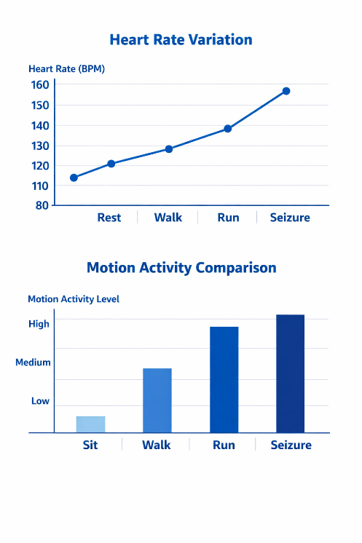

Fig 5: Heart Rate Variation
Figure 6.1 shows the variation in heart rate and motion activity under different conditions, including resting, walking, running, and seizure simulation. The results indicate a significant increase in both heart rate and body movement during seizure activity, demonstrating the system's ability to distinguish seizure events from normal activities.
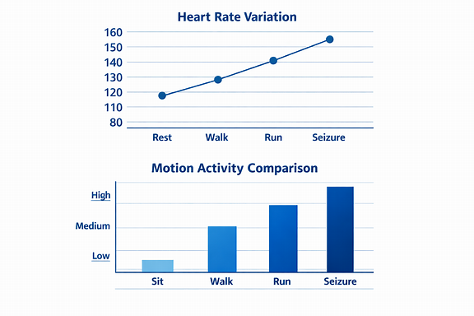
Fig 6: Motion Activity Comparison
Figure 6.1 illustrates that both heart rate and body movement increase significantly during seizure activity compared to normal daily activities, enabling accurate seizure detection.
6.11 TESTING OF SENSORS
MPU6050
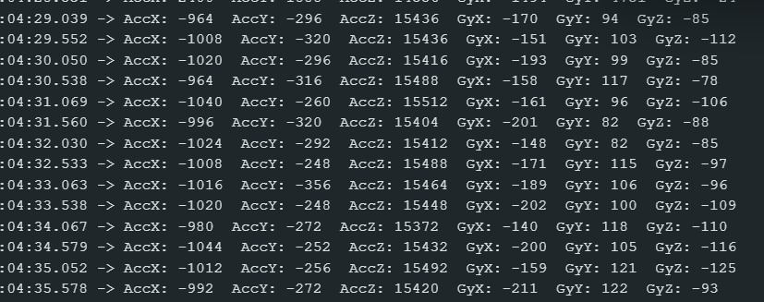
Fig 7: Serial Monitor Output of MPU6050 Sensor Readings
Figure 6.2 shows the real-time accelerometer (Acc X, Acc Y, Acc Z) and gyroscope (Gy X, Gy Y, Gy Z) readings obtained from the MPU6050 sensor through the Arduino Serial Monitor. The successful display of sensor values confirms that the MPU6050 is properly interfaced with the ESP32 and is continuously acquiring motion data for seizure detection.
6.12 SUMMARY
This chapter presented the experimental results and performance evaluation of the proposed Smart Seizure Detection Prototype. The system successfully monitored heart rate and body movements, detected seizure-like events, generated emergency alerts, and uploaded data to the IoT platform. The obtained results demonstrate that the proposed solution can provide continuous patient monitoring, improve emergency response, and enhance the safety of individuals living with epilepsy.

Chapter 7 Conclusion
CONCLUSION AND FUTURE SCOPE
7.1 INTRODUCTION
This chapter presents the overall conclusion of the proposed Smart Seizure Detection Prototype Using IoT and Machine Learning project. It summarizes the objectives achieved, key findings obtained during implementation, limitations encountered, and possible future enhancements that can further improve the system.

7.2 PROJECT SUMMARY
Epilepsy is a neurological disorder that causes sudden and unpredictable seizures, which may result in injuries, delayed medical assistance, and reduced quality of life. Continuous monitoring of patients is often difficult using conventional hospital-based systems due to their high cost, limited portability, and dependence on specialized equipment.

To address these challenges, a wearable Smart Seizure Detection Prototype was proposed and developed using an ESP32 microcontroller, MAX30102 Heart Rate and SpO₂ Sensor, and MPU6050 Accelerometer and Gyroscope Sensor. The system continuously monitors physiological and motion-related parameters and analyses them using intelligent detection algorithms to identify seizure-like events.

Whenever abnormal conditions such as elevated heart rate, excessive body movement, repetitive shaking, or fall-like motion are detected, the system activates an alarm and sends notifications through IoT services. The detected events are also stored on a cloud platform for future monitoring and analysis.

7.3 ACHIEVEMENTS OF THE PROJECT
The following objectives were successfully achieved:
- Design and development of a wearable seizure detection prototype.
- Continuous monitoring of heart rate and body movement parameters.
- Integration of MAX30102 and MPU6050 sensors with ESP32.
- Real-time seizure detection using intelligent decision-making algorithms.
- Generation of emergency alerts during abnormal events.
- Cloud-based storage and monitoring of seizure records.
- Development of a portable and cost-effective healthcare monitoring solution.

7.4 KEY FINDINGS
The implementation and testing of the proposed system led to the following observations:
- Heart rate significantly increased during seizure-like activities.
- Abnormal shaking patterns and sudden movements were successfully detected using the MPU6050 sensor.
- Combining physiological and motion parameters improved seizure detection reliability.
- The system was capable of generating real-time alerts with minimal delay.
- IoT integration enabled remote monitoring and storage of patient information.

These findings demonstrate that wearable sensor technologies can play an important role in supporting epilepsy monitoring and emergency response.

7.5 IMPACT OF THE PROPOSED SYSTEM
The proposed Smart Seizure Detection Prototype can contribute significantly to healthcare monitoring by:
- Enhancing patient safety through continuous monitoring.
- Reducing response time during seizure emergencies.
- Assisting caregivers in providing timely support.
- Supporting healthcare professionals with seizure history records.
- Improving the quality of life of individuals living with epilepsy.

7.6 LIMITATIONS
Although the proposed system performs effectively as a monitoring tool, certain limitations exist:
- The system does not replace EEG-based clinical diagnosis.
- False alarms may occur during vigorous physical activities.
- Sensor accuracy depends on proper placement of the wearable device.
- Internet connectivity is required for IoT communication and cloud services.
- The prototype is intended as a supportive healthcare device rather than a certified medical instrument.

7.7 FUTURE SCOPE
The proposed system can be enhanced further through the following improvements:
- Integration of advanced machine learning and deep learning models for improved detection accuracy.
- Development of a dedicated Android or iOS mobile application.
- Miniaturization of the prototype into a commercial smartwatch form factor.
- Addition of more physiological sensors for comprehensive health monitoring.
- Implementation of personalized seizure prediction based on individual patient data.
- Integration with hospital information systems and electronic health records.
- Development of battery optimization techniques for longer wearable operation.
- Real-time communication with healthcare professionals through telemedicine platforms.

7.8 CONCLUSION
The Smart Seizure Detection Prototype Using IoT and Machine Learning successfully demonstrates the feasibility of a wearable healthcare solution for continuous epilepsy monitoring. By integrating the MAX30102 heart rate sensor and MPU6050 motion sensor with an ESP32 microcontroller, the system can monitor physiological and movement-related parameters, detect seizure-like events, generate emergency alerts, and maintain patient records through IoT connectivity.
The proposed solution is portable, cost-effective, and suitable for everyday use, making it a valuable supportive tool for epilepsy patients and caregivers. Although it cannot replace professional medical diagnosis, it provides an effective platform for real-time monitoring, emergency response, and future research in wearable healthcare technologies.

BIBLIOGRAPHY
[1] S. Ganguly, S. Chakraborty, A. Roy, M. V. Patil and R. Pagare, "Seizing the Moment: Multimodal EEG Trends and Real-Time Epilepsy Seizure Detection with Dual Deep Nets," in 2025 IEEE Pune Section International Conference (Pune Con), Pune, India, Dec. 12–14, 2025, pp. 1–6, doi: 10.1109/PuneCon66808.2025.11132311.2. PuneCon2025_Paper1055.pdf

[2] S. Hassan, E. Mwangi and P. K. Kihato, "IoT Based Monitoring System for Epileptic Patients," Heliyon, vol. 8, Art. no. e09618, 2022, doi: 10.1016/j.heliyon. 2022.e09618. Keywords: {Internet of Things (IoT); Epilepsy; Generalized Tonic-Clonic (GTC); Fuzzy Logic; Seizure Detection; ECG; EMG; Accelerometer; ESP32; Thing Speak; IFTTT}.
IoT based monitoring system for epileptic patients.pdf

[3] Maxim Integrated Products, "MAX30102 High-Sensitivity Pulse Oximeter and Heart-Rate Sensor for Wearable Health Applications," Datasheet, Rev. 1, May 2018. Keywords: {Pulse Oximeter; Heart Rate Sensor; Blood Oxygen Saturation (SpO₂); Photoplethysmography (PPG); Wearable Health; Optical Sensor; Red LED; Infrared LED; I²C Interface; FIFO Memory; Temperature Sensor; Low-Power Operation}.
MAX30102.PDF

[4] Espressif Systems, "ESP32 Series Datasheet," Datasheet, Version 5.2, 2023. Keywords: {ESP32; Wi-Fi; Bluetooth; Dual-Core Microcontroller; IoT; GPIO; SPI; I²C; UART; ADC; DAC; PWM; Low-Power Operation; Deep Sleep; Wireless Communication}.esp32_datasheet_en.pdf

[5] InvenSense Inc., " MPU-6050 Product Specification," Datasheet, Document No. PS-MPU-6000A-00, Rev. 3.4, Aug. 19, 2013. Keywords: {MPU-6050; MPU-6000; MEMS Sensor; Accelerometer; Gyroscope; Motion Tracking; Digital Motion Processor (DMP); I²C Interface; SPI Interface; Temperature Sensor; 6-Axis Motion Sensor; FIFO; Low-Power Operation}. mpu-6050_datasheet_v3 4.pdf

ANNEXURE A:

List of Publications and Research Paper (In its Original formats)

- S. Hassan, E. Mwangi and P. K. Kihato, "IoT Based Monitoring System for Epileptic Patients," Heliyon, vol. 8, Art. no. e09618, 2022.

- S. Ganguly, S. Chakraborty, A. Roy, M. V. Patil and R. Pagare, "Seizing the Moment: Multimodal EEG Trends and Real-Time Epilepsy Seizure Detection with Dual Deep Nets," 2025 IEEE Pune Section International Conference (PuneCon), 2025.

- Maxim Integrated Products, "MAX30102 High-Sensitivity Pulse Oximeter and Heart-Rate Sensor for Wearable Health Applications," Datasheet, Rev. 1, May 2018.

- InvenSense Inc., "MPU-6000 and MPU-6050 Product Specification," Datasheet, Document No. PS-MPU-6000A-00, Rev. 3.4, Aug. 19, 2013.

- Espressif Systems, "ESP32 Series Datasheet," Version 5.2, 2023.

- UCI Machine Learning Repository, "Epileptic Seizure Recognition Dataset."

- Thing Speak IoT Platform Documentation.

- Telegram Bot API Documentation.

