

|  |
| --- |
| **Web Design Development**  **Lab 1: Initiation to HTML** |

**Exercise N°1**

Type the corresponding HTML code of the following “test.htm” web page:

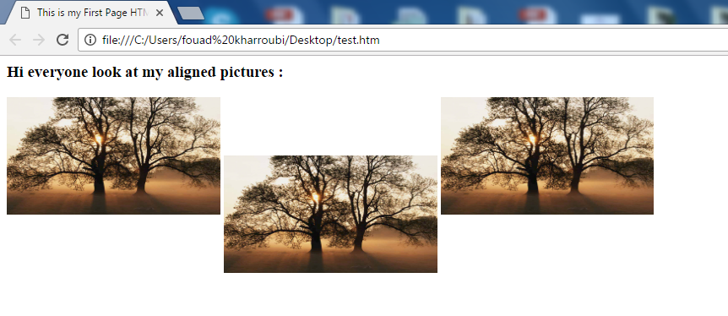

**Exercise N°2**

Make another HTML code using the same “test.htm” code as the last exercise, however the first sentence will be a link which will point on “hello.htm” webpage.

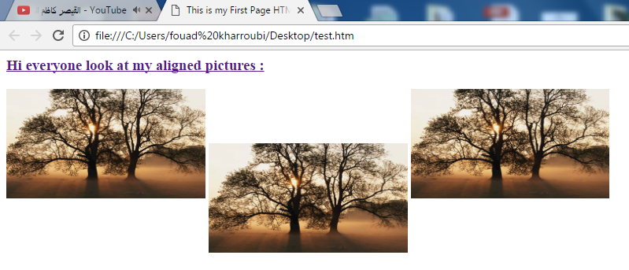

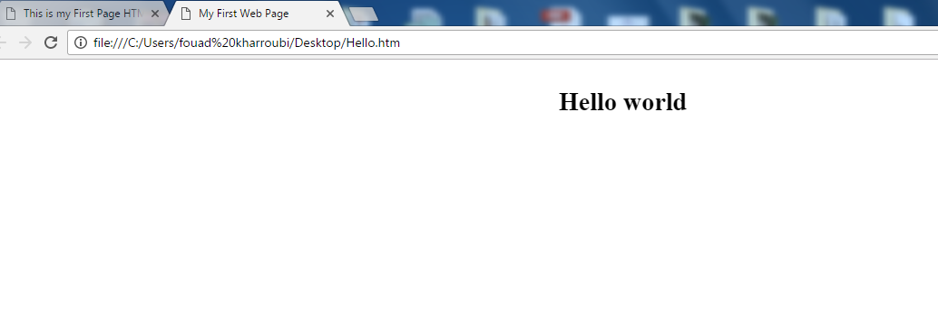

**Exercise N°3**

1. Print the squares of the numbers 1 - 20. Each number should be on a separate line, next to it the number 2 superscripted, an equal sign and the result. (Example: 10² = 100)
2. Create some links to various search engines (baidu, yahoo, altavista, google, etc)
3. Create links to five different pages on five different websites that should all open in a new window.
4. Create a page with a link at the top of it that when clicked will jump all the way to the bottom of the page. At the bottom of the page there should be a link to jump back to the top of the page.

**Exercise N°4**

1. Display five different images. Skip two lines between each image. Each image should have a title.
2. Display an image that has a border of size 2, a width of 200, and a height of 200.
3. Display an image that when clicked will link to a search engine of your choice (should be opened in a new window.
4. Display an image that when clicked will link to itself and will display the image in the browser by itself