

|  |
| --- |
| **Web Design Development**  **Lab 2: HTML Tables** |

**Exercise N°1**

1. **Write a program to create HTML table with the following output:**

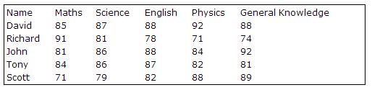

1. **Write a program to create HTML table with the following output:**

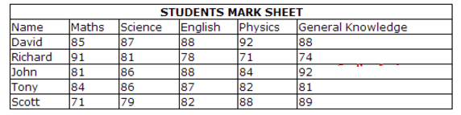

1. **Write a program to create HTML table with the following output:**

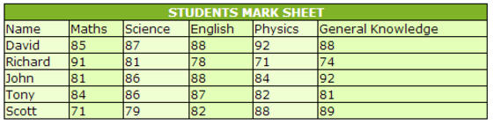

**Exercise N°2**

1. **Write a program to create HTML table with the following output:**

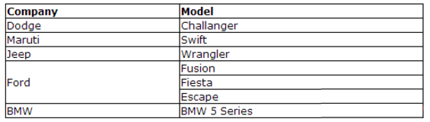

**Exercise N°3**

1. **Create a table showing the population growth rate for countries around the world. It should look like this: (the link is** [**https://www.cia.gov/library/publications/the-world-factbook/**](https://www.cia.gov/library/publications/the-world-factbook/)**)**

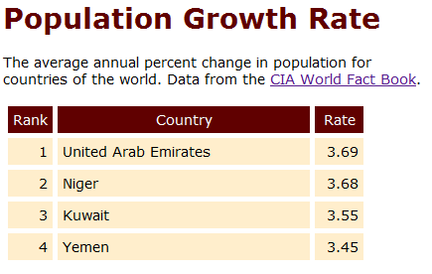

**Exercise N°4**

1. **Write a program to create HTML tables with the following output:**

