

|  |
| --- |
| **Web Design Development**  **Lab 3: CSS Vs HTML** |

**Exercise N°1**

1. **Using your Web editor create a style sheet file called “mystyle.css”. It should look like this one:**

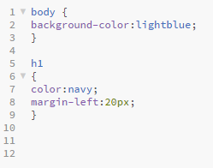

1. **Add an external style sheet with the URL: "mystyle.css" to the following HTML code.**

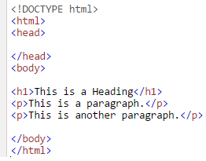

1. **Consider the same HTML above. Set "background-color: linen" for the page, using an internal style sheet.**
2. **Consider the same HTML above. Set "background-color: linen" for the page, using an inline style sheet.**
3. **Consider the following HTML code. Remove all styles, except the external style sheet "mystyle.css".**

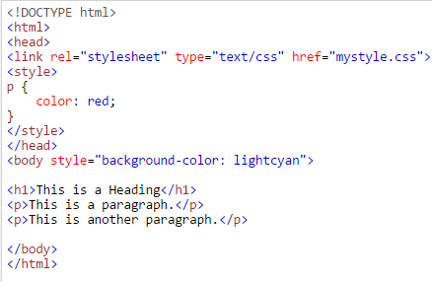

**Exercise N°2**

**Let’s Consider the HTML code of the corresponding table above in the right side. Please modify as the following style by using CSS.**

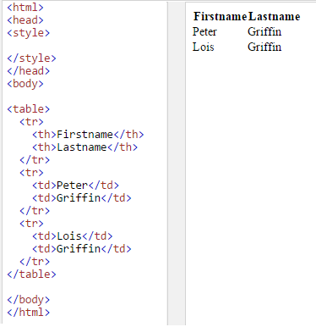

1. **Set the border to "2px solid green" for table, th and td elements.**
2. **Collapse the table borders into a single border.**
3. **Set the width of the table to "100%".**
4. **Set the text alignment in <td> elements to "right".**
5. **Set the padding in <th> elements to "15px".**
6. **Set the background color of <th> elements to "lightblue".**

**Exercise N°3**

1. **Write a program to create an HTML CSS table with the following output using 3 ways of inserting style sheets:**

* **External style sheet**
* **Internal style sheet**
* **Inline style sheet**

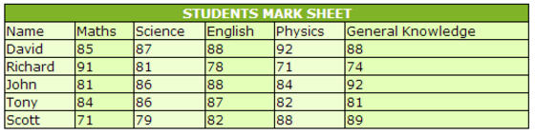

**Exercise N°4**

1. **Write a program to create an HTML CSS table with the following output using 3 ways of inserting style sheets:**

* **External style sheet**
* **Internal style sheet**
* **Inline style sheet**

