

|  |
| --- |
| **Web Design Development**  **Lab 4: CSS, HTML Forms, divisions and Dropdown Menu/Navigation Bar** |

**Exercise N°1**

1. **Using your Web editor you will create a simple HTML Form. The page should look like following:**

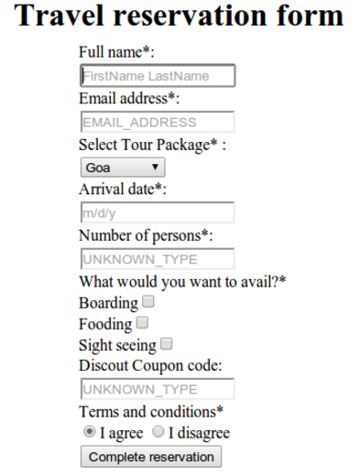

**Exercise N°2**

1. **Using your Web editor you will create a simple HTML Form. The page should look like following:**

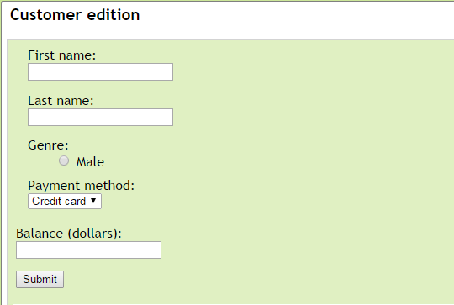

**Exercise N°3**

1. **Using your Web editor you will create a simple HTML Form. The page should look like following:**

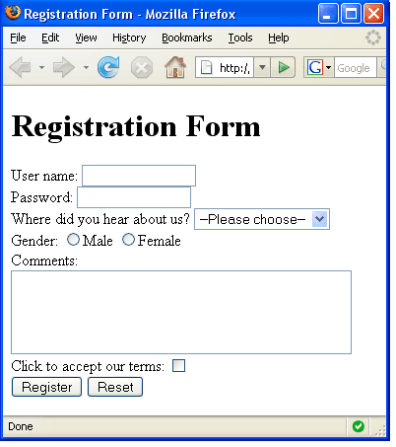

**Exercise N°4**

1. **Type this code in your web editor and change the color of the iframe's border to magenta and the link to “www.baidu.com”**

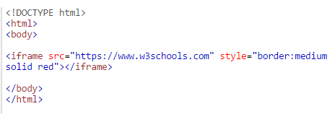

**Exercise N°5**

1. **Using the division tag <div> and classes in CSS imagine we want to create 6 divisions like following:**

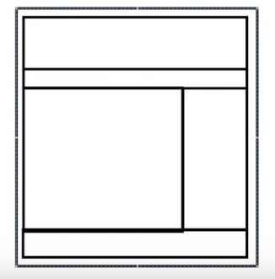

**To do so, you should create an html page and** **external style sheet with the URL: "mystyle.css" which should be added to your HTML page code. The final results should look like this one below:**

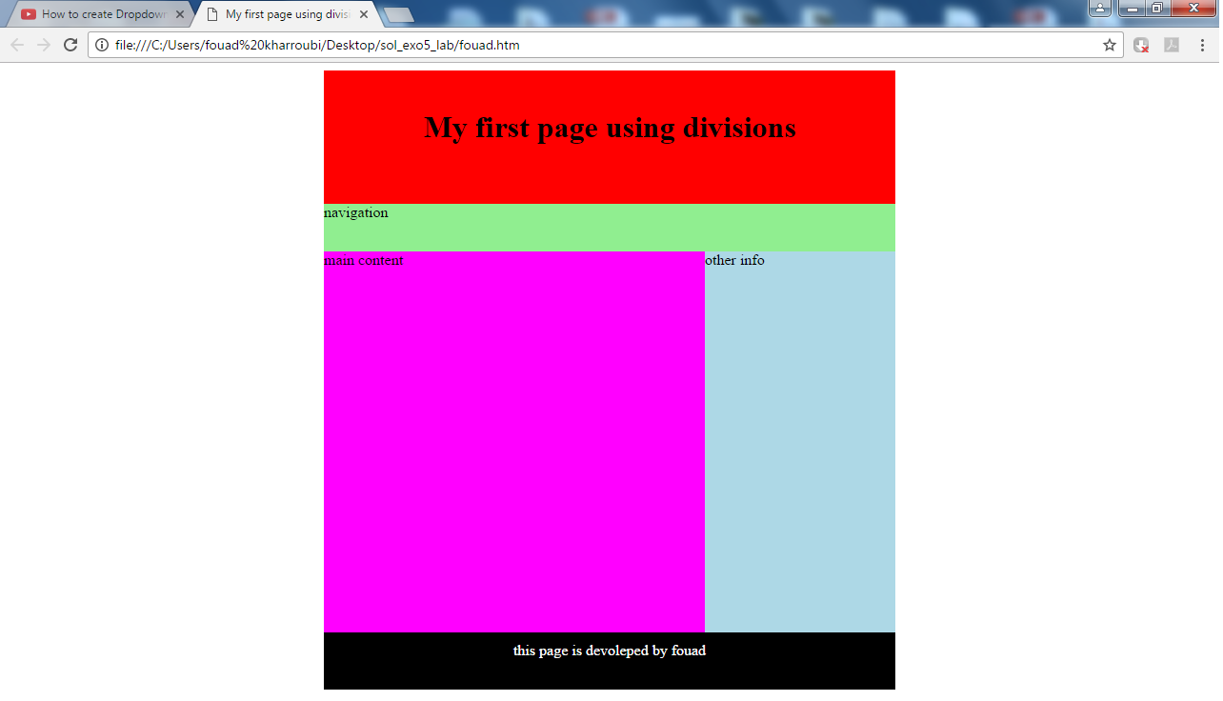

**Exercise N°6**

1. **Try to create a Dropdown Menu/Navigation Bar using Html and CSS. It should look like this one below:**

