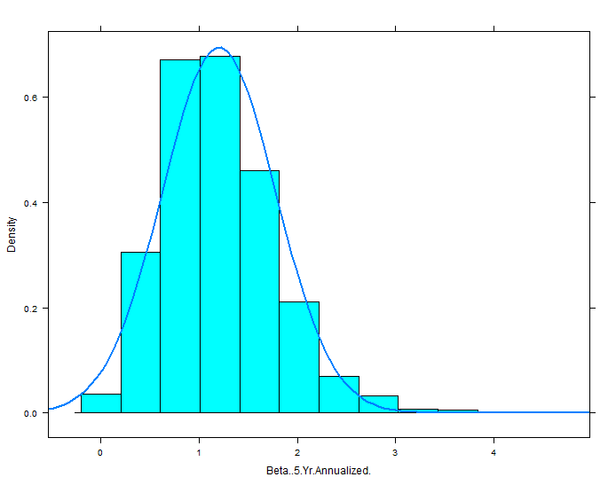Distribution of beta over 2500+ stocks:

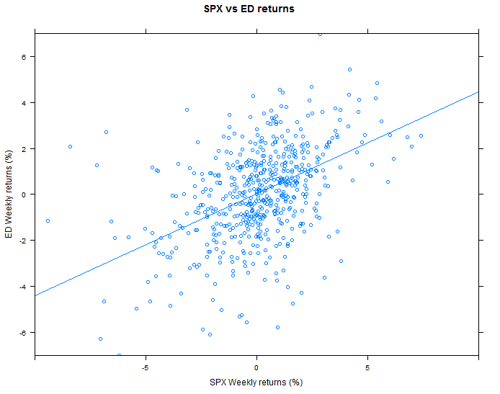Low beta stock (ED) - computed beta = slope of the line = 0.83

Medium beta stock (IBM) – computed beta – 0.89



High beta stock (ADSK) – computed beta = 1.42

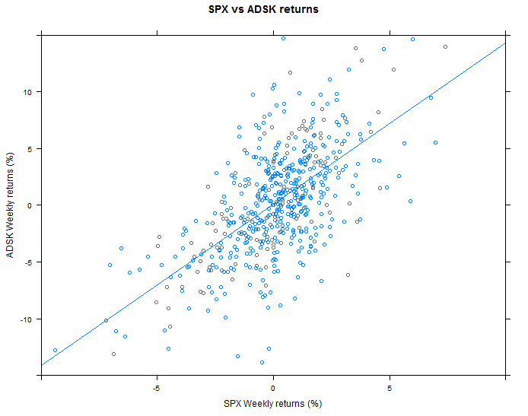

**Beta (5-year) vs stock returns for 5000 stocks**

(using 2nd dataset)

