Ticker Research Report
High-Level Overview | April 14, 2026

1. Bloom Energy (BE) — Public Stock
Bloom Energy designs and manufactures solid oxide fuel cell (SOFC) systems that generate clean, reliable on-site electricity. Originally focused on commercial and industrial power, the company has pivoted heavily toward AI data center power solutions, partnering with Oracle for up to 2.8 GW of fuel cell deployments.

Key Metrics
Metric | Value
Stock Price | $198.71
Market Cap | $49.6B
P/E (Trailing) | N/A (currently unprofitable)
P/E (Forward) | ~114.7
52-Week Range | $16.01 – $203.41
Sector | Industrials / Clean Energy
HQ | San Jose, California

Stock Performance
Bloom Energy shares surged approximately 291% over the past year, driven by massive AI data center demand and the Oracle partnership. The stock moved from ~$16 to over $198, making it one of the best-performing energy stocks of the year.
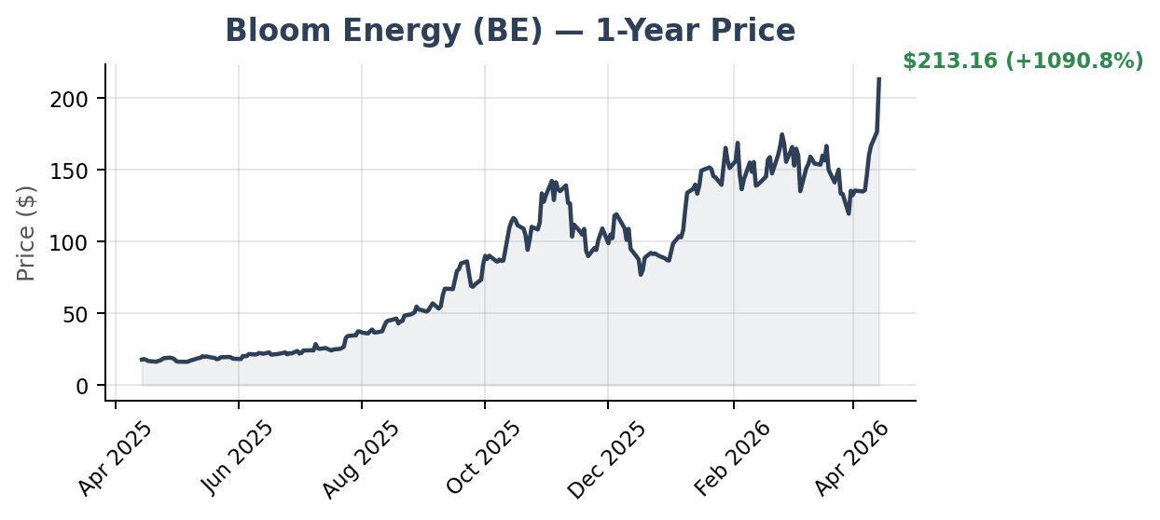

Comparable Companies
Company | Ticker | Focus | Market Cap
Plug Power | PLUG | Hydrogen fuel cells (mobility/forklifts) | ~$5B
FuelCell Energy | FCEL | Carbonate fuel cells (utility-scale) | ~$1.5B
Ballard Power | BLDP | PEM fuel cells (heavy-duty transport) | ~$2B
Oklo | OKLO | Nuclear micro-reactors (data centers) | ~$6B

2. Allo Energy — Private
"Allo Energy" does not appear to be a publicly traded company. Two private companies match this name:

ALLO Energy Ltd (UK)
A private limited company registered in Scotland, focused on smart-home energy AI and optimization. Limited public financial data available.

Alléo Energy (US)
A US-based private company working on carbon-negative green hydrogen production. Also limited public disclosure. If you meant a different company (e.g., Aalo Atomics for nuclear energy), let me know and I can research that instead.

3. Sidus Space (SIDU) — Public Stock
Sidus Space is a micro-cap satellite company providing space-as-a-service through its LizzieSat multi-mission platform, onboard AI computing (FeatherEdge), and mission software (FeatherWare). The company designs, manufactures, and operates small satellites for near-real-time Earth observation and data analytics.

Key Metrics
Metric | Value
Stock Price | ~$4.93
Market Cap | ~$328M
P/E (Trailing) | N/A (unprofitable)
2025 Revenue | $3.4M
52-Week Low/High | ~$0.80 / ~$5.00
Sector | Aerospace & Defense
HQ | Cape Canaveral, Florida

Stock Performance
SIDU surged ~97% in late March/early April 2026 after being selected for the Missile Defense Agency (MDA) SHIELD program — an IDIQ contract with a $151B ceiling. YTD the stock is up roughly 44%. However, the company remains deeply unprofitable with a net loss of $29.5M in 2025.
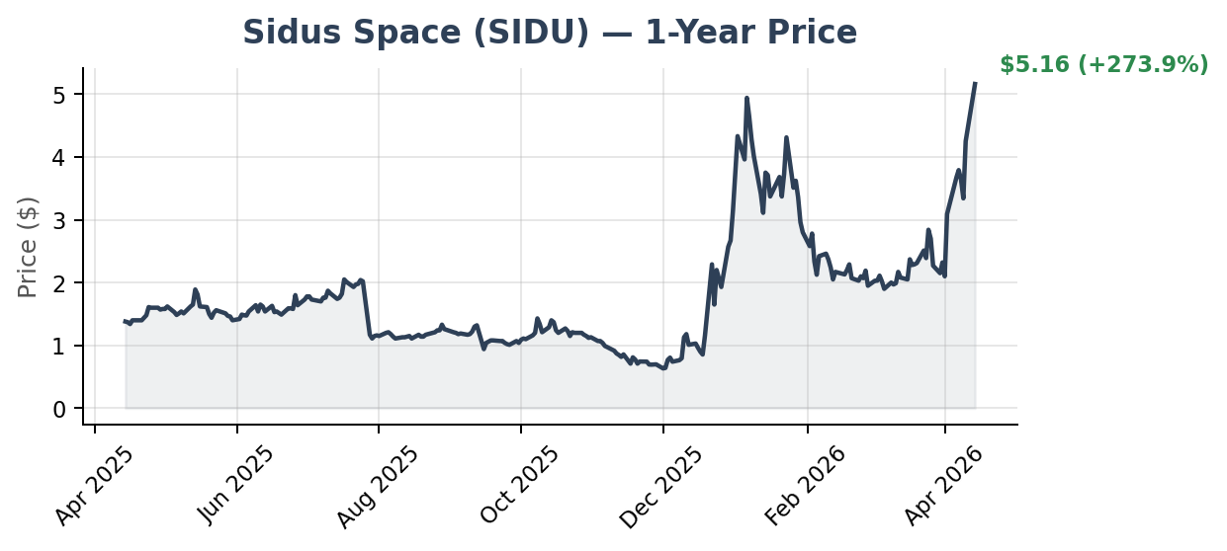

Comparable Companies
Company | Ticker | Focus
Rocket Lab | RKLB | Small launch vehicles + satellite buses
AST SpaceMobile | ASTS | Space-based cellular broadband
York Space Systems | Private | Tactical small satellites
Iridium | IRDM | Global satellite communications

4. Power Infrastructure ETFs — GRID & VOLT
Two ETFs best capture the "power infrastructure" theme:

GRID — First Trust NASDAQ Clean Edge Smart Grid Infrastructure
Metric | Value
AUM | $7.6B
Expense Ratio | 0.56%
1-Year Return | +61.1%
Holdings | ~65 stocks
Focus | Smart grid, electric utilities, energy storage
Top 5 Holdings: Eaton Corp (8.3%), National Grid (8.0%), Johnson Controls (8.0%), ABB Ltd (7.6%), Schneider Electric (7.2%).
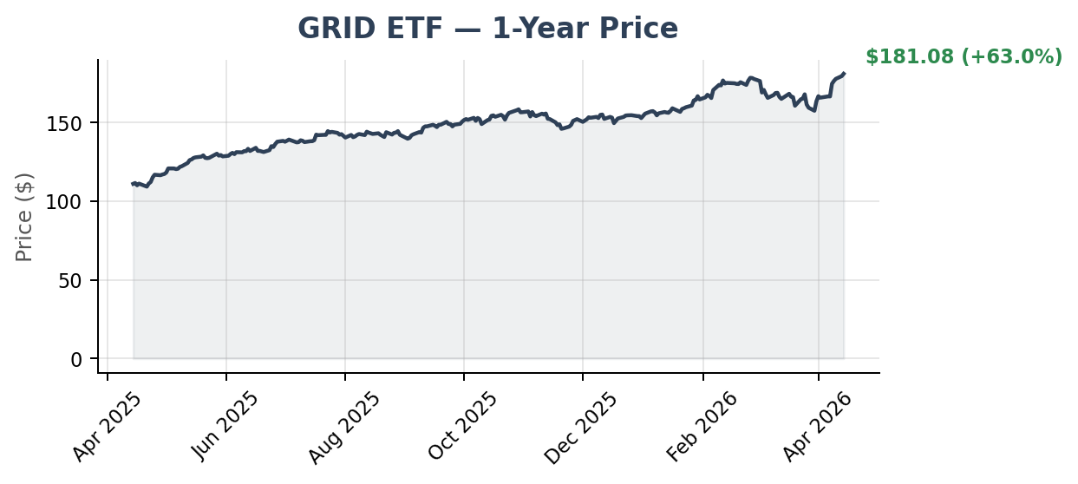

VOLT — Tema Electrification ETF
Metric | Value
AUM | ~$500M
Expense Ratio | 0.75%
1-Year Return | +60%
Holdings | ~29 stocks (concentrated)
Focus | US electrification, grid infra, nuclear
Top 5 Holdings: Bel Fuse (6.6%), Powell Industries (6.5%), NextEra Energy (6.4%), Quanta Services (4.9%), American Electric Power (4.7%). VOLT is more concentrated and actively managed vs. GRID's passive index approach.
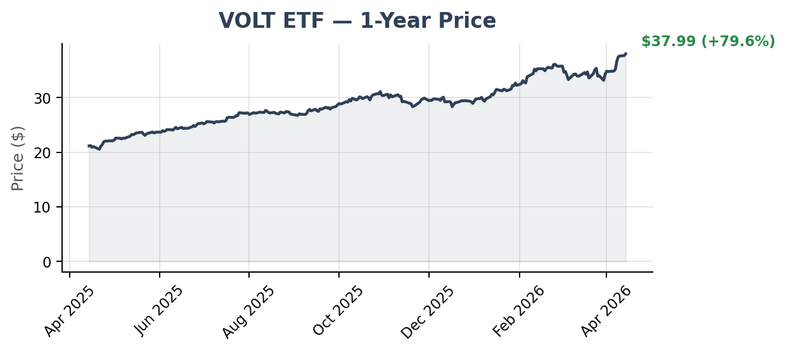

5. Cerebras Systems — Private (IPO Pending)
Cerebras builds the world's largest AI chips, including the Wafer Scale Engine (WSE), which packs an entire wafer's worth of transistors into a single chip. The company competes directly with Nvidia in AI training and inference hardware.

Key Facts
Metric | Value
Latest Valuation | $23.1B (Series H, Feb 2026)
Total Funding | ~$2.9B across 8 rounds
2023 Revenue | $78.7M
2024 Revenue | ~$421M (estimated)
Key Deal | $10B+ compute agreement with OpenAI through 2028
IPO Target | Q2 2026, Nasdaq (ticker: CBRS)
HQ | Sunnyvale, California

Funding Timeline
Round | Date | Amount | Valuation
Series F | 2021 | $250M | $4B
Series G | Sep 2025 | $1.1B | $8.1B
Series H | Feb 2026 | $1B | $23.1B
Key investors include Tiger Global, AMD, Fidelity, Benchmark, Coatue, and Altimeter. CFIUS cleared the company after G42's stake was restructured to non-voting shares.

6. Luma AI — Private
Luma AI develops generative AI models for video and image creation. Its flagship product, Dream Machine, enables users to generate photorealistic videos from text and image prompts. The company targets creators, advertisers, and film studios.

Key Facts
Metric | Value
Latest Valuation | $4.0B (Nov 2025)
Total Funding | $1.07B across 6 rounds
Latest Round | $900M (led by Humain, Saudi-backed)
2024 Revenue | ~$8M
Business Model | Subscription (creators) + Enterprise (studios)
Founded | 2021
HQ | Palo Alto, California
Key investors include Amazon, Andreessen Horowitz, and Amplify Partners. Luma competes with Runway, Pika, and OpenAI's Sora in the AI video generation space.

7. Scale AI — Private
Scale AI provides data infrastructure for AI development, including data labeling, model evaluation, and synthetic data generation. Originally a labeling company, Scale evolved into a critical AI supply chain player serving OpenAI, Google, Microsoft, Meta, and the US Department of Defense.

Key Facts
Metric | Value
Latest Valuation | $29B (post-Meta investment)
Total Funding | ~$15.9B
Meta Investment | $14.8B for 49% non-voting stake (Jun 2025)
2024 Revenue | $870M (ARR $1.5B by year-end)
2026 Revenue Target | ~$2B (+130% YoY)
Key Contracts | OpenAI, Google, Microsoft, DoD ($249M)
HQ | San Francisco, California
Former CEO Alexandr Wang moved to a senior role inside Meta as part of the deal. Scale is now led by former Uber executive Jason Droege as CEO. No IPO has been announced.

8. Castelion — Private
Castelion is a modern defense production company specializing in advanced hypersonic strike systems. Founded in 2022, it became a unicorn in just 3 years. The company applies modern hardware development and manufacturing processes to address national security challenges, with its flagship product being the Blackbeard hypersonic missile system.

Key Facts
Metric | Value
Latest Valuation | $2.8B (Series B, Jul 2025)
Total Funding | ~$504M across 5 rounds
Series B | $350M–$360M (Jul 2025, 12 investors)
Employees | ~166 (as of Mar 2026)
Flagship Product | Blackbeard hypersonic missile
Founded | 2022
HQ | El Segundo, California

Key Developments
In January 2026, Castelion broke ground on Project Ranger, a 1,000-acre manufacturing campus in Rio Rancho, NM, designed for high-cadence production of hypersonic strike systems. The company completed a major flight test at Point Mugu Sea Range with the Naval Air Warfare Center Weapons Division. Backed by a16z and other top-tier investors. Plans for continued high-tempo testing in 2026 with increasingly complex capability demonstrations.

Disclaimer: This report is for informational purposes only and does not constitute investment advice. Data sourced from public filings, news reports, and financial databases as of April 2026. Verify all figures before making investment decisions.

