**Question 7**

1. The PERT diagram representing the tabulated information.

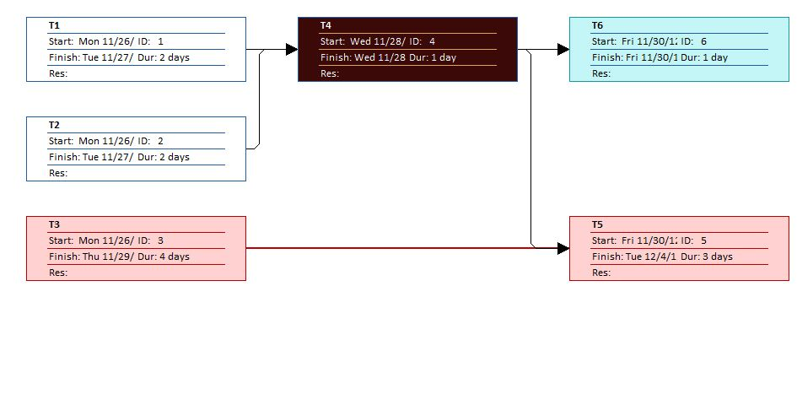

1. 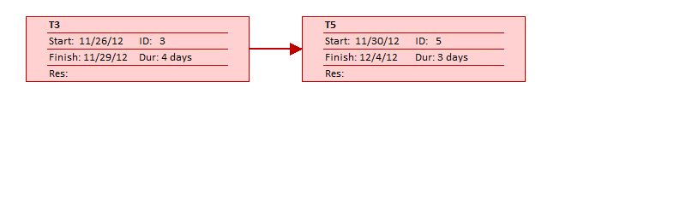The Critical Path derived from the PERT diagram above.
2. The minimum time for the project completion is Eight (8) Days .
3. The GANTT chart for the tabulated information which was used to make the PERT chart of 1. I)

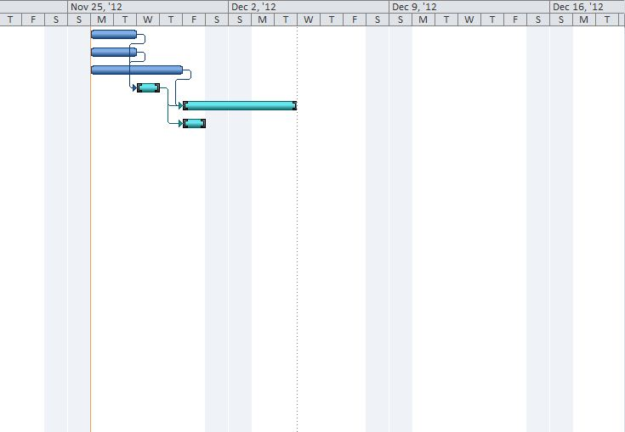

**Question 9**

1. 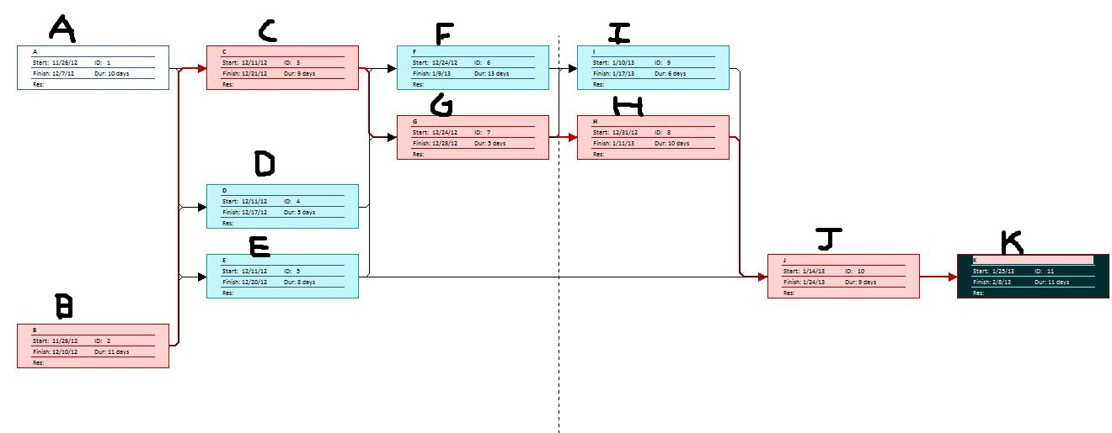The PERT diagram for the tabulated data.
2. The critical path derived from the PERT diagram above is as follows.
3. Three main reasons for using a PERT over a GNATT chart are:
4. Precedence is easier identified.
5. Easier Identification of the critical path and the critical activities.
6. Slack Time is easier determined.