Design Document for project-“Yntymak” restaurant

Group#18
Almurzina Ainur
Mrassylova Gaukhar
Sabyr Mariyam
Torgayeva Madina
Boranbayeva Nazira

Version | Date | Author | Change
0.1 | 10/08/04 | SM | Initial Document

Table of Contents
1 Introduction 3
1.1 Purpose 3
1.2 Scope 3
1.3 Definitions, Acronyms, Abbreviations 3
1.4 Design Goals 3
2 References 4
3 Decomposition Description 5
3.1 Module Decomposition 5
3.2 Concurrent Process 5
3.3 Data Decomposition 5
3.4 STATES 5
4 Dependency Description 6
4.1 Intermodule Dependencies 6
4.2 InterProcess Dependencies 6
4.3 Data Dependencies 6
5 Interface Description 7
5.1 Module Interface 7
5.2 Process Interface 7
6 Detailed Design 8
7 Design Rationale 9
7.1 Design Issues 9
7.2 <Issue 1> 9
7.3 <Issue 1> 9
8 Traceability 11

Introduction

Purpose
The purpose of this document is to explain the decomposition description of the web application for the restaurant “Yntymak”.

Scope
This document covers system decomposition, subsystems, and dependencies, as well as design rationale.

Definitions, Acronyms, Abbreviations
Term | Description
All pages | Displayed on any browser

Design Goals
1. Reliability: The main process must function consistently, and loss of users' data must be prevented.
2. Maintainability: Our code must be well organized with consistent syntax and relevant naming techniques.
3. Extensibility: The application must facilitate easy extension of the Calendar module and features to be added to the PHP Code. .
4. Response Time: All pages must load in less than 30 seconds including database processing time.
5. User Privacy: Must not be allowed to access another users to his own event, and must not be allowed access to others' events
6. Visual Consistency: The application's pages should be in same design.

References
None

Decomposition Description

Module Decomposition

WeB Application AA

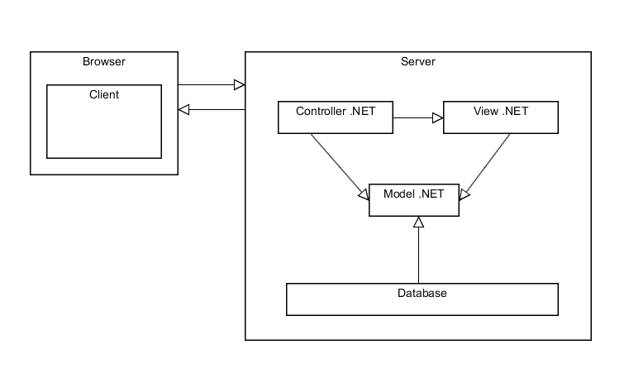
The web application has two main parts: browser part and server part. Server part is fully written on Visual Studio .NET Framework on C# code which is consist of 4 main subsystems: controller, view, model and database.

View Description AA

The view manages the display of information. The view is dependent on the model subsystem, because it requests from it to generate an output representation to the user.

Controller Description AA

A controller interprets the mouse and keyboard inputs from the user, and then send commands to the model to update the model's state (e.g., editing a document). It can also send commands to its associated view to change the view's presentation of the model (e.g., by scrolling through a document).

Model Description GM

The model manages the behavior and data of the application domain, responds to requests for information about its state (usually from the view), and responds to instructions to change state (usually from the controller).

Database Description
Database is used to store all the data(events). Specifically, all the events the user creates, and
details for each particular event will be stored here. On request, it will return an event(s) and its
corresponding data. Also, it will allow new entries as the user creates and adds new events. And it will be accessible to only admin.

Concurrent Process

View Description AA

View subsystem has actually 6 main pages:

Main page

Gallery page

Menu page

Table reservation page

Menu order page

About us page

Contacts page

View subsystem depends on model subsystem and doesn’t have any concurrent processes inside because it’s just the representation of information to user.

Controller Description AA

Controller description has 3 main concurrent processes. They are table reservation, menu order and changing of reservation and/or order.

Table reservation description

Here controller controls the error preventions. It tries to help to user to fill all blanks properly.

At the same time, while user choosing the date and time of reservation, controller send request to the model and model takes out from database the needed information is table free at that date and time).

After clicking on submit button, controller again send the request to model and saves the reservation to the database only if there is no conflicts or errors. Otherwise controller notifies the user about errors and ask him to complete all blanks properly. This function repeats repeatedly until there won’t be errors.

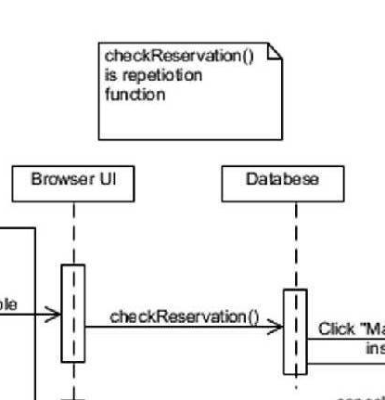

The part of UML diagram.

Menu order description
After clicking submit button controller group all orders and count the total price of order.
If user wants to change the order then controller ticks all made orders in menu and then renewing the order after clicking on submit button.
After clicking on confirm button controller saves this order to database through using of model subsystem.
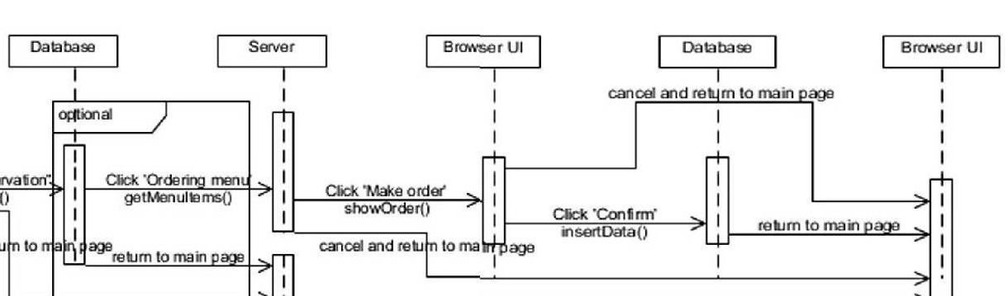
The part of UML diagram.

Change of reservation description
Controller checks e-mail from database and if e-mail is identified then it send to user’s e-mail link which allow him/her to change her order. Otherwise controller notify about non-identification of e-mail.

Model Description GM
Model is the connecting link which is connects view with controller. So every page that has controller has the model subsystem. Model subsystem is needed to update the information in view and change the state in controller.
3.2.4 Database Description(KP)

Data Decomposition
Database

Reservation table:

. 'event_id INT UNSIGNED NOT NULL AUTO_INCREMENT, '
. 'name VARCHAR(50) NOT NULL, '
. 'surname VARCHAR(50) NOT NULL, '
. 'telephone VARCHAR(50) NOT NULL, '
. 'e_mail VARCHAR(50) NOT NULL, '
. 'date DATE NOT NULL, '
. 'amount_of_people INT UNSIGNED NOT NULL, '
. 'table INT UNSIGNED NOT NULL, ' ;

Menu table:

. 'event_id INT UNSIGNED NOT NULL AUTO_INCREMENT, '
. 'salad VARCHAR(50) NOT NULL, '
. 'pervoe VARCHAR(50) NOT NULL, '
. 'vtoroe VARCHAR(50) NOT NULL, '
. 'dessert VARCHAR(50) NOT NULL, '
. 'drink VARCHAR(50) NOT NULL, '

Order table:

. 'FOREIGN KEY(reservation_id));'
. 'event_id INT UNSIGNED NOT NULL AUTO_INCREMENT, '
. 'order VARCHAR(50) NOT NULL, '

Minutes of Meeting Form


Team #:18
Date:20/03/2015
 |  |  |  |  |  |  |  |  | Informed about
 |  |  | Student Name (Initials) | Present? |  |  | Late > 5 mins? |  | absence? |  |  |  |  | Scribe?
 |  | 1 | Ainur Almurzina | + |  |  | -
 |  | 2 | Madina Torgayeva | + |  |  | -
 |  | 3 | Mariyam Sabyr | + |  |  | -
 |  | 4 | Gaukhar Mrassylova | + |  |  | -
 |  | 5 | Nazira Boranbayeva | + |  |  | -
 |  |  | Student Name (Initials) |  | Old Action Item |  |  |  |  |  | Status
 |  | 1 | A.Almurzina | Module decomposition, concurrent process |  |  |  |  | +
 |  | 2 | M.Torgayeva | Module decomposition,concurrent process |  |  |  |  | +
 |  | 3 | M.Sabyr | Database description, data decomposition |  |  |  |  | +
 |  |  |  | Purpose, scope, design goals
 |  | 4 | G.Mrassylova |  |  |  |  |  | +
 |  | 5 | N.Boranbayeva | Database description, data decomposition |  |  |  |  | +

Agenda / Discussion Summary

Complete the assignment A5_DD1: 1)Design document for web application-“Yntymak” restaurant

2)minutes of meeting form 3)work distribution

 |  |  | Student Name (Initials) |  | New Action Item |  |  |  | Due Date
 |  | 1 | A.A |  | Prototype of ‘reservation’,’main’ pages |  | 25/03/15
 |  | 2 | M.T |  | Prototype of mobile application |  | 25/02/15
 |  |  |  |  | Prototype of “menu”,”about us” pages
 |  | 3 | M.S |  |  |  | 25/02/15
 |  | 4 | G.M |  | Prototype of “gallery”,”contact” pages |  | 25/02/15
 |  | 5 | N.B |  | Prototype of mobile application |  | 25/02/15

Team Work Distribution Form

Assignment #:A5_DD1
Team #:18

Date:20.03.2015
 |  |  |  | % of total effort | Lots of
 |  | Student Name (Initials) | Signature | (adds to 100) | extra work? | Description of what done
 | 1 | Ainur Almurzina | + | 20% | - | Module decomposition, concurrent process of web application
 | 2 | Mrassylova Gaukhar | + | 20% | - | Purpose, scope, design goals
 | 3 | Sabyr Mariyam | + | 20% | - | Database description, data decomposition of web application
 | 4 | Torgayeva Madina | + | 20% | - | Module decomposition,concurrent process of mobile application
 | 5 | Boranbayeva Nazira | + | 20% | - | Database description, data decomposition of mobile application

