Project QXsl-fo overview
The aim of this project is to create WYSIWYG xsl-fo editor. Output of QXsl-fo application is xslt document which contain fo marks of formating objects. Using xsl-fo procesor (e.g. Fop) we can generate pdf or ps documents. If with xslt document is used also XML, as a data source, we can generate variable tables, blocks of texts or lists.

Current state of project
Curent version is 0.0.1. Project is currently not usable. It can load only simple xslt document and show base formating objects. Current implementation :
- implement these formating objects: fo:block, fo:block-container,fo:body-region,fo:border-region,fo:external-graphic
- implement undo framework
- show inserted object in hierarchy
- show attributes (only chosed) of object
- can move and resize using drag&drop fo:block-container and fo:region-body

To check project posibilities try open qxsl-fo/data/xsl/base.xsl file

Used syntax
Classes with prefix „fo“ represent concrete formating object (e.g. FoBlock represent fo:block)
Postfix „doc“ represent document part of formating object. Postfix „view“ represent view part of formating object

Application layout
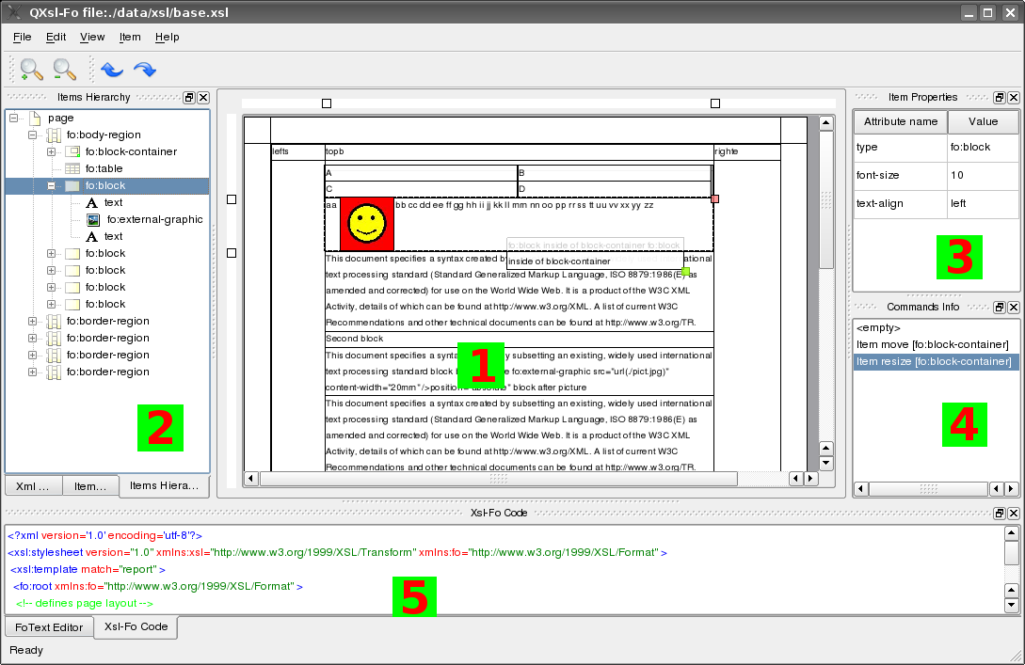
Workplace (1)
Workplace is represented by QgraphicsView/QGraphicsScenes.

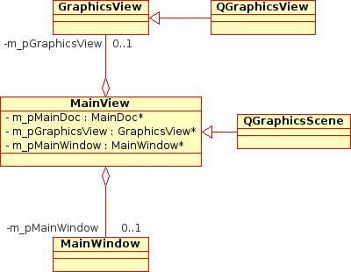

DockWidgets (2,3,4,5)
ItemToolBoxDoc()

ItemPropertiesDoc (3)

ItemHierarchyTreeDoc (2)

CodeView (5)

Undo dock window (4)

Formating objects
FoBlock

