Manual
Application: GWTEventService
Version: 1.0
Manual version: 1.0
Last manual update: 2008-12-31
Author: Sven Strohschein
Project home: http://gwteventservice.googlecode.com/
Contents
1 Introduction 3
1.1 Advantages 3
2 Configuration 3
3 Get started / Usage Guide 4
3.1 Think of your needed events 4
3.2 Define your domains 4
3.3 Write your listeners and events 4
3.4 Connection-Handling 6
4 API - Overview 7
4.1 API class diagram 7
4.1.1 Server side 7
4.1.2 Client side 8
4.2 Polling compared to Comet / server-push 8
4.2.1 Polling sequence diagram 8
4.2.2 Comet / server-push sequence diagram 9
5 Deployment 10
6 RoadMap 11
7 Conclusion / Feedback 11
8 FAQ 12
9 Appendix 13
9.1 Code-Examples 13
9.2 Demo application and “EventFilter” functionality 15

Introduction
GWTEventService is an event-based client-server communication framework. It uses GWT-RPC and the Comet / server-push technique. Chapter 4.2 demonstrates how the communication with Comet / server-push works. The client side offers a high-level API with opportunities to register listeners to the server like to a GUI component. Events can be added to a domain on the server side and the listeners on the client side get informed about the incoming events. The server side is completely independent of the client implementation and is highly configurable. Domains can be defined to decide which events are important for the different contexts. A domain can be handled as a unique key for a context.
It's not nearly as difficult as it is proclaimed to be.

Advantages
- Encapsulation of the client-server communication
- High-level API with listeners and events
- Only one open connection for event listening
- Reduction of server calls
- Reduction of connection peaks
- Events are returned directly when the event has occurred (instead of polling)
- Events are bundled to reduce server calls
- Based on the GWT-RPC mechanism
- Automatic timeout recognition and handling
- Extensible architecture
These advantages are not guaranteed for all cases and could also be disadvantages in some special cases compared with polling or other technologies.

Configuration
To get an application running with GWTEventService, the gwteventservice.jar must be included in the classpath. The gwt-xml must include an entry to inherit “de.novanic.eventservice.GWTEventService”.
Example
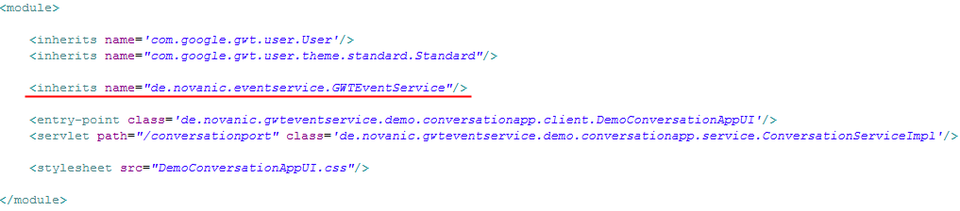
If you want to execute the tests, you need to include the libraries JUnit 3.x or greater (http://www.junit.org) and EasyMock 2.x or greater (http://www.easymock.org). For more information about building GWTEventService yourself and setup the project (with sources), please take a look in the developer guide of GWTEventService.
To configure GWTEventService you can use “eventservice.properties”. The location of the properties file must be attached to the classpath of the server side application. The default values and the description of the times can be seen in the following table.
Alternatively, a configuration loader can be defined if you want to load the configuration from another source. The interface “ConfigurationLoader” must be implemented and must be attached as a custom loader (“EventServiceConfigurationFactory#addCustomConfigurationLoader(...)”). Custom loaders are executed in sequence and before the standard configuration loaders.
Overview about the configurable times:
Time (in milliseconds) | Default value | Description
Min. waiting time | 0 | Time to wait at minimum (even when events have already occurred)
Max. waiting time | 20000 | Time to wait at maximum (canceled when an event occurred)
Timeout time | 90000 | Time till timeout (when the time is reached, the user will be removed from listening for events)

With that configuration possibilities, the server side behavior can be influenced very flexibly. If desired, it is even possible to run GWTEventService in polling mode if min. waiting time is set to a value greater than zero and max. waiting time is set to zero (server side polling mode).

Get started / Usage Guide
Here you can find a small tutorial to see how to get started with GWTEventService. Some UML diagrams to understand and get an overview about the API can be found in chapter 4. The get started instructions should help you to define your first domains and to write your first own listener and events. It's a little bit work to define all the classes and to adjust the client- and server classes, but you should get a clean architecture and design. Let's start to think, define and write.

Think of your needed events
You may know listeners and events of different GUI frameworks like Swing or AWT. The client API of GWTEventService works nearly the same way, but with the difference that you are registering the listeners imaginable to the server. That listening method can theoretically resolve all polling calls to the server. You need to think of and define the events which your client side has to know about. For example a conversation application will at least need a UserJoinEvent, UserLeaveEvent and a NewMessageEvent. The events can be simple Beans or POJOs and can theoretically get all serializable values which are available at the server. The Event interface is only a marker interface and there is logically no default implementation. The domain can't knowingly be got from the Event, because the listener shouldn't be aware of the different domains. If the listener has to differentiate between the different domains, it is a clear signal that you should define different listeners. But when you really need the domain in your events, nothing stops you defining your own abstract event...

Define your domains
Domains are needed to distinguish the various contexts. Domains can be understood as a unique key / id and it is nothing magic or complicated. For example you could have a UserJoinEvent which is triggered when a user joined a game and you want to recognize that in a game list and on a waiting page. In that case you could define a “game-domain” where all events important for the game go to (something like GameStartEvent and UserLeaveEvent, etc.). Now you have the idea to write a conversation plugin for your application. In that case you will also need a UserJoinEvent and UserLeaveEvent, but it shouldn't be handled the same way like in the game context. To reuse the two events (or also the listener if it is factually possible) you can define another domain like “conversation-domain” to avoid conflicts between the same events in different contexts.

Write your listeners and events
Now the interesting part: How can I make it work? First you will need to write your events like defined in 3.1. The events must implement the Event interface (de.novanic.eventservice.client.Event) and must be available to the client- and to the server side. A simple project structure to reach that can be seen in the demo-application (chapter 9.2). At this version you have to add the events via the server side, which makes sense, because the events must be known by the server to distribute the events to the other clients. The event implementations can hold every serializable value / object to which you have access on the server side and must be serializable itself. There are a few special rules for serializable types (see http://code.google.com/docreader/#p=google-web-toolkit-doc-1-5&s=google-web-toolkit-doc-1-5&t=DevGuideSerializableTypes for more information). Common made mistakes are for example that the class doesn't have a default constructor (no arguments) or that final variables are not transferred.
Events can be added via an EventExecutorService (method addEvent(Domain, Event)). An EventExecutorService can be got from the EventExecutorServiceFactory or if you have a servlet, you can extend from RemoteEventServiceServlet which is an implementation of EventExecutorService. That's it for the server side.
The listeners must only be accessible by the client side, because the server doesn't need to know anything about listeners. The only very logical method you need to implement is the “apply” method of the RemoteEventListener interface (de.novanic.eventservice.client.listener.RemoteEventListener). The apply method gets an Event as a parameter and your logic must be able to decide how to handle the event. It's a good practice to define methods in a listener interface like “onUserJoin” and “onUserLeave” which can be implemented in the real implementation of the listener. An adapter class or abstract implementation of the listener can offer the apply method implementation. It is often needed to differ the events via “instanceof” checks. That will be improved with a later version of GWTEventService.
Complete code examples can be found in chapter 9.1 (Appendix: Code-Examples). Here is an example of an implemented “apply” method:
GameUserListenerAdapter
public abstract class GameUserListenerAdapter implements GameUserListener
{
public void apply(Event anEvent) {
if(anEvent instanceof UserJoinEvent) {
onUserJoin((UserJoinEvent)anEvent);
} else if(anEvent instanceof UserLeaveEvent) {
onUserLeave((UserLeaveEvent)anEvent);
}
}

public void onUserJoin(UserJoinEvent aUserJoinEvent) {}

public void onUserLeave(UserLeaveEvent aUserLeaveEvent) {}
}

Now you have the events and the listeners. Maybe you recognized that you need a Domain (de.novanic.eventservice.client.event.domain.Domain) to add an event. This is the last step: The registering of listeners and adding of events with domains. A domain can be got from the DomainFactory (de.novanic.eventservice.client.event.domain.DomainFactory) with a unique String (domain name). It would be a good idea to hold the domain name or the Domain as a constant, available for the client- and server side, to ensure that you access the right domains.
RemoteEventService (de.novanic.eventservice.client.event.RemoteEventService) can be used to register and deregister listeners (client side). The equivalent methods are named “addListener” and “removeListener”. All methods have an optional callback parameter, if you need to know when the change is really active.
Something special and optional is the EventFilter (de.novanic.eventservice.client.event.filter.EventFilter). EventFilters can be added from client side and are processed on server side. With an EventFilter the server side can decide if an Event is really important for the user or not. An EventFilter has only to implement the method “match(anEvent : Event) : boolean”. This functionality is planned to extend in a future release. See the road map for more information: http://code.google.com/p/gwteventservice/wiki/StartPage

Connection-Handling
The connection-handling is completely solved internal of RemoteEventService (de.novanic.eventservice.client.event.RemoteEventService). GWTEventService creates only one connection to the server for event listening. The connection is opened when a listener is added and closed when the last listener is removed. Therefore it's important that listeners are removed when they become unneeded. When a listener is never removed, the connection is still open as long as the client is active (until timeout or browser closed). The client logs activate and deactivate messages to control the connection-handling. There are different ways to remove an unneeded listener: The listener can be removed directly, all listeners of a domain can be removed (the listener object isn't needed) or all listeners can be removed. Look at the RemoteEventService in the class diagram (chapter 4.1) and the corresponding JavaDoc for more information.

API - Overview

API class diagram
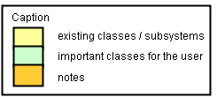

Server side
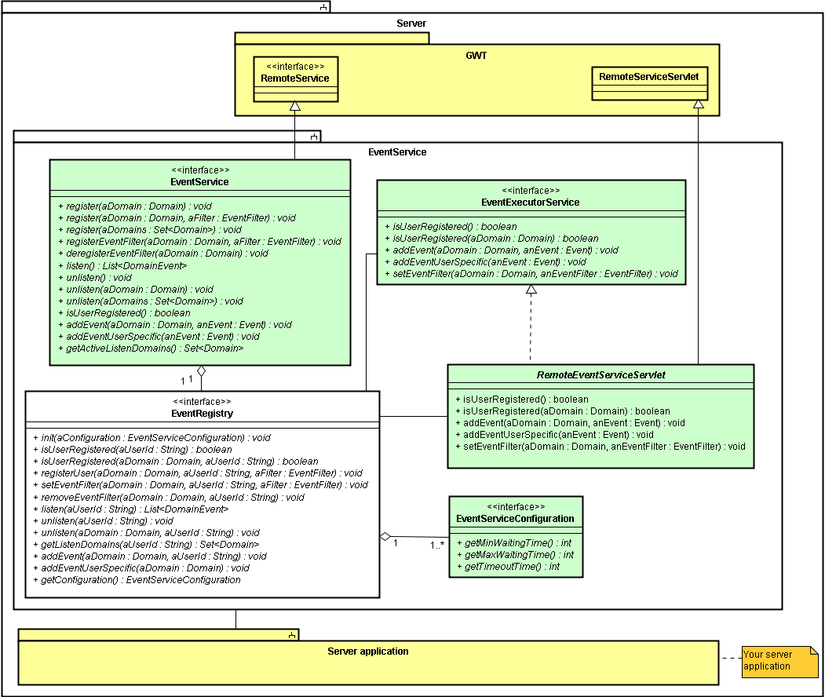

Client side
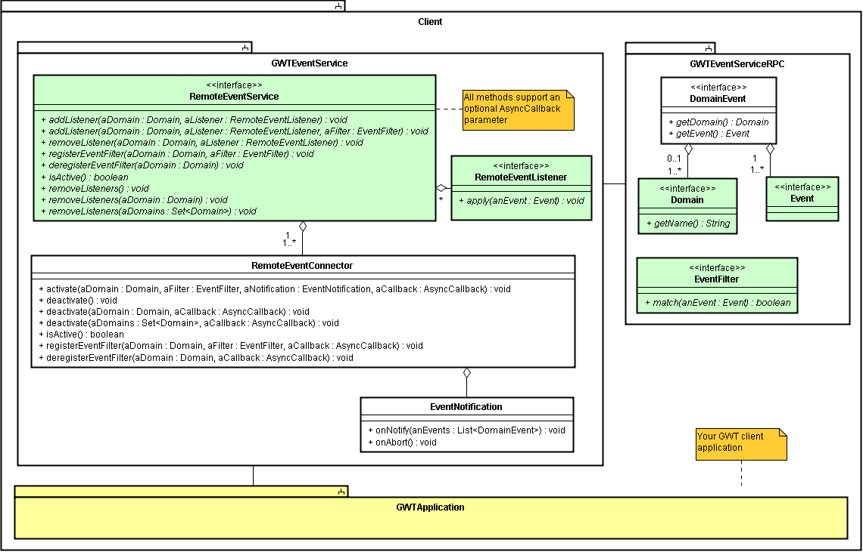

Polling compared to Comet / server-push

Polling sequence diagram
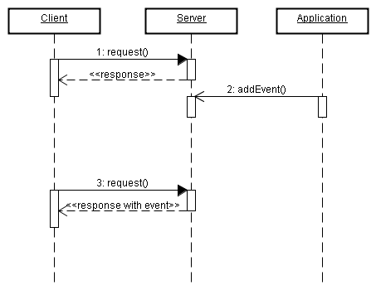

Comet / server-push sequence diagram
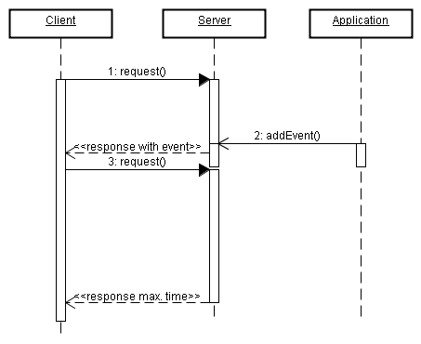

Deployment
The deployment of a GWT application which uses GWTEventService is very easy when your application is already prepared for deploying. That short article describes the deployment with Apache Tomcat (http://tomcat.apache.org/), but is comparable to other web servers.
The JAR file of GWTEventService must simply be put into the “lib” directory of your WAR archive (or exploded directory) and a servlet mapping must be added to your web module deployment descriptor (web.xml). The following two figures show the structure of a WAR file containing the GWTEventService library and a web.xml with the important part of the appropriate servlet mapping.

WAR structure
- WAR
  - <your module path> (generated sources)
  - META-INF
  - WEB-INF
    - classes (compiled application, shouldn't contain any files of GWTEventService)
    - lib (libraries which are used by the application)
      - gwt-servlet.jar
      - gwteventservice.jar
    - web.xml

web.xml
<web-app>

...

<servlet>
<servlet-name>EventService</servlet-name>
<servlet-class>
de.novanic.eventservice.service.EventServiceImpl
</servlet-class>
</servlet>

<servlet-mapping>
<servlet-name>EventService</servlet-name>
<url-pattern>/<your-GWT-module-path>/gwteventservice</url-pattern>
</servlet-mapping>

...

</web-app>

If you need to know more about the deployment process you can take a look at the developer guide of GWTEventService. There is a description/example for the deployment of the demo application.

RoadMap
GWTEventService 1.0 – Initial main feature release (released since 2008-12-31)
GWTEventService 1.1
- Revised configuration loading
- Optional configuration with servlet parameters (Web Container Config XML)
- Support for Annotations
- Simplified event mapping for listeners
GWTEventService 1.2
- Possibility to add events directly from the client side
- Timeout listener
GWTEventService 1.3
- Domain registry to improve the handling of domains
- Support for subdomains
GWTEventService 2.x
- Rule engine for event bundle definitions
- New puffer engine for waiting connections / clients
- Observable interface with reference implementations for Collections and Maps
- Extended internal command handling
- Historization of events
GWTEventService 3.x
- GWTEventService-Console (for monitoring and configuration)

The road map has the state of 2008-12-31. To get the current road map, see http://code.google.com/p/gwteventservice/wiki/StartPage

Conclusion / Feedback
We hope GWTEventService will fit your needs to replace polling with a generic solution and supports you to cleanup the architecture of client-server communication with GWT. We are looking forward to get some feedback, suggestions or questions about the manual or the GWTEventService framework. You can contact us per mail: novanic@gmx.de

FAQ
Q: | Events or internal data of Events are not correctly transferred
A: | Consider that Events must be serializable and require some special rules. For example the class does require a no-argument constructor and variables declared as final are not transferred. For more information see: http://code.google.com/docreader/#p=google-web-toolkit-doc-1-5&s=google-web-toolkit-doc-1-5&t=DevGuideSerializableTypes
Q: | Event listening doesn't work correctly with more than one web browser instance on the same client
A: | That is a general problem of web browsers / web applications, because the browser uses the same session for all web browser instances. To get it work you can run two or more different web browser applications (for example the GWT Hosted Mode Browser and your standard web browser or two other different web browsers when you have installed more than one). That problem doesn't occur with the GWT Hosted Mode Browser. You can start more instances of the GWT Hosted Mode Browser with the “-noserver” option (the configuration is described in the developer guide of GWTEventService).
Q: | The build script of GWTEventService doesn't find GWT classes.
A: | The environment variable “GWT_HOME” must be set correctly. See the chapter “Build with Apache Ant” in the developer guide of GWTEventService for more information.

Appendix

Code-Examples
Here are some code examples to demonstrate the implementation of events and listeners. UserJoinEvent and UserLeaveEvent are subclasses of GameUserEvent. Chapter 9.2 is referencing to a complete demo-application using GWTEventService.

GameUserListener
package de.novanic.gwteventservice.manual.example;

import de.novanic.eventservice.client.event.listener.RemoteEventListener;
import de.novanic.gwteventservice.manual.example.event.UserJoinEvent;
import de.novanic.gwteventservice.manual.example.event.UserLeaveEvent;

public interface GameUserListener extends RemoteEventListener
{
void onUserJoin(UserJoinEvent aJoinEvent);

void onUserLeave(UserLeaveEvent aLeaveEvent);
}

GameUserListenerAdapter
package de.novanic.gwteventservice.manual.example;

import de.novanic.eventservice.client.event.Event;
import de.novanic.gwteventservice.manual.example.event.UserJoinEvent;
import de.novanic.gwteventservice.manual.example.event.UserLeaveEvent;

public abstract class GameUserListenerAdapter implements GameUserListener
{
public void apply(Event anEvent) {
if(anEvent instanceof UserJoinEvent) {
onUserJoin((UserJoinEvent)anEvent);
} else if(anEvent instanceof UserLeaveEvent) {
onUserLeave((UserLeaveEvent)anEvent);
}
}

public void onUserJoin(UserJoinEvent aUserJoinEvent) {}

public void onUserLeave(UserLeaveEvent aUserLeaveEvent) {}
}

GameUserEvent
package de.novanic.gwteventservice.manual.example.event;

import de.novanic.eventservice.client.event.Event;
import de.novanic.gwteventservice.manual.example.Game;
import de.novanic.gwteventservice.manual.example.User;

public class GameUserEvent implements Event
{
private Game myGame;
private User myUser;

public GameUserEvent() {}

public GameUserEvent(Game aGame, User aUser) {
setGame(aGame);
setUser(aUser);
}

public Game getGame() {
return myGame;
}

public void setGame(Game aGame) {
myGame = aGame;
}

public User getUser() {
return myUser;
}

public void setUser(User aUser) {
myUser = aUser;
}
}

Example class of usage
package de.novanic.gwteventservice.manual.example;

import de.novanic.eventservice.client.event.RemoteEventService;
import de.novanic.eventservice.client.event.RemoteEventServiceFactory;
import de.novanic.eventservice.client.event.domain.Domain;
import de.novanic.eventservice.client.event.domain.DomainFactory;
import de.novanic.gwteventservice.manual.example.event.UserJoinEvent;
import de.novanic.gwteventservice.manual.example.event.UserLeaveEvent;

public class UsageClass
{
private static final Domain GAME_DOMAIN = DomainFactory.getDomain("gamedom”);

public void init() {
//do something

RemoteEventServiceFactory theEventServiceFactory =
RemoteEventServiceFactory.getInstance();
RemoteEventService theEventService =
theEventServiceFactory.getRemoteEventService();

theEventService.addListener(GAME_DOMAIN, new GameUserListenerAdapter() {
public void onUserJoin(UserJoinEvent userJoinEvent) {
//do something with the new user
}

public void onUserLeave(UserLeaveEvent userLeaveEvent) {
//do something with the leaved user
}
});

//do something
}
}

Demo application and “EventFilter” functionality
There is a demo application called “DemoConversationApp” for GWTEventService available. It shows a small conversation application with a channel-system to demonstrate the “EventFilter” functionality. There is only one domain for the conversation context and an EventFilter to divide the conversation into different channels. The EventFilter is processed on the server side and checks the channels to decide if an event is important for the particular user. If not, the connection is still active, otherwise the events are returned to the client/user. Global events like “NewChannelEvent” or “CloseChannelEvent” are processed by the EventFilter without a check for a channel.
The most important functionality is contained in the class “ConversationControl” (de.novanic.gwteventservice.demo.conversationapp.client.conversation.control.ConversationControl) and should be a good entry point to study the usage in practice.
Project-SVN-URL: http://gwteventservice.googlecode.com/svn/trunk/
Demo-SVN-URL: http://gwteventservice.googlecode.com/svn/trunk/demo/

