Developer Guide
Application: GWTEventService
Software version: 1.1
Document version: 1.1.0
Last document update: 2009-07-05
Author: Sven Strohschein
Project home: http://gwteventservice.googlecode.com/

Contents
1 Introduction 3
2 Project setup 4
2.1 Checkout the sources 4
2.2 Project setup with Eclipse 4
2.3 Demo application setup with Eclipse (conversation application) 10
3 Build with Apache Ant 11
4 Deployment of the demo application 12
5 Configuration loading 12
5.1 Default configuration loading sequence 12
5.2 Extending the configuration loading 13

Introduction
This developer guide or usage guide should help you to setup the GWTEventService project and the demo application. A general description and instructions to configure GWTEventService for your own projects are contained in the manual which can be found in the developer release and in the Wiki of GWTEventService (http://code.google.com/p/gwteventservice/wiki/Configuration).

Project setup

Checkout the sources
There are two ways to get the sources. The sources are bundled with the developer release of GWTEventService and can be extracted to setup the project, but I suggest to checkout the sources from SVN. That makes it easier to create patches, revert changes, etc.. You can checkout the sources anonymously with your SVN-client with the following repository information (read-only).
SVN-URL for the trunk version: http://gwteventservice.googlecode.com/svn/trunk/
If you have some suggestive changes, improvements, bug fixes or new features implemented that should be officially committed to the project, you may create a patch and post it to the ticket system (http://code.google.com/p/gwteventservice/issues/list) or to the forum or send it to a project member. It is also possible to become a project member with an account for committing changes to the repository. Simply ask a project member, at best with an interesting patch or with some patches or suggestions sent to the community before.

Project setup with Eclipse
It is recommended to create the workspace for GWTEventService in the root directory of your GWTEventService installation. There are three projects/modules for GWTEventService and three projects/modules for the demo application.

Module structure
GWTEventService – Modules
- EventService (server side)
- EventServiceRPC (between server and client side)
- GWTEventService (client side)

Demo Conversation Application – Modules
- DemoConversationApp (server side)
- DemoConversationAppRPC (between server and client side)
- DemoConversationAppUI (client side)

The demo application is also structured like described in the graphic above. The module DemoConversationAppUI contains the GWT GUI components and the listeners (RemoteEventListener). That is possible, because the server side operates with events and domains and doesn't need to know the listeners. The events are defined in the module DemoConversationAppRPC, because the events are needed by the server and by the client side. That module is required to resolve circular module dependencies. The service implementations are defined in the module DemoConversationApp and at that point, events can be added to the EventRegistry (by extending RemoteEventServiceServlet or the usage of EventExecutorService).
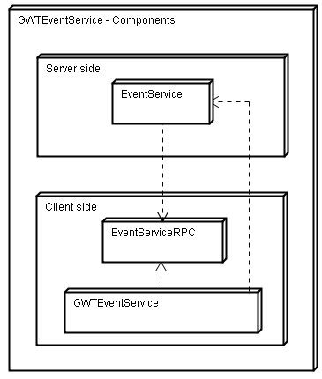

After having created your workspace, you can import the predefined Eclipse projects like shown below (File → Import → General → Existing Projects into Workspace). That must be done for all three or six modules.

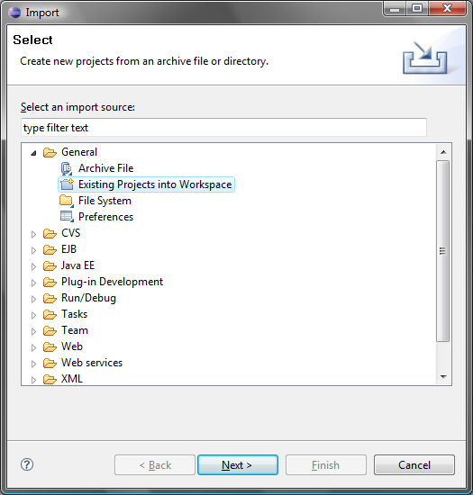
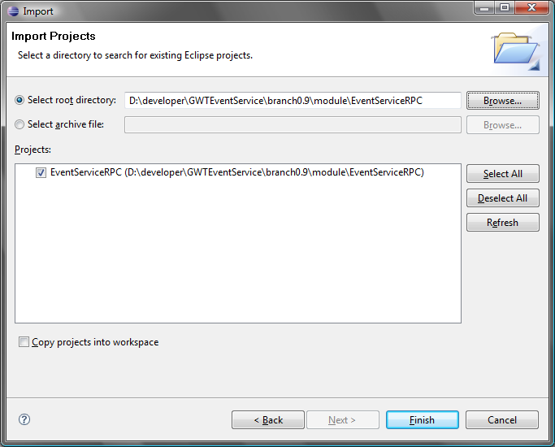

When all modules/projects are added to the workspace the build path should be configured like in the screenshot at the bottom of the page. If you need to compile/run the tests, the paths for JUnit (http://www.junit.org) and EasyMock (http://www.easymock.org) must be changed to include your downloaded libraries or you can copy the libraries to the predefined “lib” directory. The module/project dependencies should match to the dependency graphic above.
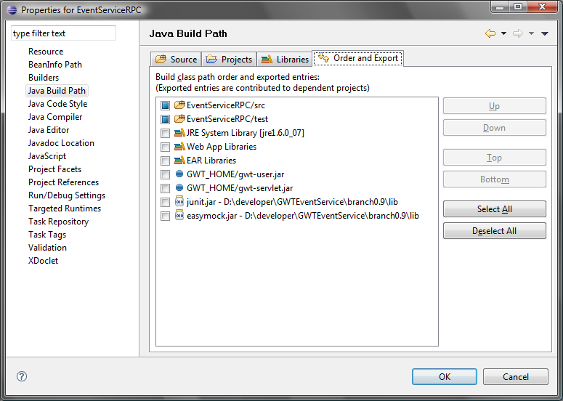

When you use Cypal Studio (http://code.google.com/p/cypal-studio/) for GWT development, your settings should be similar to the following screenshot.
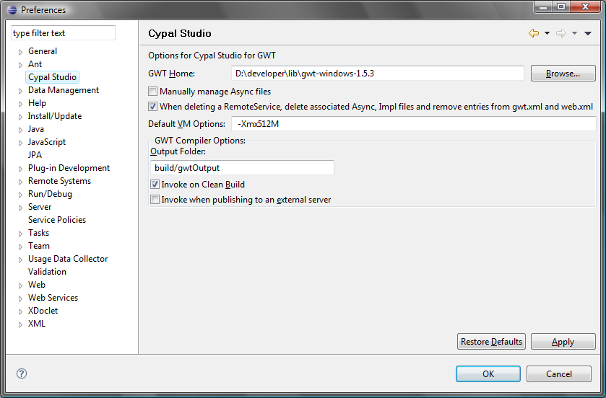

Demo application setup with Eclipse (conversation application)
Here is an example of the classpath configuration of the demo application (DemoConversationApp) and a “Run Configuration” for Eclipse. The GWT module class to start the application is “de.novanic.gwteventservice.demo.conversationapp.DemoConversationAppUI”.
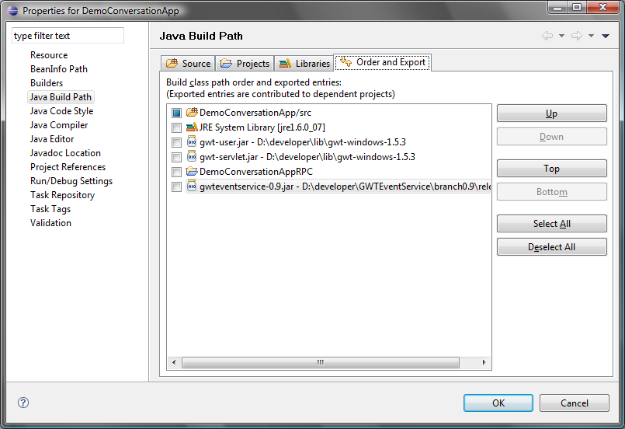

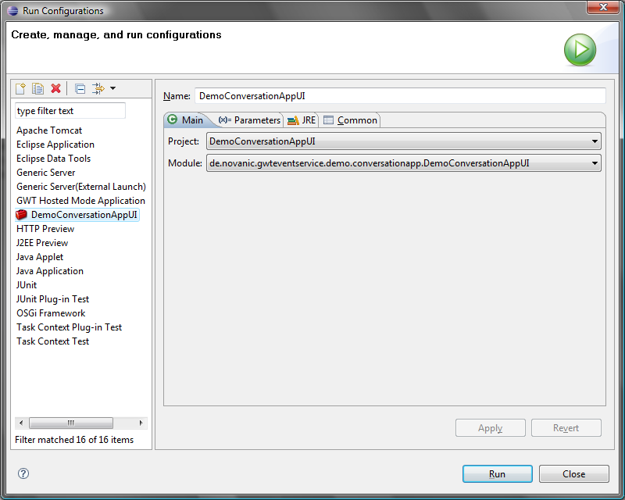

There is a built-in solution delivered with GWT to test the conversation application in Hosted-Mode with more than one user. The first user must start the application normally (with server). The other users can join the server by adding the start parameter “-noserver” to the “Run Configuration”. Now you can run more than one client to try out the conversation application. With GWT 2.0 the Development Mode can be used to simply run the application in different browsers. It is necessary to run it in different browsers to simulate various clients, because the most browsers use the same session within multiple instances.

Build with Apache Ant
The general build script can be found in the root directory of GWTEventService. There are three important Ant targets. “dist” / “package-release-full” is defined as the default target. It builds the whole project sources with documentation, release-notes, RoadMap, etc. and creates the core- and developer-release files. With the other two targets, the core and the developer package can be built as single (“package-release-core” and “package-release-developer”).
To build the project with Ant and run the tests, you will need to put JUnit 3.x or greater (http://www.junit.org) and EasyMock 2.x or greater (http://www.easymock.org) in the pre-configured “lib” directory located in the root directory of GWTEventService. As an alternative you may redefine the “libdir” property in the build script to use your own library directory. The root directory of the GWT installation must also be known by the build script. There are two ways to do that: You could setup the environment variable “GWT_HOME” with the path to the root directory of GWT or you could copy the GWT installation into your library directory, described above.
The core release does only contain the absolutely necessary data to get an application using GWTEventService to run. Here you can see the differences between the core- and the developer-release in detail.
 | core release | developer release
jars | yes | yes
licence | yes | yes
about | yes | yes
release-notes | yes | yes
default configuration | yes | yes
sources | no | yes
javadoc | no | yes
documentation | no | yes
demo application | no | yes
RoadMap | no | yes

Deployment of the demo application
The general deployment of GWT applications which are using GWTEventService is described in the manual of GWTEventService. Here is an example how to deploy the demo application which is packed with the developer release of GWTEventService and of course available in the SVN repository. There is a build script in the demo repository (gwteventservice/demo/build.xml) to build a WAR file and exploded directory. The build script also requires the path configuration like described in chapter 3 and a gwteventservice.jar in the root or “release” directory. It contains two targets to create the WAR file: “dist” and “dist-dep”. In addition to “dist”, “dist-dep” calls the global build script to build the gwteventservice.jar.
The created WAR file can be deployed normally to your web server. After deploying the WAR file, you should reach the application with the following URL. The “democonversation” part of the URL (name of the WAR file) may not be necessary/allowed, depending on the configuration of your web server.

URL
http://localhost:8080/democonversation/DemoConversationAppUI.html
protocol | server name | : | port | / | deployment name / WAR file | / | GWT module start page
http:// | localhost | : | 8080 | / | democonversation | / | DemoConversationAppUI.html

Configuration loading
That chapter describes the possibilities to load configurations for GWTEventService.

Default configuration loading sequence
There is a default sequence to load the GWTEventService configuration. It is searched for a properties file “eventservice.properties” at first. When that properties file isn't found at the classpath, the configuration parameters of the web-descriptor are taken. That means an eventservice.properties can be put at the classpath to overwrite the configuration parameters of the web-descriptor. When no configuration parameters / servlet-parameters are defined in the web-descriptor, the default configuration is loaded (min. time zero seconds, max. time 20 seconds, timeout time 90 seconds). That sequence can be manipulated and extended with custom configuration loaders and configuration levels. See chapter 5.2 (Extending the configuration loading).
The default sequence to load the GWTEventService configuration is demonstrated below.
Position | ConfigurationLoader | ConfigLevel | Default search location
1 | PropertyConfigurationLoader | DEFAULT (5000) | /classes/eventservice.properties
2 | WebDescriptorConfigurationLoader | DEFAULT (5000) | /WEB-INF/web.xml
3 | DefaultConfigurationLoader | HIGHEST (10000) | -

Extending the configuration loading
It is possible to manipulate or extend the configuration loading. For example to load the configuration from a remote database or an external XML file. That can be done by implementing a ConfigurationLoader. ConfigurationLoader is a simple interface which provides a load method and a method to check if the configuration is available. That custom loader can be embedded in the loading process with EventServiceConfigurationFactory which provides methods to add, remove and replace ConfigurationLoader (de.novanic.eventservice.config.loader.ConfigurationLoader) registrations. ConfigurationLoader instances must be registered to a ConfigLevel to define the order. There are five predefined levels (LOWEST, LOW, DEFAULT, HIGH and HIGHEST). As seen in the table of chapter 5.1 (Default configuration loading sequence), there are two configuration loaders at DEFAULT level and the DefaultConfigurationLoader is registered to the HIGHEST level. An ConfigurationLoader which is registered at a higher level (after DefaultConfigurationLoader) it hasn't an effect, because the DefaultConfigurationLoader is always available. When a custom ConfigurationLoader should for example be checked before searching for a properties file, it is recommend to register it to the LOW or LOWEST level or to a finer defined level which can be created with ConfigLevelFactory.

Configuration level overview
Level | Range | Default ConfigurationLoaders
ConfigLevelFactory.LOWEST | 1 - 2499 | -
ConfigLevelFactory.LOW | 2500 - 4999 | -
ConfigLevelFactory.DEFAULT | 5000 - 7499 | PropertyConfigurationLoader (5000)  WebDescriptorConfigurationLoader (5000)
ConfigLevelFactory.HIGH | 7500 - 9999 | -
ConfigLevelFactory.HIGHEST | >= 10000 | DefaultConfigurationLoader (10000)

