|  |
| --- |
|  |

|  |
| --- |
| **Architecture Driver Specification** |
| Human Resource Management |
|  |
| Define architectural drivers and the development strategy for HRM system. The document was written follow the online template for architectural drivers specification |
|  |
| **HRM Team** |
| **11/3/2011** |
|  |

Contents

1.1 Purpose 3

1.2 Definition and Acronyms 3

4.1 Use case Modeling 4

4.1.1 Use case Level 1 4

4.1.2 Use case Level 2 6

5.1 Quality Attribute List 7

5.2 Quality Attribute Scenario 8

*Key Quality Attributes* 8

6.1 Technical Constraints 8

6.2 Business Constraints 8

7.1 Priority Scale 9

7.2 Difficulty Ranking Scale 9

7.3 Functional Requirement 9

7.4 Quality Attribute Scenarios 10

7.5 Technical Constraint 10

7.6 Minimal Acceptable Delivery 10

**Revision History**

|  |  |  |  |
| --- | --- | --- | --- |
| Date | Version | Author | Description |
|  |  |  |  |
|  |  |  |  |
|  |  |  |  |
|  |  |  |  |

1. Introduction

# 1.1 Purpose

The function of Human Resources departments is generally administrative and common to all organizations. Organizations may have formalized selection, evaluation, and payroll processes. The HR function consists of tracking existing employee data which traditionally includes personal histories, skills, capabilities, accomplishments and salary. To reduce the manual workload of these administrative activities, Van Lang University began to electronically automate many of these processes by introducing specialized Human Resource Management Systems.

# 1.2 Definition and Acronyms

|  |  |
| --- | --- |
| **Name** | **Description** |
| HRM | Human Resource Management |
| HRM Staff | The employee who is working in Human Resource Department |
|  |  |
|  |  |
|  |  |
|  |  |
|  |  |

2. Project Overview

HRM is particularly developed for human resource management in university / colleges. The system consists of key modules:

* Personal information management
* Employee labor contract management
* Recruitment & training processing
* Payroll
* Administration panel - Utilities

3. Architecture Driver Overview

The architectural drivers presented in this document include:

* **Functional Requirements:** These requirements are presented in the form of specifications and use cases.
* **Quality Attribute Requirements:** These requirements are presented in the form of quality attribute scenarios.
* **Business Constraints:** They include schedule, cost, and procedural demands that will impact how the system is designed or implemented
* **Technical Constraints**: they specify that a particular product, tool, language, OS, platform, network, protocol, algorithm, and so forth must be used in the system.

These architectural drivers will influence the architectural design and implementation of the project. Additionally, they will impact the schedule and quality of the project. As a whole these architectural drivers define the scope of the project.

4. Functional Requirement

# 4.1 Use case Modeling

# 4.1.1 Use case Level 1

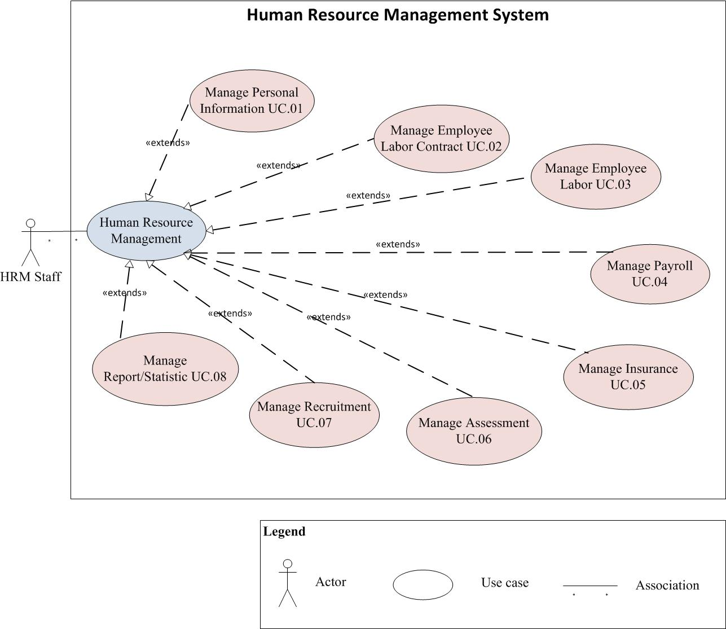

*Figure 1: Use case diagram Level 1 for HRM System*

|  |  |  |  |
| --- | --- | --- | --- |
| **ID** | **Use Case** | **Description** | **Actor** |
| UC.01 | Manage Personal Information | Manage the personal information of all staff in Van Lang university, including employees’ ID number, date of birth, place of birth, gender, number of insurance, address, telephone, current accommodation, working department, title, job title.... | HRM Staff |
| UC.02 | Manage Employee Labor Contract | Detailed management about the contracts between the employees and employers: probation contracts, job training, the time limited and unlimited official contracts. In addition, the management is included keeping track of renewal contract and storing profiles when employees quit working or suspend the contract. | HRM Staff |
| UC.03 | Manage Employee Labor | * Manage the kind of labor * Manage the checking in of staff * Manage the checking in of lecture * Manage the status of the staff and lecture. |  |
| UC.04 | Manage Payroll | The input figures for the salaries such as the minimum wage, payment for further study, long - term training, payment for working overtime, the figures of salary adjustments based on the results and how to emulate the monthly salary as required. Modules also provide the output:   * Table of income apart from salary * General report on payment of wages * Report on salary increase plan (quarterly and monthly) |  |
| UC.05 | Manage Insurance | * Manage the Health Insurance * Manage the increasing/decreasing the labor * Support for tracking the interest of the labor that take part in Health Insurance |  |
| UC.06 | Manage Assessment | * Manage the emulation assessment process * Manage the result of emulation after assessing. |  |
| UC.07 | Manage Recruitment | * Detailed management about applicants’ profiles * Keeping track of detailed information on the job interviews * When applicants are chosen, the records will be automatically updated to official profiles of the staff * Planning and monitoring the training plan implementation of the whole staff. * Keeping track of the training, and the cost for training implementation. * Keeping track of the advanced training cost and payment for each member in the teaching staff. |  |
| UC.08 | Manage Report/Statistic | * Report and statistic the quantities, status of operation of Van Lang university annual |  |

# 4.1.2 Use case Level 2

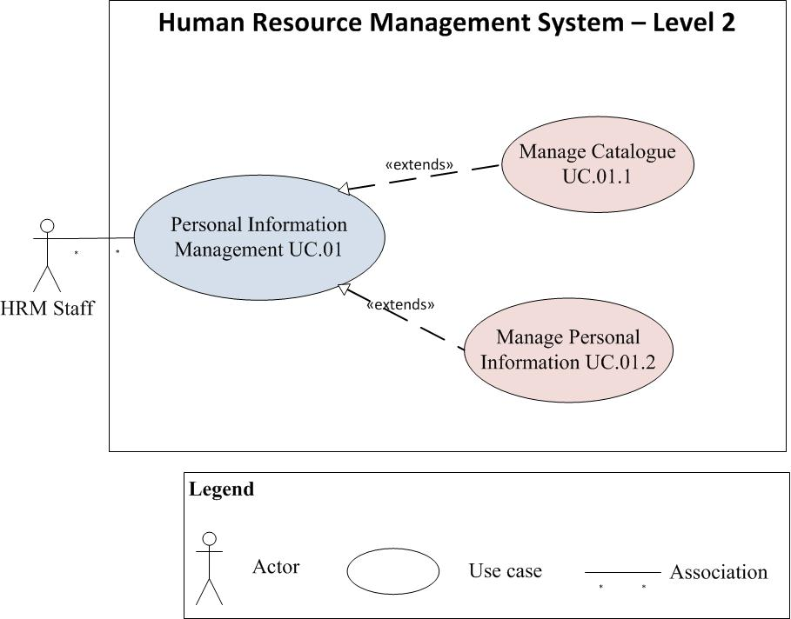

*Figure 2: Use case diagram Level 2 for HRM System*

|  |  |  |  |
| --- | --- | --- | --- |
| **ID** | **Use Case** | **Description** | **Actor** |
| UC.01.1 | Manage Catalogue | Allow the HRM staff to add/remove/update the catalogue | HRM Staff |
| UC.01.2 | Manage Personal Information | Manage the personal information of all staff in Van Lang university, including employees’ ID number, date of birth, place of birth, gender, number of insurance, address, telephone, current accommodation, working department, title, job title.... | HRM Staff |

# 4.1.2 Use case Level 3

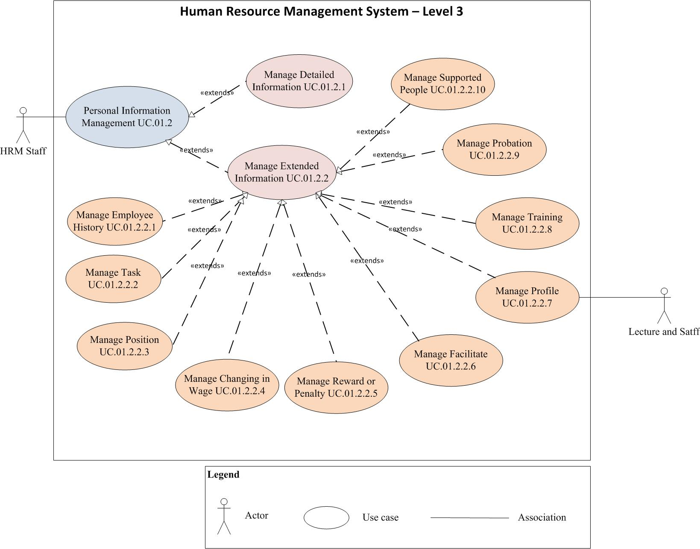

*Figure 3: Use case diagram Level 3 for HRM System*

|  |  |  |  |
| --- | --- | --- | --- |
| **Use case title:** Manage Employee History | | | **Use case ID: UC.01.2.2.1** |
| **General use case description:** Allow the HRM staff record the information of this staff before working in Van Lang University. | | | |
| **Entities involved:** HRM staff | | | |
| **Preconditions:** The HRM staff log in the system successfully | | | |
| **Primary use case flow of events:** | | | |
| 1 |  | | |
| 2 |  | | |
| 3 |  | | |
| **Primary use case post conditions:** | | | |
| **Alternate use case # flow of events:** | | | |
| 1 | |  | |

5. Quality Attribute Requirements

# 5.1 Quality Attribute List

|  |  |  |  |
| --- | --- | --- | --- |
| **System quality attributes** | | | |
| **ID** | **Quality attributes** | **Description** | **View** |
| QA.01 | **PERFORMANCE** | -The time for staring the HRM system is fast.  -The response time of HRM system for each user interaction will be improved and the resource for each interaction will be reduced. | Stakeholder |
| QA.02 | **SECURITY** | -The HRM system will run safety. It cannot be accessed by unauthorized users, support detect the attacks and recover from the attack.  -The data of human resources in Van Lang University will be protected from attacker. | Technical |
| QA.03 | **USABILITY** | -The HRM system have the consistent screens and easy to uses. It does not take time for training.  -The HRM system provide adequate user document including help, user manual and tutorials for user guidance | Stakeholder |
| QA.04 | **SCALABILITY** | -The current system is just for about 10 users but it requires the system can expand more to 30- 40 users at a time. | Stakeholder |
| QA.05 | **MODIFIABILITY** | -The HRM system supports the developers or maintainer can easy add new function or modify the current function whenever the business rules are change. The first release of HRM system just focuses on “Personal Information Management”. However, there will be more modules, which will be added to system in next release. | Technical |
| QA.06 | **AVAILABILITY** | -The HRM will have periodically backup of database to ensure that whenever the database server is crashed, the data will not be lost. | Technical |

# 5.2 Quality Attribute Scenario

## *Key Quality Attributes- Performance*

|  |  |  |  |
| --- | --- | --- | --- |
| **Title of scenario:**  **Ability to handle many user interactions when they modify the “Personal Information”** | | **ID: QA.01** | **Version: 1.0** |
| **Last Changed: 11/7/2011** |
| **Quality attribute:** Performance | | **Characterization ID:** QAS.01 | |
| **Describe stakeholder role proposing the description:** The HRM staffs, Architect | | | |
| Source(s) of the stimulus | The HRM staffs who responsible for modifying the “Personal Information” | | |
| Stimulus | Updating or Modifying the “Personal Information” in both detailed and extended information. | | |
| Relevant environmental conditions | The HRM system is in normal mode.  The number of user transactions is 10. | | |
| Architectural elements | The HRM system | | |
| System response | The HRM system process all transaction:   * Update the new information to database * Log the transaction. | | |
| Response measure(s) | The response time for each transaction is about 2-4 seconds. | | |

|  |  |  |  |
| --- | --- | --- | --- |
| **Title of scenario:**  **The performance when the user choose to show any field in “Personal Information”** | | **ID: QA.01** | **Version: 1.0** |
| **Last Changed: 11/7/2011** |
| **Quality attribute:** Performance | | **Characterization ID:** QAS.02 | |
| **Describe stakeholder role proposing the description:** The HRM staffs, Architect | | | |
| Source(s) of the stimulus | The HRM staffs who want to show personal information (detail and extend) | | |
| Stimulus | Choose any fields in Personal Information Management for showing on grid. | | |
| Relevant environmental conditions | The HRM system is in normal mode. | | |
| Architectural elements | The HRM system | | |
| System response | The HRM system gets the data of each field from database and display on grid. | | |
| Response measure(s) | The response time for showing is about 2 seconds. | | |

|  |  |  |  |
| --- | --- | --- | --- |
| **Title of scenario:**  **The performance when the HRM staffs want to create new lecturer/staffs** | | **ID: QA.01** | **Version: 1.0** |
| **Last Changed: 11/7/2011** |
| **Quality attribute:** Performance | | **Characterization ID:** QAS.03 | |
| **Describe stakeholder role proposing the description:** The HRM staffs, Architect | | | |
| Source(s) of the stimulus | The HRM staffs | | |
| Stimulus | -Create new lecturer/ staff information  -Input personal information and confirm to add to system database. | | |
| Relevant environmental conditions | The HRM system is in normal mode. | | |
| Architectural elements | The HRM system | | |
| System response | If all information of new lecturer/staff is inputted correctly, the system will save these information in database. | | |
| Response measure(s) | The response time for storing information is about 3- 6 seconds. | | |

|  |  |  |  |
| --- | --- | --- | --- |
| **Title of scenario:**  **The performance when the HRM staffs want to search any lecturer/ staff** | | **ID: QA.01** | **Version: 1.0** |
| **Last Changed: 11/7/2011** |
| **Quality attribute:** Performance | | **Characterization ID:** QAS.04 | |
| **Describe stakeholder role proposing the description:** The HRM staffs, Architect | | | |
| Source(s) of the stimulus | The HRM staffs | | |
| Stimulus | -Input the Resource ID or name  -Choose the search type  -Confirm for searching | | |
| Relevant environmental conditions | The HRM system is in normal mode. | | |
| Architectural elements | The HRM system | | |
| System response | The HRM system starts searching and show the search result. | | |
| Response measure(s) | The response time for searching is about 3- 6 seconds. | | |

## *Key Quality Attributes- Modifiability*

|  |  |  |  |
| --- | --- | --- | --- |
| **Title of scenario:**  **Ability to add/ delete/ modify functionality** | | **ID: QA.05** | **Version: 1.0** |
| **Last Changed: 11/7/2011** |
| **Quality attribute:** Modifiability | | **Characterization ID:** QAS.05 | |
| **Describe stakeholder role proposing the description:** Architect | | | |
| Source(s) of the stimulus | The developer, end-users | | |
| Stimulus | Wish to   * Add new functionality * Delete existing functionality * Modify existing functionality | | |
| Relevant environmental conditions | The HRM system is in build time | | |
| Architectural elements | The HRM system | | |
| System response | -Locates places in architecture to be modified  -Makes modification without affecting other functionality  -Tests modification  -Deploys modification | | |
| Response measure(s) |  | | |

|  |  |  |  |
| --- | --- | --- | --- |
| **Title of scenario:**  **Ability to modify the user interface (UI)** | | **ID: QA.05** | **Version: 1.0** |
| **Last Changed: 11/7/2011** |
| **Quality attribute:** Modifiability | | **Characterization ID:** QAS.05 | |
| **Describe stakeholder role proposing the description:** Architect | | | |
| Source(s) of the stimulus | The developer, end-users | | |
| Stimulus | Modifying the user interface includes the screen layout, text, GUI images… | | |
| Relevant environmental conditions | The HRM system is in build time | | |
| Architectural elements | The HRM system user interface | | |
| System response | -Locates UI part for modification  -Makes modification without affecting the functionality in other tiers  -Tests UI | | |
| Response measure(s) |  | | |

6. Constraints

# 6.1 Technical Constraints

|  |  |  |
| --- | --- | --- |
| **ID** | **Constraint name** | **Constraint description** |
| C.01 | Programming language | C#, WCF |
| C.02 | Development platform | .Net 4.0 |
| C.03 | Database | MS SQL Server |

# 6.2 Business Constraints

|  |  |  |
| --- | --- | --- |
| **ID** | **Constraint name** | **Constraint description** |
| C.04 | Time limitation | The end of the project is in April 31st,2012 |

7. Prioritization

# 7.1 Priority Scale

The priority scale has been defined priority of functional requirement.

|  |  |  |
| --- | --- | --- |
| Priority (numeric) | Priority (name) | Description |
| 1 | Must Have | Must be present in the end product at all costs. |
| 2 | Should Have | Very important features that distinguish a system from others, significant to users and business. |
| 3 | Nice to have | Customer would greatly appreciate implementation of these features. |

# 7.2 Difficulty Ranking Scale

The difficulty ranking scale has been defined on the basis of complexity and effort. Complexity is defined as how difficult the design of a solution is and whether the team has previous experience in designing or implementing such a design. Both measures, for complexity and effort, are relative to each other.

|  |  |
| --- | --- |
| Difficulty (numeric) | Description |
| 1 | High complexity and large amount of effort required |
| 2 | High complexity or large amount of effort required |
| 3 | Moderate complexity and medium amount of effort required. |

# 7.3 Functional Requirement

The lower priority, the higher importance

|  |  |  |  |  |
| --- | --- | --- | --- | --- |
| **ID** | **Functional Requirement** | **Stakeholder ranking** | **Difficulty Ranking** | **Priority** |
| FR.01 |  |  |  |  |
| FR.02 |  |  |  |  |
| FR.03 |  |  |  |  |
| FR.04 |  |  |  |  |
| FR.05 |  |  |  |  |
| FR.06 |  |  |  |  |
| FR.07 |  |  |  |  |
| FR.08 |  |  |  |  |

We choose function which have high priority (>1) to deliver in given schedule, the other function will defer because they are not value with stakeholder and high risk. If we choose to implement them, the late delivery will occur.

# 7.4 Quality Attribute Scenarios

|  |  |  |  |  |
| --- | --- | --- | --- | --- |
| **ID** | **Quality attributes** | **Difficulty ranking (1,2,3)** | **Stakeholder ranking** | **Priority** |
| QA.01 | **PERFORMANCE** |  |  |  |
| QA.02 | **SECURITY** |  |  |  |
| QA.03 | **USABILITY** |  |  |  |
| QA.04 | **SCALABILITY** |  |  |  |

# 7.5 Technical Constraint

|  |  |  |
| --- | --- | --- |
| Technical constraint prioritizations | | |
| Description | **Difficulty ranking** | **Comments** |
|  |  |  |
|  |  |  |
|  |  |  |
|  |  |  |
|  |  |  |

# 7.6 Minimal Acceptable Delivery

|  |  |
| --- | --- |
| **Success criteria** |  |
| Operational description |  |
|  |
|  |
|  |
|  |
|  |
| Properties |  |
|  |