Software Requirement Specification for Global Software Development Tool
Global Software Development Tool
This document presents the requirement specification of Team TheJazzRockers working on Global Software Development Tool
The Jazz Rockers
4/24/2009

Contents
1. Revision History 4
1. Introduction 4
1.1 Purpose 4
1.2 Document Conventions 4
1.3 Intended Audience and Reading Suggestions 5
1.4 Background 5
1.4.1 Problem Statement 6
1.5 Project Scope 6
1.5.1 Vision 6
1.5.2 Project goals 6
1.5.3 Context diagram 7
2. Product Perspective 9
3. User classes and characteristics 10
4.2 High Level Use Cases 11
4.2.1 Actors Specification: 11
4.2.2 Domain Objects 15
4.3 High Level use case: 16
High Level Use Case Diagram of GSD Tool 17
4. Operating Environment 20
4.1 Design and Implementation Constraints 20
4.1.1 User Documentation 20
4.1.2 Assumptions and Dependencies 20
5. System Features 20
5.1 System Feature 1: Data Abstraction 21
5.1.1 Description, Use Case and Priority 21
5.1.2 Stimulus/Response Sequences 22
5.1.3 Use Case Diagram 23
5.1.4 Functional Requirements 28
5.2 System Feature 2: Traceability Definition 35
5.2.1 Description, Use Case and Priority 35
5.2.2 Stimulus/Response Sequences 36
5.2.3 Use Case 003: Traceability view definitions 38
5.2.4 Functional Requirements 40
5.3 System Feature 3: Import Data 44
5.3.1 Description, Use Case and Priority 44
5.3.2 Stimulus/Response Sequences 45
5.3.3 Use Case 004: Import Data 45
5.3.4 Functional Requirements 47
5.4 System Feature 4: Authorization 48
5.4.1 Description, Use Case and Priority 48
5.4.2 Stimulus/Response Sequences 49
5.4.3 Use Case 004: Authorization 49
5.4.4 Functional Requirements 51
Mapping between High level Functinal Requirements and SRS requirements 52
External Interface Requirements 56
User Interface for System Feature 1 56
Prototype for System Feature 2 61
Alternative Prototype 66
Quality Attribute Requirements 70
Appendix 70
High Level Functional Requirements 70
Appendix A: Glossary 70
References 71

Revision History

Name | Date | Reason For Changes | Version
Bhanu Sistla | 11/30/08 | Initial Version | 0.1
Bhanu Sistla | 01/18/09 | Added Functional Requirements | 0.2
Bhanu Sistla | 02/17/09 | Refined Functional Requirements | 0.5
Bhanu Sistla | 04/24/09 | Created Final Version | 1.0
Bhanu Sistla | 04/24/09 | Correct Inspection Defects | 1.1

Table 1: Revision History

Introduction

Purpose
The purpose of this software requirement specification document is to specify the requirements for the development of a Global Software Development Tool (GSD). This document covers the requirements against which the team would develop the intended product. The product developed must comply with all the ‘must have’ requirements (the requirements with the shall statements) in order to be called as being ‘complete’ and ‘ready to deliver’.

Document Conventions
The requirements have been grouped together under system features. Each system feature represents a use case along with its other attributes. The related requirements to that specific system feature are group together. Each requirement is further divided into sub-requirements.

The requirement statements containing ‘shall’ indicates it is a must-to-have requirement.
The requirement statements containing ‘should’ indicates it is a ‘nice-to-have’ requirement. Each requirement has its own priority and attributes associated with it.

Following are the attributes of each requirement:

- Design level : High/Medium/Low
- Stability: Stable/Unstable
- Priority: High / Medium / Low
- Complexity: High/Medium/low
- Risk: Possible Risk associated with each requirement
- Type: Must have or Nice to have
- Dependency on other requirements
- Exit criteria : the criteria to be used to call the requirement to be complete

Intended Audience and Reading Suggestions

Following are the intended audience of this document
- Clients
- End users of the product
- The Jazz Rockers Team members
- Mentors
- MSE faculty and students

The document is structured in the following format. It presents the project scope, project vision, business goals, and problem statement followed by the requirement specifications.

Background
The client needs a tool to support its global software development. In particular, they desire a tool that provides both upward and downward traceability for all artifacts and activities across all disciplines in a software development lifecycle and that helps globally distributed teams collaborate using a common platform. This Global Software Development (GSD) tool, which is to be created by The Jazz Rockers, is to be both a running software application and also a framework upon which additional functionality can be added at a later time by the client after The Jazz Rockers have delivered their final release of the tool.

Problem Statement
As mentioned, our client has several globally distributed business units. Different business units use different tools to collect and manage software related data.
Client has following key issues,
- Different business units have different processes for collecting software engineering data (metrics, artifacts etc.).
- Making meaningful observations about the collected data is hard.
- Collected data in one phase of a software engineering process is not always used in downstream processes.

Project Scope

Vision

In order to resolve the above mentioned issues our client has a vision to build a tool which would be able to,

- To integrate data emerging from various tools and processes. These tools include tools for software engineering, project management, and collaboration.
- To establish traceability among different artifacts
- To create role-based views using the integrated data and different traceability
- To extend IBM Jazz Platform / Rational Team Concert
The vision of the project is to develop abstracted representation of data coming from different tools and software processes. In addition, multi-modal views of real time data are provided to make project teams more aware of the project and the processes. The tool can also maintain relationships between multiple project data elements, illustrating how they are related to each other and their impact on each other. It enables project management teams to monitor and track different tasks in projects. It would also provide basis to organize historical data for future developments.

Project goals
- To develop an extension to Jazz - Rational Team Concert(RTC)
- To ADTDs that are managed by IBM Jazz Platform
- To establish traceability between different abstracted data elements
- To provide traceability view definitions to different stakeholders
- To import fixed-format data into Jazz repository

Note: By data we mean the entire project related information that is being created, updated, retrieved or deleted in Jazz repository during various phases of the project. The data represents documents, source files, status reports, defect logs, architecture and design documents, specifications, and all other kinds of artifacts. It also includes the information on resources, timeline, progress, schedules, budget, estimation, planning and reporting data.

Context diagram
Following figure depicts the context of the project.

Figure 2: Context diagram

Description:
The above context diagram represents the interaction of the GSD tool with the existing Jazz Server and RTC components. The GSD tool is being built as an extension to the RTC Client which has Jazz technology (Server and Repository) as its underlying framework.

In the above context diagram, the component in blue called ‘GSD Tool’ is the one that we are developing. The components in grey represent the existing system. The user interacts with the GSD tool as well as the RTC client. Thus, the primary objective of the GSD tool is to extend the capabilities of the Jazz Server. The user shown in the context diagram can belong to one of the two categories:
- Process Manager: is the one who defines the abstraction of data elements stored in the Jazz repository which in turn is based on Jazz server. The data elements stored in the Jazz server is referred as ‘Jazz element’. An abstraction of the ‘Jazz element’ as defined by the process manager is known as an ‘ADTD’.
- Normal Users: other users who use the tool to create their role based reports or extract a specific view from the tool (process manager is a normal user with special authorization to be able to define abstraction). This category of users makes use of the capabilities that are provided by the tool.
These ADTDs establish the base on which a traceability is defined. A traceability can be defined as a relationship between two ADTDs. A defined traceability can be bi-directional, meaning the data and control flow can occur from both sides. Also, a traceability can also be defined between two traceabilities, thus enabling a process manager to be able to define a chain of relationships between related ADTDs, using principle of transitivity (if A is related to B, and B is related to C, then A is related to C).

The objective behind defining traceabilities between different ADTDs is to be able to generate different role based views. These role based views are generated based on the traceability definitions that have been used by the view which in turn extract data from the Jazz repository based on its definition. Thus, different users with different roles are assigned to different views that show traceabilities between different elements.
Another important capability of the tool is to provide compatibility between the existing tool and the new tool. GSD tool can import data from files having a predefined format (Word, CSV, and Excel) and stores the data into the Jazz repository. Thus, the data stored in external tools would be exported to a specific file format that GSD tool understands, and then stores it in the Jazz repository.

For example:
- A process manager wants to assign an integrator tester (a normal user) his role based view that shows the tests on which that specific user should work on and the requirements covered by each test (like in traceability matrix).
- In order to do this, the process manager first defines an ADTD called ‘requirements’ that would be based on the Jazz element of type ‘requirement’ in the Jazz server. Similarly, he creates another ADTD called ‘test cases’ (of type ‘tests’ in Jazz element) and yet another one called ‘integrator tester’ (of type Resource in Jazz Element).
- He then defines a relationship between requirements to test cases and another relationship between test cases to integrator tester. The GSD tool would automatically define a transitive relationship between integrator tester and requirements.
- Now, the process manager defines a view containing the traceability that he/she defined in the previous step. This view in turn is assigned to the specific user of that particular role.
- Now when an integrator tester ‘X’ logs onto the system, the tool presents him a view that shows all the test cases he/she is suppose to be working on along with the requirements that each test case is related to. In order to present this view, the GSD tool accesses the Jazz server to get the data related to the ADTDs that is stored in the Jazz repository. This interaction happens through the RTC client. In this way, our GSD tool provides extensibility to the existing Jazz server.

Product Perspective

This is a new green floor development project initiated by the client.
The Global Software Development (GSD) tool, created by the Jazz Rockers for the client, is both a running software application and also a framework upon which additional functionality can be added, that provides both upward and downward traceability for all artifacts and activities across all disciplines in a software development lifecycle.

Unlike traditional CASE (Computer-Aided Software Engineering) tools that can only directly trace between two adjacent lifecycle phases, our product can trace an artifact or activity upstream or downstream to any corresponding artifact(s) and/or activity (ies) directly associated with it, no matter how many phases away the artifacts/activities are generated/performed.

In addition, the GSD tool provides the stepping stones to breaking the barriers to problems inherent to global software development - or even co-located software development, for that matter. Out of the box, it provides functionality to streamline communication and collaboration among all members of a project and also provides a different view of the project, depending on the user's role, whether that is manager, tester, developer, etc. In addition, by providing extension points developed according to the Rational Jazz platform's specification, it is built with future extensibility in mind, allowing for new features to be added incrementally, all using a standardized and well-documented platform.

User classes and characteristics

Following are the various categories of the users who would be using the system
- Project/Process Managers: Project managers of the organization would be using this tool in order to keep track of the project status, monitor and track resources, schedules, assign work packages and so on.
- Systems Designers: An architect/system designer designs the architecture of the system and creates work packages from requirements.
- Functional Developers: writes functional requirement specifications from the internal requirement specifications.
- Programmers: perform code implementation and performs unit tests.
- System Integrators and testers: who performs the integration and integration test and logs the errors.

High Level Use Cases

Actors Specification:

Actor Specification
Actor Name: Process Manager Abstract: Yes
Description:
Process manager is an abstract actor and plays a critical role. The process manager is responsible for defining the processes for the team in the system. He establishes connection s between the GSD tool and the external tools. He defines the software data elements that are going to be captured.

Actor Specification
Actor Name: External Tool Abstract: No
Description:
External tool is an external system. There can be multiple external tools interfaced with the GSD tool. External tool can be one of the tools including, Requirements Management Tool, Change Control Tool, Version Control Tool etc. External tool provides specific functionalities and provides data to the GSD tool.

Actor Specification
Actor Name: Architect Abstract: Yes
Description: An architect is an abstract actor and plays a role of system designer. He designs the architecture of the system and creates work packages from requirements. Following are the activities performed by an architect
- Create Design (architecture)
- Create Work Packages (1/requirement)
- Create Internal SRS (from Customer requirements)

Actor Specification
Actor Name: Programmer Abstract: Yes
Description: A programmer is an abstract player who does code implementation and performs unit tests. Following are his activities:
- Access Functional Requirement Documents
- Implement
- Write Unit Tests
- Run Unit Tests
- Fix Defects

Actor Specification
Actor Name: Functional Developer Abstract: Yes
Description: A Functional developer is an abstract player who writes functional requirement specifications from the internal requirement specifications. Following are his activities:
- Create Functional Requirement Documents

Actor Specification
Actor Name: Upper Management Abstract: Yes
Description: Upper management is an abstract player who assigns project manager to a team. Following are his activities:
- Initiate Project (consists of: Assign Project Manager to project, assign team member to project)

Actor Specification
Actor Name: Project Manager Abstract: Yes
Description: Project manager is an abstract player who assigns keeps track of project status, assign responsibilities and monitors project progress.
Following are his activities:
- Allocate tasks to individuals
- Monitor project progress
- Control scheduling, planning and tracking of project

Actor Specification
Actor Name: Component Tester Abstract: Yes
Description: Component tester is an abstract actor who tests and reports error logs after testing each component.
Following are his activities:
- Write Component Tests
- Run Component Tests
- Log Defects

Actor Specification
Actor Name: Version Control System Abstract: No
Description: Version control system is a non abstract actor which represents an external system that contains data related to the different version of the project.
Following are its activities:
- Upload version-controlled artifacts
- Download version-controlled artifacts

Actor Specification
Actor Name: Change Control System Abstract: No
Description: Change control system is a non abstract actor which represents an external system that contains data that tracks the changes done in the project.

Following are its activities:
- Retrieve Change Requests
- Store Change Requests

Actor Specification
Actor Name: Requirements Management System Abstract: No
Description: Requirements management system is a non abstract actor that contains the requirements of the project and relationships between different requirements.
Following are its activities:
- Retrieve Requirements
- Store Requirements

Actor Specification
Actor Name: System Integrator Tester Abstract: Yes
Description: System integrator is an abstract actor who performs the integration test and logs the errors.
Following are its activities:
- Write Integration Tests
- Run Integration Tests
- Log Defect

Domain Objects

Domain object | Description | Use case
Software data | Software data represents a superset of data elements of the software development lifecycle. Software data includes different metrics, measurements, artifacts and process parameters related to software development lifecycle.  e.g. Defects/KLOC, requirement, work package, artifacts in CSV, task priority, productivity, schedule, team members, estimate etc. | UC001
Database | Database is an integral part of the GSD tool. It is responsible for holding the data and the relationships between data. It facilitates data mining, which enables the GSD to populate multiple representations of the data. It emulates data warehouse for project data. It can store all kinds of project data, including project documents, metrics, architecture documents, source code etc. | UC001
Data relationship | Data relationship is a logical linkage between two software data elements. Data relationships are defined and managed for the purpose of having strong governance over software projects. Each data relationship has its own semantic and contributes to the goals to achieve effective project governance. | UC001
Data source | Data source produces data elements. Data sources can be internal or external to the GSD tool. Internal data source can be a team process or an artifact from the tool’s central repository. And external data source can be an external tool (e.g. Change control or Requirement management tool) or an external artifact. Data sources are connected to the GSD tool using connectors. | UC001
Team Process | Process is a development method defined for a team. Team process can have milestones or checkpoints. Process can have indicators that represent its status and health. | UC001
Artifact | Artifact can be any document or file related to the software development. Artifacts include source code files, word documents etc. | UC001
Transformation  Rule | Transformation rule defines how an input data should be converted or formatted into the given output format. It takes an input, processes the input and produces the output. Transformation rule can also include filter to accept the data selectively. Transformation rule is analogous to the transformation logic in Extract Transform and Load (ETL) tools. | UC001
Change Control Management tool | Change control management tool is external to the GSD tool. The tool is used to manage and co-ordinate software changes in an organization. It does the work/task management for changes as well. | UC002

High Level use case:
Below are the description of use cases, high level and detailed use case diagrams, activity diagrams and scenario use cases.
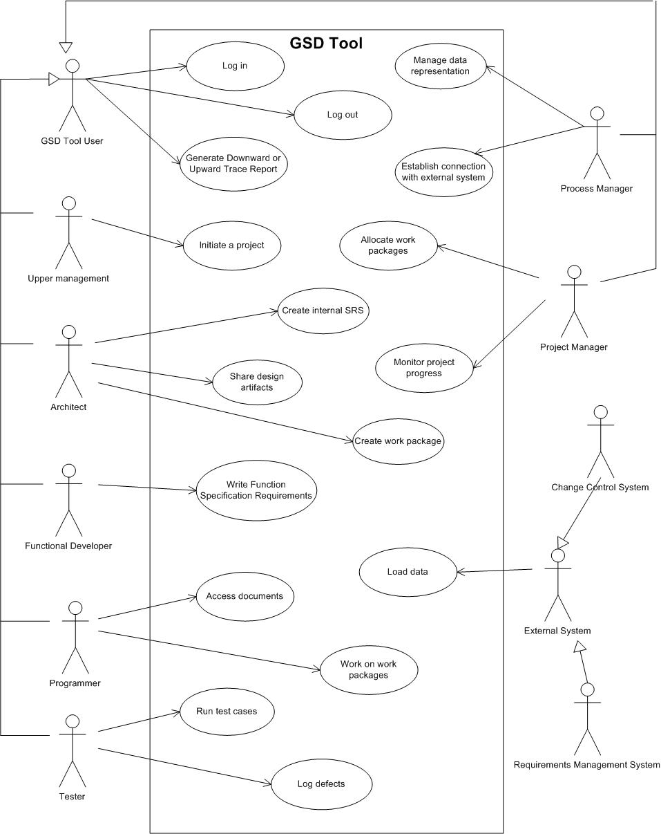
Figure 3 – High Level Use Case Diagram of the Workflow in the client’s company

High Level Use Case Diagram of GSD Tool
Following Use case diagram represents the high level use case view of our GSD tool.

Figure 5- High Level Use Case Diagram on GSD tool

Figure 5.1 - Overall use case diagram (refined)

Operating Environment
The system must operate on Windows and Linux environment. The hardware platform can be a PC based workstation or a UNIX workstation. The tool must co-exist with already installed Rational Team Concert application.

Design and Implementation Constraints
The product must be developed upon the Jazz Framework and must be delivered as a plug-in to, along with server-side components for, IBM Rational Team Concert.

User Documentation
Following are the documentation that shall be provided:
- User manual
- Scenario test cases
- Tutorials

Assumptions and Dependencies

Our assumption is that the client would have license for RTC, since our product shall be developed as a plug in to it along with the server side components. Also, the development of our GSD components depend upon the current version of the RTC which is RTC 1.0.1.1 which when updated by the vendor, might need changes to our development as well.

System Features
In this section, functional requirements are organized for the product by its system features Relevant use cases and prototypes are also provided as example where ever applicable. There are four major features/categories by which the requirements are grouped:
- Data Abstraction
- Traceability Views
- Authorization
- Import Manager
Each system feature consists of following attributes:
- System Feature Number
- System Feature Name
- Priority
- Use case
- System Feature Description
Other than the above mentioned attributes, we also rank each system feature on a scale of 1 – 5 (with one being the lowest and 5 being the highest) for each of the following parameters:

- Benefit: The benefit for the clinets and users of the product that would be achieved by implementing this system feature. A benefit with value 1 would mean, this feature provides very low or least important functional benefits to the system, and a benefit of value 5 would mean, the feature provides very important functional benefits, upon which other functionalities are probably dependent.
- Cost: The cost associated with developing each feature. A cost with value 5 would mean it is a highly resource intensive task meaning, it would take excessive number of person hours. We internally make use of a pairwise estimation technique to determine the number of hours required for a functionality/requirement.

System Feature 1: Data Abstraction
This system feature describes the requirements related to the creation of ADTDtype definitions and its instances.

Description, Use Case and Priority

System Feature Number | System Feature Name | Priority | Use Case
1. | Data Abstraction | High | UC001
Table 1 - System Feature 1

Description:
This system feature forms one of the core features of our tool. It handles creation of ADTDtype definition (ADTD), applying transformation rules (which is a nice to have feature), ability to extract data from the Jazz repository, extracting selected attributes from the Jazz data element and allowing association of a file revision to that of an existing ADTD.

Priority: HIGH
The priority of this system feature is high because it forms the core functional
module of the tool, since all other components and functionalities would depend
upon this feature.

Cost | Benefit
4 | 4
Table 2 – Cost-Benefit-Risk Analysis of System Feature 1

Stimulus/Response Sequences
- Process manager selects create new data element (ADTD)
- The GSD tool presents a create new data element screen
- Process manager selects the type of data element from the list of available Jazz element
- Process manager enters name of the new ADTD
- Process manager selects the roles to which this new ADTD would be accessible to
- Process Manager selects data source to which this ADTD should be linked to
- Having selected the source, he then selects the required process data and then the indicators from the process (indicators are the existing data elements based upon which the new ADTD would be created).
- Having linked the ADTD to a source, now the process manager can optionally, attach transformation rules to the ADTD.
  - Transformation rule to be attached could be one or more of the existing rules or a new rule can also be created.
- Having selected required rules, he applies the rule to the data element and then saves the changes.
- A new ADTD gets created, the definition of which is stored in the GSD tool, but the values of it are stored in the Jazz repository.
- The process manager may also chose to edit or delete the already existing ADTDs.
- The system shall provide the process manager with an option to modify / delete the existing ADTDs
- The process selects the required ADTD that we wishes to change or delete
- In case of modifications, the system allows the process manager to modify the ADTD and in case of deletion, the system shall allow the deletion
- The system then allows the process manager to save the changes
- The required changes are refelected in the jazz repository

Use Case Diagram
Following is the use case diagram for system feature:

Data Abstraction

Figure 5: Use Case – Data Abstraction
This use case consists of Process manager as the primary actor. Create new abstract data element is a use case explained below that inturn includes sub use cases like selecting data source (that inturn includes selecting existing process), creating transformational rules , selection transformational rules and assigning roles to the ADTDs.

Following are the sub use-cases and their description:
- Select Data Source: this use case deals with selecting an internal data source or external data source (nice to have feature), in case of ADTDs that are existing in an external system.
- Create Transformation Rule: this use case deals with the functionalities offered to the user for being able to create a transformation rule.
- Assign roles to data elements: this use case deals in assigning roles to ADTDS by the process manager to allow selected roles to be able to view selected data elements.

Use case name: | Manage data abstraction
Unique use case ID: | UC001
Primary actor(s): | Process Manager
Secondary actor(s): | NA
Brief description: | Primary actor tries to create a new ADTD type. In order to define the same, he makes use of existing data elements in the jazz repository by choosing a data source, which will be an internal source. He optionally also tries to apply some transformation rules to the newly created ADTD. Primary actor may also want to assign access to this ADTD to only a selected few roles.
Pre conditions: | - Process manager knows how to create ADTD  - GSD tool is up and running  - Jazz Server is up and running  - Predefined Jazz data types exist in the Jazz repository
Flow of events: | - Create ADTD:  The actor creates a new ADTD. The actor initializes the attributes of the data element. Attributes include name, type etc. The system provides the list of element types that includes process.  - Associate the data element with its source:  The actor associates the data element with one of the sources. If the data element is of process type then the actor chooses one of the processes and then chooses one of its indicators as the source. This implies the data element is bound to have values that the selected source provides.  If the connection for the selected source is missing, then the data element cannot be created or saved.  - Define the transformation rule for the data element:  Transformation rule is defined by the actor. Transformation rule takes input from the data source, transforms it in the defined format and gives output. The output represents the data element.  - Validate (optionally) if the abstract data representation doesn’t violate consistency of the existing Jazz repository:  The new data element is validated to check if it does not cause any inconsistency in the tool’s database. If the data element is consistent, then it is saved in the database and is ready to use.  - If the data element is causing inconsistency, the data element is removed.
Activity diagram | Refer to figure 4 below
Post conditions: | Data representation for the data elements created in the process has been validated and set-up. The tool is ready to capture the defined data.
Priority: | High
Alternative flows and exceptions: | - The intended source of the data element that is being defined is missing. This exception might happen when the established connection with the Jazz server or RTC that is the source of the data element is lost during the process.  - The data element that is being defined or modified causes an inconsistent state in the database, so it is reverted back and the data element is removed.
Non-behavioral requirements: | The representation of data elements should be robust and extendible enough to accommodate new types. (please refer to the QA document provided as a link in the appendix for further details)
Assumptions: | One data element is associated with only one source.
Issues: | How inconsistencies are recognized?  Answer – to be decided  What kinds of transformation rules should be applied?  Answer – already mentioned in this document  Can the actor combine multiple data sources under one data  element?  Answer – No.
Source: | Meeting minutes of Client meetings (dated 10/17 and 10/03).

1. Initialize attributes of the new abstract data element
2 Associate the data element with one of the source
3. Set-up a trigger that captures the data for the data element
4. Define transformation rule for the data element
5. Verify if the data element does not cause the Database inconsistency.
Alternate flow / Exception: The abstract data element discarded.
Causes inconsistency
The data element is saved
The connection is lost
The source is selected

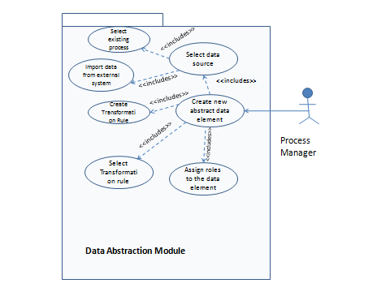

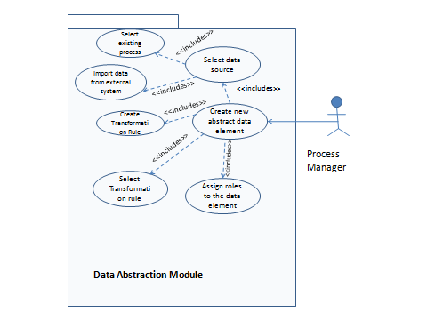

Figure 6 - Activity diagram for “Create Data Abstract Data Type Definition (UC001)

Functional Requirements

REQ-1 – Create a new ADTD

Requirement ID | REQ-1
Requirement Name | The system shall allow a process manager to define a new Abstract Data Type Definition (ADTD)
Design Level | Medium
Stability | Stable
Priority | High
Complexity | High
Risk | Medium
Type | Must Have
Dependency on other requirements | No
Requirements Dependent on this Requirement | Yes [REQ2], [REQ3], [REQ4], [REQ5], [REQ6]
Exit Criteria | The process manager is able to create and save an ADTD
Table 3 – REQ-1

Sub-Requirements: REQ-1
Sub-Requirement ID | Requirement Description
REQ-1.1 | The system shall provide the process manager with an option to create a new data element
REQ-1.2 | The system shall provide a new ‘Create Data Element’ screen when the process manager chooses the above option
REQ-1.3 | The system shall provide a place holder for the process manager to enter the name of the new ADTD
REQ-1.4 | The system shall provide the process manager an option to select the type of the data source
REQ-1.5 | The system shall provide the process manager to assign the newly create ADTD to selected roles
REQ-1.6 | The system shall provide the users to select an existing process as a data source
REQ-1.7 | The system should provide the user a list of available projects to select the data source from (under existing process)
REQ-1.8 | The system should provide the user an option to search for a required project from a given list of available projects (under existing process)
REQ-1.9 | The system shall provide user an option to select a process related to the selected project in the above step
REQ-1.10 | The system shall provide the user a list of indicators(existing data elements) to select from after having selected a process
REQ-1.11 | The system should provide the users an option to perform a search on the list of processes and indicators(existing data elements)
REQ-1.13 | The system shall provide the user with an option to save the created data element and should link it to the data source as selected by the user.
REQ-1.14 | The system shall allow the process manager to edit and delete the already create ADTDs.

REQ-2 – Provide association of externally located abstract data elements to Jazz Elements

Requirement ID | REQ-2
Requirement Name | The system should allow an abstract data element to be associated with Jazz repository’s internal data elements (e.g. work item, defect, etc.) [Note: This requirement is valid only for elements present in external systems]
Design Level | Medium
Stability | Stable
Priority | Medium
Complexity | Medium
Risk | Medium
Type | Must Have
Dependency on other requirements | Yes [REQ-1]
Dependency of other requirements on this requirement | No
Exit Criteria | The process manager is able to define an association between Abstract data element and Jazz Internal Element
Table 4 – REQ-2

Sub-Requirements: REQ-2
Sub-Requirement ID | Requirement Description
REQ-2.1 | The system shall be able to connect to the external system in which the abstract data elements to be linked to jazz elements reside
REQ-2.2 | The system shall provide the process manager with an option to select an existing abstract data element from an external system
REQ-2.3 | The system shall display the selected abstract element in a new screen.
REQ-2.4 | The system shall provide the process manager an option to select existing Jazz element from the Jazz repository
REQ-2.5 | The system shall allow the process manager to assign the newly create abstract data element to the selected Jazz element
REQ-2.6 | The system shall provide the users to save the association

REQ-3 – Provide association of ADTDs to File Revision

Requirement ID | REQ-3
Requirement Name | The system shall allow an ADTD to be associated with a file revision in the Jazz repository.
Design Level | Medium
Stability | Stable
Priority | Medium
Complexity | Medium
Risk | Medium
Type | Must Have
Dependency on other requirements | Yes [REQ-1]
Dependency of other requirements on this requirement | No
Exit Criteria | The process manager is able to define an association between ADTD and the File revision available in an Jazz configuration management system
Table 5 – REQ-3

Sub-Requirements: REQ-3
Sub-Requirement ID | Requirement Description
REQ-3.1 | The system shall be able to connect to the system in which the file revision to be linked to ADTDs reside
REQ-3.2 | The system shall provide the process manager with an option to select an existing file revision from the change management system
REQ-3.3 | The system shall be able to display the selected File Revision details
REQ-3.4 | The system shall provide the process manager an option to select existing ADTD
REQ-3.5 | The system shall allow the process manager to associate or create a link between the selected file revision and the selected ADTD
REQ-3.6 | The system shall provide the users to save this association

REQ- – Allow creation of ADTD using selected attributes of Jazz element

Requirement ID | REQ-
Requirement Name | The system shall allow selecting certain attributes of Jazz data elements to be a part of ADTD
Design Level | Medium
Stability | Stable
Priority | Medium
Complexity | Medium
Risk | Medium
Type | Must Have
Dependency on other requirements | Yes [REQ-1]
Dependency of other requirements on this requirement | No
Exit Criteria | The process manager could create an ADTD using selected attributes from the Jazz Element.
Table 6 – REQ-

Sub-Requirements: REQ-
Sub-Requirement ID | Requirement Description
REQ-.1 | [Assuming REQ 1.1 is in place] The system shall provide the user an option to select attributes of an existing Jazz element
REQ-.2 | The system shall provide the process manager with an option to associate these selected attributes to a newly created ADTD.
REQ-.3 | The system shall provide the users to save this association

REQ-5 –Create new transformation filter

Requirement ID | REQ-5
Requirement Name | The system should allow a process manager to create a new transformation filter
Design Level | Medium
Stability | Stable
Priority | Medium
Complexity | Medium
Risk | Medium
Type | Nice to Have
Dependency on other requirements | Yes [REQ-1]
Dependency of other requirements on this requirement | Yes [REQ-6]
Exit Criteria | - New Transformation filter could be created and saved
Table 7 – REQ-5

Sub-Requirements: REQ-5
Sub-Requirement ID | Requirement Description
REQ-5.1 | [Assuming REQ 1.1 is in place] The system shall provide the user an option to create a new transformation rule
REQ-5.2 | The system shall provide the user to select the type of the rules. Following are the possible types:  - Rule based on a query to extract data based on existing ADTDs and process elements  - Rules based on mathematical expression  - Rules based on ‘case’ conversion of the text (meaning upper case to lower case or lower case to upper case)
REQ-5.3 | The system shall allow the user specify the name of the transformational rule
REQ-5.4 | The system shall allow the user to save the transformation rule

REQ-6 – The transformation filter can be associated with an ADTD

Requirement ID | REQ-6
Requirement Name | The system should allow a transformation filter to be associated with an ADTD.
Design Level | Medium
Stability | Stable
Priority | Medium
Complexity | Medium
Risk | Medium
Type | Nice to Have
Dependency on other requirements | Yes [REQ-1], [REQ-5]
Dependency of other requirements on this requirement | No
Exit Criteria | - Transformation Filter could be linked to the ADTD  - The values represented by ADTD are the correct transformed values
Table 8 – REQ-6

Sub-Requirements: REQ-6
Sub-Requirement ID | Requirement Description
REQ-6.1 | [Assuming REQ 5 is in place] The system shall provide the process manager an option to select either select an existing transformation rule or create a new rule [refer to REQ-5]
REQ-6.2 | The system shall provide the process manager with an option to associate these selected attributes to a newly created ADTD.
REQ-6.3 | The system shall provide the users to save this association

System Feature 2: Traceability Definition
This system feature describes the requirements related to the traceability definition and traceability relationships between different ADTDs and traceability view definition definitions.

Description, Use Case and Priority

System Feature Number | System Feature Name | Priority | Use Case
1. | Traceability view definitions | High | UC002
Table 9 - System Feature 2

Description:
This system feature forms another core feature of our tool. It handles creation of traceability definitions and views between the above defined ADTDs, displaying the traceability view definition definitions, chaining of relationships (meaning defining traceability between two existing traceability definitions), exporting the views to a .csv file and charts as images and provides sorting and filter criteria on the elements participating in the view.
Priority: HIGH
The priority of this system feature is high because it forms another core functional
module of the tool. The main aim of the project which is to be able to represent bi-directional traceabilities between different elements is achieved through this system feature.
Cost | Benefit
5 | 5
Table 9 – Cost-Benefit-Risk Analysis of System Feature 2

Stimulus/Response Sequences

Create Traceability View Definition
- The process manager selects ‘Create Traceability View Definition’
- The system provides a new screen to the process manager for creating a new traceability definition
- Process Manager enters the name of the traceability definition
- Traceability Manager is provided with an option to select the type of traceability definition
  - Define Traceability Relationship between ADTD elements
  - Define Traceability Relationship between existing Traceabilities.
- Having selected the type, a list of ADTDs or existing traceabilities definitions is provided under Source Field and Destination Field.
- The Process Manager selects the source of the traceability definition
- He then selects the destination of the traceability definition
- The process manager then saves the traceability element definition

Display Traceability view definitions:
- The user is provided with an option view Traceability reports
- The user selects the option to view the reports
- The system provides a list of different traceability reports available to the user as per the authorization defined for his role
- The user selects a particular traceability report
- The system displays the traceability report
- The system should also allow the user to be able to click and see a list of available traceability relationships related to that element.
- The user clicks (right clicks) on a traceability definition
- The system displays a list of available traceability relationships associated with the selected one
- The user selects the required related traceability definition
- The system navigates from the current traceability view to the one the selected by the user and displays it to the user

Create Filters and Sort
- The user is provided with an option to create a filter on the displayed report
- The system filters the records based on the given filter values by the user and displays only
those records that match the filter criteria
- The system also provides the user an option to sort the records of the report based
- The user selects to sort the whole report by particular traceability element present in the report
- The system sorts the report according to the chosen sort criteria by the user

Export Reports and Charts
- The user is also provided with an option to export the report in to a CSV file
- The user selects to export the report into a CSV file
- The system asks the user for the file name
- The user enters the file name
- The system exports the contents of the report into given file name
- The user wants to export the charts and graphs of the report into image files
- The system provides the user an option to export the charts and figures into an image file (.jpg, .png , .gif or .bmp)
- The system asks the user for the file name
- User provides the file name and location
- The system saves the charts and graphs into the given filename and location

Use Case 003: Traceability view definitions

Figure 7: Traceability view definition Use Case Diagram
The above use case diagram show use case related to traceability view definition definition which has process manager and normal user as the primary actors. The use cases related to creating traceability definition, viewing traceability elements, managing and providing authorization, defining filters, generating traceability views, sorting the traceability element, exporting traceability view definitions, importing data from files are sub-uses of this use case which have been covered in the following requirements.

Use case name: | Create and View Traceability Definition
Unique use case ID: | UC002
Primary actor(s): | Process Manager
Secondary actor(s): | Normal User
Brief description: | Primary actor tries to create a new traceability definition. In order to do so, he selects existing ADTDs or existing traceabilities and selects the source and destination of the traceability definition.  The secondary actor tries to see the generated traceability view definitions. He also tries to export the report and charts to CSV file or as images. He can also perform sorting and filtering.
Pre conditions: | - Process manager knows how to create traceability definition  - GSD tool is up and running  - Jazz Server is up and running  - Predefined ADTDs and traceability definitions exist in the GSD repository
Flow of events: | - Create traceability Definition:  The actor creates a traceability definition. The actor initializes the attributes of the traceability definition. Attributes include name, type of definition etc. The system provides the list of ADTDs or list of available traceabilities already defined to the user to select as source and destination. The user saves the defined relationship.  - View Traceability View Definition:  The user (process manager or normal user) tries to view the traceability report related to his role. If this actor is not authorized to see the report, then an error message would be displayed to the user, else the required report would be shown.  - Export traceability report to CSV file and charts to Image File:  The user tries to export the data from the traceability view definition to an external report. The system accepts the location and file name and stores the file in a CSV file. Likewise it stores charts and graphs as images.  - Perform Sorting  The user tries to sort the elements of the traceability definition in ascending or descending order. The system returns the sorted records as per the sorting criteria.  - Create Filters:  The user tries to create filters using specific values of the traceability elements. The system returns the records that match the filter criteria.
Post conditions: | Traceability definition was created by the system and got stored in the Traceability Configuration repository. The tool is ready to display the traceability view definitions.
Priority: | High
Alternative flows and exceptions: | - The traceability definition that is being defined or modified causes an inconsistent state in the database, so it is reverted back and the traceability definition is removed.
Non-behavioral requirements: | The representation of traceability elements and definition of relationship between them should be robust and extendible enough to accommodate new types.
Source: | Meeting minutes of Client meetings (dated 10/17 and 10/03).

Functional Requirements

REQ-7 – Create a new traceability definition

Requirement ID | REQ-7
Requirement Name | The system shall allow a process manager to define a new Traceability Definition
Design Level | Medium
Stability | Stable
Priority | High
Complexity | High
Risk | Medium
Type | Must Have
Dependency on other requirements | Yes [REQ -1]
Dependency of other requirements on this requirement | Yes [REQ-8]
Exit Criteria | The process manager is able to create and save a new traceability definition.
Table 10 – REQ-7

Sub-Requirements: REQ-7
Sub-Requirement ID | Requirement Description
REQ-7.1 | The system shall provide the process manager with an option to create a new traceability definition
REQ-7.2 | The system shall provide a new ‘Create Traceability view definition’ screen when the process manager chooses the above option
REQ-7.3 | The system shall provide a place holder for the process manager to enter the name of the new traceability view definition
REQ-7.4 | The system shall provide the process manager an option to select the type of the traceability definition (whether between two different ADTDs or between two traceabilities)
REQ-7.5 | The system shall provide the process manager to assign the newly created traceability definition to selected roles
REQ-7.6 | The system shall provide the users an option to select an existing ADTD or traceability definition as the source and another one as the destination.
REQ-7.7 | The system shall allow the user to save the established relationship between the source element and the destination element.
REQ-7.8 | The system shall store the relationship between the source and destination in the traceability configuration repository.
REQ-7.9 | The system shall allow the authorized users to be able to share the traceability definitions

REQ-8 – Display Traceability view definitions

Requirement ID | REQ-8
Requirement Name | The system shall allow all authorized users to display the traceability view definitions related to their roles
Design Level | Medium
Stability | Stable
Priority | High
Complexity | High
Risk | Medium
Type | Must Have
Dependency on other requirements | Yes [REQ-7]
Dependency of other requirements on this requirement | No
Exit Criteria | The authorized user is able to see the selected traceability view definition.
Table 11 – REQ-8

Sub-Requirements: REQ-8
Sub-Requirement ID | Requirement Description
REQ-8.1 | The system shall provide the users an option to select display of required traceability view definitions
REQ-8.2 | The system shall provide a new ‘Display Traceability view definition’ screen
REQ-8.3 | The system shall allow the user to select a particular traceability view definition depending upon his authorization.
REQ-8.4 | They system shall open the selected view and display the values of the relationships defined in the view (this view will represent the bidirectional traceability between one of the following relationships: requirements and components, components and work packages, requirements and work packages, work packages and test cases, requirements and related requirements, requirements and design documents, customer requests and requirements, the design and code/implementation, components and the responsible people who are working or had worked on the components.)
REQ-8.5 | The system should provide the users an option to export the contents of the view to a CSV file
REQ-8.6 | The System should ask the user inputs for the file name and the location where the file has to be stored
REQ-8.7 | The system should export all selected or filtered records of the traceability view definition into the above file and store the file in the given location.
REQ-8.8 | The system should allow the users to export charts and graphical view of traceability as images
REQ-8.9 | The system should allow the users to specify the file name and the location where the image file has to be stored
REQ-8.10 | The System should allow the users to sort the displayed records in ascending or descending order
REQ-8.11 | The system should allow the user to define a filter on the displayed records
REQ-8.12 | The system should return the records that match the filter criteria defined
REQ-8.13 | The system shall allow the user to copy and paste the textual data of a traceability view definition into a local file (word, excel etc). Images cannot be copied.
REQ-8.14 | The system should display the traceability from the requirements to the related chat or discussion
REQ-8.15 | The system shall be able to represent the complex data elements that contain primitive and other complex data elements. Requirements, change requests and metrics will be modeled as complex ADTDs.

System Feature 3: Import Data
This system feature describes the requirements related to the import of data that must follow a pre-defined fixed comma separated (.csv) file format into the jazz repository.

Description, Use Case and Priority

System Feature Number | System Feature Name | Priority | Use Case
3. | Import Data | High | UC003
Table 12 - System Feature 3
Description:
This system feature describes the functionality related to the processing of external files and subsequent the data contained within them into the jazz repository. The files to be processed are bound to follow a pre-defined comma separated format (.csv format).
Priority: High
The priority of this system feature is low because it is a nice to have feature and is the smallest module to be built.
Cost | Benefit
2 | 3
Table 12 – Cost-Benefit-Risk Analysis of System Feature 3

Stimulus/Response Sequences
- The user is also provided with an option to import the contents of an external comma separated (.csv) file in to the jazz repository
- The system checks for the validity of the file as to whether it meets the required fixed format
- On validation , the contents from the valid file will be processed and uploaded to the jazz repository
- Failure of validation would discard the file and will allow the user to either select another one or cancel the operation.

Use Case 004: Import Data

Figure 7: Traceability view definition Use Case Diagram
Use case name: | Import data
Unique use case ID: | UC003
Primary actor(s): | Process Manager
Secondary actor(s): | NA
Brief description: | Primary actor tries to import the contents of a predefined file format e into the jazz repository.
Pre conditions: | - The file is available  - The file follows a fixed pre-defined format and is a comma separated file  - The GSD tool is up and running  - The Jazz server is up and running
Flow of events: | The user requests for the contents of a file to be imported to jazz repository. The tool allows the user to select the required file. The tool validates the format of the file to match the pre-condition. The contents of the valid file are then imported into the jazz repository. In case of an invalid file, the contents would be discarded and the user would have an option to reselect or cancel the operation.
Post conditions: | The contents from the specified file are available in the new jazz repository.
Priority: | High
Alternative flows and exceptions: | - The contents of the file to be imported causes an inconsistent state in the database, so it is reverted back and the file is removed from the repository.
Source: | Meeting minutes of Client meetings (dated 10/17 and 10/03).

Functional Requirements

REQ-9 – Import data into jazz repository

Requirement ID | REQ-9
Requirement Name | The system shall allow the process manager to select an option to import data from external files
Design Level | Medium
Stability | Stable
Priority | High
Complexity | Low
Risk | Low
Type | Must have
Dependency on other requirements | No
Exit Criteria | The contents from the given file could be processed and uploaded into the jazz repository.
Table 10 – REQ-9

Sub-Requirements: REQ-9
Sub-Requirement ID | Requirement Description
REQ-9.1 | The system shall provide the user with an option to be able to select ‘File Import’
REQ-9.2 | The system shall provide the user an option to specify the file path
REQ-9.3 | The system shall verify the format of the file
REQ-9.4 | The system shall store the contents of the valid file into the jazz repository
REQ-9.5 | In case of an invalid file, the system shall provide an error message with an option to reselect or cancel the operation.

System Feature 4: Authorization
This system feature describes the various authorization related requirements for different roles of the GSD user.

Description, Use Case and Priority

System Feature Number | System Feature Name | Priority | Use Case
4. | Provide Authorization | Medium | UC004
Table 13 - System Feature 4
Description:
This system feature describes the functionality related to the user authorization.
Priority: MEDIUM
The priority of this system feature is medium because it does not form the core functionality of the system to be built.
Cost | Benefit
2 | 3
Table 14 – Cost-Benefit-Risk Analysis of System Feature 4

Stimulus/Response Sequences
- The process manager defines roles for the available resources
- The process manager associates every ADTD to authorized users
- Users can access only those traceability definitions and ADTDs to which they have been given authorization. The authorized users cannot modify the displayed Traceability view definition. But for ADTDs, the process manager is allowed to do modifications to it, but the normal users are not authorized to do so.
- Non authorized users are barred from accessing requested elements or views and are notified

Use Case 004: Authorization
Figure 7: Traceability view definition Use Case Diagram
Use case name: | Provide Authorization
Unique use case ID: | UC004
Primary actor(s): | Process Manager
Secondary actor(s): | Normal Users
Brief description: | Primary actors define authorization to different roles and different elements.
Pre conditions: | - The file is available  - The file follows a fixed pre-defined format and is a comma separated file  - The GSD tool is up and running  - The Jazz server is up and running
Flow of events: | The process manager defines authorization to users for traceability view definitions and ADTDs. The users access views and elements assigned to their roles. The authorized users are presented with the required views and elements. They can only see the views and ADTDs but cannot edit it. Only process manager is allowed to provide authorization and do modifications.
Post conditions: | Authorizations for traceability view definitions and ADTDs are defined. Only authorized users get to access the views and ADTDs.
Priority: | Low
Alternative flows and exceptions: | - The non authorized users try to access the elements they are not authorized to . The system discards their requests and notifies the user with an error message.
Source: | Meeting minutes of Client meetings (dated 10/17 and 10/03).

Functional Requirements

REQ-10 – Provide authorization to roles and users

Requirement ID | REQ-10
Requirement Name | The system shall allow a process manager to assign roles to the defined users.
Design Level | Medium
Stability | Stable
Priority | Medium
Complexity | Medium
Risk | Medium
Type | Must have
Dependency on other requirements | No
Requirements dependent on this requirement | No
Exit Criteria | The authorized users can access their role based views and elements related to the views.
Table 15 – REQ-10

Sub-Requirements: REQ-10
Sub-Requirement ID | Requirement Description
REQ-10.1 | The system shall allow a process manager to define roles to the users
REQ-10.2 | The system shall allow the process manager to assign authorization to the roles for each traceability view definition, the elements associated in it and the available ADTDADTDs
REQ-10.3 | The system shall allow the user to access his role based traceability view definition
REQ-10.4 | The system shall display the selected role based view or a selected ADTD that the user is authorized to view after validating his authorization
REQ-10.5 | The system shall not allow any modifications to the displayed traceability view definition
REQ-9.7 | The system should allow an authorized user to engage elements in a selected traceability definition.
REQ-9.8 | The system shall allow sharing of ADTDs only among the authorized users.

Mapping between High level Functinal Requirements and SRS requirements
- Data Abstraction
ID | Description | Requirement ID
FR1 | The system shall allow the user to define new abstract data element or create a new data element that represents an existing data element in Jazz data repository. | REQ-1
FR2 | The system shall allow an abstract data element to be associated with Jazz repository’s internal data elements (e.g. work item, defect, etc.). | REQ-2
FR3 | The system shall allow an abstract data element to be associated with a file revision in the Jazz repository. | REQ-3
FR4 | The system shall allow selecting certain attributes of Jazz data elements to be a part of abstract data element. | REQ-4
FR5 | The system shall allow the system's data module to read data items from the Jazz repository component. | REQ–9.4
FR6 | The system should allow a transformation filter to be associated with an abstract data element. | REQ-6
- Traceability Views
ID | Description | Requirement ID
FR7 | The system shall allow the user to create a relationship between two abstract data elements. The relation is called as a traceability definition. | REQ-7
FR8 | The system shall allow the user to create a new relationship of existing two traceability definitions (chaining of relationships). | REQ-7.4
FR9 | The system shall allow an authorized user to view instances of a selected traceability definition. Instances are elements that are participating in a selected traceability. Let’s call this resulting view as traceability view. | REQ-8
FR10 | The system shall be able to represent complex data elements that contain primitive and other complex data elements. Requirements, change requests, metrics will be modeled as complex abstract data elements. | REQ-8.15
FR11 | The system shall display the traceability view visually. | REQ-8
FR12 | The system shall represent the bidirectional traceability between requirements and components, components and work packages, requirements and work packages, work packages and test cases, requirements and related requirements, requirements and design documents, customer requests and requirements, the design and code/implementation, components and the responsible people who are working or had worked on the components. | REQ-8.4
FR13 | The system shall represent the traceability from requirements to the related discussion or clarifications. | REQ-8.14
FR14 | The system shall share traceability definitions among authorized users. | REQ 7.9
FR15 | The system shall allow user to copy and paste the data of the traceability view in the table. | REQ-8.13
FR16 | The system should allow the user to define different sorting criteria in a traceability view. | REQ-8.10
FR17 | The system should allow the user to define his filter criteria in the traceability view. | REQ-8.11
FR18 | The system should allow user to export the table of the data of traceability view to CVS file. | REQ-8.5
FR19 | The system should allow user to export the graphical view of traceability to image. | REQ-8.8
- Import Data
ID | Description | Requirement ID
FR20 | The system shall import a fixed format comma separated file into Jazz repository. The mapping of fields in a CSV file to the elements in the Jazz repository is known. | REQ-9
- Authorization
ID | Description | Requirement ID
FR21 | The system shall allow a process manager to assign roles to the defined users. | REQ-10
FR22 | The system shall allow authorization on the abstract data elements in the data module. | REQ-10.2
FR23 | The system shall share abstract data definitions only with authorized users | REQ-9.8
FR24 | The system shall allow a process manager to grant read/write privileges on traceability definitions to the users. | NA
FR25 | The system may allow an authorized user to engage elements in a selected traceability definition. | REQ-9.7
Table 16 – Mapping between Functional Requirements and REQs

External Interface Requirements

User Interface for System Feature 1
UI Prototype 1
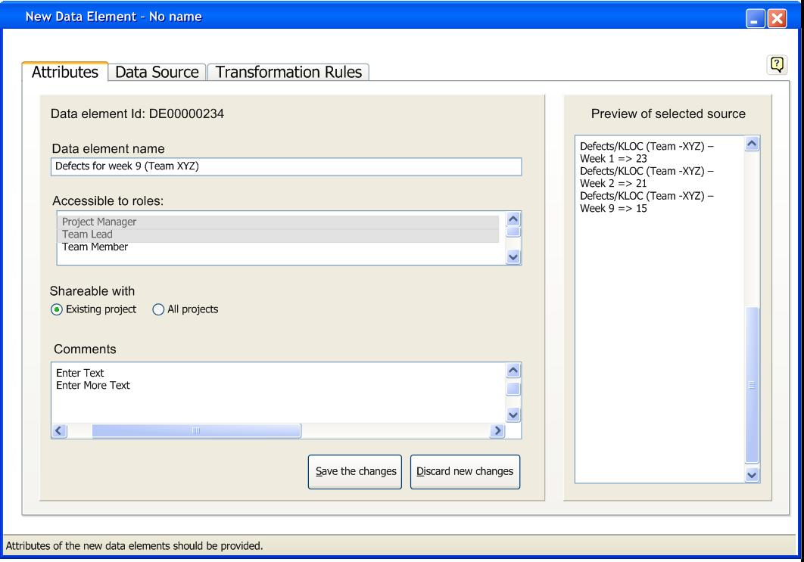
Fig.7: Attributes screen

Fig. 7 depicts the attributes of a new ADTD (ADTD) that is being created. The user must specify the name of the ADTD. User can select multiple roles which can access the data element that is being created. The ADTD (ADTD) can be shared across different projects by clicking on “All projects” option button or it could be restricted to the current project in which the data element is being created. Preview of selected source is initially empty and is loaded with the data once the user selects the data source for the new data element. User can specify the data source for the new data element by navigating to the data source tab. Selecting a data source for a new data element is mandatory and specifying transformation rules is optional.
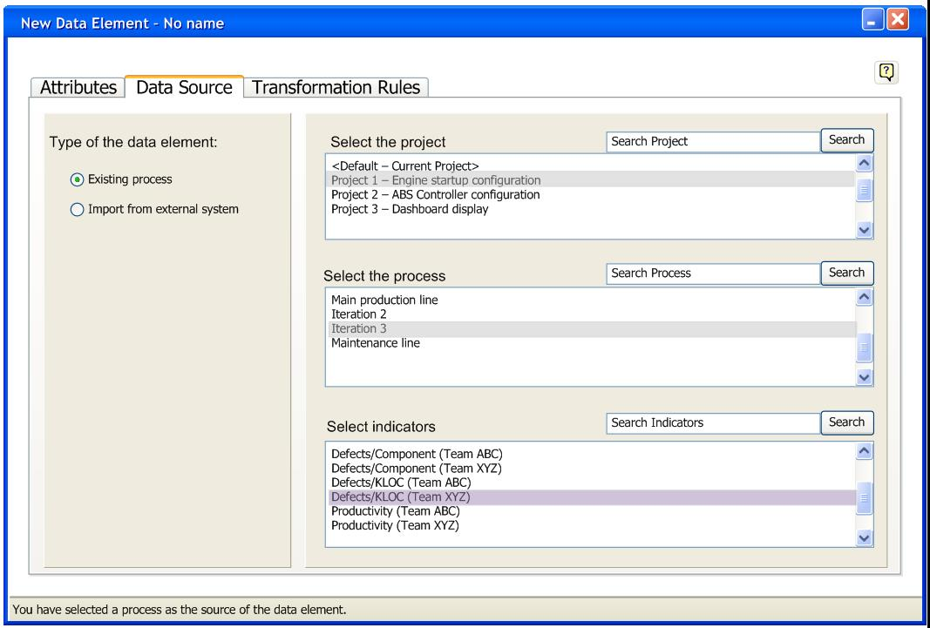
Fig.8 - Select a data source

Fig 8 depicts how the user selects a data source. In case of “Existing Process” the user has to select the project from the list box, and then the processes related to the project are listed in the process list. When the user selects the process, indicators associated with that process are listed in the indicators list. The final step is to select an indicator as a data source.

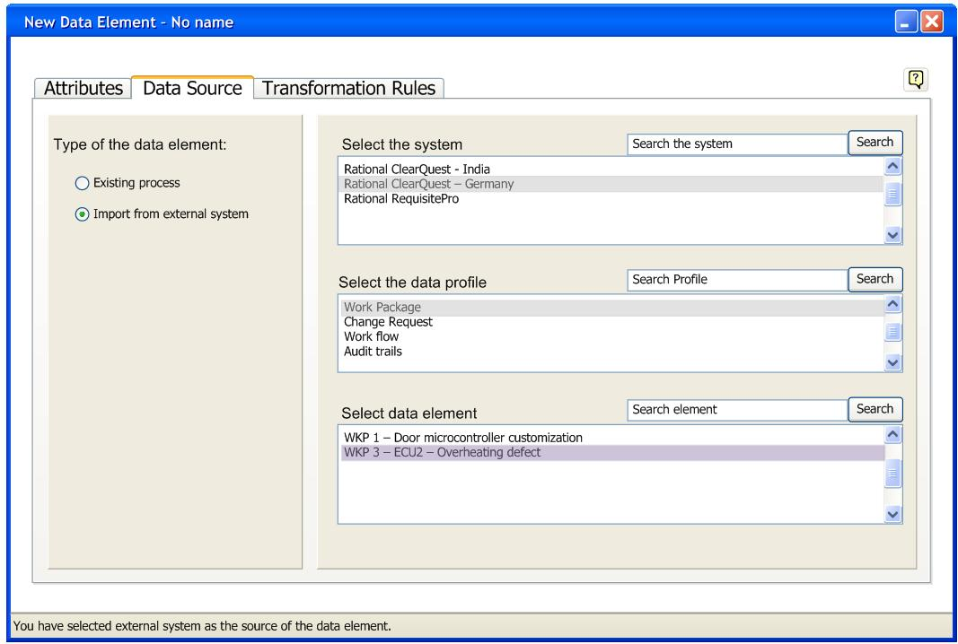
Fig.8.1: Select a data source – 2

Fig 8.1 depicts how the user selects a data source. In case of “Import from external system” the user has to select the system from the list box, and then the data profiles related to the system are listed in the data profile list. When the user selects the profile, data elements associated with that process are listed in the elements list. The final step is to select a data element as a data source.

External systems are the software systems that out GSD tool will gather data from. Every system has numerous types of data elements. Data profile is set of related data elements.

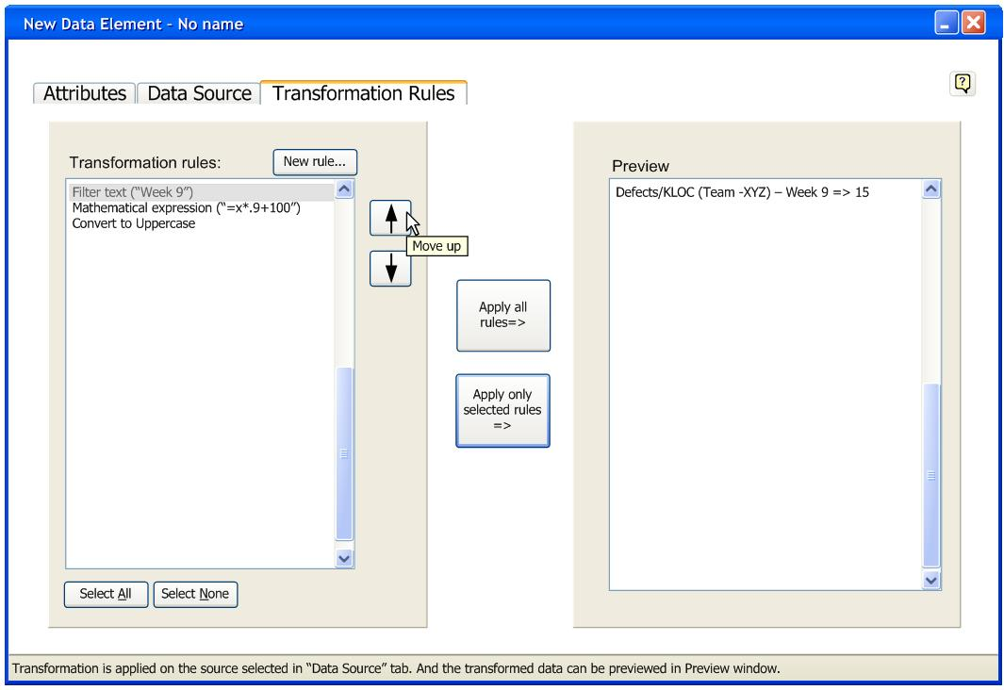
Fig.9: Transformation rules

Transformation rules the processing rules that are applied in a particular sequence on the incoming data from the selected data source. The order in which rules (only selected) are displayed in the “Transformation rules” list box determines the sequence of their application on the data. New rule can be created by clicking on the button “New rule”, which navigates to the transformation rule manager. Only selected rules are applied to the data in a displayed order. The order of rule application can be altered by moving up/down the rules in the box using the up and down buttons.

“Apply all rules” button, applies all the rules from the left hand side rules list box on the data read from the data source. After the rules are applied, the transformed data is previewed. “Apply selected rules” only applies the rules that are selected. The user can select multiple rules from the rules list box.

It is necessary that the user selects the data source, in order to preview the data. If the data source is not selected by the user, preview is not available; however, the user still could add transformation rules.

Prototype for System Feature 2
View components related to requirements

Fig.9.1: Traceability between Requirements and Components

In the Requirements View, the user can select the requirement he wants to get the components related to the chosen requirement shown in the Components view while the relationship between requirements and components is shown in Requirement and Components view located in the bottom of the interface.

The user can view the requirements that are related to the these component shown in the Component view, how much effort has been input for the requirements, and how many percentages the effort occupy by the selected component in each requirement.

The user can sort order with Requirement, Total Effort, or Percentages.
The user can single click on a specific component to view the related information of it in Component Description view.

In the Responsible Users view, all the users have been with responsibility for the components of the selected requirement are shown. The user can right-click the name of each name, and select the function he/she wants, e.g. chat with people or send the chosen people e-mail.

The user can export the data into a file for late reference. Help is provided through clicking Help button and the user can get help anywhere in the prototype.

Fig.9.2: Requirement Description

The user can view the details of the selected requirement, such as date created, date modified, what project it belongs, etc., under Requirement Description tab.

Fig.9.3: Requirements to the selected component

The user can double click a component to open another window through which the relationship between the requirements and the specific component is shown with which the user can Export the data into a file. The user can also double click the component in the tree diagram in Requirement view to complete the same task.

Fig.9.4: Help

When the user seeks help by clicking Help button, A Help window will appear with the default items which depend where the user clicks the Help button. The user can search what he wants with key words.
Fig.9.5: Error message

Searching requirement function provides to help the user find the requirement he wants in thousand of them. When the requirement the user wants can’t be found, an error message will shown up stating no record is found and reminding the user to verify his input.

Fig.9.6: Assign Responsibilities to Requirements

Assign Responsibilities to Requirements: The user can navigate to this tab to select from the list of requirements available; the ones that he wants to assign responsibilities to. In the first half of central panel, the user can do a multiple select to select the requirements, save the selection. Once the requirements are selected and saved, the responsibilities could be chosen from the lower half of the screen , can be saved, after which the Assign button gets activated and let user assign the chosen requirements to the selected responsibilities.

Fig.9.7: View components to requirements

View components to requirements: This is one of the important focus areas that we chose to design a prototype for. The user navigates to the tab for view requirements to component mapping. All the requirements related to the given project are displayed. The user can export the list to a file or choose a requirement to view the component details.

Alternative Prototype
Following prototype shows the alternatives to the above mentioned prototypes for system feature 2.

Fig.9.8: Component details

Component Details: The components belonging to a particular requirement are displayed. The list of the components can be exported to a file. The requirement details are displayed on left panel. Clicking on each component will show the component details. The relationship between different components can be viewed by navigating to Components Graph.


Require
ment
Details
Values
Requirem
ent ID
R0010
Requirem
ent Name
Check
Locking
Project ID
P0001
Date
Created
02.10.98
Date
Modified
10.10.02
Created
By
Adam
Smith
…
…
…
.
…
Require
ment
Details
Values
Requirem
ent ID
R0010
Requirem
ent Name
Check
Locking
Project ID
P0001
Date
Created
02.10.98
Date
Modified
10.10.02
Created
By
Adam
Smith
…
…
…
.
…
Component Details
Related
Requirements
Component Details: View components mapped to requirements (
Yellow
color
indicates the current tab selection )
Componen
ts ID
Componen
ts Name
Efforts in %
Date
Created
Date
Modified
Created By
…
Bearing
…
..
..
..
…
Componen
ts ID
Componen
ts Name
Efforts in %
Date
Created
Date
Modified
Created By
…
Bearing
…
..
..
..
…
Search Criteria can be
entered in the first row
Export to file
Export to file
Cancel
Cancel
Components Graph
Help
Help
No Records Found for Components Name = Bearing
No Records Found for Components Name = Bearing
Fig.9.9: Warning message
A Warning message is displayed when the user search criteria does not return any records.

Fig.9.7: Component graph

Component Graph: navigating to this tab show the graphical view of how components are related to each other. For instance, we can see that component C0002 is related to C3011 which is related to C3201.

Fig.9.10: Help
The help button shows the help related to the navigation tab currently being displayed.

Quality Attribute Requirements
Our Quality Attribute requirements have been documented under the following link:

https://msesrv4a-vm.scs.ad.cs.cmu.edu:8443/svn/GSD/trunk/QAW/TheJazzRockers-QA%20Scenarios.docx

Appendix

High Level Functional Requirements
Following is the link to our high level functional requirements.
https://msesrv4a-vm.scs.ad.cs.cmu.edu:8443/svn/GSD/trunk/GSD%20Architecture/High%20Level%20Functional%20Requirement-nanli.docx

Appendix A: Glossary
Serial # | Abbreviation | Meaning
1. | ADTD | ADTD
2. | SRS | Software requirement Specification
3. | GSD | Global Software Development Tool
4. | MSE | Masters in Software Engineering
5. | CSV | Comma separated values
7. | Client | Representatives; Marcelo Cataldo and Charles Shelton
8. | SAD | Software Architecture Document
9. | SDD | System Design Document
10 | ADTD | Abstract Data Type Defintion

References
- Use Cases document
https://msesrv4avm.scs.ad.cs.cmu.edu:8443/svn/GSD/trunk/Requirements/Jazz%20Rockers%20Use%20Cases%20%20v2.0.docx
- SOW
https://msesrv4avm.scs.ad.cs.cmu.edu:8443/svn/GSD/trunk/SOW/The%20Jazz%20Rockers%20SOW%20v1.5.docx
- Quality Attribute Document
https://msesrv4avm.scs.ad.cs.cmu.edu:8443/svn/GSD/trunk/QAW/Jazz%20Rockers%20QA%20Scenarios.docx
- Prototypes documents
https://msesrv4avm.scs.ad.cs.cmu.edu:8443/svn/GSD/trunk/Requirements/Jazz%20Rockers%20Prototype.docx

