|  |
| --- |
|  |

|  |
| --- |
| **Architecture Driver Specification** |
| Human Resource Management |
|  |
| Define architectural drivers and the development strategy for HRM system. The document was written follow the online template for architectural drivers specification |
|  |
| **HRM Team** |
| **11/3/2011** |
|  |

Contents

1.1 Purpose 3

1.2 Definition and Acronyms 3

4.1 Use case Modeling 4

4.1.1 Use case Level 1 4

4.1.2 Use case Level 2 6

5.1 Quality Attribute List 7

5.2 Quality Attribute Scenario 8

*Key Quality Attributes* 8

6.1 Technical Constraints 8

6.2 Business Constraints 8

7.1 Priority Scale 9

7.2 Difficulty Ranking Scale 9

7.3 Functional Requirement 9

7.4 Quality Attribute Scenarios 10

7.5 Technical Constraint 10

7.6 Minimal Acceptable Delivery 10

**Revision History**

|  |  |  |  |
| --- | --- | --- | --- |
| Date | Version | Author | Description |
| 11/4/2011 | 1.0 | Tường Nguyễn | Update use case, technical constraint, project overview and quality attributes |
| 11/7/2011 | 1.0.1 | Tân Trần | Update quality attribute description and scenarios for performance |
| 11/7/2011 | 1.0.2 | Tân Trần | Update scenarios for modifiability |
| 11/8/2011 | 1.0.3 | Tường Nguyễn | Update use case |
| 11/8/2011 | 1.0.4 | Tân Trần | Update scenarios for usability and availability |
| 11/9/2011 | 1.0.5 | Tường Nguyễn | Update use case diagram, use case description |
| 11/22/2011 | 1.0.6 | Tường Nguyễn | Update Function Priority, QA Priority, Technical Constraints |
| 11/25/2011 | 1.0.7 | Tường Nguyễn | Update Scenario of Performance, Availability |
| 11/29/2011 | 1.0.8 | Tân Trần | Update Scenario of Scalability, Security |

1. Introduction

# 1.1 Purpose

The function of Human Resources departments is generally administrative and common to all organizations. Organizations may have formalized selection, evaluation, and payroll processes. The HR function consists of tracking existing employee data which traditionally includes personal histories, skills, capabilities, accomplishments and salary. To reduce the manual workload of these administrative activities, Van Lang University began to electronically automate many of these processes by introducing specialized Human Resource Management Systems.

# 1.2 Definition and Acronyms

|  |  |
| --- | --- |
| **Name** | **Description** |
| HRM | Human Resource Management |
| HRM Staff | The employee who is working in Human Resource Department |
| VLU | Van Lang University |
|  |  |
|  |  |
|  |  |
|  |  |

2. Project Overview

HRM is particularly developed for human resource management in university / colleges. The system consists of key modules:

* Personal information management
* Employee labor contract management
* Recruitment & training processing
* Payroll
* Administration panel - Utilities

3. Architecture Driver Overview

The architectural drivers presented in this document include:

* **Functional Requirements:** These requirements are presented in the form of specifications and use cases.
* **Quality Attribute Requirements:** These requirements are presented in the form of quality attribute scenarios.
* **Business Constraints:** They include schedule, cost, and procedural demands that will impact how the system is designed or implemented
* **Technical Constraints**: they specify that a particular product, tool, language, OS, platform, network, protocol, algorithm, and so forth must be used in the system.

These architectural drivers will influence the architectural design and implementation of the project. Additionally, they will impact the schedule and quality of the project. As a whole these architectural drivers define the scope of the project.

4. Functional Requirement

# 4.1 Use case Modeling

# 4.1.1 Use case Level 1

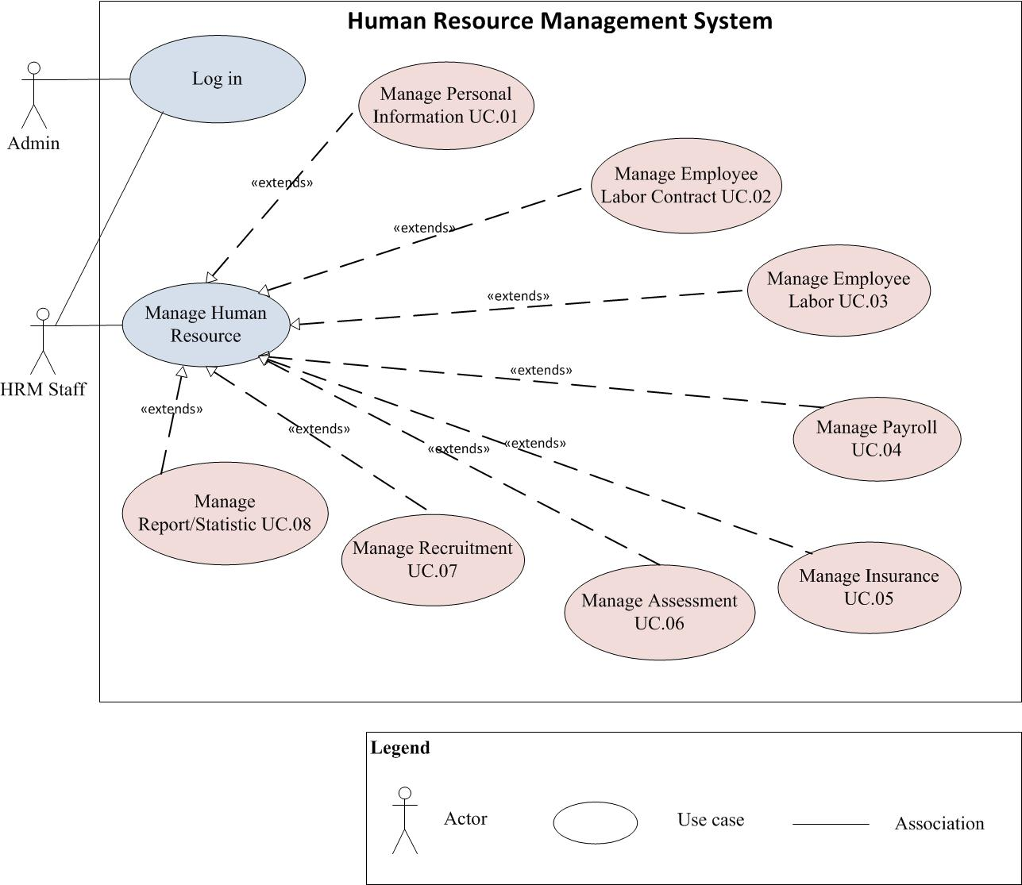

*Figure 1: Use case diagram Level 1 for HRM System*

|  |  |  |  |
| --- | --- | --- | --- |
| **ID** | **Use Case** | **Description** | **Actor** |
| UC.01 | Manage Personal Information | Manage the personal information of all staff in Van Lang university, including employees’ ID number, date of birth, place of birth, gender, number of insurance, address, telephone, current accommodation, working department, title, job title.... | HRM Staff |
| UC.02 | Manage Employee Labor Contract | Detailed management about the contracts between the employees and employers: probation contracts, job training, the time limited and unlimited official contracts. In addition, the management is included keeping track of renewal contract and storing profiles when employees quit working or suspend the contract. | HRM Staff |
| UC.03 | Manage Employee Labor | * Manage the kind of labor * Manage the checking in of staff * Manage the checking in of lecture * Manage the status of the staff and lecture. |  |
| UC.04 | Manage Payroll | The input figures for the salaries such as the minimum wage, payment for further study, long - term training, payment for working overtime, the figures of salary adjustments based on the results and how to emulate the monthly salary as required. Modules also provide the output:   * Table of income apart from salary * General report on payment of wages * Report on salary increase plan (quarterly and monthly) |  |
| UC.05 | Manage Insurance | * Manage the Health Insurance * Manage the increasing/decreasing the labor * Support for tracking the interest of the labor that take part in Health Insurance |  |
| UC.06 | Manage Assessment | * Manage the emulation assessment process * Manage the result of emulation after assessing. |  |
| UC.07 | Manage Recruitment | * Detailed management about applicants’ profiles * Keeping track of detailed information on the job interviews * When applicants are chosen, the records will be automatically updated to official profiles of the staff * Planning and monitoring the training plan implementation of the whole staff. * Keeping track of the training, and the cost for training implementation. * Keeping track of the advanced training cost and payment for each member in the teaching staff. |  |
| UC.08 | Manage Report/Statistic | * Report and statistic the quantities, status of operation of Van Lang university annual |  |

# 4.1.2 Use case Level 2

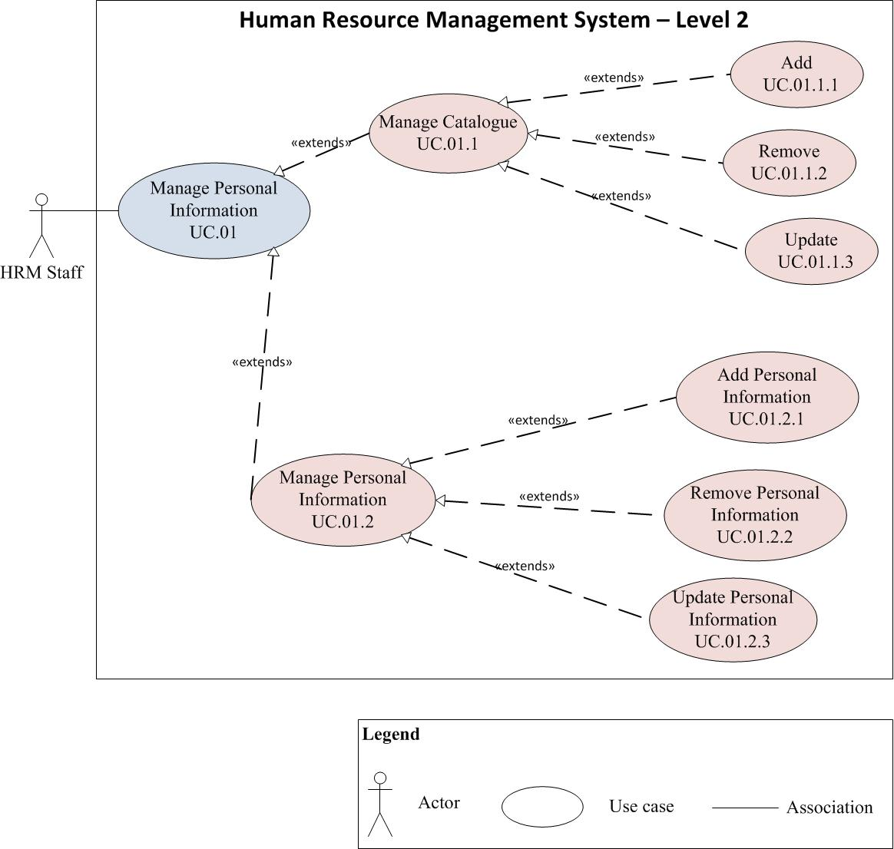

*Figure 2: Use case diagram Level 2 for HRM System*

|  |  |  |  |
| --- | --- | --- | --- |
| **ID** | **Use Case** | **Description** | **Actor** |
| UC.01.1 | Manage Catalogue | Allow the HRM staff to add/remove/update the catalogue | HRM Staff |
| UC.01.2 | Manage Personal Information | Manage the personal information of all staff in Van Lang university, including employees’ ID number, date of birth, place of birth, gender, number of insurance, address, telephone, current accommodation, working department, title, job title.... | HRM Staff |

# 4.1.2 Use case Level 3

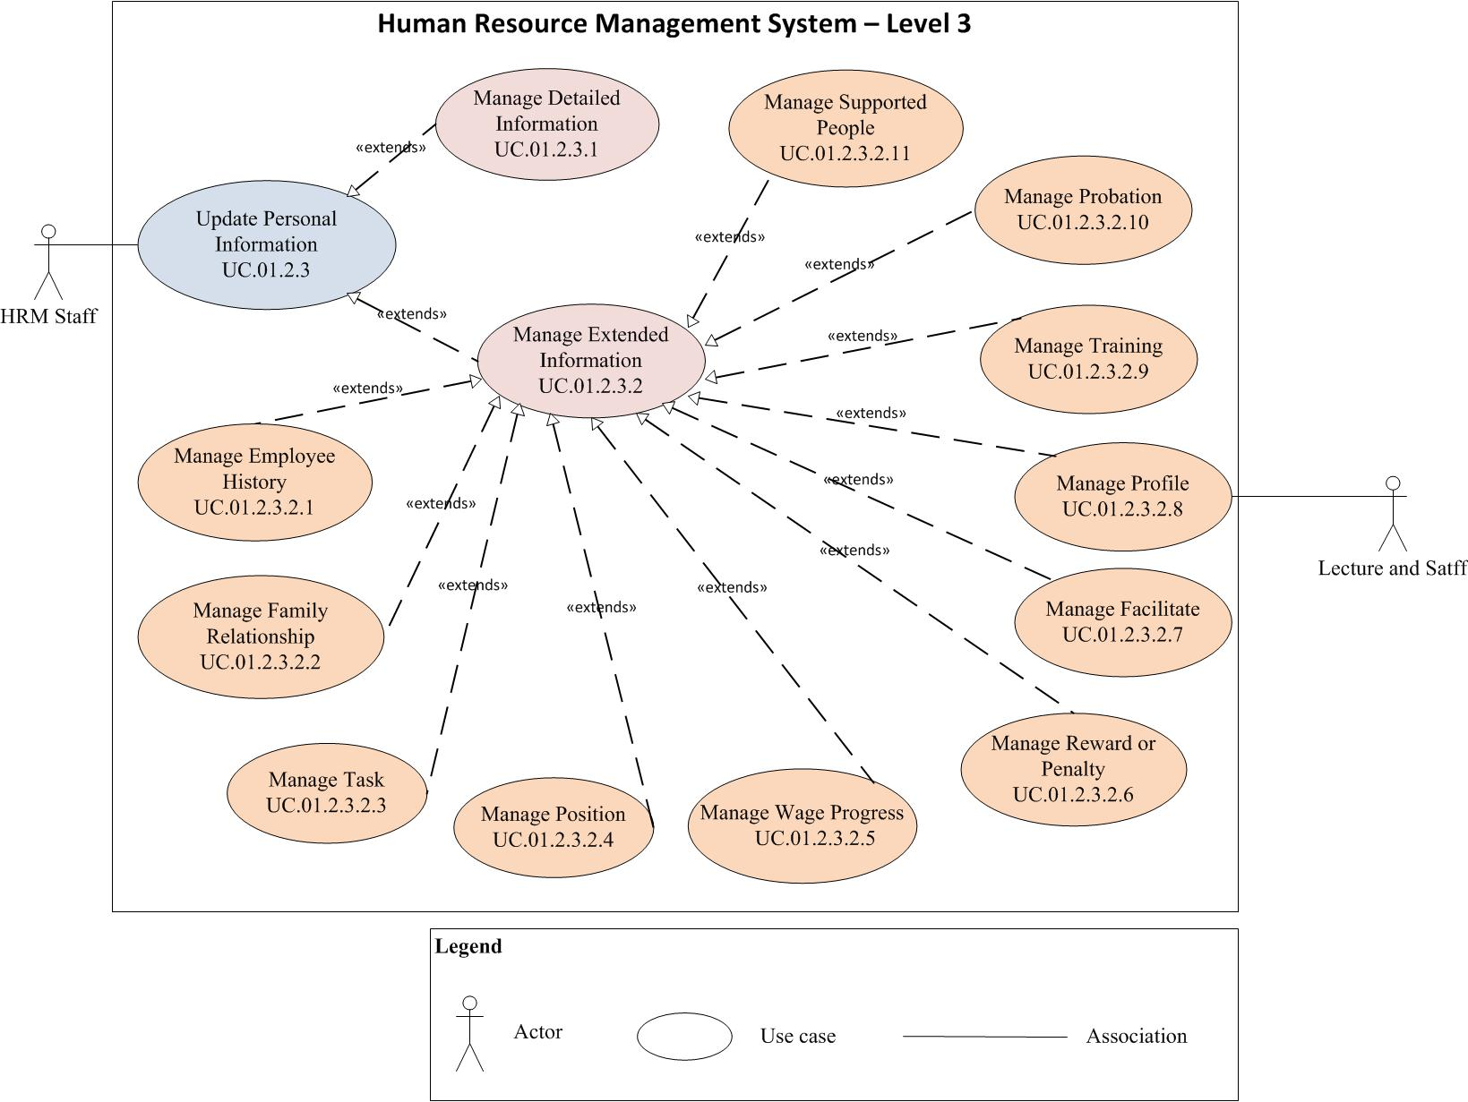

*Figure 3: Use case diagram Level 3 for HRM System*

|  |  |  |
| --- | --- | --- |
| **Use case title:** Manage Employee History | | **Use case ID: UC.01.2.2.1** |
| **General use case description:** Allow the HRM staff to record the information of this staff before working in Van Lang University. | | |
| **Entities involved:** HRM staff | | |
| **Preconditions:** The HRM staff log in the system successfully, choose the “Personal Information Management” and choose the staff that need to be updated the information | | |
| **Primary use case flow of events:** | | |
| 1 | The HRM staff choose the “Manage Employee History” function | |
| 2 | The HRM staff chooses the parts that need to be updated by inputting the new information | |
| 3 | Choosing the “Save” button | |
| 4 | Exiting “Manage Employee History” interface and return the main page. | |
| **Primary use case post conditions:** The new information of employee will be updated | | |

|  |  |  |
| --- | --- | --- |
| **Use case title:** Manage Family Relationship | | **Use case ID: UC.01.2.2.2** |
| **General use case description:** Allow the HRM staff to record the family relationship of staff | | |
| **Entities involved:** HRM staff | | |
| **Preconditions:** The HRM staff log in the system successfully, choose the “Personal Information Management” and choose the staff that need to be updated the information | | |
| **Primary use case flow of events:** | | |
| 1 | The HRM staff choose the “Manage Family Relationship” function | |
| 2 | The HRM staff chooses the parts that need to be updated by inputting the new information | |
| 3 | Choosing the “Save” button | |
| 4 | Exiting “Manage Family Relationship” interface and return the main page. | |
| **Primary use case post conditions:** The new information of employee will be updated | | |

|  |  |  |
| --- | --- | --- |
| **Use case title:** Manage Task | | **Use case ID: UC.01.2.2.3** |
| **General use case description:** Allow the HRM staff to record the information about the process of work this staff at the working place. | | |
| **Entities involved:** HRM staff | | |
| **Preconditions:** The HRM staff log in the system successfully, choose the “Personal Information Management” and choose the staff that need to be updated the information | | |
| **Primary use case flow of events:** | | |
| 1 | The HRM staff choose the “Manage Task” function | |
| 2 | The HRM staff chooses the parts that need to be updated by inputting the new information | |
| 3 | Choosing the “Save” button | |
| 4 | Exiting “Manage Task” interface and return the main page. | |
| **Primary use case post conditions:** The new information of employee will be updated | | |

|  |  |  |
| --- | --- | --- |
| **Use case title:** Manage Position | | **Use case ID: UC.01.2.2.4** |
| **General use case description:** Allow the HRM staff to keep track of changing in the position and academic title of the staff | | |
| **Entities involved:** HRM staff | | |
| **Preconditions:** The HRM staff log in the system successfully, choose the “Personal Information Management” and choose the staff that need to be updated the information | | |
| **Primary use case flow of events:** | | |
| 1 | The HRM staff choose the “Manage Position” function | |
| 2 | The HRM staff chooses the parts that need to be updated by inputting the new information | |
| 3 | Choosing the “Save” button | |
| 4 | Exiting “Manage Position” interface and return the main page. | |
| **Primary use case post conditions:** The new information of employee will be updated | | |

|  |  |  |
| --- | --- | --- |
| **Use case title:** Manage Wage Progress | | **Use case ID: UC.01.2.2.5** |
| **General use case description:** Allow the HRM staff to keep track of changing in wage of the staff at the Van Lang University | | |
| **Entities involved:** HRM staff | | |
| **Preconditions:** The HRM staff log in the system successfully, choose the “Personal Information Management” and choose the staff that need to be updated the information | | |
| **Primary use case flow of events:** | | |
| 1 | The HRM staff choose the “Manage Wage Progress” function | |
| 2 | The HRM staff chooses the parts that need to be updated by inputting the new information | |
| 3 | Choosing the “Save” button | |
| 4 | Exiting “Manage Wage Progress” interface and return the main page. | |
| **Primary use case post conditions:** The new information of employee will be updated | | |

|  |  |  |
| --- | --- | --- |
| **Use case title:** Manage Reward or Penalty | | **Use case ID: UC.01.2.2.6** |
| **General use case description:** Allow the HRM staff to record the process of reward or penalty of the staff | | |
| **Entities involved:** HRM staff | | |
| **Preconditions:** The HRM staff log in the system successfully, choose the “Personal Information Management” and choose the staff that need to be updated the information | | |
| **Primary use case flow of events:** | | |
| 1 | The HRM staff choose the “Manage Reward or Penalty” function | |
| 2 | The HRM staff chooses the parts that need to be updated by inputting the new information | |
| 3 | Choosing the “Save” button | |
| 4 | Exiting “Manage Reward or Penalty” interface and return the main page. | |
| **Primary use case post conditions:** The new information of employee will be updated | | |

|  |  |  |
| --- | --- | --- |
| **Use case title:** Manage Facilitate | | **Use case ID: UC.01.2.2.7** |
| **General use case description:** Allow the HRM staff to record the providing the facilitates for the staff | | |
| **Entities involved:** HRM staff | | |
| **Preconditions:** The HRM staff log in the system successfully, choose the “Personal Information Management” and choose the staff that need to be updated the information | | |
| **Primary use case flow of events:** | | |
| 1 | The HRM staff choose the “Manage Facilitate ” function | |
| 2 | The HRM staff chooses the parts that need to be updated by inputting the new information | |
| 3 | Choosing the “Save” button | |
| 4 | Exiting “Manage Facilitate ” interface and return the main page. | |
| **Primary use case post conditions:** The new information of employee will be updated | | |

|  |  |
| --- | --- |
| **Use case title:** Manage Profile | **Use case ID: UC.01.2.2.8** |
| **General use case description:** Allow the HRM staff to record the updating about the change in profile of the staff | |
| **Entities involved:** HRM staff | |
| **Preconditions:** The HRM staff log in the system successfully, choose the “Personal Information Management” and choose the staff that need to be updated the information | |
| **Primary use case flow of events:** | |
| C:\Users\KIM TUONG\Downloads\Architecture for HRM\UC - Profile.jpg | |
| **Primary use case post conditions:** The new information of employee will be updated | |

|  |  |
| --- | --- |
| **Use case title:** Manage Training | **Use case ID: UC.01.2.2.9** |
| **General use case description:** Allow the HRM staff to record the information that related to the course, result of training… | |
| **Entities involved:** HRM staff | |
| **Preconditions:** The HRM staff log in the system successfully, choose the “Personal Information Management” and choose the staff that need to be updated the information | |
| **Primary use case flow of events:** | |
| C:\Users\KIM TUONG\Downloads\Architecture for HRM\UC - Dao tao.jpg | |
| **Primary use case post conditions:** The new information of employee will be updated | |

|  |  |  |
| --- | --- | --- |
| **Use case title:** Manage Probation | | **Use case ID: UC.01.2.2.10** |
| **General use case description:** Allow the HRM staff to keep track of probation process of the staff | | |
| **Entities involved:** HRM staff | | |
| **Preconditions:** The HRM staff log in the system successfully, choose the “Personal Information Management” and choose the staff that need to be updated the information | | |
| **Primary use case flow of events:** | | |
| 1 | The HRM staff choose the “Manage Probation” function | |
| 2 | The HRM staff chooses the parts that need to be updated by inputting the new information | |
| 3 | Choosing the “Save” button | |
| 4 | Exiting “Manage Probation” interface and return the main page. | |
| **Primary use case post conditions:** The new information of employee will be updated | | |

|  |  |  |
| --- | --- | --- |
| **Use case title:** Manage Supported People | | **Use case ID: UC.01.2.2.11** |
| **General use case description:** Allow the HRM staff to record the number of supported people, for the purpose of the family allowances. | | |
| **Entities involved:** HRM staff | | |
| **Preconditions:** The HRM staff log in the system successfully, choose the “Personal Information Management” and choose the staff that need to be updated the information | | |
| **Primary use case flow of events:** | | |
| 1 | The HRM staff choose the “Manage Supported People” function | |
| 2 | The HRM staff chooses the parts that need to be updated by inputting the new information | |
| 3 | Choosing the “Save” button | |
| 4 | Exiting “Manage Supported People” interface and return the main page. | |
| **Primary use case post conditions:** The new information of employee will be updated | | |

5. Quality Attribute Requirements

# 5.1 Quality Attribute List

|  |  |  |  |
| --- | --- | --- | --- |
| **System quality attributes** | | | |
| **ID** | **Quality attributes** | **Description** | **View** |
| QA.01 | **PERFORMANCE** | -The time for staring the HRM system is fast.  -The response time of HRM system for each user interaction will be improved and the resource for each interaction will be reduced. | Stakeholder |
| QA.02 | **SECURITY** | -The HRM system will run safety. It cannot be accessed by unauthorized users, support detect the attacks and recover from the attack.  -The data of human resources in Van Lang University will be protected from attacker. | Technical |
| QA.03 | **USABILITY** | -The HRM system have the consistent screens and easy to uses. It does not take time for training.  -The HRM system provide adequate user document including help, user manual and tutorials for user guidance | Stakeholder |
| QA.04 | **SCALABILITY** | -The current system is just for about 10 users but it requires the system can expand more to 30- 40 users at a time. | Stakeholder |
| QA.05 | **MODIFIABILITY** | -The HRM system supports the developers or maintainer can easy add new function or modify the current function whenever the business rules are change. The first release of HRM system just focuses on “Personal Information Management”. However, there will be more modules, which will be added to system in next release. | Technical |
| QA.06 | **AVAILABILITY** | -The HRM will have periodically backup of database to ensure that whenever the database server is crashed, the data will not be lost. | Technical |

# 5.2 Quality Attribute Scenario

## *Key Quality Attributes- Performance*

|  |  |  |  |
| --- | --- | --- | --- |
| **Title of scenario:**  **Ability to handle many user interactions when they modify the “Personal Information”** | | **ID: QA.01** | **Version: 1.1** |
| **Last Changed: 11/25/2011** |
| **Quality attribute:** Performance | | **Characterization ID:** QAS.01 | |
| **Describe stakeholder role proposing the description:** The HRM staffs, Architect | | | |
| Source(s) of the stimulus | The HRM staffs who responsible for modifying the “Personal Information” | | |
| Stimulus | Updating or Modifying the “Personal Information” in both detailed and extended information. | | |
| Relevant environmental conditions | The HRM system is in normal mode.  The number of user transactions is 10. | | |
| Architectural elements | The HRM system | | |
| System response | The HRM system process all transaction:   * Update the new information to database * Log the transaction. | | |
| Response measure(s) | The response time for each transaction is about 2-4 seconds. | | |

|  |  |  |  |
| --- | --- | --- | --- |
| **Title of scenario:**  **The performance when the user use browser to access for modify the “Personal Information”** | | **ID: QA.01** | **Version: 1.1** |
| **Last Changed: 11/25/2011** |
| **Quality attribute:** Performance | | **Characterization ID:** QAS.02 | |
| **Describe stakeholder role proposing the description:** The HRM staffs, Architect | | | |
| Source(s) of the stimulus | - The HRM staffs who want to modify personal information (detail and extend) at somewhere (not at VLU) by using browser through Internet to access HRM system  - The Lectures who want to update “Profile Management” (in extended information) at somewhere (not at VLU) by using browser through Internet to update the topic, article, or curriculum… | | |
| Stimulus | Updating or Modifying the “Personal Information” in both detailed and extended information. | | |
| Relevant environmental conditions | The HRM system is in normal mode. | | |
| Architectural elements | The HRM system. | | |
| System response | The HRM system process all transaction:   * Update the new information to database * Log the transaction. | | |
| Response measure(s) | The response time for showing is about 2 seconds. | | |

|  |  |  |  |
| --- | --- | --- | --- |
| **Title of scenario:**  **The performance when the HRM staffs want to import the data (decision) to save in HRM system.** | | **ID: QA.01** | **Version: 1.1** |
| **Last Changed: 11/25/2011** |
| **Quality attribute:** Performance | | **Characterization ID:** QAS.03 | |
| **Describe stakeholder role proposing the description:** The HRM staffs, Architect | | | |
| Source(s) of the stimulus | The HRM staffs | | |
| Stimulus | The HRM staffs want to import the data, the decisions into database of HRM system | | |
| Relevant environmental conditions | The HRM system is in normal mode. | | |
| Architectural elements | The HRM system | | |
| System response | All of data and decision are imported into database of HRM system. | | |
| Response measure(s) | The response time for importing data is about 5 seconds for 500 rows and 20 columns. | | |

## *Key Quality Attributes- Modifiability*

|  |  |  |  |
| --- | --- | --- | --- |
| **Title of scenario:**  **Ability to add new functionalities/modules such as recruitment, insurance… modules** | | **ID: QA.05** | **Version: 1.0** |
| **Last Changed: 11/7/2011** |
| **Quality attribute:** Modifiability | | **Characterization ID:** QAS.04 | |
| **Describe stakeholder role proposing the description:** Architect | | | |
| Source(s) of the stimulus | The developer, end-users | | |
| Stimulus | The first release of HRM project is focusing on Personal Information Management module. But in next release the user wish to   * Add new functionalities/modules including recruitment, insurance, labor contract, payroll, assessment management, reward and penalty management, labor management modules | | |
| Relevant environmental conditions | The HRM system is in build time | | |
| Architectural elements | The HRM system client and server side | | |
| System response | -Locates places in architecture to be modified.   * The UI component on client side * The services and business flow on server side.   -Makes modification without affecting other functionality  -Tests modification  -Deploys modification | | |
| Response measure(s) | The time for adding: 2-3 days  The resource for adding: 2 resources (one for integration and the other for testing and deploy) | | |

|  |  |  |  |
| --- | --- | --- | --- |
| **Title of scenario:**  **Ability to modify the user interface (UI)** | | **ID: QA.05** | **Version: 1.0** |
| **Last Changed: 11/7/2011** |
| **Quality attribute:** Modifiability | | **Characterization ID:** QAS.05 | |
| **Describe stakeholder role proposing the description:** Architect | | | |
| Source(s) of the stimulus | The developer, end-users | | |
| Stimulus | Modifying the user interface includes the screen layout, text, GUI images… | | |
| Relevant environmental conditions | The HRM system is in build time | | |
| Architectural elements | The HRM system client side | | |
| System response | -Locates UI part for modification  -Makes modification without affecting the functionality in other tiers  -Test the modification. | | |
| Response measure(s) | The time for modifying: 1-2 days (depend on the size of modification)  The resource for adding: 1 resources (one for modifying and the other for testing and deploy) | | |

|  |  |  |  |
| --- | --- | --- | --- |
| **Title of scenario:**  **Ability to modify the client from using Silverlight to Windows Form (WPF)** | | **ID: QA.05** | **Version: 1.0** |
| **Last Changed: 11/7/2011** |
| **Quality attribute:** Modifiability | | **Characterization ID:** QAS.06 | |
| **Describe stakeholder role proposing the description:** Architect | | | |
| Source(s) of the stimulus | The developer, end-users | | |
| Stimulus | Wish to modify the client side from using Silverlight (web browser application) to windows form application (WPF) | | |
| Relevant environmental conditions | The HRM system is in build time | | |
| Architectural elements | The HRM system client | | |
| System response | -Locates part for modification   * The View and Model component   -Makes modification without affecting the functionality in other tiers  -Tests UI | | |
| Response measure(s) | The time for modifying: 5-7 days  The resource for adding: 2 resources (one for modifying and the other for testing and deploy) | | |

## *Key Quality Attributes- Usability*

|  |  |  |  |
| --- | --- | --- | --- |
| **Title of scenario:**  **Ability to make user feel comfortable** | | **ID: QA.03** | **Version: 1.0** |
| **Last Changed: 11/8/2011** |
| **Quality attribute:** Usability | | **Characterization ID:** QAS.07 | |
| **Describe stakeholder role proposing the description:** Architect | | | |
| Source(s) of the stimulus | The end-users | | |
| Stimulus | Want to feel comfortable and easy to use with the UI | | |
| Relevant environmental conditions | The HRM system is in run time | | |
| Architectural elements | The HRM system user interface | | |
| System response | * The personal information is group into different category so that it will be easier to find the information. * HRM support the help and tutorial for user guidance. * HRM system supports to show multiple views. | | |
| Response measure(s) |  | | |

|  |  |  |  |
| --- | --- | --- | --- |
| **Title of scenario:**  **Ability to make user feel comfortable** | | **ID: QA.03** | **Version: 1.0** |
| **Last Changed: 11/8/2011** |
| **Quality attribute:** Usability | | **Characterization ID:** QAS.08 | |
| **Describe stakeholder role proposing the description:** Architect | | | |
| Source(s) of the stimulus | The end-users | | |
| Stimulus | Want to minimize the impact of the error | | |
| Relevant environmental conditions | The HRM system is in run time | | |
| Architectural elements | The HRM system user interface | | |
| System response | * The error message will be shown when the error occur and direct the way to fix the problem to user * User can cancel the operation when the errors occur. | | |
| Response measure(s) | Cancellation takes less than 2 seconds | | |

## *Key Quality Attributes- Availability*

|  |  |  |  |
| --- | --- | --- | --- |
| **Title of scenario:**  **Ability for working when the server crashes** | | **ID: QA.07** | **Version: 1.1** |
| **Last Changed: 11/25/2011** |
| **Quality attribute:** Availability | | **Characterization ID:** QAS.09 | |
| **Describe stakeholder role proposing the description:** Architect | | | |
| Source(s) of the stimulus | The HRM database server | | |
| Stimulus | Before crashing about 60 minutes, the server will warn and ask the user what data need to be backup to be able to work at home. | | |
| Relevant environmental conditions | The HRM system is in normal mode | | |
| Architectural elements | The HRM database | | |
| System response | The system will back up the data that the user request | | |
| Response measure(s) | Database connection timeout: 60 seconds  The time for automatically backup depends on size of data  Time for preparing the server: 1 hour | | |

## *Key Quality Attributes- Scalability*

|  |  |  |  |
| --- | --- | --- | --- |
| **Title of scenario:**  **Ability to run on multi database** | | **ID: QA.07** | **Version: 1.1** |
| **Last Changed: 11/29/2011** |
| **Quality attribute:** Scalability | | **Characterization ID:** QAS.10 | |
| **Describe stakeholder role proposing the description:** Architect | | | |
| Source(s) of the stimulus | The HRM database server | | |
| Stimulus | Now, the HRM system uses SQL Database server but the HRM can also run on other database MySQL | | |
| Relevant environmental conditions | The HRM system is in normal mode | | |
| Architectural elements | The HRM database | | |
| System response | The system can work well with new database | | |
| Response measure(s) | The time for changing to new database: 3 days | | |

## *Key Quality Attributes- Security*

|  |  |  |  |
| --- | --- | --- | --- |
| **Title of scenario:**  **Ability to protect the database from attacker** | | **ID: QA.07** | **Version: 1.1** |
| **Last Changed: 11/29/2011** |
| **Quality attribute:** Security | | **Characterization ID:** QAS.11 | |
| **Describe stakeholder role proposing the description:** Architect | | | |
| Source(s) of the stimulus | The unauthorized user | | |
| Stimulus | Access and attack database server | | |
| Relevant environmental conditions | The HRM system is in normal mode | | |
| Architectural elements | The HRM database, HRM server | | |
| System response | The HRM use WCF service so that the user will not know the path of database server and database is protected. | | |
| Response measure(s) |  | | |

6. Constraints

# 6.1 Technical Constraints

|  |  |  |
| --- | --- | --- |
| **ID** | **Constraint name** | **Constraint description** |
| C.01 | Programming language | C# |
| C.02 | Development framework | .Net 4.0, WCF, Silverlight, Entity framework |
| C.03 | Database | MS SQL Server |
| C.04 | Network | ADSL/Mega WAN |

# 6.2 Business Constraints

|  |  |  |
| --- | --- | --- |
| **ID** | **Constraint name** | **Constraint description** |
| C.05 | Time limitation | The end of the project is in April 31st,2012 |

7. Prioritization

# 7.1 Priority Scale

The priority scale has been defined priority of functional requirement.

|  |  |  |
| --- | --- | --- |
| Priority (numeric) | Priority (name) | Description |
| 1 | Must Have | Must be present in the end product at all costs. |
| 2 | Should Have | Very important features that distinguish a system from others, significant to users and business. |
| 3 | Nice to have | Customer would greatly appreciate implementation of these features. |

# 7.2 Difficulty Ranking Scale

The difficulty ranking scale has been defined on the basis of complexity and effort. Complexity is defined as how difficult the design of a solution is and whether the team has previous experience in designing or implementing such a design. Both measures, for complexity and effort, are relative to each other.

|  |  |
| --- | --- |
| Difficulty (numeric) | Description |
| 1 | High complexity and large amount of effort required |
| 2 | High complexity or large amount of effort required |
| 3 | Moderate complexity and medium amount of effort required. |

# 7.3 Functional Requirement

The lower priority, the higher importance

|  |  |  |  |  |
| --- | --- | --- | --- | --- |
| **ID** | **Functional Requirement** | **Stakeholder ranking** | **Difficulty Ranking** | **Priority** |
| FR. | Manage Detailed Information | 1 | 2 | **1** |
| FR. | Manage Extended Information | 1 | 1 | **1** |
| FR. | Manage Employee History | 2 | 2 | **2** |
| FR. | Manage Family Relationship | 1 | 2 | **2** |
| FR. | Manage Task | 1 | 3 | **2** |
| FR. | Manage Position | 1 | 1 | **1** |
| FR. | Manage Wage Progress | 1 | 1 | **1** |
| FR. | Manage Reward or Penalty | 2 | 2 | **2** |
| FR. | Manage Facilitate | 3 | 3 | **2** |
| FR. | Manage Profile | 1 | 1 | **1** |
| FR. | Manage Training | 1 | 1 | **1** |
|  | Manage Probation | 2 | 3 | **2** |
|  | Manage Supported People | 1 | 2 | **2** |

We choose function which have high priority (>1) to deliver in given schedule, the other function will defer because they are not value with stakeholder and high risk. If we choose to implement them, the late delivery will occur.

# 7.4 Quality Attribute Scenarios

|  |  |  |  |  |
| --- | --- | --- | --- | --- |
| **ID** | **Quality attributes** | **Difficulty ranking (1,2,3)** | **Stakeholder ranking** | **Priority** |
| QA.01 | Performance | 1 | 1 | **1** |
| QA.02 | Security | 1 | 1 | **1** |
| QA.03 | Usability | 1 | 3 | **3** |
| QA.04 | Scalability | 2 | 1 | **2** |
| QA.05 | Modifiability | 3 | 1 | **1** |
| QA.06 | Availability | 3 | 2 | **3** |