MySerieS v 1.1

What is MySerieS
MySeries is an application which helps you organize your favorite tv series. You can check which episodes you have downloaded, which subtitles, if you have watched it or not, informed about the episodes aired in the following days etc.
The series episodes titles and air dates are updated from the Internet so you don’t have to input anything. Also the application can check the series local folder and updates the info about the download and the subtitles of each episode.
The application enables you to download subtitles and torrents for the episodes and also lets you open the episodes in your default media player.

The Main Window
MySeries main window comprises of three main panels:
- The series panel.
- The next episodes panel , and
- The episodes panel.

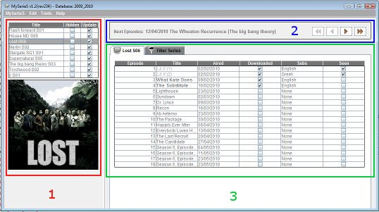

The Series Panel
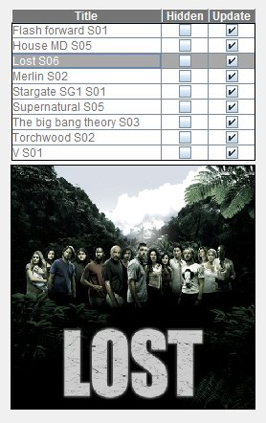
Series Panel
The series panel consists of the series table and the current selected series screenshot.
The series table has 3 columns:
- Title - The series title and season column.
- Hidden - The hidden column. If a series is hidden it’s episodes will not show up in the Next episodes panel and in the filters table).
- Update - The update column. If update is enabled Internet update will update the series episodes’ data.
The series screenshot can be added through “Edit Series” and it’s saved in the “/images” sub folder of the application. If no screenshot exists the default MySerieS logo will be displayed.

The hidden and update columns are editable so clicking on a check box will update the series hidden/update status.

Right clicking on a series will bring up the Series pop pup menu.

The series pop up menu
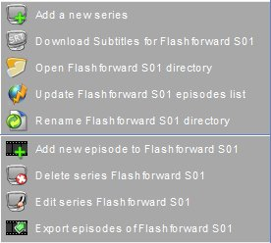
The available buttons in series pop up menu are:
- Add a new series – Adds a new series to the database.
- Download subtitles – Opens in the web browser the web page with the series subtitles (It currently works only for http://www.tvsubtitles.net and http://www.subtitleonline.com ).
The series codes for the websites can be obtained through the “Edit Series” panel. Which site will be used can be selected in the “Options” panel.
- Open local folder – Opens the local folder with the series files (The path is provided in the “Edit Series” panel.)
- Update episodes list – Updates the series episodes from http://www.epguides.com or http://www.tvrage.com . Which site will be used can be selected in the “Options” panel.
- Rename files – Renames the files in the series local directory according to some rules you can set (eg “series – S01x12 – title.avi” or “series SE01EP12 title.avi” etc )
- Add new episode – Add manually a new episode to the series.
- Delete series – Delete a series.
- Edit series – Brings up the “Edit Series” panel for editing the series.
- Export episodes - Exports the series episodes to a text file which can be used later for importing the episodes in another database.

The Next Episodes Panel
The next episodes panel displays the episodes that are to be aired in the following days. You can select in “Options-Next Episodes” if those that are aired but not downloaded or seen are shown or not. You can also set the number of episodes are displayed. The hidden series' episodes are not displayed.

The Episodes Panel
The episodes tab panel consists of 2 tabs. The series episodes tab and the filters tab.

The series episodes tab
The episodes tab is a table with 6 columns:
- Episode : The episodes. Number
- Title : The episodes title. It's in italics lighter color if the episode is seen, bold if it's available for seeing (video & subtitles downloaded) and normal for the not seen or not available for seeing.
- Aired : The day that the episodes is aired. The date format (12/04/2010 , 04/24/10, Fri 16-04-2010 etc can be set in the “Options panel”)
- Downloaded : The downloaded status of the episode (Yes / No)
- Subs : The subtitle status of the episode (None / Greek. English / Both)
- Seen : The seen status of the episode (Yes / No)

All columns are editable. The episode, title and aired column can be updated through the “Internet Update” too. The downloaded and subtitles columns can be updated automatically by checking the series local folder (if it's provided). This updates only the episodes with with download status “no” and subtitle status not “Both”

The episodes pop up menu
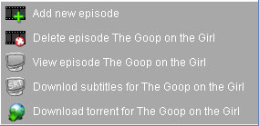
The available buttons in the episodes pop up menu are:
- Add new episode – Adds a new episode to the selected series.
- Delete episode – Deletes the selected episode. (Disabled in filtered episodes table and if no episode is selected).
- View episode – View the episode in your default media player. (Disabled if local series folder is not provided or no episode is selected).
- Download subtitles – Connects to http://www.tvsubtitles.net or http://www.subtitleonline.com (You can choose the site in the options) and attempts to download and unzip the subtitles in the series local folder. If no local folder is provided or the site does not allow direct download for the subtitle file, the internet browser opens and downloads the zip file. If the subtitle for your primary language (defined in options) is not found the application attempts to download the secondary's one. (Disabled if no episode is selected).
- Download torrent – Opens the “download torrent form” to search for the selected episodes torrent. (Disabled if no episode is selected).

The filters tab
The filters panel consists of the filters selection panel and the filtered episodes table.
In the selection panel you can choose the filter option (download status, seen status, subtitles status) and you can also save these options by typing the filter's name in the last editable drop-down and press the save button (You can also delete unused filters by choosing the filter in the last drop-down and press the delete button).
Each time you change a drop-down's the filter is applied. The episodes that match the filter criteria appear in the filtered episodes table. (Note that hidden series do not appear).
The filtered episodes table has 7 columns :
- Series - The series title and season.
- Episode – The episode number.
- Title – The episodes title.
- Aired – Episodes aired date.
- Downloaded – The downloaded status of the episode.
- Subs – The subtitle status of the episode.
- Seen – The seen status of the episode.
The downloaded, subs and seen columns are editable.

