MySerieS v 1.1

# What is MySerieS

MySeries is an application which helps you organize your favorite tv series. You can check which episodes you have downloaded, which subtitles, if you have watched it or not, informed about the episodes aired in the following days etc.

The series episodes titles and air dates are updated from the Internet so you don’t have to input anything. Also the application can check the series local folder and updates the info about the download and the subtitles of each episode.

The application enables you to download subtitles and torrents for the episodes and also lets you open the episodes in your default media player.

# The main window

MySeries main window comprises of three main panels:

1. The series panel.

2. The next episodes panel , and

3. The episodes panel.

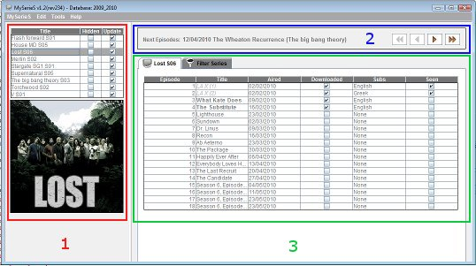

# The Series Panel

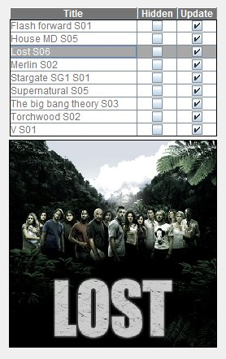The series panel consists of the series table and the current selected series screenshot.

Series Panel

The series table has 3 columns:

1. The series title and season column.
2. The hidden column. If a series is hidden it’s episodes will not show up in the Next episodes panel and in the filters table).
3. The update column. If update is enabled Internet update will update the series episodes’ data.

The series screenshot can be added through “Edit Series” and it’s saved in the “/images” subfolder of the application. If no screenshot exists the default MySerieS logo will be displayed.

The hidden and update columns are editable so clicking on a checkbox will update the series hidden/update status.

Right clicking on a series will bring up the Series Popup menu.

## The series popup menu

The available buttons in series popup menu are:

* **Add a new series –** Adds a new series to the database.
* 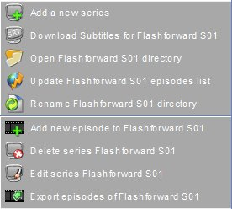**Download subtitles** – Opens in the web browser the web page with the series subtitles (It currently works only for <http://www.tvsubtitles.net> and <http://www.subtitleonline.com> ).  
  The series codes for the websites can be obtained through the “Edit Series” panel. Which site will be used can be selected in the “Options” panel.
* **Open local folder –** Opens the local folder with the series files (The path is provided in the “Edit Series” panel.)
* **Update episodes list –** Updates the series episodes from <http://www.epguides.com> or <http://www.tvrage.com> . Which site will be used can be selected in the “Options” panel.

Series popup

* **Rename files –** Renames the files in the series local directory according to some rules you can set (eg “series – S01x12 – title.avi” or “series SE01EP12 title.avi” etc )
* **Add new episode –** Add manually a new episode to the series.
* **Delete series –** Delete a series.
* **Edit series –** Brings up the “Edit Series” panel for editing the series.
* **Export episodes -** Exports the series episodes to a text file which can be used later for importing the episodes in another database.