Olympic Weightlifting  
Competition Management System

v2.8.1 – January 2012

Installation Guide (Windows)

Jean-François Lamy

lamyjeanfrancois@gmail.com

# About this guide

This guide describes the installation procedure for the Olympic Weightlifting Competition Management System for the Windows operating system[1]. The procedures described here have been tested under Windows XP (SP3) and Windows 7.

The screen captures in this guide were done using the Chrome browser. Even though the system should work in any modern browser (Internet Explorer 8, Firefox, Chrome, Safari, WebKit) under Windows, Linux, Android and iOS, the most tested variation is Chrome under Windows.

# Pre-requisites

* You must have Administrator rights on the computer. This is normally the case for a personal laptop.

# Downloading the installation files

The installation files are accessible at the following location <http://code.google.com/p/owlcms/downloads/list>

* **Select the installation file :** Look for the most recent **.msi** file and click on the link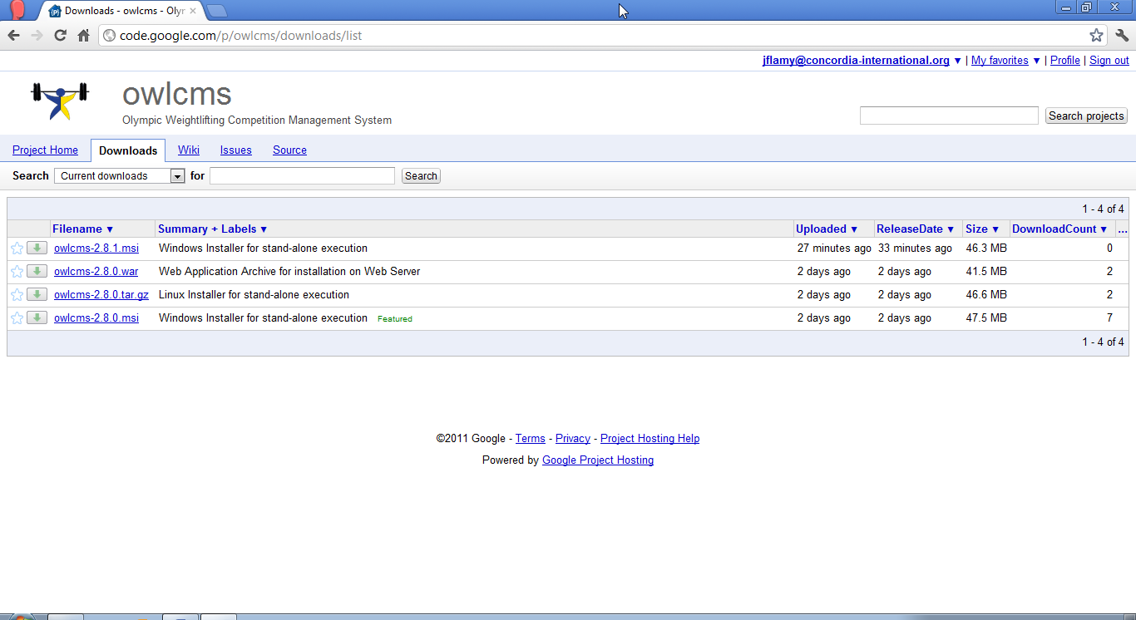
* **Download the installer:** Click on the link as highlighted below 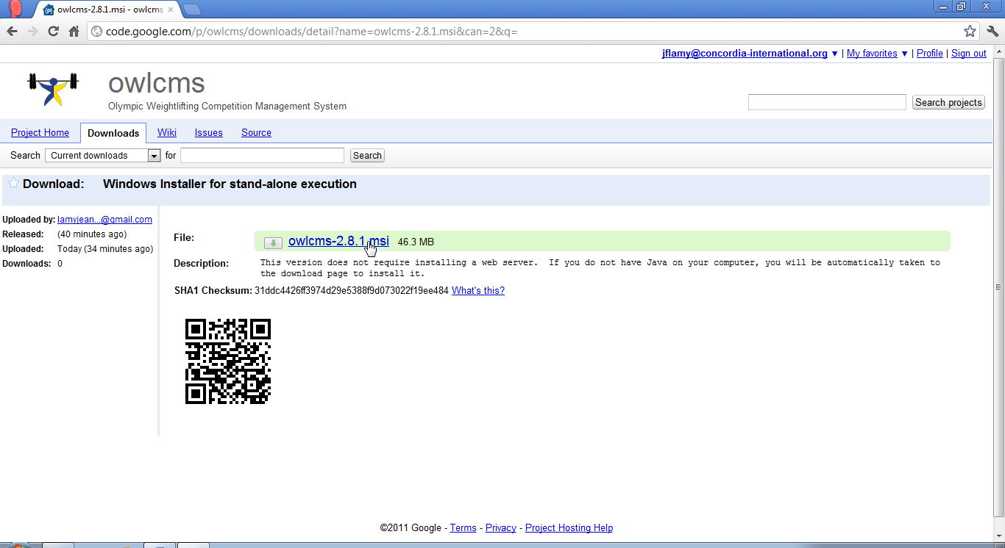

# Installating the System

* **Run the installer :** After the download completes, start the installation process. You will be prompted to authorize the installer with a prompt similar to the following.  
  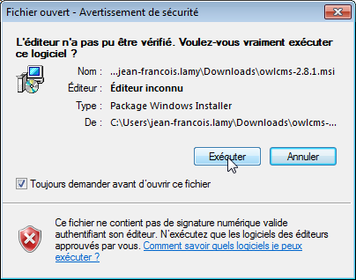
* **Perform the installation:** You will then see the actual installation screen.   
  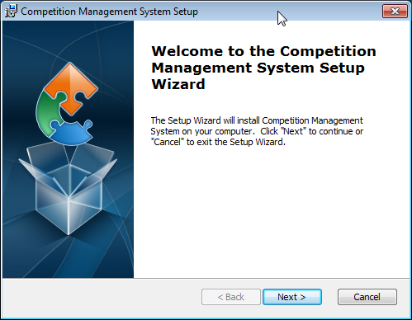
* **Accept all the default values:** Keep using the “Next>” button until you reach the final screen. Then hit “Finish”  
  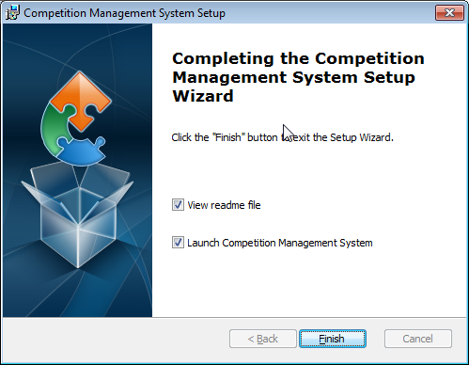
* **Check correct installation:** You should see two icons on your screen, one named “Competition App”, the other “Start Competition System”. A “readme.txt” file should be displayed (in the Notepad editor) and a black rectangular area should be visible (see below). The last line displayed in the black box should be

INFO: Starting ProtocolHandler ["http-bio-80"]

which indicates that the program is now acting as a Web Server (it is waiting for browsers to connect using the HTTP protocol on the standard port “80”)

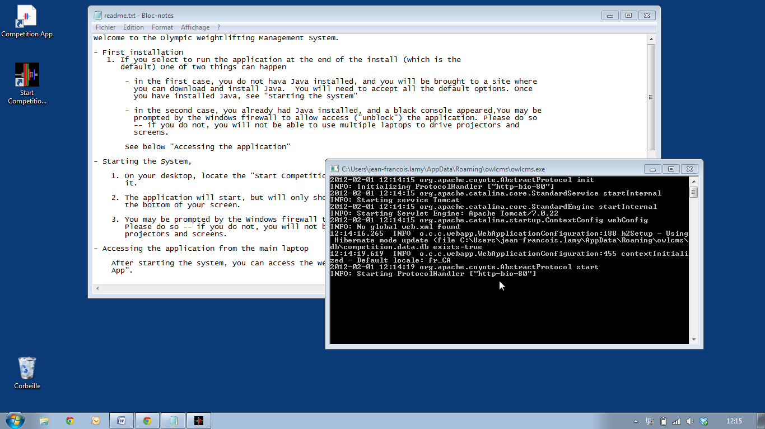

* **Access the competition management application:** Double click the shortcut named “Competition App”. You should see the following.  
  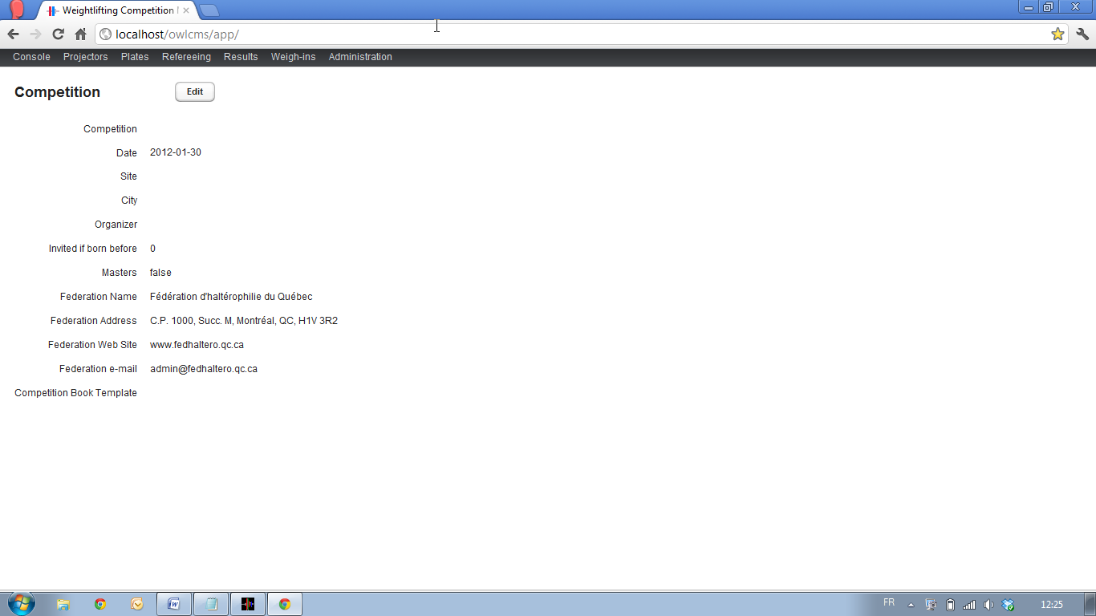

# Stopping the system

The system runs in a so-called “console” window (the black window that started at the end of the install). The window will normally become hidden by other windows (as exemplified in the previous screen shot). When the system is run subsequently, the console is started “minimized”, meaning that it will show up only in the task bar at the bottom of the screen.

* **Locate the icon for the competition system in the task bar:** The icon is a black square with colored lifting plates (as highlighted in the following picture)



* **Close the console window:** There are two ways to do this
  1. Right-click on the icon and use the “close window” option
* Click on the icon, which will bring the black console to the forefront. Use the regular “close” button at the top right  
  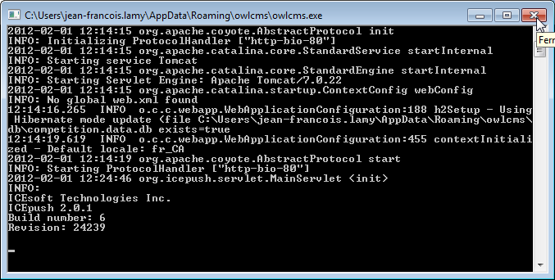

# Accessing the menu items

* **Locate All Programs**: At the bottom left of the screen, locate the entry for “All Programs” that appears when clicking on the Windows menu (as highlighted below)  
  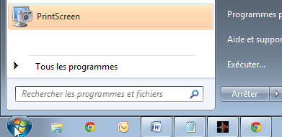
* **Locate the “Competition Management System” Program Group:** Click on the “All Programs” entry as shown in the previous item, and scroll down until you see “Competition Management System”. Clicking will show the various entries in the group, as follows 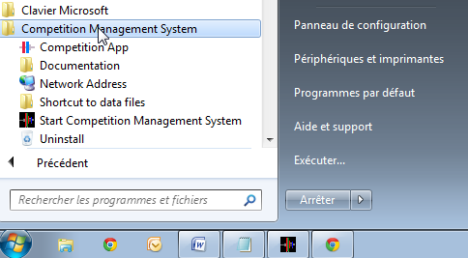

# Uninstalling

* **Stop the system**
* **Copy or delete the data files:**  Usethe “**Shortcut to data files**” entry in the “Competition Management System” group to get to the directory that contains the directory. You should either delete the files (if you don’t need them anymore) or take a back-up. You can always restore older files by removing the files in the directory and replacing them with another copy (such as a back-up).

If files are removed, the system will recreate new ones when it is started.

* **Perform the uninstall:** Locate the Uninstall shortcut in the “Competition Management System” program group, or alternately, use the Control Panel to uninstall

1. The system is also available as a Linux tar, and as a platform-neutral Java WAR archive. These two formats are targeted at advanced users and information technology professionals, are compliant with the relevant standards, and are not further discussed in this guide.