**A**

***iTRAQ, SILAC, Label Free, etc.***

Figure A1. Schematic workflow of the quantitative analysis performed in X-Tracker

**B**

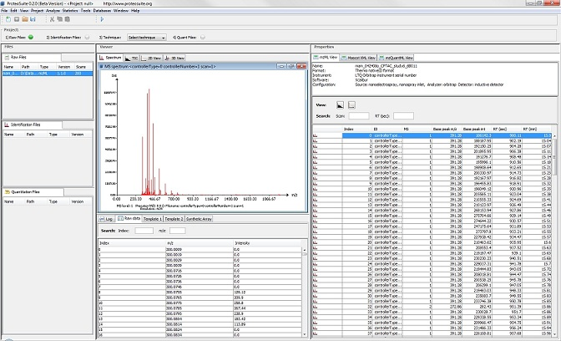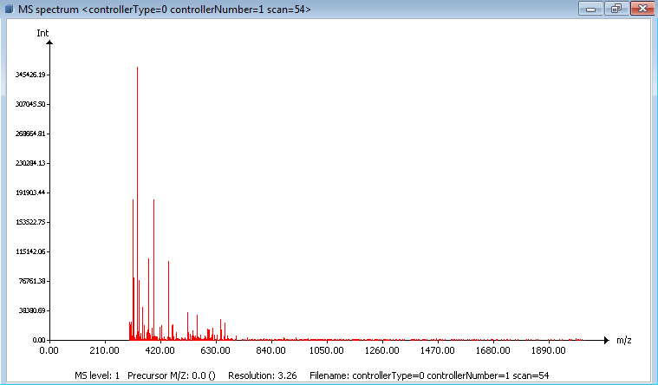

Figure B1. Screenshot of ProteoSuite

Figure B2. Example of MS spectra data visualization

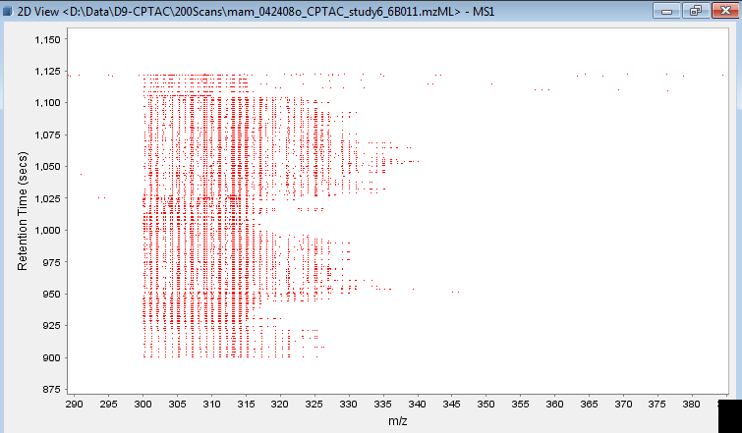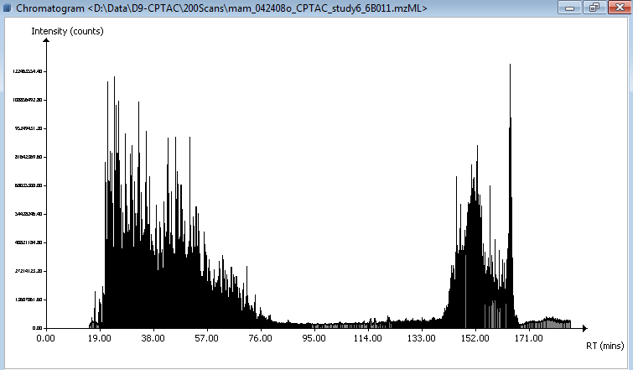

Figure B4. Example of 2D visualization

Figure B3. Example of Chromatogram visualization

**C**

**mzQuantML 1.0**

**HUPO-PSI Standards**

**Visualizer**

**mzIdentML 1.1**

**mzML 1.1**

**MSGF+**

**emPAI**

**iTRAQ,**

**TMT**

**ProteoSuite**

**loadRawMGF**

***PSI***

**loadRawMzML**

***SILAC***

***15N***

***iTRAQ***

***Label Free***

***…***

**iTraqQuantitation**

***PSI***

**outputMZQ**

**quantEMPAI**

**outputCSV**

***PSI***

**outputMzTab**

**loadMascotIdent**

***PSI***

**loadMzIdentML**

**Notation:**

**Plugin released**

**Plugin under development**