GSA Dctm Connector
Configuration documentation

1. Prerequisites iii
2. Installation of the Dctm Connector on Tomcat 4
2.1 Installation of the DctmConnector.jar 4
2.2 Starting of the connector manager 4
2.3 Checking of the connector’s availability 4
2.4 Configuration of the dmcl.ini file 4
3. Configuration of the connector in the GSA 5
3.1 Configuration of the connector manager 5
3.2 Configuration of a new connector instance 7
3.2.1 Connector instance: general parameters 8
3.2.2 Connector instance: detailed parameters 9
3.3 Configuration of the crawling pattern 11
3.4 Checking of the crawling 12

Prerequisites
To set up a GSA Dctm connector, the prerequisites are the following ones:
- To have a JDK 1.4.2
- To have a Tomcat server 5.0
- To have previously set up a Connector Manager on that Tomcat server
- To have set up the DFC on the server where Tomcat is installed

Installation of the Dctm Connector on Tomcat

Installation of the DctmConnector.jar
Open the webapps directory of your Tomcat.
You will see a connector-manager directory.
Put the DctmConnector.jar, which contains the whole Dctm connector, in the WEB-INF/LIB directory of your connector-manager application.

Starting of the connector manager
In a windows console, move at the root directory of Tomcat, such as:
C:\TomCat 5.0>
Run Tomcat lauching the following command:
bin\catalina.bat run
The connector manager will automatically start.

Checking of the connector’s availability
If the Tomcat server is started, the connector manager and the connector set up, a new directory DctmConnector should appear in the WEB-INF/connectors directory of the connector-manager application.

Configuration of the dmcl.ini file
In the dmcl.ini file, available in the Windows directory, enter the required values in the following properties:
host =swp-srv-gsaecm (name of the Dctm server where are stored the documents you want to crawl)
port =1489 (Dctm server’s port)

Configuration of the connector in the GSA

Configuration of the connector manager
Logon to the GSA Administration Center on port 8000.
To configure a new connector-manager on your gsa administration console, click on the “Connector Administration” tab.
The detailed menu below will appear:
Fig. 1
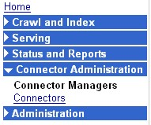
Click on the “Connector Managers” link.
In the top of the right frame, the list of the existing connector managers is displayed.
Fig. 2
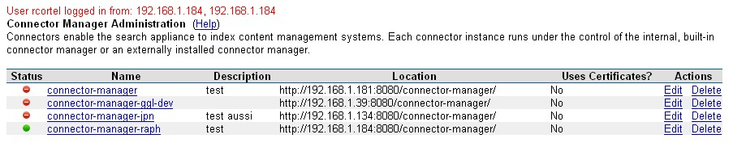

In the bottom of the right frame, a form is dedicated to the definition of a new connector manager.
Fig. 3
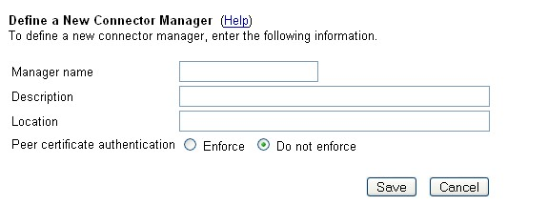
To create a new connector manager, the Tomcat server on which it is set up, needs to be running.
Enter the needed information, as described below:
In the Manager name field, which is mandatory, choose the name you want to give to your connector manager. This name will appear in the list of existing connector-managers.
In the Description field, you can enter a short description of the connector manager (its location, the way it is used...).
In the Location field, which is mandatory, enter the IP address of the Tomcat server where the connector-manager is running with the name of the connector manager directory (/connector-manager/), in the following way:
Http://TOMCAT_IP:TOMCAT_PORT/connector-manager/
If you have enabled https authentication on your Tomcat server, check the “enforce” option of the Peer certificate authentication field.
When the form is completed, click on the “Save” button to finish.
A new line is added for the new Connector Manager in the existing Connector Managers list with the message “New Connector Manager successfully added”.

Fig. 4
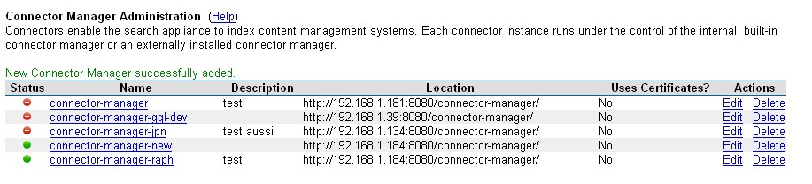
If the Tomcat server on which the Connector Manager is installed is not started or if the indicated location is invalid, the following message will be displayed above the form:
Fig. 5
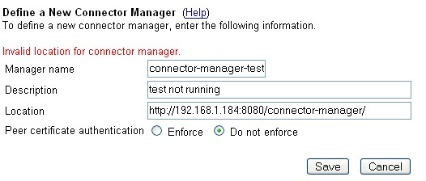

Configuration of a new connector instance
To create a new connector instance on the GSA administration console, it is necessary to start the Tomcat server where the connector is set up.
In the “Connector Administration” menu, click on the “Connectors” link.
Fig. 6
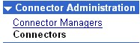
In the top of the right frame, the list of the existing connectors is displayed, with their type.
Fig. 7
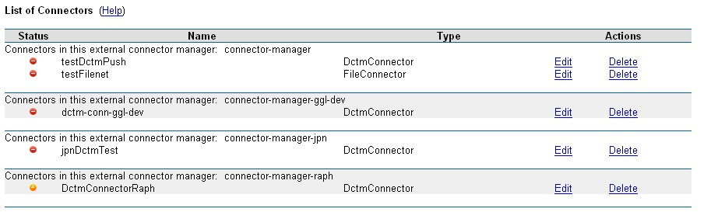
In the bottom of the right frame, a form is dedicated to the definition of a new connector instance.

Fig. 8
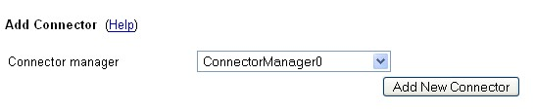
Choose the name of the Connector Manager where the connector is set up in the Connector managers list.
Click on the “Add New Connector” button.
A new form will appear with the general parameters of the connector instance.

Connector instance: general parameters
Fig. 9
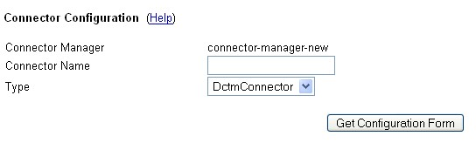
In the Connector Manager field, is indicated the name of the Connector Manager you have chosen.
In the Connector Name field, enter the name you want to give to your instance.
In the Type List, choose DctmConnector.
Click on the “Get Configuration Form” button.
A new form will appear with the detailed parameters of the connector instance.

Connector instance: detailed parameters
Fig. 10
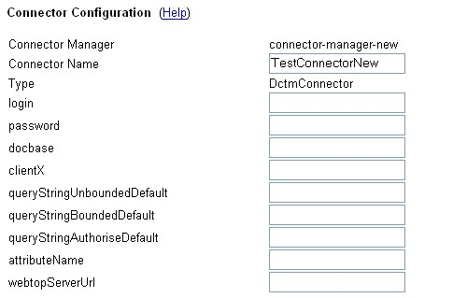
In the login field, enter the login of a Documentum super user, who can access to all the documents.
In the password field, indicate the password of this super user.
In the docbase field, enter the name of the docbase where the documents you want to crawl are stored.
In the clientX field, enter the name of the client class you want the DctmConnector to use:
com.google.enterprise.connector.dctm.dctmdfcwrap.DmClientX
In the queryStringUnboundedDefault field, indicate the dql query which is needed to crawl all the documents, for example:
select i_chronicle_id, r_object_id, r_modify_date from dm_sysobject where r_object_type=''dm_document'' order by r_modify_date, i_chronicle_id
Note: this query will only crawl the documents of dm_document type.
In the queryStringBoundedDefault field, indicate the dql query which is needed to crawl the documents with a date criteria, for example:
select i_chronicle_id, r_object_id, r_modify_date from dm_sysobject where r_object_type=''dm_document'' and r_modify_date >= ''{0}'' order by r_modify_date, i_chronicle_id
The date criteria will automatically replace the {0} symbol when the query will be performed.
Note: this query will only crawl the documents of dm_document type.
In the queryStringAuthoriseDefault field, enter the beginning of the dql query which is needed to perform the authorization process, for example:
select r_object_id from dm_sysobject where r_object_id in (
In the attributeName field, indicate the name of the id field chosen to perform the authorization process, for example:
r_object_id
In the webtopServerUrl field, enter the beginning of a document url, on a webtop server which is linked to the Documentum server where the documents are stored, for example:
http://swp-vm-wt:8080/webtop/drl/objectId/
Below this block of parameters, another form is displayed, which offers the possibility to configure the number of documents traversed per minute by the Connector Manager.
Fig. 11
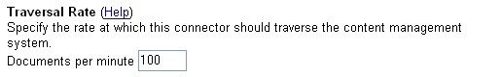
At the bottom of the screen, another form is displayed to configure the schedule of the crawling.
Fig. 12
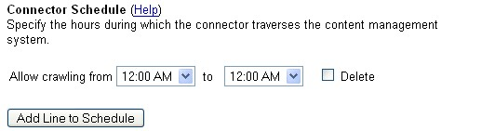
When the form is completed, you can click on the “Save configuration” button.

If the connector is correctly configured, the screen with the Connectors list is displayed with the new connector, just created.
Fig. 13
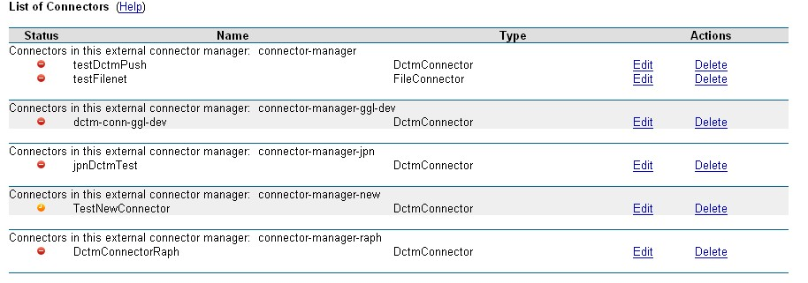
If the installation of the instance is successful, a new subfolder TestNewConnector (the name of the new instance) has been created in the WEB-INF/connectors/DctmConnector folder (in the connector-manager application), with a TestNewConnector.properties file inside.

Configuration of the crawling pattern
In the “Crawl and Index” menu, click on the “Crawl URLs” link.
Fig. 14
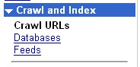

In the “Follow and Crawl Only URLs with the Following Patterns” text box, add the connector crawling pattern, on the model below:
Googleconnector://CONNECTOR_NAME.localhost/

Fig. 15
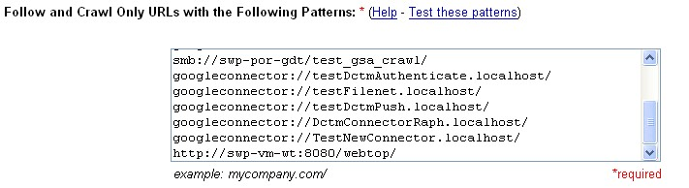

Checking of the crawling
In the “Crawl and Index” menu, click on the “Feeds” link.
Fig. 16
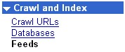
The screen below is then displayed in the right frame.
Fig. 17
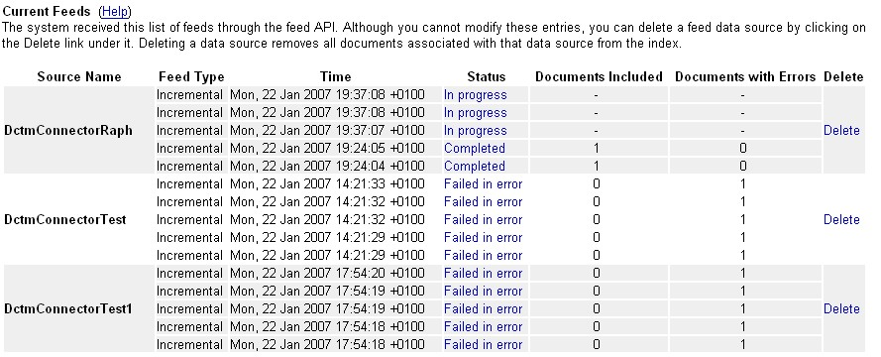
The feeds related to the new connector instance will appear in this screen.

