Rebstöckerstrasse 59  
  
60329 Frankfurt am Main  
Germany  
2/13/2020

VR Bank Deutschland GmbH

Eschborner Landstrasse 42

60486 Frankfurt am Main,

Germany

**VR-WAN2020**

**O-2638714**

Dear Dr. Horst Warendorf,

On behalf of Verizon, I am pleased to provide the enclosed document that outlines how our capabilities and expertise can align with your needs to support your key business outcomes. With a combination of global solutions and subject matter expertise, Verizon has a track record helping organisations like VR Bank improve performance while reducing overhead cost.

We live in dynamic times. To move forward, you need a partner who can combine technology and possibility in new ways. What serves your enterprise today is merely groundwork for what will propel it tomorrow. With the right partner, you can do more than react to the future. You can lead your industry into it. Our broad range of strategic solutions, services, and expertise can help VR Bank improve the performance of your applications, secure your critical data and collaborate with your customers, partners, suppliers, and employees.

Verizon delivers global solutions that power innovation and enable customers like VR Bank to do business better.

Our experts offer a wide range of managed network services to help you stay focused on your business goals. Drive growth with an agile software-defined network or improve application performance with Application Aware Routing and WAN Optimization Services, all backed by a service level tailored to your organization's needs. Choose from simple monitoring and notification or full outsourcing. Our comprehensive business network services can improve performance and help you stay ahead of the competition.

I recommend that we present our solution to your key stakeholders in person at a time and location most convenient to you. We will describe in detail how we will deliver your desired outcomes, answer questions about our solution, and agree to the next steps in the procurement process.

In the meantime, if you have any questions regarding our proposal, please contact me at +49 174 9890511 or via email at frank.muller@de.verizon.com.

Yours sincerely,

Frank Müller  
Client Partner  
Verizon



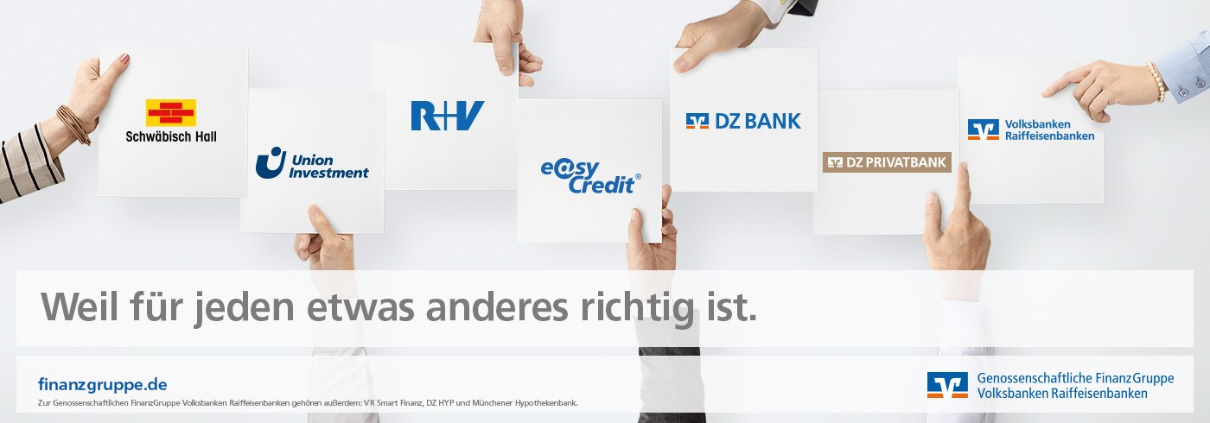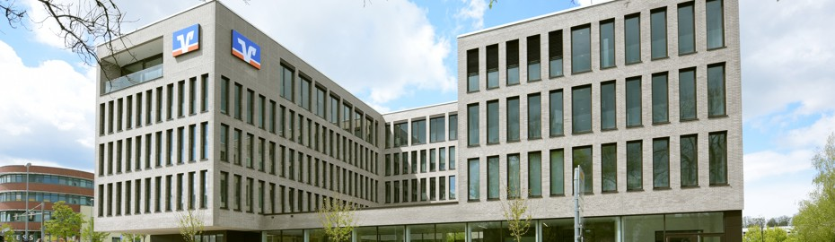

**Table of Contents**

**1.** **Executive Summary 2**

1.1 Keep customers engaged by delivering personalised solutions 2

1.2 Benefits to you 2

1.2.1 Solution benefits 3

1.3 Summary 3

**2.** **Virtual Network Services – SD WAN 4**

**3.** **Private IP 7**

**4.** **VR Bank’s solution 9**

1.1 Connections for: 9

1.2 SD-WAN: 10

**5.** **Pricing 11**

**6.** **Network Overview 12**

6.1 Europe – Node Coverage 12

**7.** **Legal Information 14**

1. **Executive Summary**

We are pleased to provide this proposal that demonstrates our commitment to VR Bank to provide solutions that meet your business needs. We have included our approach which leverages the investments we have made in emerging technologies so that the benefits can be directly passed onto you. Our solution focuses on delivering key outcomes such as secure, mission-critical services, as well as controlling Total Cost of Ownership (TCO).

* 1. **Keep customers engaged by delivering personalised solutions**

It’s a mobile world. People use devices to do almost everything, especially banking. Your customers expect financial services to be available wherever life takes them. ATMs, mobile points of sale and smartphones make it easier than ever to serve their needs.

Your customers also want to know their personal data is secure, and that they control how and where it’s used. Safeguarding their information and assets is more than just good business—it goes a long way towards gaining customer trust.

* 1. **Benefits to you**

At Verizon, we know how market disruptions can impact financial institutions and the implications those disruptions have on business infrastructures. But many threats can be mitigated by implementing forward-thinking solutions.

Services-based business and technology infrastructures can transform your customer's business into one that is more agile, customer-focused, resilient, and virtual. We have the assets and expertise to help financial services customers make the transition. Our solutions offer the following benefits to customers in the financial services industry.

|  |  |
| --- | --- |
| * + 1. **Solution benefits** | |
| **Easy way to pay** | Today companies of all types and sizes offer mobile apps for payments. So it’s more important than ever to distinguish your company from the competition. When you make financial transactions secure and easy, you’ll win customers and build lasting relationships. |
| **Reach customers** | Wireless ATMs and mobile branches bring the bank to the customer for less than the cost of permanent locations. No landline costs or installations. You can quickly set up new locations. |
| **Track preferences** | More data means personal bankers and wealth managers can pinpoint your customers’ preferences, interests and tastes. So you can tailor your marketing to grow revenue and relationships. |
| **Managing access** | Customers demand anytime access to vital information. Regulators require transparency. Learn more about threats facing the industry and how financial services use secure networks and other solutions to help protect against data breach. |

* 1. **Summary**

Our financial services technologies deliver benefits so you can generate new revenue channels, satisfy customers and stay competitive. Drive mobile banking through digital devices, secure your sensitive transactional data, and deliver personalised member experiences all with the help of pioneering financial industry solutions.

We believe our solution provides VR Bank with a comprehensive technology solution that will help you achieve your objectives. Our proposed solution can help VR Bank control total cost of ownership, and improve resiliency and redundancy on a secure network. By selecting Verizon as your solution partner, VR Bank can leverage our adaptable technology platforms, expertise, experience and innovation so you can continue to focus on your business.

We look forward to moving into the next discussion phase and refining our solution together to meet your needs now and in the future.

|  |  |  |
| --- | --- | --- |
| 1. Virtual Network Services – SD WAN | | |
| As the flow of digital information continues to increase, the demand for cloud and mobile technologies has increased too. With this surge, application performance and public cloud access have become top priorities for businesses. Not only are you expected to reach more people in more places – you need to do it more cost-effectively and without sacrificing performance.  To overcome these challenges, businesses are turning to a software defined WAN (SD WAN) hybrid networking approach to help balance the cost benefits of using the public internet with the performance of MultiProtocol Label Switching (MPLS). Premises-based SD WAN hardware can help you by routing traffic across different network paths based on changes in demand, application needs and network quality. It also lets you set quality of service (QoS) thresholds that use public and private WAN traffic without sacrificing performance or security.  Whilst QoS allows you to prioritise applications within a specific WAN circuit, hybrid networking lets you select paths at the application level. To get this level of flexibility you need application visibility, path instrumentation and dynamic path routing. These all require new intelligence and network management approaches. Virtual Network Services – SD WAN delivers all that, giving you the agility, routing intelligence and control your business needs.  **Make the move to SD WAN with Verizon.**  As the demands on networks evolve, networks must evolve too. The virtualization that happened in the data centre is now happening in the network. That’s how Virtual Network Services – SD WAN from Verizon can give you an alternative to proprietary, appliance-based SD WAN services. It lets you use virtual network functions (VNFs) to simplify your ability to migrate to an intelligent hybrid network that integrates broadband or other network services into your corporate WAN. |  | The solution allows you to easily take advantage of application routing and path selection to use both public and private IP services together. With its automated route changes, you can send data over the available transport service best suited for each application. This helps you improve the use of your network resources to get better network and application performance. It also simplifies your management efforts too. And since you’re using virtual SD WAN services to create your hybrid network, you can easily and dynamically:   * Adjust your WAN to handle changes in internet traffic. * Maintain the performance and security of real-time and sensitive applications. * Automatically measure and monitor performance of multiple services in your hybrid network. * Use application routing to get granular control over when an application transaction should use a specific service. * Keep private WAN services available for your mission-critical applications and help improve overall traffic flow by offloading internet-bound traffic.   **Verizon is recognized as a leader in delivering networking, security and cloud solutions that can help you with game-changing virtualization initiatives.**  **An easier approach to hybrid networking.**  Virtual Network Services – SD WAN comes with easy-to-deploy universal customer premises equipment (uCPE) that lets you easily and dynamically serve up the SD WAN services you need. With a single uCPE per site, you can choose to run multiple network services, such as routing, security and WAN optimisation in plug-and-play fashion. |

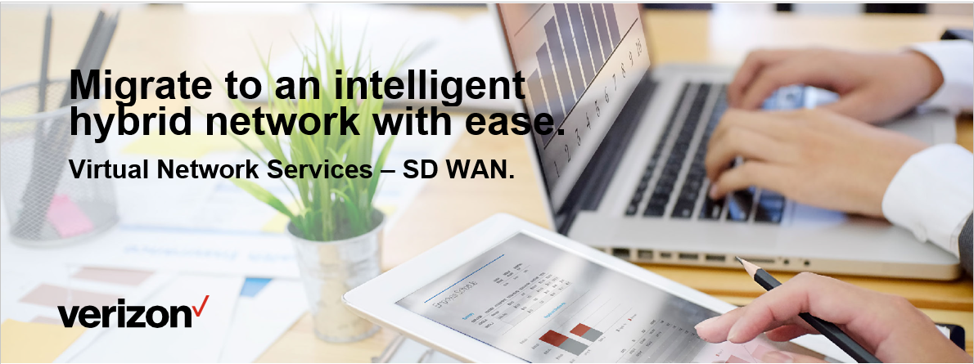

|  |  |  |
| --- | --- | --- |
| Our automated orchestration and service chaining link all the different services, so they work seamlessly together as a unified service. The ability to spin up those services on demand gives you the agility and control you need. And you get integrated, full management capabilities.   * Deploy quickly instead of weeks or months. * Select from up to five different sizing models with flexible, pay-as-you-go pricing models. * Get integrated full-service management and world-class transport services like Private IP and Internet Dedicated Services, plus support for Verizon Wireless 4G LTE. * Boost agility by changing service tiers and even vendors quickly and efficiently–plus automatically update these changes across your VNFs with integrated service chaining.   And since the solution is vendor neutral, you have the freedom to shop from a rich ecosystem of leading vendors, mixing and matching the best-in-class  services that are the right fit for your needs, including the following:   * Essential and application-aware routing (NAT, split tunnel, DPI and URL-based). * Security and encryption (AES-256). * QoS (classification, policing, remarking and scheduling). * Service-side routing and multicast. * Advanced policies (service chaining and extranet). * VPNs up to system scale. |  | Quickly and easily spin up the network services you need from the vendors you want.  **Get better visibility and control over your network.**  Verizon gives you the tools, monitoring, oversight and life-cycle support you need for application visibility, control and performance–regardless of changes in your network traffic.   * Make better use of your network with more granular control over where, and under what circumstances, an application transaction uses a specific service. * Improve traffic flow by offloading internet-bound traffic, keeping WAN services available for real-time and mission-critical applications. * Create routing policies on an app-by-app basis to make sure each workload uses the best available transport.   **Benefits of Virtual Network Services – SD WAN.**  Our comprehensive solution delivers a range of benefits for your business, including:   * More efficient operations, with managed orchestration of VNFs tied together into a unified service. * Better control over costs and capital expenditures. * Better network and application performance with on-the-fly resource availability. * Greater ability to distribute traffic across multiple, available paths. * Ability to add cost-effective broadband circuits to dedicated WAN circuits, where needed. |

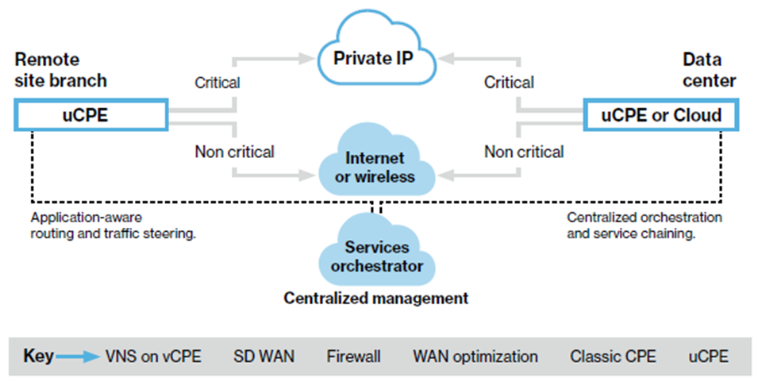

|  |  |  |
| --- | --- | --- |
| * Better routing decisions automatically made based on application requirements and actual network conditions. * Fewer human errors, simpler configuration and faster provisioning with automation. * Better user experiences with critical applications due to corrective actions based on performance monitoring. * Higher business agility due to flexible network load balancing and backup. * Greater ability to avoid downtime with proven change-management processes. * Easier migrations using standardized SD WAN operational practices. * Simplified management with end-to-end managed services. * Scalable network resources allocated on-the-fly, per application needs. |  | **Take the complexity and difficulty out of moving to a hybrid SD WAN approach.**  **Why Verizon?**  As your one-stop shop for managed virtual network services, we make it easy to get the agility, flexibility and performance you need to help secure your network and meet the fast-changing demands of business. Verizon is recognized as a leader in delivering networking, security and cloud solutions that provide game-changing virtualization initiatives for the modern, hyper-connected world.  We have a rich ecosystem of partners for providing the VNFs you need. With our experience managing over 300,000 security, network and hosting devices, and over 4,000 customer networks in 142 countries, you can have confidence in our ability to smooth your transition to virtual network services and deliver the end-to-end managed services that will help you protect your mission-critical data and your business. And 95 percent of the Fortune 500 rely on our services and technologies.  **Learn more.**  Your network and mission-critical applications need a better approach. To find out how you can get the agility, flexibility and high performance of a hybrid network, contact your Verizon account representative. |





|  |  |  |
| --- | --- | --- |
| 1. Private IP | | |
| **Your organisation has never stood still. After all, to succeed, you can’t stop evolving or growing. Your network has to do the same. Demands from new apps and business processes require an innovative network that can provide simple and flexible coverage around the world. You need a reliable and scalable solution capable of powering the growth of your digital organisation.**  Verizon Private IP can give you a network as broad and dynamic as your organisation. It lets you build a flexible, scalable network that offers any-to-any IP connectivity whilst giving you excellent security and reliability. It’s a virtual private network (VPN) based on Multi-Protocol Label Switching (MPLS) that can overlay your existing infrastructure and grow along with your organisation. To you, that means simple, secure connections for whatever business challenge comes your way.    **Enabling the cloud and the business.**  Private IP treats your mission-critical applications the way you want them to be treated: with the speed and priority “mission critical” implies. It provides a foundation that can automate your business processes for e-commerce, shared intranets, and more that can automate your business processes.  Private IP is flexible transport and secure access; whether connecting to remote offices or to the Cloud, this service provides a simple, secure, and reliable solution for all your data and applications. |  | **Scalability**.  Connect multiple locations and configurations within your VPN.  **Cost control**.  Consolidate data, voice, and video services through a single connection, which can improve productivity whilst helping control training, travel, and communication expenses.  **Varying classes of service**.  Use six classes of service to prioritise all types of network traffic for low latency, low jitter, and high availability.  **Flexible IP routing**.  Guide traffic along the best routes for your organisation with support for multiple encapsulation methods and routing protocols.  **Flexibility**.  Choose from multiple levels of control, ranging from simple monitoring and notification, to project-related professional services, to fully outsourced network management.  **Expansive reach**.  Take your business further and let your users access the network around the globe.  **Exceptional service**.  Get 24-hour customer service, advanced reporting capabilities, and competitive service level agreements (SLAs).  **Access Options**.  Support for multiple services and oversubscription on select Ethernet access circuits. |
| We continue to evolve our Private IP solution. With the  capabilities of our Secure Cloud Interconnect, Private IP now provides on-demand, consumption-based bandwidth to a growing ecosystem of leading cloud service providers. This capability, along with the ability to pair Private IP with segregated Verizon Wireless 4G LTE access, makes Private IP an effective way to meet the demands of agile businesses growth.    **Delivering dependable connectivity.**  You need to connect with businesses next door and affiliates and customers on the other side of the world. Our Private IP solution is available in more than 170 markets and we continue to expand as we team with reputable carriers around the world to offer your organisation consistent quality and service.  Your intranet not only allows your employees to communicate, it also protects valuable company and employee data. You may have a similar portal for customers and vendors, or connect with them through a robust and secure e-business platform. IP based WANs, like Verizon Private IP, combine all the elements you need to support intranets and e-business applications. You get the benefit of a more efficient network whilst you simplify the way you do business.  **Powering your growth.**  Through Private IP, we provide networking for thousands of customer networks, spanning hundreds of thousands of connections. This gives us the experience necessary to build a solution that can help power the growth of your enterprise. Whether you manage your own network or join the more than 4,000 customer networks under the care of our managed services team, you’ll get a WAN that adapts to demands fast, letting users stay productive and your business stay competitive |  | **Learn more:**  Contact your Verizon account representative or visit:  [verizon.com/business/products/private-ip/](https://www.verizon.com/business/products/private-ip/) |

1. **VR Bank’s solution**

VR Bank has locations around the world. Verizon understands the need to change network speeds at your fingertips wherever possible.

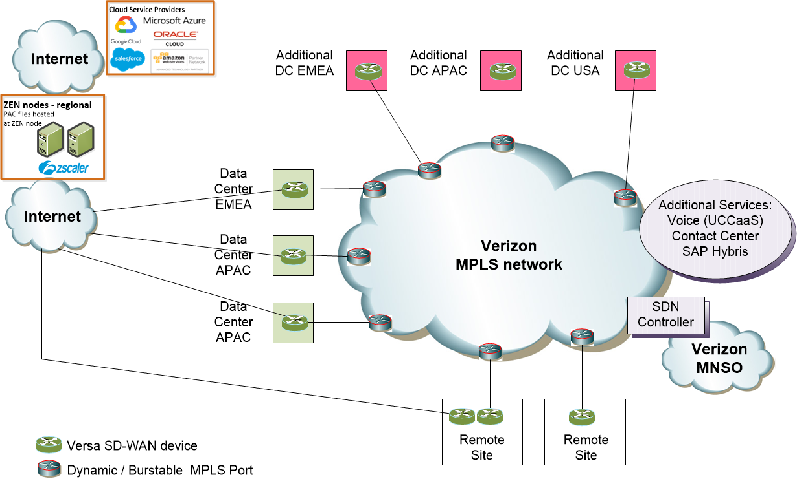

Above schematic describes what we understand as VRs requirements.

***During the initial discussions with VR Bank we have noted the requirements for the WAN connections as well as the possibilities for the SDWAN overlay.***

* 1. **Connections for:**
* Remote Site to 3 main Data Centers as well as the 3 additional Data Centres
* Remote sites to breakout to CSP locally and back-up via Customer DC’s.
* Remote and Hub Site to Zscaler Cloud Proxy
* GRE Tunnel over internet at remote and hub sites
* Backup access to Zscaler via MPLS (3 main DC’s)
* Local internet breakouts to access Cloud services.
* Dynamic Bandwidth on MPLS is mandatory
* Cloud Services: SAP-C4C and SAP Hybris
* Minimum Access speed shall be 10 Mbps
  1. **SD-WAN:**

Dedicated device vs. Virtual Network Services (whitebox)

SD-WAN vendor Viptela or Versa? (open)

SD-WAN to support Zscaler setup

SD-WAN GRE tunnel to Zscaler (ZEN)

SD-WAN to Zscaler via internet access, backup via MPLS

Cisco IOS-XE SD-WAN is still not available. Viptela and OS-XE SD-WAN will be compatible to each other.

Network Segmentation is required

Co-Management to be defined in detail

Customer WAN and Security teams need access on same VNS whitebox (Governance to be defined)

1. **Answers to VR Bank’s questions**

How many consecutive years has your company been providing the SD WAN solution?

**Verizon Response**

Verizon is the first Managed Service Provider (MSP) to have offered a comprehensive best-in-class multivendor SDWAN offering, since Aug 2016. Additional we're working to launch the full spectrum of service management models for SD WAN ranging from monitor-only, to hybrid co-management, to full management.

How many SD WAN customers and total number of sites are in production currently?

**Verizon Response**

Verizon currently supports over 100 unique VNS/SD WAN customers across thousands of global locations. Approximately 60% of our customers have some combination of Cisco Viptela SD WAN deployed both with vEdge purpose built hardware and on the uCPE platform service chained with another network service (typically a security solution).

Our NOCs located in Cary, North Carolina and Manila, Philippines are staffed 24x7x365 with a tiered approach to customer support. These centers currently support a total of 113 VNS/SDWAN customers across 3,005 locations. 61 of these customers have Cisco Viptela SDWAN deployed across 2,856 locations - most of them with vEdge HW. This includes remote spoke sites with vEdge CPE and VCP-hosted controller complexes.

What’s the cost of added SD WAN support services

**Verizon Response**

* + 1. **Standard monthly fee:**

The fixed monthly fee includes uCPE, Access, MPLS, Internet, QoS, Security and SDWAN management & maintenance.

* + 1. **Additional price:**

**Client Service Management fee & Billing Program Manager**

Since Service Management and Billing Program Management support is not included in Verizon’s standard package, Local Client Service Management support and Billing Program Management has been included as an additional service, charged on a monthly basis, this to meet your requirements.

Client Service Management and Billing Program Management support fee is provided in the Pricing Section.

**SD-WAN Technical resource fee**

Since SD-WAN Technical resource support is not included in Verizon’s standard package, Verizon Designated Engineering as a Service is included in proposed solution as an additional service, charged per hour with minimum hours outlined per year.

1. **Pricing**

Budgetary pricing for the products and services described in this proposal has been included as a formal quotation accompanying this document. All prices shown are provided for information only and are based upon various assumptions. This document and the accompanying quotation do not, therefore, constitute a formal offer capable of acceptance. Provision of service and any subsequent contract to this proposal would be subject to Verizon Standard Terms and Conditions for the service provided.

1. **Network Overview**

Verizon’s presence in Europe covers 27 countries with our own physical infrastructure. We do have extended coverage to 17 more countries via our partners. Verizon offers solution in the region ranging from networking, cloud, security, datacenter to professional services. The network is the power behind our customer’s business which enables collaboration, data sharing, processes and decision making.

* 1. **Europe – Node Coverage**

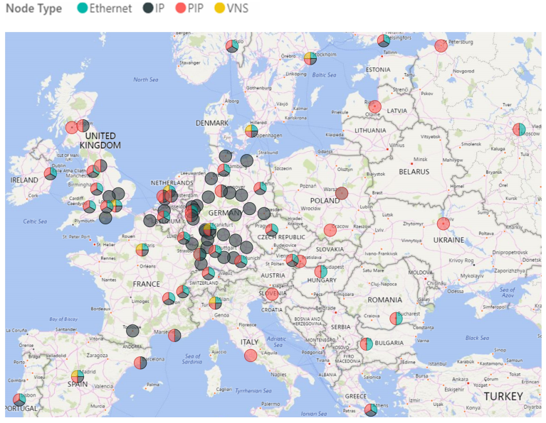

* We own and operate one of the most expansive IP backbone networks in the world.
* Our global networks span over 800,000 route miles, including terrestrial and undersea cable, spanning six continents.
* We made a $16.7 B investment in our infrastructure during 2018.
* Verizon provides global Internet of Things (IoT) coverage in more than 100 countries with plans to expand its footprint in the coming months to nearly 200 countries.
* Offices in 82 countries across six continents supporting services for government and business customers.
* We have five major global Network Operations Centres in the United States, Europe, and Asia-Pacific.
* Our nine state-of-the-art Security Operations Centres on four continents manage security devices in 20 countries.

When you combine the capabilities of our networks and staff, you end up with a global network solution that’s right for your business.

1. **Legal Information**

Verizon developed this proposal for VR Bank Deutschland GmbH to guide further consideration and discussion for services. Pricing contained in this proposal is valid for a period of 60 days from the date this proposal is submitted; noting that promotions, rates, charges, and/or discounts may be subject to change and pricing is exclusive of taxes, surcharges and governmental charges. In the event VR Bank Deutschland GmbH elects to purchase the services, Verizon will provide VR Bank Deutschland GmbH with a written agreement that includes mutually agreeable terms and conditions.

VR Bank Deutschland GmbH agrees to treat this proposal and any oral communications regarding related information (e.g., terms, proprietary technology, pricing) as confidential using a reasonable degree of care, including a prohibition against dissemination to third parties. Verizon is basing this proposal in part on certain assumptions (which may not be expressly stated), which we consider to be valid but which have not yet been confirmed. Verizon shall have no liability to VR Bank Deutschland GmbH if it turns out any of its assumptions is inaccurate.

|  |
| --- |
| [**http://www.verizonenterprise.com/**](http://www.verizonenterprise.com/)  **Verizon Deutschland GmbH Sebrathweg 20, D-44149, Dortmund, Germany USt-Ident-Nr./VAT-ID-No.: DE 814082641** |