PHISHING AND URGENCY EMAIL SUBJECT DETECTOR

Python Source Code
# Phishing and Urgency Email Subject Detector
# Mini Project Demonstration Model
import pandas as pd
from sklearn.feature_extraction.text import CountVectorizer
from sklearn.naive_bayes import MultinomialNB
# Training Dataset
data = {
"subject": [
"Urgent action required verify your account",
"Your account has been suspended immediately",
"Congratulations you won a prize",
"Meeting schedule for tomorrow",
"Invoice for your recent purchase",
"Update your password now",
"Limited time offer claim now",
"Project discussion reminder"
],
"label": [
"phishing",
"phishing",
"phishing",
"legitimate",
"legitimate",
"phishing",
"phishing",
"legitimate"
]
}
df = pd.DataFrame(data)
# Vectorization
vectorizer = CountVectorizer()
X = vectorizer.fit_transform(df["subject"])
y = df["label"]
# Model Training
model = MultinomialNB()
model.fit(X, y)
# Urgency Keywords
urgent_words = [
"urgent", "immediately", "now",
"verify", "suspended", "limited"
]
# Prediction Function
def detect_email(subject):
subject_vector = vectorizer.transform([subject])
prediction = model.predict(subject_vector)[0]
urgency = "Normal"
for word in urgent_words:
if word in subject.lower():
urgency = "High"
break
print("Email Subject:", subject)
print("Phishing Detection:", prediction.upper())
print("Urgency Level:", urgency)
# User Input
while True:
email_subject = input("Enter email subject (or type 'exit'): ")
if email_subject.lower() == "exit":
break
detect_email(email_subject)

Execution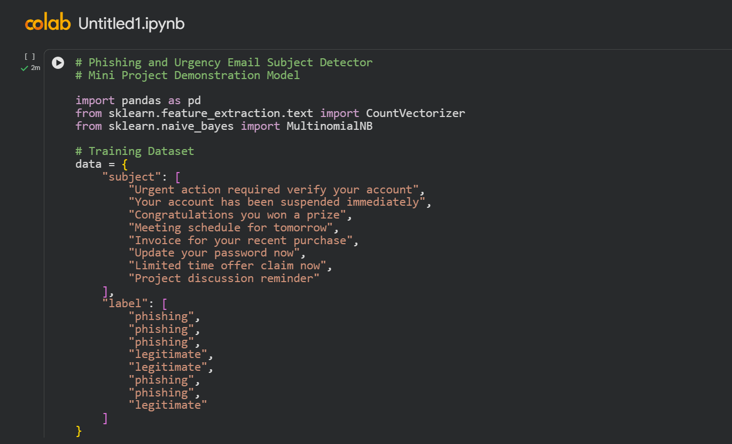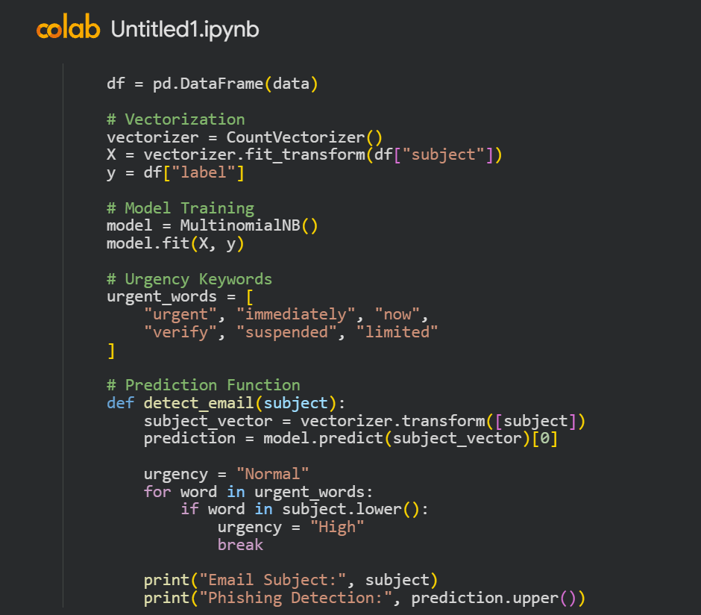
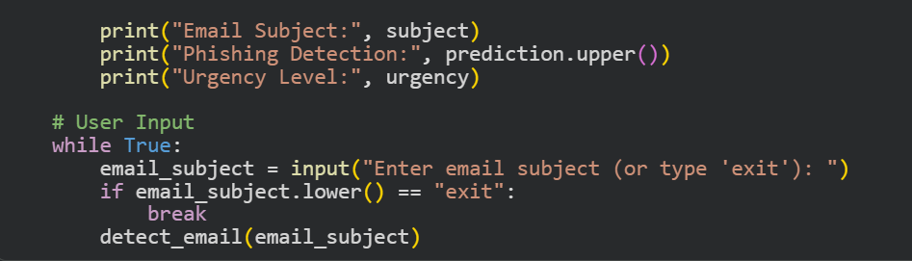

Output

