Magnetic spatial encoding and command-referenced three-dimensional contact trajectory reconstruction with a five-node soft magnetic tactile interface
Liming Qian^{a,*}, Jiaqi Li^{b}, Feng Guoª
ª Department of Mechanical Engineering, Nantong Institute of Technology, Nantong, Jiangsu Province, China
^{b} [Affiliation of Jiaqi Li to be confirmed]
* Corresponding author: Liming Qian, e-mail 20160031@ntit.edu.cn, ORCID 0009-0004-6958-2384
Abstract
Soft magnetic tactile interfaces need spatially distinguishable responses to localize contact from few readout nodes. We compared concentric-ring (CCA), checkerboard (CPA) and parallel-stripe (PSM; two silicone thicknesses) configurations using five triaxial magnetometers over a 20 × 20 mm area. In a grouped spatial holdout (36 fitting positions and 85 unseen positions), the CPA configuration produced the lowest mean planar error (0.534 mm versus 0.714–1.189 mm). A shape-normalized radial-basis-function (RBF) decoder calibrated on a 1-mm grid gave a mean planar error of 0.288 mm and X/Y/Z mean absolute errors of 0.163/0.206/0.031 mm on 441 contacts from an independent repeat record at previously calibrated coordinates and a commanded indentation of 0.4 mm. This planar error was 17.5% lower than that of a same-source 2-mm calibration. After documented magnetic-layer replacement and reassembly followed by five-point planar registration, a representative repeated XYZ action gave a command-referenced mean three-dimensional error of 0.569 mm with 99.91% output coverage. The motion reference was the programmed and time-interpolated platform trajectory, not independent external position metrology. These results support configuration-level comparison, dense calibration and bounded command-referenced trajectory reconstruction with a compliant magnetic tactile interface.
Keywords: Tactile sensor; Magnetic sensor; Localization; Calibration; Trajectory reconstruction; Soft magnetic interface

1 Introduction
Robot fingers and soft contact interfaces must know where they are touched and how the contact moves [1]. Optical sensors give dense contact images [2,3], and distributed Hall-effect skins give compact three-axis taxels [4]. Magnetic tactile sensors are attractive because a magnetized elastomer or embedded magnets move when the surface deforms, and the field change is read by magnetometers that can be separated from the contact surface and its wiring [5,6]. The design question is not only how large a field change can be generated, but whether the field pattern encodes position in a way that is distinguishable, robust to indentation depth and stable during continuous contact.
Magnetic skins can localize contacts accurately with sparse readout. Hellebrekers et al. decoded a magnetic silicone skin with five triaxial nodes and a neural network [7]; Yan et al. used a periodically magnetized film with a 3 × 3 triaxial Hall array and axis-specific networks, and also position-conditioned indentation lookup [8]; Hu et al. combined magnetic maps, Kriging and nearest-neighbor matching over 220 × 220 mm with sixteen magnetometers [9] (numerical comparison in Table 3). Replaceable skins and adaptation between instances [10,11] and taxel-value isolines for super-resolution [12] have also been studied. These studies motivate a common-readout comparison of magnetic layouts and a separate evaluation of static localization, calibration transfer and continuous motion.
Prior magnetic tactile studies commonly use commanded robot or motion-stage coordinates as contact-location labels. ReSkin used specified Dobot Magician XY positions [10], Hu et al. used an electrically driven XYZ platform [9], and Yang et al. used an XY motion platform [19]; their published experimental protocols did not report a separate external instrument for verifying the commanded XY position. Following this convention, we evaluate trajectories against the programmed and time-interpolated platform motion and report command-referenced reconstruction errors rather than independently metrologized absolute positioning accuracy.
We evaluate how magnetic spatial encoding and calibration density support contact tracking with five readout nodes using a shape-normalized RBF decoder. Our contributions are: (i) a common-readout, grouped spatial-holdout comparison of three layouts in four tested structural configurations, with a field-based diagnostic of the normalized response; (ii) a same-source 121- versus 441-position calibration comparison on one reserved repeat record; and (iii) radial, circular and simultaneous XYZ motion demonstrations after documented magnetic-layer reassembly and planar registration. The main static result is produced by one frozen 441-node DC-RBF and the single reserved Trial 154 test record; it is not assembled from different models. The RBF-labelled analyses share the same core mapping implementation, while their training datasets and frozen parameter instances differ, and the causal analysis adds a separately identified history-residual branch. All positions are referenced to commanded Cartesian-platform coordinates.

2 Materials and methods

2.1 Sensor and set-up
Magnet layouts. The concentric-ring array (CCA) has 19 axially magnetized Ø4 × 1 mm discs (one central, six at radius 5 mm, twelve at 10 mm) with alternating polarity around each ring. The checkerboard array (CPA) has 25 axially magnetized Ø5 × 1 mm discs on a 5 × 5 grid (nominal 5 mm pitch) with alternating polarity between neighbors. The parallel-stripe layer (PSM) is a 1-mm-thick sheet with ten alternating stripes, used with silicone-isolation thicknesses of 2.5 mm (PSM-L) and 4.5 mm (PSM-H); the CCA and CPA use the default 4.5 mm isolation, a nominal compliant layer, not a measured magnet-to-sensor gap (Fig. 1). The nominal disc volumes are 238.8 mm³ (CCA) and 490.9 mm³ (CPA). The study therefore compares four structural configurations of three layouts with a shared readout but different magnet geometry and volume; the CPA disc volume is 2.06 times that of the CCA, so it is not an equal-volume experiment. The pole pitch of the PSM sheet and the absolute polarity of the viewing face were not determined, so polarities in Fig. 1 are illustrative.
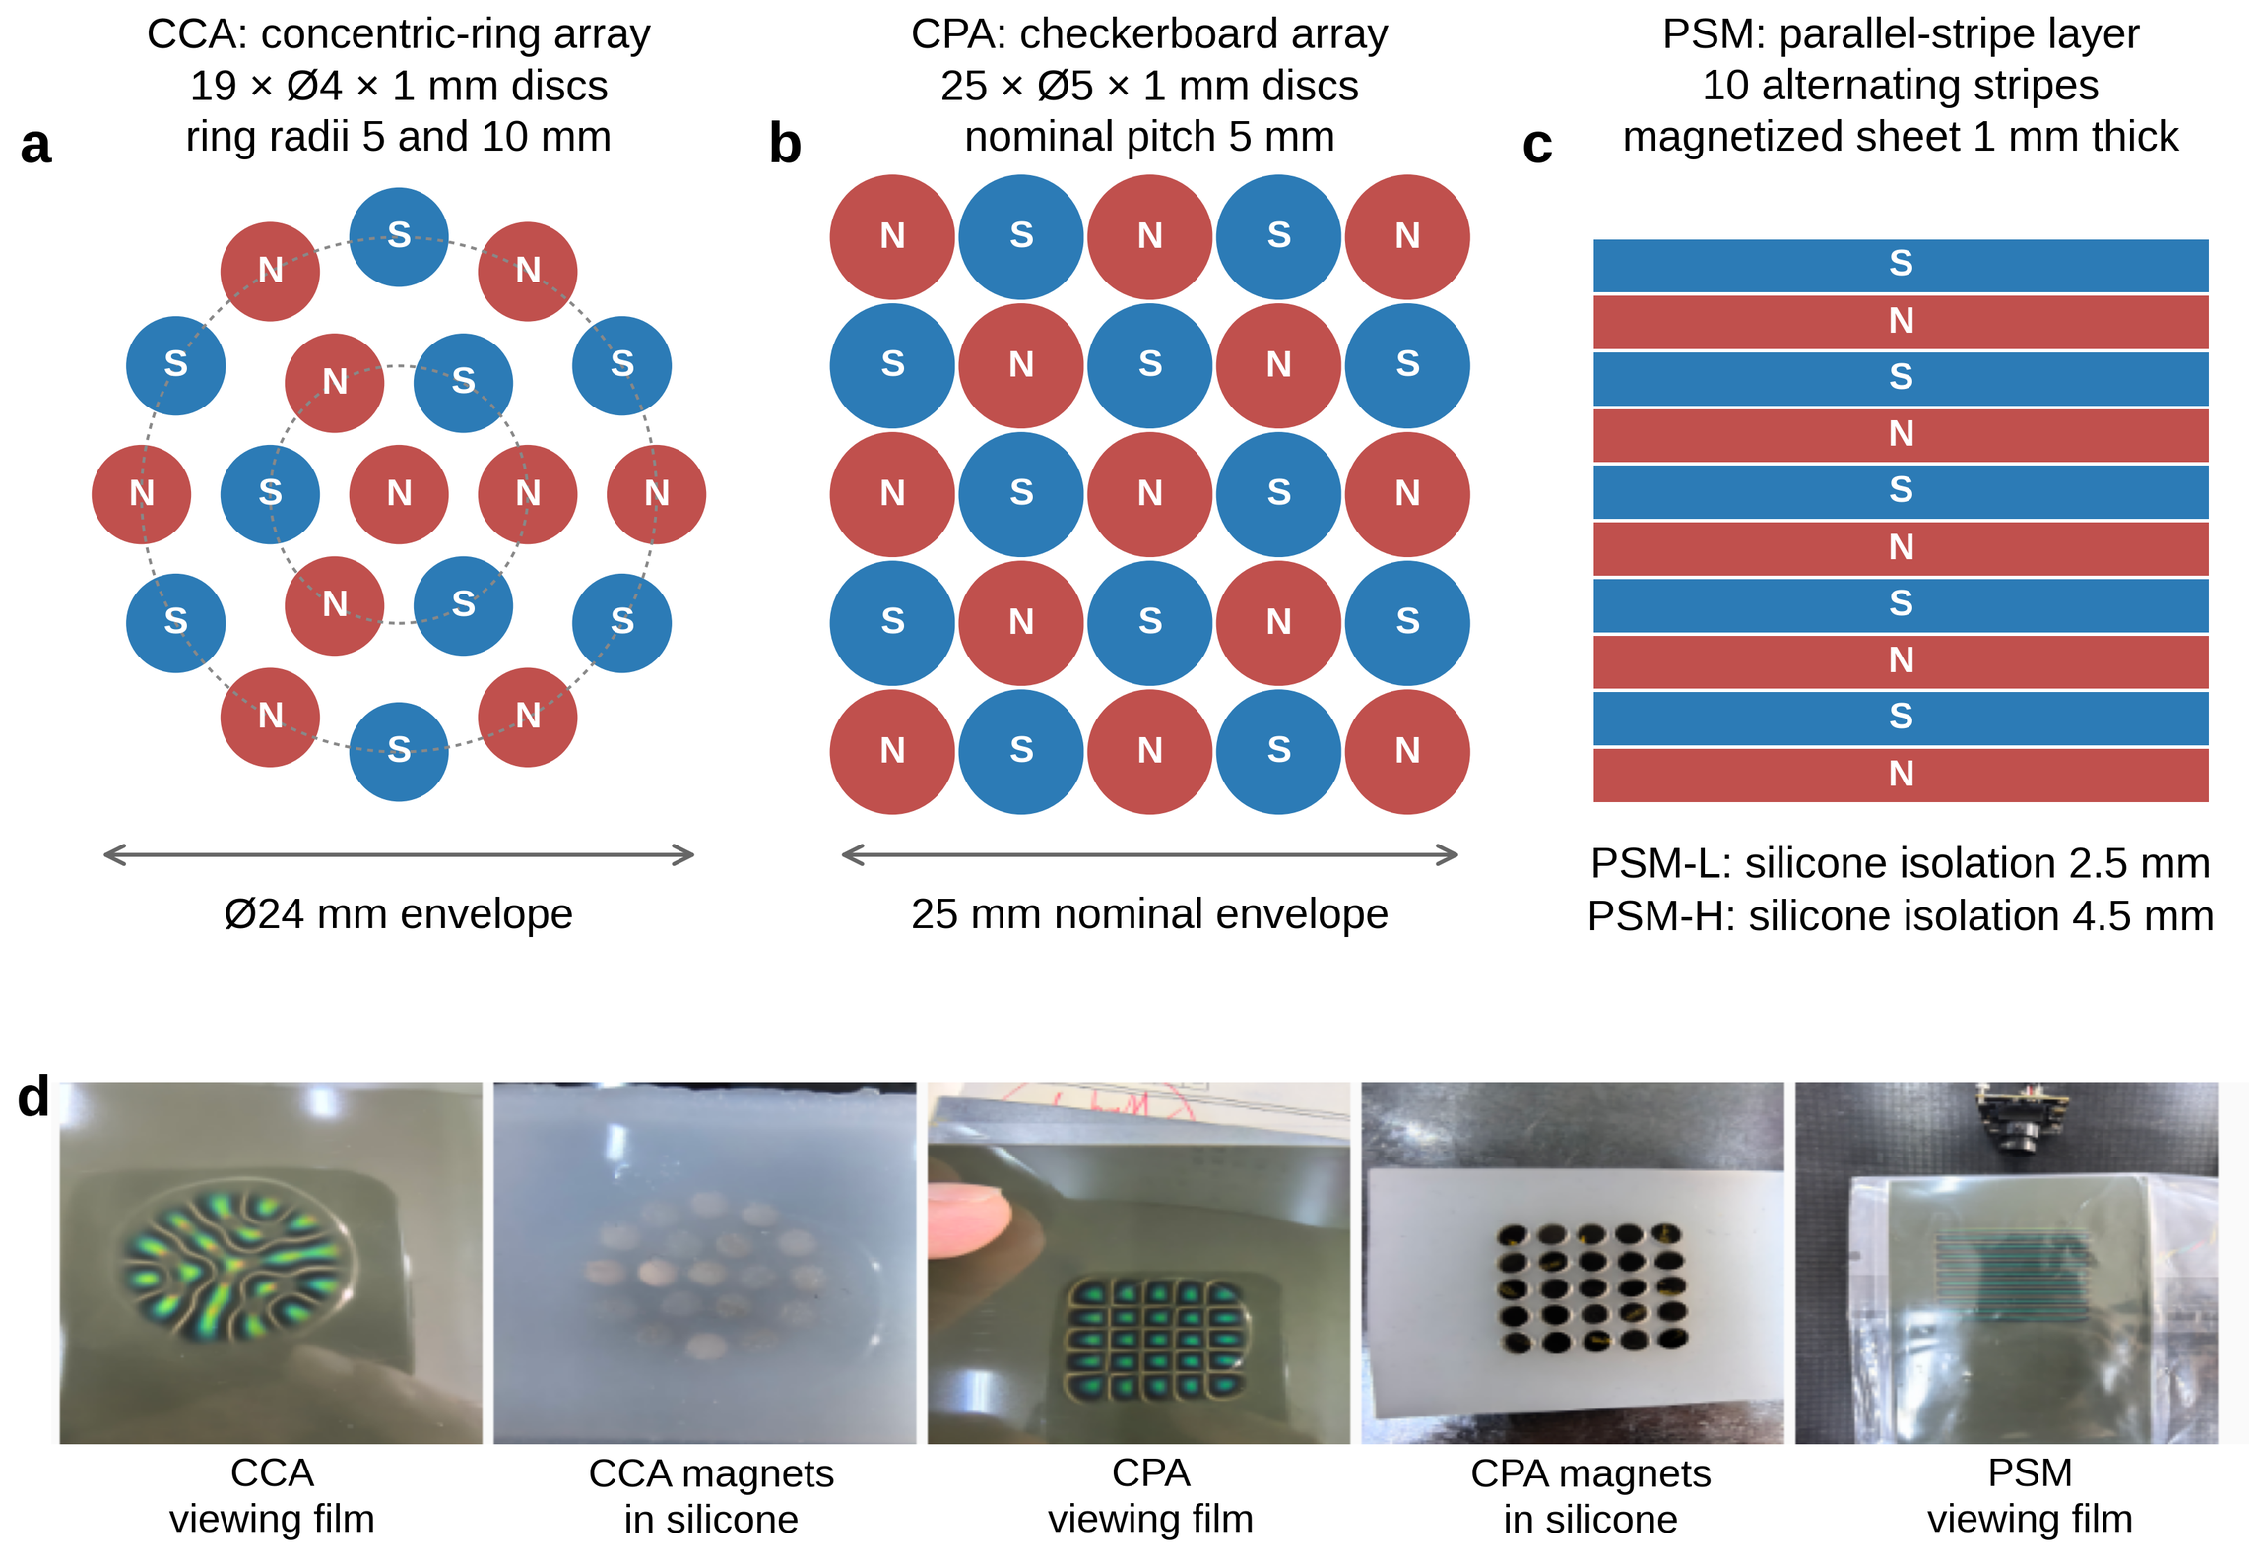
Fig. 1. Magnet layouts. (a–c) CCA, CPA and PSM; red and blue denote opposite polarities on one face, not field strength (PSM not to scale). (d) Photographs: viewing-film images (qualitative) and magnets embedded in silicone.
Readout and contact. The 46 × 56 mm composite specimen was evaluated over its central 20 × 20 mm. Five MLX90393 magnetometers [13] supplied 15 magnetic channels at S1–S5 = (−7.594, 7.594), (−7.594, −7.594), (7.594, 7.594), (7.594, −7.594) and (0, 1.406) mm relative to the center of the corner nodes; the measured S5 offset was retained (Fig. 2). Contact used a conical brass indenter with a measured 1 mm tip (4 mm maximum outer diameter, M6 × 1 thread, 13 mm long), and contact position denotes the indenter axis. The compliant material was C0005, a two-part platinum-cured silicone (supplier data: Shore C 5, A:B = 1:1, 30 min working time and 2–4 h cure at 25 °C; tensile strength 1.20 MPa, tear strength 6.30 N mm−1 and elongation 900%). CPA discs had a supplier-reported surface field of 1800 G (0.18 T); the magnet grade was not specified. These are supplier specifications, not measured specimen properties or a reconstructed cure history.
Acquisition configuration. The 67 successfully decoded per-device register snapshots for the released records specify GAIN = 5, HALLCONF = 12, RES_X/Y/Z = 0, DIG_FILT = 0, OSR = 0, OSR2 = 0 and temperature compensation disabled; the acquisition logs record a 400 kHz I2C clock and no temperature read in the magnetic cycle. A further 23 device readback entries contain diagnostic status errors and are retained without interpreting them as register values. The decoded snapshots take precedence over a legacy profile comment that mentioned gain 7. The requested magnetic period was 20 ms, whereas timestamps gave effective grouped rates of 37.82–38.59 frames s−1 for the 17 reported Session III records and 65.63 frames s−1 for static Trial 154. Across 111 unloaded 0.35-s windows in those Session III records, the median per-channel standard deviation was 6.62 μT (95th percentile 12.23 μT) and the median absolute early-to-late window shift was 3.48 μT (95th percentile 11.74 μT). Trial 154 gave corresponding medians of 6.66 and 3.75 μT over 441 windows. These short unloaded-window statistics do not quantify temperature drift, creep or long-term stability.
Positioning platform. The indenter was driven by the axes of a JGAURORA A5S desktop Cartesian 3D printer under host software that sent absolute-coordinate commands and logged time-stamped commands and events. The readout board sat in a printed holder on the platform (Fig. 2c), with the assembly center at platform coordinates (149.0, 147.0) mm and a contact-reference height Zc of 13.8 mm in Session III. Each trial moved to a safe height and the center, acquired an unloaded baseline, and then performed approach, indentation or XYZ motion, hold, retraction and re-centering, each move followed by a host wait. Contact moves were commanded at 0.5–2 mm s−1 with 0.5 s holds. Dynamic references were reconstructed from the command log and recorded timing. Consequently, the reported dynamic error is command-referenced trajectory reconstruction error: it includes platform tracking, controller timing, compliance and contact-patch effects and is not an independently metrologized absolute positioning error. Platform repeatability and backlash were not measured separately.
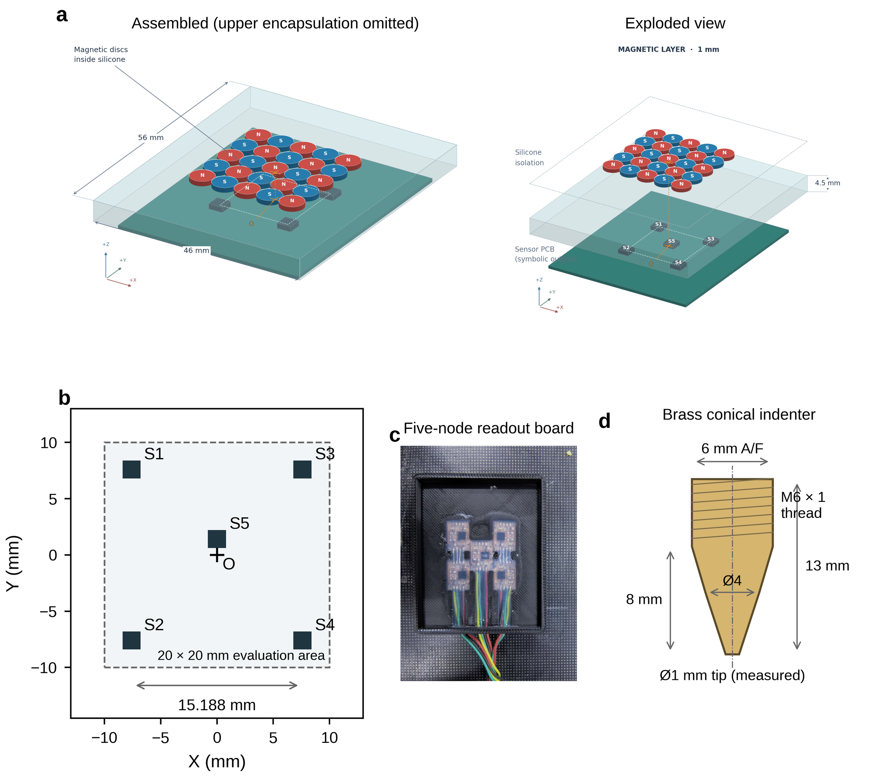
Fig. 2. Sensor structure. (a) Assembled and exploded CPA specimen (illustrative geometry, not a fabrication drawing or field simulation). (b) Positions of the five magnetometers and the 20 × 20 mm evaluation area. (c) Readout board. (d) Brass indenter; only dimensioned values are quantitative.

2.2 Coordinates and calibration
With assembly center (X_{c}, Y_{c}), contact-reference height Z_{c} set at initialization of each assembly, and platform coordinates (X_{p}, Y_{p}, Z_{p}), the contact coordinate is
 | $$q={\left(x,y,z\right)}^{⊤}={\left(X_{p}−X_{c}, Y_{p}−Y_{c}, Z_{c}−Z_{p}\right)}^{⊤}$$ | (1)
so depth z is positive downward. Calibration used the commanded depth stored with each contact. A single indenter visited grid positions (Fig. S1): 2-mm spacing gives 121 positions on 20 × 20 mm and 1-mm spacing 441, always with five physical nodes. Each contact comprised an unloaded move, a baseline, indentation, a hold and a lift. The baseline B₀ and the steady response are channel-wise medians from 180 to 20 ms before the press and before the end of the hold. Samples were organized by physical contact, so adjacent frames of one hold were never treated as independent.

2.3 Data sets and evaluation protocols
Layout libraries were collected in Session 0; dense calibration and a reserved repeat were collected in Session I; depth repeatability was recorded in Session II; and the reported motion and grid records were collected in Session III. An audit of 398 trial metadata files from 18–20 September identified ten transitions among CPA, CCA, PSM-L and PSM-H; the operator record confirms that the relevant layer changes involved physical removal and reassembly. CPA reappeared at Trial 148 and at S20260919 Trials 013, 054 and 113, with Trials 054 and 113 explicitly labelled five_point_reassembly. Trials 26–39 of S20260920 share one saved registration after the final CPA restoration; that shared transform defines a record group and does not imply that the entire study contained only one physical reassembly. The present records do not constitute repeated, identical-protocol remount cycles and therefore do not estimate a cross-remount performance distribution. For the configuration comparison, 36 anchor positions (4-mm grid; 216 contacts at 0.2/0.5/0.8 mm) of each 121-position library fitted each model and selected its hyperparameters by leave-one-position-out validation; all depths and repeats of the other 85 positions (510 contacts) formed the test set. The dense-calibration test was a complete 441-position repeat at 0.4 mm (Trial 154), recorded in the same session as training Trials 149, 150 and 153 and excluded from fitting and selection. Dynamic results are reported only for the records used in the figures, tables and stated claims; development, aborted and unpublished trials are not treated as one prospectively defined evaluation cohort.

2.4 Decoders
The five-node reading B (15 channels) gives the baseline difference, amplitude and unit response
 | $$ΔB=B−B_{0}, A=∥ΔB∥_{2}, u=\frac{ΔB}{max\left(A,ε\right)}$$ | (2)
with A in μT and ε = 10⁻¹² μT a numerical guard. Position changes the inter-channel structure of the response, whereas depth changes amplitude and, less, shape; normalization reduces the effect of amplitude on position matching. The unit responses of all contacts at calibration position j were averaged and renormalized to a shape center c_{j}. With M centers and node coordinate matrix P, a regularized Gaussian RBF regression [14] is used:
 | $$K_{ij}=exp​\left(−γ∥c_{i}−c_{j}∥_{2}^{2}\right), W={\left(K+λ_{xy}I\right)}^{−1}P$$ | (3)
 | $$\hat{p}\left(u\right)=\sum_{j=1}^{M}{exp}​\left(−γ∥u−c_{j}∥_{2}^{2}\right)w_{j}$$ | (4)
The output is continuous between nodes. The 441-node regression is DC-RBF (dense calibration), and the regression on the 121-node 2-mm subgrid of the same source is SC-RBF (sparse calibration); their hyperparameters were chosen on training data only and then frozen. SC-RBF and DC-RBF use the same shape-normalized Gaussian-RBF mapping code and differ in calibration density, training contacts and frozen parameter values. The 0.288 mm headline result uses only the frozen 441-node DC-RBF with Trial 154. Depth uses L = ln max(A, 10−6 μT) and a 32-dimensional feature vector
 | $$ϕ={\left[u^{⊤}, L, L^{2}, {\left(uL\right)}^{⊤}\right]}^{⊤}$$ | (5)
which is standardized and fitted by ridge regression [15] with an unpenalized intercept, so the depth-amplitude relation varies with response direction. A workspace-constrained parameter instance, WD-RBF, uses the same core RBF mapping calibrated on the 0.4 and 0.6 mm levels and outputs a position only when the amplitude (≥ 291.7 μT) and shape-cosine (≥ 0.9853) gates are passed; frames failing a gate remain invalid and in the coverage denominator. The pooled DC-RBF is another frozen instance of the same RBF framework fitted to a different calibration pool. WD-Causal is identified separately because it adds a history-dependent residual branch to a static kernel-ridge estimate; it was fitted on nine Session I recordings and on no Session III record. These bookkeeping distinctions do not imply that the paper compares different regression families or claims that RBF is superior to neural networks.
Each assembly is registered to the platform frame with contacts at the center and four known points. With p_{i} the median hold-phase prediction and q_{i} the platform position of the i-th registration contact, a rigid planar transform is estimated in closed form [16]:
 | $$\left(\hat{R},\hat{t}\right)=arg\min_{R∈SO\left(2\right), t}\sum_{i=1}^{5}{{∥Rp_{i}+t−q_{i}∥}_{2}^{2}}$$ | (6)
It leaves z unchanged. Session III transforms contained rotations of 0.5°–10.5° and translations of about 1–2.7 mm. These values are coordinate-transform magnitudes, not registration errors. Each transform was fixed for its record group before test errors were inspected and was never refitted to a reported trajectory, so any remaining registration error is included in the reported command-referenced error. The five registration-point residuals were not retained for these historical records. Future acquisitions should save the commanded and predicted registration points, fit residuals and registration time.

2.5 Metrics, references and statistics
The command-referenced planar error is the Euclidean distance between prediction and the programmed, time-interpolated platform position, averaged over contacts or valid motion frames. We also report the median, 95th percentile (P95) and root-mean-square error (RMSE); depth error is the mean absolute error (MAE) of z, and three-dimensional error is the mean Euclidean XYZ distance. Static intervals are descriptive 95% percentile intervals from 5000 nonparametric bootstrap resamples [17]. Dynamic references were reconstructed frame by frame from command start time, velocity and estimated segment run time, with a 50-ms start guard except for short circle segments. Circles comprised 128 straight segments with a host wait after each and were not constant-speed motions. Coverage is the fraction of frames in the commanded window with valid decoder output; invalid frames remain in the denominator. Repeatability is the mean difference between two executions at equal commanded progress. No test trajectory was translated, rotated or otherwise aligned after decoding.
Field diagnostics were computed on the 0.5 and 0.8 mm levels of each 121-position library from the planar Jacobian of the unit response and the repeat-difference covariance: the whitened minimum gradient σ_{min} (mm⁻¹) describes the most weakly resolved local direction, and δ_{NL} is the single-frame noise-limited position bound under Gaussian noise [18] (Section S1.4).

3 Results

3.1 Magnet layout and spatial encoding
On 510 unseen contacts per tested structural configuration, all outputs were valid (Table 1). Under the present five-node readout, acquisition protocol and per-configuration parameter selection, CPA produced the lowest mean and median planar errors and the lowest depth error. Its median (0.364 mm) was 41% below that of CCA (0.614 mm), whereas the P95 values differed by 7% (1.505 versus 1.611 mm), and CPA produced one large outlier (8.08 mm versus 2.7–4.1 mm for the others). Because magnet volume, geometry, specimen identity and selected parameters were not matched as controlled factors, this is a configuration-level association rather than a causal ranking of layout alone.
Table 1. Localization error on 510 unseen contacts per tested structural configuration (36 anchor positions for fitting and 85 for testing) and field diagnostics from the same libraries (σmin: whitened minimum gradient; cosine: shape similarity between 0.5 and 0.8 mm; δNL: noise-limited bound).
Configuration | XY mean (mm) | XY median (mm) | XY P95 (mm) | Z MAE (mm) | σ_{min} median (mm⁻¹) | σ_{min} P10 (mm⁻¹) | Cosine (median) | δ_{NL} (mm)
CCA | 0.714 | 0.614 | 1.611 | 0.0634 | 9.28 | 4.33 | 0.99865 | 0.126
CPA | 0.534 | 0.364 | 1.505 | 0.0575 | 8.98 | 6.50 | 0.99966 | 0.136
PSM-L | 0.930 | 0.795 | 2.124 | 0.0897 | 9.89 | 5.90 | 0.99798 | 0.121
PSM-H | 1.189 | 0.920 | 2.994 | 0.0864 | 6.28 | 4.74 | 0.99636 | 0.182
CPA did not have the largest median gradient (8.98 mm−1 versus 9.89 for PSM-L), but it had the highest low-percentile gradient (P10 6.50 mm−1), the lowest local condition number (1.57 versus 1.69–1.95) and the highest cross-depth shape similarity (Fig. 3). CCA had the largest median amplitude (1504 μT versus 1066 μT for CPA), so the performance ordering did not follow response strength. Measured errors were 4–8 times the noise-limited bound, which did not rank the configurations in the same order. These diagnostics are retrospective associations across four tested configurations and are not a demonstrated physical mechanism. CPA was used in the subsequent experiments.
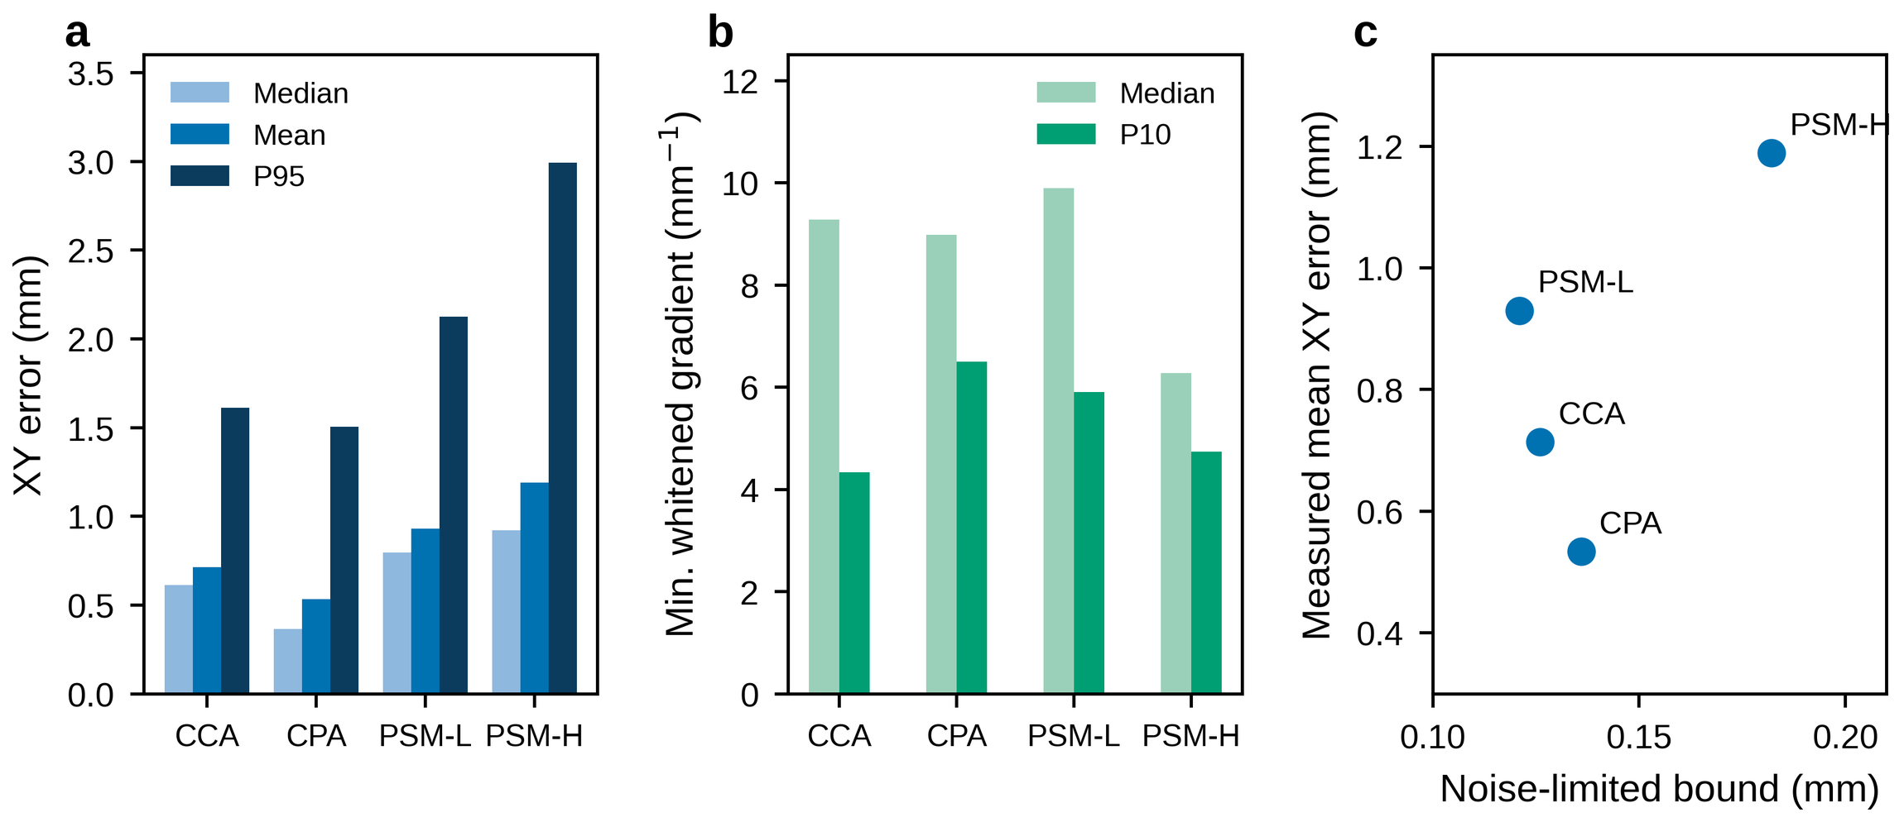
Fig. 3. Layout comparison. (a) Median, mean and 95th-percentile planar error. (b) Median and 10th-percentile whitened minimum gradient. (c) Mean planar error against the noise-limited bound δ_{NL}.

3.2 Dense calibration and static localization
On all 441 reserved repeat contacts at 0.4 mm (Trial 154), the 1-mm DC-RBF gave a mean planar error of 0.288 mm (descriptive 95% bootstrap interval 0.266–0.313 mm), median 0.223 mm, P95 0.790 mm and RMSE 0.380 mm, with X/Y/Z MAEs of 0.163/0.206/0.0315 mm (Table 2, Fig. 4). The SC-RBF fitted to the same source, with its own selected hyperparameters (Table S1), gave 0.349 mm (0.325–0.376 mm). The paired reduction was 0.061 mm (0.045–0.077 mm), or 17.5%, and the DC-RBF was more accurate on 294 of 441 contacts (66.7%). No contact was removed on the basis of prediction error.
Table 2. Static localization on 441 held-out repeat contacts (Trial 154, 0.4 mm); brackets give descriptive 95% bootstrap intervals.
Calibration | Training contacts | X MAE (mm) | Y MAE (mm) | XY mean (mm) | XY median (mm) | XY P95 (mm) | XY RMSE (mm) | Z MAE (mm)
SC-RBF, 121 nodes | 363 | 0.208 | 0.239 | 0.349 [0.325, 0.376] | 0.280 | 0.866 | 0.444 | 0.0337
DC-RBF, 441 nodes | 1322 | 0.163 | 0.206 | 0.288 [0.266, 0.313] | 0.223 | 0.790 | 0.380 | 0.0315
This is an independent-repeat localization test at previously calibrated coordinates and a commanded indentation of 0.4 mm: every DC-RBF test position lies on its 1-mm grid, but the complete Trial 154 recording was excluded from fitting and parameter selection. A post hoc split of the frozen predictions into the 121 SC-RBF nodes and the other 320 positions gave 0.358 and 0.346 mm for SC-RBF and 0.301 and 0.283 mm for DC-RBF. The dense-calibration benefit therefore appears on both subsets, but it is the combined effect of denser spatial coverage and more training contacts and is not an unseen-position or unseen-depth generalization result. In a direct response comparison at the 440 coordinates available in both Trial 153 and Trial 154, the median cosine between the 15-channel unit responses was 0.99942 and the median amplitude change was +0.36% (95th percentile absolute relative change 2.80%). These values describe repeat response variation and are not an independent estimate of platform positioning error. For calibrated-node output, DPL identified 412 of the 441 Trial 154 contacts (93.42%) with 0.0731 mm mean node error; it uses a different 2489-contact library and output task and is not a continuous-resolution claim or a density ablation.
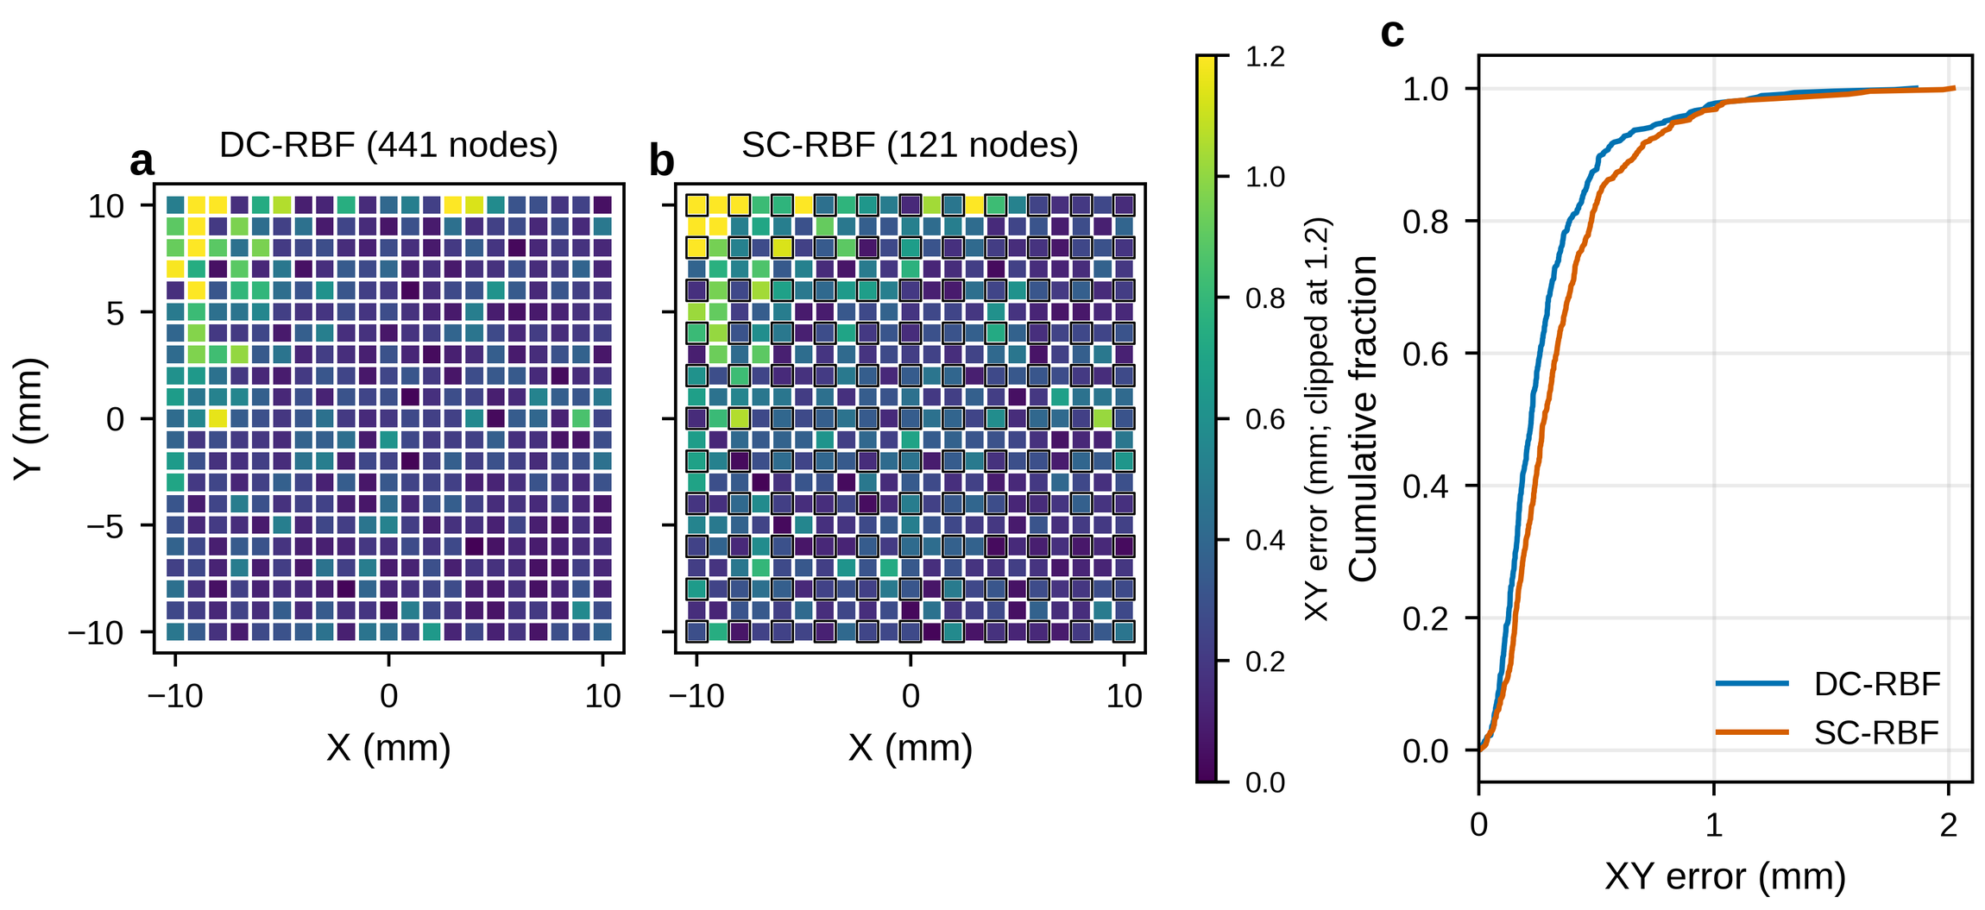
Fig. 4. Static localization error on the 441 held-out repeat contacts (post hoc analysis of frozen models). (a, b) Planar error per position for the DC-RBF and SC-RBF; outlines mark the 121 SC-RBF nodes. (c) Cumulative distribution.
Table 3 compares static position with static position and displacement with displacement while also listing the stated position-reference protocol. The present X/Y MAEs (0.163/0.206 mm) and Z MAE (0.0315 mm) are numerically below the 1.15/1.16/0.25 mm of Hellebrekers et al. [7] and above the X/Y MAEs of 0.09/0.11 mm of Yan et al. [8]. Areas, indentation ranges, calibration budgets, data splits and reference protocols differ, so the table is contextual rather than a ranking. The present values remain explicitly command-referenced, and a force error is not converted into an indentation error.
Table 3. Published static localization and indentation results beside the present independent-repeat test. Metrics retain their original definitions. The final column states the position reference reported in the checked experimental method and whether separate external position metrology was reported.
Study | Nodes (area) | Position error | Depth error | Position reference / separate external position metrology
Hellebrekers et al. [7] | 5 nodes and a reference (40 × 40 mm) | MAE X/Y 1.15/1.16 mm | Z MAE 0.25 mm | Automated loading coordinates / not reported in checked protocol
Yan et al. [8] | 9 triaxial Hall taxels (18 × 18 mm) | X/Y MAE 0.09/0.11 mm (fivefold) | Position-conditioned lookup; Z MAE not reported in the checked text | Programmed indentation grid / not reported in checked protocol
Hu et al. [9] | 16 (220 × 220 mm) | About 1.2 mm average | Force response reported | Electric XYZ stage; digital force gauge for force / position metrology not reported
This study, DC-RBF | 5 (20 × 20 mm) | MAE X/Y 0.163/0.206 mm; XY mean 0.288 mm | Z MAE 0.0315 mm | Printer commands and time interpolation / not performed

3.3 Tangential and planar trajectories
In 0.6 mm, 6 mm cross scans (Table 4), the WD-RBF gave a mean planar error of 0.510 mm (P95 0.964 mm) against 0.855 mm for the SC-RBF, with coverage 97.4% and 100% and a larger depth error (0.0789 versus 0.0498 mm). This compares two single records, not an ablation. The causal decoder gave 0.453 mm in the eight-direction scan of radius 4 mm (0.466 and 0.440 mm for the two executions; Fig. 5a) and, in segmented circles, 0.407 mm for r = 2 mm and 0.772 mm for r = 4 mm (0.390 and 0.752 mm including host waits). A third circle, r = 5 mm, gave 1.129 mm, so error rose with radius. The mean radial deviation from the commanded circle was 0.25, 0.43 and 0.63 mm (fitted radii 2.22, 4.06 and 4.83 mm). The planar error exceeded the radial deviation, so part of it lies along the path, where the timing-based reference contributes uncertainty that cannot be assigned to the sensor alone. With the pooled DC-RBF, larger-range records had coverage of 81–88% and errors of 0.77 mm (Fig. S3). The circles are recognizable but distorted, and the radius dependence is consistent with larger static errors near the edge (Fig. 4a).
Table 4. Tangential and planar records (Session III), 0.6 mm depth. Errors are for valid frames; circles use moving segments. Run-to-run: mean XY difference between the two executions at equal commanded progress.
Trial | Decoder | Motion | XY mean (mm) | Z MAE (mm) | Coverage (%) | Run-to-run XY (mm)
4 | SC-RBF | Cross scan, 6 mm travel | 0.855 | 0.0498 | 100.0 | –
5 | WD-RBF | Cross scan, 6 mm travel | 0.510 | 0.0789 | 97.4 | –
17 | WD-Causal | Eight directions, r = 4 mm | 0.453 | 0.0556 | 100.0 | 0.174
18 | WD-Causal | Circle, r = 2 mm | 0.407 | 0.0485 | 100.0 | 0.226
20 | WD-Causal | Circle, r = 4 mm | 0.772 | 0.0829 | 100.0 | 0.209
19 | WD-Causal | Circle, r = 5 mm | 1.129 | 0.1062 | 100.0 | 0.231
37 | Pooled DC-RBF | Eight directions, r = 8 mm | 0.771 | 0.1294 | 88.1 | 0.812
38 | Pooled DC-RBF | Circle, r = 4 mm | 0.770 | 0.0992 | 81.1 | 0.216
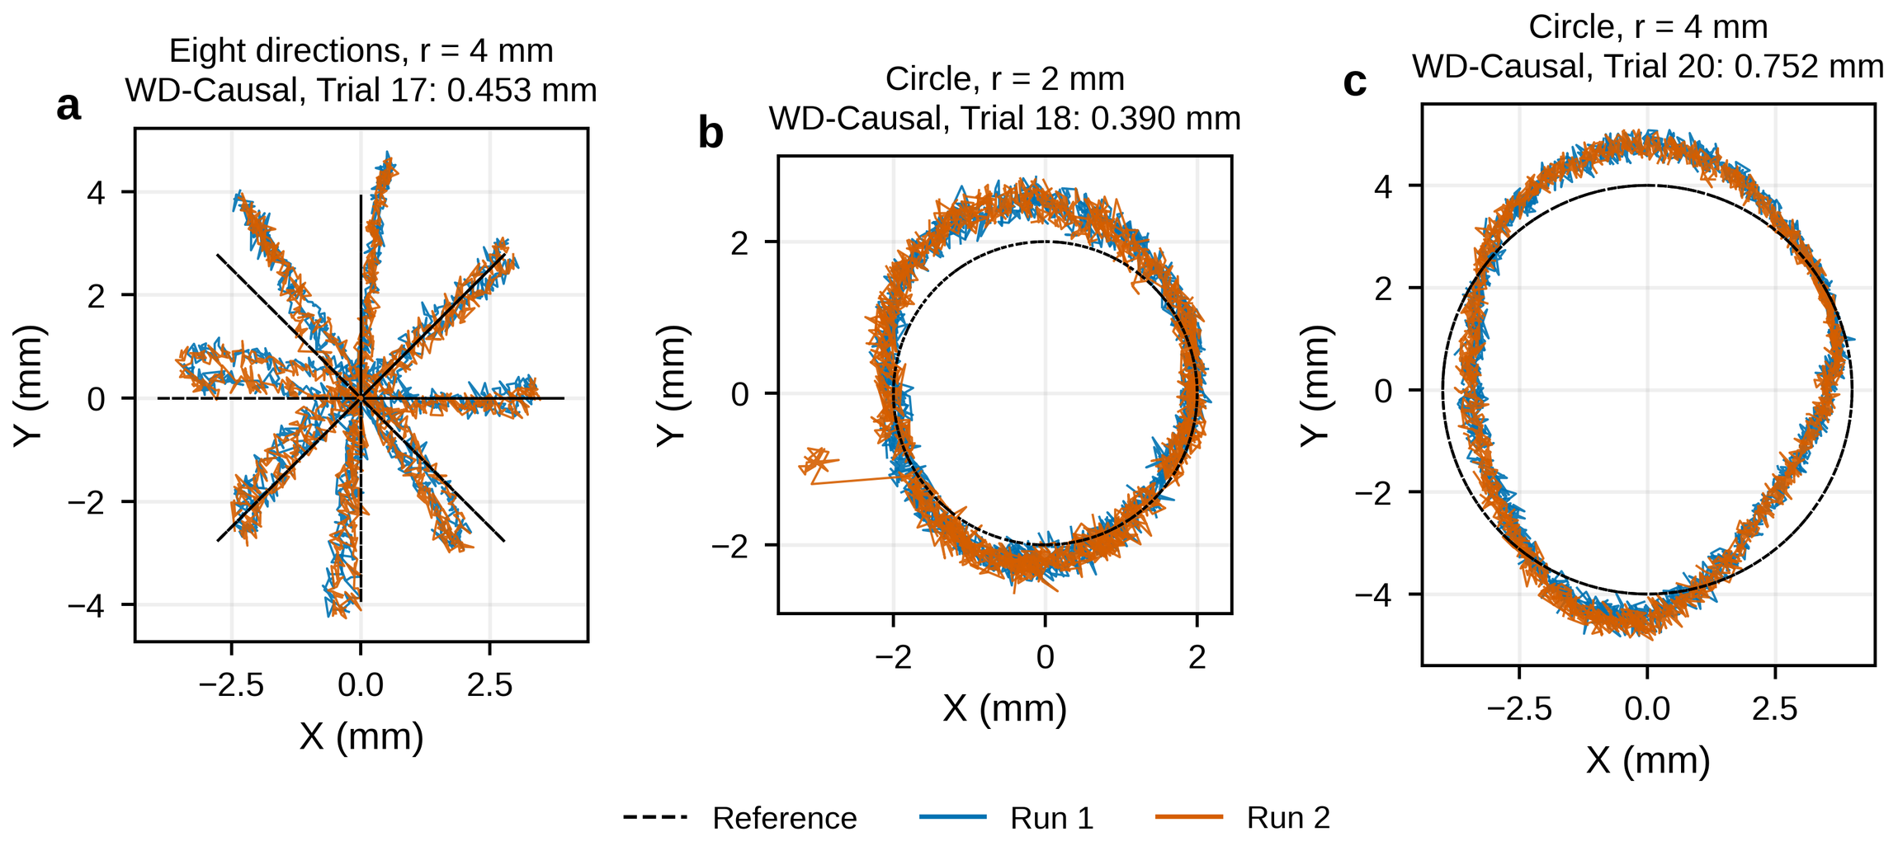
Fig. 5. Decoded planar trajectories of the causal decoder. (a) Eight directions, r = 4 mm (Trial 17). (b) Circle r = 2 mm (Trial 18) and (c) r = 4 mm (Trial 20). The command is dashed; no fitting was applied to the outputs.

3.4 Three-dimensional trajectories
Eight compound-action records (Trials 26, 28, 30, 31, 32, 34, 35 and 36) are reported as representative command-referenced trajectory demonstrations using the saved pooled DC-RBF, gate and registration. They were not preregistered as a prospectively defined all-direction benchmark and are not used to estimate an all-direction success rate or unknown-trajectory generalization. Trial 32, a ramp of (+8, −8, +1.2) mm at 1 mm s−1 (Fig. 6), gave three-dimensional errors of 0.564 and 0.574 mm for its two executions (overall 0.569 mm), a planar error of 0.561 mm (P95 1.03 mm), a depth MAE of 0.0725 mm and 1091 valid outputs from 1092 frames. Correlations with the command were 0.994–0.996 for X and Y and 0.998 for Z; at equal progress, the executions differed by 0.365 mm in the plane and 0.0131 mm in depth. Larger scatter during the first two seconds, an increasing Y deviation near the end and a positive depth offset show that the aggregate error does not imply uniform performance along the path.
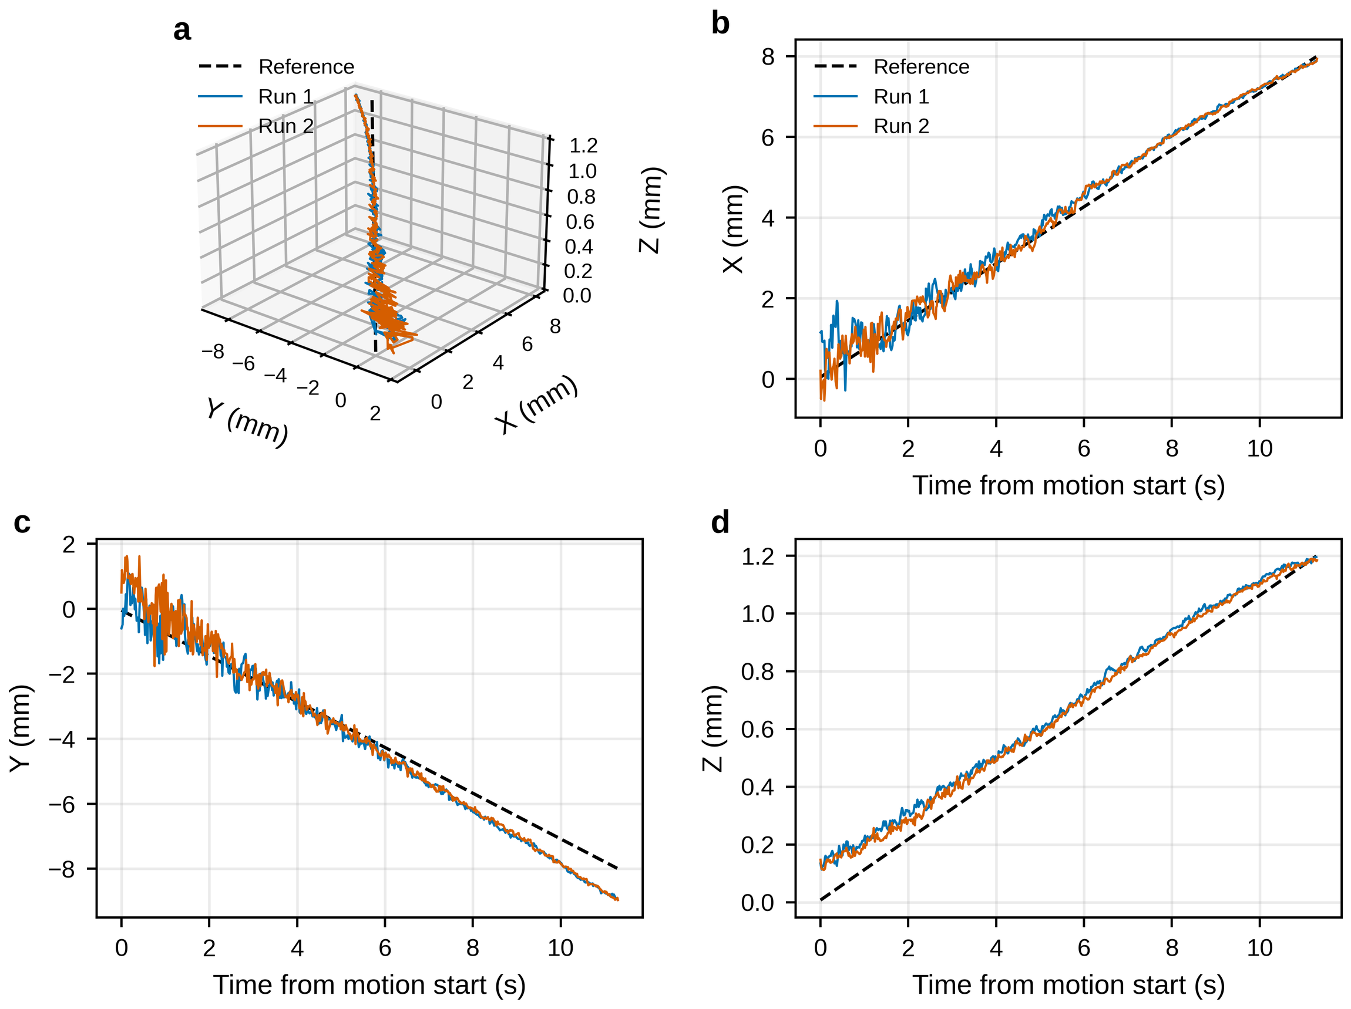
Fig. 6. Simultaneous XYZ motion (Trial 32; increment (+8, −8, +1.2) mm). (a) Three-dimensional path and (b–d) X, Y and Z time series of two executions; the reference is reconstructed from the platform command.
For these eight explicitly listed actions, output coverage ranged from 98.74% to 100%, and the command-referenced mean three-dimensional error ranged from 0.569 to 0.796 mm (median 0.710 mm). These ranges describe only the reported actions in the tested workspace. The motions couple indentation with radial position, and maximum commanded indentations of 1.0–1.4 mm exceed the 0.2–0.8 mm calibration range; edge effects and depth extrapolation therefore cannot be separated. Repeating the same eight actions would strengthen repeatability evidence but would not by itself remove action-set selection effects. A confirmatory benchmark, if pursued, would require a new action set defined independently of these results, frozen parameters and unconditional reporting of every action in that new set.

3.5 Cross-session grid, registration sensitivity and depth repeatability
Trial 39 is an 81-position grid (central 16 × 16 mm, 2-mm pitch and 0.6 mm commanded indentation) recorded after magnetic-layer reassembly and five-point registration; all 81 contacts produced valid output. Its command-referenced mean planar error was 0.728 mm (P95 1.154 mm), X/Y MAEs were 0.398/0.538 mm, depth MAE was 0.106 mm and biases were (+0.251, +0.170, +0.105) mm. It belongs to the same saved model-and-registration group as Trials 26–38 and is one result after reassembly, not a universal expectation for every remount. Its difference from the 0.288 mm reserved-repeat result cannot be attributed to reassembly alone because depth, grid, model library and acquisition conditions differ. Registration sensitivity analysis changed mean planar error by 0.01–0.05 mm for ±1° rotation and by 0.13–0.44 mm for ±0.5 mm translation. A joint fit over the eight reported XYZ records lowered the mean from 0.689 to 0.675 mm, indicating that a single global rigid adjustment explains little of the residual. The four causal-decoder records showed a common residual rotation of about 6° and should be rechecked in future acquisition. At the center, Trials 133 and 134 yielded depth MAEs of 0.0309 and 0.0308 mm and a mean between-record difference of 0.00565 mm; this demonstrates local repeatability but not whole-area or cross-remount repeatability.

4 Discussion
Configuration and encoding. Under one readout and protocol, CPA produced the lowest error among the four tested structural configurations and also showed the highest cross-depth shape similarity and low-percentile normalized-response gradient. Because CPA and CCA did not have matched magnet volume, each configuration used one specimen and parameter selection was performed per configuration, the data support a configuration-level association rather than a universal layout optimum or a causal field mechanism. Matched-volume specimens, repeated fabrication and simulation would be needed only for that stronger claim.
Static accuracy and transfer. The 0.288 mm value is a localization error on independent physical contacts at calibrated positions, neither a training residual nor merely a repeatability statistic; the dense-model advantage holds at sparse-node and between-node positions, but a separate unseen-position test of the dense map remains desirable. Results after reassembly are less favorable (0.728 mm for the grid; 1.17 mm for an older library), but depth, grid, library and acquisition also differ, so part of the difference cannot be assigned to assembly. A practical system may still need re-calibration or adaptation, as studied for replaceable skins [10,11].
Dynamic behavior. Multiple magnetic-layer switches and physical reassemblies occurred between the dense calibration and later CPA tests. After the final CPA restoration and five-point registration, the eight reported representative XYZ actions yielded 0.569–0.796 mm command-referenced three-dimensional errors and 98.74–100% coverage. Their common saved registration defines the evaluation group; it does not imply that only one reassembly occurred. These records are demonstrations of the listed actions rather than a prospectively defined all-direction benchmark, and the study does not estimate an identical-protocol cross-remount distribution. Residual depth offset, larger errors near some workspace edges and the approximately 6° residual rotation in the earlier causal group identify concrete targets for improved calibration. Hysteresis, creep, temperature effects and long-term drift were not measured.
Limitations. (i) One specimen was tested per structural configuration, with single-point contact from a 1 mm indenter; detailed dynamic validation covers CPA only. (ii) Dynamic errors are referenced to programmed and time-interpolated platform motion, so they include platform tracking, controller timing, compliance and contact-patch effects; independent external position metrology was not performed, and the values are not absolute metrological accuracy. (iii) The contact-reference height was set during initialization; force, whole-surface deformation, simultaneous multi-contact sensing and batch variability were outside the task. (iv) Supplier specifications are not measured material properties. (v) RBF branches share one core mapping framework but use different calibration pools and frozen parameter instances; incompatible tasks are not pooled. (vi) Bootstrap intervals treat grid contacts as independent and are descriptive. (vii) The eight representative XYZ actions are not a prospective all-direction benchmark, and the existing reassembly records do not form repeated identical-protocol remount cycles. Future work may add independently metrologized motion when absolute accuracy is the target, a prospectively defined action set, replicated matched-volume specimens, saved registration residuals, and multi-cycle hold-and-recovery tests for hysteresis and creep.

5 Conclusions
This study asked how layout shapes spatial encoding, whether dense calibration improves accuracy, and whether a static response map supports continuous three-dimensional tracking.
Tested configurations. With one five-node readout and a grouped spatial holdout, CPA produced the lowest mean planar error on unseen positions (0.534 mm versus 0.714–1.189 mm) together with the most stable cross-depth response and the highest low-percentile gradient among the four tested configurations. Because magnet volume and specimen identity were not matched, this is an association under the present protocol rather than a causal ranking of layout alone.
Calibration density. One frozen 441-node DC-RBF gave a command-referenced mean planar error of 0.288 mm and a depth MAE of 0.0315 mm on all 441 contacts of reserved Trial 154 at previously calibrated coordinates and 0.4 mm commanded indentation. This was 17.5% lower than a 2-mm same-source calibration on the same test contacts. A separate node decoder correctly classified 93.42% of calibrated nodes; its 0.0731 mm node error is not a continuous-resolution claim.
Continuous tracking. After documented magnetic-layer reassembly and five-point registration, eight representative XYZ actions gave command-referenced mean three-dimensional errors of 0.569–0.796 mm with 98.74–100% output coverage. The causal decoder gave 0.453 mm in an eight-direction action and 0.407–1.129 mm on segmented circles as radius increased; an 81-position post-reassembly grid gave 0.728 mm planar error. These values apply to the listed actions, models, workspaces and command-reference protocol and are not an all-direction success rate or absolute metrological accuracy.
Implications. Under the reported calibration and test conditions, the five-node shape-normalized RBF decoder achieved submillimeter static localization and command-referenced trajectory reconstruction without using a deep neural network. This is a feasibility result for the implemented sensor-decoder system; it does not claim that RBF outperforms neural networks or that deep learning is generally unnecessary. Stronger claims about universal configuration ranking, cross-remount repeatability or absolute positioning would require the corresponding controlled experiments.
CRediT authorship contribution statement
[Author A: Conceptualization, Methodology, Investigation, Software, Formal analysis, Writing – original draft. Author B: Supervision, Funding acquisition, Writing – review and editing. To be completed for all authors.]
Declaration of competing interest
[The authors declare that they have no known competing financial interests or personal relationships that could have appeared to influence the work reported in this paper. (Confirm; also complete Elsevier’s declarations tool.)]
Funding
[This work was supported by … [grant number …]. / This research did not receive any specific grant from funding agencies in the public, commercial, or not-for-profit sectors.]
Data availability
The public repository contains every record used in the manuscript, including the eight representative compound actions, together with contact-level static data, compact dynamic predictions and command-derived references, selected unloaded baseline windows, hardware snapshots, remount evidence, frozen model parameters, configuration files and scripts needed to reproduce the reported tables, figures and summary metrics: https://github.com/googo2025/MagTouch-RA-3d-trajectory-recon [20], release tag sna-a-revision-2026-09-21. Development logs, aborted runs and unpublished configurations that do not support a manuscript claim are outside the release scope and remain internal research assets. The compact dynamic release reproduces recorded-output metrics and does not contain every original magnetic time stream.
Declaration of generative AI and AI-assisted technologies in the manuscript preparation process
[During the preparation of this work the author(s) used Claude (Anthropic) and Codex (OpenAI) to assist with manuscript restructuring, language editing, analysis-code preparation and reproducibility checks. Scientific figures were plotted from recorded data by reproducible scripts; no experimental image was generated or altered. The authors reviewed and edited the output and take full responsibility for the published content. (Author to confirm or amend according to journal policy.)]
Acknowledgements
[Acknowledgements, if any.]
References
[1] R.S. Dahiya, G. Metta, M. Valle, G. Sandini, Tactile sensing—from humans to humanoids, IEEE Trans. Robot. 26 (2010) 1–20.
[2] W. Yuan, S. Dong, E.H. Adelson, GelSight: high-resolution robot tactile sensors for estimating geometry and force, Sensors 17 (2017) 2762.
[3] M. Lambeta, P.-W. Chou, S. Tian, et al., DIGIT: a novel design for a low-cost compact high-resolution tactile sensor with application to in-hand manipulation, IEEE Robot. Autom. Lett. 5 (2020) 3838–3845.
[4] T.P. Tomo, M. Regoli, A. Schmitz, et al., A new silicone structure for uSkin—a soft, distributed, digital 3-axis skin sensor and its integration on the humanoid robot iCub, IEEE Robot. Autom. Lett. 3 (2018) 2584–2591.
[5] H. Wang, G. de Boer, J. Kow, et al., Design methodology for magnetic field-based soft tri-axis tactile sensors, Sensors 16 (2016) 1356.
[6] T. Hellebrekers, O. Kroemer, C. Majidi, Soft magnetic skin for continuous deformation sensing, Adv. Intell. Syst. 1 (2019) 1900025. https://doi.org/10.1002/aisy.201900025.
[7] T. Hellebrekers, N. Chang, K. Chin, M.J. Ford, O. Kroemer, C. Majidi, Soft magnetic tactile skin for continuous force and location estimation using neural networks, IEEE Robot. Autom. Lett. 5 (2020) 3892–3898. https://doi.org/10.1109/LRA.2020.2983707.
[8] Y. Yan, Z. Hu, Z. Yang, W. Yuan, C. Song, J. Pan, Y. Shen, Soft magnetic skin for super-resolution tactile sensing with force self-decoupling, Sci. Robot. 6 (2021) eabc8801. https://doi.org/10.1126/scirobotics.abc8801.
[9] H. Hu, C. Zhang, X. Lai, H. Dai, C. Pan, H. Sun, D. Tang, Z. Hu, J. Fu, T. Li, P. Zhao, Large-area magnetic skin for multi-point and multi-scale tactile sensing with super-resolution, npj Flex. Electron. 8 (2024) 42. https://doi.org/10.1038/s41528-024-00325-z.
[10] R. Bhirangi, T. Hellebrekers, C. Majidi, A. Gupta, ReSkin: versatile, replaceable, lasting tactile skins, Proc. Mach. Learn. Res. 164 (2022) 587–597.
[11] R. Bhirangi, V. Pattabiraman, E. Erciyes, Y. Cao, T. Hellebrekers, L. Pinto, AnySkin: plug-and-play skin sensing for robotic touch, arXiv preprint, arXiv:2409.08276, 2024.
[12] H. Sun, G. Martius, Guiding the design of superresolution tactile skins with taxel value isolines theory, Sci. Robot. 7 (2022) eabm0608. https://doi.org/10.1126/scirobotics.abm0608.
[13] Melexis N.V., MLX90393 Triaxis magnetic node datasheet, Revision 012, 18 November 2025. https://media.melexis.com/-/media/files/documents/datasheets/mlx90393-datasheet-melexis.pdf.
[14] B. Schölkopf, A.J. Smola, Learning with Kernels, MIT Press, Cambridge, MA, 2002.
[15] A.E. Hoerl, R.W. Kennard, Ridge regression: biased estimation for nonorthogonal problems, Technometrics 12 (1970) 55–67.
[16] S. Umeyama, Least-squares estimation of transformation parameters between two point patterns, IEEE Trans. Pattern Anal. Mach. Intell. 13 (1991) 376–380.
[17] B. Efron, R.J. Tibshirani, An Introduction to the Bootstrap, Chapman & Hall, New York, 1993.
[18] S.M. Kay, Fundamentals of Statistical Signal Processing, Volume I: Estimation Theory, Prentice Hall, Englewood Cliffs, 1993.
[19] X. Yang, B. Li, L. Yang, H. Shen, Robust estimation of contact force and location for magnetic-field-based soft tactile sensor considering magnetic source inconsistency, Sensors 21 (2021) 5388. https://doi.org/10.3390/s21165388.
[20] [dataset] MagTouch-RA-3d-trajectory-recon, GitHub repository, 2026. https://github.com/googo2025/MagTouch-RA-3d-trajectory-recon, release tag sna-a-revision-2026-09-21.

