A Verified Simulation Framework and Region-Wise Surface Morphology Design for Hollow Curved Vision-Based Tactile Sensors
[Author names, affiliations including city/province/country, corresponding author* and email — to be completed by the authors]
Abstract: Simulation can reduce the cost of selecting curved tactile-sensor designs when computed image changes are traceable and numerically credible. We present an independently verified mechanical–optical framework for a hollow cylinder–hemisphere sensor and compare 15 inner-surface morphologies across four regions and three indenter approach depths. Analytic derivatives of refractive paths agree with independent double-precision automatic differentiation to a maximum relative difference of 1.867×10−12. A diagnostic pixel changes from 53.243717 to 0.327348 digital numbers after correction while the frame maximum remains unchanged, showing why global brightness checks are insufficient. Corrected images support 360 condition groups spanning illumination, reflectance, blur and photon capacity, evaluated using three blind full-frame detectors. At 0.1 mm in the apex neighborhood, smooth-surface recall is 0–12.50%, compared with 87.50–100% for round ends and 100% for paired tips under the primary comparison. Round ends, paired tips, latitude lines and cross lines remain non-dominated across all evaluated region–depth combinations. The contribution is an auditable chain from numerical verification to conditional design comparison, providing reproducible evidence for prioritizing region-wise sensor morphologies.
Keywords: Curved tactile sensor; Mechanical–optical simulation; Numerical verification; Surface morphology; Conditional observability
1. Introduction
Touch is an essential sensing channel for dexterous robotic manipulation (Dahiya et al., 2010; Kappassov et al., 2015; Li et al., 2020). Vision-based tactile sensors infer contact by imaging the geometric and optical changes of an elastomer with a camera, and they achieve far higher spatial resolution than discrete taxel arrays (Shimonomura, 2019; Yuan et al., 2017). Planar and hemispherical designs such as GelSight, DIGIT and TacTip are widely used (Yuan et al., 2017; Lambeta et al., 2020; Ward-Cherrier et al., 2018); GelTip, OmniTact and GelSight Svelte provide finger-shaped or multi-directional coverage (Gomes et al., 2020; Padmanabha et al., 2020; Zhao and Adelson, 2023), and Insight, Minsight and AllSight achieve omnidirectional or fingertip-scale curved sensing (Sun et al., 2022; Andrussow et al., 2023; Azulay et al., 2024). Curved structures enlarge the sensing coverage, but image scale, occlusion, internal light transport and deformation transfer are not uniform across the surface, so the surface morphology has to be designed region by region.
Simulation is the main means of comparing large numbers of candidate morphologies. Taxim builds an image model from measured examples (Si and Yuan, 2022), TACTO provides fast rendering-based simulation (Wang et al., 2022), Agarwal et al. simulated vision-based tactile images with physically based rendering (Agarwal et al., 2021), Gomes et al. simulated optical tactile sensors with flat and complex morphologies (Gomes et al., 2021; Gomes et al., 2023), SimTac offers a coupled mechanical–optical simulation framework (Zhang et al., 2026), and DiffTactile provides a differentiable tactile simulator (Si et al., 2024); finite-element methods have also been used to generate ground-truth force distributions for tactile learning (Sferrazza et al., 2019). However, the correctness of an optical simulation involves at least three levels (Kajiya, 1986; Pharr et al., 2016): whether the rays satisfy the interface and target geometry; whether path contributions are converted into radiometric quantities through the correct area–solid-angle relationship; and whether the integration and sensor models can resolve the changes to be observed. Recomputing downstream metrics alone cannot rule out systematic errors in the input radiometry itself, and the correctness of code and algorithms has to be checked separately, following the distinction between verification and validation (Oberkampf and Roy, 2010; Roache, 1998). For weak signals such as shallow contact, a radiometric error may be mistaken for the advantage of a particular morphology.
Regarding surface morphology and marker design, the TacTip family uses 3D-printed biomimetic pin structures (Ward-Cherrier et al., 2018), Sferrazza and D’Andrea used randomly distributed markers to increase resolution (Sferrazza and D’Andrea, 2019), and Tang and Nanayakkara discussed marker morphology and spatial distribution from the perspective of deformation information encoding (Tang and Nanayakkara, 2026). These studies mostly address flat surfaces or a single region. Selecting structures only by static pixel size or local display sharpness ignores the observable change after loading, and reporting high recall at a single depth can hide weak regions under shallow contact.
This paper connects numerical credibility to simulation-driven sensor selection. Its original contribution is the combined evidence chain: an analytic refractive-area implementation independently checked against automatic differentiation; a diagnostic demonstration that a severe local radiometric error can survive unchanged frame maxima; and a paired region-by-depth comparison of 15 inner-surface morphologies, each solved on its own full-shell mesh. The comparison retains weak regions and shallow-contact failures and identifies non-dominated candidates under explicit imaging assumptions. Existing ray-differential and differentiable-rendering theory supplies the mathematical foundation; the reproducible verification and the controlled curved-envelope design study provide the contributions here. The resulting data and audit records establish a foundation for subsequent recognition-based design comparisons.
2. Sensor model and simulation methods
2.1. Sensor envelope and surface morphologies
The fixed envelope consists of a cylinder with an outer radius of 16 mm and a length of 60 mm capped by a hemisphere, with an inner-skin radius of 14.2 mm. The transparent inner core has outer and inner radii of 11.3 mm and 9.8 mm and a refractive index of 1.49, and the cavity inside the core is filled with air. The camera is located at the axial base (z = −22 mm) and uses an equidistant projection with a 140° diagonal field of view and an image size of 1280×720; all LEDs are located at the base (Fig. 1). Three-dimensional gaps and optical paths are computed on the saved solids, and the apex geometry is not approximated by the radial geometry of the cylinder. The main parameters are listed in Table 1. These optical and sensor parameters are model assumptions that have not been calibrated against real camera intrinsics, the modulation transfer function (MTF) or material scattering; image digital numbers (DN) are the outputs under this exposure and sensor model.
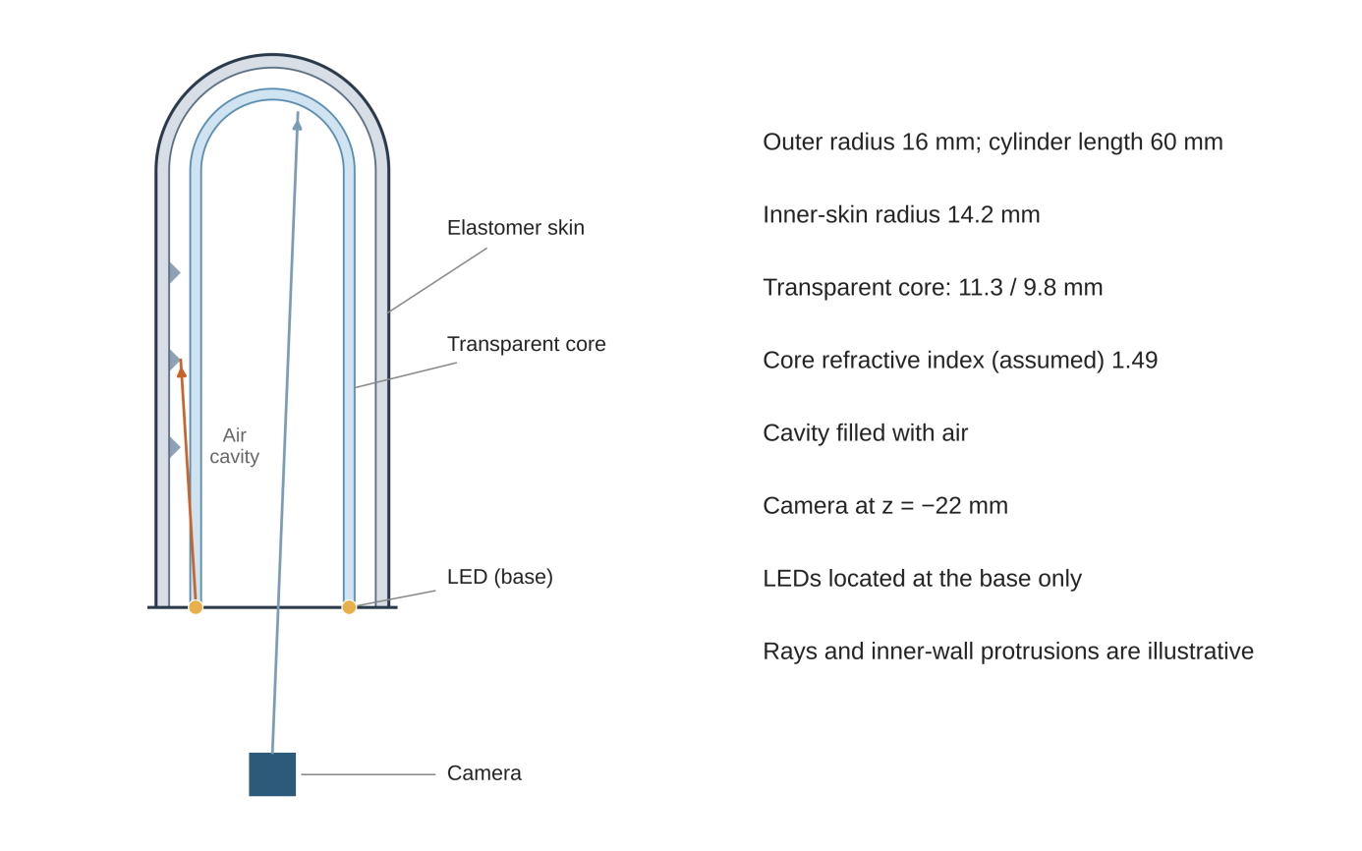
Fig. 1. Hollow sensor structure and optical paths
Note. Structure and optical paths of the single-camera hollow sensor (schematic). Dimensions follow the nominal model; all LEDs are located at the base (only two are shown). Colored lines indicate path relationships and are not ray-tracing results; the inner-wall protrusions are illustrative and do not represent the actual layout of the candidate morphologies.
Table 1. Nominal model and physical parameters
Parameter | Value
Outer cylinder radius; length | 16 mm; 60 mm
Inner-skin radius | 14.2 mm
Transparent core outer radius; inner radius | 11.3 mm; 9.8 mm
Camera position; image size | z = −22 mm; 1280×720
Nominal diagonal field of view | 140°, equidistant projection assumed
Refractive index of transparent core | 1.49
Elastomer Young’s modulus E; Poisson’s ratio ν | 0.25 MPa; 0.4
Indenter radius; contact penalty coefficient | 12.5 mm; 20 N/mm³
The 15 inner-surface morphologies are smooth, rib, round end, cone, pit, raised ring, recessed ring, cross, chevron, paired tips, wedge, meridional lines, latitude lines, cross lines and coded lines (Fig. 2). The saved design identifier is smooth_08px_pitch1p35 for the control and 16px_pitch1p8 for the other candidates. These identifiers describe the registered layout; readable image size varies across the curved surface. Saved rest meshes and case identities define the compared geometries. Table S1 retains each case identifier alongside region, approach depth and imaging conditions, so the result matrix can be joined to its own geometry rather than interpreted as interchangeable surface textures.
The accompanying visual archive extends the reusable design resources to 129 saved parameter layouts, with 123 camera files associated by embedded mesh fingerprints. Inner-surface points, saved height maps and camera observations can be inspected together. The complete controlled comparison additionally retains 3,240 paired summaries across reflectance, illumination and detector settings, corresponding to 12,960 conditional entries. These resources provide supplementary inspection and reuse beyond the representative figures.
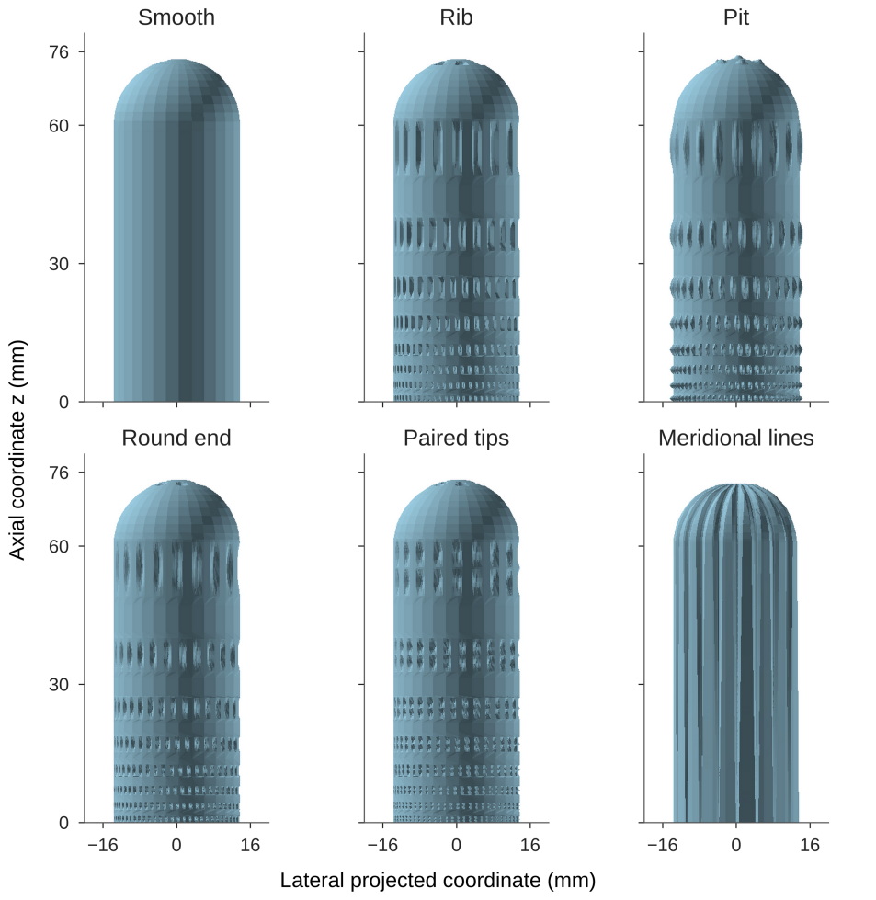
Fig. 2. Saved inner-surface morphology meshes
Note. Cutaway views of the inner surface of the saved meshes of six morphologies. The six saved rest-state (REST) meshes are drawn directly as orthographic projections of the front half of the inner surface at a common scale; the mesh-rendering pixels are those of the original rendering, and the axes and labels were redrawn to the original scale. The blue-gray shading is for display only; the figure is neither a camera image nor a new mechanical or optical solution.
2.2. Mechanical model and loading
The material is modeled as a compressible Neo-Hookean finite-strain elastomer (Holzapfel, 2000; Bonet and Wood, 2008) with Young’s modulus E = 0.25 MPa and Poisson’s ratio ν = 0.4. The strain-energy density is
 | $$W\left(F\right)=\frac{μ}{2}\left[tr\left(F^{T}F\right)−3\right]−μlnJ+\frac{λ}{2}{\left(lnJ\right)}^{2}, J=detF$$ | (1)
where μ = E/[2(1 + ν)] and λ = Eν/[(1 + ν)(1 − 2ν)]. External contact uses a spherical indenter with a radius of 12.5 mm and an area-integrated penalty potential (Wriggers, 2006):
 | Πc=k2f,s​Af wsmingfs,02 | (2)
where A_{f} is the reference area of surface triangle f, w_{s} is the weight of integration point s, g_{fs} is the gap at that point, and the penalty coefficient is k = 20 N/mm³; contact inside the core is treated in the saved nodal form. The strain energy is integrated over the reference tetrahedral volumes. Lengths are in mm, forces in N and energies in N·mm. The model does not include friction, adhesion or time-dependent material behavior.
Each morphology has its own volume mesh with two tetrahedral layers through the thickness, and only the actual base nodes are fixed. The smooth reference contains 4035 nodes and 15,936 tetrahedra; the pit mesh contains 59,397 nodes and 234,492 tetrahedra. Positive volume, closed boundaries, energy gradients and tangents are checked separately from equilibrium convergence. The study compares these registered discrete candidate designs; unequal mesh densities are retained as a numerical limitation when interpreting morphology differences.
Each morphology is loaded at four positions and three depths, giving 180 loading fields and, with 15 rest fields, 195 boundary scenes. Positions are registered by meridional arc length s = 27, 52, 60 and 82.30530784 mm at azimuth φ = 0: near side, far side, transition and apex neighborhood (Fig. 3). The last is a protocol name rather than the geometric pole. Depths 0.1, 0.3 and 0.6 mm denote indenter approach distances. Comparisons therefore hold approach distance fixed; they do not impose equal reaction force or equal contact area. Each candidate uses its own independently solved mechanical field.
Newton iterations were performed within a finite budget, and the linear subproblems were solved with the preconditioned conjugate gradient (PCG) method (Saad, 2003): the CPU budget registered for three morphologies was 40 Newton and 240 PCG iterations, and GPU continuation, applied only to failed paths, allowed up to a further 40 Newton and 1200 PCG iterations. The equilibrium residual criterion was no greater than max(2×10−5 N, 0.001 × external force). This is an equilibrium check of the discrete equations and does not imply convergence of the mesh or of the contact integration.
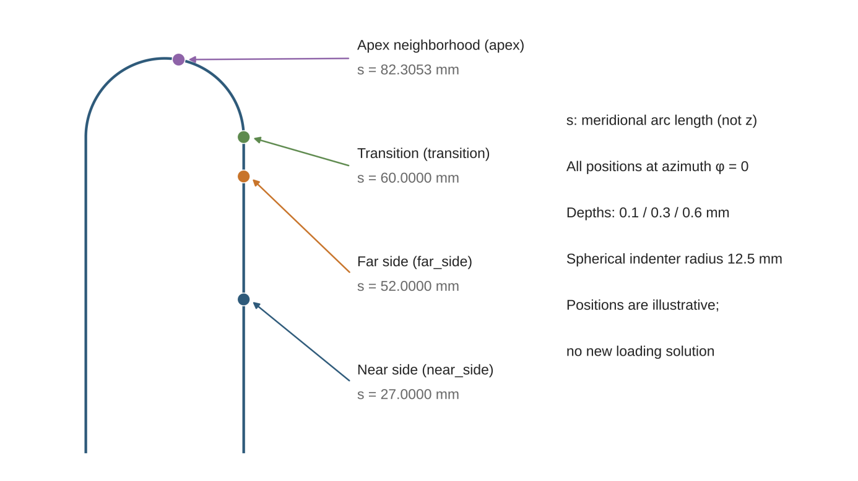
Fig. 3. Registered loading regions
Note. Schematic of the four loading regions and indenter positions. Positions are registered by the meridional arc length s = 27, 52, 60 and 82.3053 mm at azimuth φ = 0; the apex neighborhood is not the geometric pole; the spherical indenter radius is 12.5 mm. The figure only illustrates the protocol positions.
2.3. Optical model and analytic radiometry
Interface refraction follows Snell’s law, and transmission uses the unpolarized Fresnel transmittance (Born and Wolf, 1999); the base aperture and the cylindrical and hemispherical interfaces inside and outside the core all take part in determining path validity. For each refractive path found, the path radiance is determined by the change of area on the target tangent plane with respect to solid angle; here this quantity is computed from analytic propagation derivatives along the fixed optical path.
Let the ray origin be q, the unit direction d, the intersection with the interface h = q + td, and the interface unit normal n. Differentiating with respect to two local parameters in the tangent plane of the incident direction, the implicit interface condition gives the differentials of the intersection distance and intersection point, consistent with the transfer relations of ray differentials (Igehy, 1999):
 | $$Δt=−\frac{n^{T}\left(Δq+t Δd\right)}{n^{T}d}, Δh=Δq+t Δd+d Δt$$ | (3)
Cylindrical and spherical interfaces use their respective normal expressions, and the derivative of the normal normalization is propagated through the projection matrix I − nn^{T}. The interface class actually traversed by the saved path is kept fixed, so that different geometric classes are not merged into one differentiable path under small perturbations. This treatment defines derivatives only inside the active branch and does not handle discontinuities caused by branch switching. Following the normal and propagation sign conventions of the existing implementation, let
 | $$η=\frac{n_{1}}{n_{2}}, c_{i}=d^{T}n, c_{t}=\sqrt{1−η^{2}\left(1−c_{i}^{2}\right)}$$ | (4)
The unnormalized refraction direction is r = ηd + (c_{t} − ηc_{i})n, with differential
 | $$Δc_{i}=n^{T}Δd+d^{T}Δn, Δr=η Δd+\left(c_{t}−ηc_{i}\right)Δn+n\left(\frac{η^{2}c_{i}}{c_{t}}−η\right)Δc_{i}$$ | (5)
where the refractive-index ratio η is held fixed. After r is normalized, the derivative of the propagation direction is (I − vv^{T})Δr/‖r‖ with v = r/‖r‖. This rule is applied successively to the interfaces inside and outside the core. The change J_{A} of the area on the target tangent plane with respect to solid angle enters the denominator of the path radiance:
 | $$J_{A}=\frac{dA}{dΩ}, E_{b}=\frac{C_{b}}{J_{A,b}}$$ | (6)
Here Cb contains the source, transmission and visibility factors for path b under the saved optical convention. Equation (6) isolates the area conversion responsible for the diagnostic error: underestimating JA can inflate a contribution even when intersection residuals are small. The legacy numerical derivative is retained as a versioned diagnostic comparator. The analytic derivatives apply inside a valid active branch; near tangency, critical refraction, failed paths or invalid area factors are recorded with validity flags rather than treated as valid zero-valued observations. Note S1 separates the equations established here from implementation parameters that require the accompanying versioned optical source.
2.4. Noise model and full-frame blind detection
The illuminations for the morphology comparison were fixed in advance as three modes: single LED4 tilted at 34° (LED4_tilt34), eight LEDs at 0° (all8_tilt00) and eight LEDs at 60° (all8_tilt60); the optical reflectance conditions were same-pale (same_pale) and contrast (contrast). The global common exposure was 1996.1886908754632, the total source power was normalized by the single- or eight-LED average, and imaging used SS1 pixel integration (SSn denotes the supersampling level of in-pixel image integration). The point-spread function (PSF) standard deviation was 0.6 or 1.2 pixels and the full well was 5000 or 20,000 e−, giving four sensor conditions; the read noise was 3 e− with linear 8-bit quantization. After Poisson photon noise and Gaussian read noise were applied (Healey and Kondepudy, 1994; Foi et al., 2008), the images were clipped and rounded to 8 bits. These exposure and noise parameters are common assumptions rather than measured camera parameters.
Each group stores 16 static reference frames, 64 threshold no-touch trials and 64 independent no-touch trials, and each loading field additionally stores 32 contact noise trials. The 72 groups of the original three morphologies and the 288 groups of the 12 added morphologies give 360 groups in total; each group contains 4 regions × 3 depths × 3 algorithms = 36 records, for a total of 12,960 conditional records. Merging the four sensor conditions under the same morphology, region, material, illumination, algorithm and depth gives 3,240 matched summaries. None of these counts adds independent physical locations.
With the reference image R, the observed image I and the declared pixel variance V, define
 | zp=Ip−Rp2Vp, Sglobal=p​zp−12N | (7)
where N is the number of pixels in the frame. The three algorithms are: (1) the pixel-standardized maximum, with score max(z); (2) the global normalized energy, with score Sglobal, a normalized form of the classical energy detector (Urkowitz, 1967; Kay, 1998); and (3) the multi-scale squared difference (Lindeberg, 1998), which searches windows of 4, 8, 16 and 32 pixels and takes the maximum of the window energy divided by √(2s2). All algorithms scan the whole frame without cropping by the contact ground truth. Following the idea of a fixed false-alarm level (Kay, 1998), the threshold is the 95th percentile of 64 development no-touch scores; the false-alarm rate (false-positive rate, FPR) is evaluated on another 64 independent no-touch trials, and the recall (true-positive rate, TPR) on 32 loaded noise trials. Wilson intervals (Wilson, 1927; Brown et al., 2001) describe only conditional repeats under the assumed noise.
2.5. Paired comparison and dominance
Under the same region, material, illumination, algorithm and depth, TPR and FPR are compared condition by condition over the four sensor conditions. Following the Pareto dominance definition used in multi-objective optimization (Deb et al., 2002), candidate A dominates candidate B if and only if
 | $${TPR}_{A,c}≥{TPR}_{B,c} \text{and} {FPR}_{A,c}≤{FPR}_{B,c}$$ | (8)
holds for all four conditions c, with at least one strict improvement. Ties are retained. Non-dominance only means that no candidate is better in both rates under the four sensor conditions; the front may include candidates with low recall and few false alarms and is therefore not equivalent to being acceptable or optimal.
2.6. Direct recomputation from raw shards
One group (smooth morphology, same-pale, all8_tilt00, PSF 0.6 pixel, full well 5000 e⁻) was selected in advance. The reference image, variance and 16 calibration frames were read from the raw reference file, together with 8 threshold shards, 8 independent no-touch shards and 4 loaded shards at the apex at 0.1 mm. Each observation shard contains 8×720×1280 uint8 images and 8×3 algorithm scores. Counts were made directly from the raw shards with the “strictly greater than the threshold” rule and checked against the results of the three algorithms in the group record. Full coverage of all 360 groups comes from the existing independent statistics and input checks; the scopes of the two are listed separately in Supplementary Note S1.
3. Independent verification of the radiometric implementation
3.1. Verification scenario and workflow
Verification was performed on the smooth reference morphology and covered two contact-integration states. Q16 and Q1024 denote the number of contact integration points on each outer-surface triangle (not mesh refinement or image supersampling), each with its own mechanical equilibrium field; verification imaging used SS4 supersampling. The diagnostic pixel is pixel (598; 301) of the near-side 0.30 mm loaded scene under LED4 at 34° without PSF blur; this pixel was found during difference diagnosis at the development stage and was not a pre-locked test location. For each Q state, the before–after comparison keeps the geometry and optical paths of that state unchanged and replaces only the path area derivative and the subsequent radiometric computation, so differences within a Q state can be attributed to the area-derivative implementation.
The verification comprised four levels (Fig. 4). (1) Geometry: 32 baseline paths and 48 additional branches found were subjected to independent full-mesh occlusion checks. (2) Area derivatives: for the 48 additional branches, the Jacobian was computed with independent double-precision (FP64) automatic differentiation (AD) (Baydin et al., 2018; Griewank and Walther, 2008) and compared with the production analytic expression; the two do not call the same formula, which avoids self-confirmation. (3) Full frames and fixed conditions: for nine states (one rest state and the loaded states of the four regions under Q16 and Q1024), all 720 rows were re-integrated row by row, with independent derivative checks on six predefined rows; in addition, the saved images of 96 predeclared material, illumination and blur conditions were replayed independently. (4) Direct raw-array recomputation: the two raw full frames of Q1024 before and after correction (float32, 1×4×720×1280 per material, covering the 0°, 12°, 34° and 60° directions of LED4 and the same-pale and contrast materials) were read directly and converted to DN with the common exposure and a 255-level linear analog-to-digital conversion (ADC) scale, and the diagnostic pixel, frame maximum and number of changed pixels were recomputed. Input file identity was checked against the SHA-256 recorded in the original scene records, and the 24 raw files read were verified before and after transfer.
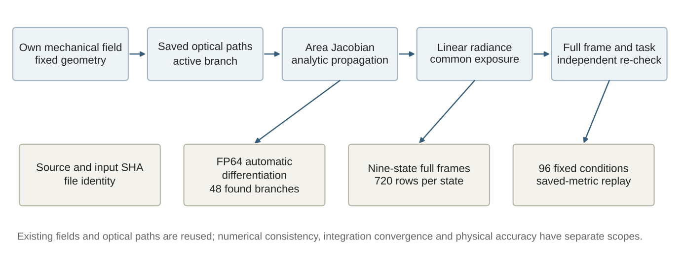
Fig. 4. Independent verification workflow
Note. Independent verification workflow. Mechanical fields and optical paths reuse saved results; area derivatives are checked against independent FP64 automatic differentiation; the full frames of nine states and the 96 fixed conditions reuse the original acceptance records.
3.2. Spurious brightness of the legacy implementation and analytic correction
In the legacy implementation, the diagnostic pixel was about 0.320883 DN under Q16 and 53.243717 DN under Q1024 (Fig. 5). The baseline path contribution was about 0.172 DN in both cases, and the difference came mainly from the area derivative of the additional refractive branches; the AD records show that the minimum ratio of the legacy Q1024 area Jacobian to the AD value was about 0.000642, indicating that the legacy implementation severely underestimated the area term of these paths. On the 48 saved paths, the maximum relative difference between analytic propagation and independent FP64 AD was 1.867019095007×10⁻¹². After correction, the diagnostic pixel was 0.328278083334 DN under Q16 and 0.327347942089 DN under Q1024, so that the two Q states agreed closely.
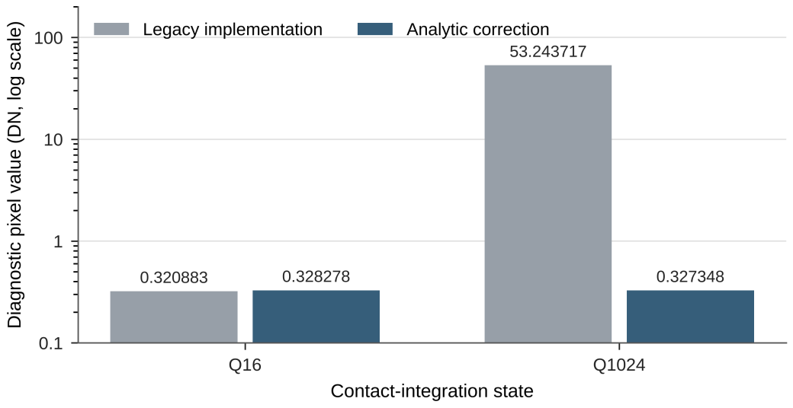
Fig. 5. Diagnostic pixel radiometry
Note. Diagnostic-pixel values before and after the analytic correction. Logarithmic vertical axis. The original mechanical field and optical paths are kept within each Q state; Q is the number of contact integration points and is unrelated to imaging supersampling (SS) or mesh level.
3.3. Full-frame and raw-array recomputation
Full-frame re-integration of the nine registered states and automatic-differentiation checks on the predefined rows completed with an empty failure list. These acceptance records establish completion for that finite verification scope. Separately, independent replay of 96 fixed conditions agreed with saved scalar results to a maximum absolute difference of 3.330669073875×10−16, at double-precision round-off level (Higham, 2002; Goldberg, 1991). The diagnostic-pixel and changed-pixel results reported below refer to the explicitly identified Q1024 scene, rather than being extrapolated to every verification state.
Fig. 6 shows the full frames and local magnifications of the same Q1024 loaded state before and after correction; both use a common linear DN mapping clipped to 0–255 without automatic exposure adjustment. The maximum of the same-pale 34° frame was 285.214270 DN both before and after correction; counting pixels whose absolute change exceeds 10⁻⁸ DN, 11,241 pixels changed for the same-pale material and 6,089 for the contrast material (this threshold only separates float32 results). An unchanged frame maximum combined with a drastic change at a specific location shows that global brightness statistics alone cannot reveal errors in local path contributions. Table 2 lists the recomputed diagnostic-pixel values for two materials and four directions: for the same-pale material, the legacy values were 18.362683–80.085406 DN and the corrected values 0.113670–0.490322 DN; for the contrast material at 34°, the value fell from 1.996639 DN to 0.012276 DN.
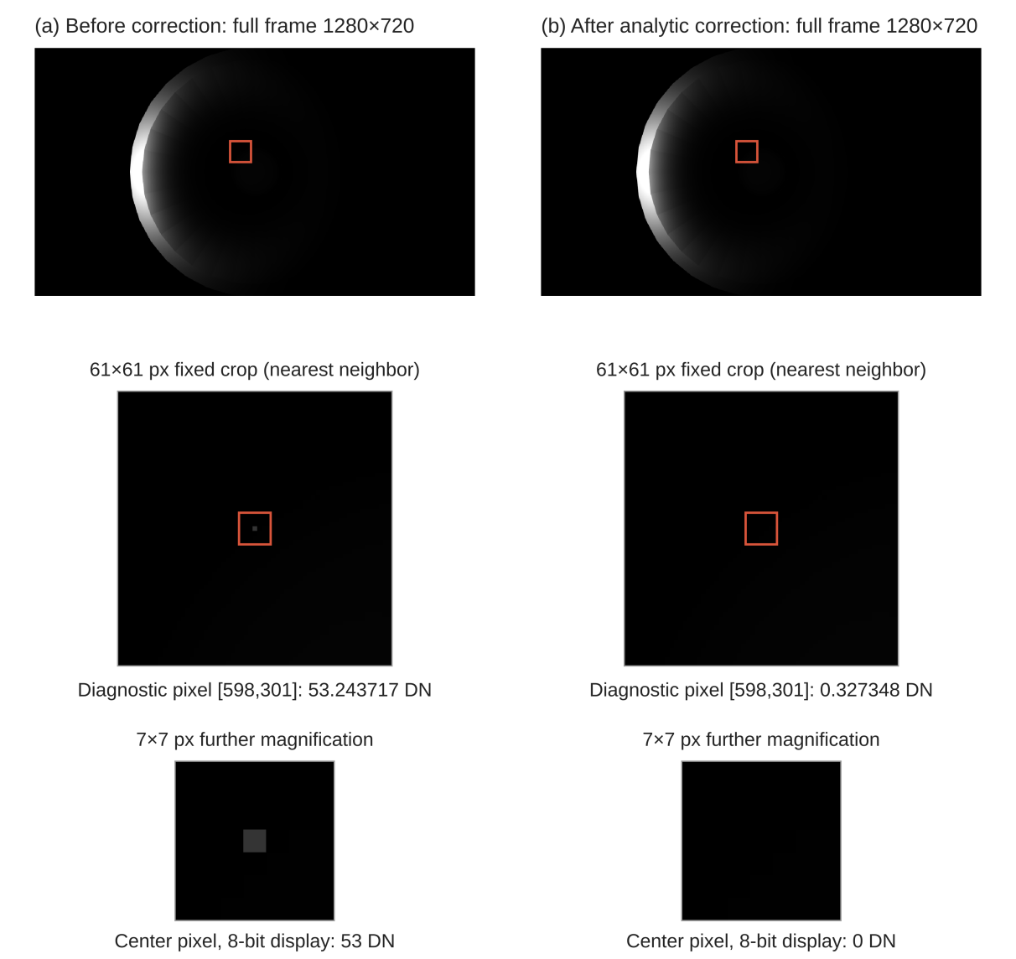
Fig. 6. Full frames and diagnostic magnifications
Note. Full frames and fixed local magnifications of the Q1024 near-side 0.30 mm loaded state before and after correction. Same-pale material, LED4, 34°. Full frames and crops share a 0–255 linear DN display; the boxes are centered on diagnostic pixel (598; 301), and the 61×61 and 7×7 pixel crops use nearest-neighbor magnification; red marks are location annotations only and do not alter the raw arrays. In the 8-bit display the center pixel is quantized to 53 DN and 0 DN; the raw floating-point values are annotated in the figure.
Table 2. Direct recomputation from the raw Q1024 frames (diagnostic pixel (598; 301))
Condition | Legacy (DN) | Analytic correction (DN)
Same-pale, 0° | 80.085406 | 0.490322
Same-pale, 12° | 75.829745 | 0.464871
Same-pale, 34° | 53.243717 | 0.327348
Same-pale, 60° | 18.362683 | 0.113670
Contrast, 34° | 1.996639 | 0.012276
Same-pale, 34°, frame maximum | 285.214270 | 285.214270
On the basis of this verification, all 360 detection groups in Section 4 were generated with the optical matrices corrected by the analytic area Jacobian, and the legacy finite-difference radiometry was not used in the morphology comparison.
4. Region-wise conditional observability of 15 morphologies
4.1. Morphology differences under shallow apex contact
The main analysis fixes the same-pale material, all8_tilt00 illumination, the global normalized energy detector and a depth of 0.1 mm. Fig. 7 gives the minimum conditional TPR of the 15 morphologies in the four regions, each cell being the minimum over the four sensor conditions; Fig. 8 shows the trends over the four regions and three depths for the smooth, round-end, meridional-line and paired-tip morphologies.
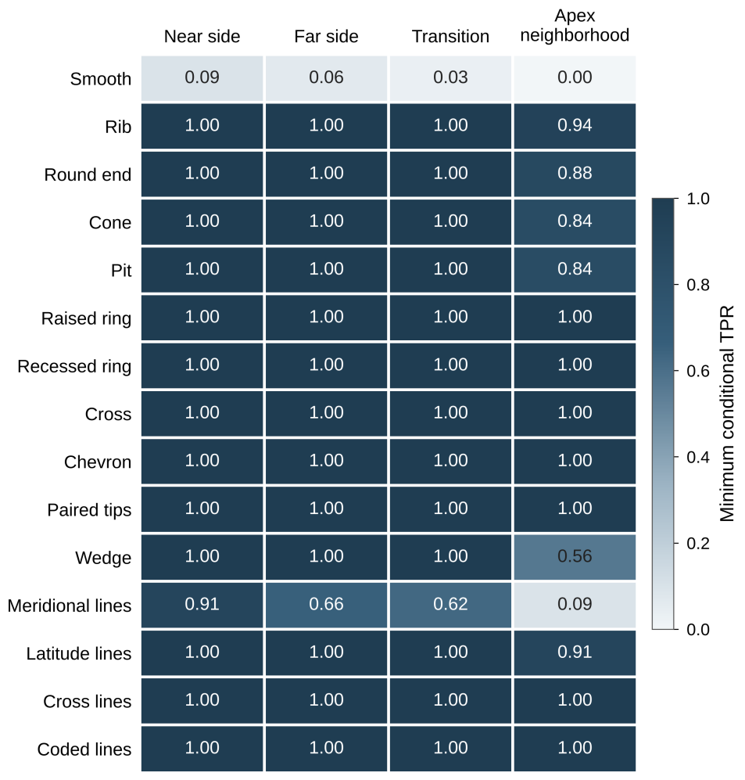
Fig. 7. Regional minimum conditional detection rates
Note. Minimum conditional TPR of 15 morphologies in four regions. Same-pale, all8_tilt00, global normalized energy, 0.1 mm. Each cell is the minimum over the four PSF–full-well conditions, not a confidence interval; all morphologies are shown.
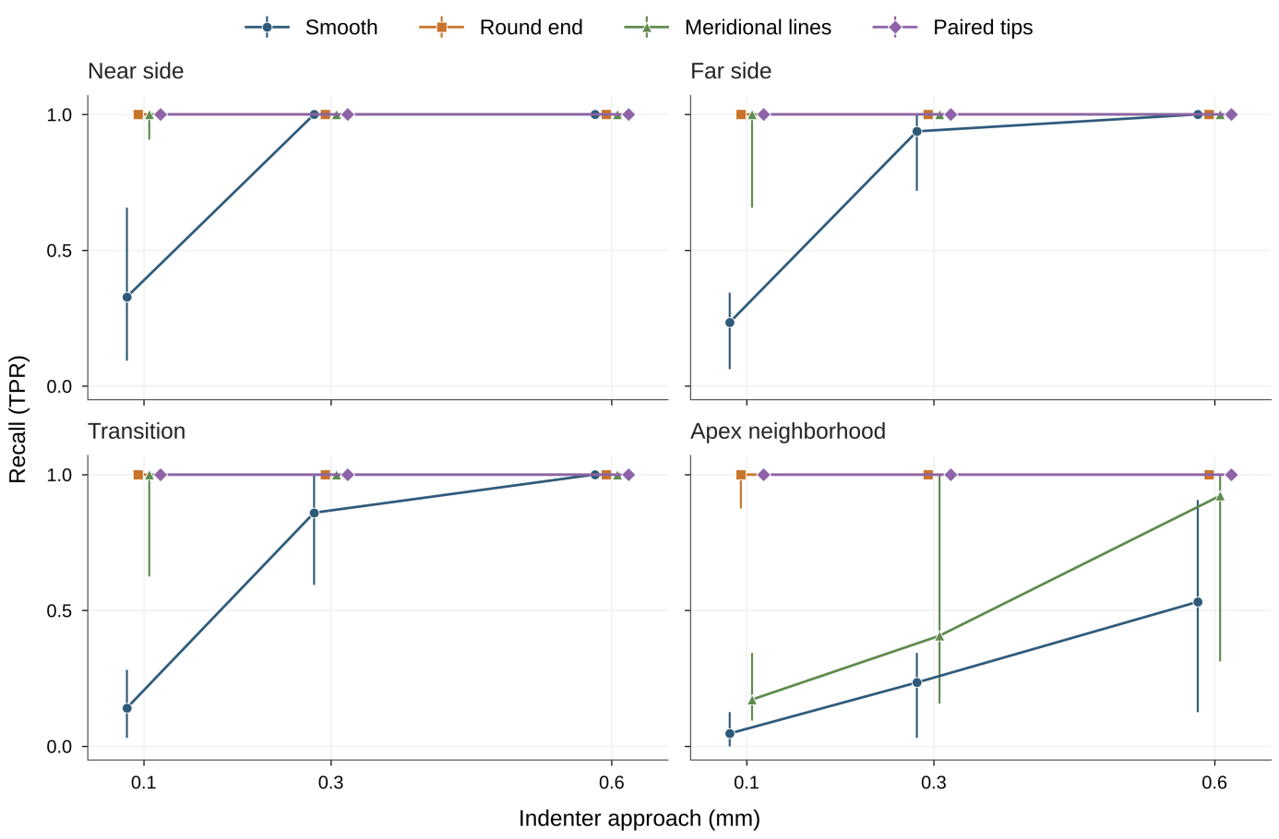
Fig. 8. Region and depth detection trends
Note. TPR versus depth and region for example morphologies. The example morphologies are smooth, round end, meridional lines and paired tips; all four regions and three depths are shown. Points are median TPRs over the four conditions and vertical bars span the condition minimum to maximum (not confidence intervals); lines only connect the discrete depths, and symbols at the same depth are slightly offset to avoid overlap.
In the apex neighborhood, the smooth surface had a TPR of 0–12.50% and an FPR of 3.13%–14.06%; the round end had a TPR of 87.50%–100% and an FPR of 0–6.25%; paired tips had a TPR of 100% and an FPR of 1.56%–7.81% (Fig. 9). Under shallow contact, relief morphologies generally produced changes that were more readily captured by the detection statistic than the smooth surface did; because a morphology changes both the mechanical and the optical response, the differences cannot be attributed to any single projection or encoding mechanism.
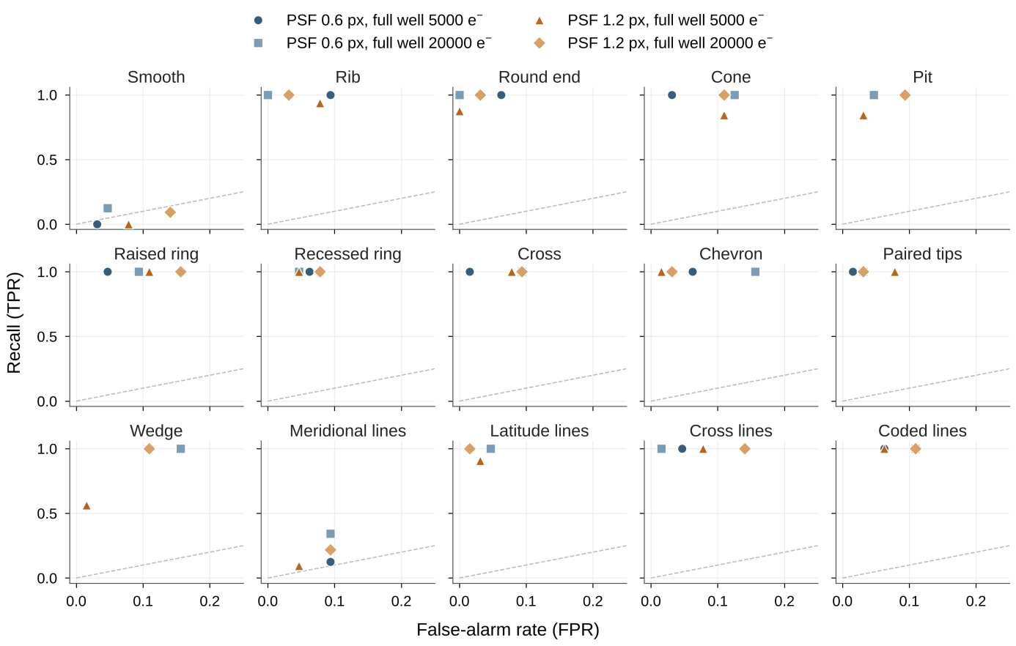
Fig. 9. Shallow apex detection and false alarms
Note. Recall and false-alarm rate for shallow apex contact at 0.1 mm. Same-pale, all8_tilt00, global normalized energy; 15 morphologies × 4 conditions = 60 points, one panel per morphology. Marker shape and color distinguish the four PSF–full-well conditions; the dashed line is the TPR = FPR reference (chance level).
4.2. Region and depth dependence
For meridional lines, the TPR at the apex was 9.38%–34.38%, compared with 90.63%–100% at the near side, 65.63%–100% at the far side and 62.50%–100% in the transition region (Figs. 7 and 8). The same morphology behaved very differently in different regions, so surface structures need to be designed region by region. As the depth increased (Fig. S1 and Table S1), at 0.3 mm the minimum conditional TPR of the 13 morphologies other than smooth and meridional lines was 100% in all four regions, whereas the smooth surface remained at 71.88%, 59.38% and 3.13% at the far side, transition and apex neighborhood, and meridional lines at 15.63% in the apex neighborhood; at 0.6 mm, only the smooth surface and meridional lines remained below 100% in the apex neighborhood, at 12.50% and 31.25%, respectively. The apex neighborhood is therefore the hardest of the four regions to observe.
4.3. Algorithm dependence
For latitude lines at the apex at 0.1 mm, the TPR was 90.63%–100% with the global normalized energy and 6.25%–100% with the multi-scale squared difference. Different statistics differ in their sensitivity to the blur and photon-noise assumptions, so morphology rankings should be reported together with the detection algorithm.
4.4. Dominance
Comparing region by region and depth by depth according to Eq. (8) under same-pale, all8_tilt00 and global normalized energy conditions, the non-dominated morphologies in the 11 region–depth combinations other than the apex neighborhood at 0.1 mm were the same four: round end, paired tips, latitude lines and cross lines. In the apex neighborhood at 0.1 mm, seven morphologies were non-dominated, additionally including rib, recessed ring and chevron (Table 3); the smooth surface was dominated by paired tips and latitude lines, and meridional lines by round end, pit, recessed ring and latitude lines.
Table 3. Dominance relations of 15 morphologies in the apex neighborhood at 0.1 mm (same-pale, all8_tilt00, global normalized energy)
Morphology | Non-dominated | Dominated by
Smooth | No | Paired tips, latitude lines
Rib | Yes | —
Round end | Yes | —
Cone | No | Cross, paired tips, latitude lines
Pit | No | Latitude lines
Raised ring | No | Cross, paired tips, cross lines
Recessed ring | Yes | —
Cross | No | Paired tips
Chevron | Yes | —
Paired tips | Yes | —
Wedge | No | Round end, chevron
Meridional lines | No | Round end, pit, recessed ring, latitude lines
Latitude lines | Yes | —
Cross lines | Yes | —
Coded lines | No | Recessed ring
4.5. Data checks and raw-shard recomputation
The existing independent paired checks covered 12,960 records, 3,240 summaries, 216 contexts and 29,160 scalar checks and verified 540 rows of the fixed display tables; the geometric scope check confirmed 180 full-shell loading fields of the morphologies themselves and 195 boundary scenes. The direct raw-shard recomputation of the designated smooth group is given in Table 4 (an example raw frame is shown in Fig. S2): the detection counts of the pixel-standardized maximum, multi-scale squared difference and global normalized energy were 2, 4 and 0 (denominator 32), and the independent no-touch false-alarm counts were 4, 4 and 2 (denominator 64), in exact agreement with the original group record. These detection and false-alarm rates lie near the origin and the diagonal of the receiver operating characteristic (ROC) space (Fawcett, 2006), indicating that, under the conditions of this group, the ability of the smooth surface to detect shallow apex contact is close to chance.
Table 4. Direct counts from the raw shards of the designated group
Algorithm | Detections (of 32) | False alarms (of 64) | Detection rate (%) | False-alarm rate (%)
Pixel-standardized maximum | 2 | 4 | 6.25 | 6.25
Multi-scale squared difference | 4 | 4 | 12.50 | 6.25
Global normalized energy | 0 | 2 | 0 | 3.125
5. Discussion
5.1. Significance of verification for morphology comparison
This case separates ray-geometry errors, path-contribution errors and integration errors: passing the geometric checks does not guarantee correct radiometry, and refining the contact integration cannot compensate for unstable derivatives in the subsequent optical contribution. The spurious brightness of the legacy implementation appeared as abnormal brightness of local pixels while the frame maximum and the global exposure were unchanged, so routine global brightness checks could not detect it. Had the morphology comparison been built on such input, similar local spurious brightness could have been misread as an observability advantage of a particular morphology. We therefore completed the radiometric verification before the morphology comparison and used the corrected optical matrices for all detection data. For simulation-to-reality (Sim2Real) studies that train or evaluate on simulated images (Gomes et al., 2021; Gomes et al., 2023; Duret et al., 2026), the version of the radiometric implementation should likewise be recorded as part of result traceability. This counterexample does not imply that all finite-difference methods fail, nor that the present analytic implementation has a general advantage over mature renderers (Pharr et al., 2016; Nimier-David et al., 2019).
5.2. Implications for region-wise morphology design
The morphology comparison reveals interactions among region, morphology, algorithm and noise conditions. The apex neighborhood is the hardest region to observe: even at 0.6 mm, the minimum conditional TPR of the smooth surface there was only 12.50%, so the smooth surface is unsuitable for covering the apex; meridional lines perform well in the side regions but weaken markedly at the apex, and are therefore better suited to the sides than to the apex. Round end, paired tips, latitude lines and cross lines were not dominated by any other morphology in any of the compared regions and depths and can serve as priority candidates for region-wise layouts. Compared with existing studies of marker and surface-morphology design (Ward-Cherrier et al., 2018; Sferrazza and D’Andrea, 2019; Tang and Nanayakkara, 2026), this study provides a complete region-by-region and depth-by-depth comparison within a long hollow curved envelope and retains the failure cases. Reporting the three depths separately rather than averaging across depths prevents high recall at large depths from masking failures under shallow indentation.
5.3. Limitations
(1) The agreement between the analytic derivatives and AD is numerical verification of the implementation, not model validation (Oberkampf and Roy, 2010); all results come from simulation and have not been checked against a physical sensor, and the transfer of the simulation conclusions to hardware requires dedicated evaluation (Gomes et al., 2021).
(2) Point light sources, the set of optical paths found, the surface-reflection approximation, and the material, lens and pixel-integration models limit the applicability of the conclusions; the analytic derivatives are defined only inside the active branch and do not handle discontinuities caused by branch switching; the diagnostic pixel was selected from development-stage differences to illustrate the failure mechanism.
(3) The 15 morphologies are not a random sample; each has only one layout and four development locations, all at the same azimuth, so performance over the full 360° azimuth cannot be estimated from them.
(4) The minimum conditional TPR is the least favorable value over four declared sensor assumptions; the FPR is shared across regions and depths within a group, and repeated values cannot be added up as more independent no-touch evidence.
(5) Comparisons were made at fixed indentation rather than fixed contact force; mesh density differs among morphologies, and the finite discretization of the contact integration and of the SS1 image integration are numerical confounders.
(6) This paper does not generate the performance of hybrid structures and does not interpret static fields as dynamic trajectories.
6. Conclusions
This study provides a reproducible route from mechanical–optical computation to region-wise morphology selection for a hollow curved tactile sensor. Analytic refractive-area derivatives agree with independently implemented automatic differentiation to 1.867×10−12 relative difference. Correcting the diagnostic pixel from 53.243717 to 0.327348 DN while preserving the frame maximum demonstrates the need to verify local radiometric contributions. On corrected images, the 15-candidate comparison identifies the apex neighborhood and shallow contact as principal design challenges. Round ends, paired tips, latitude lines and cross lines remain non-dominated across the evaluated region–depth combinations and provide concrete priorities for region-wise layouts. The numerical verification, source identities, condition-resolved tables and retained failure cases are the central methodological contribution. The design conclusions apply to the registered geometry, material model, discrete meshes and imaging assumptions; broader azimuth coverage and mesh/contact-integration sensitivity would strengthen their generality. Future simulation studies can test combined layouts and use detection, localization and deformation-recognition performance together with computational cost to further converge the sensor design.
Data availability: Supplementary Note S1 describes the verification scopes and source identities. Supplementary Fig. S1 and Table S1 provide the complete primary region–depth comparison, and Fig. S2 preserves a diagnostic full-frame example. The accompanying reproducibility package contains condition-resolved saved results, checksums and selected versioned source files. The bilingual visualization portal provides a compact entry to the research and selected data. Repository and persistent-release identifiers will be added at public release.
CRediT authorship contribution statement: [To be completed]
Funding: [To be completed]
Acknowledgments: [To be completed]
Declaration of competing interest: [To be completed]
References
A. Agarwal, T. Man, and W. Yuan (2021). “Simulation of vision-based tactile sensors using physics based rendering,” in Proc. 2021 IEEE Int. Conf. Robotics and Automation (ICRA), Xi’an, China, doi: 10.1109/ICRA48506.2021.9561122.
I. Andrussow, H. Sun, K. J. Kuchenbecker, et al. (2023). “Minsight: A fingertip-sized vision-based tactile sensor for robotic manipulation,” Advanced Intelligent Systems, vol. 5, no. 8, Art. no. 2300042, doi: 10.1002/aisy.202300042.
O. Azulay, N. Curtis, R. Sokolovsky, et al. (2024). “AllSight: A low-cost and high-resolution round tactile sensor with zero-shot learning capability,” IEEE Robotics and Automation Letters, vol. 9, no. 1, pp. 483–490, doi: 10.1109/LRA.2023.3333701.
A. G. Baydin, B. A. Pearlmutter, A. A. Radul, et al. (2018). “Automatic differentiation in machine learning: A survey,” Journal of Machine Learning Research, vol. 18, no. 153, pp. 1–43.
J. Bonet and R. D. Wood (2008). Nonlinear Continuum Mechanics for Finite Element Analysis, 2nd ed. Cambridge, U.K.: Cambridge Univ. Press.
M. Born and E. Wolf (1999). Principles of Optics: Electromagnetic Theory of Propagation, Interference and Diffraction of Light, 7th ed. Cambridge, U.K.: Cambridge Univ. Press.
L. D. Brown, T. T. Cai, and A. DasGupta (2001). “Interval estimation for a binomial proportion,” Statistical Science, vol. 16, no. 2, pp. 101–133, doi: 10.1214/ss/1009213286.
R. S. Dahiya, G. Metta, M. Valle, et al. (2010). “Tactile sensing—from humans to humanoids,” IEEE Transactions on Robotics, vol. 26, no. 1, pp. 1–20, doi: 10.1109/TRO.2009.2033627.
K. Deb, A. Pratap, S. Agarwal, et al. (2002). “A fast and elitist multiobjective genetic algorithm: NSGA-II,” IEEE Transactions on Evolutionary Computation, vol. 6, no. 2, pp. 182–197, doi: 10.1109/4235.996017.
G. Duret, A. Samsonenko, F. Zara, et al. (2026). “Automatic physically-based Sim2Real for tactile images through differentiable path-tracing rendering,” presented at the IEEE Int. Conf. Robotics and Automation (ICRA). [Online]. Available: https://shanluo.github.io/ViTacWorkshops/assets/accepted_paper/pdf/16.pdf
T. Fawcett (2006). “An introduction to ROC analysis,” Pattern Recognition Letters, vol. 27, no. 8, pp. 861–874, doi: 10.1016/j.patrec.2005.10.010.
A. Foi, M. Trimeche, V. Katkovnik, et al. (2008). “Practical Poissonian-Gaussian noise modeling and fitting for single-image raw-data,” IEEE Transactions on Image Processing, vol. 17, no. 10, pp. 1737–1754, doi: 10.1109/TIP.2008.2001399.
D. Goldberg (1991). “What every computer scientist should know about floating-point arithmetic,” ACM Computing Surveys, vol. 23, no. 1, pp. 5–48, doi: 10.1145/103162.103163.
D. F. Gomes, P. Paoletti, and S. Luo (2021). “Generation of GelSight tactile images for Sim2Real learning,” IEEE Robotics and Automation Letters, vol. 6, no. 2, pp. 4177–4184, doi: 10.1109/LRA.2021.3063925.
D. F. Gomes, P. Paoletti, and S. Luo (2023). “Beyond flat GelSight sensors: Simulation of optical tactile sensors of complex morphologies for Sim2Real learning,” in Proc. Robotics: Science and Systems XIX, Daegu, Korea, Art. no. 035, doi: 10.15607/RSS.2023.XIX.035.
D. F. Gomes, Z. Lin, and S. Luo (2020). “GelTip: A finger-shaped optical tactile sensor for robotic manipulation,” in Proc. 2020 IEEE/RSJ Int. Conf. Intelligent Robots and Systems (IROS), Las Vegas, NV, USA, pp. 9903–9909, doi: 10.1109/IROS45743.2020.9340881.
A. Griewank and A. Walther (2008). Evaluating Derivatives: Principles and Techniques of Algorithmic Differentiation, 2nd ed. Philadelphia, PA, USA: SIAM.
G. E. Healey and R. Kondepudy (1994). “Radiometric CCD camera calibration and noise estimation,” IEEE Transactions on Pattern Analysis and Machine Intelligence, vol. 16, no. 3, pp. 267–276.
N. J. Higham (2002). Accuracy and Stability of Numerical Algorithms, 2nd ed. Philadelphia, PA, USA: SIAM.
G. A. Holzapfel (2000). Nonlinear Solid Mechanics: A Continuum Approach for Engineering. Chichester, U.K.: Wiley.
H. Igehy (1999). “Tracing ray differentials,” in Proc. 26th Annu. Conf. Computer Graphics and Interactive Techniques (SIGGRAPH ’99), Los Angeles, CA, USA.
J. T. Kajiya (1986). “The rendering equation,” ACM SIGGRAPH Computer Graphics, vol. 20, no. 4, pp. 143–150, doi: 10.1145/15886.15902.
Z. Kappassov, J. A. Corrales, and V. Perdereau (2015). “Tactile sensing in dexterous robot hands—Review,” Robotics and Autonomous Systems, vol. 74, pp. 195–220, doi: 10.1016/j.robot.2015.07.015.
S. M. Kay (1998). Fundamentals of Statistical Signal Processing, Volume II: Detection Theory. Upper Saddle River, NJ, USA: Prentice Hall.
M. Lambeta, P. W. Chou, S. Tian, et al. (2020). “DIGIT: A novel design for a low-cost compact high-resolution tactile sensor with application to in-hand manipulation,” IEEE Robotics and Automation Letters, vol. 5, no. 3, pp. 3838–3845, doi: 10.1109/LRA.2020.2977257.
Q. Li, O. Kroemer, Z. Su, et al. (2020). “A review of tactile information: Perception and action through touch,” IEEE Transactions on Robotics, vol. 36, no. 6, pp. 1619–1634, doi: 10.1109/TRO.2020.3003230.
T.-M. Li, M. Aittala, F. Durand, et al. (2018). “Differentiable Monte Carlo ray tracing through edge sampling,” ACM Transactions on Graphics, vol. 37, no. 6, Art. no. 222.
T. Lindeberg (1998). “Feature detection with automatic scale selection,” International Journal of Computer Vision, vol. 30, no. 2, pp. 79–116.
M. Nimier-David, D. Vicini, T. Zeltner, et al. (2019). “Mitsuba 2: A retargetable forward and inverse renderer,” ACM Transactions on Graphics, vol. 38, no. 6, Art. no. 203.
J. Nocedal and S. J. Wright (2006). Numerical Optimization, 2nd ed. New York, NY, USA: Springer, doi: 10.1007/978-0-387-40065-5.
W. L. Oberkampf and C. J. Roy (2010). Verification and Validation in Scientific Computing. Cambridge, U.K.: Cambridge Univ. Press.
A. Padmanabha, F. Ebert, S. Tian, et al. (2020). “OmniTact: A multi-directional high-resolution touch sensor,” in Proc. 2020 IEEE Int. Conf. Robotics and Automation (ICRA), Paris, France, pp. 618–624, doi: 10.1109/ICRA40945.2020.9196712.
M. Pharr, W. Jakob, and G. Humphreys (2016). Physically Based Rendering: From Theory to Implementation, 3rd ed. Cambridge, MA, USA: Morgan Kaufmann.
P. J. Roache (1998). “Verification of codes and calculations,” AIAA Journal, vol. 36, no. 5, pp. 696–702.
Y. Saad (2003). Iterative Methods for Sparse Linear Systems, 2nd ed. Philadelphia, PA, USA: SIAM.
C. Sferrazza and R. D’Andrea (2019). “Design, motivation and evaluation of a full-resolution optical tactile sensor,” Sensors, vol. 19, no. 4, Art. no. 928, doi: 10.3390/s19040928.
C. Sferrazza, A. Wahlsten, C. Trueeb, et al. (2019). “Ground truth force distribution for learning-based tactile sensing: A finite element approach,” IEEE Access, vol. 7, pp. 173438–173449, doi: 10.1109/ACCESS.2019.2956882.
K. Shimonomura (2019). “Tactile image sensors employing camera: A review,” Sensors, vol. 19, no. 18, Art. no. 3933, doi: 10.3390/s19183933.
Z. Si and W. Yuan (2022). “Taxim: An example-based simulation model for GelSight tactile sensors,” IEEE Robotics and Automation Letters, vol. 7, no. 2, pp. 2361–2368.
Z. Si, G. Zhang, Q. Ben, et al. (2024). “DiffTactile: A physics-based differentiable tactile simulator for contact-rich robotic manipulation,” in Proc. Int. Conf. Learning Representations (ICLR), Vienna, Austria.
H. Sun, K. J. Kuchenbecker, and G. Martius (2022). “A soft thumb-sized vision-based sensor with accurate all-round force perception,” Nature Machine Intelligence, vol. 4, no. 2, pp. 135–145, doi: 10.1038/s42256-021-00439-3.
T. Tang and T. Nanayakkara (2026). “Marker information efficacy: Guiding marker design through deformation information encoding in vision-based tactile sensing,” npj Robotics, vol. 4, Art. no. 50, doi: 10.1038/s44182-026-00115-x.
H. Urkowitz (1967). “Energy detection of unknown deterministic signals,” Proceedings of the IEEE, vol. 55, no. 4, pp. 523–531.
S. Wang, M. Lambeta, P. W. Chou, et al. (2022). “TACTO: A fast, flexible, and open-source simulator for high-resolution vision-based tactile sensors,” IEEE Robotics and Automation Letters, vol. 7, no. 2, pp. 3930–3937, doi: 10.1109/LRA.2022.3146945.
B. Ward-Cherrier, N. Pestell, L. Cramphorn, et al. (2018). “The TacTip family: Soft optical tactile sensors with 3D-printed biomimetic morphologies,” Soft Robotics, vol. 5, no. 2, pp. 216–227, doi: 10.1089/soro.2017.0052.
E. B. Wilson (1927). “Probable inference, the law of succession, and statistical inference,” Journal of the American Statistical Association, vol. 22, no. 158, pp. 209–212.
P. Wriggers (2006). Computational Contact Mechanics, 2nd ed. Berlin, Germany: Springer, doi: 10.1007/978-3-540-32609-0.
W. Yuan, S. Dong, and E. H. Adelson (2017). “GelSight: High-resolution robot tactile sensors for estimating geometry and force,” Sensors, vol. 17, no. 12, Art. no. 2762, doi: 10.3390/s17122762.
X. Zhang, J. Jiang, Z. Chen, et al. (2026). “SimTac: A physics-based simulator for vision-based tactile sensing with biomorphic structures,” Cyborg and Bionic Systems, vol. 7, Art. no. 0510, doi: 10.34133/cbsystems.0510.
J. Zhao and E. H. Adelson (2023). “GelSight Svelte: A human finger-shaped single-camera tactile robot finger with large sensing coverage and proprioceptive sensing,”, arXiv:2309.10885.

